**1. ER Diagram**

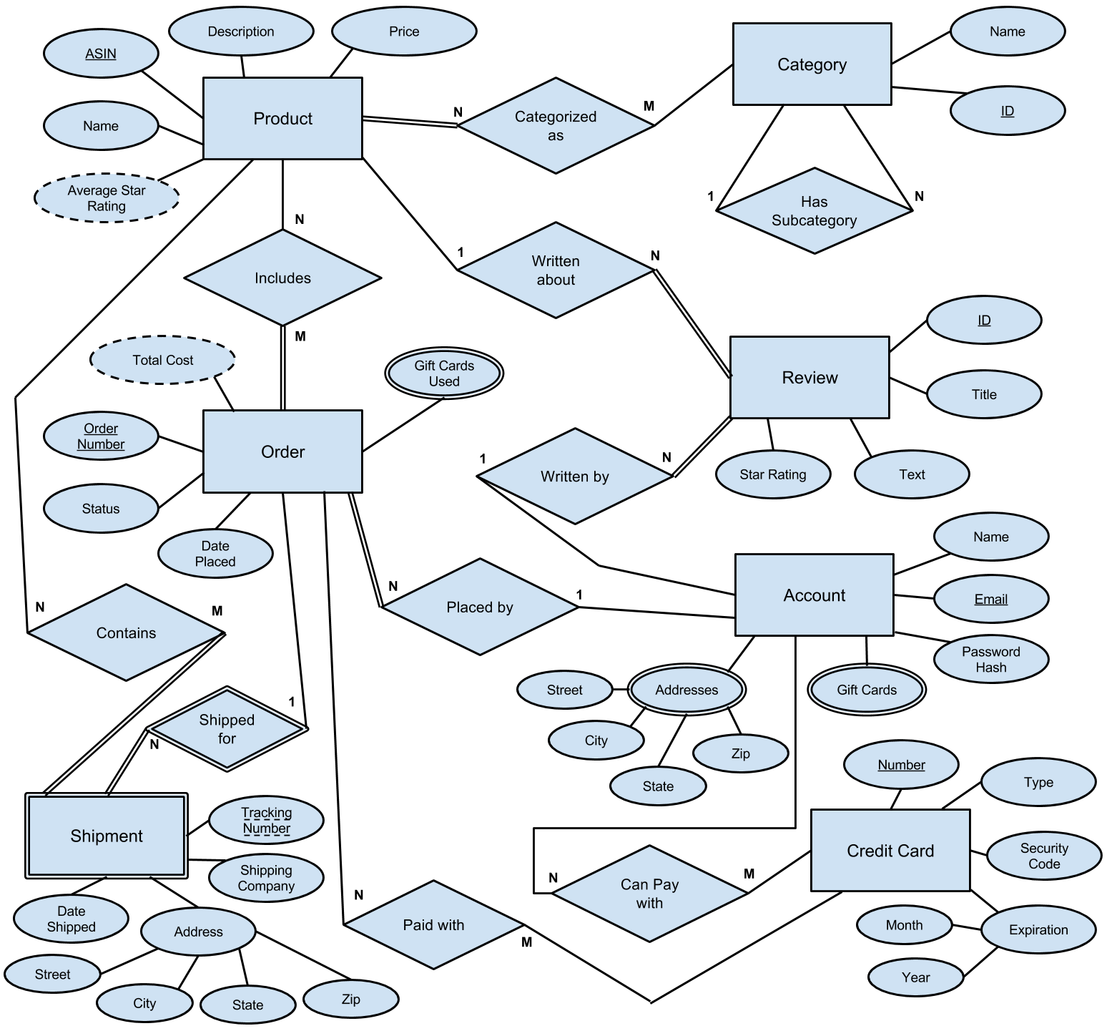

**2. Oracle Code for Creating the Database**

/* Drop the tables if they already exist. */

DROP TABLE product CASCADE CONSTRAINTS;

DROP TABLE category CASCADE CONSTRAINTS;

DROP TABLE review CASCADE CONSTRAINTS;

DROP TABLE account CASCADE CONSTRAINTS;

DROP TABLE orders CASCADE CONSTRAINTS;

DROP TABLE shipment CASCADE CONSTRAINTS;

DROP TABLE credit_card CASCADE CONSTRAINTS;

DROP TABLE product_categorized_as CASCADE CONSTRAINTS;

DROP TABLE order_includes CASCADE CONSTRAINTS;

DROP TABLE shipment_contains CASCADE CONSTRAINTS;

DROP TABLE account_credit_cards CASCADE CONSTRAINTS;

DROP TABLE order_paid_with CASCADE CONSTRAINTS;

DROP TABLE order_gift_cards CASCADE CONSTRAINTS;

DROP TABLE account_gift_cards CASCADE CONSTRAINTS;

DROP TABLE account_addresses CASCADE CONSTRAINTS;

/* Create the tables. */

CREATE TABLE product

(

ASIN CHAR (10) CONSTRAINT product_asin_pk PRIMARY KEY,

Name VARCHAR2 (128) CONSTRAINT product_name_nn NOT NULL,

Description VARCHAR2 (2048),

Price NUMBER (9, 2) CONSTRAINT product_price_nn NOT NULL

);

CREATE TABLE category

(

Category_ID NUMBER (10) CONSTRAINT category_category_id_pk PRIMARY KEY,

Name VARCHAR2 (128) CONSTRAINT category_name_nn NOT NULL,

Subcategory_Of NUMBER (10)

);

CREATE TABLE review

(

Review_ID CHAR (14) CONSTRAINT review_review_id_pk PRIMARY KEY,

Title VARCHAR2 (128),

Text VARCHAR2 (2048),

Star_Rating NUMBER (1) CONSTRAINT review_star_rating_nn NOT NULL,

Written_By VARCHAR2 (64) CONSTRAINT review_written_by_nn NOT NULL,

Written_About CHAR (10) CONSTRAINT review_written_about_nn NOT NULL

);

CREATE TABLE account

(

Email VARCHAR2 (64) CONSTRAINT account_email_pk PRIMARY KEY,

Name VARCHAR2 (128) CONSTRAINT account_name_nn NOT NULL,

Password_Hash CHAR (40) CONSTRAINT account_password_hash_nn NOT NULL

);

CREATE TABLE orders

(

Order_Number NUMBER (17) CONSTRAINT orders_order_number_pk PRIMARY KEY,

Date_Placed DATE CONSTRAINT orders_date_placed_nn NOT NULL,

Status VARCHAR2 (64) CONSTRAINT orders_status_nn NOT NULL,

Placed_By VARCHAR2 (64) CONSTRAINT orders_placed_by_nn NOT NULL

);

CREATE TABLE shipment

(

Order_Number NUMBER (17),

Tracking_Number VARCHAR2 (32),

Company VARCHAR2 (32) CONSTRAINT shipment_company_nn NOT NULL,

Date_Shipped DATE,

Street VARCHAR2 (32) CONSTRAINT shipment_street_nn NOT NULL,

City VARCHAR2 (32) CONSTRAINT shipment_city_nn NOT NULL,

State CHAR (2) CONSTRAINT shipment_state_nn NOT NULL,

Zip NUMBER (5) CONSTRAINT shipment_zip_nn NOT NULL,

CONSTRAINT shipment_ordno_trackno_pk PRIMARY KEY (Order_Number, Tracking_Number)

);

CREATE TABLE credit_card

(

Card_Number NUMBER (16) CONSTRAINT credit_card_card_number_pk PRIMARY KEY,

Type VARCHAR2 (16) CONSTRAINT credit_card_type_nn NOT NULL,

Security_Code NUMBER (4) CONSTRAINT credit_card_security_code_nn NOT NULL,

Exp_Month NUMBER (2) CONSTRAINT credit_card_exp_month_nn NOT NULL,

Exp_Year NUMBER (2) CONSTRAINT credit_card_exp_year_nn NOT NULL

);

CREATE TABLE product_categorized_as

(

Product_ASIN CHAR (10),

Category_ID NUMBER (10),

CONSTRAINT product_cat_as_asin_catid_pk PRIMARY KEY (Product_ASIN, Category_ID)

);

CREATE TABLE order_includes

(

Order_Number NUMBER (17),

Product_ASIN CHAR (10),

CONSTRAINT order_includes_ordno_asin_pk PRIMARY KEY (Order_Number, Product_ASIN)

);

CREATE TABLE shipment_contains

(

Order_Number NUMBER (17),

Tracking_Number VARCHAR2 (32),

Product_ASIN CHAR (10),

CONSTRAINT shipment_cont_ono_tno_asin_pk PRIMARY KEY (Order_Number, Tracking_Number, Product_ASIN)

);

CREATE TABLE account_credit_cards

(

Account_Email VARCHAR2 (64),

Credit_Card_Number NUMBER (16),

CONSTRAINT account_ccs_email_cardno_pk PRIMARY KEY (Account_Email, Credit_Card_Number)

);

CREATE TABLE order_paid_with

(

Order_Number NUMBER (17),

Credit_Card_Number NUMBER (16),

CONSTRAINT order_paid_w_ordno_cardno_pk PRIMARY KEY (Order_Number, Credit_Card_Number)

);

CREATE TABLE order_gift_cards

(

Order_Number NUMBER (17),

Gift_Card_Number CHAR (15),

CONSTRAINT order_gcs_ordno_gcno_pk PRIMARY KEY (Order_Number, Gift_Card_Number)

);

CREATE TABLE account_gift_cards

(

Account_Email VARCHAR2 (64),

Gift_Card_Number CHAR (15),

CONSTRAINT account_gcs_email_gcno_pk PRIMARY KEY (Account_Email, Gift_Card_Number)

);

CREATE TABLE account_addresses

(

Account_Email VARCHAR2 (64),

Street VARCHAR2 (32),

City VARCHAR2 (32),

State CHAR (2),

Zip NUMBER (5),

CONSTRAINT account_addrs_em_s_c_s_z_pk PRIMARY KEY (Account_Email, Street, City, State, Zip)

);

/* Add the foreign keys. */

ALTER TABLE category

ADD CONSTRAINT category_subcategory_of_fk

FOREIGN KEY (Subcategory_Of) REFERENCES category (Category_ID);

ALTER TABLE review

ADD CONSTRAINT review_written_by_fk

FOREIGN KEY (Written_By) REFERENCES account (Email);

ALTER TABLE review

ADD CONSTRAINT review_written_about_fk

FOREIGN KEY (Written_About) REFERENCES product (ASIN);

ALTER TABLE orders

ADD CONSTRAINT orders_placed_by_fk

FOREIGN KEY (Placed_By) REFERENCES account (Email);

ALTER TABLE shipment

ADD CONSTRAINT shipment_order_number_fk

FOREIGN KEY (Order_Number) REFERENCES orders (Order_Number);

ALTER TABLE product_categorized_as

ADD CONSTRAINT product_cat_as_asin_fk

FOREIGN KEY (Product_ASIN) REFERENCES product (ASIN);

ALTER TABLE product_categorized_as

ADD CONSTRAINT product_cat_as_catid_fk

FOREIGN KEY (Category_ID) REFERENCES category (Category_ID);

ALTER TABLE order_includes

ADD CONSTRAINT order_includes_ordno_fk

FOREIGN KEY (Order_Number) REFERENCES orders (Order_Number);

ALTER TABLE order_includes

ADD CONSTRAINT order_includes_asin_fk

FOREIGN KEY (Product_ASIN) REFERENCES product (ASIN);

ALTER TABLE shipment_contains

ADD CONSTRAINT shipment_cont_ordno_trkno_fk

FOREIGN KEY (Order_Number, Tracking_Number) REFERENCES shipment (Order_Number, Tracking_Number);

ALTER TABLE shipment_contains

ADD CONSTRAINT shipment_cont_asin_fk

FOREIGN KEY (Product_ASIN) REFERENCES product (ASIN);

ALTER TABLE account_credit_cards

ADD CONSTRAINT account_ccs_email_fk

FOREIGN KEY (Account_Email) REFERENCES account (Email);

ALTER TABLE account_credit_cards

ADD CONSTRAINT account_ccs_cardno_fk

FOREIGN KEY (Credit_Card_Number) REFERENCES credit_card (Card_Number);

ALTER TABLE order_paid_with

ADD CONSTRAINT order_paid_with_ordno_fk

FOREIGN KEY (Order_Number) REFERENCES orders (Order_Number);

ALTER TABLE order_paid_with

ADD CONSTRAINT order_paid_with_cardno_fk

FOREIGN KEY (Credit_Card_Number) REFERENCES credit_card (Card_Number);

ALTER TABLE order_gift_cards

ADD CONSTRAINT order_gcs_ordno_fk

FOREIGN KEY (Order_Number) REFERENCES orders (Order_Number);

ALTER TABLE account_gift_cards

ADD CONSTRAINT account_gcs_email_fk

FOREIGN KEY (Account_Email) REFERENCES account (Email);

ALTER TABLE account_addresses

ADD CONSTRAINT account_addrs_email_fk

FOREIGN KEY (Account_Email) REFERENCES account (Email);

**3. Oracle Code for Loading the Data**

We emailed this code and its output because it was too long to include in this report. Most of the data was retrieved from the Amazon website using a Python script, but some of it was randomly generated, including credit cards, addresses, gift cards, and passwords.

527 tuples are created in the database:

* 22 tuples in the product table
* 57 tuples in the category table
* 102 tuples in the review table
* 105 tuples in the account table
* 13 tuples in the orders table
* 12 tuples in the shipment table
* 18 tuples in the credit_card table
* 84 tuples in the product_categorized_as table
* 22 tuples in the order_includes table
* 21 tuples in the shipment_contains table
* 18 tuples in the account_credit_cards table
* 11 tuples in the order_paid_with table
* 12 tuples in the order_gift_cards table
* 13 tuples in the account_gift_cards table
* 17 tuples in the account_addresses table

**4. Relational Algebra Queries**

**1. Determine the average star rating of Fundamentals of Database Systems (7th Edition) based on its reviews. (2 tables)**

Matching_Product ← πASIN(σName='Fundamentals of Database Systems (7th Edition)'(Product))

Product_Reviews ← πStar_Rating(Matching_Product ⋈ASIN=Written_About Review)

Result ← ƷAVERAGE Star_Rating(Product_Reviews)

**2. Determine the total cost of order 10582090927795818. (2 tables)**

Products_In_Order ← πProduct_ASIN(σOrder_Number=10582090927795818(Order_Includes))

Result ← ƷSUM Price(Products_In_Order ⋈Product_ASIN=ASIN Product)

**3. List all of Nicholas Pruss's addresses that are in the city of Conway. (2 tables)**

Nicholas_Email ← πEmail(σName='Nicholas Pruss'(Account))

Result ← πStreet, City, State, Zip(σCity='Conway'(Nicholas_Email ⋈Email=Account_Email Account_Addresses))

**4. List all of the gift cards redeemed by Shane Johnson. (2 tables)**

Shane_Email ← πEmail(σName='Shane Johnson'(Account))

Result ← πGift_Card_Number(Shane_Email ⋈Email=Account_Email Account_Gift_Cards)

**5. Find the names and email addresses of everyone who has an American Express credit card saved to their account. (3 tables)**

AmEx_Cards ← πCard_Number(σType='American Express'(Credit_Card))

AmEx_Emails ← πAccount_Email(AmEx_Cards ⋈Card_Number=Credit_Card_Number Account_Credit_Cards)

Result ← πName, Email(AmEx_Emails ⋈Account_Email=Email Account)

**6. Find the tracking number, shipping company, and date shipped for all of Edwin Saez’s shipments. (3 tables)**

Edwin_Email ← πEmail(σName='Edwin Saez'(Account))

Edwin_Orders ← πOrder_Number(Edwin_Email ⋈Email=Placed_By Orders)

Result ← πTracking_Number, Company, Date_Shipped(Edwin_Orders ⋈Order_Number=Order_Number Shipment)

**7. Find the price of the most expensive product in the Books category. (3 tables)**

Books_Category ← πCategory_ID(σName='Books'(Category))

Books_Products ← πProduct_ASIN(Books_Category ⋈Category_ID=Category_ID Product_Categorized_As)

Result ← ƷMAX Price(πPrice(Books_Products ⋈Product_ASIN=ASIN Product))

**8. Determine the total amount of money that Shane Johnson has spent at Amazon. (4 tables)**

User_Email ← πEmail(σName='Shane Johnson'(Account))

User_Orders ← πOrder_Number(User_Email ⋈Email=Placed_By Orders)

User_Products ← πProduct_ASIN(User_Orders ⋈Order_Number=Order_Number Order_Includes)

Result ← ƷSUM Price(User_Products ⋈Product_ASIN=ASIN Product)

**9. Find the price of the most expensive product that each person has purchased using a gift card. (4 tables)**

Gift_Card_Orders ← πOrder_Number, Placed_By(Order_Gift_Cards ⋈Order_Number=Order_Number Orders)

Gift_Card_Products ← πProduct_ASIN, Placed_By(Gift_Card_Orders ⋈Order_Number=Order_Number Order_Includes)

Result ← Placed_ByƷMAX Price(πPrice, Placed_By(Gift_Card_Products ⋈Product_ASIN=ASIN Product))

**10. Find the names and email addresses of everyone who has purchased a product in the Video Games category. (5 tables)**

Games_Category ← πCategory_ID(σName='Video Games'(Category))

Games_Products ← πProduct_ASIN(Games_Category ⋈Category_ID=Category_ID Product_Categorized_As)

Games_Orders ← πOrder_Number(Games_Products ⋈Product_ASIN=Product_ASIN Order_Includes)

Games_Accounts ← πPlaced_By(Games_Orders ⋈Order_Number=Order_Number Orders)

Result ← πName, Email(Games_Accounts ⋈Placed_By=Email Account)

**5. Oracle Queries**

**1. Determine the average star rating of Fundamentals of Database Systems (7th Edition) based on its reviews. (2 tables)**

SELECT AVG(star_rating) FROM (SELECT star_rating FROM (SELECT asin FROM product WHERE name='Fundamentals of Database Systems (7th Edition)'), review WHERE asin=written_about);

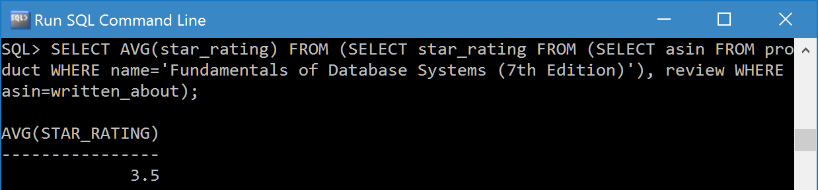

**2. Determine the total cost of order 10582090927795818. (2 tables)**

SELECT SUM(price) FROM (SELECT price FROM (SELECT product_asin FROM order_includes WHERE order_number=10582090927795818), product WHERE product_asin=asin);

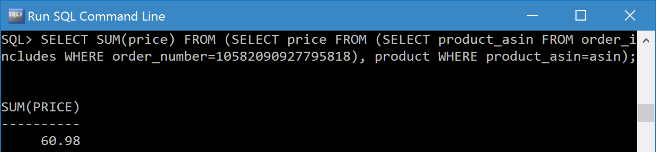

**3. List all of Nicholas Pruss's addresses that are in the city of Conway. (2 tables)**

SELECT street, city, state, zip FROM (SELECT email FROM account WHERE name='Nicholas Pruss'), account_addresses WHERE email=account_email AND city='Conway';

(Results screenshot is on the next page.)

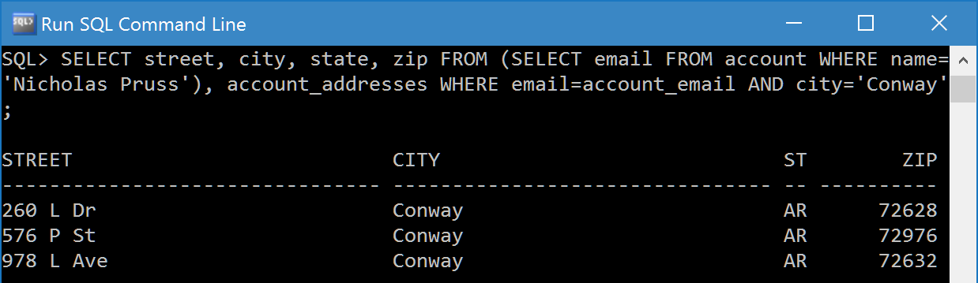

**4. List all of the gift cards redeemed by Shane Johnson. (2 tables)**

SELECT gift_card_number FROM (SELECT email FROM account WHERE name='Shane Johnson'), account_gift_cards WHERE email=account_email;

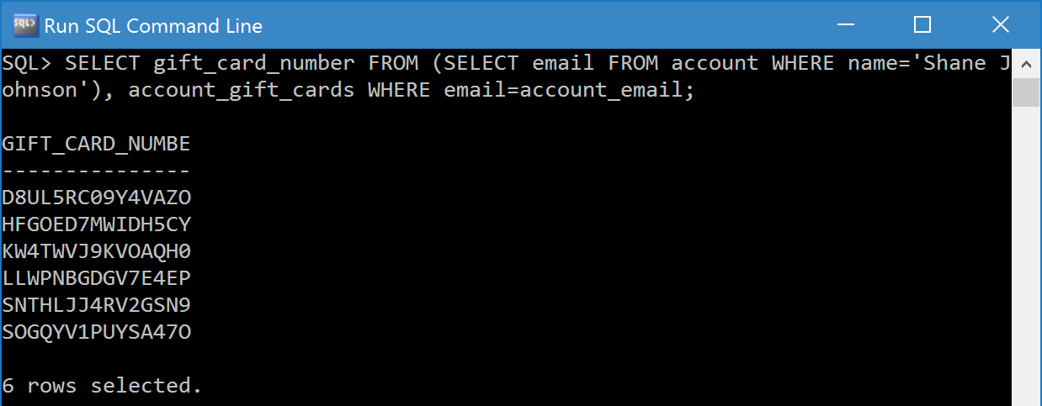

**5. Find the names and email addresses of everyone who has an American Express credit card saved to their account. (3 tables)**

SELECT name, email FROM (SELECT account_email FROM (SELECT card_number FROM credit_card WHERE type='American Express'), account_credit_cards WHERE card_number=credit_card_number), account WHERE account_email=email;

(Results screenshot is on the next page.)

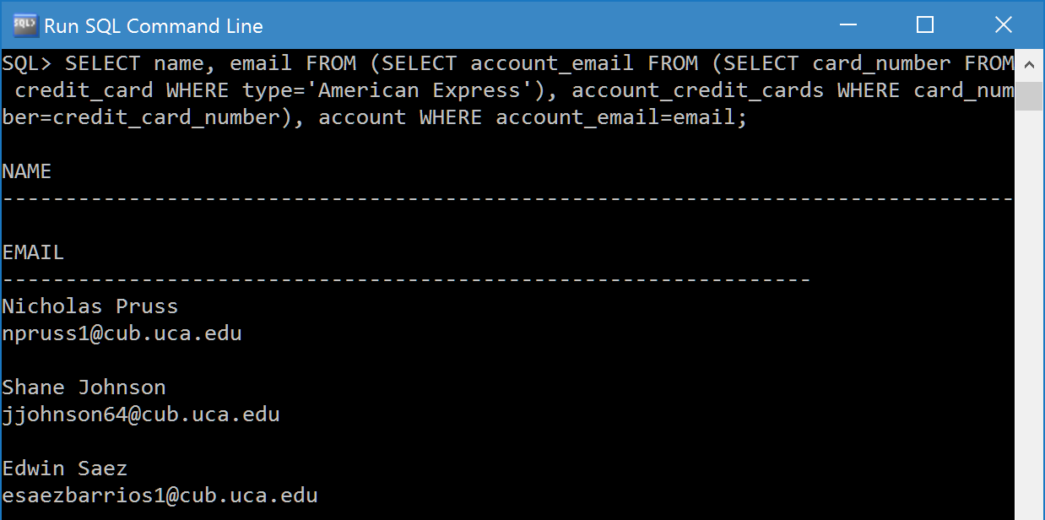

**6. Find the tracking number, shipping company, and date shipped for all of Edwin Saez’s shipments. (3 tables)**

CREATE TABLE edwin_orders AS SELECT order_number FROM (SELECT email FROM account WHERE name='Edwin Saez'), orders WHERE email=placed_by;

SELECT tracking_number, company, date_shipped FROM edwin_orders, shipment WHERE edwin_orders.order_number=shipment.order_number;

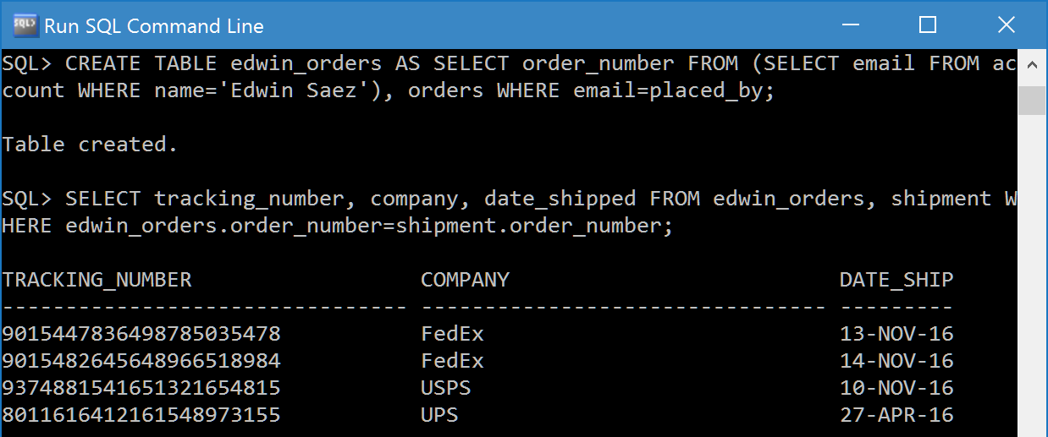

**7. Find the price of the most expensive product in the Books category. (3 tables)**

CREATE TABLE books_category AS SELECT category_id FROM category WHERE name='Books';

SELECT MAX(price) FROM (SELECT product_asin FROM books_category, product_categorized_as WHERE books_category.category_id=product_categorized_as.category_id), product WHERE product_asin=asin;

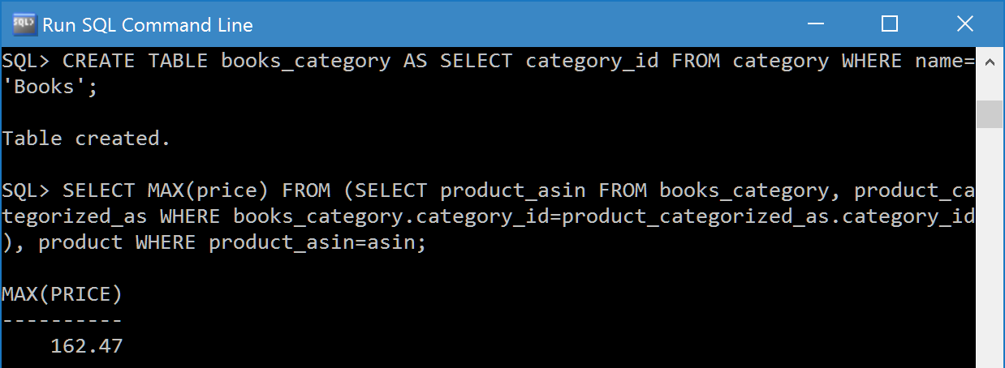

**8. Determine the total amount of money that Shane Johnson has spent at Amazon. (4 tables)**

CREATE TABLE user_orders AS SELECT order_number FROM (SELECT email FROM account WHERE name='Shane Johnson'), Orders WHERE email=placed_by;

SELECT SUM(price) FROM (SELECT product_asin FROM user_orders, order_includes WHERE user_orders.order_number=order_includes.order_number), product WHERE product_asin=asin;

(Results screenshot is on the next page.)

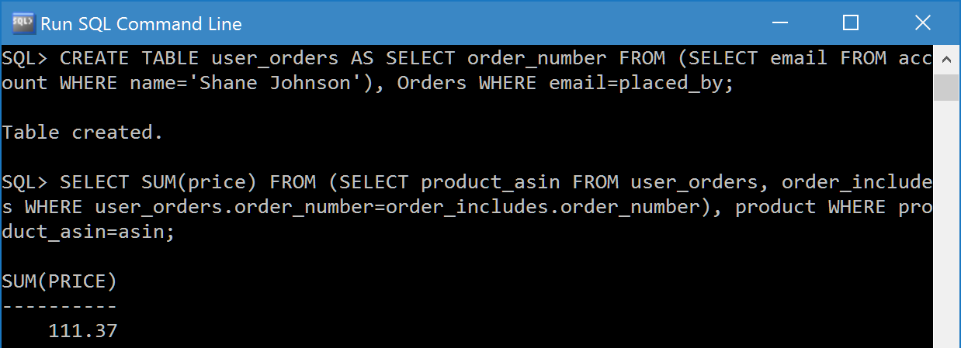

**9. Find the price of the most expensive product that each person has purchased using a gift card. (4 tables)**

CREATE TABLE gift_card_orders AS SELECT orders.order_number, placed_by FROM order_gift_cards, orders WHERE order_gift_cards.order_number=orders.order_number;

CREATE TABLE gift_card_products AS SELECT product_asin, placed_by FROM gift_card_orders, order_includes WHERE gift_card_orders.order_number=order_includes.order_number;

SELECT placed_by, MAX(price) FROM gift_card_products, product WHERE product_asin=asin GROUP BY placed_by;

(Results screenshot is on the next page.)

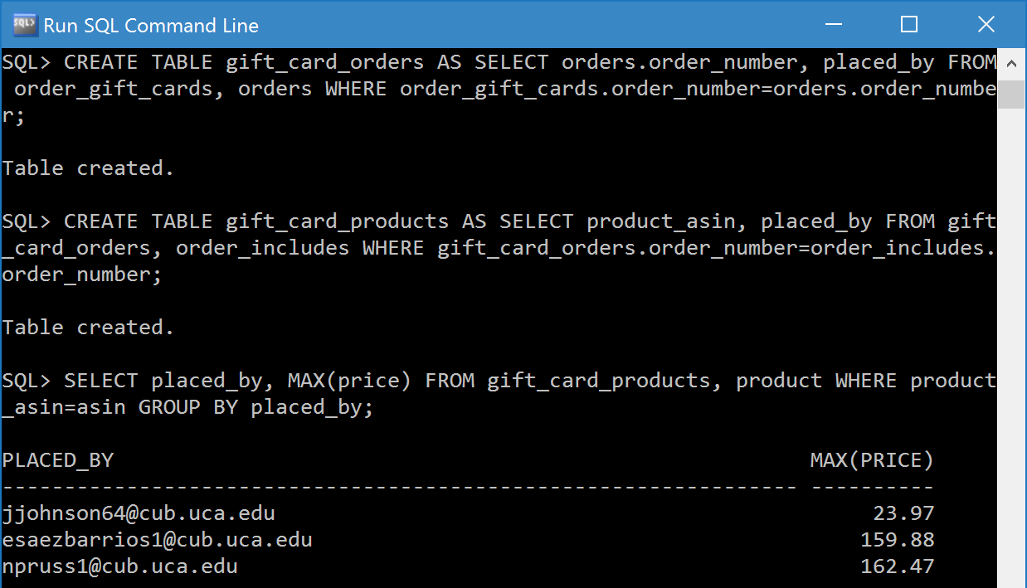

**10. Find the names and email addresses of everyone who has purchased a product in the Video Games category. (5 tables)**

CREATE TABLE games_category AS SELECT category_id FROM category WHERE name='Video Games';

CREATE TABLE games_products AS SELECT product_asin FROM games_category, product_categorized_as WHERE games_category.category_id=product_categorized_as.category_id;

CREATE TABLE games_orders AS SELECT order_number FROM games_products, order_includes WHERE games_products.product_asin=order_includes.product_asin;

CREATE TABLE games_accounts AS SELECT DISTINCT placed_by FROM games_orders, orders WHERE games_orders.order_number=orders.order_number;

SELECT name, email FROM games_accounts, account WHERE games_accounts.placed_by=account.email;

(Results screenshot is on the next page.)

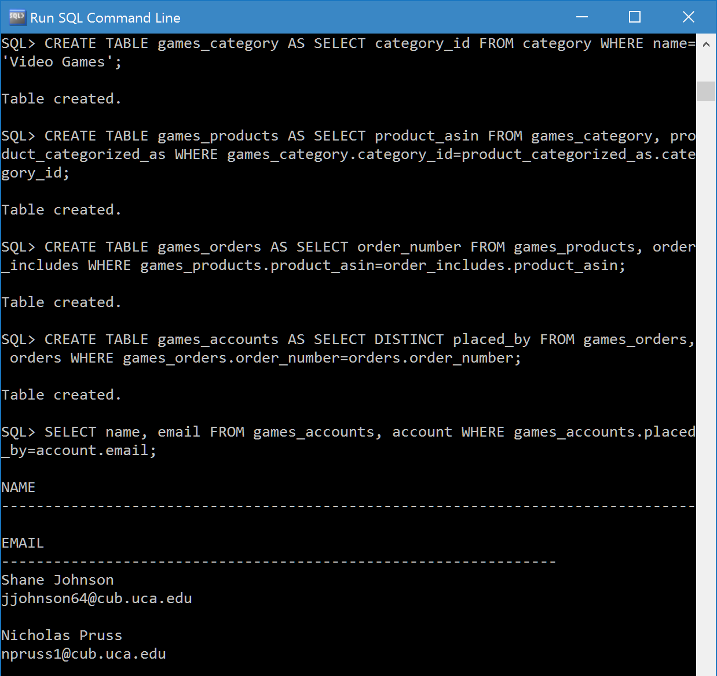

**6. Presentation Slides**

The presentation slides begin on the next page.