VRDet Project Reader
Real-Time Intraday Volatility Regime Classifier: everything the team needs for the final review and viva
Team
Abbhinav Bharadwaj (2300970100003)
Abhinav Sharma (2300970100011)
Alok Kumar Priyadarshi (2300970100033)
Atharva Agrawal (2300970100070)
Guide: Dr. Lopamudra Mohanty, Assistant Professor
Mini Project (BCS-752), Department of Computer Science & Engineering
Galgotias College of Engineering & Technology, Greater Noida · ODD Semester 2026–27
Internal study material for the final review and viva; not for submission.

Contents
Right-click and choose Update Field.

1. How to Use This Reader
This reader explains the whole project in plain language: what we built, why each design decision was made, what the numbers mean and how to answer the questions examiners are likely to ask. It is not the formal report; the report (report/VRDet_Project_Report.pdf) is what we submit. Read this first, then skim the report chapters you are presenting.
• Everyone should read Sections 2, 3 and 4 (the project on one page, the key numbers and the core ideas) and the viva question bank in Section 12.
• Whoever presents a slide should read the matching section in detail and the speaking notes in Section 11.
• Whoever runs the demo should rehearse Section 10 on the laptop that holds the data and the Angel One credentials.
The 60-second pitch
Retail intraday traders in India lose money at very high rates, much of it during sudden bursts of volatility. VRDet tells a trader, every 15 minutes, whether the NIFTY 50 is Quiet, Normal or Chaotic, and alerts them when it turns Chaotic. We define the "true" regime of every past bar with a hidden Markov model that looks at the whole history, and then train a real-time classifier that only sees the past to recover that regime. On five unseen years (2022 to 2026) our LightGBM model beats the same HMM run in real time: macro-F1 0.829 against 0.807, and two thirds fewer false alarms (0.48 against 1.45 per week), while still catching 95.5% of Chaotic episodes within about one bar. We compared 22 models; most are statistically tied, and deep networks do not help because there are only a few hundred Chaotic episodes to learn from. Everything runs locally as a Streamlit dashboard on live Angel One data.

2. The Project on One Page

2.1 The problem
SEBI studies found that about 70% of individual intraday traders in the cash segment lost money in FY23, and 93% of individual F&O traders lost money over FY22 to FY24. A big part of the risk is not the direction of the market but its state: the same trade that is reasonable in a calm session can be ruinous in a chaotic one, where prices jump through stop-losses. The India VIX is a 30-day forward-looking number and moves slowly inside a session; a price chart shows a burst only after the damage. Traders need a simple answer to "is the market calm or dangerous right now?"

2.2 What we built
• A validated dataset of 11 years of NIFTY 50 and India VIX 15-minute candles from the Angel One SmartAPI (2015 to October 2026).
• A definition of the truth: a 3-state hidden Markov model (HMM) that labels every past bar Quiet, Normal or Chaotic using the whole history (hindsight).
• A real-time classifier (LightGBM on 56 causal inputs) that recovers those labels using only data up to the current bar, and a fair benchmark to beat (the same HMM used in real time).
• A comparison of 22 models with confidence intervals and learning curves.
• A local application: a Streamlit dashboard with the Risk Radar (live regime and alerts), the Model Lab (every model, run one at a time) and the Stock Lab (the whole pipeline for any NSE stock).

2.3 The one idea to remember
Hindsight truth, real-time task
A regime is hidden. With the whole history in front of you (hindsight) you can say confidently when the COVID crash started and ended; at 10:15 on the day itself you cannot be sure whether one big bar is noise or the start of chaos. So we let a model with hindsight define the truth, and we ask a real-time model to recover it as early and as accurately as possible. The same HMM, run in real time, is the benchmark. Everything else in the project follows from this separation.

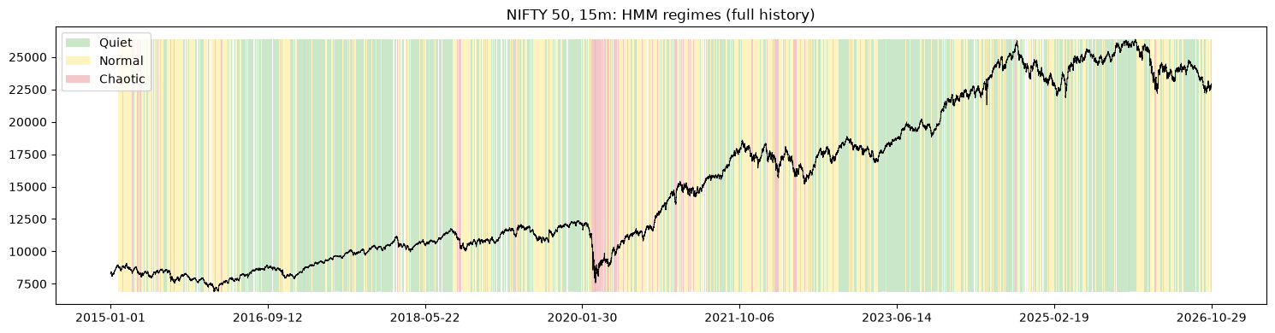
Figure 1: NIFTY 50 15-minute closes 2015–2026, shaded by the hindsight regime (green Quiet, yellow Normal, red Chaotic). The long red block in 2020 is the COVID crash.

3. Key Numbers Cheat Sheet
Learn these. Examiners like to check that the team knows its own numbers.
Topic | Number | What it means
Data span | 1 Jan 2015 – 29 Oct 2026 | NIFTY 50 15-minute candles from Angel One
Bars per session | 25 | 09:15 to 15:30 IST in 15-minute bars
Labelled bars / sessions | 72,051 / 2,889 | After validation against official daily candles
Regime shares | Quiet 49.4%, Normal 43.2%, Chaotic 7.4% | Chaotic is rare
Chaotic episodes | 342 (median about 2 hours) | Contiguous runs of Chaotic bars
HMM | 3 states, fitted on 2015–2021 | Sticky prior 0.2, minimum regime 4 bars (1 hour), Viterbi labels
Filter vs smoother | 85% vs 95% agreement with labels | The real-time gap the classifier must close
Inputs | 53 causal features + 3 HMM probabilities = 56 | Bar t uses only data up to t
Walk-forward test | 2022–2026, train from 2017 | 29,625 test bars, 1,187 sessions, 134 Chaotic episodes
Production model | LightGBM + HMM, τ = 0.30 | Chaotic if P(Chaotic) ≥ τ
Macro-F1 | 0.829 (benchmark 0.807) | Main score; HMM filter alone is the benchmark
False alarms / week | 0.48 (benchmark 1.45) | Two thirds fewer false alarms
Episode recall | 95.5% (benchmark 100%) | Share of Chaotic episodes flagged at least once
Median delay | 1 bar (15 minutes) | From episode start to first Chaotic call
Chaotic precision / recall | 0.763 / 0.681 | Bar-level
Best models | Soft voting 0.840, XGBoost 0.838 | Only these two significantly beat production (+0.01)
Worst models | QDA 0.761, AdaBoost 0.780 | Assumptions do not fit / too many false alarms
Bootstrap | 252 weekly blocks × 300 resamples | Gives 95% confidence intervals
HMM inputs share | 65% of LightGBM split gain | The model builds on the HMM filter
Live latency | ≈ 12 s per cycle, at bar close + 45 s | Regime shown within a minute of each bar
Production training | 60,301 bars (Jan 2017 – Oct 2026) | Retrained on everything for the live app
Stock Lab | ~2,700 NSE stocks | Same pipeline, per-stock HMM

4. Core Ideas Explained Simply

4.1 Volatility
Volatility is how much prices move, regardless of direction. The usual measure is the standard deviation of log returns, annualised and quoted in percent. Two facts make this project possible. First, volatility clusters: big moves follow big moves and small moves follow small moves, so the recent past says a lot about the present state. Second, volatility can be estimated better from the high and low of a bar than from its close alone. The Parkinson estimator uses the high–low range; Garman–Klass adds the open–close move. They are several times more efficient than squared returns, which matters when you want to react within a few bars.
σ_{P}² = (ln H/L)² / (4 ln 2) σ_{GK}² = ½ (ln H/L)² − (2 ln 2 − 1)(ln C/O)²

4.2 Time-of-day effects and deseasonalising
The first bars after 09:15 and the last bars before 15:30 always move more than midday bars. If we used raw returns, every opening bar would look "Chaotic". So every return and range is divided by its typical value at that time of day, computed only from earlier days (so it is causal). The result, z, is "how unusual is this bar for this time of day". This is called deseasonalising.
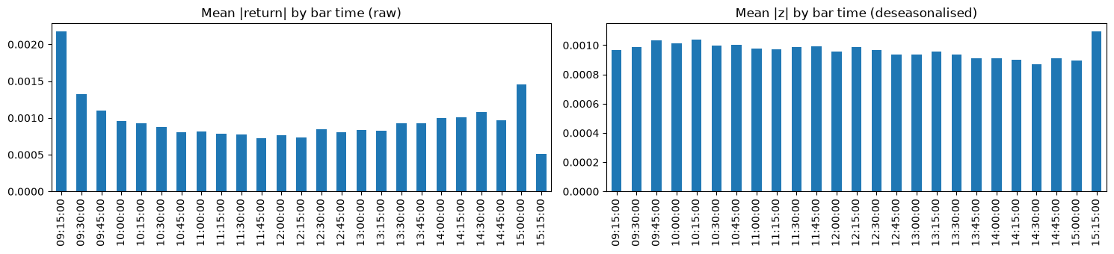
Figure 2: Average absolute return by time of day: raw (left, U-shaped) and deseasonalised (right, flat).

4.3 India VIX
The India VIX is computed by the NSE from NIFTY option prices and reflects the volatility the options market expects over the next 30 days. It is a useful input (fear builds up in option prices), but on its own it is too slow for intraday regimes. We use its level, its changes over 1, 4 and 25 bars, its z-score and the gap between VIX and realised volatility.

4.4 Hidden Markov models (HMM)
Imagine you cannot see the weather, only whether people outside carry umbrellas. The weather is the hidden state; umbrellas are the observations. An HMM has: a set of hidden states (here Quiet, Normal, Chaotic), transition probabilities between states (how likely the market is to stay Quiet or switch to Normal in the next bar), and an emission distribution per state (what returns and ranges look like in each state; here a Gaussian). Our HMM observes two numbers per bar: the deseasonalised return z and the log deseasonalised range.
Given a fitted HMM there are three ways to read the states:
Method | Uses | Real time? | Our use
Filtering (forward algorithm) | Bars 1..t | Yes | Benchmark, and 3 inputs of the classifier
Smoothing (forward–backward) | Bars 1..T (incl. future) | No | Shown for comparison
Viterbi decoding | Bars 1..T (incl. future) | No | The hindsight labels (ground truth)

The filter is honest but nervous: when a big bar arrives it does not know if more will follow. The smoother and Viterbi, having seen the next bars, are decisive. Over 2015–2026 the filter agrees with the labels on 85% of bars and the smoother on 95%. Our classifier tries to close this gap.
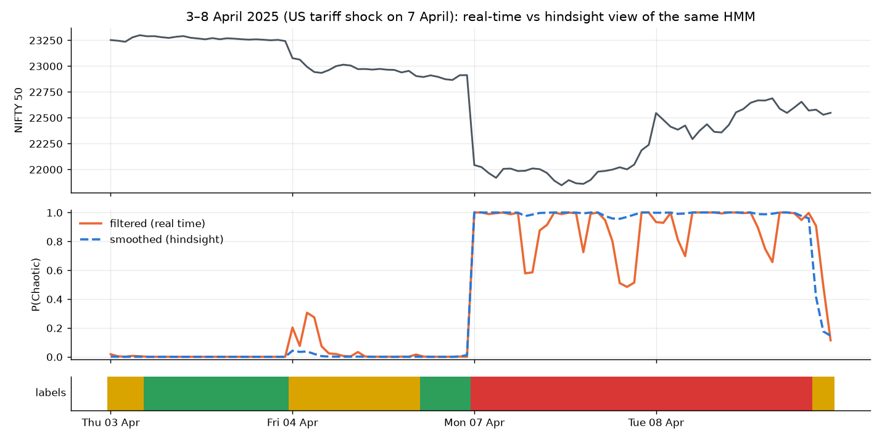
Figure 3: The same HMM around the 7 April 2025 tariff shock: the real-time filter (orange) wavers, the hindsight smoother (blue dashed) is decisive; the final labels are below.
Why three states? We compared 2 to 5 states. BIC keeps improving with more states, but the extra states are not useful: with 4 states the top state covers only 1.2% of bars (mostly COVID), with 5 states 0.6%. Three states give a Chaotic regime that is rare (7.4%) but recurring (342 episodes), which is what an alarm needs. Why sticky and minimum length? A plain HMM switches state too often. A sticky prior adds extra weight to "stay in the same state" when fitting, and a minimum regime length of 4 bars (one hour) removes one-bar flickers. With these, labels switch about once per session.

The fitted regimes
Regime | Return s.d. per bar | Typical range | P(stay) | Expected duration
Quiet | 0.066% | 0.115% | 0.950 | ≈ 20 bars (5 hours)
Normal | 0.134% | 0.206% | 0.934 | ≈ 15 bars (4 hours)
Chaotic | 0.384% | 0.423% | 0.961 | ≈ 26 bars (6.5 hours)

Chaotic bars move about 6 times as much as Quiet bars and their ranges are about 3.7 times as wide. The market almost never jumps directly between Quiet and Chaotic; it passes through Normal.

4.5 The classifier and gradient boosting
Once every past bar has a label, the real-time task is ordinary supervised classification: 56 inputs at bar t → one of three classes. Our production model is LightGBM, a gradient-boosted decision-tree ensemble. Boosting builds trees one after another; each new tree is fitted to the mistakes (gradients of the loss) of the trees so far, and the final prediction is the sum of all trees. LightGBM grows trees leaf-wise, bins features into histograms (fast) and handles missing values natively, which matters because some VIX data are missing. Ours uses 300 trees with 31 leaves each, learning rate 0.05 and at least 200 bars per leaf.

4.6 The Chaotic threshold τ
Chaotic bars are only about 7% of the data, so a model that simply picks the most probable class (argmax) rarely says Chaotic. Instead we say Chaotic whenever P(Chaotic) ≥ τ, and otherwise pick the more likely of Quiet and Normal. τ is tuned without looking at the test year: we hold out the last year of the training window, try τ = 0.10, 0.15, …, 0.60, pick the one with the best Chaotic F1 on that year, and refit on the whole window. Lower τ catches more chaos but raises more false alarms. The live app uses τ = 0.30 and lets the user switch to 0.20 (more sensitive) or 0.50 (fewer alarms).

4.7 Walk-forward validation
Neighbouring bars are almost identical, so a random train/test split would put Monday 10:00 in training and Monday 10:15 in testing, and the model would look far better than it is. Instead we test like real life: for each test year 2022 to 2026, train only on 2017 up to the previous year, then predict the whole test year. The five yearly predictions together form the out-of-sample record (29,625 bars).

4.8 Metrics
Metric | Plain meaning
Precision (Chaotic) | When we say Chaotic, how often is it really Chaotic?
Recall (Chaotic) | Of all truly Chaotic bars, how many did we flag?
F1 | Harmonic mean of precision and recall
Macro-F1 (main score) | Average of F1 for Quiet, Normal and Chaotic, each weighted equally. Accuracy would reward always saying "Normal".
PR-AUC | How well P(Chaotic) ranks Chaotic bars above others, for all thresholds at once
Episode recall | Share of Chaotic episodes in which we said Chaotic at least once
Detection delay | Bars from the start of an episode to our first Chaotic call (median)
False alarms / week | Our Chaotic runs that touch no true Chaotic bar, per 5 sessions
Confusion matrix | Table of true class vs predicted class
Cohen’s κ | Agreement between two labelings, corrected for chance (1 = identical, 0 = chance)
Block bootstrap CI | Resample whole weeks 300 times and recompute scores; the middle 95% is the interval

Episode-level metrics are what a trader experiences: was the dangerous period flagged, how late, and how many times did the alarm ring for nothing?

5. Data: Where It Comes From and What Went Wrong

5.1 Sources
• Angel One SmartAPI (free for account holders): NIFTY 50 (token 99926000) and India VIX (token 99926017) at 5-minute, 15-minute and daily resolution. Login needs the API key, client code, PIN and a TOTP (time-based one-time password, like an authenticator app), all stored in a local .env file that is never committed. Each request is capped (for example 200 days of 15-minute data), so downloads are split into date chunks and limited to about 3 requests per second. Eleven years download in under a minute.
• Yahoo Finance (yfinance): USD/INR and Brent crude daily closes, plus a NIFTY daily series as a cross-check. Its intraday history is too short (15-minute data only for about 60 days), which is why it is not the primary source.
Series | Interval | Rows | From
NIFTY 50 | 15 min | 72,646 | Jan 2015
NIFTY 50 | 5 min | 217,914 | Jan 2015
India VIX | 15 min | 67,090 | Dec 2015
NIFTY 50 / India VIX | 1 day | ≈ 4,150 each | Jan 2010
USD/INR, Brent | 1 day | ≈ 4,200–4,400 | Jan 2010

5.2 Validation rule
Every intraday session is compared with the official daily candle of the same day. A session is valid if it is not flat, has at least 13 of 25 bars, and reproduces at least two of the daily high, low and close within 1%. Invalid NIFTY sessions are dropped; invalid VIX sessions are set to missing.

5.3 Defects we found (good viva material)
• India VIX 2015–16: the vendor archive is flat, divided by 100 and rounded to integers for December 2015 to September 2016 (207 invalid sessions). We mask it, so VIX features start on 22 September 2016. This is why model training starts in 2017.
• NIFTY: 99.6–100% valid every year; only 2 bad sessions (NSE trading halt on 24 Feb 2021 and the Muhurat session on 21 Oct 2025).
• Closing candle: since 5 August 2026 the 15:15 candle is usually one print with zero range. We treat zero range as "no information", not "very quiet". Live sessions therefore score 24 bars.
• Missing candles: a return spanning a gap is set to missing, not treated as a 15-minute move.
• RELIANCE: intraday prices before 5 Jan 2022 were 1.10 times the daily series (different corporate-action adjustment), creating a fake −9.5% overnight jump. The Stock Lab rescales such sessions; valid sessions went from 60.3% to 99.9%.
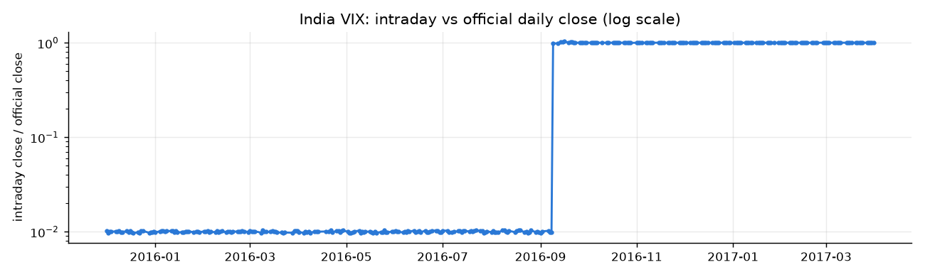
Figure 4: India VIX: intraday close divided by the official close. The 2015–16 archive is off by a factor of 100.

6. Features (the 56 Inputs)
Rule number one: a feature at bar t may only use data up to and including bar t. Cross-asset daily data (USD/INR, Brent) use the previous trading day only, because today’s close is not known during the session.
Group | Examples | Why it helps
Returns (5) | Log return, overnight gap, z, deseasonalised range, |z| | The raw signal of the current bar
Volatility (12) | Realised, Parkinson, Garman–Klass over 4, 8, 25, 125 bars | Multi-bar estimates are less noisy than one bar
Volatility dynamics (3) | Short/long ratios; volatility z-score vs 100 days | Is volatility expanding?
Trend (6) | Returns and EMA distance over 25/125 bars, drawdown, return since open | Sell-offs are more often chaotic
Calendar (5) | Time of day (sin, cos), weekday, first/last hour | Open and close behave differently
India VIX (6) | Level, changes, z-score, VIX minus realised vol | Fear priced in options
Cross-asset (4) | USD/INR and Brent previous-day return and 5-day vol | Global stress context
Lags (12) | Lagged |z|, range, 4-bar vol, VIX change (1, 2, 4 bars) | Short memory for tree models
HMM filter (3) | P(Quiet), P(Normal), P(Chaotic) from the forward filter | The benchmark’s own view

Is it circular to give the classifier the HMM filter’s probabilities?
No. The labels come from Viterbi decoding over the whole sequence, which uses future bars; the filter probabilities use only past bars. The filter is a legitimate real-time input. The question the project answers is whether extra information (multi-bar volatility, VIX, time of day, context) improves on the filter, and it does. Earlier we tried labels built from rolling volatility and rejected them, because their hindsight labels agreed 96% with the real-time version: that target would have been circular.

7. Labels: Is the "Truth" Credible?
We checked the HMM labels in three ways.

Known shock days
Date | Event | Chaotic share of the session
24 Aug 2015 | China devaluation crash | 0.84
24 Jun 2016 | Brexit result | 0.60
09 Nov 2016 | Demonetisation + US election | 1.00
21 Sep 2018 | IL&FS / DHFL crash | 0.48
12 Mar 2020 | COVID: WHO pandemic sell-off | 1.00
23 Mar 2020 | COVID lower circuit | 1.00
01 Feb 2021 | Union Budget rally | 1.00
24 Feb 2022 | Russia invades Ukraine | 1.00
04 Jun 2024 | General election results | 1.00
07 Apr 2025 | US tariff shock | 1.00

Other labelers
A Gaussian mixture model (ignores time order) labels only 1.9% of bars Chaotic and misses some shock days completely. A GARCH labeler agrees 98% with its own real-time version, so it is nearly circular, and it too misses some shock days. The HMM is the only one that flags every shock day and leaves a real gap between hindsight and real time. Agreement between labelers is moderate (κ ≈ 0.5), so the choice matters and we state it openly.

Stability
HMMs trained on 2017–2021 or 2018–2023 agree almost perfectly with ours (κ 0.96–0.97). One trained on 2015–2019 does not (κ 0.64): it never saw COVID, so it calls milder turbulence Chaotic. Lesson: the training window must contain a real crisis.
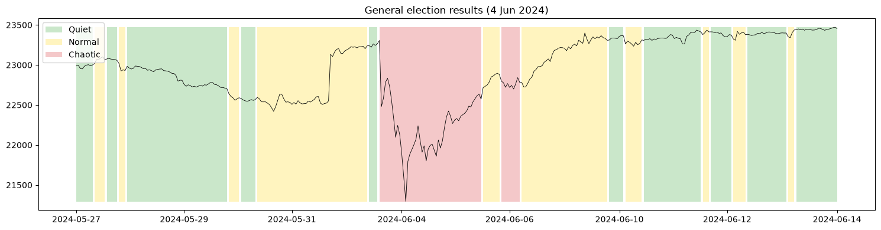
Figure 5: Hindsight regimes around the general election results of 4 June 2024.

8. The 22 Models
All models get the same 56 inputs, the same τ tuning and the same walk-forward test. One line each:
Family | Models | Idea in one line
Gradient boosting | LightGBM (production), XGBoost, CatBoost, hist. gradient boosting | Trees added one by one, each fixing the errors of the previous ones
Boosting | AdaBoost | Re-weights the bars previous trees got wrong
Bagging | Random Forest, Extra Trees | Many trees on random samples, averaged
Single tree | Decision tree (depth 6) | Readable if/then rules
Linear | Logistic regression | Weighted sum of inputs → softmax
Discriminant | LDA, QDA | Gaussian per class; shared (LDA) or separate (QDA) covariance
Probabilistic | Naive Bayes | Assumes inputs independent given the class
Kernel | SVM (RBF, Nyström approximation, calibrated) | Maximum-margin boundary in a curved feature space
Instance-based | k-NN (k = 100) | Regime shares among the 100 most similar past bars
Neural | MLP (64–32) | Feed-forward network on the current bar
Sequence | LSTM, GRU, Transformer, temporal CNN (16-bar windows) | Read the last 4 hours as a sequence
Ordinal | Ordinal LightGBM (Frank & Hall) | Uses the order Quiet < Normal < Chaotic
Ensembles | Soft voting, stacking | Average or learn to combine other models’ probabilities

Why LightGBM and not soft voting for production?
Soft voting (0.840) and XGBoost (0.838) are slightly but significantly better on macro-F1 (+0.012 and +0.009), but both raise more false alarms (0.59 and 0.54 per week vs 0.48). LightGBM has the fewest false alarms of all 22 models, trains in about 8 seconds and is one model instead of three. Since an alarm system lives or dies by trust, we kept LightGBM; soft voting is the natural upgrade and is listed as future work.

9. Results

9.1 Headline: production model vs benchmarks
Model | Macro-F1 | Episode recall | Median delay | False alarms/wk
Volatility threshold (2 h) | 0.746 | 0.761 | 3 | 0.17
GARCH(1,1)-t threshold | 0.671 | 0.709 | 2 | 0.39
HMM filter (benchmark) | 0.807 | 1.000 | 0 | 1.45
Logistic regression | 0.824 | 0.948 | 1 | 0.63
LightGBM without HMM inputs | 0.825 | 0.985 | 1 | 0.70
LightGBM + HMM (production) | 0.829 | 0.955 | 1 | 0.48

How to say it: "Our model beats the honest benchmark in every one of the five test years, and cuts false alarms by two thirds; the price is about one bar of delay and a few missed short episodes." If someone asks whether the gain is just a better threshold: tuning a threshold on the HMM filter itself only moves it from 0.807 to 0.813 with 1.19 false alarms per week, so most of the gain comes from the extra inputs.
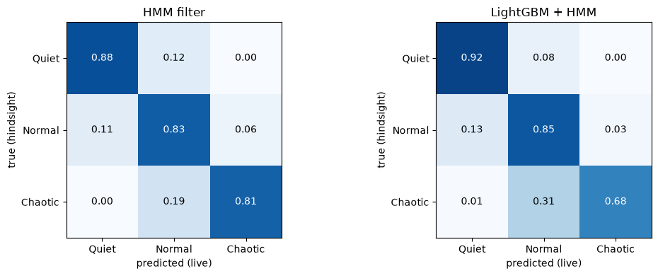
Figure 6: Confusion matrices 2022–2026 (row-normalised). Quiet and Chaotic are almost never confused; errors are between neighbouring regimes.

9.2 By year
Year | HMM filter F1 | Production F1 | HMM false alarms/wk | Production false alarms/wk
2022 | 0.818 | 0.839 | 1.74 | 0.73
2023 | 0.789 | 0.815 | 0.69 | 0.12
2024 | 0.786 | 0.795 | 1.96 | 0.29
2025 | 0.800 | 0.820 | 1.28 | 0.59
2026 | 0.784 | 0.817 | 1.63 | 0.74

9.3 Threshold trade-off
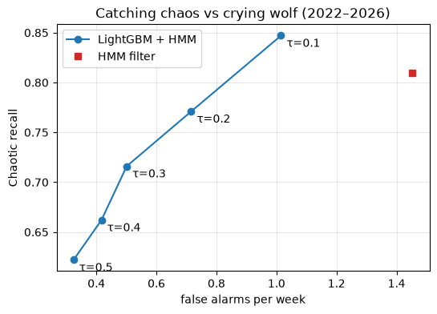
Figure 7: Recall vs false alarms for τ = 0.1 to 0.5. Every setting raises fewer false alarms than the HMM filter (red square); at τ = 0.1 the model beats it on both axes.

9.4 The 22-model comparison
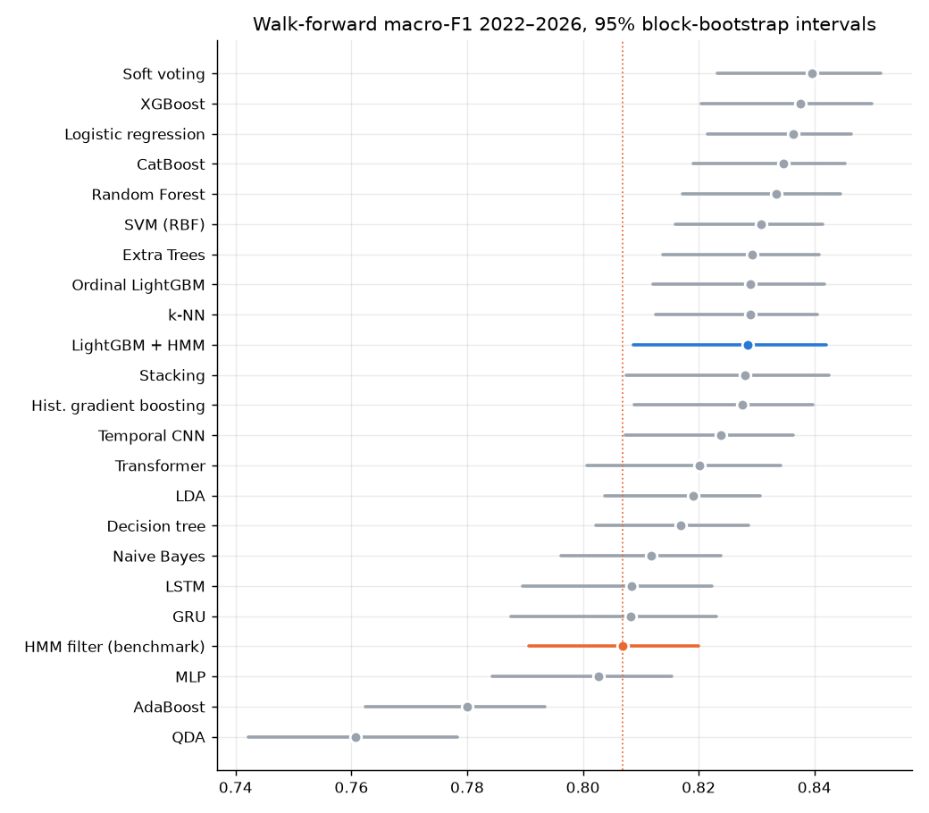
Figure 8: Macro-F1 with 95% block-bootstrap intervals for every model, 2022–2026.
• 20 of 22 models beat the HMM filter; the top 13 are within 0.012 of each other.
• Only soft voting and XGBoost are significantly better than production; 11 models are statistically tied.
• Significantly worse: decision tree, naive Bayes, LSTM, GRU, MLP, AdaBoost, QDA (and the HMM filter).
• Rankings change from year to year (production ranks 6th in 2022 and 2026, 11th–14th in 2023–2025), which is why we use the five-year walk-forward with intervals, not one split.

9.5 Why deep models do not win: learning curves
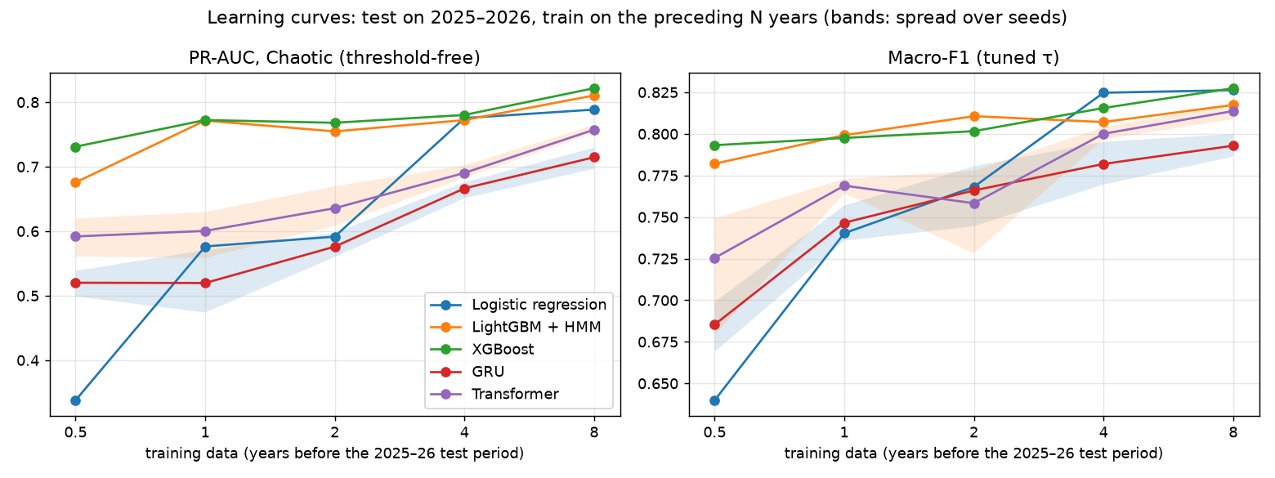
Figure 9: Learning curves with the test fixed on 2025–2026 and 0.5 to 8 years of training data.
Tree models reach PR-AUC ≈ 0.77 with one year of data (33 Chaotic episodes) and change little after. The GRU (15k parameters) and Transformer (42k) are below them at every size and still improving at 8 years. Logistic regression (171 parameters) matches XGBoost from 4 years on. The limit is the number of Chaotic episodes (226 in 8 years), not the number of bars: bars inside an episode are near-copies of each other. With this little independent evidence, small models are the right choice.

9.6 What the model looks at
The three HMM filter probabilities carry 65% of the LightGBM split gain; next come short-window Parkinson and Garman–Klass volatility, the India VIX level and the USD/INR and Brent inputs. So the model starts from the HMM’s view and corrects it with smoother multi-bar volatility and context. That explains both the fewer false alarms and the one-bar delay.
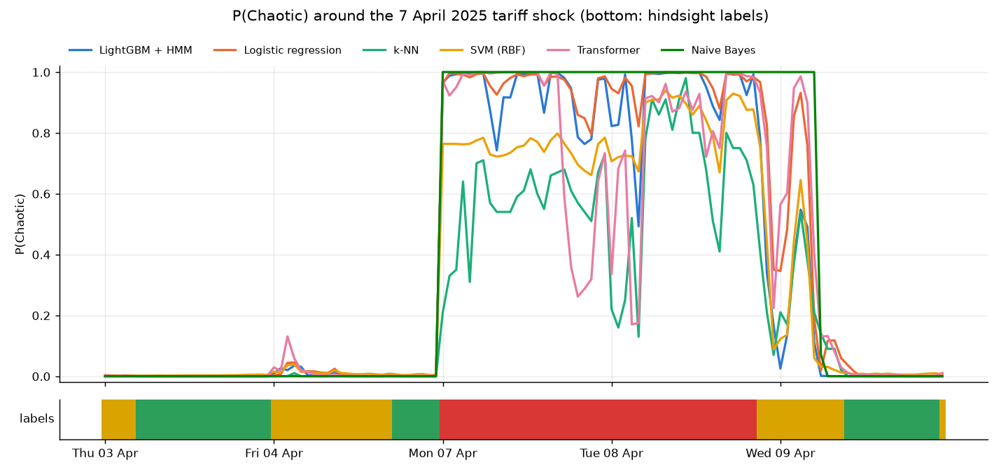
Figure 10: P(Chaotic) of several models around the 7 April 2025 tariff shock, with the hindsight labels below.

10. The Application and the Demo

10.1 How it works
1. The runner (app/runner.py) wakes 45 seconds after each bar close (09:30 … 15:30 IST).
2. It logs in to Angel One if needed and fetches new NIFTY and India VIX candles, keeping completed bars only.
3. It rebuilds the 56 inputs with vrdet.live.model_frame, the same function used in training.
4. It scores the frozen LightGBM model, applies τ and updates the alert state.
5. It writes state.json and history.parquet; the dashboard reads them and redraws.
6. One cycle takes about 12 seconds, so the regime appears within a minute of each bar.
Alerts use hysteresis: one alert when the regime turns Chaotic, and one "all clear" only after 4 consecutive non-Chaotic bars, so a flickering regime does not spam the user. Telegram delivery is optional and private (only chat ids listed in .env). Causality check: we cut the data at several bars and compared live-mode predictions with full-history predictions; the maximum difference was 0.0.
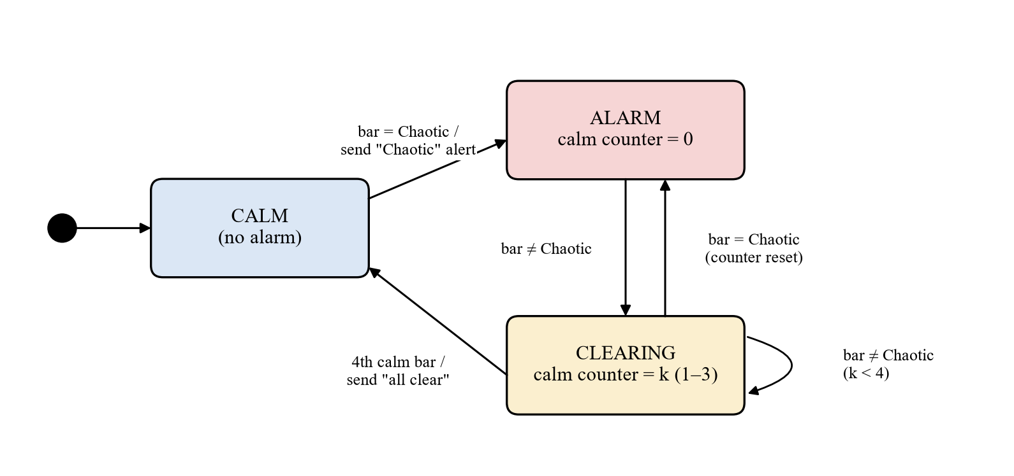
Figure 11: Alert hysteresis as a state chart.

10.2 The three dashboard pages
• Risk Radar: the current regime card (Green/Yellow/Red), P(Chaotic), confidence, NIFTY and VIX, the regime-shaded price chart, model vs HMM filter probability, the hindsight truth row, alerts, and the sensitivity setting.
• Model Lab: leaderboard of all 22 models; a Play button per model and "Play all". Runs go through a single background worker, one at a time, so the laptop never runs several heavy models together.
• Stock Lab: pick any of ~2,700 NSE stocks and the models; the app downloads data, fits a per-stock HMM on the training years, trains, tests on recent months and shows each model’s current regime. For INFY (12-month test), Random Forest scored 0.772 against 0.767 for the per-stock HMM filter.
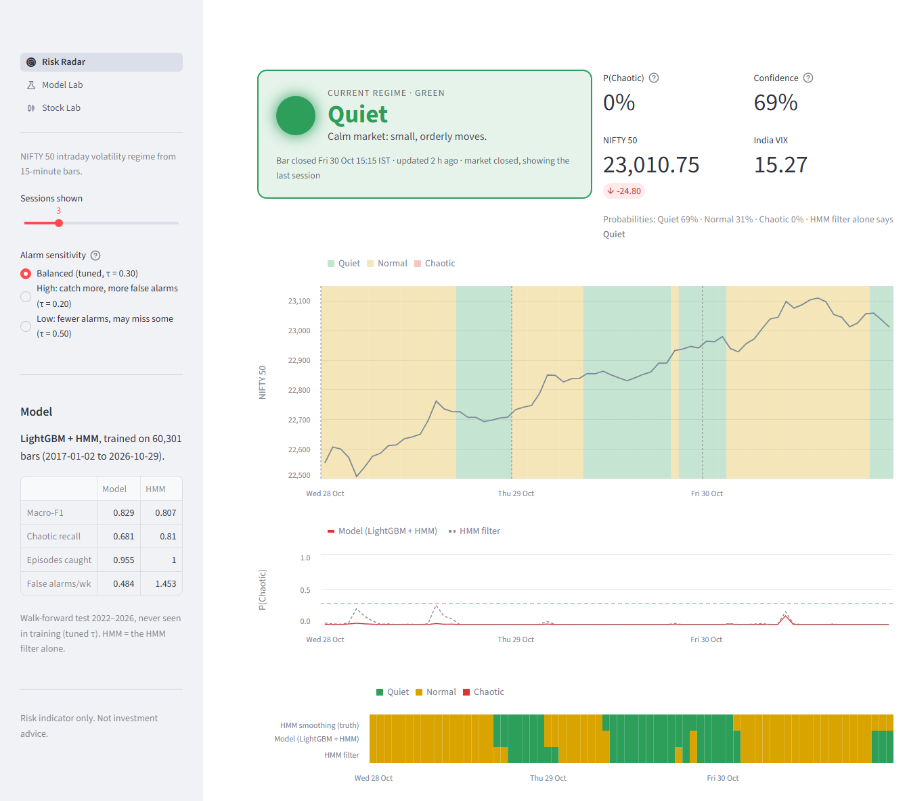
Figure 12: The Risk Radar page.

10.3 Demo script for the review
Run the demo from the laptop that has the data archive (data/raw/), the trained models and the .env credentials. Other laptops cannot run it without those files.
1. Before the review: open a terminal in the repo, activate the environment (.venv\Scripts\activate) and check the internet connection.
2. If the market is open: python app/run.py starts the runner and the dashboard. Open http://localhost:8501.
3. If the market is closed or calm: python app/run.py --replay 2025-04-07 replays the tariff-shock session bar by bar, so the regime turns Chaotic during the demo.
4. Risk Radar: point at the regime card, P(Chaotic), the shaded chart and the truth row; switch the sensitivity between 0.20, 0.30 and 0.50.
5. Model Lab: open the leaderboard, press Play on two or three models (LightGBM, XGBoost, Transformer) or "Play all" and show the side-by-side strip.
6. Stock Lab: open INFY or RELIANCE (already trained) and show the test table and current regimes. Do not start a new 8-year training live unless there is time (about 2 minutes).
7. Fallback: if the network or API fails, use the screenshots on the Implementation slide and in the report (Figures 6.3 to 6.7).

11. Presentation Plan (10 Slides, About 15 Minutes)
Suggested split across the four members; adjust as the team prefers. Aim for about 1.5 minutes per slide and leave time for the demo.
Slide | Content | Key sentence to say | Suggested speaker
1 Title | Project, team, guide | "VRDet tells a trader every 15 minutes whether the market is calm or dangerous." | Member 1
2 Introduction | Retail losses, three regimes | "We nowcast the current regime; we do not forecast prices." | Member 1
3 Literature | HMMs, ML for volatility, gaps | "Regime papers report hindsight states; we measure the real-time gap." | Member 1
4 Problem & objectives | Statement, block diagram | "Recover the hindsight label of bar t from data up to t." | Member 2
5 Methodology | 8 steps, filter vs smoother | "Truth = HMM in hindsight; benchmark = the same HMM in real time." | Member 2
6 Implementation | Stack, runner, dashboard + demo | "Same feature code in training and live; verified exactly." | Member 3
7 Results | Stats and model comparison | "0.829 vs 0.807 macro-F1 and two thirds fewer false alarms." | Member 4
8 Conclusion | Conclusion, limits, future work | "Careful targets and honest benchmarks matter more than model size." | Member 4
9 References | Key papers | (brief) | Member 4
10 Thank you | Questions | – | All

12. Limitations (Say Them Before They Are Asked)
• The truth is a model. The labels are one HMM with chosen settings; GMM or GARCH labels differ (κ ≈ 0.5). We measure how well we recover this definition of regimes. The newest bars’ labels are provisional because smoothing needs later bars.
• Few episodes. 134 Chaotic episodes in the test years (only 7 in 2023), so differences under about 0.01 macro-F1 cannot be resolved.
• Boundary effect. Labels at the end of a training window are decoded using a few bars of the next (test) year; we did not leave an embargo gap. The effect is a few bars per year.
• Detection, not prediction. We recognise chaos after it starts (median one bar) and miss some very short episodes; we cannot warn before the first violent bar.
• One data vendor. Outages, late candles or vendor changes (such as the August 2026 closing candle) affect the live system directly; index candles have no volume.
• Stocks are harder than the index: more false alarms and a smaller margin over the HMM filter.

13. Viva Question Bank
Short, accurate answers. If you do not know something, say what you do know and where it is in the report.

13.1 Concept
Q. What does your project do, in one sentence?
Every 15 minutes it classifies the NIFTY 50 into a Quiet, Normal or Chaotic volatility regime using only past data, shows it on a local dashboard and alerts the trader when the market turns Chaotic.
Q. Why nowcasting and not forecasting?
The question a trader needs answered is "is it dangerous now?", which is directly actionable. Forecasting volatility numbers has a large literature with small gains, and a regime nowcast can be evaluated in trader terms: episodes caught, delay and false alarms.
Q. What is a volatility regime, and why three?
A persistent state in which returns behave similarly. We compared 2 to 5 HMM states; beyond 3 the extra states were tiny (1.2% and 0.6% of bars, mostly COVID). Three states give a rare but recurring Chaotic class that suits an alarm, and map to a traffic light.
Q. Your labels come from a model. Isn’t the "truth" arbitrary?
It is a definition, and we say so. We checked it: all ten major shock days are labelled Chaotic, labels are stable across training windows that include a crisis (κ 0.96–0.97), and we compared it with GMM and GARCH labelers, which miss shock days or are circular.
Q. Explain filtering, smoothing and Viterbi.
Filtering gives P(state at t | data up to t) and works in real time. Smoothing gives P(state at t | all data), using the future. Viterbi finds the single most likely whole state path, also using the future. We use Viterbi for labels and the filter as the benchmark and as inputs.
Q. If the labels use future data, isn’t that leakage?
Leakage would be future data in the inputs. The target is allowed to be defined in hindsight; that is the point. All inputs are causal, and we verified that live predictions equal full-history predictions exactly.
Q. How can a classifier beat the HMM filter when the labels come from the same HMM?
The filter sees one bar at a time through a two-number Gaussian lens. The classifier also sees multi-bar volatility (less noisy), the India VIX, time of day and market context, plus the filter itself, so it can tell a one-off spike from the start of an episode more reliably. It mainly removes false alarms.
Q. What do the sticky prior and the minimum duration do?
They stop the labels from flickering. The sticky prior adds weight to self-transitions when fitting; the 4-bar minimum merges runs shorter than an hour. Together they give about one regime switch per session.
Q. Why deseasonalise?
The open and close are always more volatile. Without removing the time-of-day profile every 09:15 bar would look Chaotic. We divide each bar by its typical size at that time, computed from earlier days only.
Q. Why range-based estimators?
High and low carry information about the whole path inside the bar; Parkinson and Garman–Klass estimators are several times more efficient than squared returns, so they react faster with less noise.

13.2 Data
Q. Why Angel One and not yfinance?
Yahoo’s intraday history is short (about 60 days of 15-minute data). Angel One gives 11 years of 15-minute NIFTY and India VIX candles free to account holders, and the same API serves live data.
Q. How did you validate the data, and what did you find?
Each session is compared with the official daily candle. We found the India VIX archive scaled by 1/100 in 2015–16 (masked), two bad NIFTY sessions (dropped), the zero-range closing candle since August 2026 (treated as missing) and a RELIANCE level mismatch from corporate-action adjustments (rescaled in the Stock Lab).
Q. Why 15-minute bars?
A balance: 25 bars a day gives a timely signal, while bars are large enough that ranges are meaningful and microstructure noise is small. It also matches how often a trader can reasonably react.
Q. Why no volume features?
NIFTY is an index; index candles carry no meaningful volume. NIFTY futures volume and open interest are listed as future work.
Q. How do you handle missing data?
Invalid VIX sessions become missing; returns across missing candles become missing; zero-range candles give no range information. LightGBM handles missing values natively; other models use the training median.

13.3 Models
Q. How is τ chosen, and why not argmax?
Chaotic is only ~7% of bars, so argmax rarely says Chaotic. We tune τ on the last training year to maximise Chaotic F1, from 0.10 to 0.60, then refit; the test year is never used. Live τ = 0.30.
Q. How do you handle class imbalance?
With the tuned threshold for every model, class weights where the library supports them, and metrics that weight classes equally (macro-F1) or focus on the rare class (Chaotic precision, recall, PR-AUC).
Q. Why did LSTM, GRU and the Transformer not win?
Learning curves show the limit is the number of Chaotic episodes (226 in 8 years), not bars. Deep models need many independent examples; trees and even logistic regression extract what little signal there is with far fewer parameters. This matches the finding that trees beat deep nets on tabular data.
Q. What are soft voting, stacking and the ordinal model?
Soft voting averages the probabilities of LightGBM, XGBoost and Random Forest. Stacking fits a logistic meta-model on base-model probabilities from a held-out year. The ordinal model uses the order Quiet < Normal < Chaotic by predicting P(above Quiet) and P(above Normal) with two LightGBMs.
Q. Why does QDA do so badly? And AdaBoost?
QDA estimates a full covariance matrix for every class; the rare Chaotic class has too little data for 56 correlated inputs. AdaBoost has the highest Chaotic recall (0.88) but 1.68 false alarms per week.
Q. Why is production LightGBM if soft voting scored higher?
Soft voting is +0.012 macro-F1 but with more false alarms (0.59 vs 0.48 per week) and three models to run. LightGBM has the fewest false alarms of all models and trains in seconds. Switching is future work.

13.4 Evaluation
Q. Why macro-F1 and not accuracy?
A model that always says Normal or Quiet would get high accuracy while never catching chaos. Macro-F1 gives the rare Chaotic class the same weight as the others.
Q. Why walk-forward instead of k-fold cross-validation?
Neighbouring bars are near-duplicates and markets drift; random folds leak future information into training. Walk-forward trains only on the past and tests on the next year, as in real use.
Q. What is the block bootstrap and why weeks?
We resample whole calendar weeks with replacement 300 times and recompute every score, giving 95% intervals. Resampling single bars would ignore that neighbouring bars are correlated and make intervals too narrow.
Q. Is 0.829 vs 0.807 a real difference?
Yes. The bootstrap interval of the difference between the HMM filter and production is −0.033 to −0.011, entirely below zero, and production is better in all five test years. The false-alarm gap (0.48 vs 1.45) is large.
Q. What is Cohen’s kappa?
Agreement between two labelings corrected for chance: (observed agreement − chance agreement) / (1 − chance agreement). 1 is perfect, 0 is chance.
Q. Which year was hardest?
2024 for the production model (Chaotic recall 0.55, macro-F1 0.795), and 2023 had only 7 Chaotic episodes, so its scores are noisy.

13.5 Application
Q. Walk us through one live update.
At bar close plus 45 seconds the runner fetches new candles from Angel One, keeps completed bars, rebuilds the 56 inputs with the training code, scores the model, updates the alert state and writes the state files; the dashboard redraws. About 12 seconds in total.
Q. How do you know live features match training features?
The live app calls the same function (model_frame). We also truncated the data at several bars and confirmed that live predictions equal full-history predictions (maximum difference 0.0).
Q. How do you avoid alert spam?
Hysteresis: alert once on entering Chaotic, and "all clear" only after 4 consecutive non-Chaotic bars.
Q. Why local instead of the cloud?
Broker credentials stay on the user’s machine, broker APIs are unreliable from shared cloud IPs, and a single trader needs nothing more. The dashboard binds to 127.0.0.1 with usage statistics off.
Q. How does the Model Lab avoid overloading the CPU?
All jobs go through one background worker queue, so only one model runs at a time, and models use at most 8 of the 16 threads, leaving room for the live runner.
Q. Does it work for stocks?
Yes, through the Stock Lab, with a per-stock HMM. Results are weaker than for the index (INFY: 0.772 vs 0.767 for the filter, 2.3–2.7 false alarms per week), probably because company news is not in the inputs.

13.6 Critique and future
Q. What is novel in your project?
Treating regime detection as recovering a hindsight label in real time with an explicit benchmark from the same model; validated 15-minute NIFTY/VIX data from a free broker API; a 22-model comparison with bootstrap intervals and learning curves; and a working local tool with alerts.
Q. Can this be used to trade?
It is a risk indicator, not a trading signal and not investment advice. It can guide position size or whether to trade at all, not direction.
Q. What if the market changes structurally?
Retrain: the pipeline refits in minutes. The walk-forward test shows the model holds up across five different years, and the labeler is stable as long as its training window contains a crisis.
Q. What would you do with more time?
An early-warning model for the next bars with event calendars; futures OI, option skew, breadth and news sentiment as inputs; embargoed validation and ablations; pooled training across stocks; soft voting in production.
Q. Why not just use GARCH?
As a real-time classifier a GARCH threshold scores 0.671 macro-F1 and misses 29% of episodes. As a labeler it is nearly circular (98% agreement between its real-time and hindsight versions) and misses shock days.

14. Where Things Are in the Code
Path | What to find there
src/vrdet/angel.py | Angel One login (TOTP), chunked candle requests
src/vrdet/quality.py | Session validation against daily candles
src/vrdet/features.py | All causal features, time-of-day profile
src/vrdet/labels.py | HMMLabeler, forward filter, minimum duration, GMM/GARCH labelers, event check
src/vrdet/classifiers.py | LightGBM, logistic, TunedChaoticThreshold, walk-forward
src/vrdet/zoo.py, seqnet.py | The 22 models; LSTM, GRU, Transformer, temporal CNN
src/vrdet/evaluate.py | Macro-F1, episode recall, delay, false alarms
src/vrdet/live.py, alerts.py | Live data, frozen model, alert hysteresis, Telegram
src/vrdet/stocks.py | Stock Lab pipeline
app/runner.py, app/dashboard.py | Live loop; Streamlit pages (radar, lab, stock)
scripts/ | fetch_data, train_live_model, train_zoo, train_stock, learning_curve
notebooks/01–05 | Data, features and labels, classifier, HMM in depth, model zoo
models/ | hmm_labeler.json, live_lgbm.txt, live_model.json

15. Glossary
Term | Meaning
Bar / candle | One 15-minute interval with open, high, low, close
Session | One trading day, 09:15–15:30 IST
Regime | Persistent market state: Quiet, Normal or Chaotic
Episode | A contiguous run of Chaotic bars
Hindsight label | Regime assigned using the whole history (Viterbi); the target
Causal feature | A feature that uses only data up to the current bar
HMM filter | Real-time state probabilities of the HMM; the benchmark
τ (tau) | Threshold on P(Chaotic) above which we call Chaotic
Walk-forward | Train on past years, test on the next year, repeat
Macro-F1 | Average F1 over the three classes
PR-AUC | Area under the precision–recall curve
Block bootstrap | Resampling whole weeks to get confidence intervals
Hysteresis | Requiring several calm bars before clearing an alarm
India VIX | NSE volatility index from NIFTY options (30-day expectation)
TOTP | Time-based one-time password used for the Angel One login
Nowcasting | Estimating the current state rather than forecasting the future

