A
Project Report
on
Real-Time Intraday Volatility Regime Classifier

By
Abbhinav Bharadwaj (2300970100003)
Abhinav Sharma (2300970100011)
Alok Kumar Priyadarshi (2300970100033)
Atharva Agrawal (2300970100070)

Under the Supervision of
Dr. Lopamudra Mohanty, Assistant Professor



Computer Science and Engineering

Galgotias College of Engineering & Technology
Greater Noida, Uttar Pradesh
India-201306
Affiliated to


Dr. A.P.J. Abdul Kalam Technical University
Lucknow, Uttar Pradesh, India-226031
October, 2026

GALGOTIAS COLLEGE OF ENGINEERING & TECHNOLOGY
GREATER NOIDA, UTTAR PRADESH, INDIA- 201306.

CERTIFICATE

This is to certify that the project report entitled “Real-Time Intraday Volatility Regime Classifier” submitted by Abbhinav Bharadwaj (2300970100003), Abhinav Sharma (2300970100011), Alok Kumar Priyadarshi (2300970100033) and Atharva Agrawal (2300970100070) to the Galgotias College of Engineering & Technology, Greater Noida, Uttar Pradesh, affiliated to Dr. A.P.J. Abdul Kalam Technical University, Lucknow, Uttar Pradesh, in partial fulfillment for the award of the Degree of Bachelor of Technology in Computer Science & Engineering, is a bonafide record of the project work carried out by them under my supervision during the year 2026-2027.

Dr. Lopamudra Mohanty  Assistant Professor  Dept. of CSE | Dr. Amrita Jyoti  Professor and Head  Dept. of CSE

GALGOTIAS COLLEGE OF ENGINEERING & TECHNOLOGY
GREATER NOIDA, UTTAR PRADESH, INDIA- 201306.

ACKNOWLEDGEMENT
We have taken efforts in this project. However, it would not have been possible without the kind support and help of many individuals and organizations. We would like to extend our sincere thanks to all of them.
We are highly indebted to our project guide, Dr. Lopamudra Mohanty, Assistant Professor, Department of Computer Science and Engineering, GCET, for the guidance and constant supervision, as well as for providing necessary information regarding the project and for the support in completing it.

We are extremely indebted to Dr. Amrita Jyoti, HOD, Department of Computer Science and Engineering, GCET, for the valuable suggestions and constant support throughout our project tenure. We would also like to express our sincere thanks to all faculty and staff members of the Department of Computer Science and Engineering, GCET, for their support in completing this project on time.

We also express gratitude towards our parents for their kind co-operation and encouragement which helped us in the completion of this project. Our thanks and appreciations also go to our friends and to all the people who have willingly helped us out with their abilities.

ABSTRACT

Retail intraday traders in India lose money at high rates, much of it in sudden volatility bursts that are hard to recognise as they happen. This project builds VRDet, an application that tells a trader, every 15 minutes during market hours, whether the NIFTY 50 is in a Quiet, Normal or Chaotic volatility regime, and alerts them when it turns Chaotic. Eleven years of 15-minute NIFTY 50 and India VIX candles (2015–2026, about 72,000 bars) were downloaded from the Angel One SmartAPI and validated against official daily candles. Because a regime can only be identified reliably in hindsight, a three-state Gaussian hidden Markov model (HMM) fitted on 2015–2021 labels every bar using Viterbi decoding with a minimum regime length; these labels are the ground truth. The real-time task is then to recover the hindsight label of the current bar using only past information. A LightGBM classifier on 56 causal inputs, including the HMM’s own forward-filtered probabilities, with a tuned Chaotic threshold, was compared with 21 other models in a walk-forward test on 2022–2026. The production model reaches a macro-F1 of 0.829 against 0.807 for the HMM filter alone, catches 95.5% of Chaotic episodes with a median delay of one bar, and raises 0.48 false alarms per week against 1.45 for the benchmark. Block-bootstrap intervals show that most well-built models are statistically tied, while recurrent and attention networks are significantly worse; learning curves show that the limiting factor is the small number of Chaotic episodes, not the number of bars. The system runs entirely on a local machine as a Streamlit dashboard with a Risk Radar, a Model Lab that plays all 22 models one at a time, and a Stock Lab that retrains the pipeline for any NSE stock.

KEYWORDS: Volatility regimes, Hidden Markov model, Nowcasting, LightGBM, Walk-forward validation, NIFTY 50, India VIX, Streamlit

CONTENTS
CERTIFICATE i
ACKNOWLEDGEMENT ii
ABSTRACT iii
CONTENTS iv
LIST OF TABLES vi
LIST OF FIGURES vii
NOMENCLATURE ix
ABBREVIATIONS x
CHAPTER 1 INTRODUCTION 1
1.1 Volatility and Market Regimes 1
1.2 Motivation and Perspective 3
1.3 Description of Theoretical Concepts 4
1.4 Organisation of the Report 6
CHAPTER 2 LITERATURE REVIEW 7
2.1 Introduction 7
2.2 Related Literature Review 7
2.3 Summary of Reviewed Studies 9
2.4 Research Gaps 10
CHAPTER 3 PROBLEM FORMULATION 11
3.1 Description of Problem Domain 11
3.2 Problem Statement 12
3.3 Depiction of Problem Statement 12
3.4 Objectives 14
3.5 Scope and Assumptions 14
CHAPTER 4 PROPOSED WORK 15
4.1 Introduction 15
4.2 Proposed Methodology / Algorithm 16
4.3 Description of Each Step 17
CHAPTER 5 SYSTEM DESIGN 24
5.1 Functional Specification of System 24
5.2 Structural and Dynamic Modeling of System 26
5.3 Detailed Module Structure 32
CHAPTER 6 IMPLEMENTATION 33
6.1 Experimental Setup 33
6.2 Dataset Description 35
6.3 Application Implementation 38
CHAPTER 7 RESULT ANALYSIS 44
7.1 Performance Measures 44
7.2 Result Analysis 44
CHAPTER 8 CONCLUSION, LIMITATION AND FUTURE SCOPE 60
8.1 Conclusion 60
8.2 Limitation 61
8.3 Future Scope 61
REFERENCES 63
LIST OF PUBLICATIONS 67
CONTRIBUTION OF PROJECT 68

LIST OF TABLES
Table 2.1: Summary of the most relevant studies 9
Table 4.1: Feature groups (53 causal features + 3 HMM filter probabilities = 56 inputs) 18
Table 4.2: Number of HMM states (fitted on 2015–2021; test log-likelihood on 2022–2026) 19
Table 4.3: Fitted three-state HMM (2015–2021) 20
Table 4.4: Effect of the sticky prior and minimum regime length on the labels 21
Table 5.1: Functional requirements 24
Table 5.2: Module structure of the code base 32
Table 6.1: The 22 models compared (all with 56 inputs and tuned τ) 33
Table 6.2: Software tools and libraries 35
Table 6.3: Raw datasets in the local archive (as of 29 October 2026) 35
Table 6.4: Labelled bars and Chaotic regime by year 36
Table 7.1: Performance measures 44
Table 7.2: Hindsight regime shares on known shock days 45
Table 7.3: Comparison of labelers (fitted on 2015–2021, applied to 2015–2026) 46
Table 7.4: Label stability across training windows (compared with the production labeler, 2015–2021) 46
Table 7.5: Walk-forward results 2022–2026 (29,625 bars, 134 Chaotic episodes) 47
Table 7.6: Results by test year: HMM filter vs production model 48
Table 7.7: Effect of a fixed threshold τ on the production model (2022–2026) 49
Table 7.8: Walk-forward results of all models, 2022–2026, with 95% bootstrap intervals (300 resamples of 252 weekly blocks) 49
Table 7.9: Holdout test 2025–2026 (trained on 2017–2024), selected models 53
Table 7.10: Learning curves: PR-AUC of the Chaotic class by years of training data 56
Table 7.11: Stock Lab results for INFY (test: 31 Oct 2025 onwards) 59

LIST OF FIGURES
Figure 1.1: NIFTY 50 15-minute closes, 2015–2026, shaded by the hindsight HMM regime (green Quiet, yellow Normal, red Chaotic) 2
Figure 1.2: Mean absolute 15-minute return by time of day, raw (left) and after dividing by the causal time-of-day profile (right) 3
Figure 3.1: Block diagram of the problem: inputs, processes and outputs 12
Figure 4.1: Flowchart of the proposed methodology 17
Figure 4.2: BIC on the training years (left) and log-likelihood per bar on 2022–2026 (right) against the number of states 20
Figure 4.3: HMM observations (standardised deseasonalised return and log range) coloured by regime, with each state’s 2-s.d. emission ellipse 20
Figure 4.4: Filtered (real-time) and smoothed (hindsight) P(Chaotic) of the same HMM, 3–8 April 2025, with the final labels below 21
Figure 5.1: Level-0 data flow diagram (context diagram) 25
Figure 5.2: Level-1 data flow diagram 26
Figure 5.3: Class diagram of the main components 27
Figure 5.4: Use case diagram 28
Figure 5.5: Sequence diagram of one live cycle 29
Figure 5.6: Activity diagram of the live inference loop 30
Figure 5.7: State chart of the alert hysteresis (AlertState) 31
Figure 5.8: Deployment diagram 31
Figure 6.1: India VIX: ratio of the intraday close to the official daily close (log scale); the 2015–16 archive is scaled by 1/100 37
Figure 6.2: RELIANCE: intraday level relative to the official daily series before and after alignment 37
Figure 6.3: Risk Radar page of the dashboard (session of 30 October 2026) 39
Figure 6.4: Model Lab: leaderboard of the walk-forward test 2022–2026 40
Figure 6.5: Model Lab: every model’s regime call for each bar of the last three sessions, under the hindsight truth row 41
Figure 6.6: Stock Lab: training form and test results for INFY (8 years of history, tested on the last 12 months) 42
Figure 6.7: Stock Lab: current regime of INFY from each model, with the hindsight truth row 43
Figure 7.1: Hindsight regimes during the COVID crash, February–April 2020 45
Figure 7.2: Hindsight regimes around the general election results of 4 June 2024 45
Figure 7.3: Hindsight regimes around the US tariff shock of 7 April 2025 46
Figure 7.4: Share of Chaotic bars (left) and number of Chaotic episodes (right) by year 47
Figure 7.5: Confusion matrices, 2022–2026 (rows: hindsight label; columns: real-time prediction; row-normalised) 48
Figure 7.6: Chaotic recall against false alarms per week for thresholds τ = 0.1 to 0.5 (LightGBM + HMM) and the HMM filter 49
Figure 7.7: Walk-forward macro-F1 2022–2026 with 95% block-bootstrap intervals (production model and benchmark highlighted) 51
Figure 7.8: Macro-F1 of every model in each test year (rows sorted by overall score) 52
Figure 7.9: Holdout 2025–2026: macro-F1 (left) and PR-AUC of the Chaotic class (right) for every model 53
Figure 7.10: Holdout 2025–2026: share of Chaotic bars caught against false alarms per week (each dot one model) 54
Figure 7.11: Correlation of P(Chaotic) between models, holdout 2025–2026 55
Figure 7.12: Learning curves: PR-AUC (left) and macro-F1 with tuned τ (right) against years of training data, test fixed on 2025–2026 56
Figure 7.13: P(Chaotic) of selected models around the 7 April 2025 tariff shock, with the hindsight labels below 57
Figure 7.14: Russia–Ukraine, February 2022: NIFTY 50 and the regime calls of the production model, the HMM filter and the hindsight labels 57
Figure 7.15: LightGBM + HMM: share of total split gain of the 20 most important inputs 58

NOMENCLATURE
O_{t}, H_{t}, L_{t}, C_{t} | Open, high, low and close of bar t
r_{t} | Log return of bar t, ln(C_{t}/C_{t−1})
z_{t} | Deseasonalised return: r_{t} divided by its time-of-day profile
s_{t} | HMM state (regime) of bar t: 0 = Quiet, 1 = Normal, 2 = Chaotic
o_{t} | HMM observation vector of bar t
A = [a_{ij}] | HMM transition matrix, a_{ij} = P(s_{t} = j | s_{t−1} = i)
π | HMM initial state distribution
μ_{k}, Σ_{k} | Mean vector and covariance of the Gaussian emission of state k
α_{t}(k) | Forward (filtered) probability P(s_{t} = k | o_{1..t})
γ_{t}(k) | Smoothed probability P(s_{t} = k | o_{1..T})
σ_{RV}, σ_{P}, σ_{GK} | Realised, Parkinson and Garman–Klass volatility (annualised, %)
τ | Chaotic decision threshold on P(Chaotic)
w | Rolling window length in bars (4, 8, 25 or 125)
F₁ | Harmonic mean of precision and recall
κ | Cohen’s kappa (chance-corrected agreement)

ABBREVIATIONS
API | Application Programming Interface
ARCH | Autoregressive Conditional Heteroskedasticity
BIC | Bayesian Information Criterion
CI | Confidence Interval
CPU | Central Processing Unit
DFD | Data Flow Diagram
EMA | Exponential Moving Average
F&O | Futures and Options
GARCH | Generalised ARCH
GK | Garman–Klass volatility estimator
GMM | Gaussian Mixture Model
GRU | Gated Recurrent Unit
HMM | Hidden Markov Model
IST | Indian Standard Time
k-NN | k-Nearest Neighbours
LDA | Linear Discriminant Analysis
LSTM | Long Short-Term Memory
MLP | Multi-Layer Perceptron
NSE | National Stock Exchange of India
OHLC | Open, High, Low, Close
PR-AUC | Area Under the Precision–Recall Curve
QDA | Quadratic Discriminant Analysis
RBF | Radial Basis Function
RV | Realised Volatility
SEBI | Securities and Exchange Board of India
SVM | Support Vector Machine
TCN | Temporal Convolutional Network
TOTP | Time-based One-Time Password
UML | Unified Modelling Language
VIX | Volatility Index (India VIX)
VRDet | Volatility Regime Detector (this project)

CHAPTER 1
INTRODUCTION
Financial markets do not move with a constant level of risk. Long stretches of small, orderly price moves are interrupted by short periods in which prices swing violently, spreads widen and stop-losses are hit in quick succession. For a retail intraday trader the difference matters more than the direction of the market: the same position size that is reasonable in a calm session can wipe out a month of gains in a chaotic one. This project, VRDet (Volatility Regime Detector), builds a system that recognises, in real time and from 15-minute data, which of three volatility regimes the NIFTY 50 index is in, Quiet, Normal or Chaotic, and warns the trader when the market turns Chaotic.
The project was registered as an application-type mini project. The deliverables are a labelled historical dataset of NIFTY 50 intraday regimes, a benchmarked real-time regime classifier, a local Streamlit dashboard (the "Risk Radar") running on live market data from the Angel One SmartAPI, an alerting mechanism, and this report. This chapter introduces the background, the motivation and the theoretical concepts the rest of the report relies on.

1.1 Volatility and Market Regimes

1.1.1 Volatility
Volatility is the degree of variation of an asset’s returns over time, usually measured as the standard deviation of log returns and quoted on an annualised percentage scale. Unlike returns, which are close to unpredictable, volatility is strongly persistent: large moves tend to be followed by large moves and small moves by small moves. This volatility clustering was documented by Mandelbrot [1] and is one of the most robust stylised facts of asset returns [2]. It is the reason volatility can be modelled and, to some extent, recognised as it develops.
Volatility is not directly observable. It must be estimated, either from returns (realised volatility), from the high–low range of each bar (range-based estimators such as Parkinson [3] and Garman–Klass [4]), from a statistical model of returns (ARCH/GARCH [5, 6]), or from option prices (implied volatility). In India, the National Stock Exchange publishes the India VIX, an implied-volatility index computed from NIFTY 50 option prices that reflects the market’s expectation of volatility over the next 30 days, often called the "fear gauge" [7].

1.1.2 Market regimes
A regime is a persistent state of the market in which the statistical behaviour of returns is roughly stable, for example a low-volatility trending market or a high-volatility crisis. Regime-switching models treat the regime as a hidden variable that changes occasionally and governs the distribution of observed returns [8, 9]. In this project, three regimes are defined by their volatility:
• Quiet: small, orderly moves; per-bar return dispersion about half of the long-run average.
• Normal: typical trading conditions.
• Chaotic: violent moves; return dispersion around six times that of the Quiet regime and bar ranges almost four times as wide. Chaotic bars are rare, about 7.4% of all bars from 2015 to 2026, and arrive in episodes (342 episodes, median length a little over two hours).
The regimes map naturally to a traffic-light display (Green / Yellow / Red), which is how the dashboard presents them. Figure 1.1 shows the regimes assigned to every 15-minute bar of the NIFTY 50 from 2015 to October 2026.
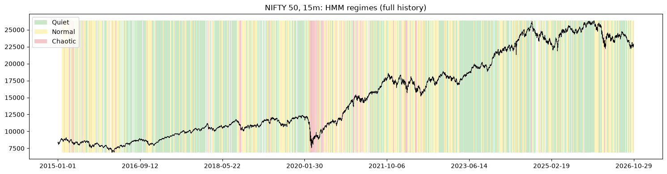
Figure 1.1: NIFTY 50 15-minute closes, 2015–2026, shaded by the hindsight HMM regime (green Quiet, yellow Normal, red Chaotic)

1.1.3 Intraday data and the Indian market
The NSE equity session runs from 09:15 to 15:30 IST, which gives 25 bars of 15 minutes per session and roughly 6,100 bars per year. Intraday volatility has a strong time-of-day pattern [10]: the first bars after the open and the last bars before the close move much more than the middle of the day (Figure 1.2). Any volatility measure computed on intraday bars must remove this pattern, otherwise the opening bar of every day would look "Chaotic". The project therefore works with deseasonalised returns and ranges (Section 4.3).
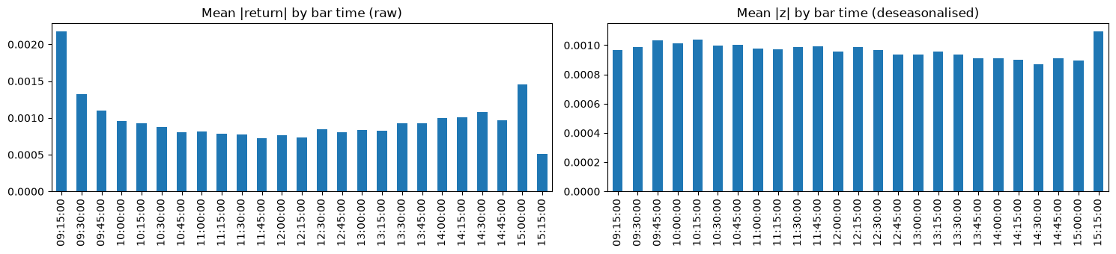
Figure 1.2: Mean absolute 15-minute return by time of day, raw (left) and after dividing by the causal time-of-day profile (right)
Retail participation in Indian markets has grown rapidly, and so have retail losses. A SEBI study of the equity cash segment found that about 70% of individual intraday traders made losses in FY 2022–23 [11], and a later study of the equity derivatives segment found that 93% of more than one crore individual F&O traders lost money over FY 2022–24 [12]. Trading through volatility spikes without recognising them is one of the ways these losses happen.

1.2 Motivation and Perspective
Professional desks monitor volatility with risk models, implied-volatility surfaces and dedicated staff. A retail trader typically has a price chart and perhaps the India VIX number. Neither answers the simple question a trader needs answered before entering a position: is the market calm or dangerous right now? The India VIX is a 30-day forward-looking measure and reacts slowly to an intraday burst; a price chart shows the burst only after it has done its damage.
The perspective taken in this project is that of nowcasting, not forecasting. The system does not try to predict tomorrow’s volatility or the direction of the next move. It answers "what state is the market in right now?", as accurately and as early as possible, using only information that is available at the moment of the decision. This is a deliberately modest goal. Volatility forecasting has a large literature and only incremental gains to show [13]; regime recognition, by contrast, is directly actionable (reduce size, widen stops, or stay out) and can be evaluated in terms a trader understands: how many dangerous episodes were caught, how late, and at the cost of how many false alarms per week.
Three further considerations shaped the project:
• Honest ground truth. Regimes are latent, so the "true" regime must itself be estimated. The project uses a hindsight model (an HMM decoded over the full sequence) to define the truth and asks the real-time system to recover it. The same HMM run in real time becomes the benchmark the machine-learning models must beat.
• Accessibility. The output is a colour, a probability and an alert, not a set of model parameters. The dashboard runs on a personal computer with a free broker API.
• Evidence over complexity. Many published volatility studies report large gains from deep or hybrid models. This project compares 22 models under one protocol, with confidence intervals, to find out how much model complexity actually buys on this problem.

1.3 Description of Theoretical Concepts

1.3.1 Realised and range-based volatility
Given bars with open O, high H, low L and close C, the log return of bar t is r_{t} = ln(C_{t}/C_{t−1}). The realised volatility over a window of w bars is the root mean square of returns, scaled to an annual figure:
σ_{RV}(t, w) = √( (1/w) Σ_{i=0}^{w−1} r_{t−i}² ) × √(25 × 252) × 100
Range-based estimators use the high and low of each bar, which carry more information about the path of prices within the bar than the close alone. Parkinson’s estimator [3] uses the high–low range, and the Garman–Klass estimator [4] adds the open–close move:
σ_{P}² = (ln H/L)² / (4 ln 2) σ_{GK}² = ½ (ln H/L)² − (2 ln 2 − 1)(ln C/O)²
Range estimators are several times more efficient than squared returns for the same number of bars, which is valuable when the goal is to react within a few bars. Rogers and Satchell [14] extended the idea to markets with drift.

1.3.2 Hidden Markov models
A hidden Markov model (HMM) [15] describes a sequence of observations o₁, …, o_{T} generated by a hidden state sequence s₁, …, s_{T} that follows a Markov chain. It is defined by an initial distribution π, a transition matrix A with a_{ij} = P(s_{t} = j | s_{t−1} = i) and, in the Gaussian case, an emission distribution N(μ_{k}, Σ_{k}) for each state k. The parameters are estimated by the Baum–Welch (expectation–maximisation) algorithm [16]. Three inference problems matter for this project:
• Filtering: P(s_{t} | o_{1..t}), the probability of the current state given observations up to now. It is computed recursively by the forward algorithm and is the only one of the three that can be used in real time.
• Smoothing: P(s_{t} | o_{1..T}), which also uses observations after t (forward–backward algorithm). It is more accurate but needs the future.
• Decoding: the single most likely state sequence, found by the Viterbi algorithm [17]. Like smoothing, it uses the whole sequence.
The forward recursion is
α_{t}(j) ∝ N(o_{t}; μ_{j}, Σ_{j}) · Σ_{i} α_{t−1}(i) a_{ij}, Σ_{j} α_{t}(j) = 1
The gap between the filtered and the smoothed view of the same model is exactly the difficulty of real-time regime detection: at the moment a large bar arrives, the filter cannot know whether it is noise or the start of a Chaotic episode, whereas the smoother, having seen the following bars, can. Regime models fitted to financial data are known to switch too often; a sticky prior that favours staying in the same state [18] and a minimum regime duration are standard remedies, and both are used here.

1.3.3 Supervised classification
Once every historical bar carries a hindsight label, recovering that label in real time is a supervised three-class classification problem: features computed from data up to bar t are mapped to the label of bar t. The project compares many classifier families (Chapter 6). The production model is LightGBM [19], a gradient-boosted decision-tree ensemble [20] that grows trees leaf-wise, bins features into histograms, and handles missing values natively. Gradient boosting builds an additive model F(x) = Σ_{m} η f_{m}(x), where each tree f_{m} is fitted to the negative gradient of the loss of the current ensemble; for three classes the loss is the multinomial log-loss and the output is a probability for each regime.
Because Chaotic bars are rare (about 7%), a classifier that picks the most probable class (argmax) is conservative: it calls Chaotic only when P(Chaotic) exceeds the other two probabilities. The project instead calls Chaotic whenever P(Chaotic) ≥ τ and tunes τ on data the test never sees. This threshold is the single most important knob for the trade-off between catching episodes and raising false alarms.

1.3.4 Walk-forward validation
Financial time series are not independent and identically distributed: neighbouring bars are strongly correlated and the data-generating process drifts over years. Random train/test splits therefore leak information from the future and overstate accuracy [21]. The project uses walk-forward (expanding-window) validation: for each test year, models are trained only on earlier years and then predict the test year, as they would have in real time. Uncertainty in the resulting scores is estimated with a block bootstrap [22], which resamples whole weeks rather than individual bars so that the dependence between neighbouring bars is preserved.

1.4 Organisation of the Report
Chapter 2 reviews the literature on volatility modelling, regime-switching models and machine learning for volatility. Chapter 3 formulates the problem, its inputs, outputs and objectives. Chapter 4 describes the proposed method step by step. Chapter 5 presents the system design with data-flow and UML diagrams. Chapter 6 covers the implementation, tools and dataset, and Chapter 7 analyses the results. Chapter 8 concludes with limitations and future scope.

CHAPTER 2
LITERATURE REVIEW

2.1 Introduction
The project draws on four bodies of work: econometric models of volatility, regime-switching models, machine-learning approaches to volatility prediction, and the methodology of evaluating models on financial time series. This chapter reviews each in turn, summarises the most relevant studies in Table 2.1, and closes with the research gaps that motivate the problem formulation in Chapter 3.

2.2 Related Literature Review

2.2.1 Econometric volatility models
Engle’s ARCH model [5] made the conditional variance of returns a function of past squared shocks, and Bollerslev’s GARCH [6] added lagged variance, giving a parsimonious model of volatility clustering that remains the workhorse of financial econometrics. GARCH models are fitted on returns alone and adapt only gradually, so they react to a sudden intraday burst with a lag of several bars. Andersen and Bollerslev [23] showed that GARCH forecasts look poor mainly because daily squared returns are a noisy proxy for true volatility, and that realised volatility computed from intraday returns is a far better target. Corsi’s HAR model [24] captures the long memory of realised volatility with daily, weekly and monthly components and is a strong, simple benchmark. Range-based estimators [3, 4, 14] extract more information per bar from the high and low. Andersen and Bollerslev [10] documented the strong intraday periodicity of volatility and showed that it must be removed before intraday volatility persistence can be studied, which directly informs the deseasonalisation used in this project.

2.2.2 Regime-switching and hidden Markov models
Hamilton [8] introduced Markov-switching models in which the parameters of a time-series model depend on an unobserved state that follows a Markov chain, with business-cycle recessions as the original application. Hamilton and Susmel [25] combined regime switching with ARCH and found that accounting for regime changes removes much of the apparent persistence of volatility. Rabiner’s tutorial [15] remains the standard reference for HMM inference: the forward–backward, Viterbi and Baum–Welch algorithms. Ang and Timmermann [9] survey regime models in finance and argue that they capture fat tails, volatility clustering and time-varying correlations with very few parameters. Kritzman, Page and Turkington [26] applied two-state HMMs to turbulence, inflation and growth measures and showed that regime-aware asset allocation reduces drawdowns. A practical issue with HMMs on financial data is that maximum-likelihood fits switch states too often; Fox et al. [18] formalised a sticky prior on self-transitions that encourages persistent states. Most of this literature works with daily or monthly data and uses the smoothed or decoded regimes, which are only available in hindsight.

2.2.3 Machine learning for volatility prediction
Gunnarsson et al. [13] systematically review studies that predict realised volatility or implied-volatility indices with AI and machine learning. They find machine-learning methods promising, with LSTM and GRU networks frequently among the top performers, but also that traditional econometric models remain highly competitive and often give similar results; they point to hybrid models and explainability as open directions. Kumar, Rao and Dhochak [27] forecast realised volatility of the Shanghai Composite, Infosys and the NIFTY with a hybrid of optimised variational mode decomposition and ANN, LSTM and GRU networks (data 2015–2022); their Q-VMD-ANN-LSTM-GRU model performs best and they highlight real-time risk insights for traders as a practical benefit. Araya, Aduda and Berhane [28] feed GARCH-family volatility estimates, fitted on SARIMA residuals, into CNN and bidirectional LSTM networks and report large reductions in MAE and RMSE over other hybrids. Deveikyte et al. [29] relate sentiment from news headlines and tweets to FTSE 100 volatility and find that negative tweet sentiment on one day is strongly negatively correlated with volatility the next, and build a topic-model-based volatility classifier.
In the broader asset-pricing literature, Gu, Kelly and Xiu [30] compared a wide range of machine-learning methods and found tree ensembles and shallow neural networks to be the best performers, with gains coming mostly from non-linear interactions among predictors. On tabular data in general, Grinsztajn, Oyallon and Varoquaux [31] showed that tree-based models still outperform deep networks on medium-sized datasets, because they are robust to uninformative features and do not need smooth target functions. The tree ensembles used here are Random Forest [32], Extra Trees [33], AdaBoost [34], XGBoost [35], LightGBM [19] and CatBoost [36]. The sequence models are the LSTM [37], the GRU [38], the Transformer [39] and temporal convolutional networks, which Bai, Kolter and Koltun [40] found to match or beat recurrent networks on many sequence tasks.

2.2.4 Evaluation methodology
López de Prado [21] documents how standard cross-validation leaks information in financial applications, through overlapping labels and serial correlation, and recommends walk-forward or purged schemes. Künsch [22] introduced the block bootstrap for dependent data, which resamples contiguous blocks to preserve short-range dependence. Saito and Rehmsmeier [41] showed that precision–recall curves are more informative than ROC curves when the positive class is rare, as the Chaotic class is here. Agreement between alternative labelings is measured with Cohen’s kappa [42], and the number of HMM states is chosen with the Bayesian information criterion [43].

2.3 Summary of Reviewed Studies
Table 2.1: Summary of the most relevant studies
Study | Data / task | Method | Key finding | Relevance to VRDet
Hamilton (1989) [8] | US GNP, quarterly | Markov-switching AR | Hidden regimes explain business cycles | Regime as a latent Markov state
Rabiner (1989) [15] | Speech (tutorial) | HMM: forward, Viterbi, Baum–Welch | Standard HMM inference | Filter (live) vs Viterbi (labels)
Hamilton & Susmel (1994) [25] | US weekly returns | Switching ARCH | Regimes absorb volatility persistence | Volatility regimes are real
Andersen & Bollerslev (1997) [10] | FX and S&P intraday | Periodicity filter | Intraday pattern must be removed | Deseasonalised returns and ranges
Kritzman et al. (2012) [26] | Macro and market, monthly | 2-state HMM | Regime-aware allocation cuts drawdowns | Practical value of regimes
Gu, Kelly & Xiu (2020) [30] | US stocks, monthly | 12 ML methods | Trees and shallow nets best | Compare many model families
Deveikyte et al. (2022) [29] | FTSE 100, daily | Sentiment + LDA classifier | Tweet sentiment relates to next-day volatility | Alternative data (future scope)
Grinsztajn et al. (2022) [31] | 45 tabular datasets | Trees vs deep nets | Trees still win on tabular data | Expect small models to win
Gunnarsson et al. (2024) [13] | Review of RV / IV studies | Systematic review | ML promising; GARCH/HAR still competitive | Benchmark against simple models
Araya et al. (2024) [28] | Stock prices, daily | SARIMA-GARCH + CNN-BiLSTM | Hybrid lowers MAE/RMSE | Hybrid econometric + ML inputs
Kumar et al. (2025) [27] | SSE, INFY, NIFTY (2015–22) | Q-VMD + ANN-LSTM-GRU | Hybrid best for all three | Indian market, NIFTY volatility

2.4 Research Gaps
The review identifies five gaps that this project addresses:
1. Forecasting rather than state recognition. Most machine-learning studies forecast a volatility number (realised volatility tomorrow) and score it with RMSE. Few treat the practical question of recognising the current regime in real time, and fewer evaluate it in trader-relevant terms (episodes caught, detection delay, false alarms per week).
2. Hindsight regimes presented as real-time signals. Regime studies usually report smoothed or Viterbi regimes, which use future data. The gap between what a regime model knows in hindsight and what it knows in real time is rarely measured.
3. Daily data. Most regime and volatility studies on Indian markets use daily data; intraday regime detection for the NIFTY 50 at 15-minute resolution with India VIX inputs is largely unexplored.
4. Weak baselines and no uncertainty. Deep and hybrid models are often compared with a few weak baselines on a single split without confidence intervals, which makes small reported gains hard to interpret.
5. No accessible tool. Published models rarely become a working, free, local application that a retail trader can run.
VRDet addresses these gaps by defining regimes with a hindsight HMM, benchmarking against the same HMM used in real time, comparing 22 models under one walk-forward protocol with block-bootstrap intervals, and delivering the result as a local dashboard with alerts.

CHAPTER 3
PROBLEM FORMULATION

3.1 Description of Problem Domain
The problem domain is intraday risk monitoring for retail traders in the Indian equity market. Intraday traders open and close positions within the same session, typically with leverage and tight stop-losses. Their main risk is not a slow trend but a sudden burst of volatility: an unexpected policy announcement, an election result, a global sell-off or a large order imbalance. During such bursts, prices gap through stop-loss levels, the bid–ask spread widens and positions that were sized for normal conditions produce outsized losses. SEBI’s studies of individual traders show how widespread losses are in both the intraday cash segment [11] and the derivatives segment [12].
The tools available to a retail trader do not address this directly. The India VIX measures expected volatility over the next 30 days and moves slowly within a session; GARCH-type models need statistical expertise to interpret and react with a lag; and the regime models of the academic literature (Chapter 2) are usually reported in hindsight on daily data. The research gaps identified in Section 2.4 lead to the following observations, which define the problem:
• A regime is a latent state, and it is only known with confidence in hindsight, after the following bars have been seen. In real time, one large bar may be noise or the start of a Chaotic phase.
• Therefore a real-time system cannot be scored against "the truth" unless the truth is defined explicitly. Here it is defined as the regime that a hindsight model assigns to each bar.
• A real-time system is useful only if it beats the obvious real-time baseline: the same hindsight model run forward in time (the HMM filter). If machine learning cannot beat it, the HMM filter alone should power the application.
• Scores must be reported per episode as well as per bar: a trader experiences an alarm system as episodes caught, delay and false alarms, not as bar-level accuracy.

3.2 Problem Statement
Given the 15-minute OHLC bars of the NIFTY 50 and India VIX, and daily USD/INR and Brent crude prices, up to and including bar t, estimate the volatility regime (Quiet, Normal or Chaotic) that a hindsight hidden Markov model assigns to bar t, with the highest possible macro-F1, the shortest detection delay for Chaotic episodes and the fewest false alarms; and deliver the estimate to a retail trader through a local dashboard and alerts within a minute of each bar closing.
Formally, let y_{t} ∈ {Quiet, Normal, Chaotic} be the hindsight label of bar t, computed from the whole sequence, and let x_{t} be a feature vector computed only from data available at the close of bar t. The task is to learn f such that ŷ_{t} = f(x_{t}) recovers y_{t}, where f is trained only on years before the year being predicted. Forecasting the regime of the next bar is outside the scope.

3.3 Depiction of Problem Statement
Figure 3.1 depicts the problem as a block diagram of inputs, processes and outputs.
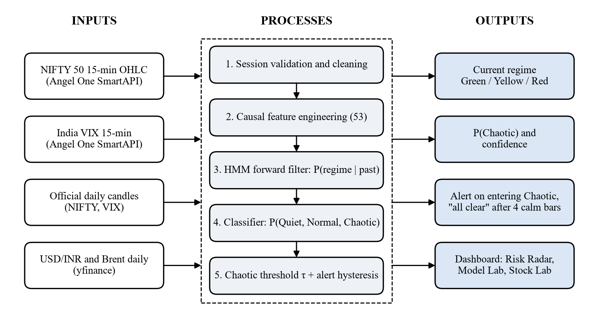
Figure 3.1: Block diagram of the problem: inputs, processes and outputs

3.3.1 Inputs
• NIFTY 50 15-minute OHLC candles (Angel One SmartAPI, token 99926000), January 2015 to October 2026, plus the live session during market hours.
• India VIX 15-minute candles (token 99926017), from December 2015.
• Official daily candles of the NIFTY 50 and India VIX, used to validate every intraday session.
• USD/INR and Brent crude daily closes (Yahoo Finance), used as cross-asset context; only the previous trading day’s values are used, so they are known before the session opens.
• User settings: alarm sensitivity (τ), and in the Stock Lab the stock and models to train.

3.3.2 Processes
1. Validation and cleaning: restrict to the regular session, drop malformed candles, compare each intraday session with the official daily candle and drop or mask invalid sessions.
2. Feature engineering: 53 causal features: returns, realised and range-based volatility over four windows, volatility ratios and z-scores, trend context, calendar, India VIX and cross-asset inputs, and lags.
3. HMM filtering: the forward filter of the labelling HMM gives P(regime | data up to t), added as three more inputs.
4. Classification: a trained classifier maps the 56 inputs to P(Quiet), P(Normal), P(Chaotic).
5. Decision and alerting: Chaotic if P(Chaotic) ≥ τ; an alert is raised on entering Chaotic and an "all clear" after four consecutive non-Chaotic bars.

3.3.3 Outputs
• The current regime as a traffic light (Green Quiet, Yellow Normal, Red Chaotic).
• P(Chaotic) and the model’s confidence, with the HMM filter’s own view for comparison.
• Alerts in the dashboard and, optionally, through a private Telegram bot.
• A price chart shaded by regime, a comparison of all models (Model Lab), and per-stock results (Stock Lab).
• For research: a labelled dataset of NIFTY 50 regimes and a benchmark of 22 models.

3.4 Objectives
1. Build a validated local archive of NIFTY 50 and India VIX intraday data from the Angel One SmartAPI and document the data defects found.
2. Define the ground-truth regimes with a hindsight HMM, check them against known market events, and compare them with alternative labelers (GMM and GARCH).
3. Design strictly causal features so that every prediction at bar t uses only data up to t.
4. Train real-time classifiers and beat the causal HMM filter benchmark in a walk-forward test on 2022–2026, on macro-F1 and on false alarms, while catching nearly all Chaotic episodes.
5. Compare a broad zoo of 22 models with confidence intervals, and determine whether deep sequence models help given the available data.
6. Deploy the production model in a local Streamlit dashboard on live data with alerts, a Model Lab and a Stock Lab for any NSE stock, without hosting anything publicly.

3.5 Scope and Assumptions
• The target asset is the NIFTY 50 index; individual NSE stocks are supported by the Stock Lab with per-stock models.
• The primary bar frequency is 15 minutes. Index candles carry no meaningful volume, so volume and order-flow features are out of scope.
• The system reports a risk state. It does not recommend trades and is not investment advice.
• Everything runs on the user’s own machine; credentials stay in a local, git-ignored file.

CHAPTER 4
PROPOSED WORK

4.1 Introduction
The proposed approach separates two questions that are usually mixed together: what is the regime? and how well can it be recognised in real time? The first is answered once, in hindsight, by a statistical model that sees the whole history. The second is a supervised learning problem whose target is the answer to the first. This design follows from the literature reviewed in Chapter 2. Regime-switching models [8, 9] provide a principled, data-driven definition of regimes that requires no arbitrary volatility thresholds, and the HMM’s smoothed and Viterbi decodings [15, 17] give the best available estimate of the regime path once the data are complete. The same model’s forward filter is what a regime model can do in real time, so it is the natural benchmark.
A classifier can improve on the filter because it is not restricted to the HMM’s two observations and its Gaussian assumptions. It can use multi-bar volatility estimates, which are more efficient than a single bar [3, 4], the India VIX, which carries the options market’s view [7], time-of-day effects [10], and the filter’s own probabilities. Gradient-boosted trees are a strong default for such heterogeneous tabular inputs [30, 31], and LightGBM in particular handles the missing values that arise from data defects without imputation [19].
Two choices guard against the most common failure modes of financial machine learning [21]. First, the target is not a function of the features: labels come from hindsight decoding over the whole sequence, while features are strictly causal. A classifier that merely re-implemented a volatility threshold would not score well against hindsight labels. Earlier experiments with labels derived from rolling volatility were rejected for exactly this reason: their hindsight labels agreed with the live filter 96% of the time, a circular target. Second, every score in Chapter 7 is out of sample in time: the HMM labeler is fitted on 2015–2021 only, classifiers are retrained for each test year on earlier years only, and the decision threshold is tuned on the last training year.
The approach also deliberately includes a broad comparison of model families. Reviews such as [13] report that LSTM and GRU networks often rank highly in volatility prediction, while [31] reports the opposite for tabular data. Rather than assume either, the project trains 22 models under one protocol and measures the differences with block-bootstrap confidence intervals, and it uses learning curves to test whether deep sequence models are held back by the amount of data.

4.2 Proposed Methodology / Algorithm
The complete method is summarised below and shown as a flowchart in Figure 4.1.
1. Data acquisition. Download NIFTY 50 and India VIX 15-minute (and 5-minute, daily) candles from the Angel One SmartAPI in date-chunked requests (2015–2026); download USD/INR and Brent crude daily closes from Yahoo Finance; store everything as a local Parquet archive.
2. Validation and cleaning. Keep the regular session (09:15–15:30 IST); validate every intraday session against the official daily candle; drop invalid NIFTY sessions and mask invalid India VIX sessions; treat zero-range candles and returns across missing candles as missing.
3. Causal feature engineering. Compute 53 features for every bar from data up to and including that bar.
4. Hindsight labelling. Fit a three-state Gaussian HMM with a sticky transition prior on 2015–2021; decode every bar with the Viterbi algorithm; enforce a minimum regime length of four bars; order states by volatility (Quiet < Normal < Chaotic).
5. HMM filter inputs. Run the HMM forward filter to obtain P(Quiet), P(Normal), P(Chaotic) given data up to t; add them as three more inputs (56 in total). The filter alone is the benchmark.
6. Walk-forward training and threshold tuning. For each test year 2022–2026: train the classifier on 2017 to the previous year; tune τ on the last training year; predict the test year. Repeat for every model in the zoo.
7. Evaluation and model selection. Score bar-level and episode-level metrics against the hindsight labels, with block-bootstrap intervals; compare with the HMM filter and other baselines; choose the production model.
8. Deployment. Retrain the chosen model on all labelled bars, freeze it, and run the live loop: fetch → features → score → alert → dashboard, at every bar close.
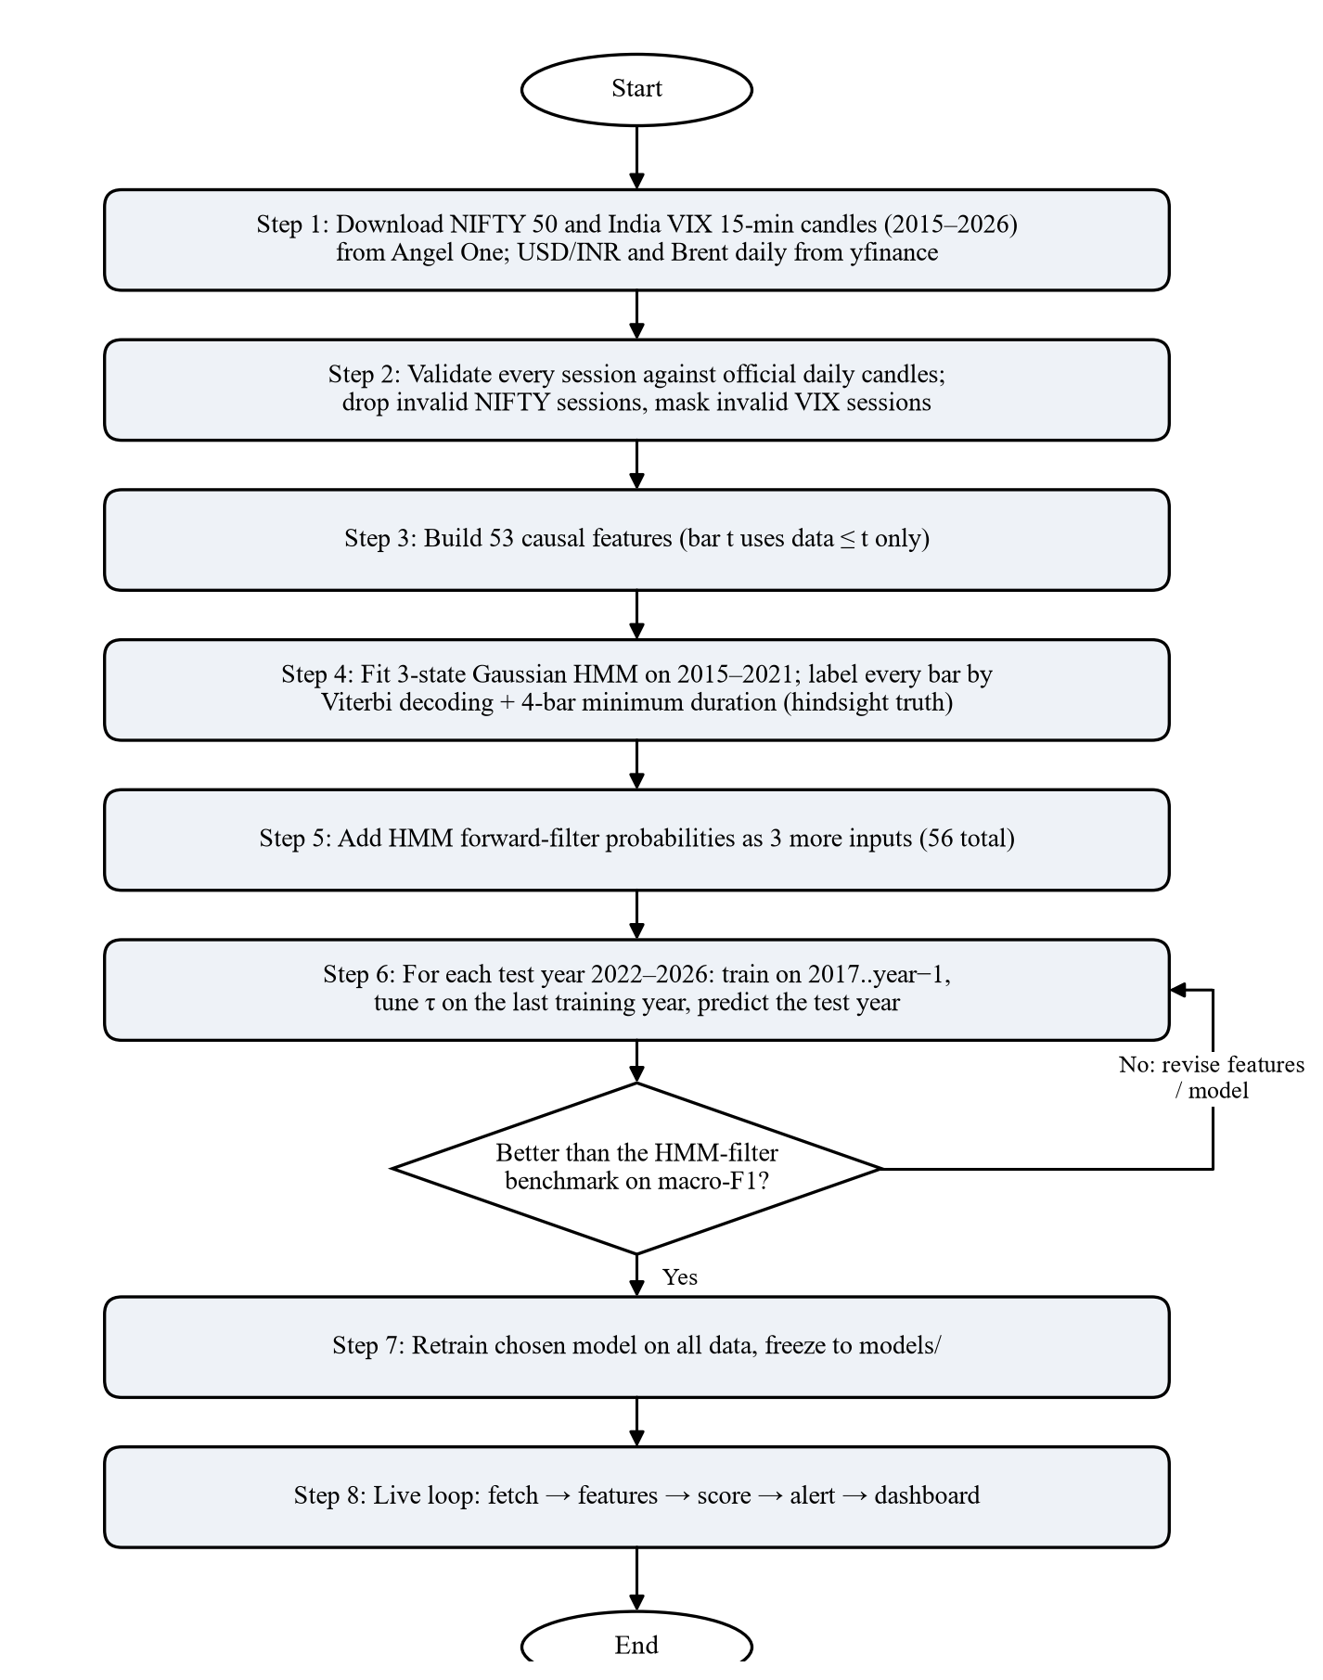
Figure 4.1: Flowchart of the proposed methodology

4.3 Description of Each Step

4.3.1 Data acquisition
The Angel One SmartAPI provides free historical and live candles to account holders. Logging in requires an API key, the client code, a PIN and a time-based one-time password (TOTP) generated from a secret; all four are read from a local .env file that is excluded from version control. Historical requests are capped per call (for example 200 days of 15-minute candles), so the download is split into date chunks and rate-limited to about three requests per second, with retries. Eleven years of NIFTY 50 and India VIX 15-minute candles download in under a minute. Yahoo Finance supplies daily USD/INR (USDINR=X) and Brent crude (BZ=F) closes; its intraday history is too short for the primary data.

4.3.2 Validation and cleaning
Vendor archives contain defects that would silently corrupt volatility features. Each intraday session is therefore compared with the official daily candle of the same day: a session is valid if it is not flat, has at least 13 of the 25 bars, and reproduces at least two of the daily high, low and close within 1%. Invalid NIFTY sessions are dropped; invalid India VIX sessions are set to missing so that VIX features are missing rather than wrong. Chapter 6 describes the defects found (Section 6.2.3). Two other rules prevent fake signals: a return that spans a missing candle is set to missing rather than treated as a 15-minute move, and a candle with zero range (high = low) is treated as carrying no range information rather than as "very quiet".

4.3.3 Causal feature engineering
Every feature at bar t uses data up to and including bar t only. Intraday volatility follows a U-shaped daily pattern (Figure 1.2), so per-bar returns and ranges are first divided by a causal time-of-day profile: for a bar at time k on day d, the profile is the average absolute return (or range) at time k over all days strictly before d, normalised to a mean of one across the day. The resulting deseasonalised return z_{t} and range are the building blocks of most features. Table 4.1 lists the feature groups.
Table 4.1: Feature groups (53 causal features + 3 HMM filter probabilities = 56 inputs)
Group | Features | Count
Returns | Log return, overnight gap, deseasonalised return z, deseasonalised range, |z| | 5
Volatility | Realised, Parkinson and Garman–Klass volatility over 4, 8, 25 and 125 bars (1 hour to 1 week) | 12
Volatility dynamics | Short/long ratios (8 vs 125 bars) for realised and Parkinson; z-score of log Parkinson volatility vs its 100-day history | 3
Trend context | Return and distance from EMA over 25 and 125 bars, drawdown from 125-bar high, return since the open | 6
Calendar | Time of day (sine, cosine), day of week, first-hour and last-hour flags | 5
Implied volatility | India VIX level, log change over 1, 4, 25 bars, VIX minus realised volatility, VIX z-score | 6
Cross-asset | USD/INR and Brent: previous-day return and 5-day volatility | 4
Lags | |z|, range, 4-bar Parkinson volatility and 1-bar VIX change, each lagged 1, 2 and 4 bars | 12
HMM filter | P(Quiet), P(Normal), P(Chaotic) from the forward filter | 3

The cross-asset series are daily, so the value of the previous trading day is used for every bar of a session; this avoids using a close that is not yet known during the session. The India VIX is aligned to NIFTY timestamps by carrying the last known value forward for at most one session.

4.3.4 Hindsight labelling with a hidden Markov model
The HMM observes, for each bar, a two-dimensional vector o_{t} = [z_{t}, ln range_{t}] of the deseasonalised return and log deseasonalised range, standardised. Each state has a Gaussian emission with diagonal covariance. The model is fitted with hmmlearn (best of four random initialisations) on 2015–2021 only and then frozen. To discourage rapid switching, a Dirichlet prior adds a pseudo-count of 0.2 × (training length) to the diagonal of the transition counts in every M-step, a sticky prior in the sense of [18]. After fitting, states are ordered by the variance of their returns, so code 0 always means Quiet and code 2 always means Chaotic.
Number of states. Two to five states were compared on the 2015–2021 data (Table 4.2, Figure 4.2). BIC [43] and the out-of-sample log-likelihood keep improving with more states, but the extra states are not useful regimes: with four states the top state covers only 1.2% of bars in 44 very long episodes (mostly the COVID crash), and with five states only 0.6%. Three states give a Chaotic regime that is rare but recurring (342 episodes), which is what an alarm system needs.
Table 4.2: Number of HMM states (fitted on 2015–2021; test log-likelihood on 2022–2026)
States | Parameters | BIC | Test log-lik. per bar | Top-state share | Top-state episodes
2 | 11 | 199,596 | −2.218 | 27.6% | 967
3 | 20 | 187,394 | −2.106 | 7.4% | 342
4 | 31 | 183,046 | −2.069 | 1.2% | 44
5 | 44 | 181,697 | −2.060 | 0.6% | 12

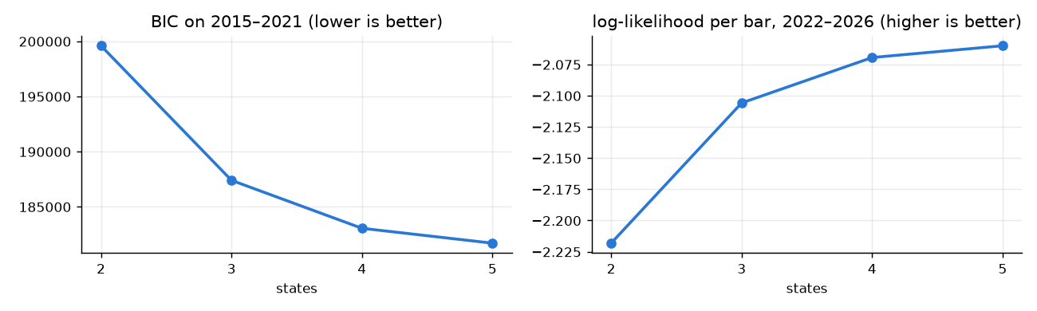
Figure 4.2: BIC on the training years (left) and log-likelihood per bar on 2022–2026 (right) against the number of states
Fitted model. Table 4.3 shows the fitted regimes. The Chaotic state’s return dispersion is about 5.8 times the Quiet state’s and its typical range about 3.7 times as wide. All three states are persistent: the expected duration is 1/(1 − a_{kk}), about 20 bars for Quiet, 15 for Normal and 26 for Chaotic. Transitions between Quiet and Chaotic are rare in both directions; the market almost always passes through Normal. Figure 4.3 shows the observations coloured by regime with each state’s emission ellipse.
Table 4.3: Fitted three-state HMM (2015–2021)
Regime | Return s.d. (per bar) | Typical range | P(stay) | → Quiet | → Normal | → Chaotic | Exp. duration
Quiet | 0.066% | 0.115% | 0.950 | – | 0.047 | 0.003 | 20.1 bars
Normal | 0.134% | 0.206% | 0.934 | 0.050 | – | 0.015 | 15.2 bars
Chaotic | 0.384% | 0.423% | 0.961 | 0.000 | 0.039 | – | 25.5 bars

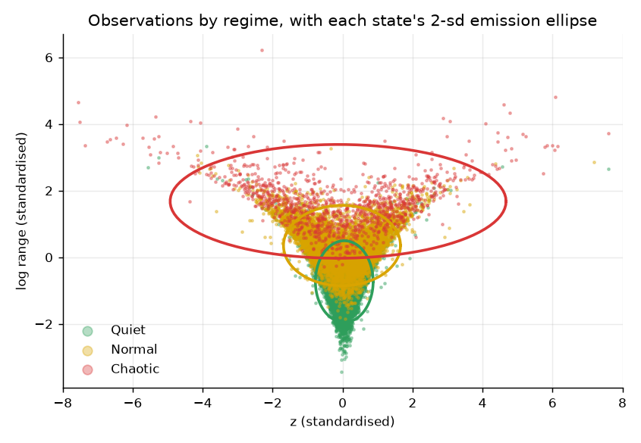
Figure 4.3: HMM observations (standardised deseasonalised return and log range) coloured by regime, with each state’s 2-s.d. emission ellipse
Decoding. The hindsight label of each bar is the Viterbi path, followed by a minimum-duration rule that merges runs shorter than four bars (one hour) into their neighbours. Figure 4.4 shows the three views of the same model around the US tariff shock of 7 April 2025: the filtered probability (real time), the smoothed probability and the final labels. The filter reacts to the first large bars but wavers; the smoother, having seen what came next, is decisive. Over 2015–2026 the filter’s argmax agrees with the labels on 85% of bars and the smoother’s on 95%; this gap is what the real-time classifier tries to close.
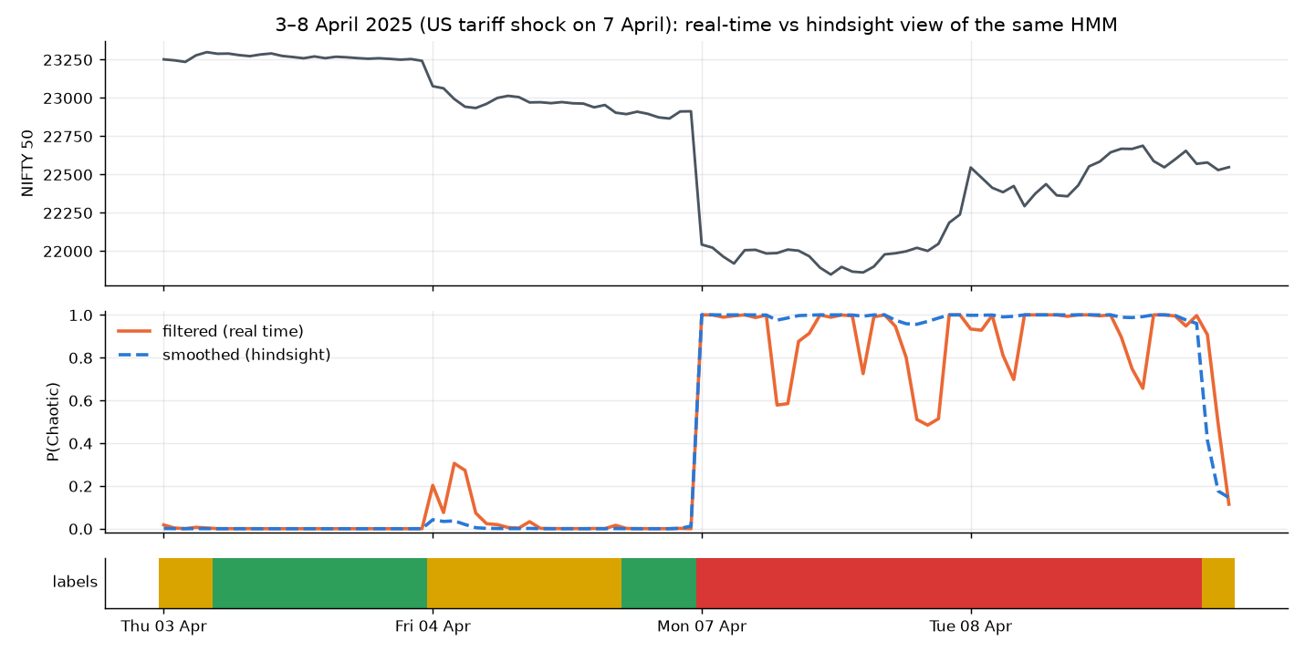
Figure 4.4: Filtered (real-time) and smoothed (hindsight) P(Chaotic) of the same HMM, 3–8 April 2025, with the final labels below
Smoothing settings. Table 4.4 shows how the sticky prior and the minimum duration change the labels. Without stickiness the labels switch more than once per session on average; a strong prior (0.5) or a long minimum (8 bars) suppresses short episodes that are genuine. The chosen setting (0.2, 4 bars) gives about one regime switch per session and labels 89% of bars on known shock days as Chaotic.
Table 4.4: Effect of the sticky prior and minimum regime length on the labels
Sticky | Min. bars | Chaotic share | Chaotic episodes | Median episode (bars) | Switches / session | Shock-day Chaotic share
0.00 | 4 | 7.0% | 405 | 7.0 | 1.12 | 0.91
0.05 | 4 | 7.9% | 440 | 8.0 | 1.14 | 0.91
0.20 | 4 | 7.4% | 342 | 8.5 | 0.95 | 0.89
0.50 | 4 | 6.9% | 282 | 9.0 | 0.74 | 0.89
0.20 | 1 | 8.0% | 580 | 4.0 | 1.48 | 0.89
0.20 | 2 | 7.9% | 498 | 6.0 | 1.34 | 0.89
0.20 | 8 | 6.5% | 180 | 14.5 | 0.50 | 0.87

4.3.5 HMM filter inputs and the benchmark
hmmlearn exposes only smoothed (future-using) state probabilities, so the forward filter was implemented separately from the saved parameters (initial distribution, transition matrix, means and variances), normalising at every step to avoid numerical underflow. The filter needs only those parameters, so the live application does not depend on hmmlearn. The three filtered probabilities are both the benchmark (argmax, or Chaotic above a tuned threshold) and three of the classifier’s inputs.

4.3.6 Walk-forward training and threshold tuning
For each test year Y from 2022 to 2026, a model is trained on all labelled bars from 2017 to Y−1 and predicts every bar of year Y. Training starts in 2017 because valid India VIX data begin in late 2016. Within each training window, the threshold τ is chosen without touching the test year: the model is fitted on the window minus its last year, τ is chosen from {0.10, 0.15, …, 0.60} to maximise the Chaotic F₁ on that last year, and the model is then refitted on the whole window. The decision rule is:
ŷ_{t} = Chaotic if P(Chaotic | x_{t}) ≥ τ, otherwise argmax{ P(Quiet | x_{t}), P(Normal | x_{t}) }
All 22 models use the same inputs, the same τ procedure and the same splits, so their scores are directly comparable. The five yearly prediction sets are concatenated into one out-of-sample record for 2022–2026 (29,625 bars, 1,187 sessions, 134 Chaotic episodes).

4.3.7 Evaluation and model selection
Models are scored against the hindsight labels with the bar-level and episode-level measures defined in Section 7.1. The primary measure is macro-F1, the unweighted mean of the three classes’ F₁ scores, which gives the rare Chaotic class the same weight as the common ones. Uncertainty is estimated with a weekly block bootstrap: the 252 calendar weeks are resampled with replacement 300 times, and every model is scored on the same resampled weeks, which gives a confidence interval for each score and for the difference between each model and the production model.

4.3.8 Deployment
The production model (LightGBM with the HMM inputs) is retrained on all labelled bars from January 2017 to the latest available bar (60,301 bars) with τ = 0.30 tuned on the last training year, and saved as a LightGBM text model plus a JSON file with the feature list and threshold; the HMM parameters are saved as JSON. The live loop (Chapter 5) recomputes the features with exactly the same function used in training. A causality check confirmed that this works: the data were cut at bar t for several test bars (first bar of a session, mid-session, 4 June 2024, 7 April 2025), and the predictions made with the truncated data were identical to those made with the full history (maximum difference 0.0).

CHAPTER 5
SYSTEM DESIGN
This chapter describes VRDet as a software system: what it does (functional specification with data-flow diagrams), how it is structured (classes and components) and how it behaves over time (sequence, activity and state diagrams). The system has two halves that share one code base: a research pipeline (data ingestion, labelling, training and evaluation, run from scripts and notebooks) and a live application (a runner process and a Streamlit dashboard). Both import the same Python package, vrdet, so the live application computes features and predictions with exactly the code that was evaluated.

5.1 Functional Specification of System

5.1.1 Functional requirements
Table 5.1: Functional requirements
ID | Requirement
FR1 | Download and incrementally update NIFTY 50 and India VIX candles (15-minute, 5-minute, daily) from the Angel One SmartAPI, and USD/INR and Brent daily closes from Yahoo Finance.
FR2 | Validate every intraday session against the official daily candle and report data quality by year.
FR3 | Compute the 53 causal features and the 3 HMM filter probabilities for every bar.
FR4 | Fit the HMM labeler, decode hindsight labels and check them against known market events.
FR5 | Train, walk-forward test and freeze each of the 22 models, one at a time.
FR6 | At every bar close during market hours, fetch new candles, score the production model and publish the regime, P(Chaotic) and history.
FR7 | Raise an alert when the regime turns Chaotic and an "all clear" after four non-Chaotic bars; deliver it on the dashboard and optionally by Telegram.
FR8 | Show the Risk Radar: regime card, probabilities, NIFTY and India VIX, regime-shaded price chart, model vs HMM filter, hindsight truth row, alert log, sensitivity setting.
FR9 | Model Lab: leaderboard and on-demand scoring of every model through a single-worker queue.
FR10 | Stock Lab: for a chosen NSE stock and models, download data, fit a per-stock HMM, train, test and show the current regime from each model.
FR11 | Replay a past session bar by bar through the live pipeline for demonstrations.

5.1.2 Non-functional requirements
• Privacy and locality: nothing is hosted; the dashboard binds to 127.0.0.1 with usage statistics off; credentials live only in a git-ignored .env file.
• Latency: the regime is updated within one minute of each 15-minute bar closing (the runner starts 45 seconds after the close; a cycle takes about 12 seconds).
• Causality: no live prediction may use data after the bar it describes.
• Resource limits: heavy jobs (model scoring, stock training) run one at a time on a single background worker, and models use at most half of the machine’s threads, so the live runner is never starved.
• Robustness: API calls are chunked, rate-limited and retried; missing or defective data become missing values, not errors.

5.1.3 Data flow diagrams
The level-0 DFD (Figure 5.1) shows VRDet as a single process with four external entities: the Angel One SmartAPI and Yahoo Finance as data sources, the trader, who receives the regime and sets preferences, and the Telegram Bot API, which delivers alerts.
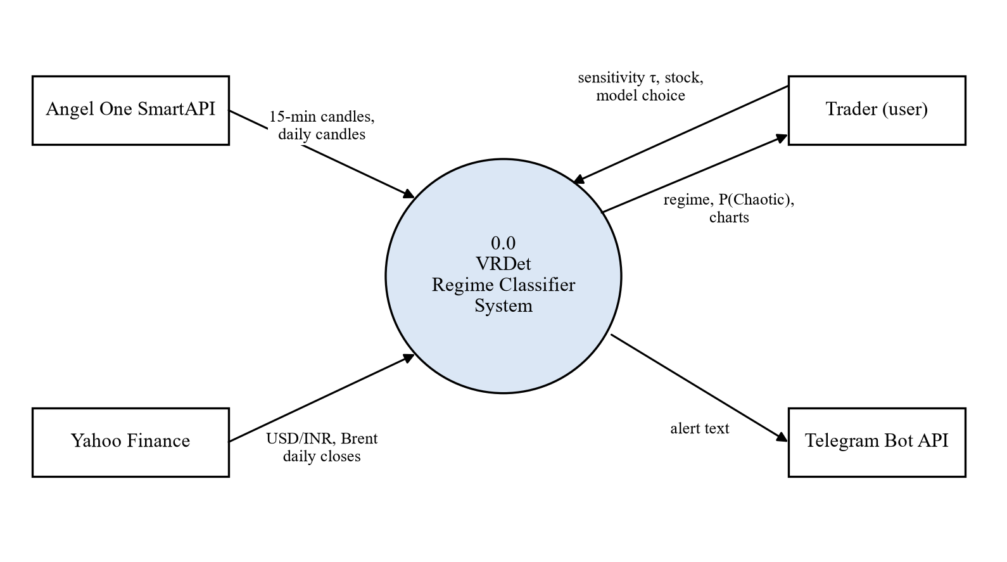
Figure 5.1: Level-0 data flow diagram (context diagram)
The level-1 DFD (Figure 5.2) decomposes the system into six processes and four data stores. Process 1.0 fetches candles; 2.0 validates sessions and appends valid bars to the archive (D1); 3.0 builds the 56 inputs using the frozen HMM parameters (D2); 4.0 scores the regime with the frozen model (D3) and writes the state and history (D4); 5.0 updates the alert state and sends alerts; 6.0, the dashboard, reads D4 and presents it to the trader.
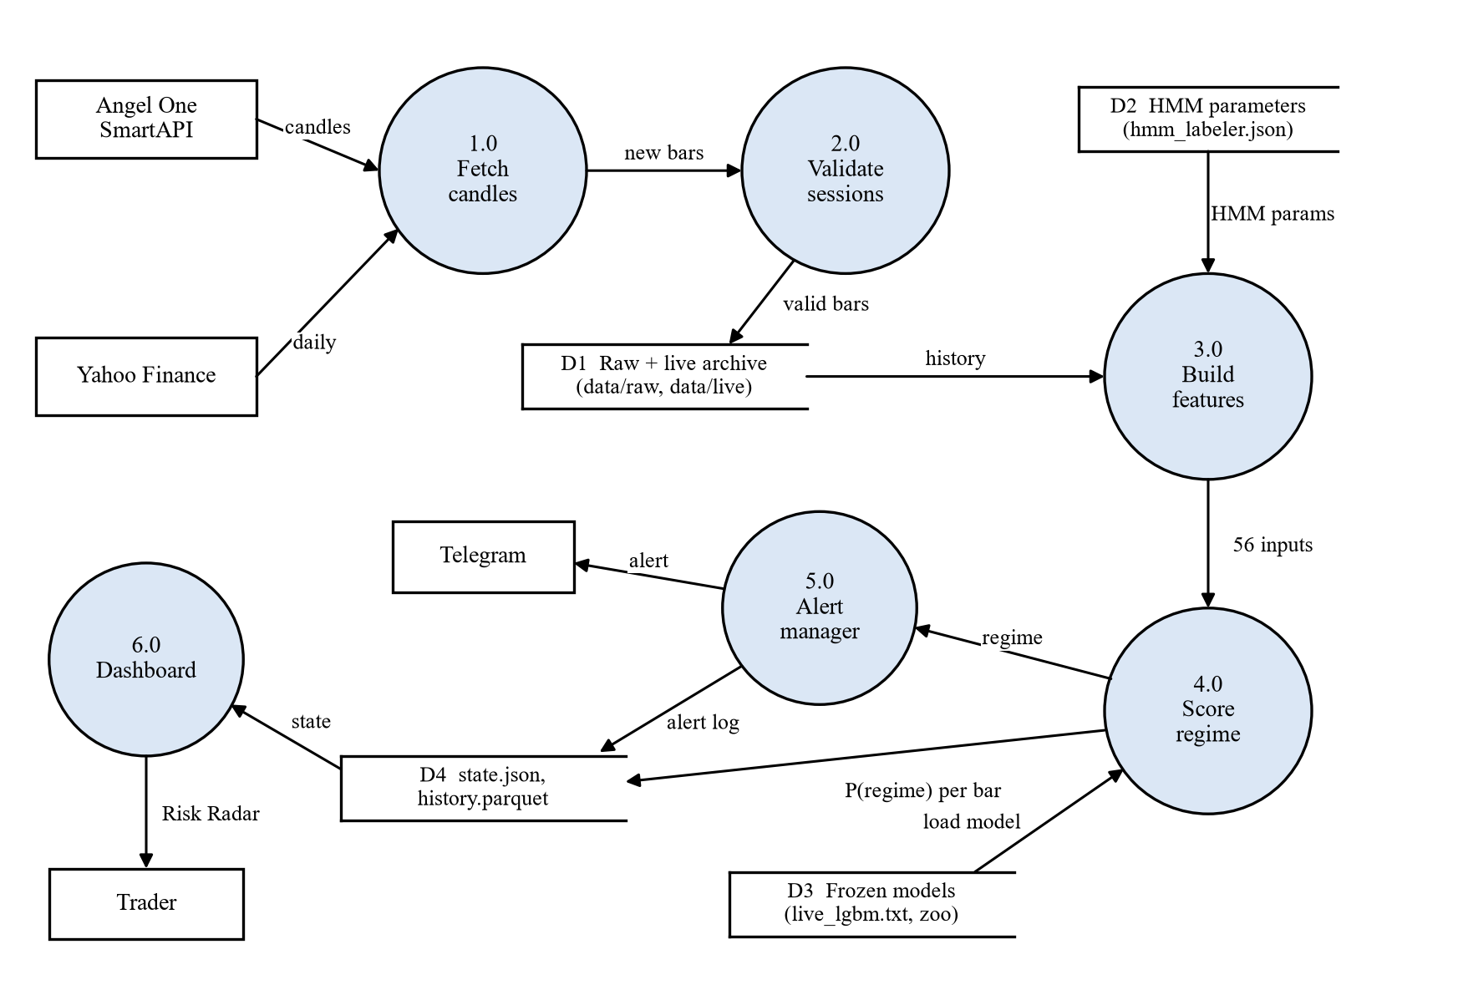
Figure 5.2: Level-1 data flow diagram

5.2 Structural and Dynamic Modeling of System

5.2.1 Class diagram
Figure 5.3 shows the main classes. The Runner owns the live loop; it uses LiveData (cached candles, refreshed from Angel One and Yahoo Finance), a RegimeModel (the frozen LightGBM booster, the feature list, τ and the HMMLabeler), an AlertState and an optional Telegram client. On the research side, TunedChaoticThreshold wraps any model in the zoo and adds the τ tuning; SequenceClassifier adapts the PyTorch networks (LSTM, GRU, Transformer, temporal CNN) to the same fit / predict_proba interface as the scikit-learn models; SoftVote, Stacking and Ordinal are composite models built from other zoo members.
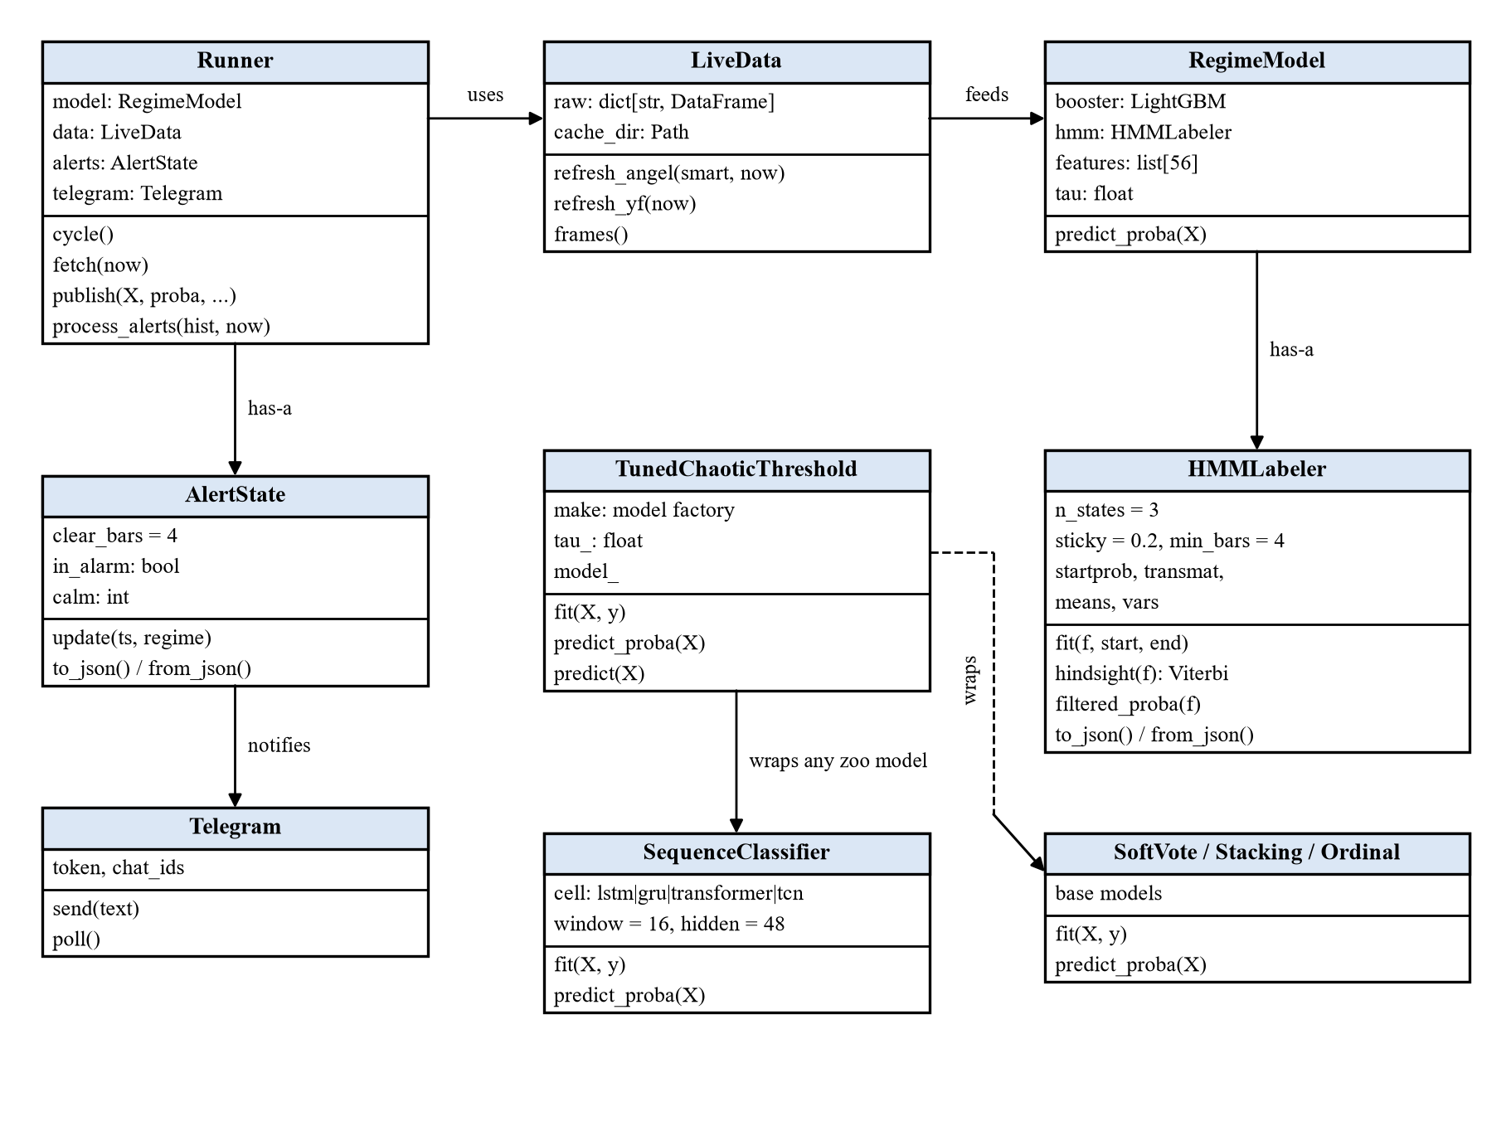
Figure 5.3: Class diagram of the main components

5.2.2 Use case diagram
The trader views the current regime, sets the alarm sensitivity, receives alerts, plays models in the Model Lab, trains models on a stock in the Stock Lab and replays past sessions. The developer or researcher additionally retrains models with the scripts and runs the research notebooks. The Angel One SmartAPI participates in every use case that needs data, and Telegram in alert delivery (Figure 5.4).
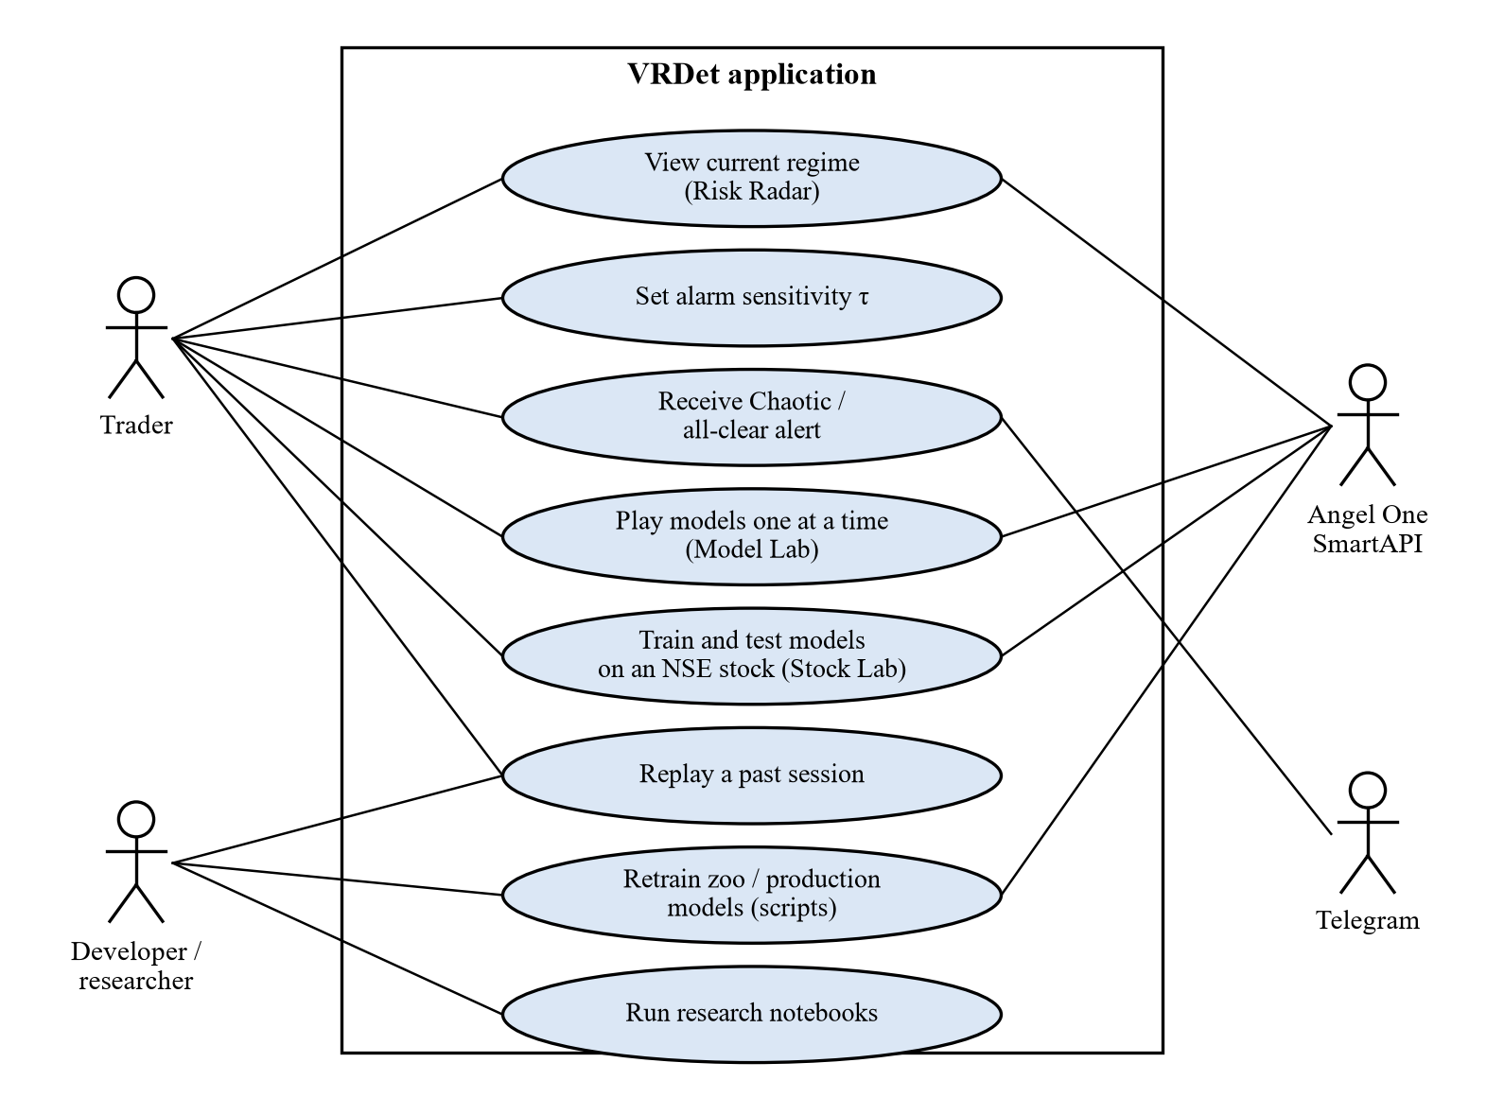
Figure 5.4: Use case diagram

5.2.3 Interaction (sequence) diagram
Figure 5.5 shows one cycle of the live loop. Forty-five seconds after a bar closes, the scheduler wakes the runner, which requests new NIFTY and India VIX candles, keeps only completed bars, rebuilds the inputs, scores the model and feeds the regime to the alert state. If the alert state changes, an alert is sent. Finally the runner writes state.json and history.parquet, which the dashboard picks up on its next refresh.
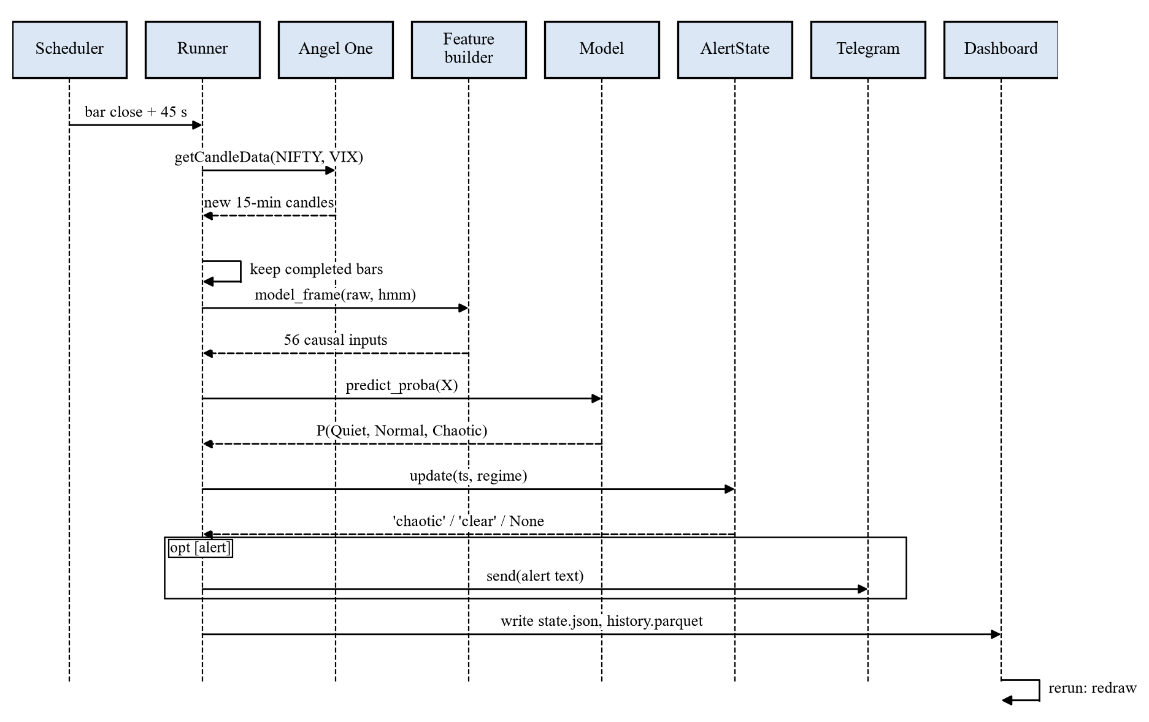
Figure 5.5: Sequence diagram of one live cycle

5.2.4 Activity diagram
The activity diagram (Figure 5.6) shows the control flow of the runner over a trading day, including the branches for a closed market and for a fetch that returns no new completed bar (for example when the vendor publishes a candle late), in which case the runner simply waits for the next cycle.
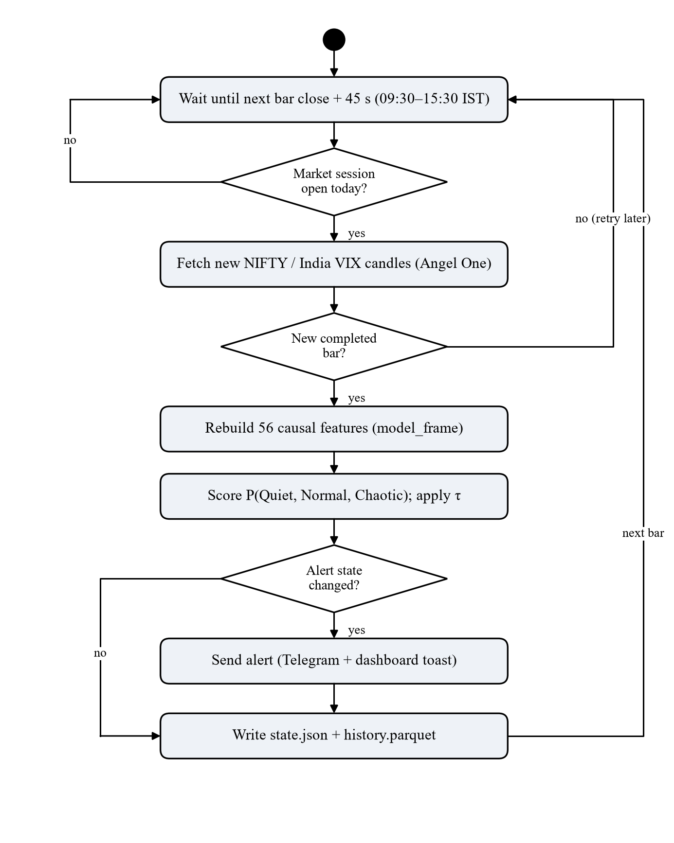
Figure 5.6: Activity diagram of the live inference loop

5.2.5 State chart diagram
Alerts use hysteresis so that a regime flickering around the threshold does not spam the user (Figure 5.7). From CALM, the first Chaotic bar sends a "Chaotic" alert and moves to ALARM. Each non-Chaotic bar increments a calm counter (CLEARING); a Chaotic bar resets it; the fourth consecutive calm bar sends "all clear" and returns to CALM. The state is saved to disk after every bar, so a restart of the runner does not repeat or lose alerts.
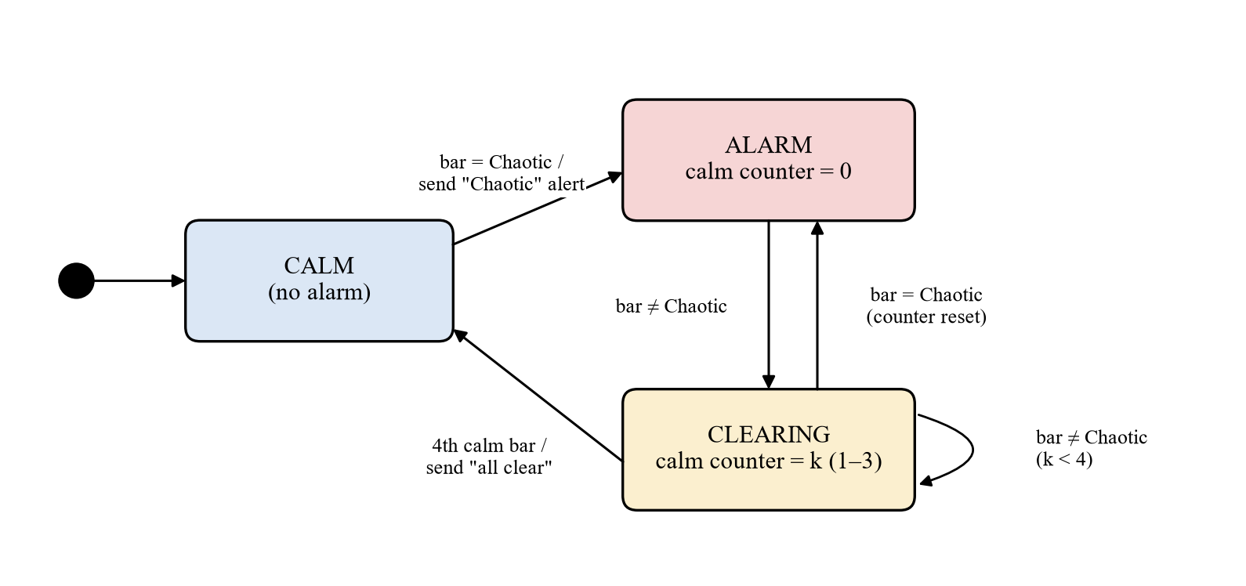
Figure 5.7: State chart of the alert hysteresis (AlertState)

5.2.6 Component and deployment diagram
Everything runs on the user’s own computer (Figure 5.8). Two processes share files on disk: the runner writes the live state, and the Streamlit dashboard reads it and serves pages only to a browser on the same machine. Inside the dashboard, a single worker thread executes Model Lab and Stock Lab jobs from a queue, one at a time. The only outgoing connections are HTTPS calls to Angel One, Yahoo Finance and, if configured, Telegram.
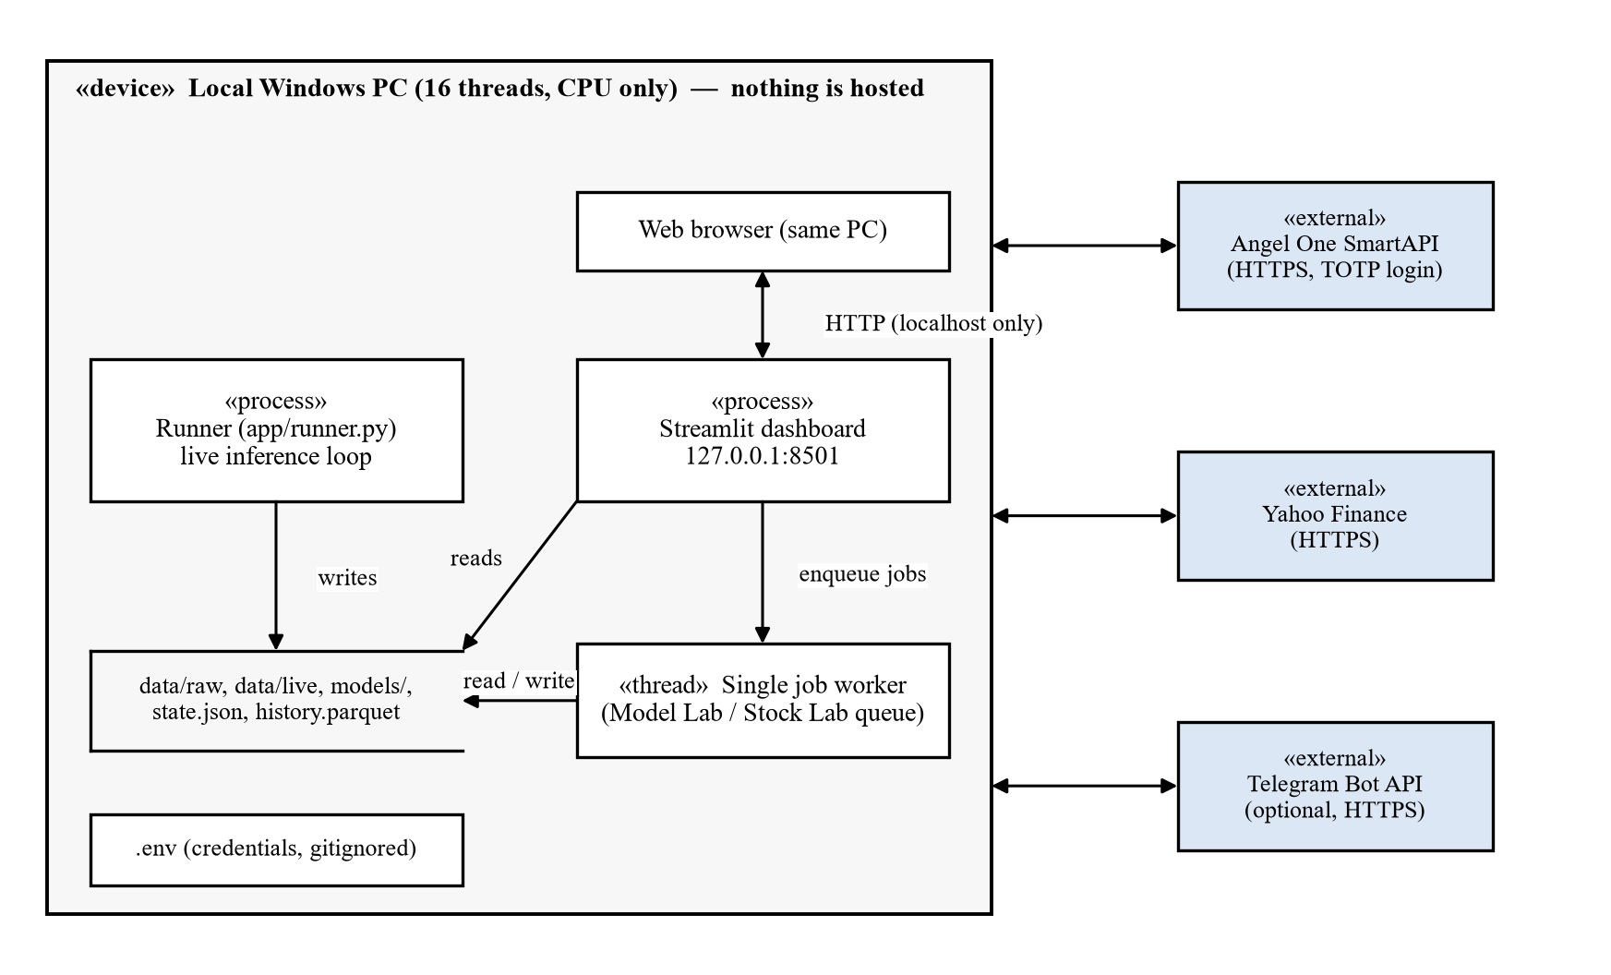
Figure 5.8: Deployment diagram

5.3 Detailed Module Structure
Table 5.2 maps the design onto the code base. The package src/vrdet holds all reusable logic; scripts/ and notebooks/ are thin drivers for research, and app/ is the live application.
Table 5.2: Module structure of the code base
Path | Responsibility
src/vrdet/angel.py | SmartAPI login (TOTP), chunked and retried candle requests, intraday cleaning
src/vrdet/data.py | Loading the local Parquet archive
src/vrdet/quality.py | Session validation against official daily candles, yearly quality report
src/vrdet/features.py | Causal features, time-of-day profiles, lags
src/vrdet/labels.py | HMM, GMM and GARCH labelers; forward filter; minimum duration; event checks
src/vrdet/classifiers.py | Baselines, LightGBM, logistic regression, tuned threshold, walk-forward
src/vrdet/zoo.py, seqnet.py | The 22 models; PyTorch LSTM, GRU, Transformer and temporal CNN
src/vrdet/evaluate.py | Bar-level and episode-level metrics
src/vrdet/live.py, alerts.py | Live data cache, frozen model, alert hysteresis, Telegram client
src/vrdet/stocks.py | Stock Lab pipeline: instrument list, download, level alignment, per-stock HMM, training
scripts/ | fetch_data, train_live_model, train_zoo, train_stock, learning_curve
notebooks/ | 01 data fetch and cleaning, 02 features and labels, 03 classifier, 04 HMM models, 05 model zoo
app/ | runner.py (live loop), dashboard.py with radar, lab and stock pages, run.py (starts both)
models/ | Frozen artefacts: hmm_labeler.json, live_lgbm.txt, live_model.json

CHAPTER 6
IMPLEMENTATION

6.1 Experimental Setup
All work, from data download to the live dashboard, runs on one Windows 11 laptop with a 16-thread CPU and no CUDA GPU. An earlier phase used Google Colab, but moving data through cloud storage was slower than running locally and broker APIs are unreliable from shared cloud IP addresses, so the project moved entirely to the local machine. The sequence networks are small enough to train on the CPU build of PyTorch in one to four minutes each.

6.1.1 Algorithms / techniques used
Labelling. Gaussian HMM (Baum–Welch fitting, Viterbi decoding, forward filtering) with a sticky prior and minimum duration, as described in Section 4.3.4. Two alternative labelers were built for comparison: a Gaussian mixture model (GMM) on volatility features, which ignores time order, and a GARCH(1,1) model with Student-t errors whose conditional volatility is binned at the 30th and 94th percentiles of the training period.
Baselines. (a) A fixed threshold on 2-hour Garman–Klass volatility; (b) the GARCH(1,1)-t threshold; (c) the HMM forward filter (argmax), the key benchmark; (d) LightGBM and logistic regression without the HMM inputs.
Model zoo. Twenty-two classifiers spanning every major family, all wrapped in the same tuned-threshold decision rule (Table 6.1). Models that cannot handle missing values get median imputation fitted on the training window; distance- and gradient-based models get standardised inputs. Sequence models see the last 16 bars (four hours) of inputs.
Table 6.1: The 22 models compared (all with 56 inputs and tuned τ)
Model | Family | Main settings
LightGBM (production) | Gradient boosting | 300 trees, 31 leaves, lr 0.05, min. 200 per leaf, 80% row/column sampling
XGBoost | Gradient boosting | 300 trees, depth 5, lr 0.05, min. child weight 20, histogram method
CatBoost | Gradient boosting | 500 symmetric (oblivious) trees, depth 6, lr 0.08
Hist. gradient boosting | Gradient boosting | scikit-learn, 300 iterations, 31 leaves, min. 200 per leaf
AdaBoost | Boosting | 100 depth-3 trees, lr 0.5
Random Forest | Bagging | 300 trees, min. 50 per leaf, √p features per split, class-balanced
Extra Trees | Bagging | As Random Forest with random split points
Decision tree | Tree | Single tree, depth 6, min. 200 per leaf
Logistic regression | Linear | Multinomial, L2 (C = 1), standardised inputs
LDA | Discriminant | Shared covariance with automatic (Ledoit–Wolf) shrinkage
QDA | Discriminant | One covariance per regime, regularisation 0.2
Naive Bayes | Probabilistic | Gaussian, on normal-score (quantile-transformed) inputs
SVM (RBF) | Kernel | 500-landmark Nyström RBF map + linear SVM (C = 0.1), sigmoid-calibrated
k-NN | Instance-based | k = 100 on standardised inputs
MLP | Neural network | Layers 64–32, L2 1e-3, early stopping
LSTM | Sequence | 16-bar window, 48 hidden units, dropout 0.2, 8 epochs (20.5k params)
GRU | Sequence | As LSTM with a GRU cell (15.4k params)
Transformer | Sequence | 2 encoder layers, 4 heads, d = 48, learned positions (41.6k params)
Temporal CNN | Sequence | Causal dilated convolutions (1, 2, 4), residual (23.8k params)
Ordinal LightGBM | Ordinal | Frank & Hall: P(> Quiet) and P(> Normal) from two LightGBMs
Soft voting | Ensemble | Mean probability of LightGBM, XGBoost, Random Forest
Stacking | Ensemble | Logistic meta-model on LightGBM, XGBoost, logistic, fitted on a held-out year

Techniques for imbalance and calibration. Class weights where the library supports them, and the tuned Chaotic threshold for all models. SVM scores are calibrated to probabilities with Platt scaling [44]; the exact RBF-kernel SVM is quadratic in the number of samples, so a Nyström approximation [45] with 500 landmarks is used. Stacking follows Wolpert [46] with a held-out year for the meta-model, and the ordinal model follows Frank and Hall [47].

6.1.2 Software tools used
Table 6.2: Software tools and libraries
Tool / library | Version | Purpose
Python | 3.13 | Language (uv-managed virtual environment)
pandas, NumPy, PyArrow | 3.1, 2.5, 26.0 | Data frames, numerics, Parquet storage
scikit-learn [48] | 1.9 | Linear, tree, kernel, neighbour and Bayesian models; metrics
LightGBM, XGBoost, CatBoost | 4.7, 3.4, 1.2 | Gradient-boosted trees
PyTorch [49] | 2.15 (CPU) | LSTM, GRU, Transformer, temporal CNN
hmmlearn | 0.3.3 | Gaussian HMM fitting and Viterbi decoding
arch | 8.0 | GARCH(1,1) baseline and labeler
smartapi-python, pyotp | 1.5, 2.10 | Angel One SmartAPI client, TOTP login
yfinance | 1.7 | USD/INR and Brent daily data
Streamlit, Altair | 1.66, 6.3 | Dashboard and interactive charts
Matplotlib | 3.11 | Figures in notebooks and this report
Jupyter, nbconvert | 7.17 | Research notebooks, executed end to end
Git / GitHub | – | Version control (data and credentials excluded)

6.2 Dataset Description

6.2.1 Source of dataset
The primary source is the Angel One SmartAPI historical candle service, which provides NSE index and equity candles at intervals from one minute to one day to any account holder at no cost [50]. The NIFTY 50 (token 99926000) and India VIX (token 99926017) were downloaded at 5-minute, 15-minute and daily resolution. Yahoo Finance, via the yfinance library, provides daily USD/INR and Brent crude closes and an independent NIFTY daily series used as a cross-check. The data are stored locally as Parquet files and are not redistributed.

6.2.2 Size (number of samples) and description of attributes
Table 6.3: Raw datasets in the local archive (as of 29 October 2026)
Series | Interval | Rows | From | Source
NIFTY 50 | 15 min | 72,646 | 01 Jan 2015 | Angel One
NIFTY 50 | 5 min | 217,914 | 01 Jan 2015 | Angel One
NIFTY 50 | 1 day | 4,132 | 04 Jan 2010 | Angel One
India VIX | 15 min | 67,090 | 01 Dec 2015 | Angel One
India VIX | 5 min | 201,244 | 01 Dec 2015 | Angel One
India VIX | 1 day | 4,168 | 04 Jan 2010 | Angel One
NIFTY 50 (check) | 1 day | 4,132 | 04 Jan 2010 | Yahoo Finance
USD/INR | 1 day | 4,380 | 01 Jan 2010 | Yahoo Finance
Brent crude | 1 day | 4,201 | 04 Jan 2010 | Yahoo Finance

Each candle has a timestamp (IST, timezone-aware) and open, high, low and close prices; index candles carry no meaningful volume. After validation the modelling dataset contains 72,634 NIFTY 50 15-minute bars with 56 inputs each, of which 72,051 bars in 2,889 sessions carry a hindsight label. The class distribution is Quiet 49.4%, Normal 43.2% and Chaotic 7.4%, and Chaotic bars form 342 episodes. Table 6.4 shows how unevenly the Chaotic regime is spread over the years: 2020 alone (COVID) holds a third of all Chaotic bars, while 2017 has two short episodes and 2023 has seven.
Table 6.4: Labelled bars and Chaotic regime by year
Year | Bars | Chaotic share | Chaotic episodes | Year | Bars | Chaotic share | Chaotic episodes
2015 | 5,600 | 8.3% | 47 | 2021 | 6,150 | 10.2% | 44
2016 | 6,150 | 4.8% | 24 | 2022 | 6,174 | 11.0% | 49
2017 | 6,111 | 0.2% | 2 | 2023 | 6,125 | 1.2% | 7
2018 | 6,108 | 4.3% | 17 | 2024 | 6,125 | 5.3% | 33
2019 | 6,100 | 3.4% | 19 | 2025 | 6,175 | 3.2% | 17
2020 | 6,207 | 31.0% | 55 | 2026* | 5,026 | 5.0% | 28

* 2026 up to 29 October.

6.2.3 Data quality findings
Validating every session against the official daily candles exposed several vendor defects, each of which would have produced false volatility signals:
• NIFTY 50: 99.6–100% of sessions are valid in every year. Only two sessions fail: the NSE trading halt of 24 February 2021 and the Muhurat (Diwali) session of 21 October 2025. A few sessions miss candles (for example the morning of 10 July 2017); returns across the gap are set to missing.
• India VIX: the vendor archive from December 2015 to September 2016 is corrupt: flat, scaled by 1/100 and then rounded to integers (207 invalid sessions, almost all in this period, Figure 6.1). These sessions are masked, so VIX features exist from 22 September 2016; from 2017 the series is 99–100% valid.
• Closing candle: since 5 August 2026 the vendor’s 15:15 NIFTY candle is usually a single print at the official close, with zero range (49 such candles in 2026). Zero-range candles are treated as missing range information, not as very quiet bars; live sessions therefore score 24 bars.
• Stocks: Angel One adjusts its intraday and daily archives differently for some corporate actions. For RELIANCE, intraday prices before 5 January 2022 were 1.10 times the daily series, which created a fake −9.5% overnight jump. Intraday sessions are rescaled to the official daily level where the two differ by a steady factor, which raised RELIANCE from 60.3% to 99.9% valid sessions (Figure 6.2).
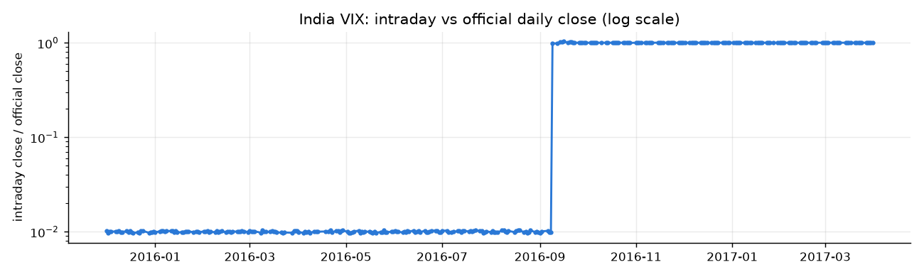
Figure 6.1: India VIX: ratio of the intraday close to the official daily close (log scale); the 2015–16 archive is scaled by 1/100
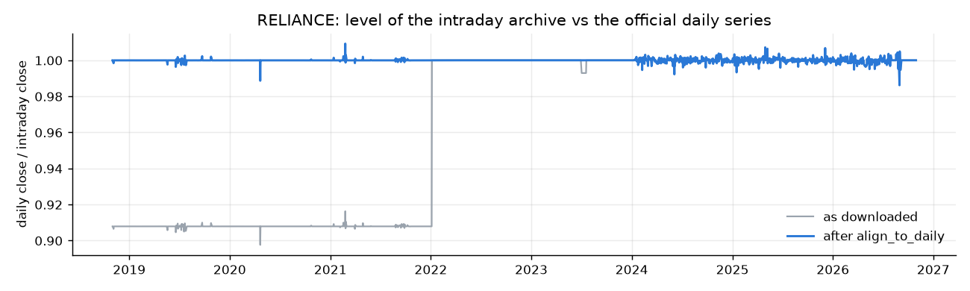
Figure 6.2: RELIANCE: intraday level relative to the official daily series before and after alignment
A fresh download was also compared candle by candle with the stored archive: the two match exactly except for a single NIFTY candle that the vendor had revised, which confirms that the download is reproducible.

6.3 Application Implementation

6.3.1 Live runner
The runner (app/runner.py) is a long-running Python process. Its schedule is the list of bar closes (09:30, 09:45, …, 15:30 IST); 45 seconds after each close it logs in to the SmartAPI if needed, requests candles since the last stored bar for the NIFTY 50 and India VIX, keeps completed bars only, merges them into a local cache, rebuilds the features with vrdet.live.model_frame (the same function used for training), scores the frozen model and writes state.json and history.parquet atomically. It then updates the alert state and, if configured, sends Telegram messages. One cycle takes about 12 seconds, mostly the feature rebuild over the whole archive. A replay mode (python app/run.py --replay 2025-04-07) pushes a past session bar by bar through the same pipeline for demonstrations when the market is closed or calm.

6.3.2 Dashboard: Risk Radar
The Streamlit dashboard (app/dashboard.py) has three pages. The Risk Radar (Figure 6.3) shows the current regime as a large coloured card with a one-line explanation, P(Chaotic), the model’s confidence, the latest NIFTY 50 and India VIX values, the price chart shaded by regime, P(Chaotic) of the model and of the HMM filter with the alarm threshold, and a strip that compares the model and the HMM filter bar by bar with the hindsight labels. The sidebar sets the number of sessions shown and the alarm sensitivity (τ = 0.20, tuned 0.30, or 0.50), which the runner also uses, and summarises the model’s walk-forward scores. Over the three sessions shown, the model matched the hindsight labels on 92% of bars and the HMM filter on 85%.
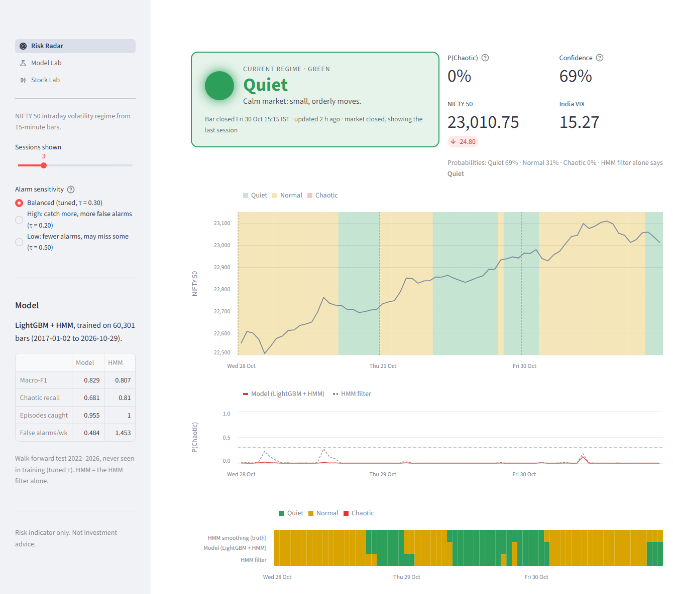
Figure 6.3: Risk Radar page of the dashboard (session of 30 October 2026)

6.3.3 Model Lab
The Model Lab (Figure 6.4, Figure 6.5) lists the walk-forward results of all 22 models and the benchmark, and lets the user score any model on the latest bars with a Play button. Because several models are heavy (the Transformer and AdaBoost take minutes to train and seconds to score), runs are queued and executed one at a time by a single background worker; "Play all" queues every model. Each model’s card shows its current call, its regime-shaded chart and its agreement with the production model and with the hindsight labels, and a strip chart shows all models side by side under the truth row.
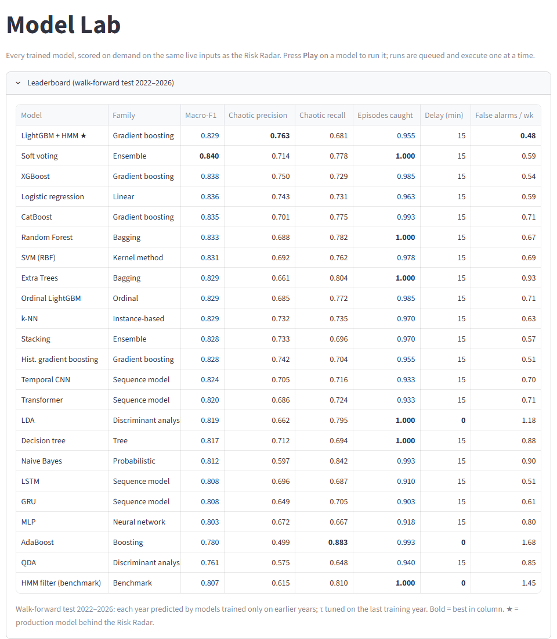
Figure 6.4: Model Lab: leaderboard of the walk-forward test 2022–2026
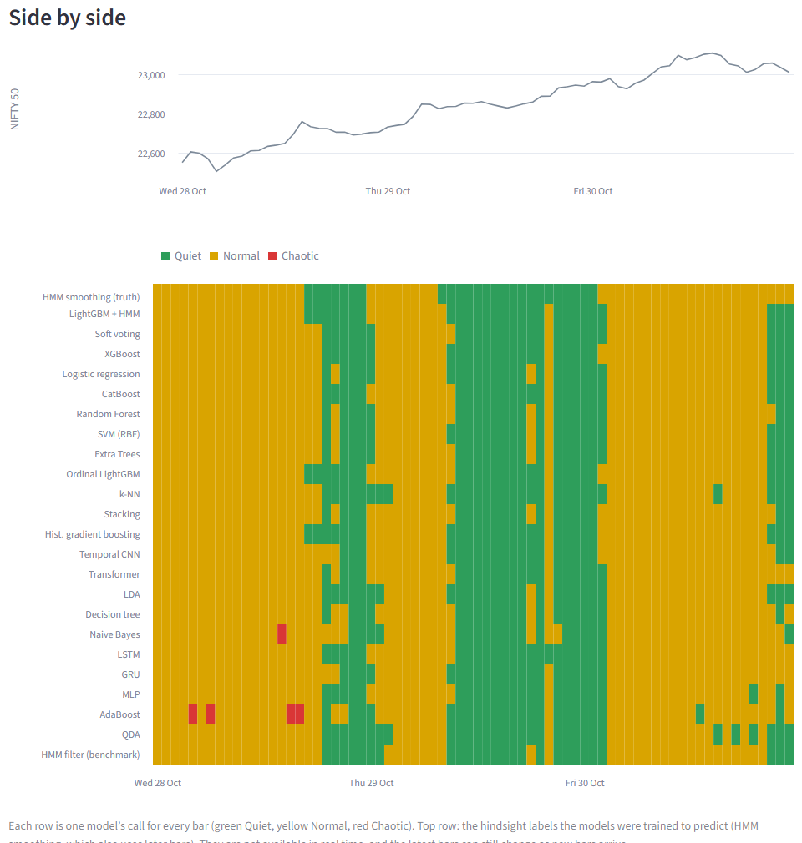
Figure 6.5: Model Lab: every model’s regime call for each bar of the last three sessions, under the hindsight truth row

6.3.4 Stock Lab
The Stock Lab applies the whole pipeline to any of about 2,700 NSE equities in Angel One’s instrument list (Figure 6.6). The user picks a stock, the models, the years of history and the test period, and presses Train & test. The job downloads and caches 15-minute and daily candles, validates and aligns the sessions, fits a per-stock HMM labeler on the training years only, trains the selected models with tuned thresholds, tests them on the most recent months, refits on all data, and shows each model’s current regime (Figure 6.7). Progress is streamed to a console panel. The same pipeline runs from the command line with python scripts/train_stock.py <SYMBOL>.
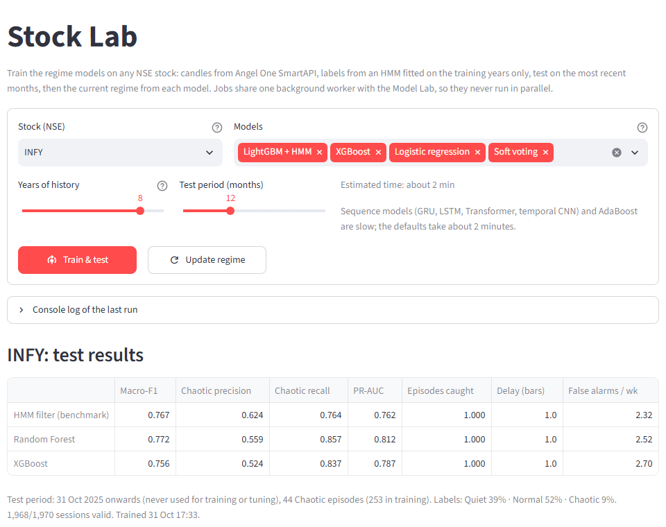
Figure 6.6: Stock Lab: training form and test results for INFY (8 years of history, tested on the last 12 months)
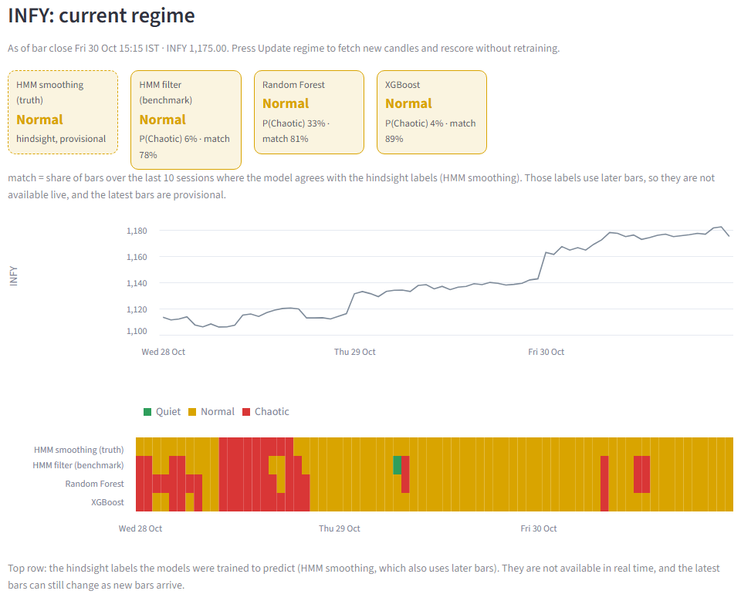
Figure 6.7: Stock Lab: current regime of INFY from each model, with the hindsight truth row

6.3.5 Security and privacy
• Credentials (API key, client code, PIN, TOTP secret, optional Telegram token) are read from a local .env file that is listed in .gitignore; a template .env.example holds only placeholder names.
• Raw and processed data, live caches and large model files are excluded from version control.
• The dashboard binds to 127.0.0.1 and Streamlit usage statistics are disabled, so no page or telemetry leaves the machine.
• Telegram alerts go only to chat ids listed in .env or users who send a private start code.

CHAPTER 7
RESULT ANALYSIS

7.1 Performance Measures
Predictions are compared with the hindsight labels on the out-of-sample years 2022–2026. Let TP, FP and FN be the true positives, false positives and false negatives of a class. The measures are:
Table 7.1: Performance measures
Measure | Definition | Why it matters
Precision (Chaotic) | TP / (TP + FP) for the Chaotic class | Share of Chaotic calls that were right; low precision means alarms are ignored
Recall (Chaotic) | TP / (TP + FN) for the Chaotic class | Share of Chaotic bars caught; missing chaos is the costliest error
F1 score | 2 · precision · recall / (precision + recall) | Balances the two
Macro-F1 (primary) | Unweighted mean of the F1 of Quiet, Normal and Chaotic | Gives the rare Chaotic class equal weight; accuracy would reward always saying Normal
Confusion matrix | Share of each true class predicted as each class | Shows which regimes are confused (Normal vs Chaotic)
PR-AUC (Chaotic) | Area under the precision–recall curve of P(Chaotic) | Threshold-free ranking quality; preferred to ROC-AUC for rare classes [41]
Episode recall | Share of true Chaotic episodes with at least one Chaotic call inside | What a trader experiences: was the episode flagged at all?
Detection delay | Bars from the start of a true episode to the first Chaotic call (median) | How late the warning comes
False alarms / week | Predicted Chaotic runs that touch no true Chaotic bar, per 5 sessions | The cost of the warnings
Cohen’s κ [42] | (p_{o} − p_{e}) / (1 − p_{e}) | Agreement between two labelings beyond chance
Bootstrap 95% CI | 2.5th–97.5th percentiles over 300 weekly-block resamples | Whether differences between models are real

7.2 Result Analysis

7.2.1 Quality of the hindsight labels
Before any classifier can be judged, the target must be credible. Table 7.2 lists the share of each regime on ten well-known shock days. Seven of the ten sessions are labelled entirely Chaotic, and every one has a substantial Chaotic share; the weakest are the Brexit result (60%) and the IL&FS/DHFL crash, whose violent move was concentrated in less than an hour (48%). Figure 7.1, Figure 7.2 and Figure 7.3 show the labels around three of these events.
Table 7.2: Hindsight regime shares on known shock days
Date | Event | Quiet | Normal | Chaotic
24 Aug 2015 | China devaluation crash ("Black Monday") | 0.00 | 0.16 | 0.84
24 Jun 2016 | Brexit referendum result | 0.00 | 0.40 | 0.60
09 Nov 2016 | Demonetisation + US election result | 0.00 | 0.00 | 1.00
21 Sep 2018 | IL&FS / DHFL intraday crash | 0.00 | 0.52 | 0.48
12 Mar 2020 | COVID: WHO pandemic declaration sell-off | 0.00 | 0.00 | 1.00
23 Mar 2020 | COVID: lower circuit, lockdown | 0.00 | 0.00 | 1.00
01 Feb 2021 | Union Budget rally | 0.00 | 0.00 | 1.00
24 Feb 2022 | Russia invades Ukraine | 0.00 | 0.00 | 1.00
04 Jun 2024 | General election results | 0.00 | 0.00 | 1.00
07 Apr 2025 | US tariff shock sell-off | 0.00 | 0.00 | 1.00

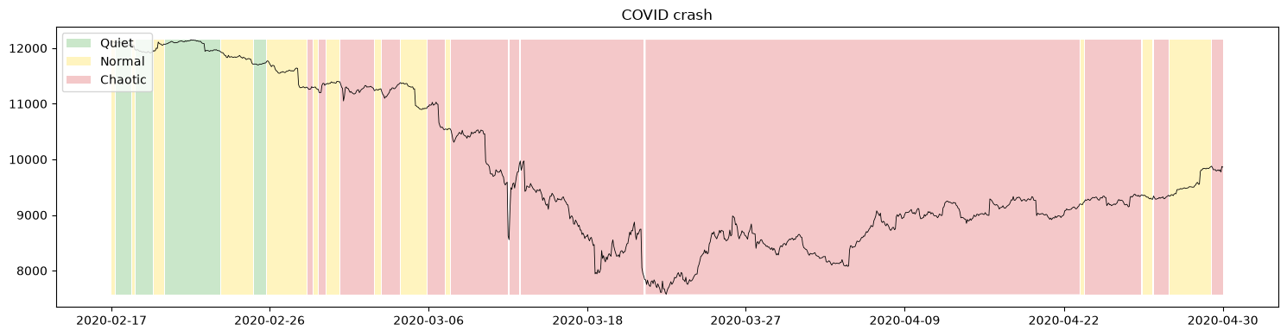
Figure 7.1: Hindsight regimes during the COVID crash, February–April 2020
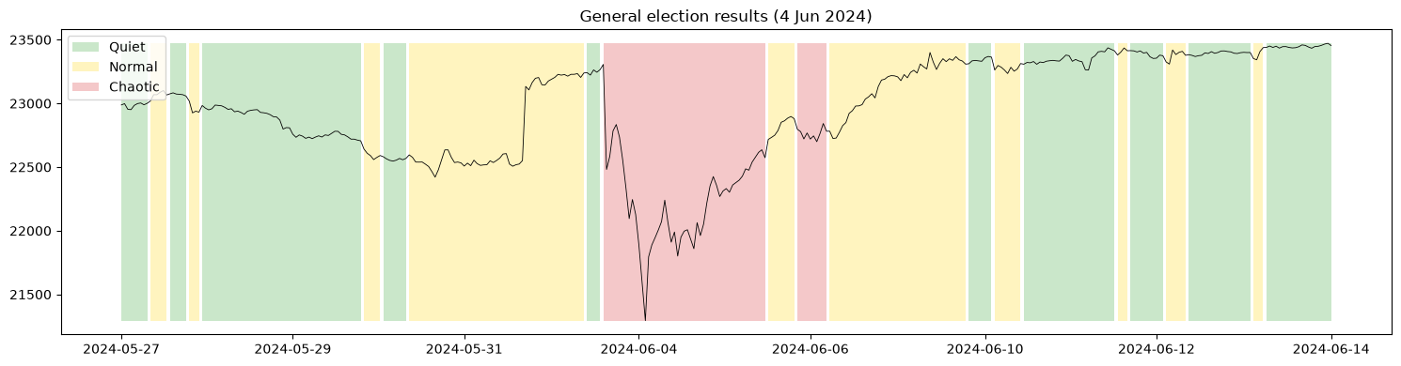
Figure 7.2: Hindsight regimes around the general election results of 4 June 2024
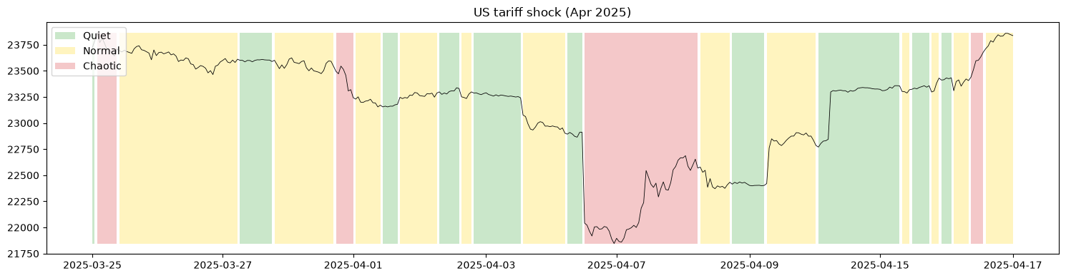
Figure 7.3: Hindsight regimes around the US tariff shock of 7 April 2025
Comparison with alternative labelers. Table 7.3 compares the HMM labels with the GMM and GARCH labelers fitted on the same years. The GMM finds very few Chaotic bars and misses some shock sessions entirely (minimum Chaotic share 0.00), because it ignores time order. The GARCH labeler agrees with its own real-time version 98% of the time: its conditional volatility is a smooth function of past returns, so its "hindsight" labels are nearly identical to real-time ones, which makes it a nearly circular target. It too misses some shock days. The HMM labels are the only ones that flag every shock day while leaving a real gap between hindsight and real time. Pairwise agreement is moderate (κ 0.50 for HMM vs GMM and vs GARCH, 0.30 for GMM vs GARCH), which shows that the choice of labeler matters and must be stated.
Table 7.3: Comparison of labelers (fitted on 2015–2021, applied to 2015–2026)
Labeler | Quiet | Normal | Chaotic | Chaotic episodes | Shock-day Chaotic (mean / min) | Real-time vs hindsight agreement
HMM (chosen) | 49.4% | 43.2% | 7.4% | 342 | 0.89 / 0.48 | 0.850
GMM | 70.1% | 28.0% | 1.9% | 61 | 0.53 / 0.00 | 0.748
GARCH(1,1)-t | 31.7% | 63.4% | 4.9% | 150 | 0.68 / 0.00 | 0.980

Stability of the labels. HMMs fitted on different windows were compared with the production labeler (Table 7.4). Labelers trained on 2017–2021 or 2018–2023 agree almost perfectly with it (κ 0.96–0.97). A labeler trained on 2015–2019 does not (κ 0.64): it has never seen the COVID crash, so its Chaotic state is calibrated to milder turbulence and it labels three times as many recent bars Chaotic. The training window must include at least one severe crisis.
Table 7.4: Label stability across training windows (compared with the production labeler, 2015–2021)
Trained on | Cohen’s κ | Agreement | Chaotic share 2022+
2015–2019 | 0.638 | 78.7% | 14.6%
2015–2021 (production) | 1.000 | 100% | 5.2%
2017–2021 | 0.958 | 97.7% | 4.6%
2018–2023 | 0.973 | 98.6% | 4.8%

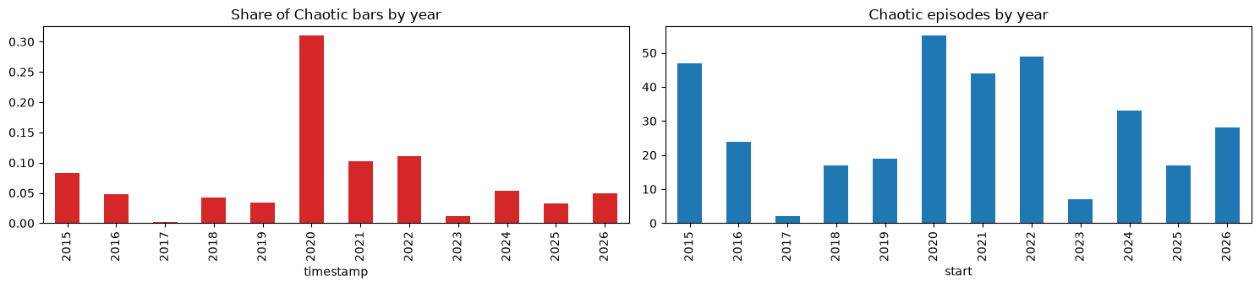
Figure 7.4: Share of Chaotic bars (left) and number of Chaotic episodes (right) by year

7.2.2 Production model against the benchmarks
Table 7.5 compares the production model with the baselines over the walk-forward test 2022–2026. The simple volatility threshold and the GARCH threshold are far behind (macro-F1 0.746 and 0.671) and miss a quarter or more of all Chaotic episodes. The HMM filter is a strong benchmark: it catches every episode with no median delay, because any bar large enough to start an episode moves its filter sharply. Its weakness is false alarms: 1.45 per week, about one every three to four sessions.
Table 7.5: Walk-forward results 2022–2026 (29,625 bars, 134 Chaotic episodes)
Model | Macro-F1 | Chaotic precision | Chaotic recall | Episode recall | Median delay (bars) | False alarms / week
Threshold (GK, 2 h) | 0.746 | 0.643 | 0.547 | 0.761 | 3 | 0.17
GARCH(1,1)-t | 0.671 | 0.430 | 0.546 | 0.709 | 2 | 0.39
HMM filter (benchmark) | 0.807 | 0.615 | 0.810 | 1.000 | 0 | 1.45
Logistic regression | 0.824 | 0.732 | 0.703 | 0.948 | 1 | 0.63
LightGBM (no HMM inputs) | 0.825 | 0.690 | 0.750 | 0.985 | 1 | 0.70
LightGBM + HMM (production) | 0.829 | 0.763 | 0.681 | 0.955 | 1 | 0.48

The production model improves macro-F1 from 0.807 to 0.829 and Chaotic precision from 0.615 to 0.763, and cuts false alarms by two thirds (1.45 → 0.48 per week). The price is a one-bar (15-minute) median delay and about six missed episodes out of 134 (episode recall 95.5%). The HMM inputs help: without them LightGBM reaches 0.825 with 45% more false alarms. Is the gain only a better threshold? Tuning a threshold on the HMM filter’s own P(Chaotic) in the same way raises it only from 0.807 to 0.813 (τ = 0.65) with 1.19 false alarms per week, so most of the improvement comes from the additional inputs, not from the threshold.
By year. The ranking holds in every test year (Table 7.6): the production model has higher macro-F1 than the HMM filter in all five years and fewer false alarms in all five, with episode recall between 0.92 and 1.00. 2024 is the hardest year for it (recall of Chaotic bars 0.55).
Table 7.6: Results by test year: HMM filter vs production model
Year | Macro-F1 HMM | Macro-F1 prod. | Episode recall HMM | Episode recall prod. | False alarms/wk HMM | False alarms/wk prod. | τ
2022 | 0.818 | 0.839 | 1.000 | 0.918 | 1.74 | 0.73 | 0.45
2023 | 0.789 | 0.815 | 1.000 | 1.000 | 0.69 | 0.12 | 0.30
2024 | 0.786 | 0.795 | 1.000 | 0.939 | 1.96 | 0.29 | 0.40
2025 | 0.800 | 0.820 | 1.000 | 1.000 | 1.28 | 0.59 | 0.15
2026 | 0.784 | 0.817 | 1.000 | 1.000 | 1.63 | 0.74 | 0.35

Confusion matrices. Figure 7.5 shows where the errors are. Neither model confuses Quiet with Chaotic (at most 1% of bars), so a Red light never appears in a calm market and vice versa. The errors are between neighbouring regimes. The HMM filter calls 6% of Normal bars Chaotic (its false alarms); the production model calls only 3%, at the cost of labelling 31% of Chaotic bars as Normal.
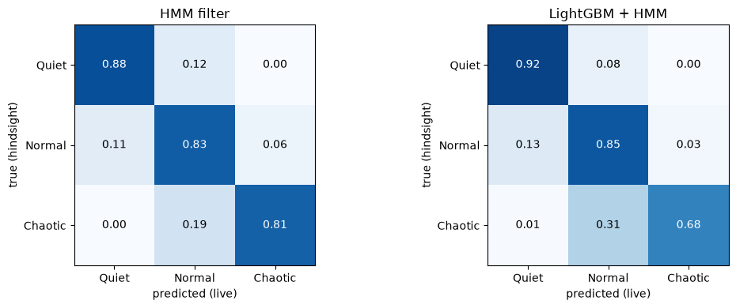
Figure 7.5: Confusion matrices, 2022–2026 (rows: hindsight label; columns: real-time prediction; row-normalised)
Threshold trade-off. Figure 7.6 and Table 7.7 show how the threshold moves the production model along the trade-off between catching chaos and crying wolf. Every setting from τ = 0.1 to 0.5 raises fewer false alarms than the HMM filter, and at τ = 0.1 the model beats the filter on both axes: higher recall (0.85 vs 0.81) with fewer false alarms (1.0 vs 1.45 per week). The dashboard exposes three settings: 0.20 (high sensitivity), the tuned 0.30 and 0.50 (few alarms).
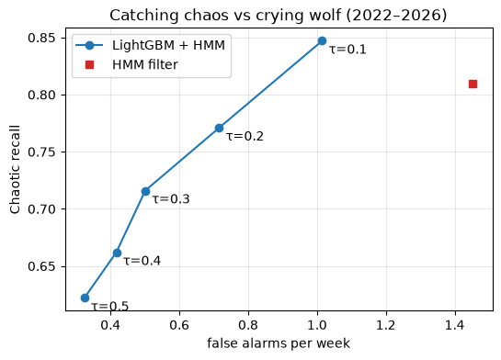
Figure 7.6: Chaotic recall against false alarms per week for thresholds τ = 0.1 to 0.5 (LightGBM + HMM) and the HMM filter
Table 7.7: Effect of a fixed threshold τ on the production model (2022–2026)
τ | Macro-F1 | Chaotic precision | Chaotic recall | Episode recall | False alarms / week
0.10 | 0.822 | 0.616 | 0.847 | 1.000 | 1.02
0.20 | 0.831 | 0.695 | 0.771 | 0.993 | 0.72
0.30 | 0.832 | 0.746 | 0.716 | 0.985 | 0.50
0.40 | 0.829 | 0.786 | 0.662 | 0.948 | 0.42
0.50 | 0.826 | 0.823 | 0.622 | 0.940 | 0.32

7.2.3 Comparison of the 22 models
Table 7.8 reports the walk-forward results of all 22 models with 95% block-bootstrap intervals and the verdict of the paired comparison with the production model. Figure 7.7 shows the same intervals graphically.
Table 7.8: Walk-forward results of all models, 2022–2026, with 95% bootstrap intervals (300 resamples of 252 weekly blocks)
Model | Macro-F1 [95% CI] | Difference vs production [95% CI] | Verdict | Ep. recall | FA / wk
Soft voting | 0.840 [0.823, 0.851] | +0.012 [+0.005, +0.018] | better | 1.000 | 0.59
XGBoost | 0.838 [0.820, 0.850] | +0.009 [+0.004, +0.015] | better | 0.985 | 0.54
Logistic regression | 0.836 [0.822, 0.846] | +0.008 [−0.001, +0.017] | tied | 0.963 | 0.59
CatBoost | 0.835 [0.819, 0.845] | +0.006 [−0.001, +0.014] | tied | 0.993 | 0.71
Random Forest | 0.833 [0.817, 0.845] | +0.005 [−0.002, +0.013] | tied | 1.000 | 0.67
SVM (RBF) | 0.831 [0.816, 0.841] | +0.003 [−0.006, +0.011] | tied | 0.978 | 0.69
Extra Trees | 0.829 [0.814, 0.841] | +0.001 [−0.008, +0.009] | tied | 1.000 | 0.93
Ordinal LightGBM | 0.829 [0.812, 0.842] | +0.001 [−0.006, +0.008] | tied | 0.985 | 0.71
k-NN | 0.829 [0.813, 0.840] | +0.001 [−0.010, +0.010] | tied | 0.970 | 0.63
LightGBM + HMM (production) | 0.829 [0.809, 0.842] | – | – | 0.955 | 0.48
Stacking | 0.828 [0.807, 0.843] | −0.001 [−0.005, +0.004] | tied | 0.970 | 0.57
Hist. gradient boosting | 0.828 [0.809, 0.840] | −0.001 [−0.006, +0.005] | tied | 0.955 | 0.51
Temporal CNN | 0.824 [0.807, 0.836] | −0.004 [−0.012, +0.004] | tied | 0.933 | 0.70
Transformer | 0.820 [0.801, 0.834] | −0.008 [−0.018, +0.001] | tied | 0.933 | 0.71
LDA | 0.819 [0.804, 0.831] | −0.009 [−0.020, +0.000] | tied | 1.000 | 1.18
Decision tree | 0.817 [0.802, 0.829] | −0.011 [−0.023, −0.001] | worse | 1.000 | 0.88
Naive Bayes | 0.812 [0.796, 0.824] | −0.016 [−0.025, −0.007] | worse | 0.993 | 0.90
LSTM | 0.808 [0.790, 0.822] | −0.020 [−0.029, −0.010] | worse | 0.910 | 0.51
GRU | 0.808 [0.787, 0.823] | −0.020 [−0.030, −0.009] | worse | 0.903 | 0.61
HMM filter (benchmark) | 0.807 [0.791, 0.820] | −0.022 [−0.033, −0.011] | worse | 1.000 | 1.45
MLP | 0.803 [0.784, 0.815] | −0.026 [−0.034, −0.018] | worse | 0.918 | 0.80
AdaBoost | 0.780 [0.762, 0.793] | −0.048 [−0.060, −0.038] | worse | 0.993 | 1.68
QDA | 0.761 [0.742, 0.778] | −0.067 [−0.084, −0.051] | worse | 0.940 | 0.85

Ep. recall = episode recall; FA / wk = false alarms per week. Verdict: the 95% interval of the difference lies above zero (better), below zero (worse) or contains zero (tied).
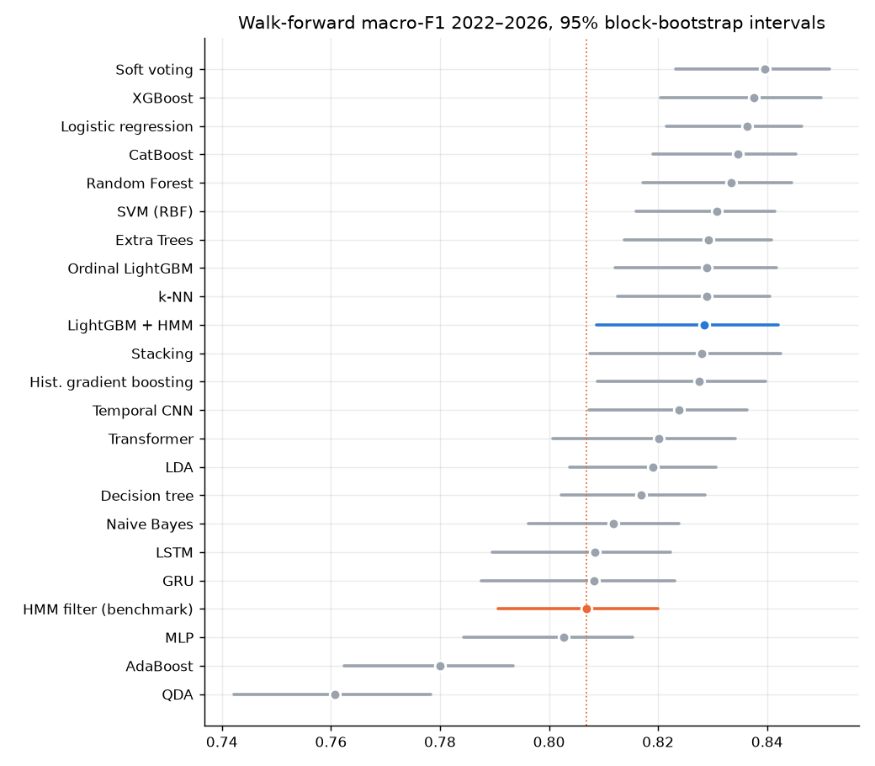
Figure 7.7: Walk-forward macro-F1 2022–2026 with 95% block-bootstrap intervals (production model and benchmark highlighted)
Four conclusions follow:
1. Most well-built models are statistically tied. Twenty of 22 models beat the HMM filter, and the top thirteen lie within 0.012 macro-F1 of each other. Eleven models cannot be distinguished from the production model at the 95% level. Model choice matters much less than the inputs and the labels.
2. Only two models are significantly better, and only slightly. Soft voting (+0.012) and XGBoost (+0.009) beat the production model with intervals that exclude zero. Both have more false alarms (0.59 and 0.54 vs 0.48 per week). LightGBM was kept for production because it has the fewest false alarms of all 22 models and trains in seconds; soft voting is the natural upgrade if a little more recall is wanted.
3. Deep sequence models do not help. The LSTM and GRU are significantly worse than the production model, and the Transformer and temporal CNN are tied with it but rank below the tree ensembles and even logistic regression, while costing four to thirty times more training time.
4. Models whose assumptions do not fit fail. QDA estimates a full covariance matrix for each regime, too many parameters for the rare Chaotic class; AdaBoost reaches the highest Chaotic recall (0.88) but raises 1.68 false alarms per week; naive Bayes suffers from strongly correlated inputs.
Figure 7.10 places every model on the trade-off between catching Chaotic bars and raising false alarms in the holdout period, and Figure 7.8 shows that the ranking shifts from year to year: the production model ranks 6th of 23 in 2022 and 2026 but 11th to 14th in 2023–2025. Rankings based on a single test year would therefore be unreliable, which is why the walk-forward test with bootstrap intervals is the basis for the conclusions above.
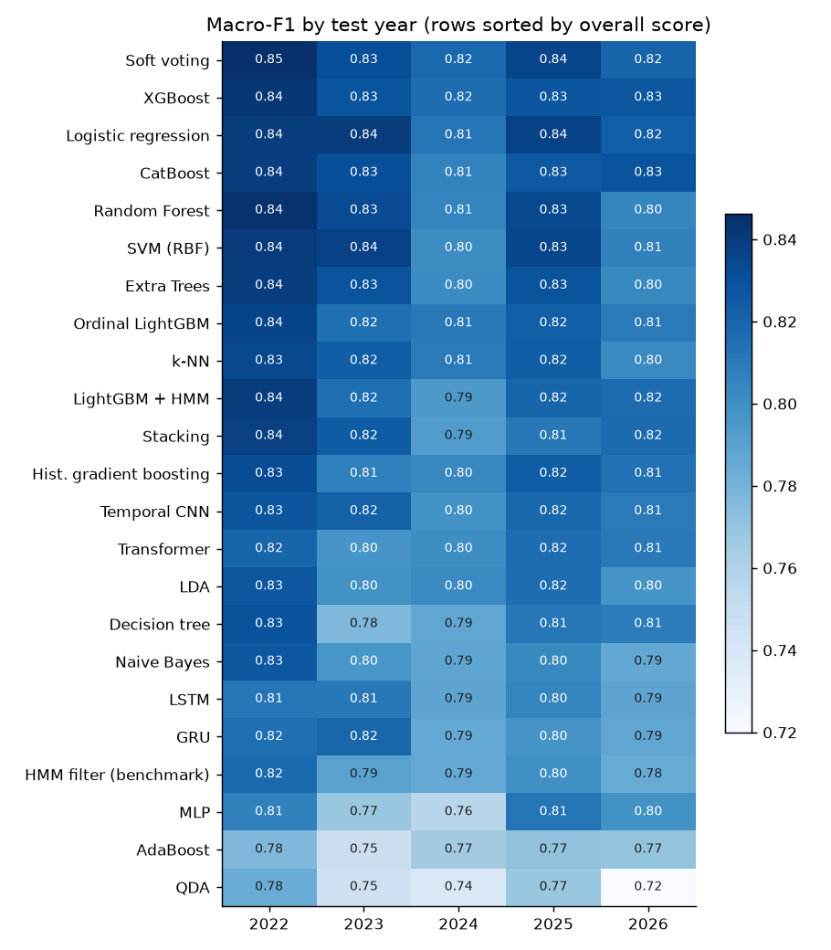
Figure 7.8: Macro-F1 of every model in each test year (rows sorted by overall score)

7.2.4 Single-split holdout 2025–2026
As a second view, every model was trained once on 2017–2024 and tested on January 2025 to October 2026 (Table 7.9, Figure 7.9). Here logistic regression (0.829) and XGBoost (0.827) lead, and LightGBM falls to 0.817 because the threshold tuned on 2024 was low (τ = 0.15), which raised its false alarms to 0.83 per week. Its threshold-free ranking quality is unchanged (PR-AUC 0.810, among the best). The HMM filter has a much lower PR-AUC (0.674) than every tree model, confirming that the additional inputs rank bars better, not just threshold them differently.
Table 7.9: Holdout test 2025–2026 (trained on 2017–2024), selected models
Model | Macro-F1 | PR-AUC (Chaotic) | Episode recall | False alarms / wk | τ | Fit time (s)
Logistic regression | 0.829 | 0.789 | 0.978 | 0.54 | 0.35 | 3
XGBoost | 0.827 | 0.822 | 1.000 | 0.72 | 0.25 | 11
Soft voting | 0.826 | 0.821 | 1.000 | 0.60 | 0.40 | 39
Transformer | 0.822 | 0.765 | 0.978 | 0.62 | 0.40 | 186
CatBoost | 0.822 | 0.811 | 1.000 | 0.61 | 0.30 | 30
Random Forest | 0.819 | 0.815 | 1.000 | 0.72 | 0.60 | 18
LightGBM + HMM | 0.817 | 0.810 | 1.000 | 0.83 | 0.15 | 6
Temporal CNN | 0.809 | 0.787 | 0.978 | 0.79 | 0.20 | 65
LSTM | 0.801 | 0.747 | 0.978 | 0.52 | 0.25 | 28
GRU | 0.793 | 0.718 | 1.000 | 0.79 | 0.15 | 44
HMM filter (benchmark) | 0.793 | 0.674 | 1.000 | 1.43 | – | 0
QDA | 0.749 | 0.577 | 0.956 | 0.94 | 0.35 | 1

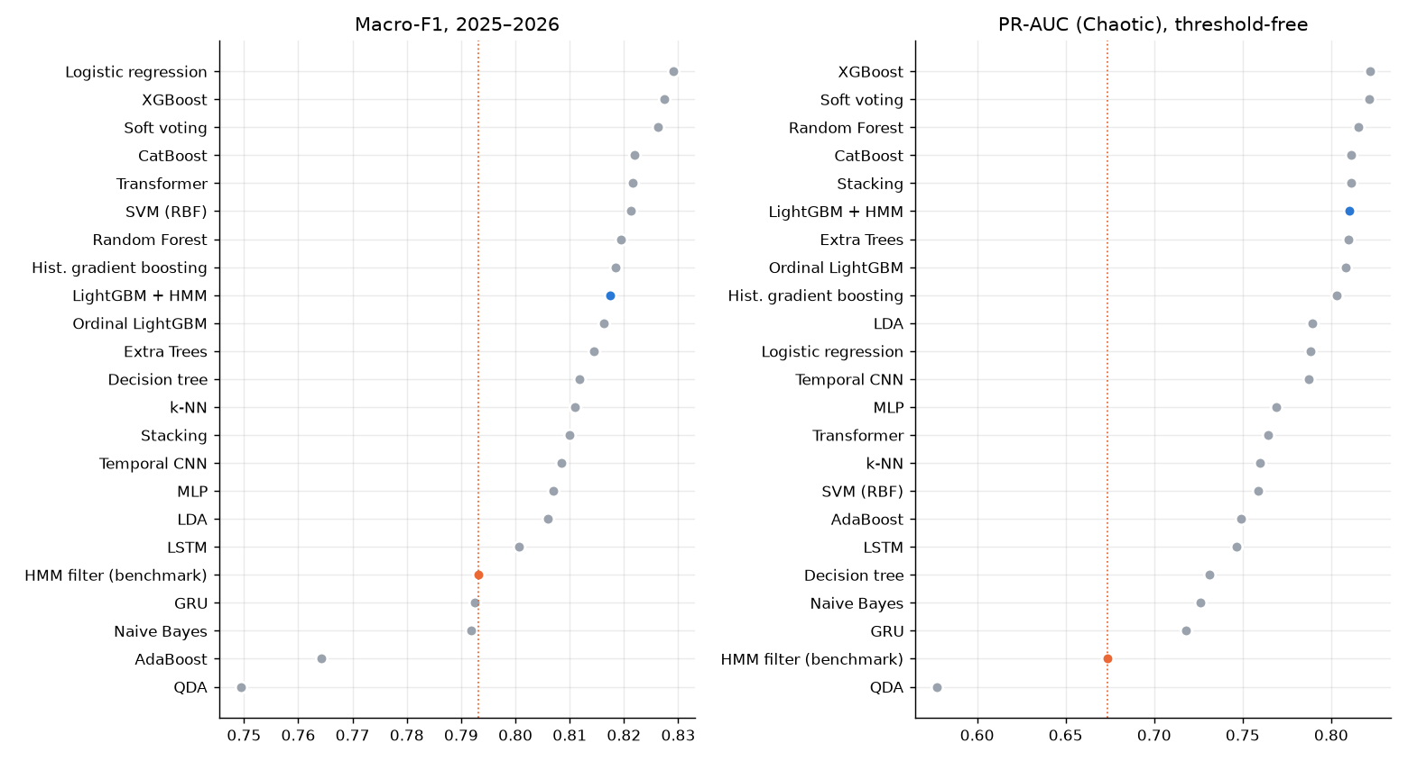
Figure 7.9: Holdout 2025–2026: macro-F1 (left) and PR-AUC of the Chaotic class (right) for every model
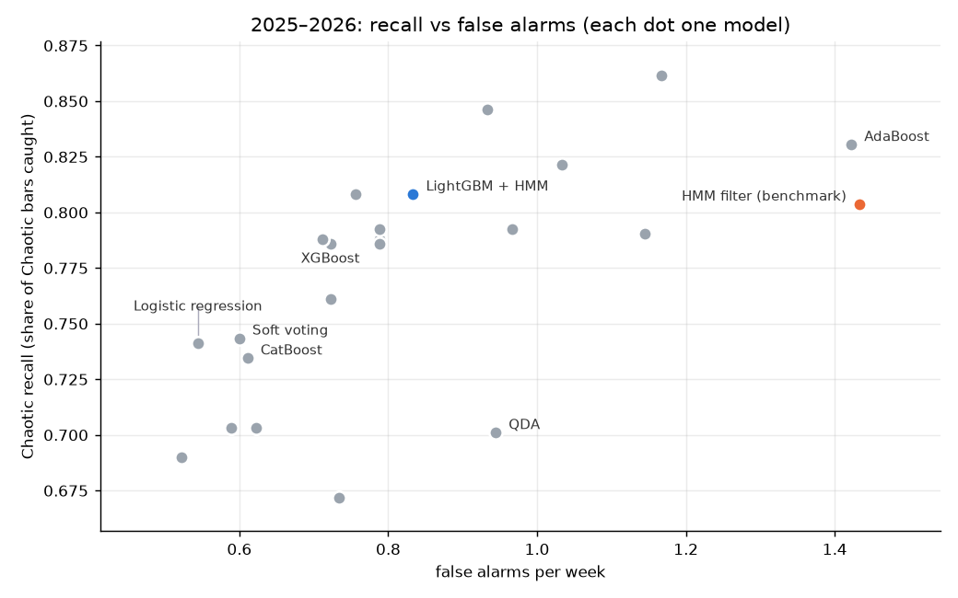
Figure 7.10: Holdout 2025–2026: share of Chaotic bars caught against false alarms per week (each dot one model)
Agreement between models. The models mostly agree with each other: averaged over all pairs, they make the same Chaotic / not-Chaotic call on 98% of bars, and the correlation of their P(Chaotic) series is high among the tree ensembles and logistic regression (Figure 7.11). The weakest models (QDA, AdaBoost, naive Bayes) and the HMM filter form the least correlated group. This is why ensembles of similar models (soft voting, stacking) give only small gains.
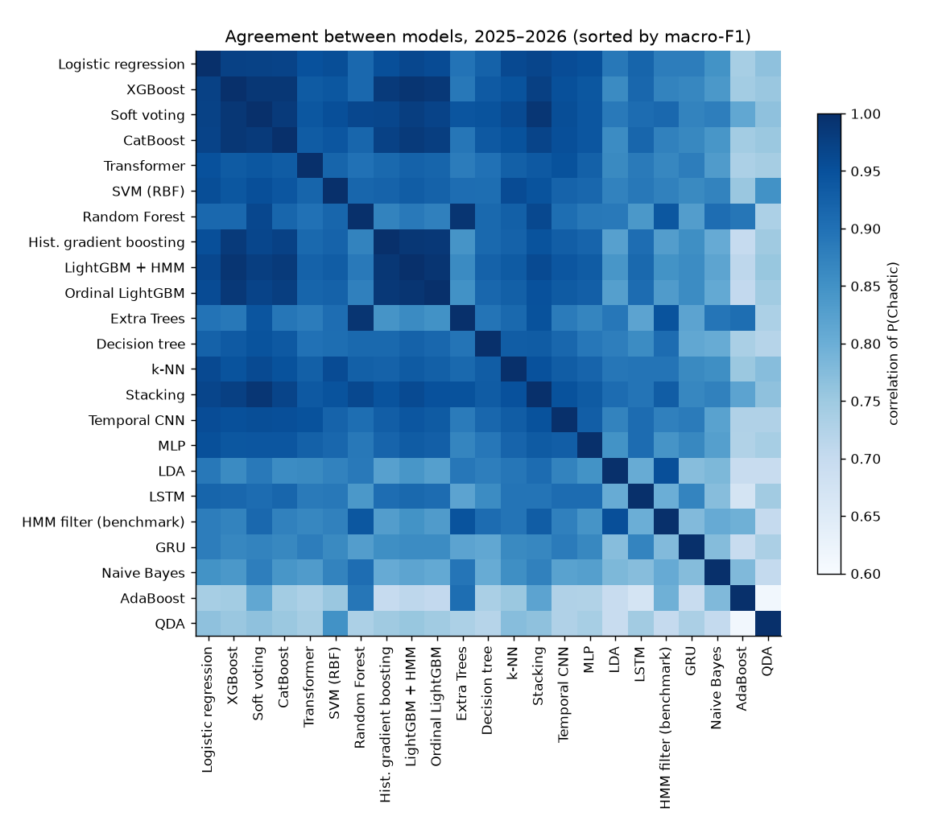
Figure 7.11: Correlation of P(Chaotic) between models, holdout 2025–2026

7.2.5 Do larger models need more data? Learning curves
Deep sequence models underperformed, and a natural question is whether they would win with more data. The learning curves in Figure 7.12 and Table 7.10 keep the test period fixed (2025–2026) and train on the preceding 0.5 to 8 years (three random seeds for the networks). The tree models reach a PR-AUC of about 0.77 with one year of data (33 Chaotic episodes) and change little after that. The GRU (15k parameters) and Transformer (42k) are below them at every size but are still improving at eight years (Transformer PR-AUC 0.59 → 0.76, XGBoost 0.73 → 0.82). Logistic regression, with 171 parameters, matches XGBoost on macro-F1 from four years on.
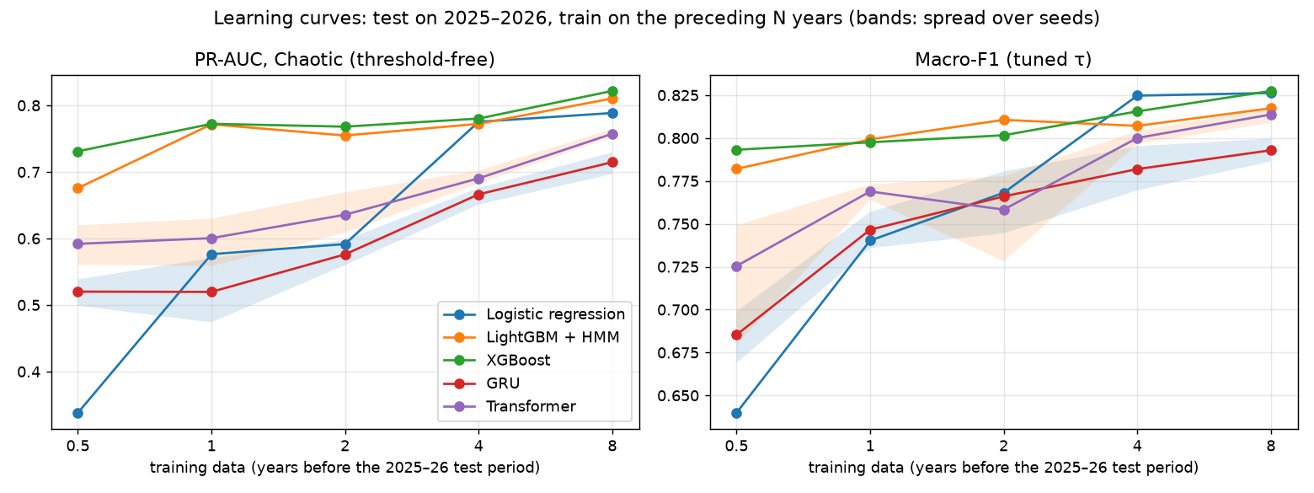
Figure 7.12: Learning curves: PR-AUC (left) and macro-F1 with tuned τ (right) against years of training data, test fixed on 2025–2026
Table 7.10: Learning curves: PR-AUC of the Chaotic class by years of training data
Training years | Chaotic episodes | Logistic | LightGBM + HMM | XGBoost | GRU | Transformer
0.5 | 20 | 0.338 | 0.676 | 0.731 | 0.520 | 0.592
1 | 33 | 0.576 | 0.772 | 0.772 | 0.520 | 0.600
2 | 40 | 0.592 | 0.755 | 0.768 | 0.576 | 0.636
4 | 133 | 0.775 | 0.772 | 0.780 | 0.666 | 0.690
8 | 226 | 0.789 | 0.810 | 0.822 | 0.715 | 0.757

The binding constraint is therefore the number of Chaotic episodes (226 in eight years), not the number of bars (about 49,000). Neighbouring bars within an episode are highly correlated and add little new information. With the history that exists, small models are the right choice; deep sequence models would need many more episodes to catch up, if they can at all. This agrees with the tabular-data findings of [31] and qualifies the more optimistic results on deep models summarised in [13].

7.2.6 Case studies
Figure 7.13 follows several models through the US tariff shock of 7 April 2025. For most models P(Chaotic) jumps to nearly 1 at the first bar of the gap-down open; k-NN rises more gradually and crosses its threshold a bar later. The models differ mainly on 8 April, when the Transformer and k-NN drop sharply for several bars while the labels stay Chaotic, and naive Bayes stays at 1.0 throughout, an overconfident model. All models fall back as the episode ends on 9 April. Figure 7.14 shows the production model, the HMM filter and the hindsight labels around the Russian invasion of Ukraine in February 2022. Both real-time views switch to Chaotic within the first bars of 24 February. In the days before the invasion the HMM filter raises several short Chaotic calls that the labels do not confirm, while the production model raises fewer; after 28 February both call Chaotic on some bars that the labels place in Normal, a reminder that real-time calls are noisier than hindsight.
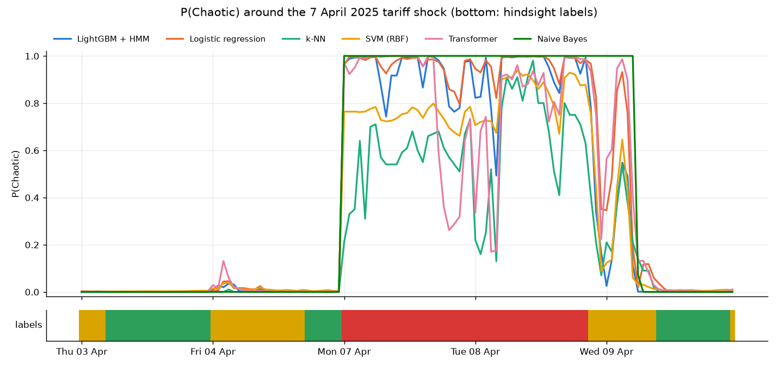
Figure 7.13: P(Chaotic) of selected models around the 7 April 2025 tariff shock, with the hindsight labels below
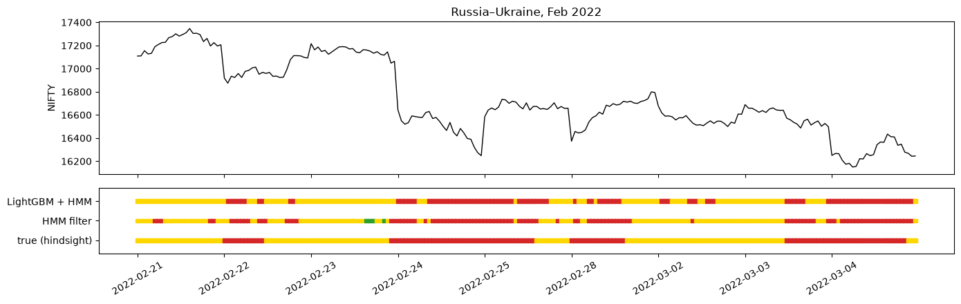
Figure 7.14: Russia–Ukraine, February 2022: NIFTY 50 and the regime calls of the production model, the HMM filter and the hindsight labels

7.2.7 Feature importance
In the production model, the three HMM filter probabilities account for 65% of the total split gain, followed by short-window range-based volatility (Parkinson 8-bar 5.9%, Parkinson 4-bar 3.7%, Garman–Klass 8- and 25-bar about 1.8% each), the India VIX level (1.4%) and the cross-asset inputs (USD/INR and Brent together 3.7%) (Figure 7.15). The model therefore uses the HMM filter as its backbone and corrects it with multi-bar volatility estimates, which are less noisy than the single-bar observations the HMM sees, and with market context. This explains both why it has far fewer false alarms than the filter and why it is about one bar slower to confirm a new episode.
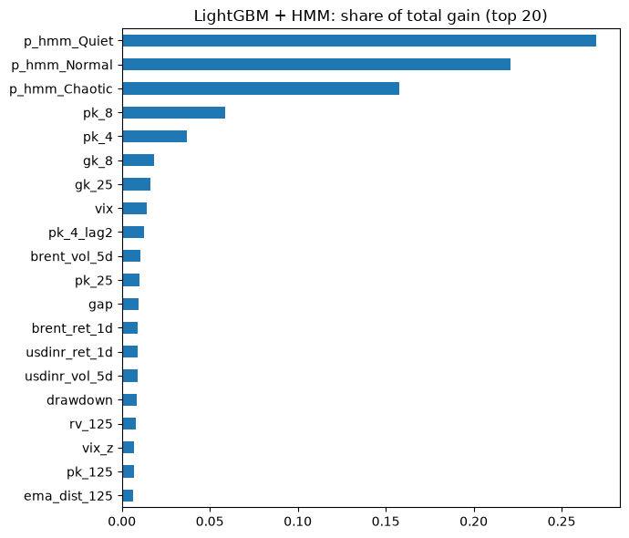
Figure 7.15: LightGBM + HMM: share of total split gain of the 20 most important inputs

7.2.8 Live system and Stock Lab
The live application has been run on market data from Angel One during October 2026. One cycle of the runner, from candle request to published state, takes about 12 seconds, so the dashboard shows the regime of a bar well within a minute of its close. Over the last three sessions shown in Figure 6.3 the production model matched the (provisional) hindsight labels on 92% of bars and the HMM filter on 85%, in line with the walk-forward test.
The Stock Lab shows that the pipeline generalises beyond the index, but also that single stocks are harder. For INFY, with eight years of history and a 12-month test (44 Chaotic episodes), the per-stock HMM filter reaches a macro-F1 of 0.767, Random Forest 0.772 and XGBoost 0.756, all with full episode recall but 2.3–2.7 false alarms per week (Table 7.11). A likely reason is that stock prices react to company news, which the index inputs and the India VIX do not capture, and per-stock histories contain fewer clean episodes; the margin of machine learning over the HMM filter is correspondingly smaller.
Table 7.11: Stock Lab results for INFY (test: 31 Oct 2025 onwards)
Model | Macro-F1 | Chaotic precision | Chaotic recall | PR-AUC | Episode recall | False alarms / wk
HMM filter (benchmark) | 0.767 | 0.624 | 0.764 | 0.762 | 1.000 | 2.32
Random Forest | 0.772 | 0.559 | 0.857 | 0.812 | 1.000 | 2.52
XGBoost | 0.756 | 0.524 | 0.837 | 0.787 | 1.000 | 2.70

7.2.9 Summary of results
• The hindsight HMM labels are credible (all ten shock days flagged), stable when the training window contains a crisis, and leave a real gap between hindsight and real time (85% vs 95% agreement).
• The production model beats the HMM filter benchmark in every test year: macro-F1 0.829 vs 0.807, false alarms 0.48 vs 1.45 per week, 95.5% of episodes caught with a median delay of one bar.
• Across 22 models, differences are small; only soft voting and XGBoost are significantly better than production, by about 0.01. LSTM, GRU, MLP, AdaBoost, QDA, naive Bayes and the decision tree are significantly worse.
• Learning curves show the limit is the number of Chaotic episodes, which favours small models.

CHAPTER 8
CONCLUSION, LIMITATION AND FUTURE SCOPE

8.1 Conclusion
This project built VRDet, a real-time intraday volatility regime classifier for the NIFTY 50, and delivered it as a working local application. The work makes the following contributions:
1. A validated intraday dataset. Eleven years of NIFTY 50 and India VIX candles from the Angel One SmartAPI, validated session by session against official daily candles, with vendor defects found and handled (the 2015–16 India VIX scaling, the single-print closing candle, stock level adjustments).
2. An explicit, credible ground truth. A three-state sticky HMM with Viterbi decoding labels 7.4% of bars Chaotic in 342 episodes and flags all ten major shock days examined. Separating hindsight labels from causal inputs avoids a circular target.
3. A real-time classifier that beats the honest benchmark. LightGBM on 56 causal inputs, including the HMM filter’s probabilities, with a tuned Chaotic threshold, improves macro-F1 from 0.807 to 0.829 and cuts false alarms by two thirds, in a walk-forward test on five unseen years, in every year.
4. A fair comparison of 22 models. With block-bootstrap intervals, most well-built models are statistically tied; deep sequence models are not better, and learning curves show why: the number of Chaotic episodes, not of bars, limits what can be learned.
5. A usable tool. A Streamlit Risk Radar on live data with alerts and hysteresis, a Model Lab that runs every model on demand without overloading the machine, and a Stock Lab that retrains the whole pipeline for any NSE stock, all running locally with credentials kept private.
The main lesson is that, for regime detection, careful definition of the target, causal features and an honest benchmark matter far more than model complexity. A small, well-validated gradient-boosted model is as good as any of the alternatives tried and is fast enough to retrain in seconds.

8.2 Limitation
• The truth is a model. The labels are the output of one HMM with chosen settings; a different labeler (GMM, GARCH) gives different regimes (κ ≈ 0.5). The results measure how well the system recovers this particular definition of regimes. The latest bars’ labels are provisional, because smoothing uses bars that have not happened yet.
• Few episodes. The test period contains 134 Chaotic episodes, and 2023 had only seven, so yearly scores are noisy and differences of less than about 0.01 macro-F1 cannot be resolved.
• Boundary effects. Labels near the end of each training window are decoded with knowledge of the following bars, which belong to the test year. No gap (embargo) is left between training and test windows; the effect is limited to a few bars per year but is not zero.
• Detection, not prediction. The system recognises a Chaotic regime once it has started, with a median delay of one bar; it cannot warn before the first violent bar of an episode, and it misses some very short episodes.
• Data dependence. The live system depends on a single broker API; outages, late candles or changes in the vendor’s data (such as the closing candle change in August 2026) affect it directly. Index candles carry no volume, so order-flow information is unavailable.
• Stocks are harder. Per-stock models have more false alarms and a smaller margin over the HMM filter, as company news is not among the inputs.
• Local only. By design nothing is hosted, so the dashboard serves one user on one machine.

8.3 Future Scope
• Early warning. Add a separate model for the probability that the next bars will be Chaotic, using event calendars (RBI policy, budget, election and US data days) and overnight global markets.
• Richer inputs. NIFTY futures volume and open interest, option-implied skew, market breadth across the 50 constituents, and news or social-media sentiment, which [29] found to relate to next-day volatility.
• Purged validation and calibration. Leave an embargo gap between training and test windows [21], calibrate probabilities, and report reliability diagrams.
• Ablations. Quantify the contribution of each input group (HMM inputs, India VIX, macro series) by removing it and re-running the walk-forward test with bootstrap intervals.
• Pooled training for stocks. Train one model across many stocks, with stock-level normalisation, to multiply the number of Chaotic episodes available, which the learning curves identify as the main constraint; this is also the setting in which sequence models might become competitive.
• Ensemble in production. Switch the live model to soft voting, which was significantly better in the walk-forward test, if a slightly higher false-alarm rate is acceptable.
• Deployment options. A secured multi-user deployment with authentication, mobile push notifications and automated tests, if the tool is to be shared beyond a single machine.

REFERENCES
[1] Mandelbrot, B. (1963) The variation of certain speculative prices. Journal of Business, Vol. 36, No. 4, 394–419.
[2] Cont, R. (2001) Empirical properties of asset returns: stylized facts and statistical issues. Quantitative Finance, Vol. 1, No. 2, 223–236.
[3] Parkinson, M. (1980) The extreme value method for estimating the variance of the rate of return. Journal of Business, Vol. 53, No. 1, 61–65.
[4] Garman, M.B. and M.J. Klass (1980) On the estimation of security price volatilities from historical data. Journal of Business, Vol. 53, No. 1, 67–78.
[5] Engle, R.F. (1982) Autoregressive conditional heteroscedasticity with estimates of the variance of United Kingdom inflation. Econometrica, Vol. 50, No. 4, 987–1007.
[6] Bollerslev, T. (1986) Generalized autoregressive conditional heteroskedasticity. Journal of Econometrics, Vol. 31, No. 3, 307–327.
[7] Whaley, R.E. (2000) The investor fear gauge. Journal of Portfolio Management, Vol. 26, No. 3, 12–17.
[8] Hamilton, J.D. (1989) A new approach to the economic analysis of nonstationary time series and the business cycle. Econometrica, Vol. 57, No. 2, 357–384.
[9] Ang, A. and A. Timmermann (2012) Regime changes and financial markets. Annual Review of Financial Economics, Vol. 4, 313–337.
[10] Andersen, T.G. and T. Bollerslev (1997) Intraday periodicity and volatility persistence in financial markets. Journal of Empirical Finance, Vol. 4, No. 2–3, 115–158.
[11] Securities and Exchange Board of India (2023) Analysis of profit and loss of individual traders dealing in equity cash segment (intraday). SEBI Research Study, July 2023.
[12] Securities and Exchange Board of India (2024) Analysis of profit and loss of individual traders dealing in equity F&O segment, FY22–FY24. SEBI Research Study, September 2024.
[13] Gunnarsson, E.S., H.R. Isern, A. Kaloudis, M. Risstad, B. Vigdel and S. Westgaard (2024) Prediction of realized volatility and implied volatility indices using AI and machine learning: a review. International Review of Financial Analysis, Vol. 93, 103221.
[14] Rogers, L.C.G. and S.E. Satchell (1991) Estimating variance from high, low and closing prices. Annals of Applied Probability, Vol. 1, No. 4, 504–512.
[15] Rabiner, L.R. (1989) A tutorial on hidden Markov models and selected applications in speech recognition. Proceedings of the IEEE, Vol. 77, No. 2, 257–286.
[16] Baum, L.E., T. Petrie, G. Soules and N. Weiss (1970) A maximization technique occurring in the statistical analysis of probabilistic functions of Markov chains. Annals of Mathematical Statistics, Vol. 41, No. 1, 164–171.
[17] Viterbi, A.J. (1967) Error bounds for convolutional codes and an asymptotically optimum decoding algorithm. IEEE Transactions on Information Theory, Vol. 13, No. 2, 260–269.
[18] Fox, E.B., E.B. Sudderth, M.I. Jordan and A.S. Willsky (2011) A sticky HDP-HMM with application to speaker diarization. Annals of Applied Statistics, Vol. 5, No. 2A, 1020–1056.
[19] Ke, G., Q. Meng, T. Finley, T. Wang, W. Chen, W. Ma, Q. Ye and T.-Y. Liu (2017) LightGBM: a highly efficient gradient boosting decision tree. Advances in Neural Information Processing Systems, Vol. 30, 3146–3154.
[20] Friedman, J.H. (2001) Greedy function approximation: a gradient boosting machine. Annals of Statistics, Vol. 29, No. 5, 1189–1232.
[21] López de Prado, M. (2018) Advances in Financial Machine Learning. John Wiley & Sons, Hoboken, NJ.
[22] Künsch, H.R. (1989) The jackknife and the bootstrap for general stationary observations. Annals of Statistics, Vol. 17, No. 3, 1217–1241.
[23] Andersen, T.G. and T. Bollerslev (1998) Answering the skeptics: yes, standard volatility models do provide accurate forecasts. International Economic Review, Vol. 39, No. 4, 885–905.
[24] Corsi, F. (2009) A simple approximate long-memory model of realized volatility. Journal of Financial Econometrics, Vol. 7, No. 2, 174–196.
[25] Hamilton, J.D. and R. Susmel (1994) Autoregressive conditional heteroskedasticity and changes in regime. Journal of Econometrics, Vol. 64, No. 1–2, 307–333.
[26] Kritzman, M., S. Page and D. Turkington (2012) Regime shifts: implications for dynamic strategies. Financial Analysts Journal, Vol. 68, No. 3, 22–39.
[27] Kumar, S., A. Rao and M. Dhochak (2025) Hybrid ML models for volatility prediction in financial risk management. International Review of Economics and Finance, Vol. 98, 103915.
[28] Araya, H.T., J. Aduda and T. Berhane (2024) A hybrid GARCH and deep learning method for volatility prediction. Journal of Applied Mathematics, Vol. 2024, Article ID 6305525.
[29] Deveikyte, J., H. Geman, C. Piccari and A. Provetti (2022) A sentiment analysis approach to the prediction of market volatility. Frontiers in Artificial Intelligence, Vol. 5, 836809.
[30] Gu, S., B. Kelly and D. Xiu (2020) Empirical asset pricing via machine learning. Review of Financial Studies, Vol. 33, No. 5, 2223–2273.
[31] Grinsztajn, L., E. Oyallon and G. Varoquaux (2022) Why do tree-based models still outperform deep learning on typical tabular data? Advances in Neural Information Processing Systems, Vol. 35, Datasets and Benchmarks Track.
[32] Breiman, L. (2001) Random forests. Machine Learning, Vol. 45, No. 1, 5–32.
[33] Geurts, P., D. Ernst and L. Wehenkel (2006) Extremely randomized trees. Machine Learning, Vol. 63, No. 1, 3–42.
[34] Freund, Y. and R.E. Schapire (1997) A decision-theoretic generalization of on-line learning and an application to boosting. Journal of Computer and System Sciences, Vol. 55, No. 1, 119–139.
[35] Chen, T. and C. Guestrin (2016) XGBoost: a scalable tree boosting system. Proceedings of the 22nd ACM SIGKDD International Conference on Knowledge Discovery and Data Mining, 785–794.
[36] Prokhorenkova, L., G. Gusev, A. Vorobev, A.V. Dorogush and A. Gulin (2018) CatBoost: unbiased boosting with categorical features. Advances in Neural Information Processing Systems, Vol. 31.
[37] Hochreiter, S. and J. Schmidhuber (1997) Long short-term memory. Neural Computation, Vol. 9, No. 8, 1735–1780.
[38] Cho, K., B. van Merriënboer, C. Gulcehre, D. Bahdanau, F. Bougares, H. Schwenk and Y. Bengio (2014) Learning phrase representations using RNN encoder–decoder for statistical machine translation. Proceedings of EMNLP 2014, 1724–1734.
[39] Vaswani, A., N. Shazeer, N. Parmar, J. Uszkoreit, L. Jones, A.N. Gomez, Ł. Kaiser and I. Polosukhin (2017) Attention is all you need. Advances in Neural Information Processing Systems, Vol. 30, 5998–6008.
[40] Bai, S., J.Z. Kolter and V. Koltun (2018) An empirical evaluation of generic convolutional and recurrent networks for sequence modeling. arXiv preprint arXiv:1803.01271.
[41] Saito, T. and M. Rehmsmeier (2015) The precision-recall plot is more informative than the ROC plot when evaluating binary classifiers on imbalanced datasets. PLoS ONE, Vol. 10, No. 3, e0118432.
[42] Cohen, J. (1960) A coefficient of agreement for nominal scales. Educational and Psychological Measurement, Vol. 20, No. 1, 37–46.
[43] Schwarz, G. (1978) Estimating the dimension of a model. Annals of Statistics, Vol. 6, No. 2, 461–464.
[44] Platt, J. (1999) Probabilistic outputs for support vector machines and comparisons to regularized likelihood methods. Advances in Large Margin Classifiers, MIT Press, 61–74.
[45] Williams, C.K.I. and M. Seeger (2001) Using the Nyström method to speed up kernel machines. Advances in Neural Information Processing Systems, Vol. 13, 682–688.
[46] Wolpert, D.H. (1992) Stacked generalization. Neural Networks, Vol. 5, No. 2, 241–259.
[47] Frank, E. and M. Hall (2001) A simple approach to ordinal classification. Proceedings of ECML 2001, Lecture Notes in Computer Science, Vol. 2167, 145–156.
[48] Pedregosa, F. et al. (2011) Scikit-learn: machine learning in Python. Journal of Machine Learning Research, Vol. 12, 2825–2830.
[49] Paszke, A. et al. (2019) PyTorch: an imperative style, high-performance deep learning library. Advances in Neural Information Processing Systems, Vol. 32.
[50] Angel One Ltd. (2026) SmartAPI documentation: historical candle data and market data APIs. https://smartapi.angelbroking.com/docs.

LIST OF PUBLICATIONS
Nil. No paper based on this work has been published or communicated so far.

CONTRIBUTION OF PROJECT
Contribution to society. Retail participation in Indian markets has grown quickly, and regulatory studies show that most individual intraday and derivatives traders lose money [11, 12]. VRDet gives a retail trader a free, private and easily understood risk signal: a traffic light that turns red when the market becomes chaotic, with an alert, so that position sizes can be reduced or trades avoided at the most dangerous times. It does not recommend trades.
Technical contribution. The project contributes (i) a validated, documented pipeline for 15-minute NIFTY 50 and India VIX data from a free broker API, including the detection of vendor data defects; (ii) an explicit hindsight definition of intraday volatility regimes and a real-time benchmark derived from the same model; (iii) a reproducible comparison of 22 classifiers with block-bootstrap intervals and learning curves; and (iv) an open, local application with a Risk Radar, a Model Lab and a Stock Lab.

