Below is the screenshot of the first bullet point to list the country three times

Below are the results from the unit tests

* Run test_cities.py again. It should fail. Take a screenshot of the result and paste into your Word documentA screenshot of a computer program

  AI-generated content may be incorrect.
* Now modify your city_country function in city_functions.py so that the population parameter is optional.

* Modify your city_country function in city_functions.py so it requires a fourth parameter, language. It should now return a single string of the form City, Country - population xxx, Language, such as **Santiago, Chile - population 5000000, Spanish**.

* Now modify your city_country function in city_functions.py so that the language argument is optional.

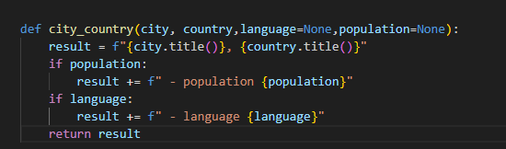

* Run city_functions.py. Call the function at least three times using a City, Country for one, City, Country, Population for the next and City, Country, Population, Language for the last. Excecute city_functions.py and take a screenshot of the result. Paste that screenshot into your Word document.

