Design Document

Introduction
This simulation models the evacuation of a small town in response to an emergency such as a bushfire.
This simulation system is a continuation of work produced for previous projects. The application is built using the BDI-Matsim integration project.
Instructions for building and running the software can be found in the README files within the respective repositories and the accompanying user guide.
The agents are coded in Jack from code generated by the Prometheus Design Tool (PDT).

Overview
The Bushfire Application is an extension to earlier work integrating the Jack BDI agent system with the BDI-MATSim integration system. The BushfireApplication class extends the generic JackModel class. This provides the interface between the BDI and ABM components of the application.
Refer to the following for more information on the BDI-MATSim and ABM-Jack projects.
Introducing Reactive BDI agents into MATSim.pdf
Adding BDI Agents to MATSim Traffic Simulator.pdf
Integrating BDI Agents into a MATSim Simulation.pdf
The following diagram illustrates the functional components of the system.

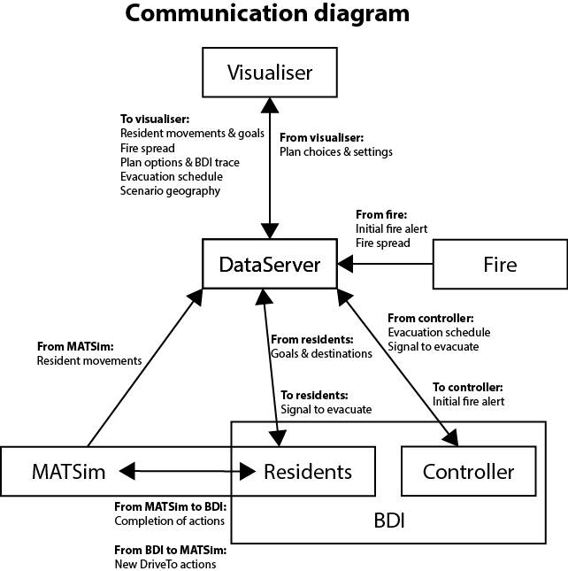

Data Server
The central piece of architecture is the data server. This provides a subscription based data service. Each component registers itself as a subscriber to certain types of data. When a component publishes that data, it is sent to all subscribers. This allows for a modular system architecture. If a component needs access to a certain type of data passed anywhere in the system, it can subscribe to it – the source of the data need not be specifically aware of the subscribing components.
Additionally, components can register as passive sources of data, in which case, the data server periodically polls them with the updated simulation time to request updated data to publish. As an alternative to this, for data that is not updated frequently, components can register their next update time with the data server, which will wait until that time before polling for new data. The fire module has been implemented this way.

Fire Model
This is simply a wrapper around the fire data file. It is polled by the data server for time stamped fire information. The Fire Model publishes new records from the fire data. The evacuation controller and the visualiser both subscribe to these data. The location of the fire is not currently part of the knowledge base of any of the agents.
At present the fire model is a simple text file that describes the spread of the fire over time. This is represented as a series of timestamps, each followed by a set of coordinates describing a polygon bounding the newest fire position. For example:

0.8314372920000002 ← timestamp
-37.146771964284426,142.47112449967398 -37.14677976247829,142.47318015719745 -37.14840122410896,142.47317029278324 -37.148393425753646,142.47111459087196 -37.146771964284426,142.47112449967398 ← polygon
0.8314415760000001
-37.18214865305859,142.39892448337125 -37.18215768078752,142.40098110172897 -37.18377910434753,142.40096967290296 -37.18377007643171,142.39891301011625 -37.18214865305859,142.39892448337125

Evacuation Controller
This model implements the evacuation controller agent. It waits for the fire data to be published and initiates planning the evacuation. Once it determines an evacuation schedule, this is executed via messages sent to resident agents via the data server. The controller publishes the plan information and the final schedule to the data server which is picked up by the visualiser for display and interrogation.

Residents
The residents are represented by two inter-connected agent types: BDI residents and MATSim agents. The BDI resident agents do all of the reasoning related to resident behaviour and determine when and where to evacuate based on information supplied by the evacuation controller. Once a resident determines where it wants to go, control is handed to MATSim to calculate the path to the target location.
MATSim is used to control the movement of residents. The evacuation route is defined by the controller agent as a series of control points. MATSim then moves each resident from their initial location, through each relevent control point to their designated relief centre. The control of resident agent behaviour happens outside the data server at a lower level of the architecture. MATSim also publishes the agent locations to the data server which is picked up by the visualiser for display.

Visualiser
The optional visualiser displays the scene and shows the location of residents. Messages between the data server and the visualiser are encoded as JSON strings. This provides a generic way to encode objects as strings. Refer to http://json.org/ for an explanation of the format.

BushfireApplication & JACKModel
BushfireApplication, which extends the generic JACKModel class, is the manager of the BDI component. It handles passing messages to and from individual agents, and holds the evacuation schedule for timely evacuation signals. In this guide, the names 'BushfireApplication' and 'JACKModel' are both used, depending on whether the logic in question is specific to the bushfire application, or present at the generic level.

Step-by-step execution flow

Program initialisation

- Main method initiates parsing of command-line options and configuration files, and setup of scenario geography and options
- Main method initialises the DataServer and sets the system time step duration (one minute)
- Main method initialises the MATSim and BDI managers, and ABM server
- Visualiser: If configured to do so, the main method initialises the visualiser, which listens for a connection before execution proceeds further
- Fire module: Main method passes in a fire data file, which is then parsed
- Main method calls run() on MATSim manager, which starts MATSim itself running
- BushfireApplication: MATSim model calls start() on BushfireApplication, passing a reference to itself, to which the BDI side will pass control at the end of each loop.
- BushfireApplication creates the EvacController agent
- EvacControllerAgent publishes its complete goal-plan tree, which is sent to the visualiser to give context to plan choices as they arise
- BushfireApplication publishes geography data (regions, locations, routes), which is sent to the visualiser for display
- BushfireApplication: MATSim model passes the agent list to BushfireApplication, which creates the BDI halves of the MATSim agents

The main loop now begins. However, no agents will make any actions until the fire module publishes the fire alert, a short time into the loop.

Late initialisation
Certain information is unavailable to the bushfire application until after the main loop is initiated. This information is set during the first iteration of the loop.
Resident starting location: BushfireApplication subscribes to MATSim agent movement data. Upon receiving this for the first time, it is used to set each resident agent's initial location.
Resident home region: Each agent's starting location is used to determine which region that agent belongs to.

Main loop

- MATSimModel publishes new agent movements to the data server, to be sent to the visualiser.
- JACKModel: ABM server calls takeControl() on JACKModel, passing the agent data container (ADC). This holds a record of any current or actionable actions and percepts for each agent.
- JACKModel disseminates new global percepts from the ADC to every agent
- LOOP: BushfireApplication: JACKModel calls handlePercept() for each agent's new percepts.
  - For ARRIVED percepts, a new Arrived event is posted to that agent.
  - For the Fire Alert percept, if the agent's home region matches the region now being evacuated, the agent is passed in a list of waypoints from the region to the designated relief centre, and a new EvacHouse event is posted to that agent.
  - BasicResident agents initiate plans in response to percepts.
  - BasicResidents call packageAction() on JACKModel (through the ActionManager interface) when new actions are initiated by BDI plans.
  - BushfireApplication translates abstract DriveTo destinations into specific link IDs (e.g. 'school' → link #1234).
  - BushfireApplication publishes the BDI plan & action to the data server, for display in the visualiser.
  - JACKModel inserts the new action into the agent data container.
- JACKModel waits until all BDI agents are idle (i.e. finished processing percepts and initiating new plans and actions) before returning control to the MATSim model.
- MatsimAgentManager: MatsimAgentManager inserts new ARRIVED percepts for each agent into the agent data container, and marks completed actions as PASSED.
- MATSimModel returns the updated agent data container to the MATSim planner, which has MATSim plan new routes based on new DriveTo actions.

Initiation and planning of evacuation

- Fire module publishes a fire alert after a short time delay, a few steps into the simulation.
- BushfireApplication:
  - If the program is configured to use the EvacController agent, a RespondToFire event is posted to that agent.
  - If the EvacController is bypassed, BushfireApplication simply forwards the fire alert directly to all resident agents (as a percept). They begin evacuating immediately, to randomly chosen relief centres.
- EvacController handles the RespondToFire event with the EvacuationResponse plan. For details on this agent's goal-plan tree, see detail under the Agents section below.
- EvacController uses a PlanChoice meta-level reasoning plan to handle any goals for which a plan choice can be made (either by user input, by configuration file, or automatically). This plan creates a PlanDecoder to handle choosing a plan and forward the options onto the user interface. See 'Jack Plan Interface' below for details.
- EvacController builds up an evacuation schedule for each region, based on the plans used to handle the AssignReliefCentres, EstablishRoutes, and EstablishSchedule subgoals. As each of these subgoals is completed, the schedule (partial or complete) is published for display in the visualiser.
- EvacController: once the schedule is complete, in the ExecuteEvacPlan, the controller publishes an evac broadcast.
- BushfireApplication: Once the evacuation broadcast is received, BushfireApplication passes a fire alert percept to resident agents when their home regions are scheduled to evacuate.
- BasicResidents post an EvacHouse event on receiving the fire alert. See detail under the Agents section below for more information on this agent's goal-plan tree.

Agents

Residents
Residents are created by the BDI-MATSim component and instantiated as agents in the bushfire simulation. These agents respond to the evacuation message sent by the controller agent and then rely on the MATSim simulation to generate a specific route to leave their residence and evacuate the area. The evacuation message will instruct residents to evacuate according to regions. Residents decide for themselves if they should evacuate.
The following diagram shows the plan-goal tree for residents. When instructed to evacuate, they will enact one of the plans: PickupKids, PickupRels or ImmediateEvacuate. The decision is based on whether the resident has children or relatives to collect prior to evacuation.

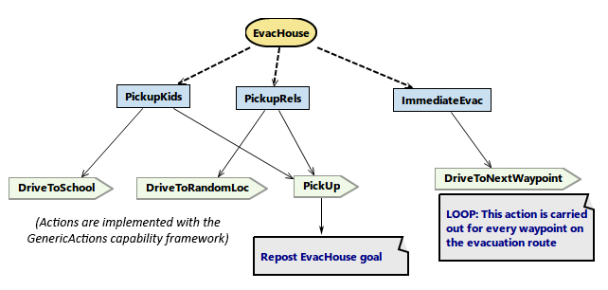
Residents are randomly allocated children or another relative in the town and this determines whether they evacuate immediately, or first detour to collect their children from school or their relative from a random location in the town.
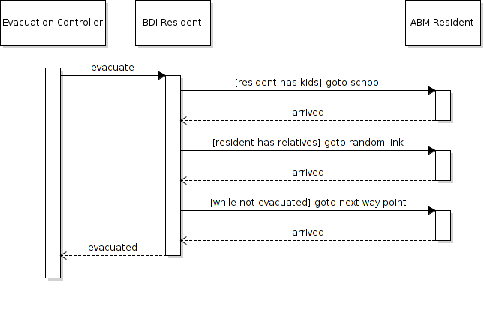

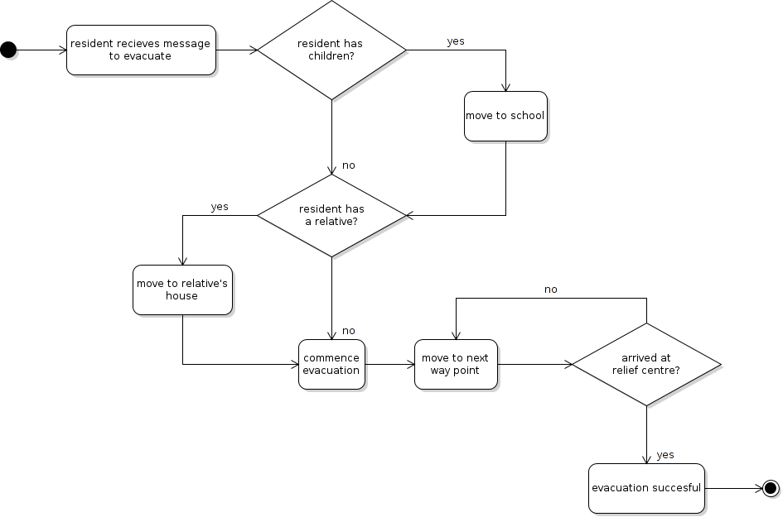

Evacuation Controller
The evacuation controller performs two function. First it determines an evacuation schedule for the town based on its characteristics and the location of the fire. Then it enacts and monitors the execution of the evacuation. The evacuation is initiated by broadcasting a message to all residents that those in certain regions should evacuate.
The following diagram shows the plan-goal tree for the controller.
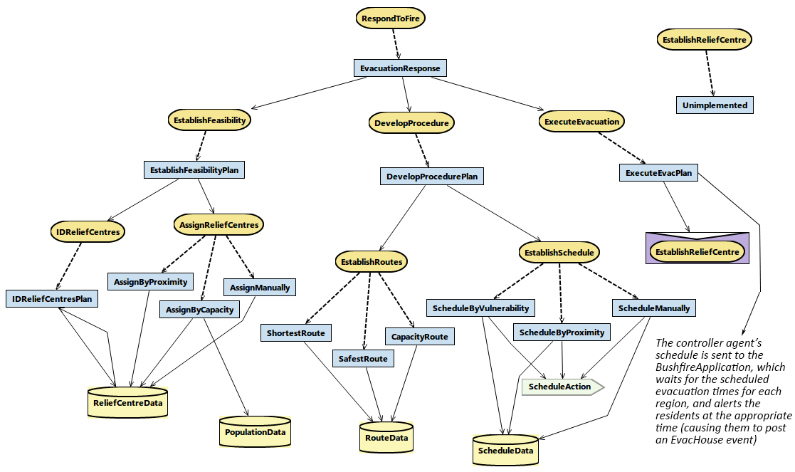
The controller has three initial goals: establish the feasibility of an evacuation, develop the evacuation schedule and execute the evacuation.
In order to establish the feasibility of an evacuation, the controller first identifies if there are any relief centres available and, if so, selects one based on either their proximity or capacity. Assuming a relief centre is selected, the controller then determines a route to the relief centre and determines an evacuation schedule for each region in the town. Once an evacuation schedule has been developed, the controller sends the evacuation message to the residents.
NOTE: In the current implementation, the controller does not monitor the evacuation or adjust the schedule. Once the evacuation schedule is determined it is executed.
The evacuation controller relies on information in the geography file that defines where relief centres are located and their capacity. The scenario file also defines how many “regions” the town is divided into and the routes from each region to each relief centre.
Refer to the User Guide for information on how to define the geography.
Some of the plan choices available to the controller can be manually selected by the user. Refer to the section on “Intervention” under “User Interface” below.

User Interface
The optional user interface performs two functions: It allows the user to observe the evacuation; and it allows the user to intervene in or interrogate the decision making of the controller agent.
Visualisation
The visualiser shows an image of the area being evacuated with evacuees displayed as colour coded cars. The relief centres, schools and control points are marked.
The user is able to control the speed of the visualisation and pause it.
They can click on the evacuees to get information on what the evacuee is doing.
Intervention
A number of decision points are available for the user to intervene in the controller agent's decision. Selection of the intervention points is done via the controller agent config file. Refer to the user guide for an explanation of how to configure scenarios.

Jack Plan Interface
The program allows the user to manually choose which plan to use to satisfy certain goals, overriding Jack's default plan selection. This is facilitated by some data within the Jack plans and supporting Java code. The system is general and can be adapted to other Jack applications, with some setup for the particular goals and plans of interest.

Setup
For the plan choice to be intercepted by the program for any given goal, the agent must use a plan that handles the PlanChoice event, for meta-level reasoning. This plan must be declared to choose for the event in question, with a "#chooses for event <EventName>" directive.
For example, the Jack code for the plan ChooseEstablishSchedule includes the following directives.
#handles event PlanChoice ev;
#chooses for event EstablishSchedule;
#uses interface EvacController self;

Refer to the Jack documentation for more information about meta-plans.
http://www.aosgrp.com/documentation/jack/Agent_Manual_WEB/index.html#Meta-level%20Reasoning
http://www.aosgrp.com/documentation/jack/Agent_Manual_WEB/index.html#Plan%20Declarations

Secondly, the selectable plans include some additional data - a name and a description, to be displayed to the user when selecting a plan. These plans override the getInstanceInfo() method to return an object of class ExtendedPlanInstanceInfo, which extends PlanInstanceInfo to include this additional data.
Some plans may allow the user to manually select additional options - for example, the bushfire program includes plans to allow manual selection of relief centres and scheduling for each region. These plans also include these options (as a Settings object) within the ExtendedPlanInstanceInfo object.

Plan Selection Overview
The chooser plan creates a PlanDecoder object, to which it passes the intercepted event and an array of strings that describe the current BDI goal-plan execution trace. The PlanDecoder is then asked to choose a plan to handle the event.
The PlanDecoder extracts the list of applicable plans from the event and calls getInstanceInfo() to get their detailed information. If the program is configured to intercept the event in question, then the information for each plan (and any available manual settings options attached to them) is published to the DataServer, to be picked up by the visualiser or other UI module and then displayed to the user. In the bushfire program, the selectable plan information is converted to JSON data to be sent to the Unity-based visualiser.
The agent's complete goal-plan tree may be specified elsewhere in the program, to be displayed in the user interface, giving context to the current choice. In the bushfire program, the visualiser matches each line in the current event's BDI trace against elements of the complete goal-plan tree, highlighting any matching lines and allowing the user to follow the controller agent's reasoning.
The response from the user, selecting a plan and possibly including any chosen manual settings, is set on a static variable within the PlanDecoder class. If the program is configured for user input and a visualiser/UI is connected, the PlanDecoder thread sleeps until this response variable is set, then matches the response to one of the applicable plan signatures. If the program is configured for no user input or a visualiser/UI is not connected, the PlanDecoder either selects the plan set in the program's configuration XML if this is available, or uses the default Jack plan selection otherwise.
The PlanDecoder object then returns the selected plan signature to the meta-level reasoning plan, which sets the chosen plan in the event. That plan is then executed, using any manual settings chosen, if applicable.
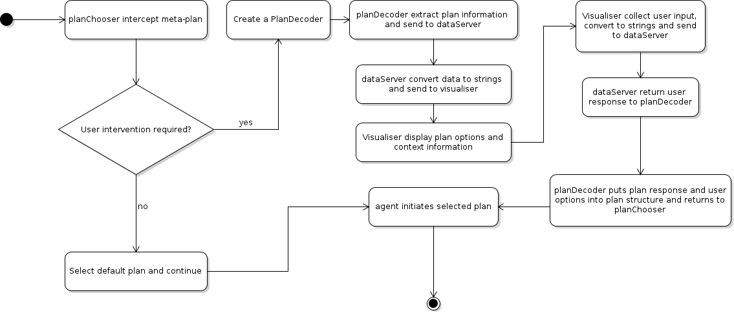

See MatsimImterface Project Report.pdf.
At present, all residents in the appropriate regions will obey the evacuation message, but this behaviour could be altered in the future to include residents ignoring the message, or residents from the wrong regions choosing to evacuate.

