Bushfire Evacuation Simulation

Developer Guide

Source Code
The source code and tools are stored in a bitbucket repository. Dhirendra Singh is the administrator.
https://bitbucket.org/dhixsingh/bdi-abm-integration
The visualiser code is in:
https://bitbucket.org/Kidney/fire-sim-unity
There are some older tools and supporting documents in this repository:
https://bitbucket.org/dhixsingh/bdi-abm-integration-support

External Dependencies
Some integrations (bdi-matsim and abm-jack) rely on additional libraries or jar files. The README files for those integration projects explain how to acquire those libraries and where to put them.

Compiling with Ant
An Ant script file (build.xml) has been created to manage building the software and distributions.
To build the application from the repository, change directory to the examples/bushfire directory and type: “ant build”.
This will attempt to build the application and all integration dependencies. refer to comments in the build file for additional compilation options.

Maps
Maps and GIS will cause grief. They always do.
Geoscience Australia are the experts. They have lots of information on map projections.
http://www.ga.gov.au/home

This is a useful web site that can do coordinate transforms between lat-lon and UTM.
http://home.hiwaay.net/~taylorc/toolbox/geography/geoutm.html

Misc info

GIT
GIT is an open source software revision control system. All of the code for this and related projects is held in GIT repositories. GIT for linux and windows can be downloaded and installed from http://git-scm.com/.
Under windows it is easiest to use “Git Gui”. To clone a repository, run GitGui and select the “clone” menu option.

Eclipse Java IDE
Java development is best done using eclipse. However, the Prometheus Design Tool (PDT) used to develop Jack agent based software does not work with versions of eclipse later than Kepler. Therefore it is essential that you download that version.
The eclipse home page is here: https://eclipse.org/. Instructions for installing eclipse on linux and windows can be found there.
The Kepler version can be found here: https://eclipse.org/kepler/

JOSM Open Street Map Viewer
JOSM is a viewer/ editor for OSM files. It can be downloaded from https://josm.openstreetmap.de/.
This software is useful for confirming that an OSM file contains the required roads. It could also potentially be useful for adding, deleting or editing roads and road attributes.
to run the file from the command line use:
java -jar josm.jar
Information on JOSM and links to other OSM editors can be found here. http://wiki.openstreetmap.org/wiki/JOSM

MATSim Network Editor
Once an OSM file has been converted to a MATSim network file it can be useful to view the network to ensure it is complete. A MATSim network editor is available as an extension to MATSim. Instructions for using the editor are found here.
http://matsim.org/docs/extensions/networkEditor
To download the editor, download MATSim from the sourceforge repository http://sourceforge.net/projects/matsim/files/.
Open the MATSim extensions by selecting the “MATSim” folder. See the following diagram.
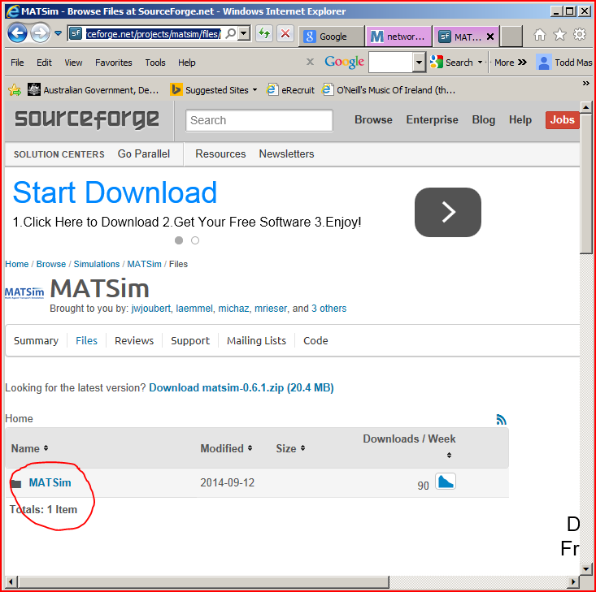
Then open the latest version of MATSim (or search for an older version if required).
Then open the “extensions” folder. See below.
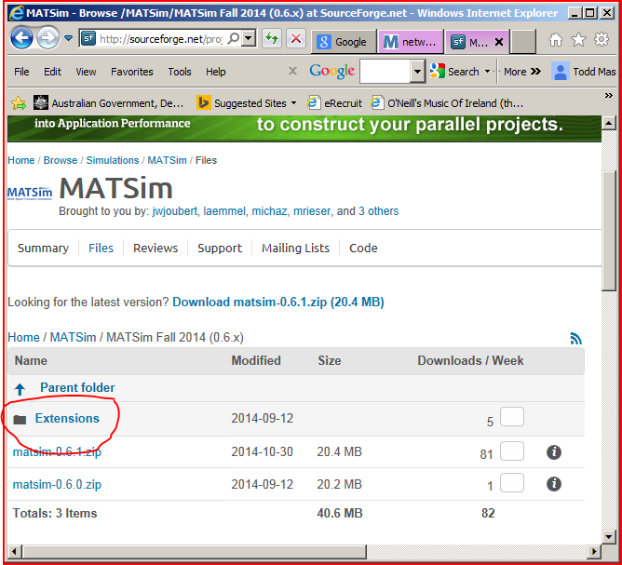
And download the network editor.
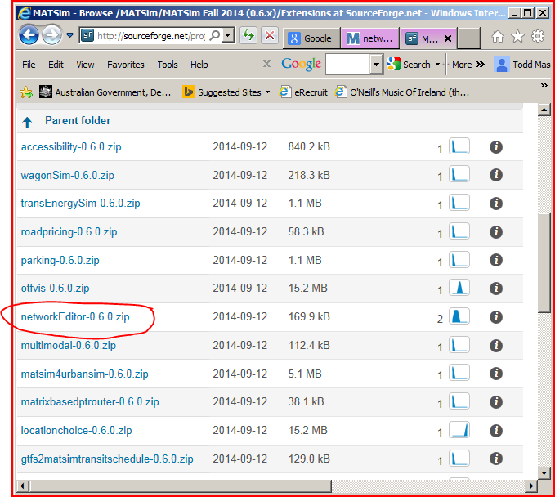

QGIS
It can be helpful to have a basic Geographic Information System to confirm that the address shape files are correct. QGIS is a free open source cross platform GIS. Information on downloading and installing it can be found here.
http://www.qgis.org/en/docs/index.html

Unity
The unity development environment is needed to modify the source code for the visualiser. Se the following url for details on getting and using the UNity environment.
http://unity3d.com/unity/download

Issues
The Bushfire Application still relies on a taxi-parameter.txt file from an earlier stage of this project.
Road link lengths, should be in m, but existing conversion produces very small lengths. See:
http://www.matsim.org/docs/tutorials/8lessons/input/creating/network
http://www.matsim.org/files/dtd/network_v1.dtd

Other Documentation
https://sites.google.com/site/rmitagents/emergency-management
A useful paper on matsim architecture: http://matsim.org/uploads/121/matsim_architecture_and_simulation_times_4a4b4cfa4f.pdf

