Bushfire Evacuation Simulation

User Guide

Introduction
This simulation models the evacuation of a small town in response to an emergency such as a bushfire. It is able to be run with or without a graphical user interface (GUI).
The simulation consists of a number of elements:
An evacuation controller that develops and executes the evacuation plan.
A resident simulation that models the behaviour of residents when they are instructed to evacuate
A traffic simulation that controls the movement of residents around the road network.
A model of a fire threat that initiates the evacuation.

Distribution
The software is distributed as a single zip file. When this is unpacked, it creates a root folder that contains a run script file and two subfolders. The “bin” subfolder contains the executable code (jar files) and the “scenario” subfolder contains the scenarios.
Directory/ file | Contents
./bin | Contains the Java jar and class files needed to run the simulation and tools.
./dep | Empty directory to contain external dependencies.
./scenarios | Contains the scenarios for the bushfire simulation.
./doc | Contains documentation.
./gui | Contains the graphical user interface.
README | Basic description of the distribution.
run.sh | Script to run the simulation on Linux.
run.bat | Script to run the simulation on Windows.

At present, two scenarios are supplied: Barwon Heads and Halls Gap. Refer to the section on “Scenarios” for details about the scenarios. Refer to the section “Configuring Scenarios” for details on the contents of scenario files.

Running the Simulation

Linux
The script file “run.sh” will run the default scenario with default conditions.
After unpacking the zip file, it may be necessary to change the permission of the script file to make it executable. Use the command “chmod +x run.sh”.
To run the simulation directly from the command line, use the following command:
java -cp <class_path> bushfire.BushfireMain -c <scenario_file>
For example:
java -cp bin/bushfire.jar:bin/abmjack.jar:bin/bdiabm.jar:bin/bdimatsim.jar:dep/gson-2.3.1.jar:dep/jack.jar:dep/MATSim_r28802.jar bushfire.BushfireMain -c scenarios/halls_gap/halls_gap.xml

Windows
The batch file “run.bat” will run the default scenario with default conditions.
To run the simulation directly from the command line, use the following command:
java -cp <class_path> bushfire.BushfireMain -c <scenario_file>
For example:
java -cp bin/bushfire.jar;bin/abmjack.jar;bin/bdiabm.jar;bin/bdimatsim.jar;dep/gson-2.3.1.jar:dep/jack.jar;dep/MATSim_r28802.jar bushfire.BushfireMain -c scenarios/halls_gap/halls_gap.xml

Graphical User Interace
By default, the simulation runs without a GUI.
To run with the GUI, the simulation must be run with the additional command line option “-gui”. This requires that the scenario file includes the correct port number. For example, “<port number="9876"/>” must be included in the scenario xml file.
java -cp <class_path> bushfire.BushfireMain -c <scenario_file> -gui
For example:
java -cp bin/bushfire.jar:bin/abmjack.jar:bin/bdiabm.jar:bin/bdimatsim.jar:dep/gson-2.3.1.jar:dep/jack.jar:dep/MATSim_r28802.jar bushfire.BushfireMain –gui -c scenarios/halls_gap/halls_gap.xml
The script files run.sh and run.bat will accept an additional command line argument “-gui” which will cause them to run the visualiser software.
For example:
run.sh -gui
The GUI software is found in a directory called “gui” in the distribution. Software versions have been provided for windows 32 bit, windows 64 bit, linux 32 bit and linux 64 bit.
To run the GUI, run the file corresponding to your operating system. For example FireSim_win32.exe for windows 32 bit.
Once the GUI starts, you will be prompted to select a graphics resolution. The default offered should work on most computers.
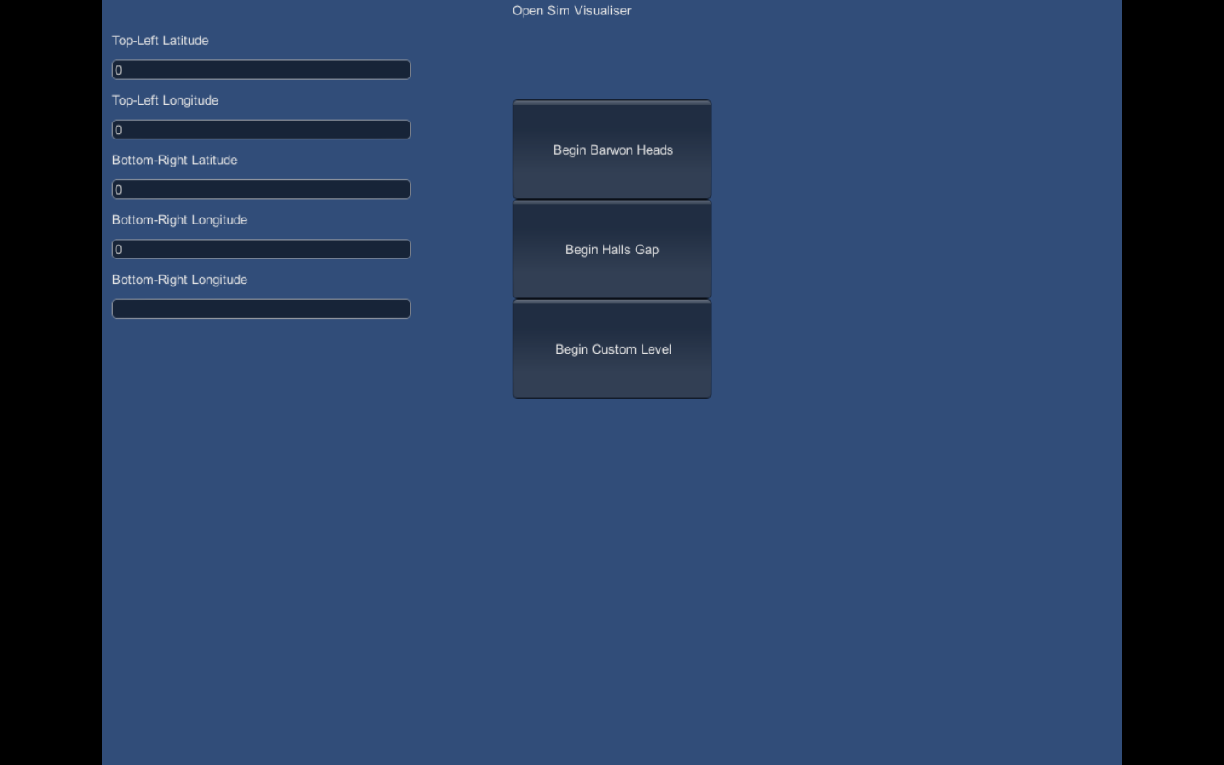
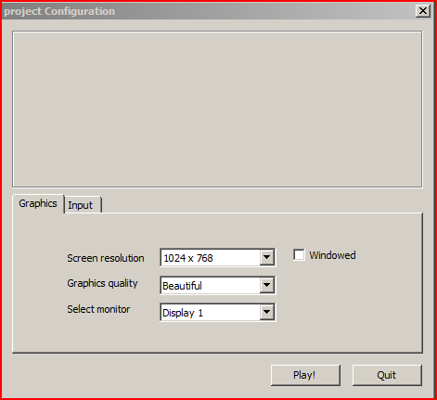
After selecting a resolution, you will be prompted to select a scenario.
Ensure you select the same scenario that will be run by the simulation. Once the GUI finishes initialising, select “start” to run the simulation.
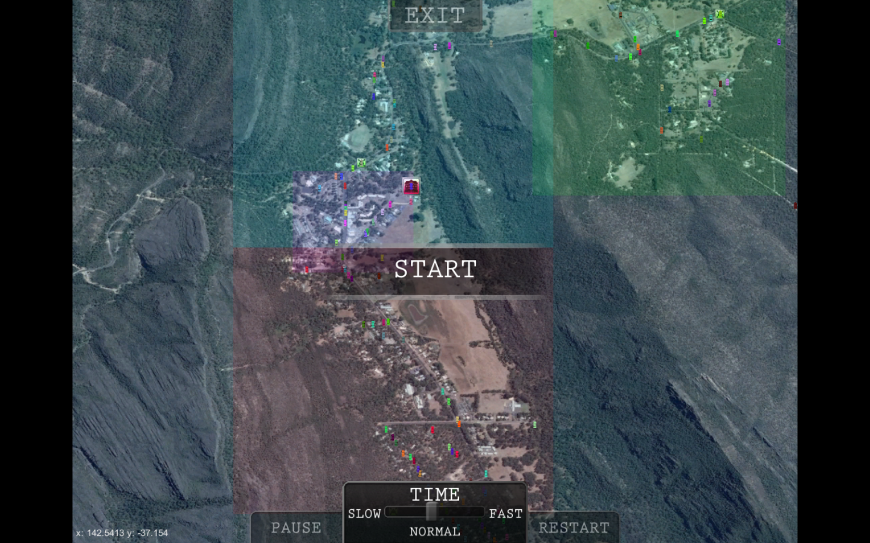

User Interface
The graphical user interface is used to show the unfolding of the scenario. The display consists of a map or satellite image of the area over which is displayed the residents, represented by cars, and symbols representing key locations in the town, control points used to define routes and the relief centres (or markers that represent relief centres that are actually of the map).
Add a picture to show all the elements above

Command Line Arguments

File Name | Function
-c <config file> | Required. Specifies the config (xml) file to use for the scenario.
-r <run name> | Optional. Specifies a “run” name that is appended to all output files to identify a run of the simulation. This is primarily used when running the simulation multiple times non-interactively to generate data.
-gui | Optional. Enables the use of the graphical user interface.
-x <xoffset> | Optional. Apply the offset to the x coordinate of the fire data to slightly shift the fire.
-y <yoffset> | Optional. Apply the offset to the y coordinate of the fire data to slightly shift the fire.
-verbose | Enables additional log messages in the resident log file.

Functionality
This simulation models the evacuation of a town in response to an emergency such as a bushfire.
The township is defined in a set of files that specify the road network, the population, nearby relief centres and routes to get to the relief centres. Multiple scenarios can exist for a given location that allow variations in any of the above characteristics. This could be used to explore different evacuation plans, or represent population changes due to seasonal conditions.
The simulation comprises two functional parts: the evacuation controller and residents. Both are represented by software agents. Refer to the Bushfire Design document for details on the implementation of the agents and the software components of the simulation.

Controller
The simulation begins with the assumption that an evacuation is to be initiated. The evacuation controller agent uses the data from the configuration files to determine which relief centre(s) will be used, which regions of the town will evacuate and in what order, and the route the residents will use to reach the relief centre. The scenario can be configured so that the controller makes all of these decisions automatically or allows the user to make some or all of them.
The geography of the town is defined as part of the scenario. At a minimum the scenario must have at least one relief centre. The town can be treated as a single region or divided into multiple smaller regions.
include picture of town showing coloured regions
The scenario defines at least one route between each region and each relief centre. The controller uses information about the relief centres and the routes to determine the order in which regions will evacuate and where they will go.
include pic showing route defined by control points and relief ctr
At the calculated time, the controller sends a message to the residents informing them that a region has been ordered to evacuate. The response of the residents is determined individually by them.

Residents
Residents in a given region respond to the instruction from the controller to evacuate that region. Their response depends on a number of configuration factors.
Residents are randomly assigned children who must be colelcted from school prior to evacuation. The scenario configuration file specifies the probability that a resident will have children.
Residents are randomly assigned another family member who lives elsewhere in the town. If a resident has another family member, they will travel to a random location in the town prior to evacuating. The scenario configuration file specifies the probability that a resident will have a relative.
Once a resident decides to evacuate, they will pick up any children and/ or relatives they have and then move to the designated relief centre following the route defined by the scenario.
The following diagram shows the steps each resident follows to evacuate.
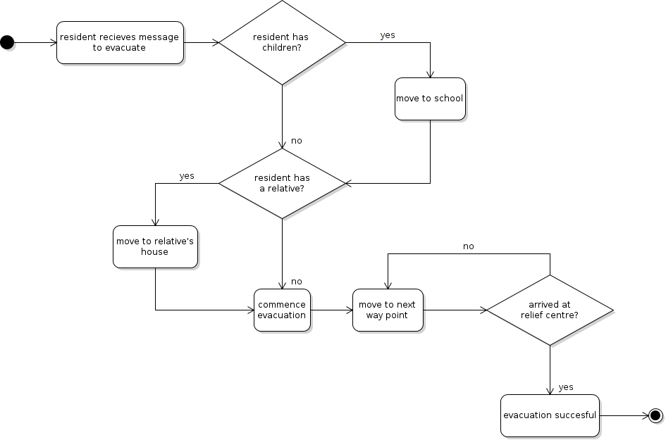

Output
In addition to the graphical display, the simulation produces output files. These can be used to compare different scenarios.
Controller Log
The controller produces an output file “EvacController-report<time stamp><run name>.log”. This records the decisions made by the evacuation controller agent and produces some summary statistics.
Resident Log
The software produces an output file “BasicResidents-report-<time stamp><run name>.log”. This records actions taken by all residents, such as whether they will pick up children and which way point they are moving to. An optional command line argument “-verbose” can be used to enable additional logging of each position update sent by MATSim to the visualiser.
Simulation Log
The general simulation log is defined in the scenario configuration file by the attribute “logFile”. This records general functions and any errors and would not normally be analysed as part of the run.
MATSim Output
The MATSim component of the simulation also produces output data. The location of these files is specified in the MATSim configuration file. By default this is the “output” directory. Refer to the MATSim documentation for information on interpreting these data.
http://matsim.org/docs

Configuring Scenarios
Each scenario requires a number of files that provide input data or configuration options. These are shown in the following diagram.
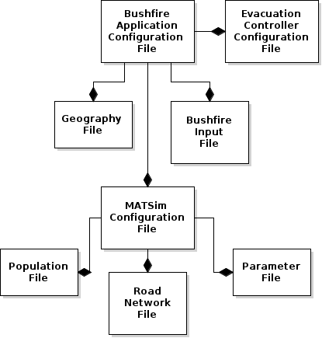
The files are described in the following table.
Title | Name | Function
Bushfire Application Configuration File | <scenario name>.xml | The scenario configuration file. This includes parameters used by the simulation and references to other data files.
Bushfire Input File | <scenario name>_fire_grid.txt | The area occupied by the fire over time.
Geography File | <scenario name>_geography.xml | Defines regions, locations and routes specific to this scenario.
Evacuation Controller ConfigurationFile | <scenario name>_controller.xml | Defines the behaviour of the evacuation controler agent.

Additionally, the MASTim simulation requires the following input files.
Title | File Name | Function
MATSim Configuration File | <scenario name>_config.xml | The MATSim configuration file.
Road Network File | <scenario name>_network.xml | The description of the road network used by the traffic simulation.
Population File | <scenario name>_population.xml | The initial locations of the population.
MATSim Parameter file | <scenario name>_parameters.txt | Parameters that control the behaviour of the traffic simulation.

Bushfire Application Configuration File
The primary scenario file is the scenario configuration file (xml). This identifies the names of other files and defines some configuration options.
Attribute | Description | Example
logfile name | The file where the evacuation controller and resident log information will be recorded. | scenarios/halls_gap/bushfire.log
matsimfile name | A file that defines the MATSim (traffic simulator) input data. | scenarios/halls_gap/halls_gap_config.xml
firefile name | A model of a fire. | scenarios/halls_gap/halls_gap_fire.txt
bdisimfile name | A file that defines parameters that control the execution of the traffic simulation. | scenarios/halls_gap/halls_gap_parameters.txt
port number | The port ID used to connect to the GUI. | 9876
geographyfile name | Defines the geography of the town for the evacuation controller. | scenarios/halls_gap/halls_gap_geography.xml
controllerfile name | Defines the behaviour of the controller agent and which decision points can be interrupted by the user. | scenarios/halls_gap/halls_gap_controller.xml
demographics | Defines the behaviour of residents. A proportion of the population can be assigned children and/ or relatives. Refer to the section on resident functionality. | <demographics relatives="0.0" kids="0.0" />
evac_delay | This sets a range (minimum and maximum) that is used to randomly assign a delay to each resident before they commence evacuating. | <evac_delay min="1.0" max="5.0" />

Example
<simulation>
<output_directory name ="scenarios/harrietville/" />
<logfile name="scenarios/harrietville/bushfire.log" />
<matsimfile name="scenarios/harrietville/harrietville_config.xml"/>
<firefile name="scenarios/harrietville/harrietville_fire.txt" />
<bdisimfile name="scenarios/harrietville/harrietville_parameters.txt"/>
<controllerfile name="scenarios/harrietville/harrietville_controller.xml"/>
<geographyfile name= "scenarios/harrietville/harrietville_geography.xml"/>
<port number="9876"/>
<demographics relatives="0.0" kids="0.0" />
<evac_delay min="1.0" max="5.0" />
</simulation>

Need to add example of image registration
Any of these attributes can be changed so that a different data file can be loaded. For example, multiple populations files may exist that describe different sized populations.

Bushfire Input File
The bushfire scenario requires a file that describes the progress of the fire. This is a text file with time stamped records defining the spread of the fire.
Each record consists of a time stamp (hours as floating point) followed by five sets of lat-long coordinates that define a four sided polygon where the first coordinate is repeated as the last coordinate to close the polygon.
recalculate coords for fire in UTM
For example:
0.026415144

-37.19615776116862, 142.27951505663208 -37.1961688225524, 142.2815720429773 -37.19779022080561, 142.28155803188073 -37.197779159192876, 142.27950100109135 -37.19615776116862, 142.27951505663208

Geography File
The geography file is used by the bushfire application to define the geography of the town so that the evacuation control agent can determine an evacuation schedule.
The geography file defines: locations, routes, regions and relief centres. At least one relief centre and its corresponding location must be defined for an evacuation to occur.
At present, setting up regions, relief centres and routes is a time consuming manual process. This is because evacuation points and control points must be set to a node on the road network so that MATSim can plan a route to them.
Locations
Locations define points on the map and are displayed on the visualiser. They are used by other elements of the geography. For example, each relief centre must have an associated location that defines where the relief centre is located.
<location
name = "evacPoint01"
id = "1082"
type = "e"
/>

Attribute | Description
<name> | The name of the location. This must ne unique as it is referenced by other elements of the geography to define a location.
<id> | The MATSim network link id that corresponds to this location.
<type> | The type of location. c = control point, e = evacuation point (relief centre), s = school. This is used by the visualiser to display an appropriate symbol.

Relief Centres
The most important element of the geography is to define possible locations to evacuate to. These are referred to as relief centres. The scenario must have at least one relief centre defined or the control agent is unable to issue an evacuation order.

<relief_centre>
<data
name = "Stawell"
location = "evacPoint01"
capacity = "300"
/>
</relief_centre>

Each relief centre has a number of attributes associated with it.
Attribute | Description
Name | The name of the relief centre. This is displayed on the GUI and used in the log file.
Capacity | The number of people that can be housed at the relief centre. This is used to assign relief centres by capacity.
location | This must refer to a named location found in the geography file.

Regions
Each town may optionally be divided into regions. If so, the evacuation controller will determine how and when each region will evacuate separately. If the town is not divided into regions, the evacuation controller and residents treat the whole area as one region.
Residents determine for themselves which region they are in and respond accordingly. Regions can overlap, in which case residents assume they are in the smallest applicable region.
Need new example with utm coords

<region>
<data
name = "north"
long="142.5217"
lat = "-37.13403"
closestReliefCentre = "Stawell"
/>
<routes>
<route
reliefCentre = "Stawell"
route = "northeast-short"
/>
<route
reliefCentre = "Ararat"
route = "northeast-short"
/>
<route
reliefCentre = "Hamilton"
route = "south-long"
/>
</routes>
<polygon>
<vertex
long="142.5131"
lat = "-37.14108"
/>
<vertex
long="142.5131"
lat = "-37.12698"
/>
<vertex
long="142.5303"
lat = "-37.12698"
/>
<vertex
long="142.5303"
lat = "-37.14108"
/>
</polygon>
</region>

Attribute | Description
Name | The name of the relief centre. This is displayed on the GUI and used in the log file.
lat/ long | This coordinate is used to define the centre of the region. That information is used to compute the distance to each relief centre and as the starting point for route length calculations.
<closestRelief Centre> | Identifies the relief centre to pick if selecting by closest.
<routes> | Specifies which route to use to travel to each potential relief centre.
<polygon> | Defines the shape of the region as a sequence of coordinates (vertices). At present, this needs to be an orthogonal rectangle.

Routes
Routes define a path from a region to a relief centre. Each route comprises a number of waypoints. When evacuating, residents will move from one waypoint to the next, using the MATSim simulation to plan movement between waypoints. Each waypoint must be defines as a location in he geography file.

<route>
<data
name = "northeast-long"
capacity = "3"
safety = "4"
/>
<path>
<waypoint
name="controlPoint02"
/>
<waypoint
name="controlPoint01"
/>
</path>
</route>

Attribute | Description
<name> | The name of the relief centre. This is displayed on the GUI and used in the log file.
<capacity> | An arbitrary rating scale (higher is greater capacity) that is use by the evacuation controller to determine the best route if selecting by capacity. This is an integer value, but should be limited to 1-10 or a similar small scale.
<safety> | An arbitrary rating scale (higher is safer) that is used by the evacuation controller to determine the best route if selecting by safety. This is an integer value, but should be limited to 1-10 or a similar small scale.
<path> | This defines a series of waypoints that comprise the route. Each waypoint must be a location defined in the geography file.

Controller Agent Configuration
The controller agent attempts to develop an evacuation schedule and then execute that schedule. It makes a series of decisions about which relief centre(s) to use, which routes and the sequence in which regions will be evacuated. Optionally, the user is offered opportunities to override the automated decisions and select options for themself.
The controller agent configuration file is used to identify which decisions points will be presented to the user to choose a plan. It also provides options to set whether the controller agent will be used. This has been included to maintain compatibility with older scenarios that do not have the required information for the controller agent to make decisions, such as the Barwon Heads scenario.

Example
<controller>
<bypassing
bypass="false"
userControl="true"
/>
<choicePoints>
<goal name="assign_relief_centres"
manual="true" choice="AssignByCapacity"/>
<goal name="establish_routes" manual="true"
choice="ShortestRoute"/>
<goal name="establish_schedule" manual="true"
choice="ScheduleByProximity"/>
</choicePoints>
</controller>

Attribute | Description
bypass | True or false. This controls whether the controller agent is bypassed (true) by the fire message. If bypassed residents will simply initiate their own evacuation response.
userControl | True or false. This provides a high level setting to enable (true) or disable (false) user interaction. If this is false, the visualiser will show the evacuation, but will not allow the user to intervene in the controller agent planning.
<choicePoints> | This element defines which goals are available for the user to manually select plans. The configuration must specify the goal name, whether manual selection is available (true), and what choice to make if the simulation is run with this setting but without the visualiser.

MATSim Input Files
The MATSim simulation requires two files that define the road network and the population of the town. The road network is generated from an Open Street Map and the population file is generated from an address shape file. See the section “Creating a New Scenario” for information on generating these files.
MATSim then also requires a configuration file that determines its run-time behaviour. This file must reference the network and population files. For example:
<module name="network">
<param name="inputNetworkFile" value="./scenarios/halls_gap/halls_gap_network.xml" />
</module>
<module name="plans">
<param name="inputPlansFile" value="./scenarios/halls_gap/halls_gap_population.xml" />
</module>

The final MATSim configutaion file is the parameter file. This defines some information used by the BDI-ABM integration layer.

DURATION,720
TIME_FOR_JOB,30
TIME_COUNT,0
MULTIPLIER,1
TOTAL_JOBS,0
NUMBER_OF_TAXIS,1000
DISTANCE_THREDSHOLD,6000
MAX_DURATION,1
DISTANCE_CALCULATION_DURATION,300
DURATION_REASONING,60

Creating a New Scenario
A new scenario requires four stages: building the data required by the traffic simulator; building the image required by the GUI; building the information required by the evacuation controller; and linking the data together in a scenario file.
A new scenario folder should be created to store all of the data files as they are created. For example, create a new folder “scenarios/harrietville” to store scenarios files for Harrietville.

Traffic Simulator
The MATSim traffic simulator requires two inputs: the map of the road network; and the initial population file. The latter task can be done in two ways: randomly or from an address shape file.

Create the Road Network
The road network is generated from an open street map (OSM) file. This can be downloaded from the web site:
http://www.openstreetmap.org
Navigate to the required location using the site’s search bar. For example, to find the town of Harrietville, enter “Harrietville, vic”.
To export the OSM, select “export” on the tool bar. See the diagram below.

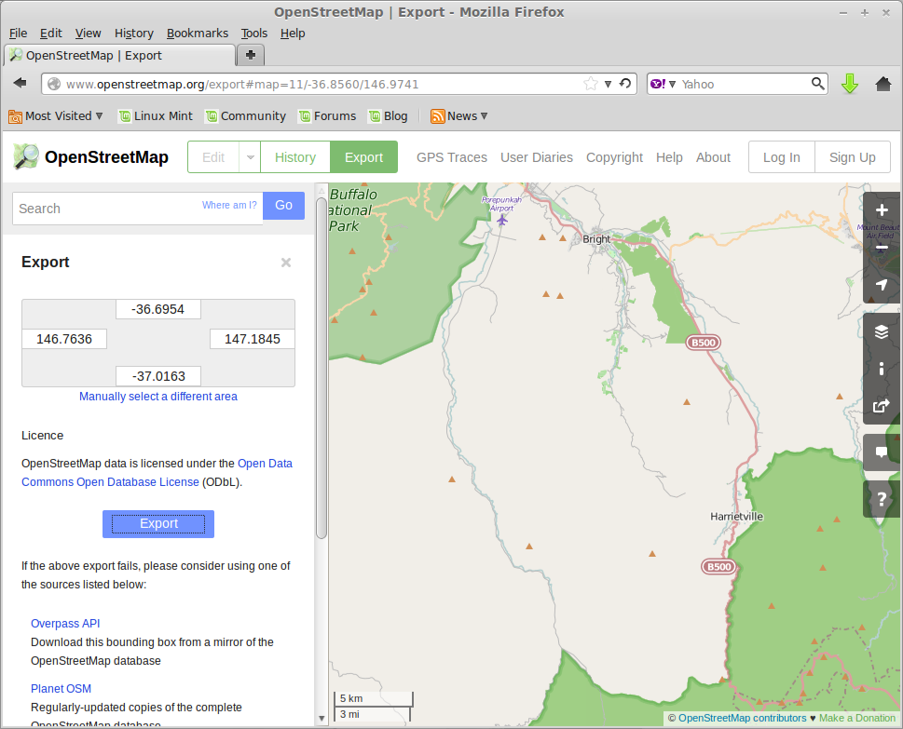
Save the file with an appropriate name in the input directory, eg input/harrietville.osm.
The OSM file then needs to be translated into a MATSim network file.
The script NetworkGenerator.sh in the distribution can be used to perform this conversion. Open the NetworkGenerator.sh and edit the fields “INPUT_FILE”, “OUT_FILE” and “WKT” accordingly. INPUT_FILE is the path to input osm file. OUT_FILE is the path to output network file. WKT is the the ESRI well known string based on the UTM zone of the network. For Australia, the ESRI WKT can be generated using menu in lower left of http://spatialreference.org/ref/epsg/28354/ page. Default value is set to MGA zone 54.

Next run the script.
> sh NetworkGenerator.sh

Create Population File
Create the Population File from a Shape File
Address shape files for Victoria can be ordered, free of charge, from the Victorian Government. Land usage data are managed by the Department of Environment and Primary Industry. Access this via the website <http://land.vic.gov.au> . To order address information for a town, select “Vicmap Data” from the menu on the website or go directly to <http://services.land.vic.gov.au/landchannel/content/vicmapdata?productID=1>
From that web form, select the town, coordinate system (MGA Zone nn on GDA-94) and data format (ESRI (shape)). For example, to order address data for Harrietville, use the settings displayed below.

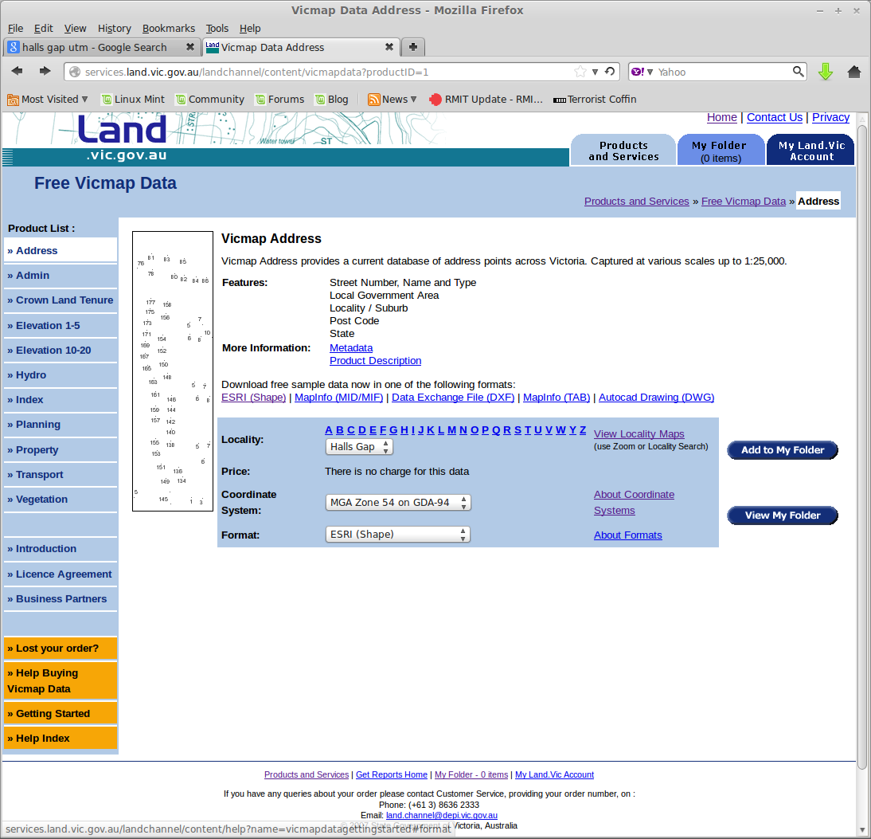

Select the “Add to My Folder” button and follow the instructions to complete the order. You will be asked to provide an email address to receive the data, which should arrive within 30 minutes.
Once the data arrives (as a zip file), save it to your computer and unzip it.
The address data is enclosed in a set of files: ADDRESS.dbf, ADDRESS.sbn, ADDRESS.sbx, ADDRESS.shp, ADDRESS.shx. They may be located in a sub-directory of the zip file.
Copy these files to the input folder of the distribution, and ideally rename them to something appropriate, such as “harrietville.*”. Then run the population generator utility.
The script PopulationGenerator.sh in the distribution can be used to generate population xml using the input sddress files. Open the PopulationGenerator.sh and edit the fields “INPUT_FILE”, “OUT_FILE” and “ID_PREFIX” accordingly. INPUT_FILE is the path to input shp file. OUT_FILE is the path to output population file. ID_PREFIX is the prefix that will be appened in frond af all agent IDs.

Next run the script.
> sh PopulationGenerator.sh

Create the Population File Randomly
An alternative method of producing a population file has been provided that simply randomly places residents on the map without regard to streets or addresses. This can be found in the bin folder.
To run the program, use the command:
java bushfire-0.0.1-SNAPSHOT.jar agentsoz.util.MatsimPopulationFileCreator -p <population> -ur <x> <y> -ll <x> <y>
This will create a file called “population.xml” containing the definitions for the specified number of people (<population>) located within a rectangle defined by the supplied upper right and lower left coordinates (UTM).
The coordinates can be determined using google maps and right-clicking on the map.

MATSim Configuration Files
MATSim requires two additional files. The first is a configuration file which defines the run time behaviour of MATSim and the second is a parameter file that configures the BDI-ABM integration layer. To create these files, simply copy an existing one from another scenario, for example Halls Gap: halls-gap_config.xml and halls_gap_parameters.txt.
The parameter file needs to have the “NUMBER_OF_TAXIS” parameter set to at least as many residents are in the population file.
The config.xml file needs to reference the network and population files that were created above. For example

<module name="network">
<param name="inputNetworkFile" value="./scenarios/harrietville/harrietville_network.xml" />
</module>
<module name="plans">
<param name="inputPlansFile" value="./scenarios/harrietville/harrietville_population.xml" />
</module>

Bushfire Application
The bushfire application requires a scenario configuration file. This is an xml file that contains references to other required input files and some options that control the behaviour of the simulation.
Refer to the section “Configuring Scenarios” for details on the contents of this file.

Geography
Creating a geography file is currently a manual process.
Regions are defined by the lat-lon coordinates that specify their vertices. However, routes and relief centres rely on locations which specify target destinations that can be interpretted by MATSim as destinations.
MATSim uses 'links' to specify destinations. These are road segments that go from node (vertex) to node and are directional. Hence, all locations in the geography file must specify a link ID so that MATSim can determine a route.
To generate a location:
The most effective way to generate locations and their coresponding link IDs is to use the MATSim Network Editor to identify links. The Developer's Guide explains how to download and install the Network Editor.
Once a road network is created (refer to Create The Road Network above) load it in the editor. An example of the Harrietville file is shown below.
MATSim Network Editor | JOSM Open Street Map Editor
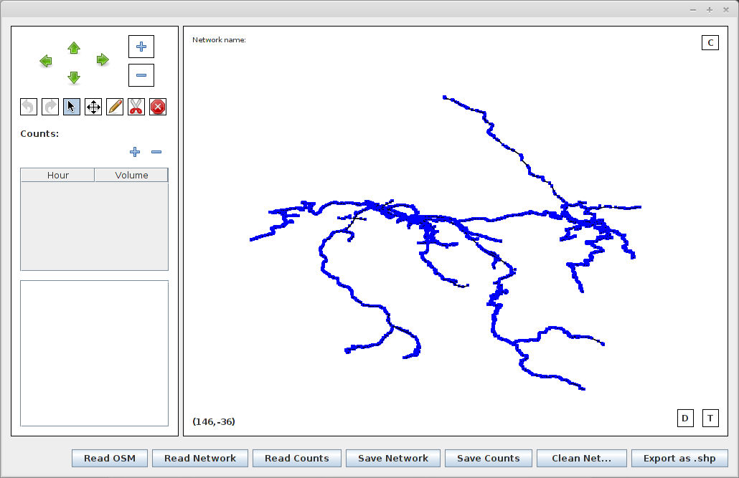 | 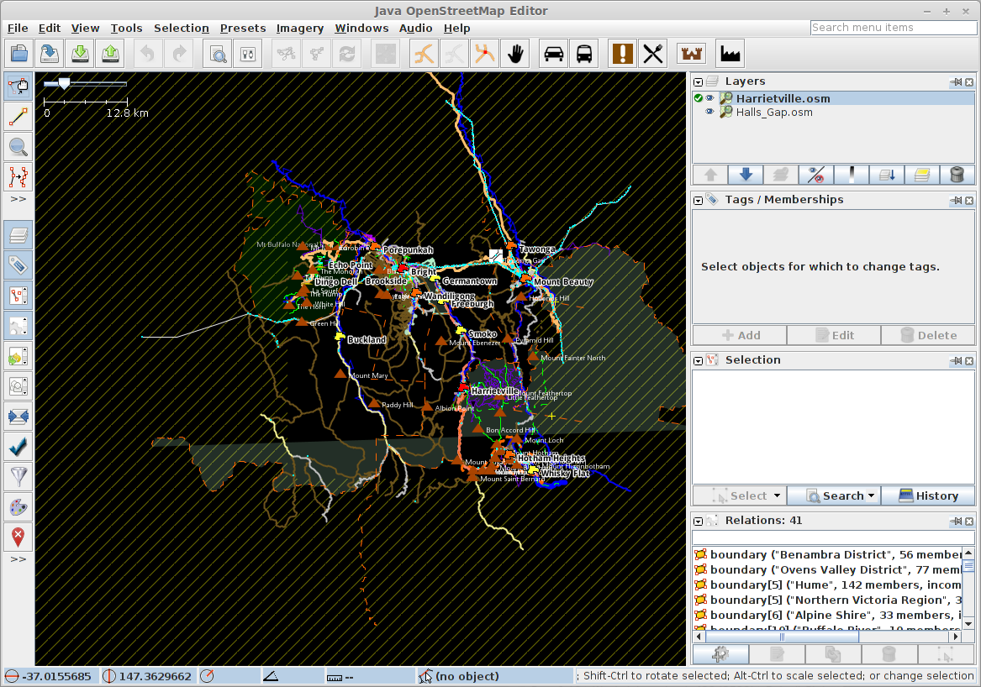

It can be helpful to use google maps or a similar tool to display a refernce version of the area to aid in navigating and identifying critical locations.
The following images show the MATSim Network Editor view and the Google Map view of the same location around Harrietville.
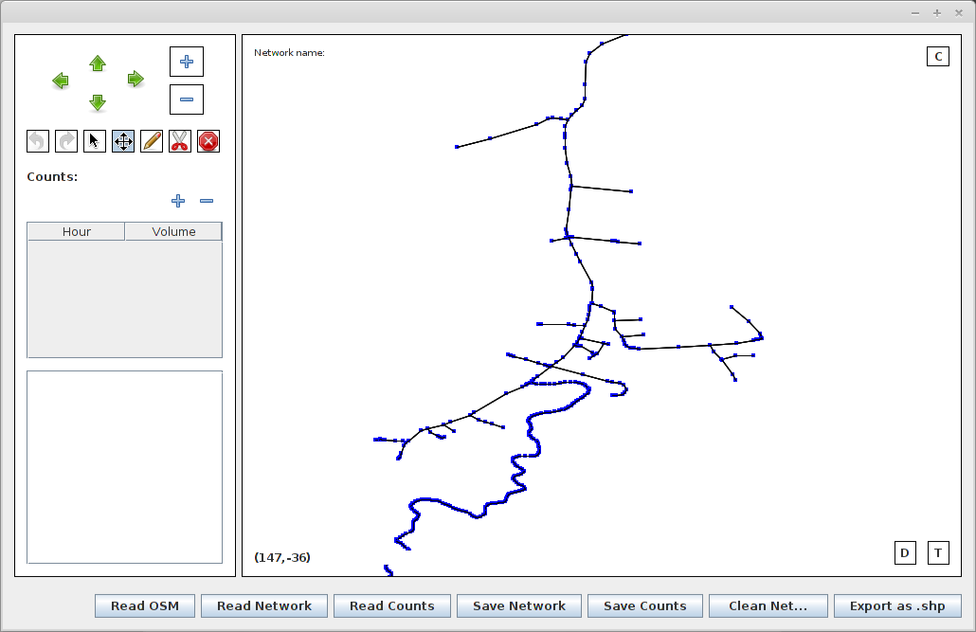 | 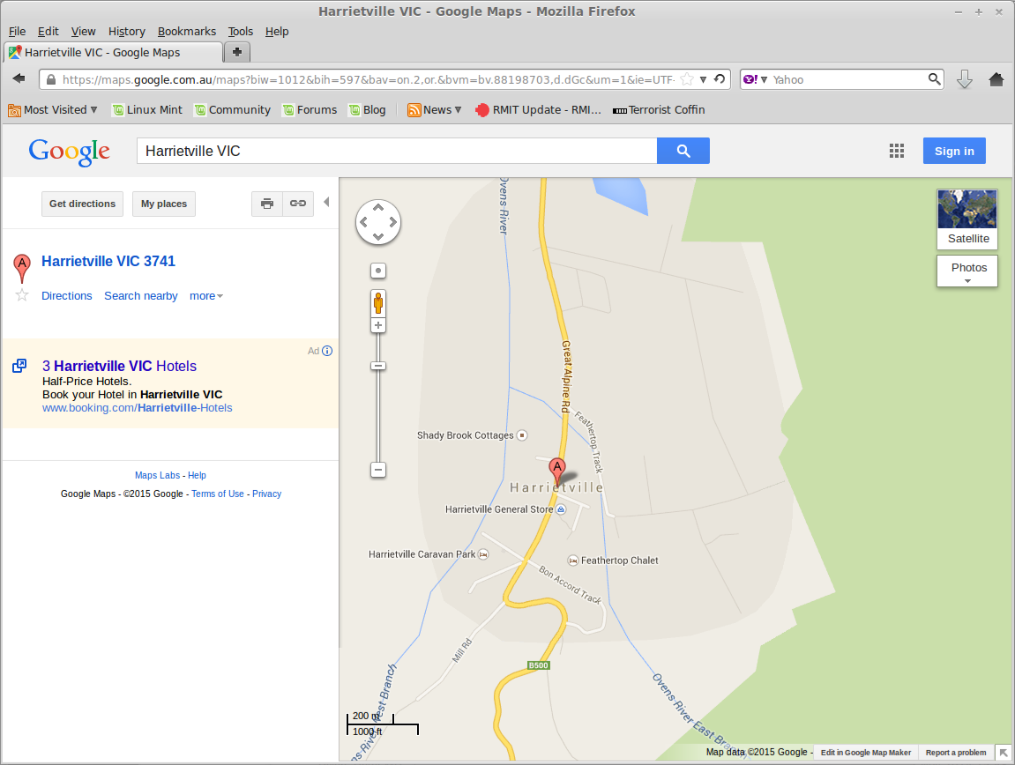

Use the zoom and pan functions of the Network Editor to find the desired location. Then select the 'link' that ends with the desired destination node. For example, the intersection highlighted in the above google map illustration is shown below in the MATSim Network Editor.
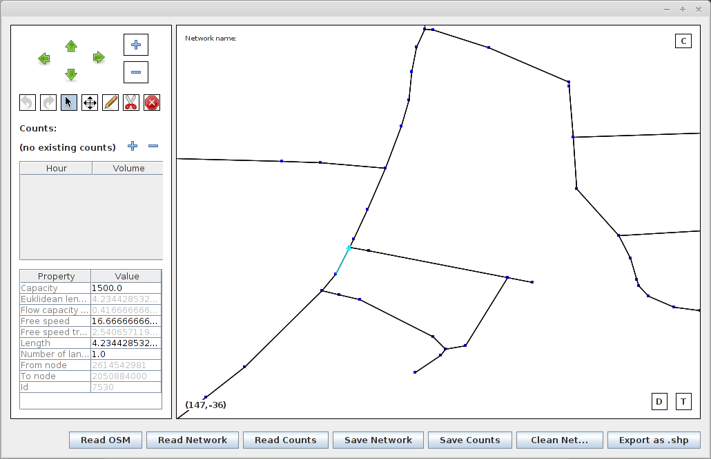
Note that 'links” are directional so it is important to ensure the correct link is selected. Selecting the link again, toggles which end (node) is selected. The link ID is then found in the table on the left hand side of the editor window. In the above case it is 7530. Therefore to add that point as a location in the geography file, you would use the following information.

<location
name = "intersection"
id = "7530"
type = "c"
/>

To get the correct coordinates (which are only used for documentation, they are not interpretted by the software) select the node itself in the editor, as shown below.
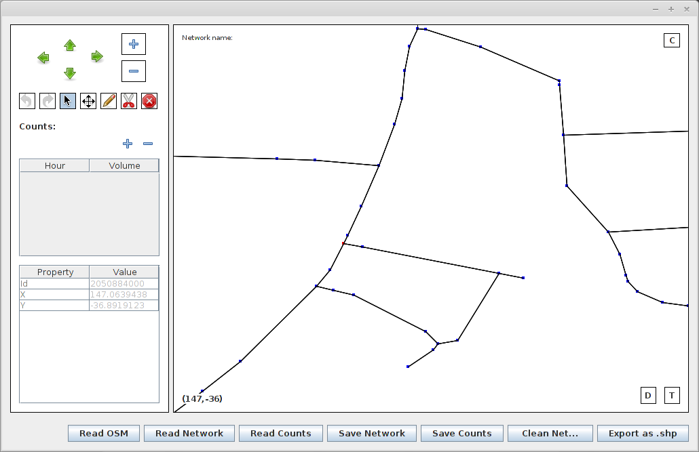
need to edit image to highlight red coord
The minimum requirement for a geography file is a relief centre. Adding the following data for the town of Bright as a relief centre will produce a working scenario.

<location
name = "bright"
id = "10214"
type = "e"
/>
<relief_centre>
<data
name = "Bright"
location = "bright"
capacity = "300"
/>
</relief_centre>

Fire Data
The fire data used by this application is a text file containing grid cells that represent the fire spreading over time. It was originally generated from a file produced by the Phoenix RapidFire fire spread model. Instructions for generating a new file from Phoenix output are still being developed.
At present, only one fire file exists. This represents a fire running west to east that changes direction north at the end of the time period. To create a fire file for a new scenario, this existing fire needs to be copied and “moved” to the new location.
The location of this fire can be moved by applying an offset to the data within the fire file. This is done using the tool “MoveFire” found in the bin folder of the distribution.
To run the program, use the command:
java -cp ./bin MoveFire -in <inFile> -out <outFile> -lat <latOffset> -long <longOffset>
chenge lat-lon to utm
Where, <inFile> is the name of the input file describing the existing fire, <outFile> is the name of the new file to create, <latOffset> is the offset to apply to all latitude values in the input file, and <longOffset> is the offset to apply to all longitude values in the file.

GUI
The GUI requires an image of the area that has been registered so as to line up with the road network coordinate system. The pointer to the image file, and its corner coordinates need to be defined in the scenarion configuration file (eg harrietville.xml). The image file itself needs to be placed in the same directory as the visualiser executable program (the gui directory in the standard distribution).
The simplest (low resolution) method for doing this is to capture an image from google maps using a screen capture utility.
For example, a Harrietville scenario could use the following data, and a coresponding image.
Need to update example coords
<image file="harrietville-map"
west="147.015409"
east="147.15909"
north="-36.819867"
south="-36.915725" />
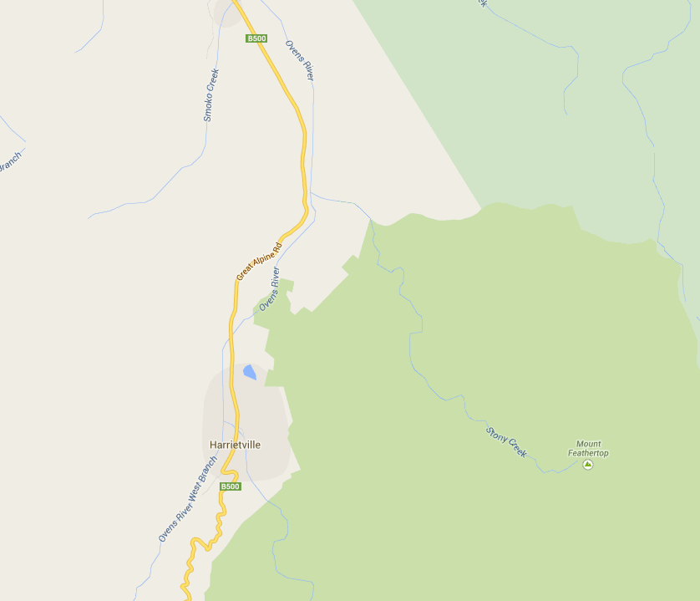
Need to go through Dan's documentation to see how he imported a better image

Scenarios
Two scenarios have been developed; Halls Gap and Barwon Heads.

Halls Gap
Halls Gap is a small town near the Grampians National park north west of Melbourne.
This scenario uses the evacuation controller agent to stagger the evacuation of residents by regions.
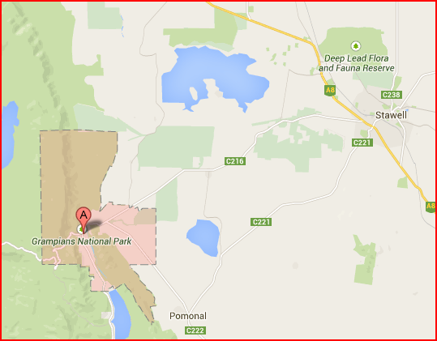
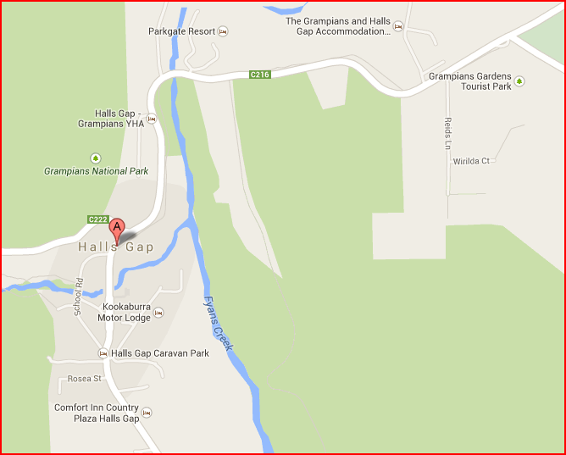
The data for this scenario was generated from Open Street Map and Victorian Land data as described in this user guide. Teh supplied scenario includes 500 residents.

Barwon Heads
Barwon Heads is a coastal town on the Bellarine Peninsula near Geelong. This scenario was developed during an early stage of the project.
This scenario does not use the evacuation controller agent and residents simply evacuate immediately.
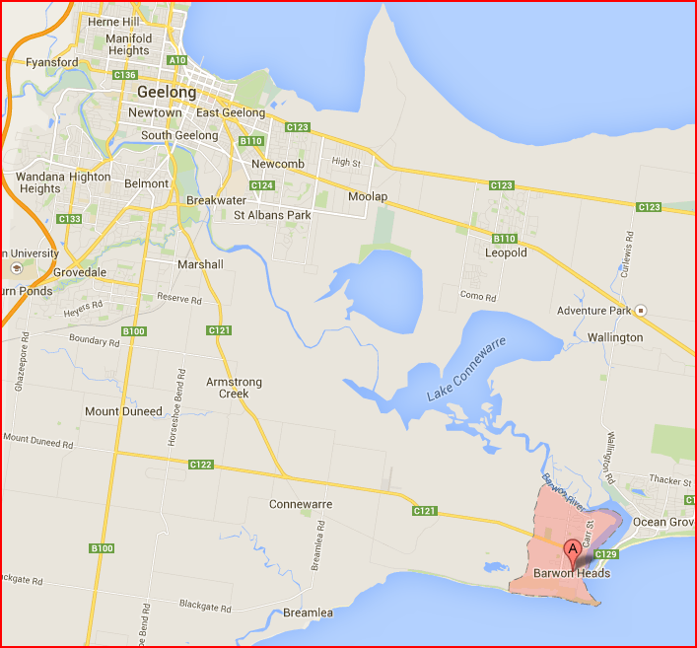
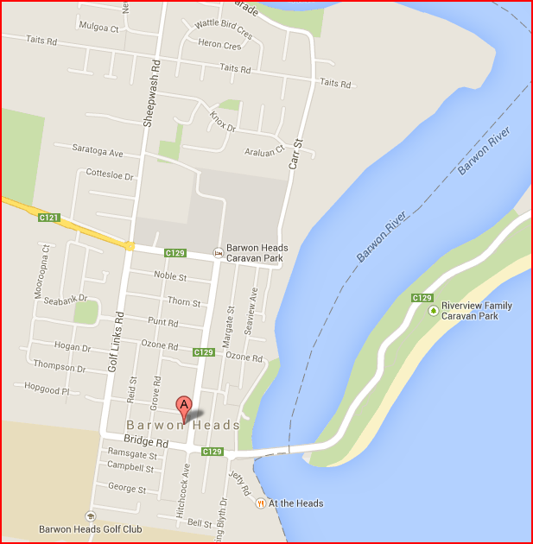

Currently, for simplicity, residents detremine which region they are in assuming that the regions are all defined by squares. That is, they test to see if their location is within the minimum and maximum x and y values that define the region.
For information on the contents of this file, refer to the MATSim documentation.
At the time of writing this document, the meaning and effect of the parameters in this file have not been investigated. All that is known is that it is required and the “NUMBER_OF_TAXIS” parameter needs to be larger than the population size of the town being evacuated. This is a remnant of an earlier stage of this project and will be re-engineered in the future.
Note: This information was correct as at January 2015. The government departments responsible for these data, and the associated web sites, change periodically.
It is important to get data in MGA format (UTM) as MATSim requires a rectilinear grid.
Refer to the Developer Guide for instructions on how to download and use the JOSM Open Street Map Editor.

