

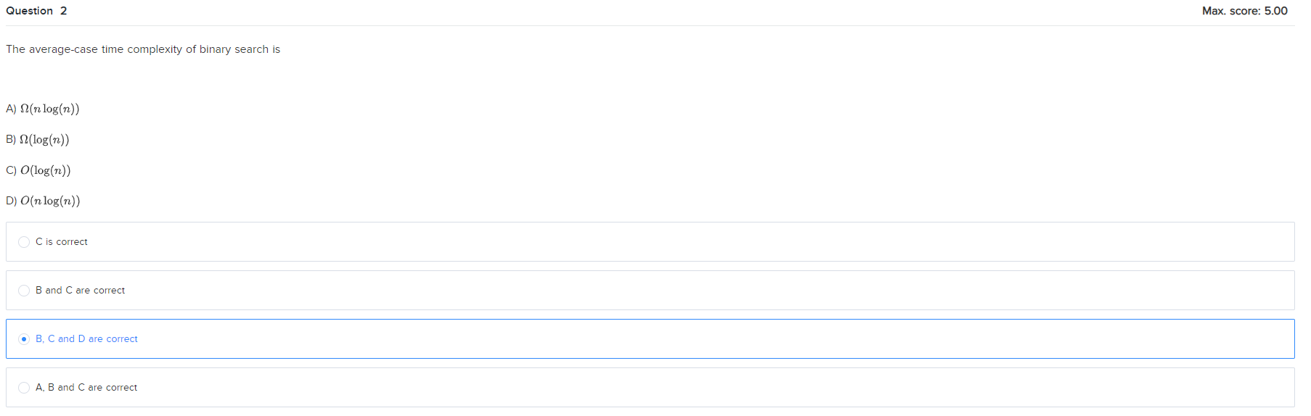

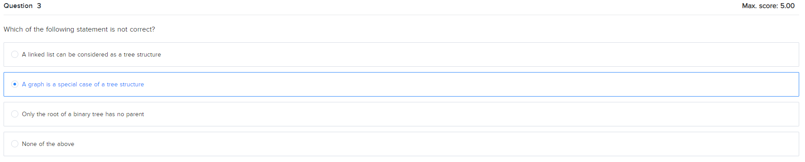

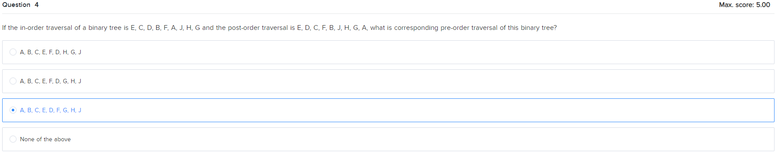

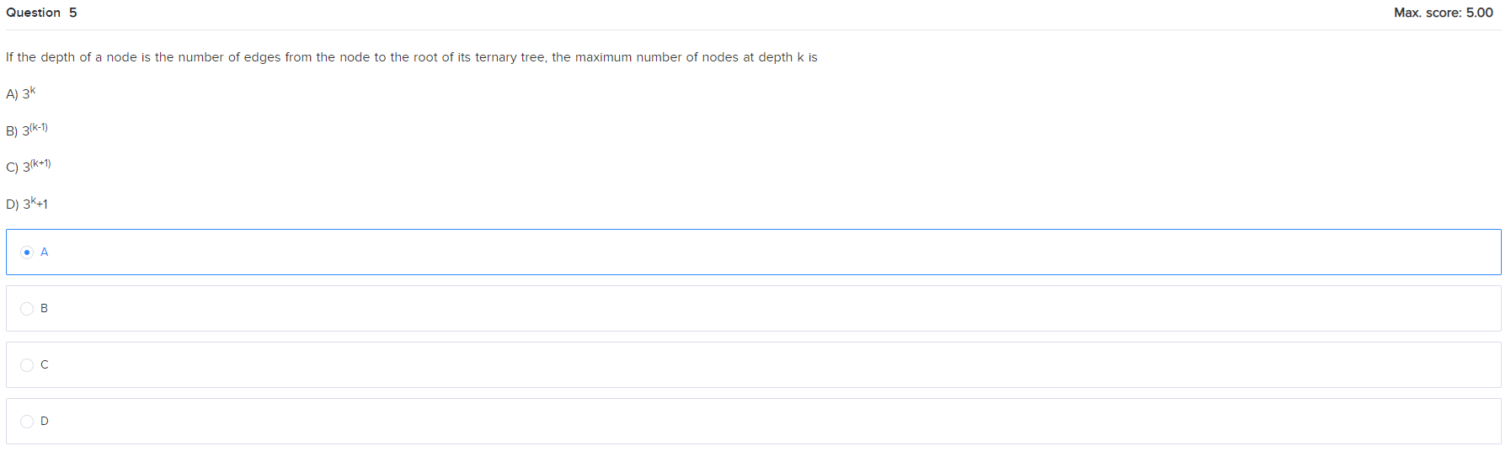

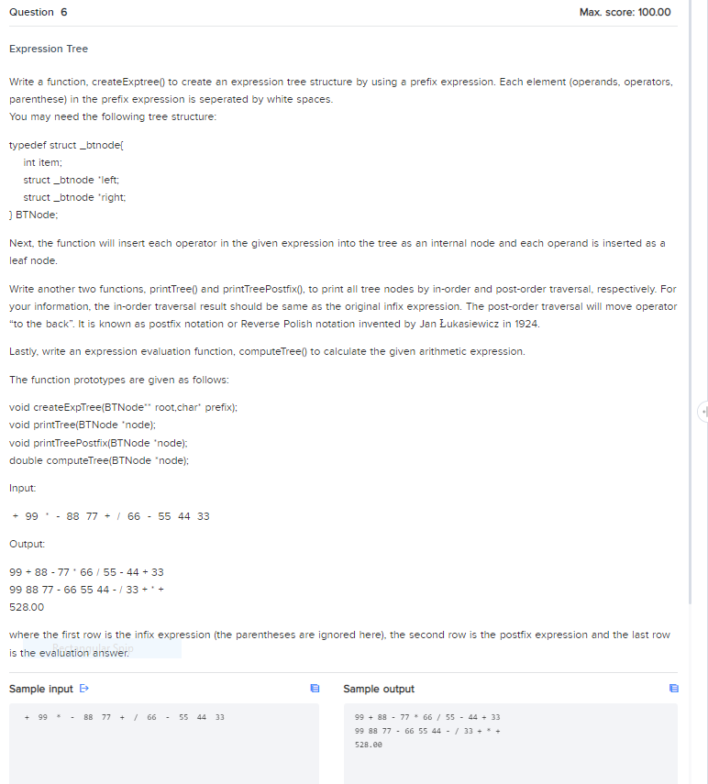

+ 99 * - 88 77 + / 66 - 55 44 33

99 + 88 - 77 * 66 / 55 - 44 + 33

99 88 77 - 66 55 44 - / 33 + * +

528.00

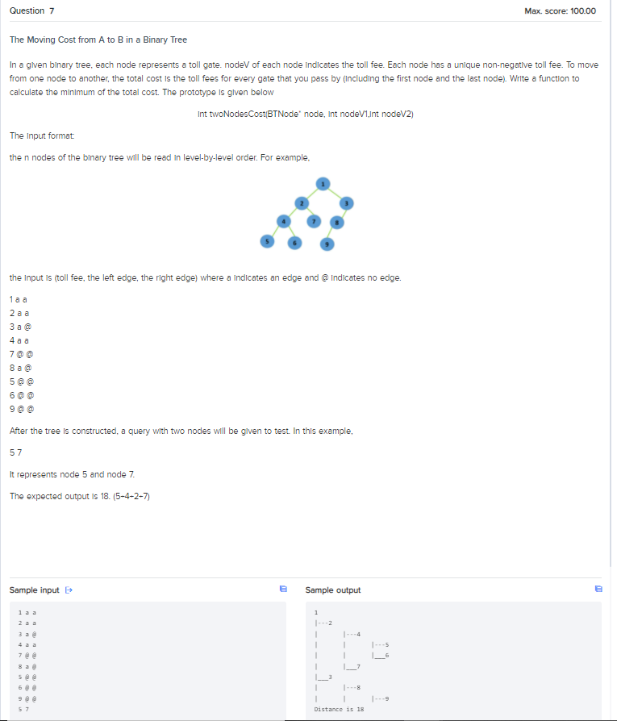

1 a a

2 a a

3 a @

4 a a

7 @ @

8 a @

5 @ @

6 @ @

9 @ @

5 7

1

|---2

| |---4

| | |---5

| | |___6

| |___7

|___3

| |---8

| | |---9

Distance is 18

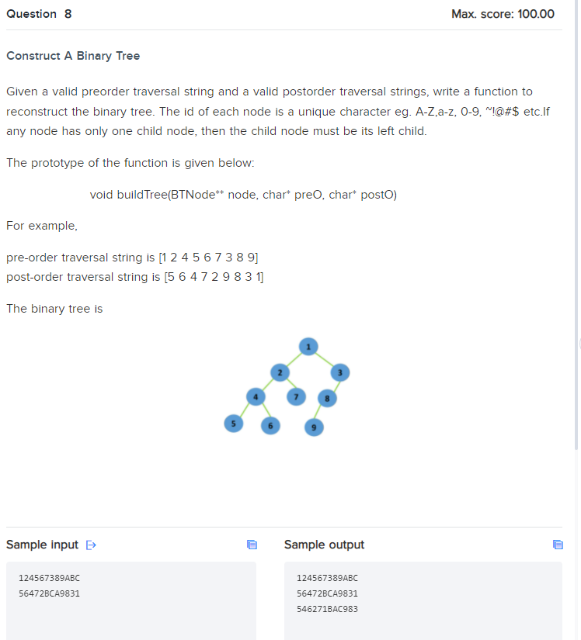

124567389ABC

56472BCA9831

124567389ABC

56472BCA9831

546271BAC983