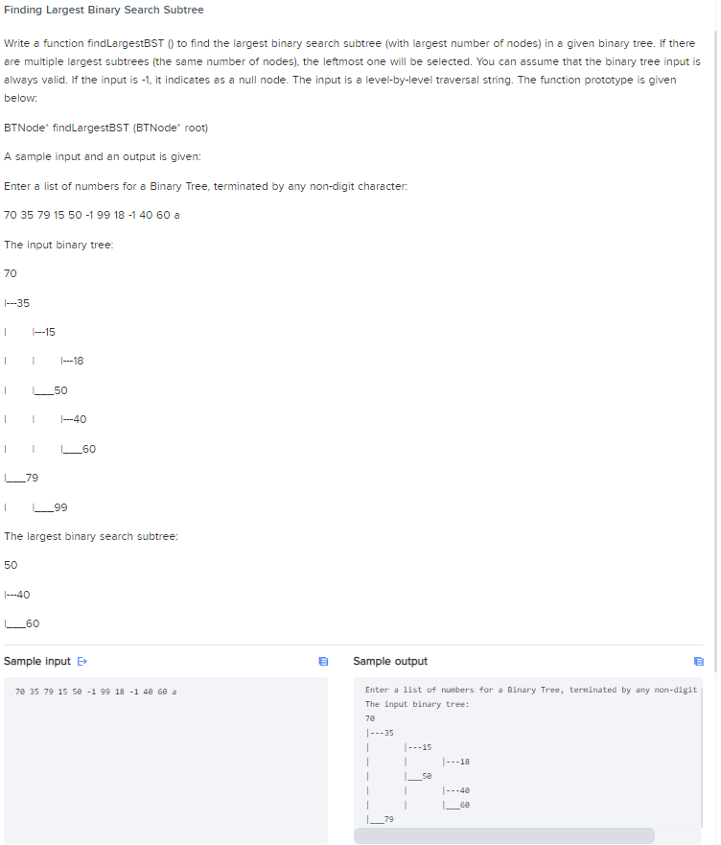

70 35 79 15 50 -1 99 18 -1 40 60 a

Enter a list of numbers for a Binary Tree, terminated by any non-digit character:

The input binary tree:

70

|---35

| |---15

| | |---18

| |___50

| | |---40

| | |___60

|___79

| |___99

The largest binary search subtree:

50

|---40

|___60

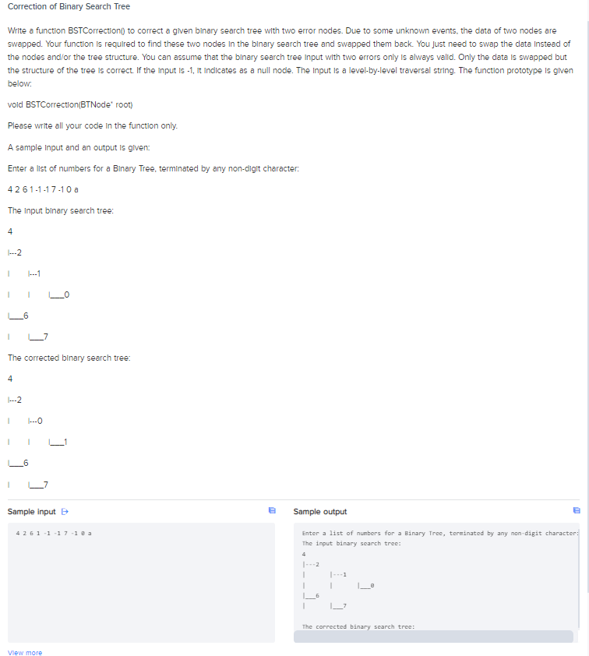

4 2 6 1 -1 -1 7 -1 0 a

Enter a list of numbers for a Binary Tree, terminated by any non-digit character:

The input binary search tree:

4

|---2

| |---1

| | |___0

|___6

| |___7

The corrected binary search tree:

4

|---2

| |---0

| | |___1

|___6

| |___7