, functional, code-based example of something, don't forget to check out the 30+ example applications in the distribution under delta3d/examples. Also, there are over 20,000 lines of unit tests that show actual uses of the system under delta3d/tests.

Simcore & StealthViewer.

Delta3D Simulation Core and Stealth Viewer - A part of Delta3D-Extras.  
  
  
The Delta3D Simulation Core (aka SimCore) is a major project that is a part of the Delta3D-Extras repository. This project provides a massive set of functionality that is typically needed by most Modeling & Simulation (M&S) projects. It provides a ready-to-go capability to help get other projects off the ground. At the most basic level, SimCore provides a base set of components and game actors that are needed to understand, render, and work with entities.  
  
Out of the box, it is configured to work with High Level Architecture (HLA) networking. It understands the concepts of entity types, remote vs local objects, interactions, and core entity behaviors. It processes network traffic in order to create, visualize, and dead reckon entities and provides most of the base behaviors needed to construct new virtual simulators that can publish and interact in a simulation network.  
  
The SimCore also includes the Stealth Viewer. This tool is a functionally complete instructor operator station that allows users to view a simulation event as a passive 'stealth' observer. It includes basic commodity features such as the ability to fly anywhere & look anywhere; configuring networks and maps; connecting to and disconnecting from a network; user preferences; entity search and attach behaviors; and basic tools such as the binoculars and compass. It also provides the ability to record an entire scenario and play it back viewed from any where, at any angle, from 1/10 to 16X real-time.  
  
Together, the Simulation Core and Stealth Viewer expose the following major features: HLA Networking; Dead Reckoning & Ground Clamping; Terrain Visualization; Particle System Management; Weather System; Dynamic Lights; Audio Effects; Rendering Support Component; Massive Munition System; Integrated NVidia PhysX(tm) physics engine; Articulations; Entity Types; Open GL Shaders for vehicles and terrain; Base Audio & 3D model asset collection; Heads Up Display; Coordinate Conversion; Camera Motion Models; XML Configuration; User Tools (binoculars, compass, help); After Action Review (AAR) - record & playback; and Character Animation.  
  
The SimCore repository was originally developed by the US Marine Corps for Program Management for Training Systems (PMTRASYS) as part of the Deployable Virtual Training Environment (DVTE). Since its release, it has been adopted by a number of other organizations and companies both in the US and abroad.  
  
The Simulation Core and Stealth Viewer are available as open source. Since they are released under Delta3D-Extras, you will need to build and configure them yourself. Simulation Core is available from Subversion at the following URL: "https://delta3d-extras.svn.sourceforge.net/svnroot/delta3d-extras/SimulationCore/trunk/". You will need CMake in order to build and configure the software. In addition to Sim Core, you will also need the PhysX repository. The complete instructions for accessing, configuring, and building everything needed for simulation core are available here: [Delta3D Simulation Core And Stealth Viewer Build Process](https://web.archive.org/web/20160408233515/https:/delta3d-extras.svn.sourceforge.net/svnroot/delta3d-extras/SimulationCore/trunk/doc/SimCore_BuildAndInstall_CurrentVersion.pdf). For more information about NVidia PhysX, please see this news item: [PhysX Integration with Delta3D Released To Public](https://web.archive.org/web/20160408233515/http:/www.delta3d.org/article.php?story=20080111154112305&topic=news).  
  
  
**A partly cloudy day attached to a flying entity**  
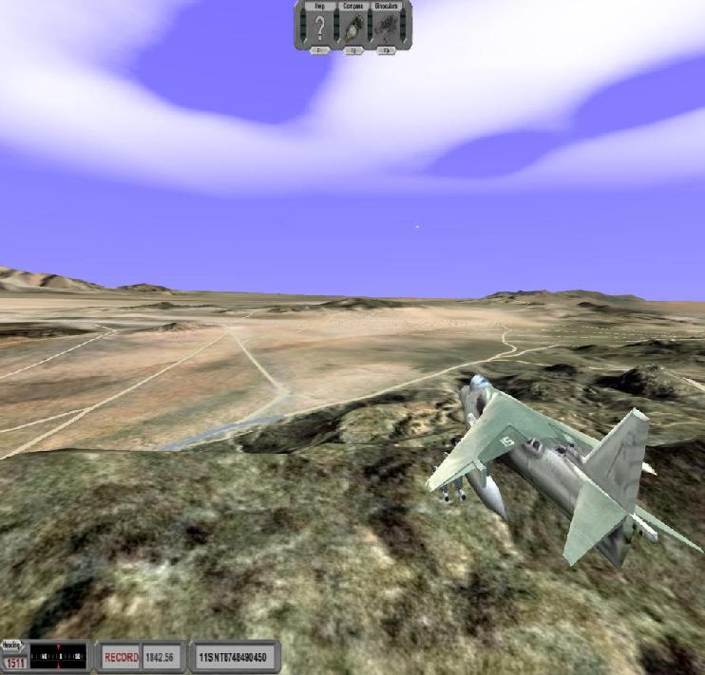  
  
**A HMMWV virtual simulator shows physics particles, lighting, and articulation**  
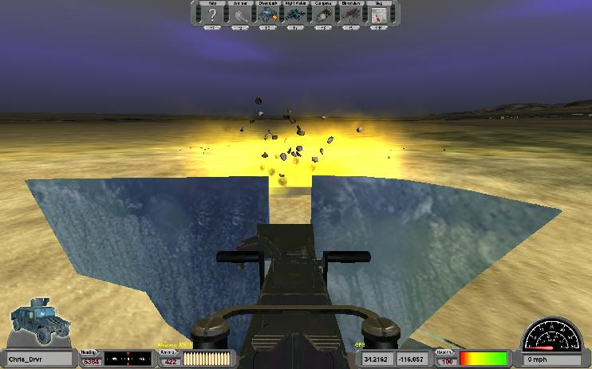  
  
**Example of a night vision sensor model on top of Sim Core**  
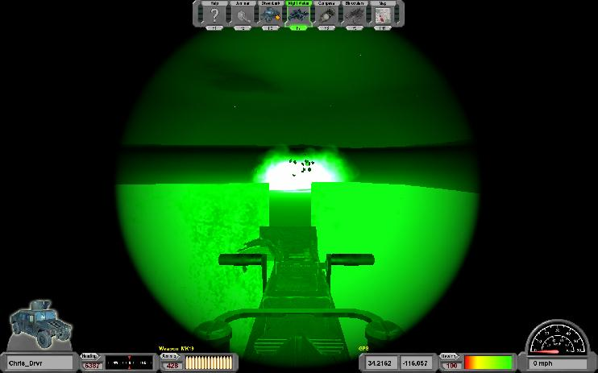  
  
**A large city terrain within the Stealth Viewer**  
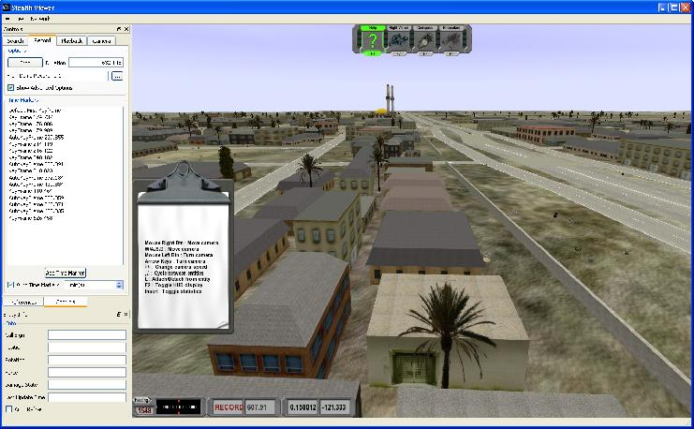  
  
**Attached to a helicopter showing missile trails & nighttime lighting**  
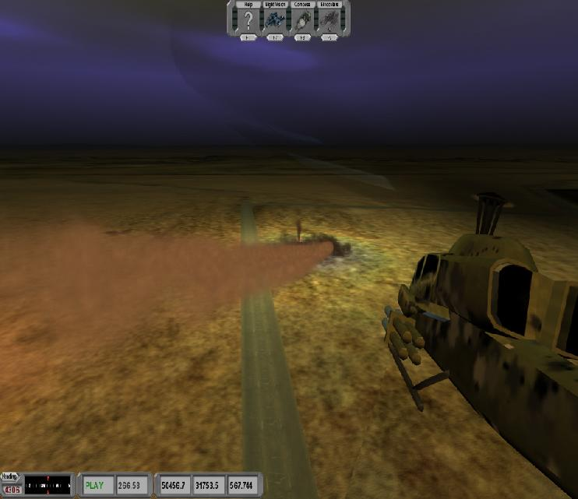  
  
**OSG Ephemeris snow**  
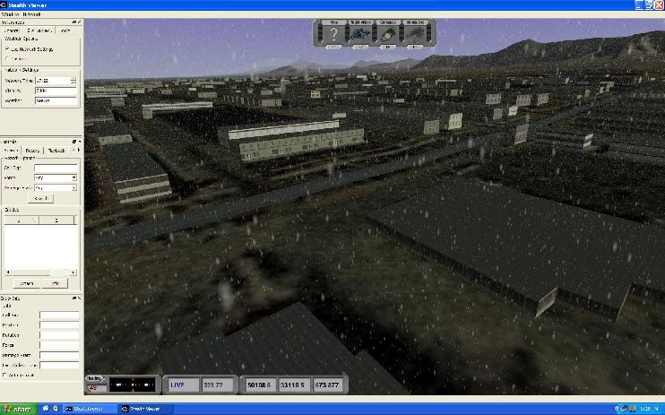  
  
**Tracer visualization for direct fire during Replay**  
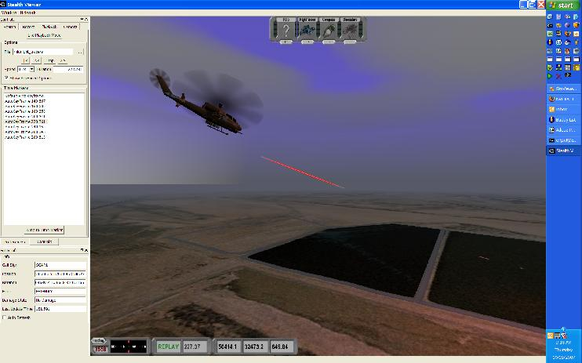  
  
**Direct weapons fire, dynamic lighting, tracers, and impact effects**  
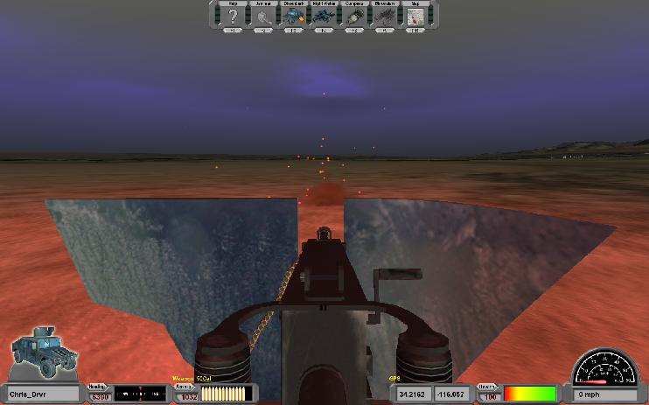  
  
**A complex scene visualized in the Stealth View**  
