**Problem 1:**

(Key: * multiply; ^ exponent)

1. Probability that Armando will have a cold on W.

Pr(cold free on W) = (99/100)^3

Pro(cold on Wednesday) = 1 - (99/100)^3

1. Probability that Armando will have symptoms on M and a F (caught S, Su, M and then again on W, Th, or F)

*🡪 1- Prob not sick M,T,W and 1-Prob not sick W,Th,F*

(1 - (99/100)^3) * (1 - (99/100)^3)

1. Probability that he’ll be healthy during the weekend, sick at some point in the week and healthy again during the next weekend

*🡪 from Th to Sunday must be cold free; must catch a col on at least M, T, or W; must be cold free Th-Su*

= (99/100)^4 * (1 - (99/100)^3) * (99/100)^4

1. Probability that both Armando and Fredo are both sick on F. [Answer under assume that Fredo has the same propensity for getting sick]

🡪 *1-prob sick W, T, F for Armando and same for Fredo*

(1 - (99/100)^3) * (1 - (99/100)^3)

**Simple Simulation (No Drug Treatment):**

*graph plotting the average number of viruses after simulation with 100 trials

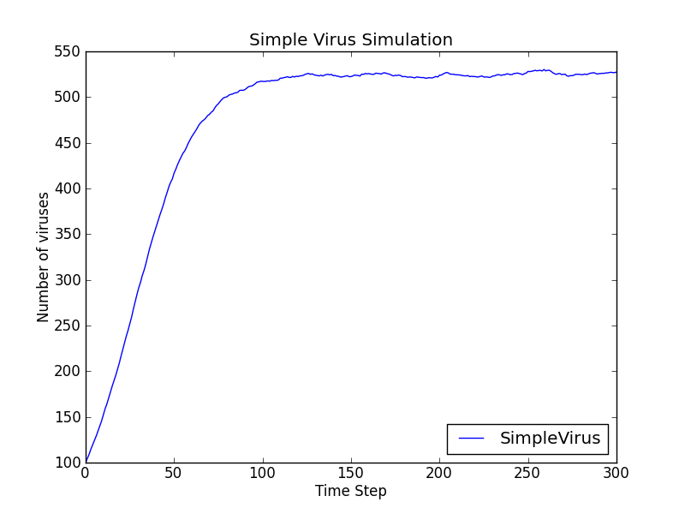

1. **About how long does it take before the population stops growing?**

About 150 time-steps

1. **How does the # of trials affect the curve and why (play around w/ smaller values of numTrials)?**

The rise looks a bit more linear, the inflection point harder to determine and much more notably, the curve does not level off smoothly – rather, the virus population fluctuates a fair degree even after it ‘stabilizes’.

**Problem 5: Simulation with Drugs:**

**\*plots with avg total virus pop and avg pop of fredonol resistant virus particles over time**

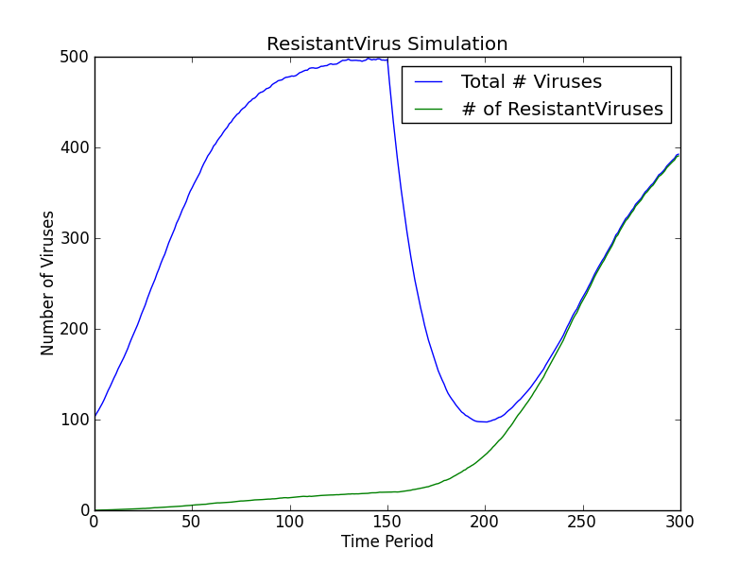

1. **What trends do you observe? Are they consistent with your intuition?**

The virus population rises during the first 150 steps (looks like the graph for SimpleVirus simulation) but drops dramatically after the drug is applied. The surviving (drug-resistant) viruses (which were few in number before) now increase greatly (until the total pop = resistant virus pop as all non-resistant viruses are dead).

**Problem 6: Delayed**

**\*4 histograms (300, 150, 75, 0 time step delays)**

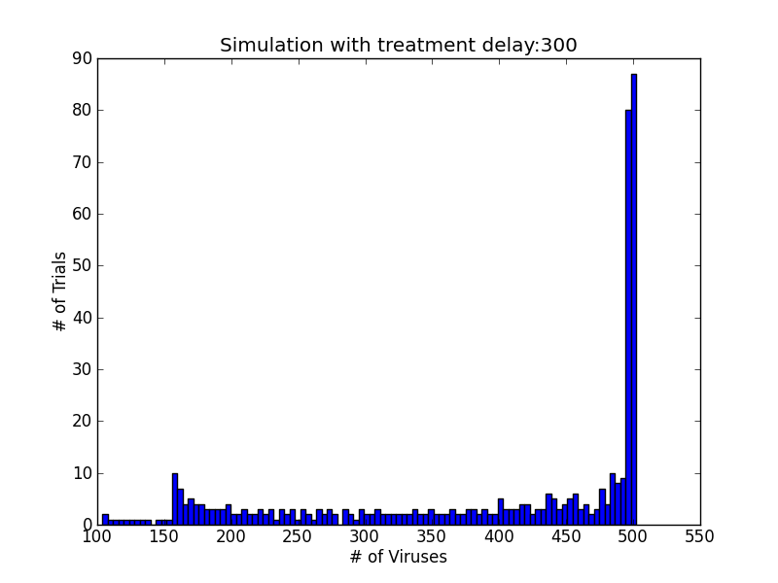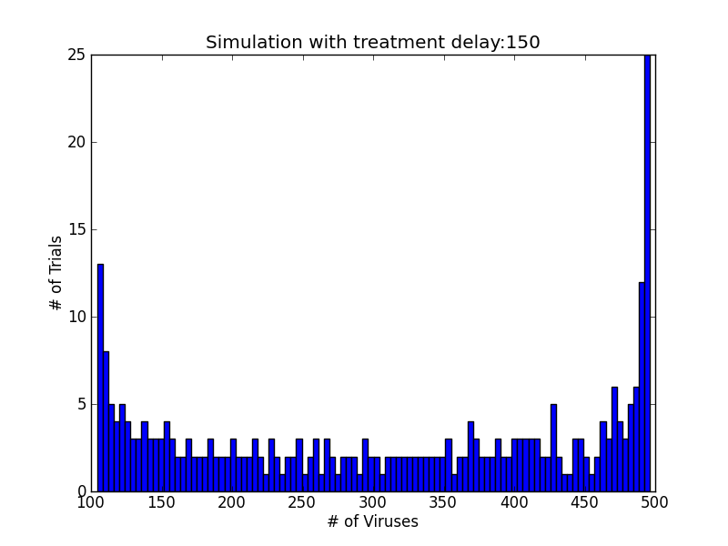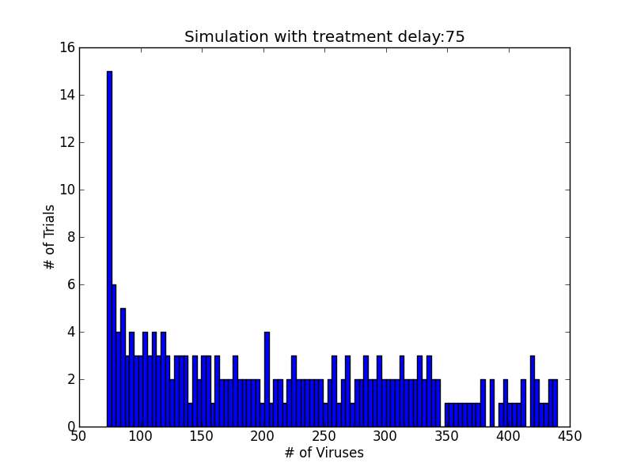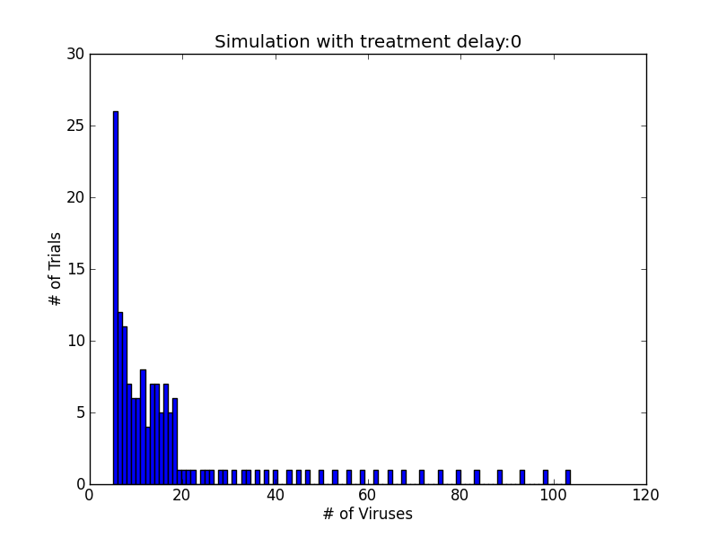

1. **The number of trials you repeated for each condition and why you think it is reasonable.**

*Tried 1, 25, 75, 100, 150, 300 for each condition. Graphs do not appear to change much after the following number of trials/condition:*

*Delay 0: 200*

*Delay 75: 50 is sufficient*

*Delay 150:*

*Delay 300:*

1. **If you consider final virus particle counts of 0-50 to be cured (or in remission), what percentage of patients was cured (or in remission) at the end of the simulation?**

*About half of the ones with 0 delay treatment and none of the others.*

1. **What is the relationship between the number of patients cured (or in remission) and the delay in treatment?**

*The earlier the drug is administered the greater the number of patients cured.*