Creating own Shell with Compilers

Abstract

Shell program is an application that acts as an interaction layer between the Operating System and the Computer hardware and features. The most popular shell programs in UNIX includes sh, csh, tcsh, ksh and bash; these are almost working well but has limited data types, debugging is hard and has dependencies that take time to configure. This paper will present testing techniques to conquer these limitations using a new advanced shell.
Keywords—Linux; Operating System; UNIX shells kernel; Malware; Limitations of shells; OS Architecture

Introduction
With continuous advancement in Science & Technology, the demand of Computer Scientists has increased along with more passionate students, but for a beginner, shells have a steeper learning curve as it lacks any UI. Furthermore, also the conventions used are difficult to memorize as those are barely abbreviations such as cd stands for change directory and “chmod” stands for change mode. As a result, beginners are scared of command-line and they just want to stick with GUI. Therefore, this research paper attempts to create a new shell which will enable a new Computer Science enthusiast to get into command-line and motivate him to use it to experience powerful tools and save time.

Background and Previous Work
A new shell can be created in multiple languages like C, Java, Python and so on and but to make the shell more efficient and powerful we are going to use C. Being lower level and closest to the hardware, it is one of the fastest programming languages. This language will allow us to explore the operating system in depth and add features that require the use of hardware.
“The earliest system software was written in assembly language primarily because there was no alternative, but also for reasons including efficiency of object code, compilation time, and ease of debugging [1].” Furthermore, research proves that it is impossible to create an operating system or interact with lower level hardware without the use of lower level languages such as Assembly and C. Even though Python is the easiest language, but it cannot be used because it is extremely high level.
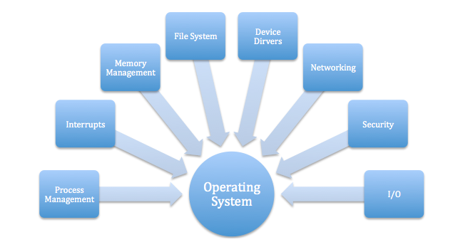

Fig. 1. Features to consider while making an OS/ Shell

Project Description
In order to create a shell, more powerful than the existing shells and which has commands more readable and easier to learn, our goal is going to first learn how an existing shell works. Therefore, the project goals to create a new shell as an add on the UNIX operating system which will not only enable programmers to compile the code but also to do calculations in the easiest way. For calculations, the project goal will be to handle all the exceptions and teach the user exactly what is happening. Along with every command the user types, the new shall will have abilities to auto-complete, suggest alternatives, tutorials and a lot more. For instance, when a user runs “5/0” it will give Zero Division error, but our goal is going to make it extremely simple by not just showing the error but by providing the steps to fix it.
The entire goal for this project is simplicity, to enable a layperson to use the shell and discover why the shell is way better without searching the internet. Furthermore, the project aims to add the following features to the custom shell:

Creating a new shell

Adding an ability to handle exception along with steps to fix it

Easier to memorize commands such use of changePerm instead of chmod

Adding an ability to compile multiple programming languages (preinstalled packages)

Ability to automate with one click such as running a line 10 times

Timeline
3.1. January 29 – Feb 15

Create a custom shell using C

3.2. Feb 16 – March 10

Adding all the features mentioned above

3.3. July 11 – July 25

Automate testing and results reporting, prepare written report. Make it ready to test in front of a lay man.

References

- “System programming language,” Wikipedia, 14-Jan-2019. [Online]. Available: https://en.m.wikipedia.org/wiki/System_programming_language. [Accessed: 27-Jan-2019].
- Balasundar, P. (2019). Introduction To Operating Systems. [online] Tech Blog. Available at: https://pbalasundar.wordpress.com/2012/06/11/introduction-to-operating-systems/ [Accessed 27 Jan. 2019].
- Anon, (2019). [online] Available at: https://www.quora.com/What-are-the-limitations-of-shell-scripting [Accessed 27 Jan. 2019].
- Balasundar, P. (2019). Introduction To Operating Systems. [online] Tech Blog. Available at: https://pbalasundar.wordpress.com/2012/06/11/introduction-to-operating-systems/ [Accessed 27 Jan. 2019].
- Himmelein, D. and profile, V. (2019). Build your own operating system. [online] Himmele.blogspot.com. Available at: http://himmele.blogspot.com/2011/07/build-your-own-operating-system.html [Accessed 27 Jan. 2019].

