**Easy section**

1. **2014**

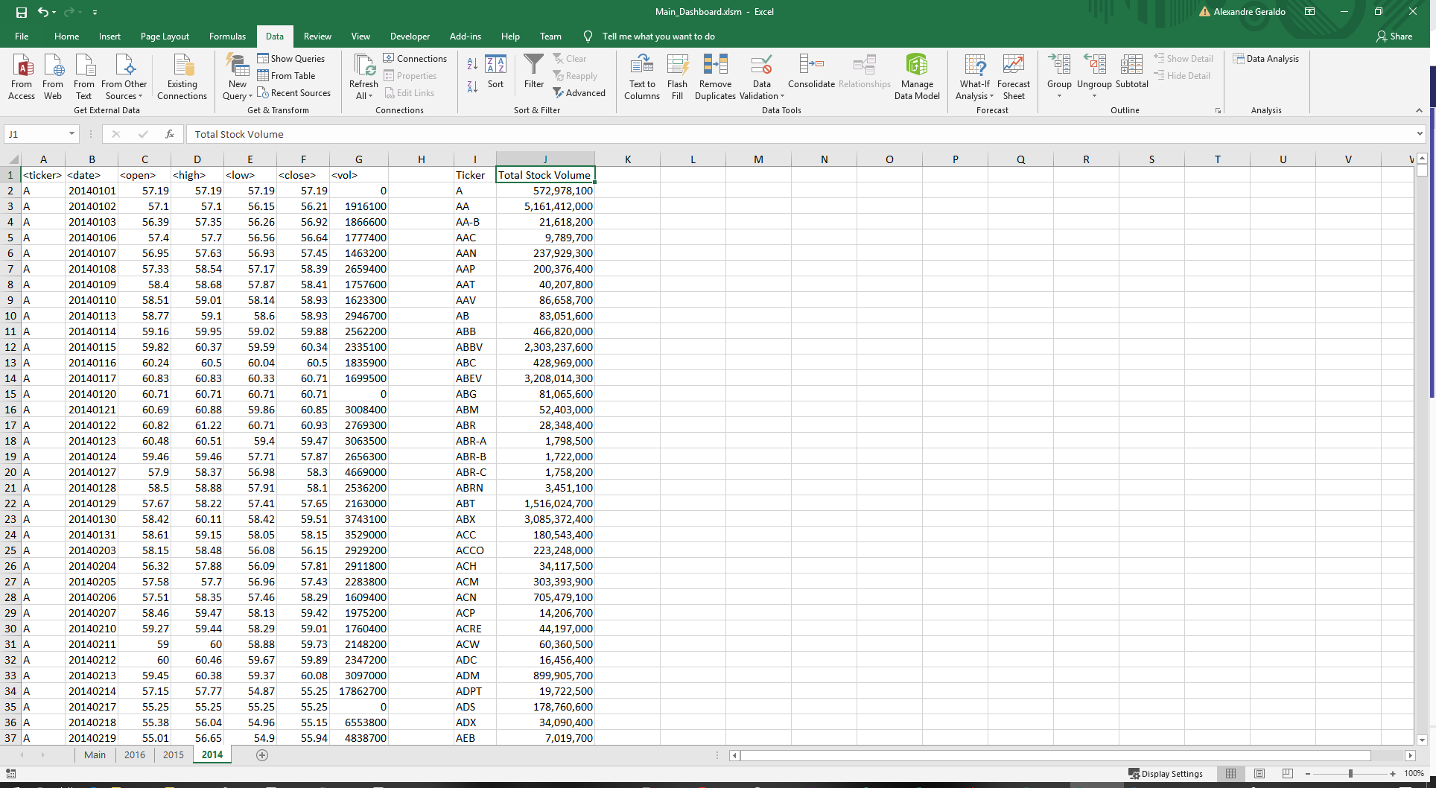

1. **2015**

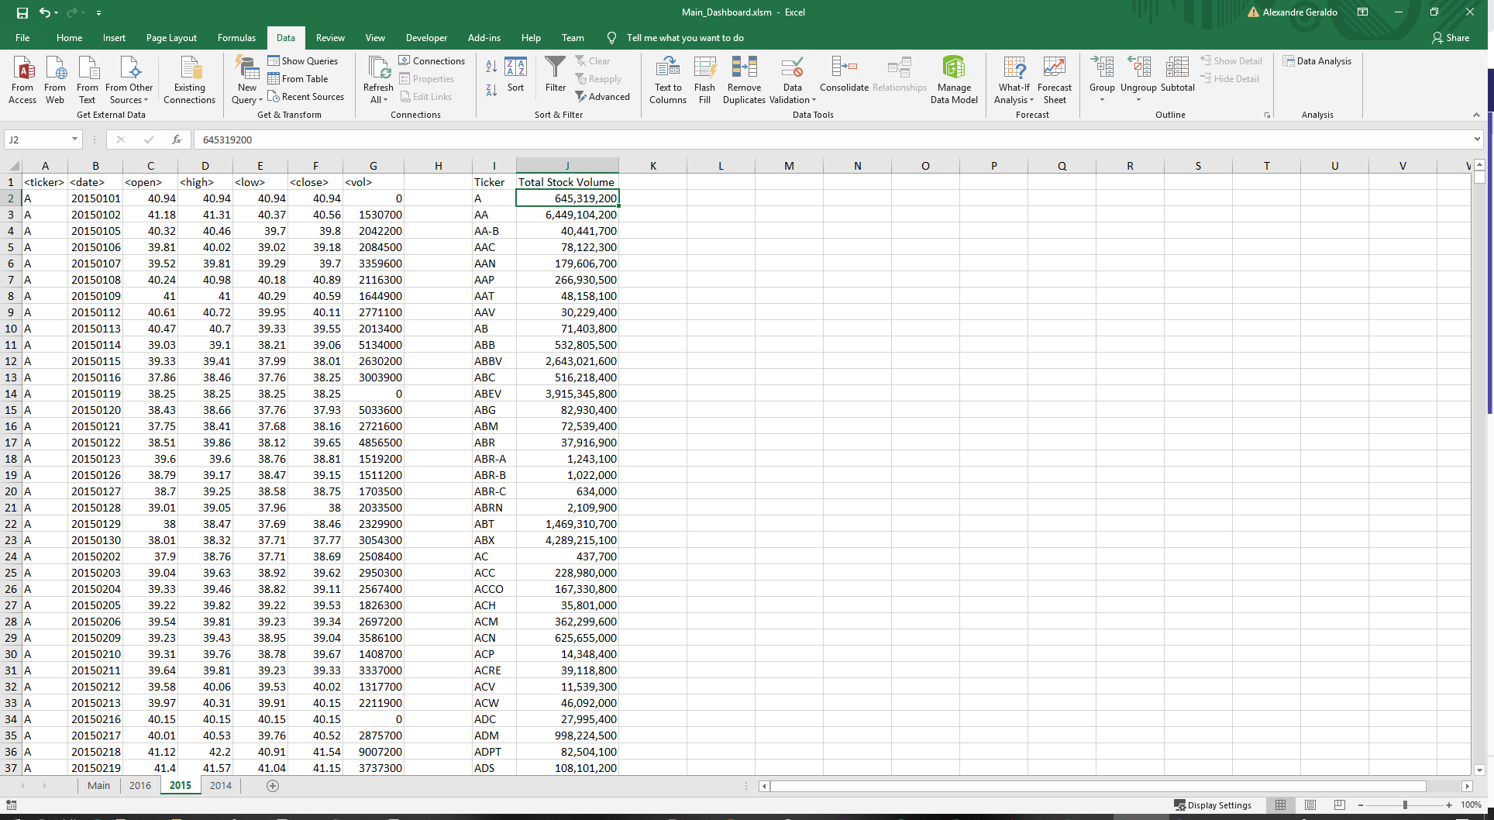

1. **2016**

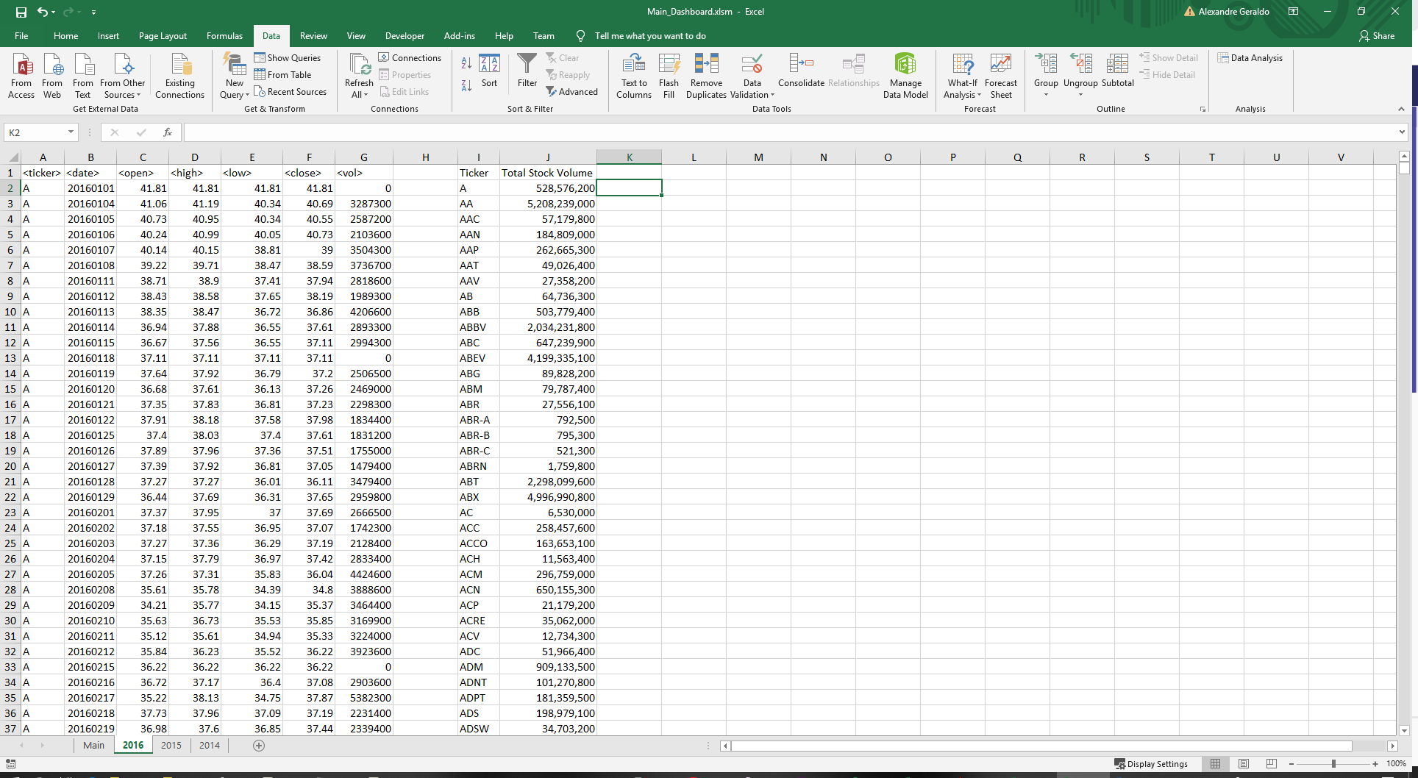

**Moderate section**

1. **2014**

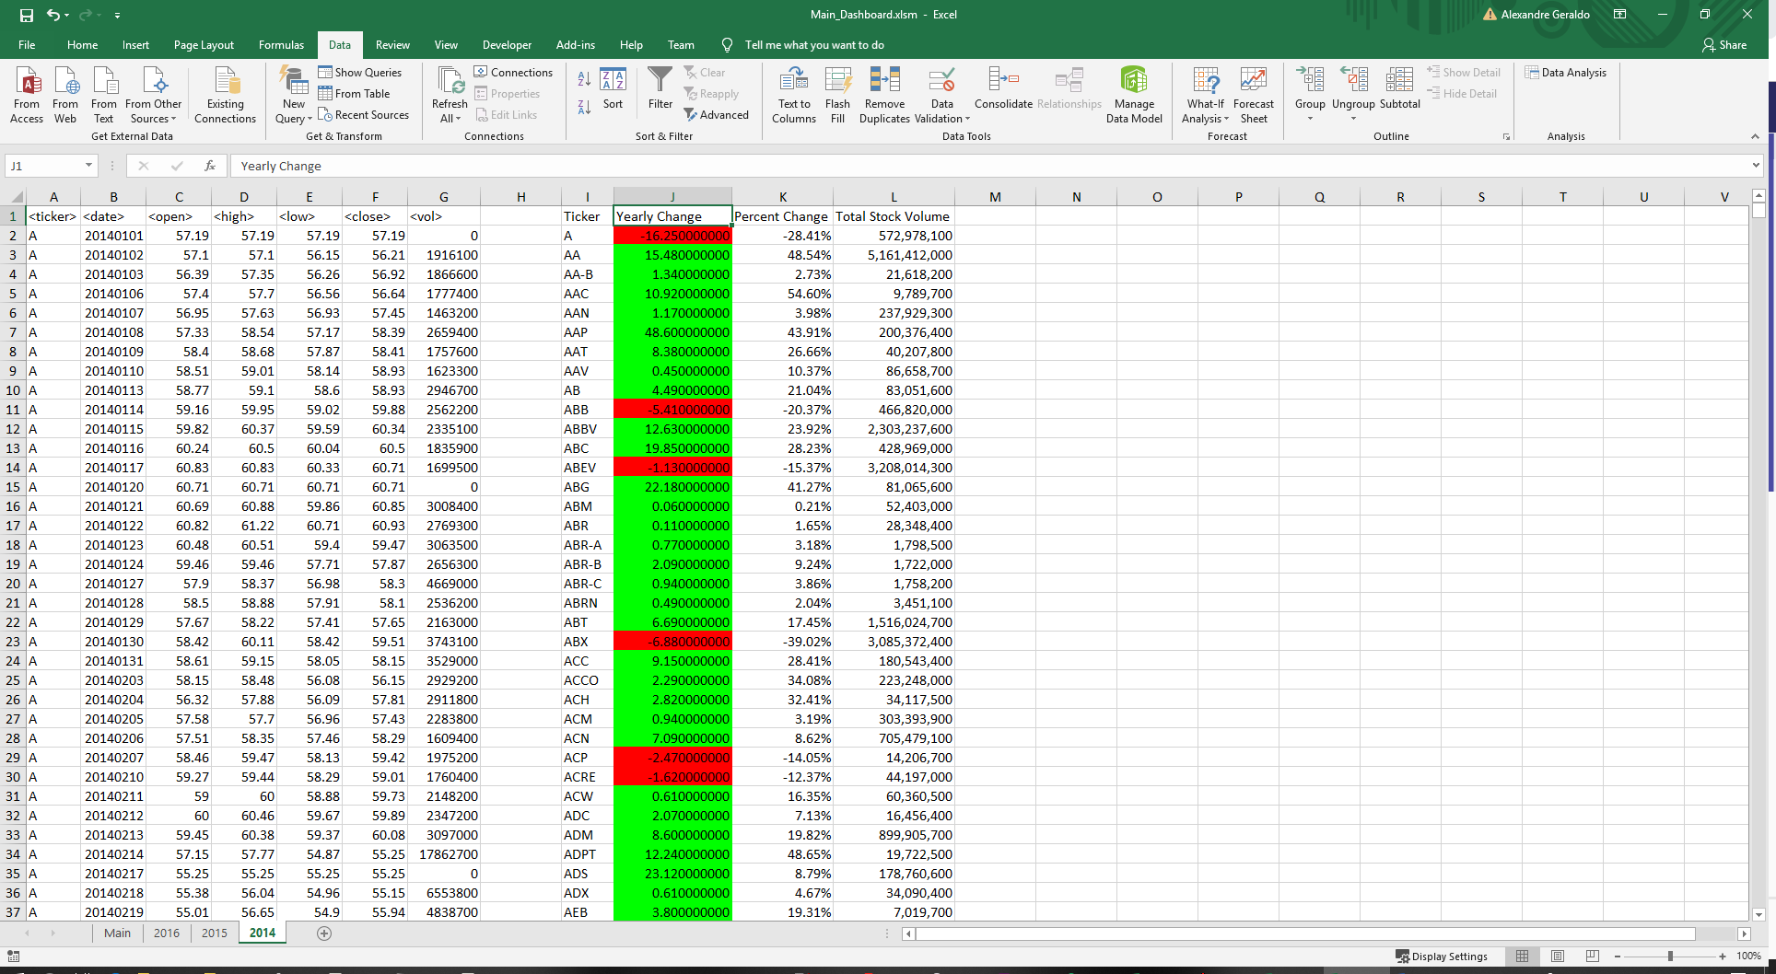

1. **2015**

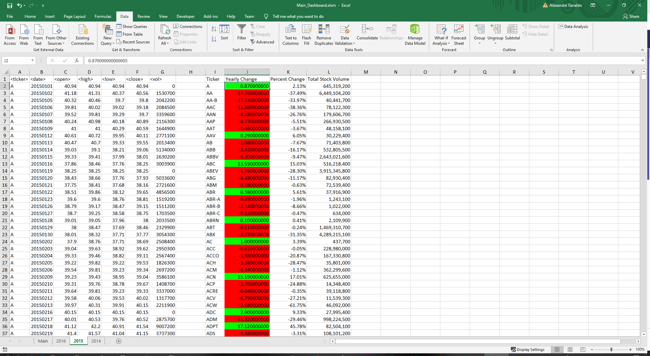

1. **2016**

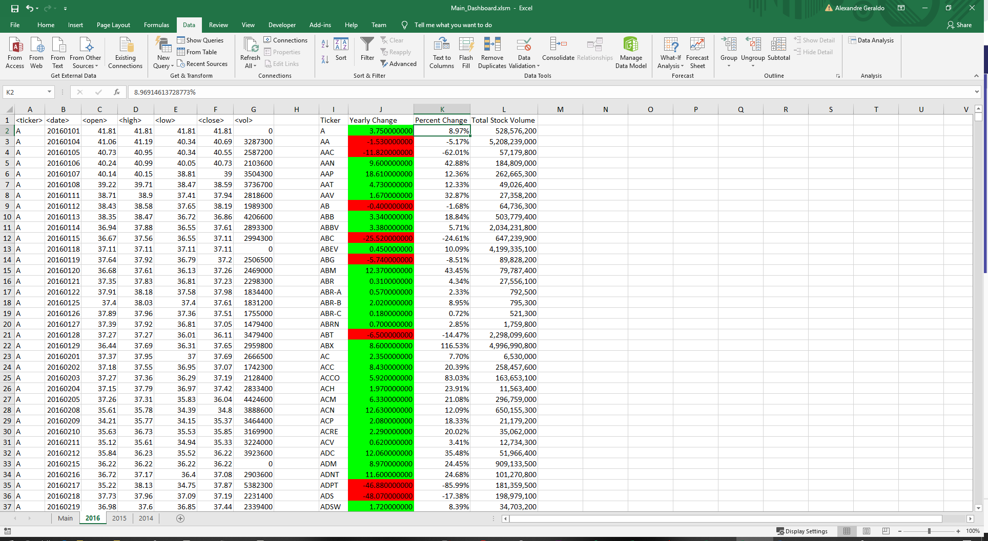

**Hard section**

1. **2014**

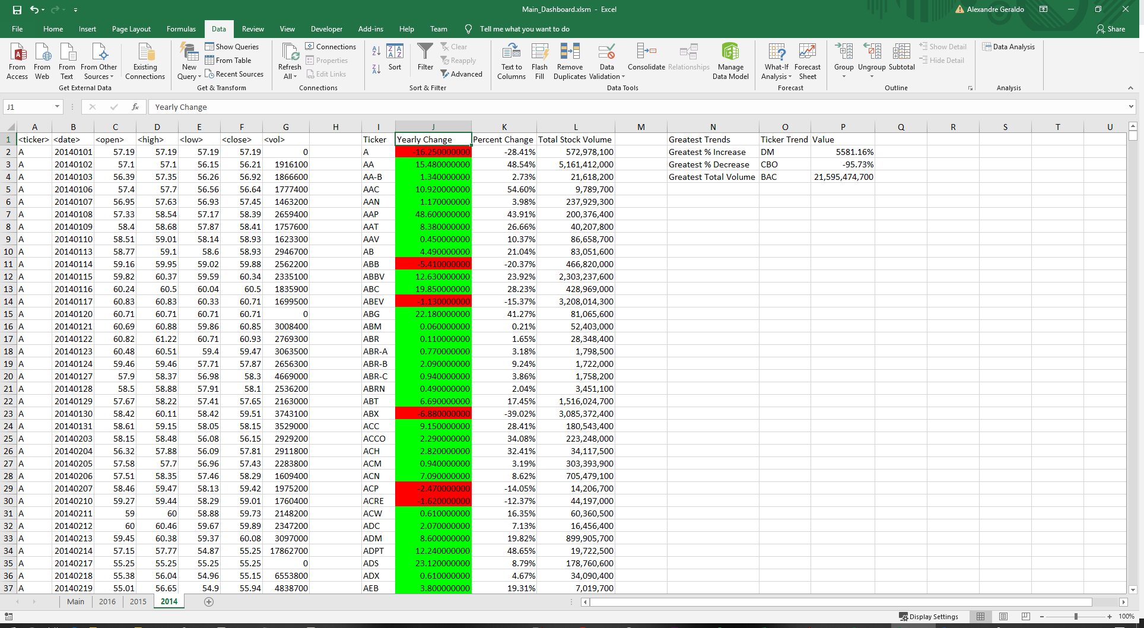

1. **2015**

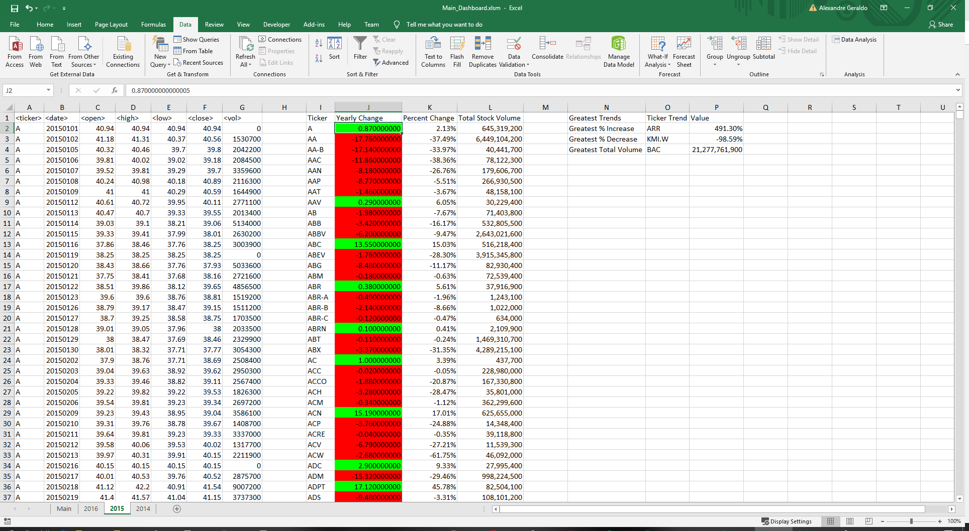

1. **2016**

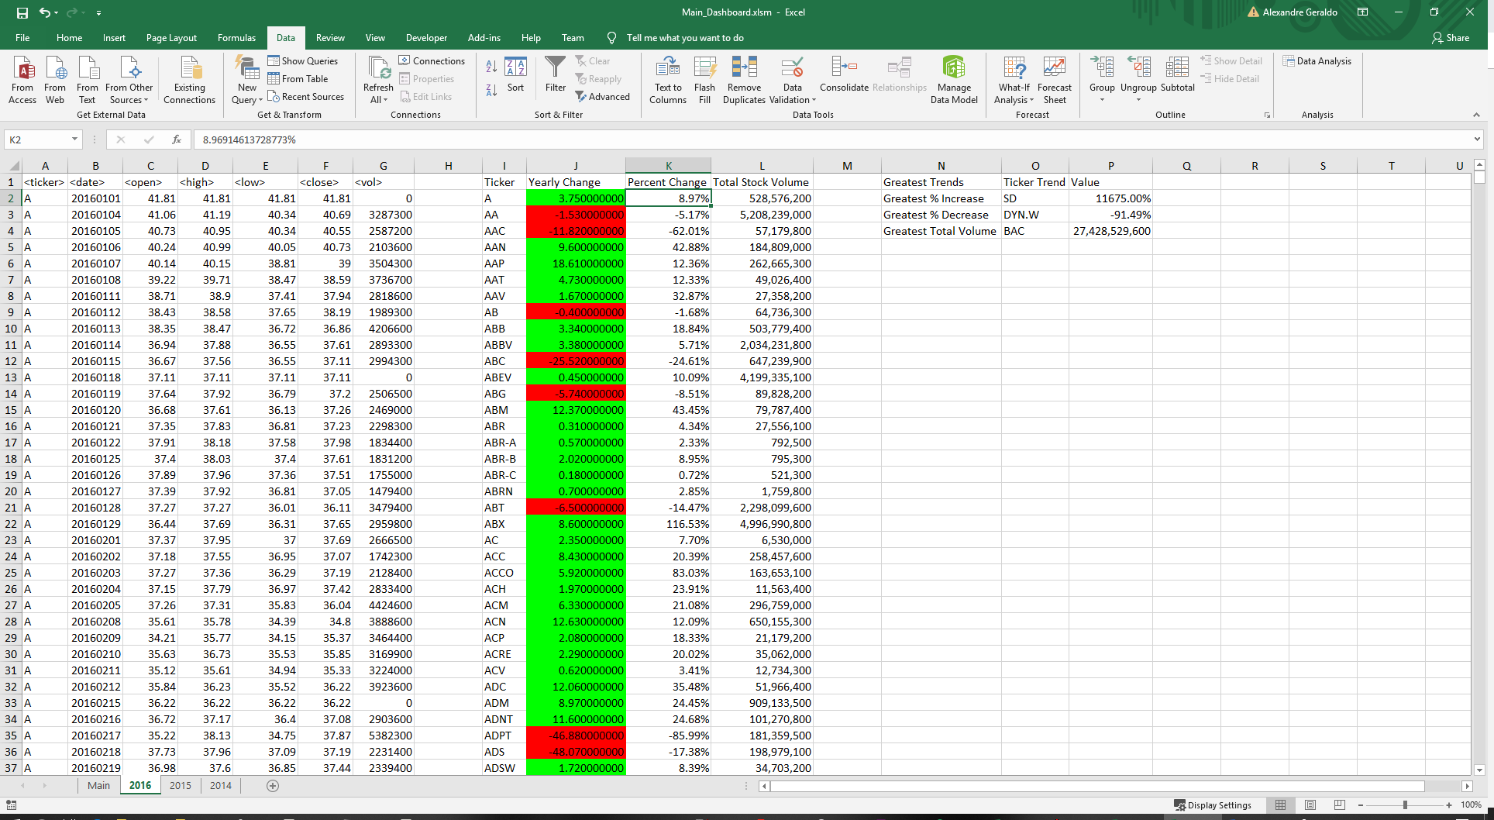

**Challenge section**

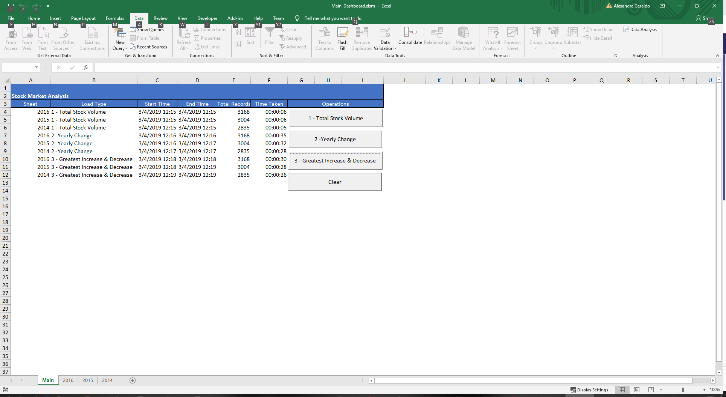

**Source Code**

**Github URL :** **https://github.com/ageraldo1/gt_data_science_hw/blob/master/Unit2/Main_Dashboard.cls**

VERSION 1.0 CLASS

BEGIN

MultiUse = -1 'True

END

Attribute VB_Name = "Sheet1"

Attribute VB_GlobalNameSpace = False

Attribute VB_Creatable = False

Attribute VB_PredeclaredId = True

Attribute VB_Exposed = True

Option Explicit

Const analysisDashboardSheetName = "Main"

Dim headerOperation1(1) As String

Dim headerOperation2(3) As String

Dim headerOperation3(6) As String

Private Sub endAnalysis(totalRecords As Long)

Dim currentRow As Long

With Worksheets.Item(analysisDashboardSheetName)

currentRow = .Cells(.Rows.Count, 1).End(xlUp).Row

.Cells(currentRow, 4).Value = Now()

.Cells(currentRow, 5).Value = totalRecords

.Cells(currentRow, 6).Value = .Cells(currentRow, 4).Value - .Cells(currentRow, 3).Value

.Cells(currentRow, 6).NumberFormat = "hh:mm:ss"

End With

Application.ScreenUpdating = True

End Sub

Private Sub startAnalysis(sheetName As String, analysisType As String)

Dim nextRow As Long

Application.ScreenUpdating = False

With Worksheets.Item(analysisDashboardSheetName)

nextRow = .Cells(.Rows.Count, 1).End(xlUp).Row + 1

.Cells(nextRow, 1).Value = sheetName

.Cells(nextRow, 2).Value = analysisType

.Cells(nextRow, 3).Value = Now()

End With

End Sub

Private Function loadADT(analysisType As Integer, activeSheet As Worksheet) As Object

Dim tickerADT As Object

Dim lastRow As Long

Dim tickerName As String

Dim tickerVolume As Double

Dim tickerValues(6) As Variant

Dim i As Long

Set tickerADT = CreateObject("Scripting.Dictionary")

lastRow = activeSheet.Range("A1").End(xlDown).Row

If analysisType = 1 Then

For i = 2 To lastRow

tickerName = activeSheet.Cells(i, 1).Value

tickerVolume = activeSheet.Cells(i, 7).Value

With tickerADT

If .Exists(tickerName) Then

.Item(tickerName) = .Item(tickerName) + tickerVolume

Else

.Add tickerName, tickerVolume

End If

End With

Next

ElseIf analysisType = 2 Then

' (0) = date_open

' (1) = date_close

' (2) = open

' (3) = close

' (4) = yearly change = closed - open

' (5) = % change = yearly change / open

' (6) = total stock volume

For i = 2 To lastRow

tickerName = activeSheet.Cells(i, 1).Value

tickerValues(0) = activeSheet.Cells(i, 2).Value

tickerValues(1) = activeSheet.Cells(i, 2).Value

tickerValues(2) = activeSheet.Cells(i, 3).Value

tickerValues(3) = activeSheet.Cells(i, 6).Value

tickerValues(4) = tickerValues(3) - tickerValues(2)

If (tickerValues(2) > 0) Then

tickerValues(5) = tickerValues(4) / tickerValues(2)

Else

tickerValues(5) = 0

End If

tickerValues(6) = activeSheet.Cells(i, 7).Value

With tickerADT

If .Exists(tickerName) Then

If DateDiff("d", CDate(Mid(tickerValues(0), 1, 4) & "-" & Mid(tickerValues(0), 5, 2) & "-" & Mid(tickerValues(0), 7)), CDate(Mid(.Item(tickerName)(0), 1, 4) & "-" & Mid(.Item(tickerName)(0), 5, 2) & "-" & Mid(.Item(tickerName)(0), 7))) < 0 Then

tickerValues(0) = .Item(tickerName)(0)

tickerValues(2) = .Item(tickerName)(2)

End If

If DateDiff("d", CDate(Mid(tickerValues(1), 1, 4) & "-" & Mid(tickerValues(1), 5, 2) & "-" & Mid(tickerValues(1), 7)), CDate(Mid(.Item(tickerName)(1), 1, 4) & "-" & Mid(.Item(tickerName)(1), 5, 2) & "-" & Mid(.Item(tickerName)(1), 7))) > 0 Then

tickerValues(1) = .Item(tickerName)(1)

tickerValues(3) = .Item(tickerName)(3)

End If

tickerValues(4) = tickerValues(3) - tickerValues(2)

If (tickerValues(2) > 0) Then

tickerValues(5) = tickerValues(4) / tickerValues(2)

Else

tickerValues(5) = 0

End If

tickerValues(6) = .Item(tickerName)(6) + tickerValues(6)

.Item(tickerName) = tickerValues

Else

.Add tickerName, tickerValues

End If

End With

Next

End If

Set loadADT = tickerADT

End Function

Private Sub cmd_clear_Click()

Dim activeSheet As Worksheet

Dim deleteRange As Range

Dim lastRow As Long

Dim lastColumn As Long

Dim i, y As Long

For Each activeSheet In Worksheets

If activeSheet.Name = analysisDashboardSheetName Then

lastRow = activeSheet.Range("A3").End(xlDown).Row

If lastRow <> activeSheet.Rows.Count Then

For i = 4 To lastRow

With activeSheet

For y = 1 To 6

.Cells(i, y).Clear

Next

End With

Next

End If

Else

For i = 0 To UBound(headerOperation1)

With activeSheet.UsedRange

Set deleteRange = .Find(What:=headerOperation1(i), MatchCase:=True, LookAt:=xlWhole)

If Not deleteRange Is Nothing Then

deleteRange.EntireColumn.Delete

End If

End With

Next

For i = 0 To UBound(headerOperation2)

With activeSheet.UsedRange

Set deleteRange = .Find(What:=headerOperation2(i), MatchCase:=True, LookAt:=xlWhole)

If Not deleteRange Is Nothing Then

deleteRange.EntireColumn.Delete

End If

End With

Next

For i = 0 To UBound(headerOperation3)

With activeSheet.UsedRange

Set deleteRange = .Find(What:=headerOperation3(i), MatchCase:=True, LookAt:=xlWhole)

If Not deleteRange Is Nothing Then

deleteRange.EntireColumn.Delete

End If

End With

Next

End If

Next

End Sub

Private Sub cmd1_Click()

Dim tickerDict As Object

Dim tickerKey As Variant

Dim activeSheet As Worksheet

Dim nextColumn As Long

Dim i As Long

Set tickerDict = CreateObject("Scripting.Dictionary")

headerOperation1(0) = "Ticker"

headerOperation1(1) = "Total Stock Volume"

For Each activeSheet In Worksheets

If activeSheet.Name <> analysisDashboardSheetName Then

startAnalysis activeSheet.Name, cmd1.Caption

'***** load data structure

Set tickerDict = loadADT(1, activeSheet)

'***** print data structure

nextColumn = activeSheet.Range("A1").End(xlToRight).Column + 2

i = 2

With activeSheet

.Cells(1, nextColumn).Value = headerOperation1(0)

.Cells(1, nextColumn + 1).Value = headerOperation1(1)

For Each tickerKey In tickerDict.Keys

.Cells(i, nextColumn).Value = tickerKey

.Cells(i, nextColumn + 1).Value = tickerDict.Item(tickerKey)

.Cells(i, nextColumn + 1).NumberFormat = "#,##0"

i = i + 1

Next

.Cells.EntireColumn.AutoFit

End With

endAnalysis (tickerDict.Count)

End If

Next

End Sub

Private Sub cmd2_Click()

Dim tickerDict As Object

Dim tickerKey As Variant

Dim activeSheet As Worksheet

Dim nextColumn As Long

Dim i As Long

Set tickerDict = CreateObject("Scripting.Dictionary")

headerOperation2(0) = "Ticker"

headerOperation2(1) = "Yearly Change"

headerOperation2(2) = "Percent Change"

headerOperation2(3) = "Total Stock Volume"

For Each activeSheet In Worksheets

If activeSheet.Name <> analysisDashboardSheetName Then

startAnalysis activeSheet.Name, cmd2.Caption

'***** load data structure

Set tickerDict = loadADT(2, activeSheet)

'***** print data structure

nextColumn = activeSheet.Range("A1").End(xlToRight).Column + 2

i = 2

With activeSheet

.Cells(1, nextColumn).Value = headerOperation2(0)

.Cells(1, nextColumn + 1).Value = headerOperation2(1)

.Cells(1, nextColumn + 2).Value = headerOperation2(2)

.Cells(1, nextColumn + 3).Value = headerOperation2(3)

For Each tickerKey In tickerDict.Keys

.Cells(i, nextColumn).Value = tickerKey

.Cells(i, nextColumn + 1).Value = tickerDict.Item(tickerKey)(4)

.Cells(i, nextColumn + 1).Interior.ColorIndex = IIf(tickerDict.Item(tickerKey)(4) > 0, 4, 3)

.Cells(i, nextColumn + 1).NumberFormat = "#,##0.000000000"

.Cells(i, nextColumn + 2).Value = tickerDict.Item(tickerKey)(5)

.Cells(i, nextColumn + 2).NumberFormat = "0.00%"

.Cells(i, nextColumn + 3).Value = tickerDict.Item(tickerKey)(6)

.Cells(i, nextColumn + 3).NumberFormat = "#,##0"

i = i + 1

Next

.Cells.EntireColumn.AutoFit

End With

endAnalysis (tickerDict.Count)

End If

Next

End Sub

Private Sub cmd3_Click()

Dim tickerDict As Object

Dim tickerKey As Variant

Dim activeSheet As Worksheet

Dim nextColumn As Long

Dim i As Long

Dim gIncrease() As Variant

Dim gDecrease() As Variant

Dim gVolume() As Variant

Set tickerDict = CreateObject("Scripting.Dictionary")

headerOperation3(0) = "Ticker"

headerOperation3(1) = "Yearly Change"

headerOperation3(2) = "Percent Change"

headerOperation3(3) = "Total Stock Volume"

headerOperation3(4) = "Greatest Trends"

headerOperation3(5) = "Ticker Trend"

headerOperation3(6) = "Value"

For Each activeSheet In Worksheets

If activeSheet.Name <> analysisDashboardSheetName Then

startAnalysis activeSheet.Name, cmd3.Caption

'***** load data structure

Set tickerDict = loadADT(2, activeSheet)

'***** print data structure

nextColumn = activeSheet.Range("A1").End(xlToRight).Column + 2

i = 2

With activeSheet

.Cells(1, nextColumn).Value = headerOperation3(0)

.Cells(1, nextColumn + 1).Value = headerOperation3(1)

.Cells(1, nextColumn + 2).Value = headerOperation3(2)

.Cells(1, nextColumn + 3).Value = headerOperation3(3)

ReDim gIncrease(1), gDecrease(1), gVolume(1)

For Each tickerKey In tickerDict.Keys

.Cells(i, nextColumn).Value = tickerKey

.Cells(i, nextColumn + 1).Value = tickerDict.Item(tickerKey)(4)

.Cells(i, nextColumn + 1).Interior.ColorIndex = IIf(tickerDict.Item(tickerKey)(4) > 0, 4, 3)

.Cells(i, nextColumn + 1).NumberFormat = "#,##0.000000000"

.Cells(i, nextColumn + 2).Value = tickerDict.Item(tickerKey)(5)

.Cells(i, nextColumn + 2).NumberFormat = "0.00%"

.Cells(i, nextColumn + 3).Value = tickerDict.Item(tickerKey)(6)

.Cells(i, nextColumn + 3).NumberFormat = "#,##0"

If (Len(gIncrease(0)) = 0 Or tickerDict.Item(tickerKey)(5) > gIncrease(1)) Then

gIncrease(0) = tickerKey

gIncrease(1) = tickerDict.Item(tickerKey)(5)

End If

If (Len(gDecrease(0)) = 0 Or tickerDict.Item(tickerKey)(5) < gDecrease(1)) Then

gDecrease(0) = tickerKey

gDecrease(1) = tickerDict.Item(tickerKey)(5)

End If

If (Len(gVolume(0)) = 0 Or tickerDict.Item(tickerKey)(6) > gVolume(1)) Then

gVolume(0) = tickerKey

gVolume(1) = tickerDict.Item(tickerKey)(6)

End If

i = i + 1

Next

'*** greatest trends

nextColumn = nextColumn + 5

.Cells(1, nextColumn).Value = headerOperation3(4)

.Cells(1, nextColumn + 1).Value = headerOperation3(5)

.Cells(1, nextColumn + 2).Value = headerOperation3(6)

.Cells(2, nextColumn).Value = "Greatest % Increase"

.Cells(2, nextColumn + 1).Value = gIncrease(0)

.Cells(2, nextColumn + 2).Value = gIncrease(1)

.Cells(2, nextColumn + 2).NumberFormat = "0.00%"

.Cells(3, nextColumn).Value = "Greatest % Decrease"

.Cells(3, nextColumn + 1).Value = gDecrease(0)

.Cells(3, nextColumn + 2).Value = gDecrease(1)

.Cells(3, nextColumn + 2).NumberFormat = "0.00%"

.Cells(4, nextColumn).Value = "Greatest Total Volume"

.Cells(4, nextColumn + 1).Value = gVolume(0)

.Cells(4, nextColumn + 2).Value = gVolume(1)

.Cells(4, nextColumn + 2).NumberFormat = "#,##0"

.Cells.EntireColumn.AutoFit

End With

endAnalysis (tickerDict.Count)

End If

Next

End Sub