Lab Questions
Big Java, Late Objects / Java for Everyone, 2e

Chapter Number: 14 Sorting and Searching

1.1) When evaluating sorting algorithms, there many factors that might affect how fast an algorithm will run when it is programmed for a real machine: CPU speed, language used, type of data being sorted, type of operating system, and the number of concurrent processes running at the same time. For this reason, comparing actual running times of an algorithm is ineffectual for making judgments about how good the algorithm might be. To effectively make a judgment that is free of real world constraints, computer scientists, when comparing sorting algorithms, often simply count the number of comparisons an algorithm makes.

In this exercise, we will add a counter to the MergeSorter program to help us measure the number of comparisons of array elements being made while the routine is completing the sort.

The MergeSorter code is listed below.

private static void merge(int[] first, int[] second, int[] a)
{
int iFirst = 0; // Next element to consider in the first array
int iSecond = 0; // Next element to consider in the second array
int j = 0; // Next open position in a

// As long as neither iFirst nor iSecond is past the end, move
// the smaller element into a
while (iFirst < first.length && iSecond < second.length)
{
if (first[iFirst] < second[iSecond])
{
a[j] = first[iFirst];
iFirst++;
}
else
{
a[j] = second[iSecond];
iSecond++;
}
j++;
}

// Note that only one of the two loops below copies entries
// Copy any remaining entries of the first array
while (iFirst < first.length)
{
a[j] = first[iFirst];
iFirst++; j++;
}
// Copy any remaining entries of the second half
while (iSecond < second.length)
{
a[j] = second[iSecond];
iSecond++; j++;
}
}

The behavior we want to monitor occurs in this section of code,

if (first[iFirst] < second[iSecond])
{
a[j] = first[iFirst];
iFirst++;
}
else
{
a[j] = second[iSecond];
iSecond++;
}

It is in the above section that we compare array elements and decide which element becomes part of our merged and sorted array. By counting the number of comparisons here, we obtain a measurement that helps us gauge the speed of the algorithm. Add code that will count each comparison, maintaining the result in an integer counter. Supply a method getCounter to retrieve the counter. Supply a second method called resetCounter to set the counter to 0.

The code below supports creating and swapping elements in arrays of varying sizes.

/**
This class contains utility methods for array manipulation.
*/
public class ArrayUtil
{
/**
Creates an array filled with random values.
@param length the length of the array
@param n the number of possible random values
@return an array filled with length numbers between
0 and n - 1
*/
public static int[] randomIntArray(int length, int n)
{
int[] a = new int[length];
for (int i = 0; i < a.length; i++)
{
a[i] = (int) (Math.random() * n);
}

return a;
}

/**
Swaps two entries of an array.
@param a the array
@param i the first position to swap
@param j the second position to swap
*/
public static void swap(int[] a, int i, int j)
{
int temp = a[i];
a[i] = a[j];
a[j] = temp;
}
}

Modify the main program below so you can test sorting arrays with sizes 10000, 20000, …,90000.

/**
This program demonstrates the merge sort algorithm by
sorting an array that is filled with random numbers.
*/
public class MergeSortDemo
{
public static void main(String[] args)
{
int[] a = ArrayUtil.randomIntArray(10000, 10000);
MergeSorter.resetCounter();
MergeSorter.sort(a);
System.out.println("Array size: 10000; comparisons: " + MergeSorter.getCounter());
}
}

What are your results?

2.1) In this lab, you will implement the bubble sort algorithm. The bubble sort is so called because it compares adjacent items, "bubbling" the smaller one up toward the beginning of the array. By comparing all pairs of adjacent items starting at the end of the array, the smallest item is guaranteed to reach the beginning of the array at the end of the first pass.

The second pass begins again at the end of the array, ultimately placing the second smallest item in the second position. During the second pass, there is no need to compare the first and second items, because the smallest element is guaranteed to be in the first position.

Bubble sort takes at most n - 1 passes for an array of n items. During the first pass, n - 1 pairs need to be compared. During the second pass, n - 2 pairs need to be compared. During the ith pass, n - i pairs need to be compared. During the last pass, n - (n - 1) or one pair needs to be compared. If, during any pass, no two adjacent items need to be interchanged, the array is in order and the sort can terminate. If it continues, no further interchanges will occur.

What is the code of your BubbleSorter class?

2.2) Describe the efficiency of the bubble sort algorithm and represent it in big-Oh notation.

2.3) A variation of the bubble sort algorithm starts each pass at the beginning of the list, interchanging items as needed so that a larger item "sinks" below a smaller item following each comparison. (Such a sort might be called a "rock sort," but this term is not in common usage.)

Implement this variation for sorting an array. What is the code for your sort method?

3.1) We want to sort a list of cities by name; however, if there are two cities with the same name, then we use the state name as tie breaker. Implement a City class and a constructor

public City(String name, String state)

Also supply a toString method; we will need it for testing.

Have your City class implement the Comparable<City> interface.

What is the code of your City class?

3.2. Write a CitySortDemo class that populates an ArrayList<City> with cities and then sorts it. What is the code of your class? Remember that you can use Collections.sort to sort an array list.

3.3 Now we want to sort lists of cities first by state name, then by city name, without modifying the implementation of the City class. That means you cannot redefine the compareTo method. Instead, define a CityComparator class that implements the Comparator<City> interface.

public class CityComparator implements Comparator<City>
{
public int compare(City a, City b)
{
. . .
}
}

What is the code of your CityComparator class?

3.4) Write a CitySortDemo2 class that populates an ArrayList<City> with cities and then sorts it, using a CityComparator. What is the code of your class?

4.1) In this lab, you will implement a “guess your name” game where the computer finds a name in a sorted list of names. The computer will use this method to “guess” your last name:

This program tries to guess your last name, but you have to give some hints.
Does your name come before "MYERSCOUGH" in the dictionary? (Y/N) Y
Does your name come before "ISENBERG" in the dictionary? (Y/N) Y
Does your name come before "DIMAGGIO" in the dictionary? (Y/N) N
Does your name come before "GALLUP" in the dictionary? (Y/N) N

. . .
Is your name "HORSTMANN"? (Y/N) Y

Start out with a program that reads all names from the "last names" file at http://www.census.gov/genealogy/www/data/1990surnames/names_files.html. Discard the statistical information. Sort the names, using Collections.sort.

Use this code outline:

public class NameGuesser
{
private ArrayList<String> lastNames = new ArrayList<String>();

public void readNames() throws IOException, MalformedURLException
{
URL url = new URL("http://www.census.gov/genealogy/names/dist.all.last");
Scanner in = new Scanner(url.openStream());
. . .
}
}

What is the code for reading all names and sorting them?

4.2) Now you will implement the method that guesses the name, called guessName.

At the beginning of the search, set low to 0 and high to the maximum index of the names list. Set mid to the average of low and high, then ask the user if the name comes before the list entry at index mid. Depending on the answer, update low or high. If low == high, ask if the name matches.

What is the code for your guessName method?

4.3) How many entries does your names list have? How many guesses does your program need to make until it has guessed the user's name or given up? (Use big-Oh for your answer.)

5) In Chapter 13 we developed a class of static methods that manipulated ArrayLists of Integers. These methods included even, odd, and merge (see Lab 13.1.5 – 13.1.7). Recall that merge combines two sorted lists into a single sorted list by comparing elements at the head of each list to decide which element appears next in the sorted result. In combination, these three methods can be used to implement a recursive mergeSort method for ArrayLists.

Consider the unsorted list x = {12, 5, 9, 4, 21, 3, 33, 49, 18}. Applying even to x we can get list a = {12, 9, 21, 33, 18} and applying odd to x we can get list b = {5, 4, 3, 49}. Because lists a and b are smaller in size than x, we can recursively mergeSort a and b to obtain sorted lists c = {9, 12, 18, 21, 33} and d = {3, 4, 5, 49}. Remember that we are using recursion here, so we don’t have to show how mergeSort(c) and mergeSort(d) will work, we just have to show how the solutions to these smaller problems can be combined to sort list a. Applying merge to sorted lists c and d solves the problem of sorting x. Of course, this has to be written using logic that will stop the recursion when the lists are empty or contain a single item.

Write the code that will construct a mergeSort method with the following header:

public static ArrayList<Integer> mergeSort(ArrayList<Integer> tList)

Use the following code as a test harness for mergeSort:

import java.util.ArrayList;

public class ListMethodsRunner
{
public static void main(String[] args)
{
ArrayList<Integer> list1 = new ArrayList<Integer>();
list1.add(2);
list1.add(3);
list1.add(5);
list1.add(9);
list1.add(22);
list1.add(38);
list1.add(56);
list1.add(4);
list1.add(7);
list1.add(8);
list1.add(23);
list1.add(37);
ArrayList<Integer> tempList = ListMethods.mergeSort(list1);
if (tempList.size() == 0)
{
System.out.println("The list is empty");
}
else
{
for (Integer i : tempList)
{
System.out.println(i);
}
}
}
}

6.1) Imagine facing a rectangular formation of soldiers with m soldiers in each row and n soldiers in each column. We rearrange the soldiers by height following these rules in sequence:

The Soldier Sort
Each column of soldiers is sorted from tallest to shortest moving from back to front.
Each row of soldiers is sorted from tallest to shortest moving left to right.

The surprising fact is that after sorting each row, the soldiers are still sorted in each column. Following this procedure produces a formation of soldiers that is pleasing and looks more uniform than a formation in which the soldiers are randomly placed. Examining the formation we see the tallest soldier in the back, left, and the shortest soldier in the front right. The chart below represents an array of 10 rows and 15 columns of integers in the range 100 – 199. The values were randomly generated and placed in an array, and the array was “Soldier sorted”.

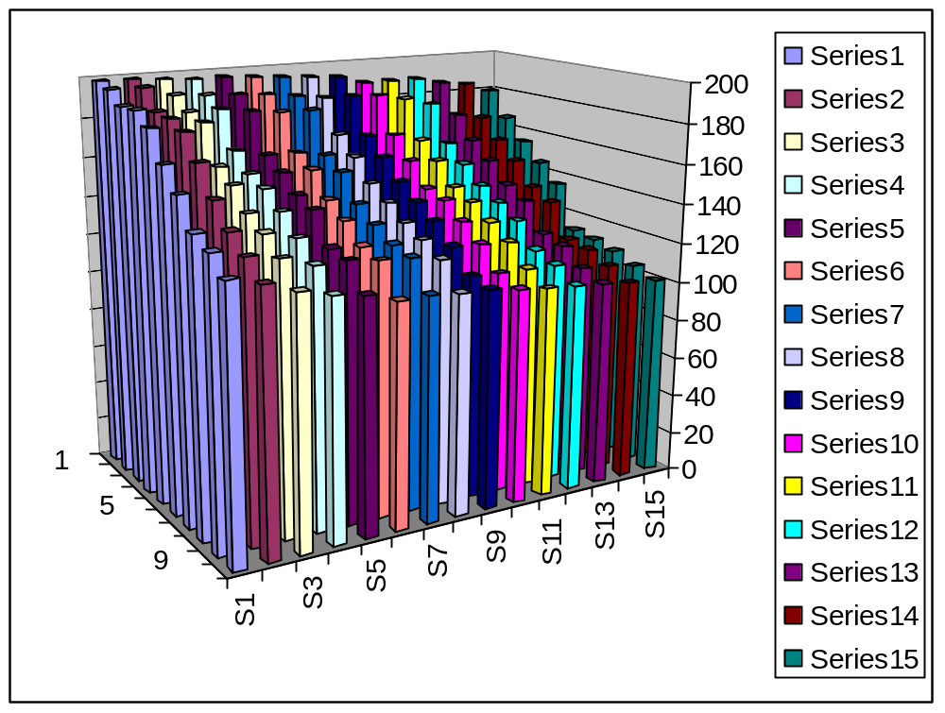

The code below generates a 10 by 15 integer array with data similar to the data in the chart above.

public class SoldierRunner
{
public static void main(String[] args)
{
final int ROWSIZE = 10;
final int COLSIZE = 15;
int[][] formation = new int[ROWSIZE][COLSIZE];
for (int i = 0; i < ROWSIZE; i++)
{
for (int j = 0; j < COLSIZE; j++)
{
formation[i][j] = (int)(Math.random() * 100) + 100;
}
}
// Print the initial formation
System.out.println("------------Initial formation------------------");
for (int i = 0; i < ROWSIZE; i++)
{
for (int j = 0; j < COLSIZE; j++)
{
System.out.print(formation[i][j] + " ");
}
System.out.println();
}
}
}

Add the code necessary to soldier sort the array and print the sorted formation. Use merge sort to sort each row and each column.

