Overview

Of

Charity Shop Daily Takings System

Date: 13/09/2023

# Introduction

* 1. Document Scope

This document outlines the purposes of the charity shop daily takings system. Technical details will not be incorporated within the scope of this document.

* 1. Intended Audience

This document is intended for users of the system and the charity SMT. In addition, this document should be made available to any technical services staff who are subsequently responsible for supporting or maintaining the system.

* 1. Version Control

|  |  |  |  |  |
| --- | --- | --- | --- | --- |
| Date | Version | Author | Section | Amendment |
| 13/09/2023 | 1.0 | Neil Carthy |  | Initial Document |
|  |  |  |  |  |
|  |  |  |  |  |
|  |  |  |  |  |

* 1. Acronyms and Abbreviations

|  |  |
| --- | --- |
| CC | Credit cards |
| COB | Close of Business |
| PDF | Portable document format, the adobe standard for document exchange |
| POS | Point of Sale (the cash register) |
| QBO | Quickbooks Online |
| SMT | Senior Management Team |
| YTD | Year to Date |

# System Description

* 1. Background

The charity runs a shop at 522 Harrow Road selling donated clothes and goods. This is a standalone retail enterprise wholly owned by the charity. It must generate a decent return on investment while being as efficient in management time consumption as possible.

The shop is open 300 days a year. Every trading day dozens of items are sold. The daily takings system is a means of recording retail data so that it can be analysed and tracked to ensure optimal performance.

* 1. Purpose

The system supports the following business objectives:

* Provide shop employees the ability to enter the required retail data.
* Track retail sales to observe trends.
* Track sales by department to assist with allocation of floor area.
* Track expenses paid by cash such as volunteers’ lunches.
* Track any cash discrepancy for each trading day. A cash discrepancy will arise when the amount of sales recorded at the till differs from the amount of money received.
* Track money received via Credit Cards versus Cash.
* Record daily sales in Quickbooks Online accounting system.
  1. Assumptions and Constraints

Assumptions:

* The shop employees will have access to the internet.
* The shop employees have the training required to use the system.
* Our charity accounting system is Quickbooks.
* Almost all sales are contained within these four departments: clothing, bric-a-brac, books, linens.
* If the original developer is no longer available to support the system then the charity will be able to secure the services of another developer with the required skills.
  1. Interfaces to External Systems

The system interfaces with Quickbooks Online (QBO) via their API. Connection to the API requires that the user i) have a valid QBO account and, ii) have authorised the system to connect to their QBO account for the purposes of entering the sales data.

Further details about the structure and functionality of the API can be found at <https://developer.intuit.com/app/developer/qbo/docs/develop/rest-api-features>

# Functional Requirements

The functional requirements describe the core functionality of the system.

* 1. Data requirements

The data requirements describe the business data needed by the system.

The numerical data that will be recorded are taken from the POS z-read. The z-read is performed by the shop manager at COB every trading day. An example z-read receipt is attached in Appendix 1.

For each of the following departments we must store both number of sales and total amount of sales each trading day:

* Clothing
* Bric-a-brac (Mostly donated homewares)
* Books
* Linens
* Donations
* Other (a catch-all bucket for anything that doesn’t fit elsewhere)

From the Z-read we must also record:

* The number of transactions
* The amount of money received by credit/debit card

We must also record the amount of any expenses that were paid that day by cash:

* Volunteer expenses such as lunches or travel reimbursement
* Operating expenses such as window cleaning or purchase of cleaning products

Finally, we record the exact amount of cash, after any expenses, and the value of any cash discrepancy.

To maintain security of the system user credentials, user role and access tokens will be stored by the system.

* 1. Functional Process Requirements
     1. Sales data interface

Charity shop employees will use a password protected internet webpage to input the daily sales data. This will be publicly facing as the charity does not have a private intranet.

The input mechanism will automatically sum the sales values to allow easy checking against the z-read. It will also automatically calculate the cash discrepancy, if any.

The user will be able to input for today’s date or a date in the past provided there does not already exist a set of data for that date.

Admin users will have the ability to amend or delete takings entries to correct errors. A future release may include an audit log of these actions.

Users will be able to add a text comment to the data to explain any anomalies.

* + 1. Reporting

Graphs and tables will be presented to the user to study the aggregate sales statistics:

* A histogram showing the distribution of daily sales over the past year and where the most recent sales value falls. This is provided to graphically demonstrate how good or bad sales were today.
* A line graph showing the most recent 10 days of trading to highlight short term trends.
* A line graph showing daily sales averaged over the preceding month and quarter to show medium term trends.
* A bar chart showing monthly sales over the past 24 months
* A bar chart showing average daily sales split by department
* A pie chart showing average daily sales split by department for the YTD.

Downloadable tables for the above charts will be available.

The graphs will be downloadable, as either an image or a PDF.

The sales values used for reporting purposes are net of expenses, cash discrepancies and donations.

* + 1. Interface to Quickbooks

The daily sales information is stored in QBO as a sales receipt. See Appendix 2 for an example.

The sales receipt has a separate line item for the sales for each department. The department line items store: description, service name, number of items sold, average price, daily sales total, VAT rate (always 0%) and the QBO class (always Harrow Road). If sales for a given department is zero then that line is skipped in QBO.

Additional lines records operating and volunteer expenses with negative values. Another cost that has its own line item is cash discrepancies. The cash discrepancy number is negative for underage and positive for overage. If any of these lines would have a zero value they are skipped.

There is also a line for CC payments. This is also a negative number.

The sun of all the various lines totals the amount of cash ‘banked’ that day. (The actual deposit to the bank account may occur days or weeks later.) In the example sales receipt shown in Appendix 2 the amount of cash banked is £177.

The system records when the user has created a QBO sales receipt. The system will only allow the user to create a single sales receipt for each day’s takings. The user may use a batch process to create multiple sales receipts for different days with a single action.

Once the sales receipt is created in QBO it cannot be amended or deleted via this system. That can only be done via the QBO website.

# Operational Requirements

These are requirements that define the environment in which the system runs but are not business rules.

* 1. Security

Access to the system requires a username and password. The user is locked out after 5 failed login attempts.

Users are split into two roles: User and Admin. Only an admin user can perform these functions:

* Quickbooks
  + Authorise a link between the system and QBO.
  + Add sales receipts to QBO either one by one or in a batch process.
* Delete or edit takings data.
* View or run security & audit reports.
* Users:
  + Add a new user.
  + Change the roles of an existing user.
  + See the list of users.
  + Suspend a user. Suspended users are still on the system but they can no longer log in.
  + Unlock the account of a user who was locked out after repeated login failures.
  1. Audit Trail

It is not a requirement that this system have an audit log function. This may be revised in future versions.

* 1. Recoverability

The system is hosted on a server at allhost.io

* 1. System Availability
  2. Performance and Capacity
  3. Data Retention

# Appendix One: Sample Z-Read

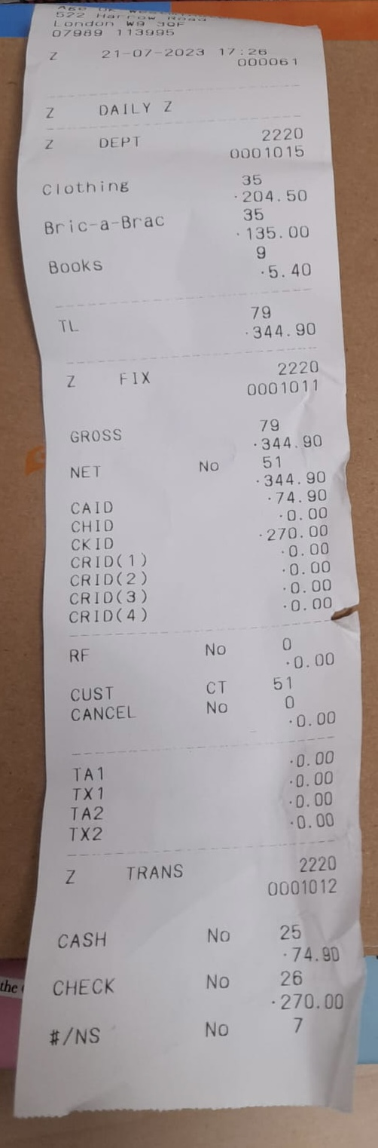

# Appendix Two: Sample QBO Sales Receipt

