Technical Details

Of

Charity Shop Daily Takings System

Date: 21/09/2023

# Introduction

* 1. Document Scope

This document outlines technical details about the charity shop daily takings system.

* 1. Intended Audience

This document is intended for any technical services staff who are responsible for supporting or maintaining the system.

* 1. Version Control

|  |  |  |  |  |
| --- | --- | --- | --- | --- |
| Date | Version | Author | Section | Amendment |
| 21/09/2023 | 1.0 | Neil Carthy |  | Initial Document |
|  |  |  |  |  |
|  |  |  |  |  |
|  |  |  |  |  |

* 1. Acronyms and Abbreviations

|  |  |
| --- | --- |
|  |  |
|  |  |
|  |  |
|  |  |
|  |  |
|  |  |
|  |  |
|  |  |

# System Description

* 1. Background

The charity runs a shop at 522 Harrow Road selling donated clothes and goods. This is a standalone retail enterprise wholly owned by the charity. It must generate a decent return on investment while being as efficient in management time consumption as possible.

The shop is open 300 days a year. Every trading day dozens of items are sold. The daily takings system is a means of recording retail data so that it can be automatically entered into our accounting system and analysed to ensure optimal retail performance.

* 1. Purpose

The system supports the following business objectives:

* Record daily sales in Quickbooks Online accounting system.
* Track retail sales to observe trends.
* Track sales by department to assist with allocation of floor area.
* Track expenses paid by cash such as volunteers’ lunches.
* Track any cash discrepancy for each trading day. A cash discrepancy will arise when the amount of sales recorded at the till differs from the amount of money received.
  1. Assumptions and Constraints

Assumptions:

* The shop employees will have access to the internet.
* The shop employees have the training required to use the system.
* Our charity accounting system is Quickbooks.
* Almost all sales are contained within these four departments: clothing, bric-a-brac, books, linens.
* If the original developer is no longer available to support the system then the charity will be able to secure the services of a substitute IT specialist with the required skills.
  1. Interfaces to External Systems

The system interfaces with Quickbooks Online (QBO) via their API. Connection to the API requires that the user i) have a valid QBO account and, ii) have authorised the system to connect to their QBO account for the purposes of entering the sales data.

Further details about the structure and functionality of the API can be found at <https://developer.intuit.com/app/developer/qbo/docs/develop/rest-api-features>

# Functional Requirements

The functional requirements describe the core functionality of the system.

* 1. Data requirements

The data requirements describe the business data needed by the system.

The numerical data that will be recorded are taken from the POS z-read. The z-read is performed by the shop manager at COB every trading day. An example z-read receipt is attached in Appendix 1.

For each of the following departments we must store both number of sales and total amount of sales each trading day:

* Clothing
* Bric-a-brac (mostly donated homewares)
* Books
* Linens
* Donations
* Other (a catch-all bucket for anything that doesn’t fit elsewhere)

From the Z-read we must also record:

* The number of transactions
* The amount of money received by credit/debit card.

We must also record the amount of any expenses that were paid that day by cash:

* Volunteer expenses such as lunches or travel reimbursement.
* Operating expenses such as window cleaning or purchase of cleaning products.

Finally, we record the exact amount of cash, after any expenses, and the value of any cash discrepancy.

* 1. Functional Process Requirements

The functional process requirements describe what the system does and how it interacts with the items defined in the data requirements section.

* + 1. Sales data interface

Charity shop employees will use a password protected internet webpage to input the daily sales data. This will be publicly facing as the charity does not have a private intranet.

The input mechanism will automatically sum the sales values and sum the number of items sold to allow easy checking against the z-read. It will also automatically calculate the cash discrepancy, if any.

The user will be able to input for today’s date or a date in the past provided there does not already exist a set of data for that date.

Admin users will have the ability to amend or delete takings entries to correct errors.

Users will be able to add a text comment to the data to explain any anomalies.

The system will inform the user if the day’s taking that they are viewing have already been uploaded to QBO. This warns the user that amending the data in the system will not affect the accounting system, possibly leading to discrepancies.

* + 1. Reporting

To view reports on the performance of the shop, SMT and shop staff will use the same password protected webpage that is used for data input.

Graphs and tables will be presented to the user to study the aggregate sales statistics:

* A histogram showing the distribution of daily sales over the past year and where the most recent sales value falls. This is provided to graphically demonstrate how good or bad sales were today.
* A line graph showing the most recent 10 days of trading to highlight short term trends.
* A line graph showing daily sales averaged over the preceding month and quarter to show medium term trends.
* A bar chart showing monthly sales over the past 24 months
* A bar chart showing average daily sales split by department
* A pie chart showing average daily sales split by department for the YTD.

Downloadable tables for the above charts will be available.

The graphs will be downloadable, as either an image or a PDF.

The sales values used for reporting purposes are net of expenses, cash discrepancies and donations.

The reports are only of the income side of the shop’s performance. Income versus expenditure reports (PNL) are viewed through QBO.

* + 1. Interface to Quickbooks

The daily sales information is stored in QBO as a sales receipt. See Appendix 2 for an example.

The sales receipt has a separate line item for the sales for each department. The department line items store: description, service name, number of items sold, average price, daily sales total, VAT rate (always 0%) and the QBO class (always Harrow Road). If sales for a given department is zero then that line is skipped in QBO.

Additional lines records operating and volunteer expenses with negative values. Another cost that has its own line item is cash discrepancies. The cash discrepancy number is negative for underage and positive for overage. If any of these lines would have a zero value they are skipped.

There is also a line for CC payments. This is also a negative number.

The sun of all the various lines totals the amount of cash ‘banked’ that day. (The actual deposit to the bank account may occur days or weeks later.) In the example sales receipt shown in Appendix 2 the amount of cash banked is £177.

The system records when the user has created a QBO sales receipt. The system will only allow the user to create a single sales receipt for each day’s takings. The user may use a batch process to create multiple sales receipts for different days with a single action.

Once the sales receipt is created in QBO it cannot be amended or deleted via this system. That can only be done via the QBO website.

# Operational Requirements

These are requirements that define the environment in which the system runs but are not business rules.

* 1. Security

Access to the system requires a username and password. The user is locked out after 5 failed login attempts.

Users are split into two roles: User and Admin. Only an admin user can perform these functions:

* QuickBooks:
  + Authorise a link between the system and QBO.
  + Add sales receipts to QBO either one by one or in a batch process.
* Delete or edit takings data.
* View or run security & audit reports.
* Users:
  + Add a new user.
  + Change the roles of an existing user.
  + See the list of users.
  + Suspend a user. Suspended users are still on the system but they can no longer log in.
  + Unlock the account of a user who was locked out after repeated login failures.
  1. Audit Trail

It is not a requirement that this system have an audit log function. This may be revised in future versions.

* 1. Recoverability

The system is hosted on a server managed by allhost.io (<https://allhost.io/>). The contents of the server are backed up by the hosting provider.

Backups are accessed and maintained via cPanel which is the name for the server administration app.

There are some limitations to the backup including:

* The backup occurs once every 24 hours so recent data could be lost.
* The database backup does not include custom functions or procedures.
* The website and the backup are managed by the same provider with the risk that if they were to close down or suffer total data loss we could lose data.

A future version of the system might include external backups.

* 1. System Availability

System availability (aka uptime) is entirely controlled by the hosting provider allhost.io. They are transparent about their uptime statistics and display the numbers at <https://status.allhost.io/>.

* 1. Performance and Capacity

Storage and bandwidth limits (if any) would be imposed by the hosting provider. As of writing we have a 20GB storage limit (current use 43MB, 0.2%) and no limit on bandwidth (current month usage 20MB).

* 1. Data Retention

Takings data is retained in the system indefinitely.

# Appendix One: Sample Z-Read

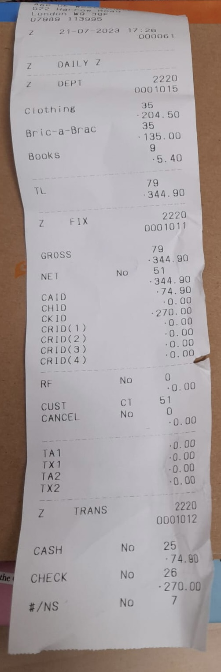

# Appendix Two: Sample QBO Sales Receipt

