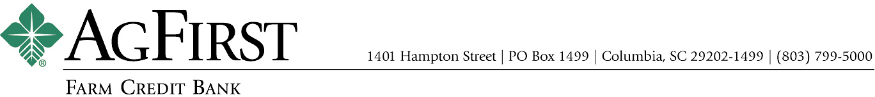

NEWS RELEASE Contacts:
Donna J. Camacho, Director of Communications
dcamacho@agfirst.com; 803-753-2251
Joy M. Upchurch, Vice President-Marketing
jupchurch@agfirst.com; 803-753-2379
Additional information at www.agfirst.com

for release

Wednesday, April 18, 2007

AgFirst names Chief Financial Officer
Columbia, S.C. — AgFirst Farm Credit Bank has named Charl L. Butler to the position of chief financial officer. Butler’s appointment was announced by Tim Amerson, AgFirst’s chief operating officer. Butler will be responsible for AgFirst’s finance and accounting functions.

“Except for a brief time at a public accounting firm, Charl has been a ‘career banker.’ Prior to the many years he served as CFO at two commercial banks, he had direct involvement at a staff level in both the accounting and finance functions—so he understands the functions from the ground up,” said Amerson. “We think that practical experience will strengthen our accounting and finance functions by adding depth and bringing in a fresh perspective.”

A native of Loris, S.C., Butler began his career in 1980 with the accounting firm Ernst & Young in Columbia. In 1982, he joined Citizens & Southern National Bank of S.C. While there, he established the bank’s asset-liability management function and served in various roles from accounting officer to chief financial officer. In 1991, he joined The National Bank of South Carolina in Columbia and served as their chief financial officer, as well as secretary to their board of directors.

“I am pleased to be joining a talented group of bankers who have built a company that, in addition to achieving solid financial performance, succeeds in its mission to provide quality financial services to its agribusiness customers,” said Butler. “My goal is to build on the financial team’s accomplishments to improve the value and delivery of financial information both within the company and to external users.”

A certified public accountant and a graduate of the Stonier Graduate School of Banking, Butler has a Masters of Accountancy from the University of South Carolina and a Bachelor of Arts in Economics from Wake Forest University. He and his wife, Melissa, live in Irmo, S.C., and have two children, Claire, 18 and Emma, 15.

About AgFirst Farm Credit Bank (www.agfirst.com): AgFirst Farm Credit Bank provides funding and financial services to 23 Agricultural Credit Associations (ACAs) in 15 eastern states and Puerto Rico. These associations, operating as Farm Credit and Ag Credit associations, provide real estate and production financing to more than 80,000 farmers, agribusinesses, and rural homeowners. AgFirst reported assets of $24.4 billion as of December 31, 2006.
AgFirst is part of the Farm Credit System, a nationwide network of agricultural and rural lending institutions cooperatively owned by their borrowers. The Farm Credit System reported combined assets of $162.9 billion on December 31, 2006.
# # #

