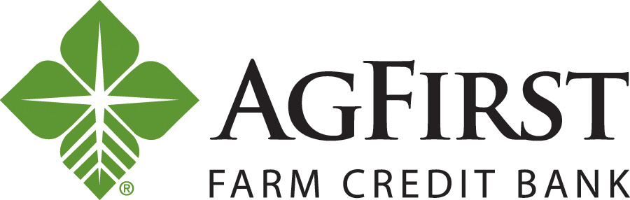

1401 Hampton Street | PO Box 1499 | Columbia, SC 29202-1499 | 803.799.5000 | agfirst.com

NEWS RELEASE Contacts:
Donna J. Camacho, Director of Communications
dcamacho@agfirst.com; 803-753-2251
Joy M. Upchurch, Vice President-Marketing
jupchurch@agfirst.com; 803-753-2379

for release

Tuesday, JANUARY 17, 2012

AgFirst Farm Credit Bank Announces
Results of Director Elections

Columbia, S.C.— AgFirst Farm Credit Bank announced today the results of recent director elections.
John S. Langford of Lakeland, Fla., was elected for a four-year term beginning January 1, 2012. Re-elected to the AgFirst board for four-year terms were Gary L. Alexander of Westminster, S.C.; Dale R. Hershey of Manheim, Penn.; Paul M. House of Nokesville, Va.; and James M. Norsworthy III of Jackson, La. In addition, Katherine A. Pace of Orlando, Fla., was re-appointed by the board as an outside director for a four-year term beginning January 1, 2012.
Retiring from the board on December 31, 2011, was Robert (Bobby) G. Sexton of Vero Beach, Fla., an AgFirst Farm Credit Bank director since 2000.
John S. Langford
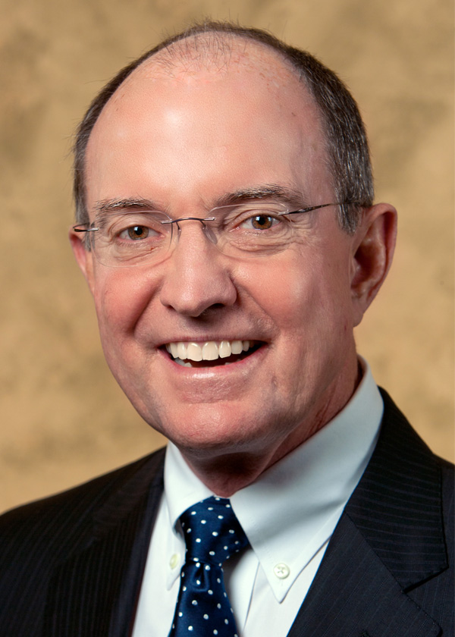
Langford has been a citrus grower for 45 years and has also been a Realtor® for 32 years, specializing in agricultural lands. He has a bachelor’s degree from Emory University and holds a Master of Business Administration from Harvard Business School. Langford is a current director and the designated financial expert on the board of Farm Credit of Central Florida, headquartered in Lakeland, Fla., and has served on its board since 2006. He also serves as director on the boards of Community Southern Bank, Lake Wales Citrus Growers Association, and Polk County Florida Farm Bureau.
Gary L. Alexander
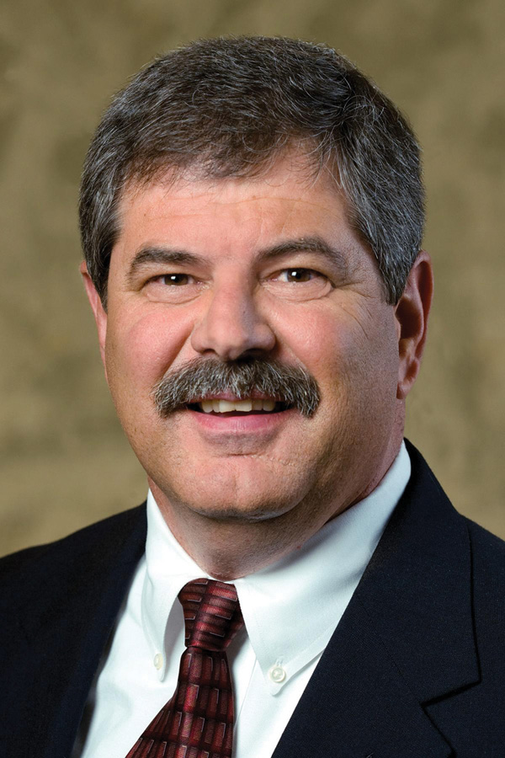
Alexander is owner and operator of Alexander Farms, Inc., a poultry production and property development business in Seneca, S.C. He markets 3.2 million broilers a year through his 18-broiler-house farm and develops residential properties. A civil engineering graduate of Clemson University, he currently serves on the board of directors of AgSouth Farm Credit and is a member of its audit and executive committees. He also serves on the board of the Farm Credit Council, a national trade organization. Alexander is currently a member of the S. C. Poultry Federation and was chairman of its board of directors from 2003 to 2004.

Dale R. Hershey
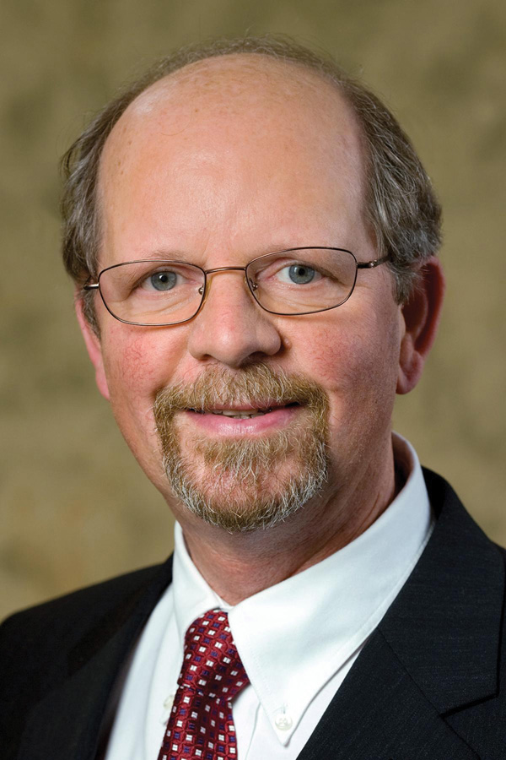
Hershey is a partner in Hershey Brothers Dairy Farms in Manheim, Penn., a dairy operation which milks 300 cows, raises 250 dairy replacements, and grows 525 acres of corn, alfalfa, soybeans, barley, rye and wheat. Hershey graduated from Penn State University with a bachelor’s degree in Community Development and a master’s degree in Ag Economics and Rural Sociology. He serves on the board of directors of MidAtlantic Farm Credit, headquartered in Westminster, Md. Hershey is a member of Pennsylvania Farm Bureau, Pennsylvania Dairy Stakeholders, and the Pennsylvania Holstein Association. Hershey also is a member of the Lancaster County Blue Ribbon Commission for Agriculture and the Penn Township Ag Advisory Committee.
Paul M. House
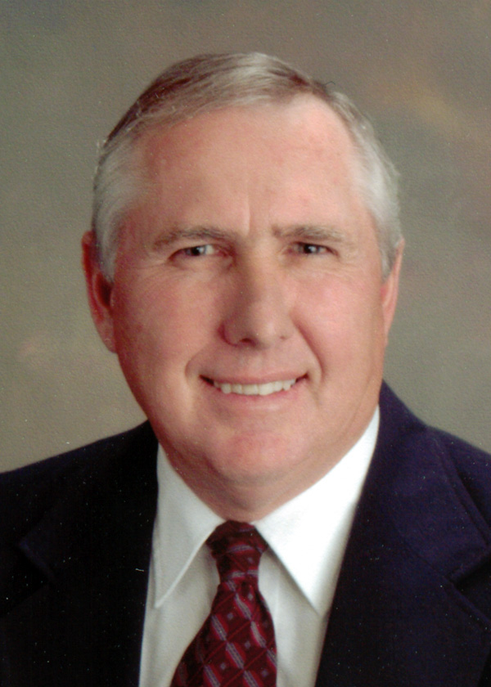
House manages Kettle Wind Farm located in Nokesville, Va., which includes 4,000 acres encompassing a 340-cow dairy operation, 1,600 acres in soybeans, 700 acres in turf grasses, and 1,440 acres in corn, hay, and wheat. He attended Glenville State College in Glenville, W. Va. House serves on the board of directors of Farm Credit of the Virginias, headquartered in Staunton, Va. He is also a member of the Virginia Farm Bureau, Maryland and Virginia Milk Producers Cooperative Association, Virginia State Dairymen’s Association, Southern States, and Genex. He has served on the AgFirst board of directors since 2002.
James M. Norsworthy III
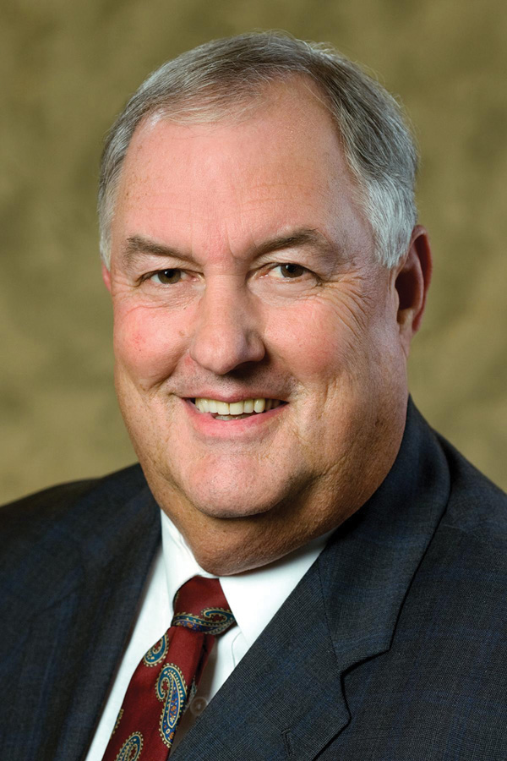
Involved in production agriculture for 38 years, Norsworthy runs 100 Cedars Cattle Farm, a 250-head cow-calf operation near Jackson, La. He also has a commercial hay operation with 125 acres in Alicia Bermuda hay and 150 acres in Bahia Grass hay and manages a 500-acre pine and hardwood timber operation. A graduate of Louisiana State University with a bachelor’s degree in Vocational Agricultural Education, he is a member of the board of directors of First South Farm Credit, headquartered in Ridgeland, Miss., and Louisiana State Farm Bureau. He is also a member of the Feliciana Farm Bureau, East Feliciana Cattleman’s Association, American Angus Association, and the Feliciana Forestry Association. Norsworthy served as mayor of the town of Jackson, La., from 1979 to 1996.
Katherine A. Pace
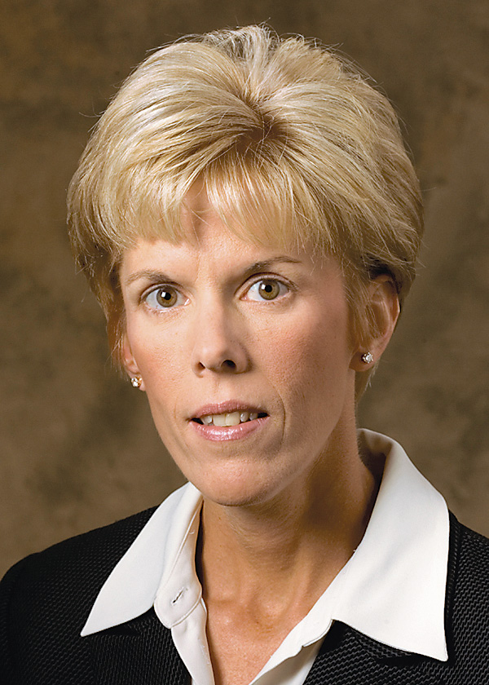
Pace, from Orlando, Fla., is a certified public accountant. Prior to forming her company, Family Business Consulting, LLC, she was a tax partner with KPMG, LLP, an audit, tax, and advisory service firm, from 1985-2005. While at KPMG, her practice included a variety of cooperative and agribusiness clients. She also participated in trade associations, such as the National Society of Accountants for Cooperatives. She is a member of the American Institute of Certified Public Accountants, the Florida Institute of Certified Public Accountants, and current and past member and director of numerous trade and charitable organizations.

Other members of the AgFirst board are: Jack W. Bentley Jr., Tignall, Ga.; James C. Carter Jr., McDonough, Ga.; Bonnie V. Hancock, Wake Forest, N.C.; Thomas W. Kelly, Tyrone, Penn.; Lyle Ray King, Ash, N.C.; M. Wayne Lambertson, Pocomoke City, Md.; S. Alan Marsh, Madison, Ala.; James L. May, Waynesburg, Ky.; Bobby E. McCollum Jr., Polkton, N.C.; Jimmy D. Poston, Johnsonville, S.C.; Walter L. Schmidlen Jr., Elkins, W. Va.; Robert H. Spiers Jr., Stony Creek, Va.; William H. Voss, McComb, Miss.; and J. Mark Wheeler, Bradenton, Fla.

###

About AgFirst Farm Credit Bank (www.agfirst.com): AgFirst Farm Credit Bank provides funding and financial services to 20 Agricultural Credit Associations in 15 eastern states and Puerto Rico. These associations, operating as Farm Credit and Ag Credit associations, provide real estate and production financing to 80,000 farmers, agribusinesses, and rural homeowners. AgFirst reported assets of more than $30 billion as of September 30, 2011.
AgFirst is part of the Farm Credit System, a nationwide network of agricultural and rural lending institutions cooperatively owned by their borrowers. Farm Credit helps maintain and improve the quality of life in rural America and on the farm, through its constant commitment to competitive lending, expert financial services, and a feeling of partnership with its customers. The Farm Credit System reported combined assets of more than $227 billion on September 30, 2011.

