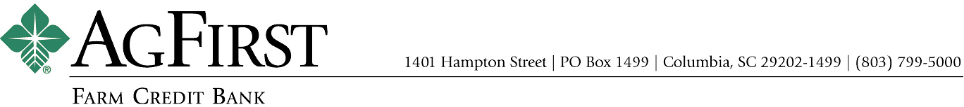

NEWS RELEASE Contacts:
Donna J. Camacho, Director of Communications
dcamacho@agfirst.com; 803-753-2251
Joy M. Upchurch, Vice President-Marketing
jupchurch@agfirst.com; 803-753-2379

for release

Friday, November 14, 2003

AgFirst Announces Record Loan Volume
Columbia, S.C. — AgFirst Farm Credit Bank today reported record loan volume for the nine months ended September 30, 2003. The agricultural lender said its loans to agricultural credit associations stood at $10.7 billion as of September 30, 2003, up 8.9 percent over the same period a year ago. AgFirst’s total loan volume was $12.3 billion as of September 30, 2003.
“Loan demand has been strong throughout 2003,” said AgFirst CEO F. A. (Andy) Lowrey. “Our agricultural borrowers have enjoyed generally good growing conditions and commodity prices this year,” he continued. “These factors, along with the low interest rate environment, have encouraged agricultural operators to expand or refinance their operations this year.”
AgFirst provides funding and financial services to 24 Farm Credit associations in 15 eastern states and Puerto Rico. These associations provide real estate and production financing to more than 80,000 farmers, agribusinesses, and rural homeowners. The associations’ gross loan volume was $12.6 billion as of September 30, 2003, an increase of $1 billion, or 8.6 percent as compared to September 30, 2002.
Net income for the three months ended September 30, 2003, was $38.5 million, as compared to $48.8 million for the same period a year ago. Net income for the nine months ended September 30, 2003, was $135.2 million, 5.7 percent less than the $143.4 million reported the previous year.
According to Lowrey, “2002 was a phenomenal year for AgFirst earnings-wise. Falling interest rates resulted in our being able to refinance our debt obligations at a faster pace than our borrowers prepaid their loans. As a result, we enjoyed a significant, but temporary, improvement in net interest
margin. Stable-to-rising interest rates in the latter part of this year have resulted in spreads beginning to move back toward more normal levels. In addition, falling rates resulted in significant gains in our secondary mortgage market operations in 2002. The performance of that portfolio declined with the sharp increase in interest rates at mid-year 2003.”
AgFirst Farm Credit Bank is part of the Farm Credit System, a nationwide network of agricultural and rural lending institutions cooperatively owned by their borrowers. The bank, which is the largest financial institution headquartered in South Carolina, reported total assets of $16.1 billion as of September 30, 2003, an increase of more than 16 percent from the same period last year. Nationally, the Farm Credit System reported combined assets of $115.2 billion on September 30, 2003, as compared to $110.6 billion on December 31, 2002. The System’s combined net income for the nine months ended September 30, 2003, was $1.34 billion, as compared to $1.37 billion the same period last year.
###
Note: AgFirst CEO Andy Lowrey is available for interviews. To schedule an interview, please call Donna Camacho, director of advertising and communications, at 803-753-2379, or email her at dcamacho@agfirst.com. Additional information is available at www.agfirst.com.

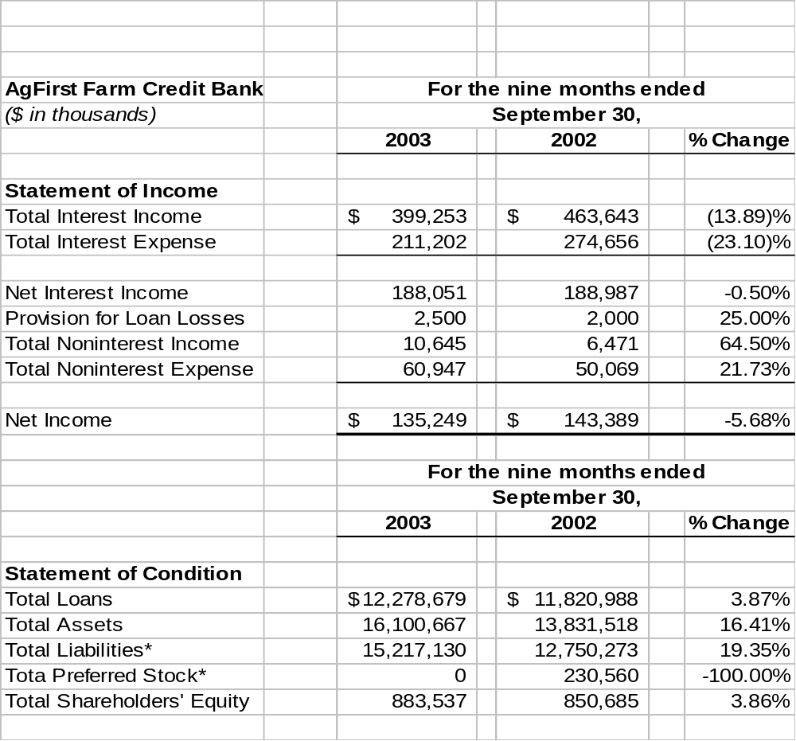

*Beginning July 1, 2003, term preferred stock is required to be reported prospectively as a liability in accordance with Statement of Financial Accounting Standards No. 150.

