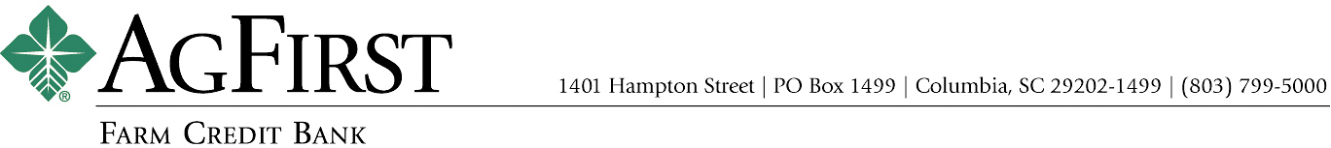

NEWS RELEASE Contacts:
Donna J. Camacho, Director of Communications
dcamacho@agfirst.com; 803-753-2251
Joy M. Upchurch, Vice President-Marketing
jupchurch@agfirst.com; 803-753-2379

for release

Tuesday, JANUARY 16, 2007

AgFirst Farm Credit Bank Announces
Results of Director Elections

Columbia, s.c.— William H. Voss of McComb, Miss., was recently elected to the AgFirst Farm Credit Bank board of directors for a four-year term beginning January 1, 2007. Re-elected to the board were Robert L. Holden of Whigham, Ga., and Eugene W. Merritt, Jr., of Easley, S.C.

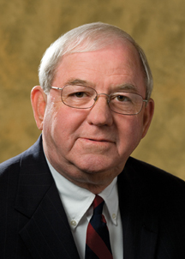
William H. (Bill) Voss
A graduate of the University of Southern Mississippi, Bill Voss owns a cattle and timber operation in southwest Mississippi. Voss, a former agricultural commodities broker, is also involved in land and commercial property management. He currently serves as chairman of the board of directors of First South Farm Credit, headquartered in Ridgeland, Miss., and is a member of the Pike County Economic Development District Board. Previously, Voss has served as chairman of the Mississippi Real Estate Commission and the Pike County Farm Service Committee.

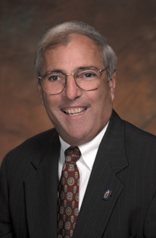
Robert L. (Bob) Holden
Bob Holden is co-owner and operator of a 910-acre farm in Whigham, Ga. His farm includes row-crop, dairy and broiler operations. He is a director of Southwest Georgia Farm Credit of Bainbridge, Ga., the American Dairy Association of Georgia, Georgia Milk Producers and Georgia Farm Bureau. Holden has served on the AgFirst board since 1990.

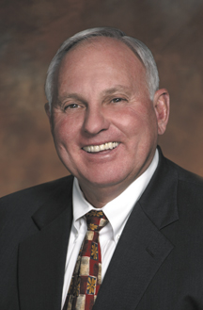
Eugene W. (Gene) Merritt, Jr.
Merritt is a landscape contractor and co-owner of a 400-acre ornamental tree farm in Easley, S.C. A graduate of Clemson University, Merritt also operates a 650-acre timber and turfgrass farm. He serves on the board of AgSouth Farm Credit, headquartered in Statesboro, Ga. He has served on the AgFirst board since 1990.

Other members of the bank board are: William C. Bess, Jr., Lincolnton, N.C.; Henry M. (Buddy) Frazee, Alachua, Fla.; Don W. Freeman, Montgomery, Ala.; Paul M. House, Nokesville, Va.; Thomas W. Kelly, Tyrone, Penn.; Lyle Ray King, Ash, N.C.; Richard Kriebel, Benton, Penn.; M. Wayne Lambertson, Pocomoke City, Md.; Paul Lemoine, Plaucheville, La.; James L. May, Waynesburg, Ky.; Katherine A. Pace, Orlando, Fla.; Dale W. Player, Bishopville, S.C.; J. Dan Raines, Jr., Ashburn, Ga.; Walter L. Schmidlen, Jr., Elkins, W.Va.; Robert G. Sexton, Vero Beach, Fla.; Kenneth A. Spearman, Winter Haven, Fla.; and Robert H. Spiers, Jr., Stony Creek, Va.

###

About AgFirst Farm Credit Bank (www.agfirst.com): AgFirst Farm Credit Bank provides funding and financial services to 23 Agricultural Credit Associations (ACAs) in 15 eastern states and Puerto Rico. These associations, operating as Farm Credit and Ag Credit associations, provide real estate and production financing to more than 80,000 farmers, agribusinesses, and rural homeowners. AgFirst reported assets of $23.2 billion as of September 30, 2006.
AgFirst is part of the Farm Credit System, a nationwide network of agricultural and rural lending institutions cooperatively owned by their borrowers. The Farm Credit System reported combined assets of $154.7 billion on September 30, 2006.

