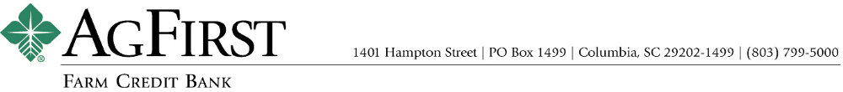

NEWS RELEASE Contacts:
Donna J. Camacho, Director of Communications
dcamacho@agfirst.com; 803-753-2251
Joy M. Upchurch, Vice President-Marketing
jupchurch@agfirst.com; 803-753-2379

for release

Tuesday, August 10, 2004

AgFirst announces Second Quarter Financial Results

Columbia, S.C. — AgFirst Farm Credit Bank reported today that its net income for the six months ended June 30, 2004, was $90.0 million, a 7.0 percent decrease from the $96.7 million reported for the same period a year ago. The bank also reported that its loan volume increased 2.3 percent and assets grew more than 5.0 percent from June 30, 2003.
“We’ve had extraordinary earnings over the last two years,” said AgFirst CEO F. A. (Andy) Lowrey, “and now our earnings are returning to a more normal level.” As rates fell in 2002 and 2003, AgFirst refinanced billions of dollars of its debt obligations. As a result, the bank realized a significant, but temporary, improvement in net interest margin. Stable to rising interest rates in 2004 have resulted in spreads moving back toward more normal levels.
AgFirst provides funding and financial services to 23 Agricultural Credit Associations (ACAs) in 15 eastern states and Puerto Rico. These ACAs, operating as Farm Credit and Ag Credit associations, provide real estate and production financing to more than 80,000 farmers, agribusinesses, and rural homeowners. The associations’ loan volume was $13.0 billion as of June 30, 2004, an increase of $600 million, or 4.84 percent as compared to June 30, 2003.
AgFirst also operates a Capital Markets Group, which arranges and participates in loans for agribusinesses, and a Secondary Mortgage Market Unit, which buys and sells agricultural and rural home loans throughout the United States.
AgFirst Farm Credit Bank is part of the Farm Credit System, a nationwide network of agricultural and rural lending institutions cooperatively owned by their borrowers. The bank, which is the largest financial institution headquartered in South Carolina, reported total assets of $16.3 billion as of June 30, 2004, up 5.21 percent from a year ago and 2.62 percent from December 31, 2003. Nationally, the Farm Credit System reported combined assets of $119.6 billion on June 30, 2004, as compared to $116.9 billion on December 31, 2003. The System’s combined net income for the six months ended June 30, 2004, was $928 million, as compared to $878 million the same period last year.

###
Note: AgFirst CEO Andy Lowrey is available for interviews. To schedule an interview, please call Donna Camacho, director of advertising and communications, at 803-753-2251, or email her at dcamacho@agfirst.com . Additional information is available at www.agfirst.com .

