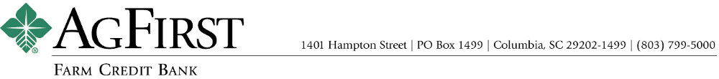

NEWS RELEASE Contacts:
Donna J. Camacho, Director of Communications
dcamacho@agfirst.com; 803-753-2251
Joy M. Upchurch, Vice President-Marketing
jupchurch@agfirst.com; 803-753-2379
Additional information at www.agfirst.com

for release

Thursday, July 22, 2004

AgFirst names director of risk management
Columbia, S.C. — AgFirst Farm Credit Bank has named F. Steven (Steve) Parrish to the position of director of risk management.

Parrish’s appointment was announced by William R. (Bill) Clayton, senior vice president and head of AgFirst’s lending and operations division. Parrish will be responsible for enterprise-wide risk management.

“Steve brings a great deal of experience and credibility to this role,” said Clayton. “With his extensive knowledge of lending and many years of experience with the Farm Credit System, he will be an asset to AgFirst as our portfolios grow in volume and complexity.”

A native of South Carolina, Parrish has an extensive background in corporate lending. He started his banking career in 1971with First National Bank of South Carolina and later worked as an examination manager with the Farm Credit Administration in McLean, Va. As a credit manager and, later, a portfolio manager with CoBank in Atlanta, Ga., Parrish was responsible for lending to large agribusiness cooperatives throughout a twenty-state territory. Most recently, Parrish has held client management positions in corporate and investment banking with SunTrust Bank in Atlanta, serving the agribusiness and health care markets.

Parrish has a Bachelor of Science degree in banking and finance from the University of South Carolina. He and his wife, Sydney, and their two children will be relocating to Columbia from Marietta, Ga.
About AgFirst Farm Credit Bank: With assets of $16.3 billion, AgFirst Farm Credit Bank is the largest financial institution headquartered in South Carolina. The bank provides funding and financial services to 23 Agricultural Credit Associations (ACAs) in 15 eastern states and Puerto Rico. These associations, operating as Farm Credit and Ag Credit associations, provide real estate and production financing to more than 80,000 farmers, agribusinesses, and rural homeowners.

AgFirst is part of the Farm Credit System, a nationwide network of agricultural and rural lending institutions cooperatively owned by their borrowers. The Farm Credit System reported combined assets of $116.9 billion on December 31, 2003.
###
Note: AgFirst CEO F.A. (Andy) Lowrey is available for interviews. To schedule an interview, please call Donna Camacho, director of advertising and communications, at 803-753-2251, or email her at dcamacho@agfirst.com. Additional information is available at www.agfirst.com.

