Intro
The Simple Truth – There is NO Speed of Light at all
The Properties of Light
How do GPS Localization Radar and Radar Speed Guns Work then if Speed of Light Cannot be Measured?
Information Theory – Shining up the Light and How Fast Information can be Transmitted
Wave-Particle Duality of Light
Reasoning

Intro
For decades, to be precise since early 20th century with the rise of “modern physics” science, a big question arose due to a “world’s genius” ideas. This has led to all sorts of confusions in school books and hilarious theories about the nature of the universe spread, such as “big bang universe” which is said to have a beginning and is expanding.
While even a bright child’s mind may ask: “How could that be? If the universe had a beginning what had there been before? How could nothing go boom if there isn’t anything?”. Still, this had been insufficient so far to just put aside such “theories”. Instead scientists and engineers have to agree with contradictions and dogmas. So there we go… we must clarify what the misconceptions with Einsteins ideas about “special relativity” and “speed of light” are.

The Simple Truth – There is NO Speed of Light at all
Galileo Galileo, Rene Descartes, Aristotle and many other scientists and philosophers debated for centuries if either speed of light may be zero, whether it is constant or infinite. Poincare and Lorentz made significant contributions on the ground of the assumption speed of light existed. But none of them ever asked: Does light, which is an electromagnetic wave, have a property of speed at all? Does speed of light exist at all? If there was such a property called “speed of light”, then according to scientific method, an experiment should be made to measure the speed to provide empirical evidence. There is no need to argue what concepts such as space and time may be, a speed could be measured by simply - well it might not be that simple after all - having two observers each with a precise clock, one observer sending a signal at time x1, and the other observer waiting for the signal to be received at time x2. And while space travel is possible nowadays one observer could even be sent to moon and wait for a strong signal sent from earth to measure the delay of the signal if it was propagating with a speed. If there is no delay between x1 and x2, or if the delay is below margin of error (for the moon this is 1.3s , or 2.6s if reflected signal round-trip delay was measured), then no evidence was available for a property of speed of light. And this is exactly the situation with “modern physics science”. No evidence is available for either a property of speed of light, the expansion of the universe, black holes, time travel or all sorts of other assumptions around this “theory”. There cannot be no doubt no more since today’s measurement and sensory equipment allows for timing precision in the nano seconds range, contrary to what Galileo Galileo had at hand for his measurements. And while no speed of light could be measured until today with extremely precise measurement and sensory equipment, instead all sorts of weird statements are made such as while speed of light is said to be 300000 km/s according to Michelson-Morley-Experiment it would be constant relative to moving observers anyway, which in essence means light has no property of propagation speed! So without jumping to conclusions before referring to “real” applied science with electromagnetic waves right now it should be obvious already there must be reasons why all books on physics science are spreading lies when it comes to “speed of light” stated to be 300000 km/s. Also, there is other dis-information and confusion spread concerning speed of light, it’s nature of particle-wave dualism, the nature of matter with the equivalence of energy and mass, or the “doppler effect” which is not appropriate to argue red-shift would provide evidence for an expanding universe.

The Properties of Light
While there is no such thing as “speed of light”, and the wording has to be precise since nothing can be faster then a thing which does not exist, meaning “exceeding speed of light” would translate to “being faster then nothing” which is nonsense. Nonetheless electromagnet waves can be characterized with properties which are:
- Frequency
- Amplitude
- Phase
- Polarization
- Angular Frequency (Omega=2Pi*f)
Some derived properties of these are:
- Energy
- Intensity
- And many more
Also there is various prominent observations with electromagnet waves:
- Wave Interference
- Phase Shift
- Frequency Shift
- Resonance
- Schwebung/Beating
All these properties are relevant for applied science such as radio carrier wave signal modulation, lasers, photography, solar cells, radar guns, GPS satellite navigation and almost all other today’s high tech which benefits from the findings of “quantum physics”. Contrary there is not a single practical application related to the “special relativity theory” and the assumption of a property of “speed of light” which it relies upon. In fact, every single equation which refers to a property of speed of light ‘c’ could either be considered irrelevant or being crude fake science leading to discussions around time travel and similar weird phantasies.
<insert illustration>

How do GPS Localization Radar and Radar Speed Guns Work then if Speed of Light Cannot be Measured?
Imagine a “standing wave”, since there is no propagation speed of light, being transmitted by a radar gun or GPS satellite:
- The electromagnet wave is transmitted
- The electromagnetic wave instantaneously (since there is no propagation speed of light) hits a (probably moving) target such as a car or aircraft and the wave again is instantaneously being reflected
- The wave and it’s reflection INTERFERE, also instantaneously
- This interference pattern (signal strength) is measured
<insert illustration>
All this happens without a propagation speed of electromagnetic waves being involved.
To measure speed with a radar gun if a target is moving:
- The phase of the reflected wave shifts according to target’s position
- And the resulting signal measured due to wave interference pattern changes (pulsing)
- And the interference pulsing speed indicates the speed of the moving target
- Which, again, is not related to a non-existent property of speed of light
To estimate the location of a target with GPS satellite signals:
- Again interference pattern of a wave and it’s reflection is measured
- But with multiple wave interference patterns from three or more moving GPS satellites have to be measured to have available three speed vectors to calculate position with
<insert illustration>
Of cause all this is not trivial and according to the desired use case the properties of the electromagnetic radar waves such as wave length and amplitude must be tuned to allow for reasonable measurements at all. Also note, it is not “doppler effect” (meaning a frequency shift according to relative speed of wave source and observer), which all books on physics and Wikipedia articles again are spreading dis-information about, which would be involved with electromagnetic waves and an observer moving relative to emission source! It is the phase shift and it’s change with interfering waves relative to the position of a radar target and observer.

Information Theory – Shining up the Light and How Fast Information can be Transmitted
Common saying is nothing can be transmitted or move faster then speed of light. This might be considered true since there is no thing which could move faster than something which does not exist. Got it? If there is no propagation speed than movement relative to it is pointless, as is the statement speed of light would be constantly measured as 300000 km/s regardless of relative movement to light source. Also there is no frequency shift involved with relative movements to a light source but phase shift alone. But let’s get to the point, what are the restrictions then to transmit information with electromagnetic waves? In essence it all comes down to the fact that it is impossible to “switch” a signal in absolute zero time, meaning all signal changes need some time. That it takes time for a signal to change state, to switch, is not at all related to an erroneously stated propagation speed of the information this signal change carries. Here is a short list of related mathematical theories which are applied in practice for mobile phone radio signal modulation for example:
- Gibbs phenomenon illustrating the relation of steepness of switching flank and the frequency band with the number of interfering wave harmonics; the more harmonic sine waves interfere (the broader the bandwidth occupied) the steeper the switching flank becomes; this translates to the faster a signal state change is (less time it needs to switch ∆t→0) the more bandwidth is occupied
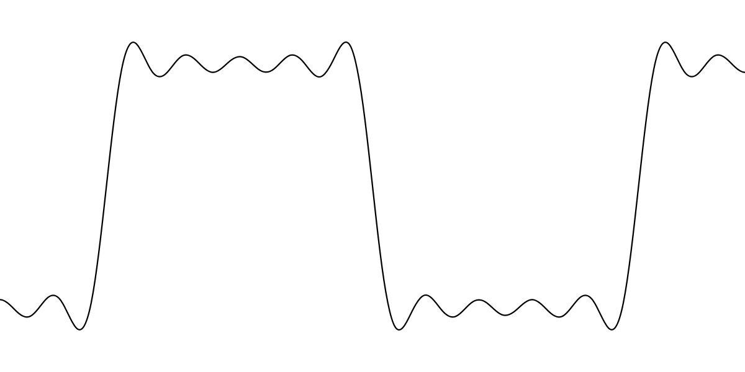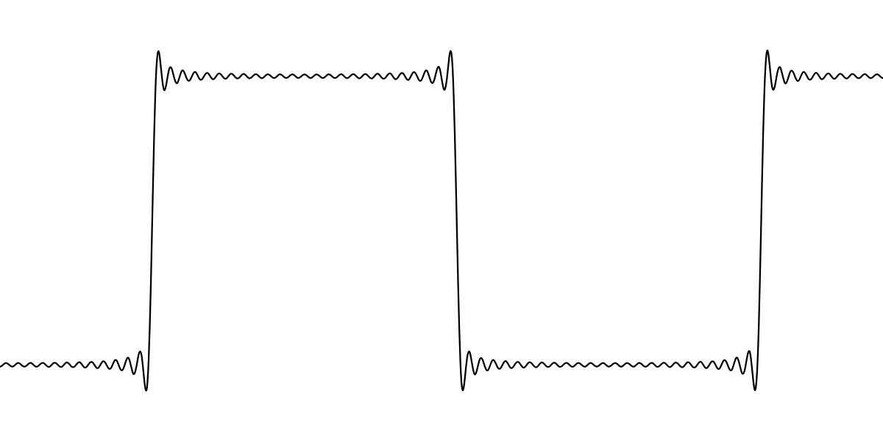
- A Perfect Dirac Impulse and occupied frequency band of it: an instant zero-time impulse would occupy infinite bandwidth with an infinite peak amplitude (a=1/∞→0)
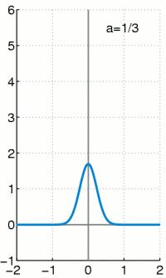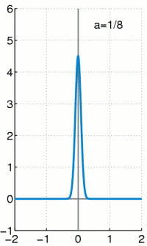
<insert formulas>
- Fourier analysis of a perfect rectangular signal would occupy infinite bandwidth (with n being the number of interfering wave harmonics n→∞, ∆t→0)
<insert illustration>
<insert formulas>
Bottom line: shining up a light always takes time. The faster a signal carrying information changes, the more bandwidth it occupies then. Infinite “fast” transmission of information would occupy all available frequencies from zero to infinite. Good luck when applying for a license to acquire this frequency band from your regulator.

Wave-Particle Duality of Light
- Particle character, also called “quantum”, is equivalent to Pi number; There is no half of an oscillation; An Oscillation (electromagnetic waves) may loose energy with declining amplitude or declining frequency, Pi number remains the same either way
- Planck constant is equivalent to Pi number but it is a scalar value and not a constant
- Angular frequency omega=2Pi*f is equivalent to the expression E=h*f → Energy is a scalar value also
- Light is an electromagnetic wave

Reasoning
- Nuclear Technology
- Military Radar and Data Transmission Systems
- Religious Big Bang Universe, no big bang, no god who created it
- No “doppler effect” frequency shift with EM-waves; no red shift, no expanding big bang universe; electromagnetic waves can and do interfere with dust and matter and loose energy due to that, either by specific wave-lengths being filtered, declining amplitude, or decreased frequency (Norman Ramsey contributor to atomic clock development, Arthur Compton contributor to Manhattan Project) which is proven with experiments and technical applications; this is why there is red-shift observed but not an assumed “doppler effect” which would apply to sound waves which contrary to electromagnetic “radiation” have a property of propagation speed; compare that with the sunset and light being shifted to red if distance of sunlight to percolate atmosphere increases due to angle of the sun relative to observer
- There is only one single fundamental physical force in universe, which is electromagnetism; gravitation is a specific form of electromagnetism; earth is a magnet, it’s rotation induces electromagnetic field from north to south pole; all material is magnetic (polymers, alloy, iron/ferrites, human body); magnetism and gravitation are equivalent, compare Coulombs Law with the equation to calculate Gravitational Force
- Upside down.

https://en.wikipedia.org/wiki/Lunar_Laser_Ranging_experiment#Details

