Explainable Machine Learning for Early Prediction of Diabetes Risk Using Clinical Data
21CSC305P - MACHINE LEARNING PROJECT
Submitted by
Jai [RA2411026010131]
Aggam [RA2411026010139]
Alphin [RA2411026010177]
Under the Guidance of
Dr. Anousouya Devi
([Designation], Department of Computational Intelligence)
in partial fulfillment of the requirements for the degree of
BACHELOR OF TECHNOLOGY
in
COMPUTER SCIENCE ENGINEERING
with specialization in AIML

DEPARTMENT OF COMPUTATIONAL INTELLIGENCE
COLLEGE OF ENGINEERING AND TECHNOLOGY
SRM INSTITUTE OF SCIENCE AND TECHNOLOGY
KATTANKULATHUR - 603 203
NOV 2026
ABSTRACT
This project develops an explainable machine learning pipeline for the early prediction of diabetes risk from routine clinical data, covering all five units of the course. The objective is to identify people at risk early and to explain which factors drive that risk. The original datasets are the Pima Indians Diabetes dataset (768 patients), the Diabetes Progression dataset (442 patients) and the Kaggle Diabetes Prediction dataset (96,146 patients after cleaning); Unit 4 uses the UCI AIM-94 dataset of 13,515 blood glucose readings from 70 patients. Units 1 and 2 analysed data quality and compared regression and classification models; a tuned support vector machine reached a test recall of 0.796 and a ROC-AUC of 0.810, and Lasso regression explained 46 percent of the variance in disease progression. In Unit 3, a Gaussian mixture fitted with the Expectation-Maximisation algorithm found three risk groups without labels, with diabetes rates of 10.8, 38.0 and 56.9 percent. In Unit 4, a Hidden Markov Model learned low, target and high glucose states and fitted new patients better than a model without time order. In Unit 5, AdaBoost built from decision stumps reached a ROC-AUC of 0.977, verified against a hand-written implementation, while Bayesian model averaging improved probability estimates only when training data was scarce. Without blood tests, every model fell to about 0.83 and logistic regression matched the best ensemble. Across all methods, blood glucose, HbA1c, body mass index and age were the main risk factors, giving a consistent and explainable basis for decision support.
TABLE OF CONTENTS
1. INTRODUCTION 1
1.1 Background, Motivation and Scope 1
1.2 Integrated Problem Statement 1
1.3 Project Objectives 2
1.4 Unit-wise Topic and Dataset Allocation 2
2. DATA ANALYSIS AND FUNDAMENTAL MACHINE LEARNING TECHNIQUES (UNITS 1 AND 2) 4
2.1 Overview of Allotted Topics 4
2.2 Dataset Description 4
2.3 Data Preprocessing 5
2.4 Exploratory Data Analysis (EDA) 7
2.5 Proposed System Architecture / Workflow 9
2.6 Algorithm Theory and Mathematical Formulation 9
2.7 Results and Performance Evaluation 10
2.8 Discussion and Findings 12
2.9 Chapter Conclusion 13
3. UNSUPERVISED LEARNING AND SEQUENTIAL DATA MODELLING (UNITS 3 AND 4) 14
3.1 Overview of Allotted Unit 3 and Unit 4 Topics 14
3.2 Unit 3 - Dataset Description and Preprocessing 14
3.3 Unit 3 - Theory, EDA, Implementation and Results 15
3.4 Unit 3 - Algorithm Theory and Mathematical Formulation 15
3.5 Unit 3 Proposed System Architecture / Workflow 16
3.6 Unit 3 - Results and Performance Evaluation 16
3.7 Unit 4 - Sequential Dataset Description 17
3.8 Unit 4 - Sequential Preprocessing and EDA 18
3.9 Unit 4 - Mathematical Formulation 19
3.10 Unit 4 Proposed System Architecture / Workflow 19
3.11 Results and Performance Evaluation 20
3.12 Discussion, Findings and Limitations 21
3.13 Chapter Conclusion 21
4. ADVANCED PREDICTIVE MODELLING AND ENSEMBLE LEARNING (UNIT 5) 23
4.1 Overview of Allotted Unit 5 Topics 23
4.2 Dataset Description and Preprocessing 23
4.3 EDA and Feature Analysis 24
4.4 Proposed Workflow / Architecture 25
4.5 Algorithm Theory and Mathematical Formulation 25
4.6 Results and Performance Evaluation 26
4.7 Comparison with Previous Models 30
4.8 Discussion, Findings and Limitations 30
4.9 Chapter Conclusion 31
5. INTEGRATED DISCUSSION AND FINDINGS 32
5.1 Dataset Comparison 32
5.2 Model Comparison 32
5.3 What Was Dropped, and Why 33
5.4 Critical Findings 34
6. OVERALL CONCLUSION AND FUTURE SCOPE 35
6.1 Future Scope 35
REFERENCES 36
APPENDIX A: CODING 38
Chapter 2: Implementation Methodology and Algorithm Configuration 38
Chapter 3: Unit 3 Proposed Workflow and Implementation Methodology 39
Chapter 3: Unit 4 Proposed Workflow and Implementation Methodology 39
Chapter 4: Implementation Methodology and Hyperparameter Configuration 39

(Right-click the table and choose Update Field to refresh page numbers.)
LIST OF FIGURES
Figure No. | Title
2.1 | Impossible zero values per Pima column (hidden missing values)
2.2 | Correlation matrix of the Pima features
2.3 | Workflow for Units 1 and 2
2.4 | Recall and precision of the tuned SVM as the decision threshold is lowered
2.5 | Confusion matrix and ROC curve of the final Pima classifier on the test set
2.6 | Permutation importance of the Pima features for the final model
3.1 | Correlation of the five features used for clustering
3.2 | Workflow for Unit 3
3.3 | EM run one step at a time: log-likelihood and the clusters after steps 1, 3 and 60
3.4 | GMM clusters, K-means clusters and the real diagnosis on two PCA components (56.1% of variance)
3.5 | One patient's glucose readings over four weeks, against the 70 to 180 mg/dL target band
3.6 | Workflow for Unit 4
3.7 | Viterbi path and smoothed state probabilities for test patient 48
4.1 | Feature importance of AdaBoost and the random forest
4.2 | Workflow for Unit 5
4.3 | From one stump to 500: test ROC-AUC and training and test error by round
4.4 | Error functions, and calibration of the library's predict_proba against σ(vote)
4.5 | BMA, best single model and equal average by training size, and the posterior weight of the best model
4.6 | Test ROC-AUC of every model with and without the blood tests
LIST OF TABLES
Table No. | Title
1.1 | Unit-wise topic and dataset allocation
2.1 | Datasets used in Units 1 and 2
2.2 | Pima attributes and hidden missing values (zeros)
2.3 | Correlation of each feature with the target
2.4 | Pima classifiers: 5-fold CV and test ROC-AUC (before tuning)
2.5 | Final PBL 1 results on the held-out test sets
3.1 | Unit 3 feature selection and transformation
3.2 | Three risk profiles found without the diagnosis
3.3 | Soft (GMM) versus hard (K-means) clustering
3.4 | UCI Diabetes (AIM-94) sequential dataset
3.5 | Learned states
3.6 | Learned transition matrix A (rows sum to 1)
3.7 | Unit 4 evaluation on 14 held-out patients
4.1 | Three ways of combining models
4.2 | The label is nearly a rule on HbA1c and glucose
4.3 | Parameter settings and model-selection decisions
4.4 | First AdaBoost rounds (all features)
4.5 | Which patients boosting focuses on (after 500 rounds)
4.6 | Test-set comparison, all features
4.7 | Robustness to wrong training labels (test ROC-AUC on clean labels)
4.8 | Bayesian model averaging by training size (mean of 10 subsets)
4.9 | Comparison with PBL 1 on the same Kaggle task
4.10 | Choosing a screening threshold (test set)
5.1 | Every dataset: why it was used, and why it was not used elsewhere
5.2 | Every model used: purpose, result, strengths and weaknesses
5.3 | Design decisions across the project
ABBREVIATIONS
Abbreviation | Meaning
ADA | American Diabetes Association
AIM-94 | Artificial Intelligence in Medicine 1994 diabetes dataset
ARI | Adjusted Rand Index
BIC | Bayesian Information Criterion
BMA | Bayesian Model Averaging
BMI | Body Mass Index
CART | Classification and Regression Trees
CV | Cross-Validation
EDA | Exploratory Data Analysis
EM | Expectation-Maximisation
GMM | Gaussian Mixture Model
HbA1c | Glycated haemoglobin (average blood glucose over 2 to 3 months)
HMM | Hidden Markov Model
KNN | k-Nearest Neighbours
MAE | Mean Absolute Error
PCA | Principal Component Analysis
RBF | Radial Basis Function
RMSE | Root Mean Squared Error
ROC-AUC | Area Under the Receiver Operating Characteristic Curve
SHAP | SHapley Additive exPlanations
SVM | Support Vector Machine
UCI | University of California, Irvine

CHAPTER 1

1. INTRODUCTION

1.1 Background, Motivation and Scope
Diabetes mellitus is a chronic condition in which blood glucose stays too high, either because the body produces too little insulin (Type 1) or responds poorly to it (Type 2). Many people live with undiagnosed diabetes or prediabetes for years, and early detection allows lifestyle changes and treatment before complications such as heart, kidney and eye disease develop. Routine clinical measurements (age, body mass index, blood pressure, family history and, where available, blood glucose and HbA1c) already carry much of the information needed to flag people at risk.
This project builds an explainable machine learning pipeline for diabetes risk. The stakeholders are clinicians and screening programmes, who need to know not only who is at risk but why, and patients, who benefit from early, low-cost screening. The scope is a decision-support prototype built on public datasets: it ranks and groups patients and explains its decisions; it is not a diagnostic device.

1.2 Integrated Problem Statement
Overall problem: given routine clinical data, identify people at high risk of diabetes early, and explain which factors drive that risk. The same problem is studied from five angles, one per unit:
- Units 1 and 2 (original datasets): analyse the data, then predict diabetes (classification) and disease progression or BMI (regression) with supervised models.
- Unit 3 (original dataset, Pima): without using the diagnosis, find natural risk groups with a Gaussian mixture fitted by the EM algorithm.
- Unit 4 (separate sequential dataset, AIM-94): model how a patient's blood glucose moves between hidden low, target and high states over time with a Hidden Markov Model.
- Unit 5 (original dataset, Kaggle): combine models with boosting and Bayesian model averaging, and test whether combining helps, including in a realistic screening setting without blood tests.

1.3 Project Objectives
- Objective 1 (Unit 1, data analysis): profile the Pima, Diabetes Progression and Kaggle datasets, detect hidden missing values and data issues, and identify the main risk factors before modelling.
- Objective 2 (Unit 2, regression and classification): reach test recall of at least 0.75 and ROC-AUC of at least 0.80 for diabetes classification, and beat the mean baseline in regression (target R² about 0.40).
- Objective 3 (Unit 3, Alternate EM): fit a Gaussian mixture by EM without labels, choose the number of clusters with BIC, verify the E and M steps by hand, and check whether the clusters separate diabetes risk.
- Objective 4 (Unit 4, Hidden Markov Model): learn glucose states and transitions from patient sequences, verify forward and Viterbi by hand, and show that time order improves the fit on new patients.
- Objective 5 (Unit 5, Combining Models): build AdaBoost from decision stumps and verify it by hand, compare boosting with bagging and single models, and test when Bayesian model averaging improves on choosing one model.

1.4 Unit-wise Topic and Dataset Allocation
Table 1.1: Unit-wise topic and dataset allocation
PBL | Unit | Allotted topic / algorithm | Dataset
PBL 1 | 1 | Data analysis: EDA, data quality, preprocessing | Original: Pima, Diabetes Progression, Kaggle
PBL 1 | 2 | Regression (Linear, Ridge, Lasso) and classification (Logistic regression, SVM, trees and others) | Original: Pima, Diabetes Progression, Kaggle
PBL 2 | 3 | Alternate EM: Gaussian mixture model, K-means as hard EM | Original: Pima
PBL 2 | 4 | Hidden Markov Model (Baum-Welch, forward-backward, Viterbi) | Approved sequential dataset: UCI Diabetes (AIM-94)
PBL 3 | 5 | Combining models: boosting (AdaBoost) and Bayesian model averaging | Original: Kaggle

Note on numbering: the team presentations were held as PBL 1 (Units 1 and 2), a combined PBL 2 and 3 review (Units 3 and 4) and a PBL 4 review (Unit 5). This report follows the template's numbering above.
CHAPTER 2

2. DATA ANALYSIS AND FUNDAMENTAL MACHINE LEARNING TECHNIQUES (UNITS 1 AND 2)

2.1 Overview of Allotted Topics
Unit 1, data analysis. Before any model, the data is profiled: data types, value ranges, class balance, distributions, correlations and, most importantly, data quality. In clinical data a value can look valid but be impossible (a glucose or BMI of 0), so these checks decide what the models can be trusted to learn.
Unit 2, regression and classification. Regression predicts a number (disease progression after one year, or BMI); classification predicts a class (diabetic or not). Linear models (linear, Ridge, Lasso and logistic regression) are interpretable through their coefficients; Ridge and Lasso add a penalty that shrinks coefficients to reduce overfitting, and Lasso can set some to exactly zero. Non-linear models (k-nearest neighbours, decision tree, random forest, gradient boosting, Gaussian naive Bayes and the support vector machine with an RBF kernel) can capture interactions and thresholds. Comparing both families on the same folds shows whether the extra complexity pays off.

2.2 Dataset Description
Table 2.1: Datasets used in Units 1 and 2
 | Pima Indians Diabetes | Diabetes Progression | Kaggle Diabetes Prediction
Source | NIDDK, via OpenML (fetch_openml, name diabetes, version 1) | Efron et al. (2004), scikit-learn load_diabetes(scaled=False) | Kaggle, diabetes_prediction_dataset.csv
Size | 768 rows x 9 columns | 442 rows x 11 columns | 100,000 rows x 9 columns (96,146 after removing 3,854 duplicates)
Features | 8 numeric clinical attributes | 10 baseline attributes (age, sex, BMI, BP, 6 serum measures s1 to s6) | 8 attributes: 4 numeric, 4 binary or categorical
Target | Outcome (1 = diabetic), 34.9% positive | progression after one year, mean 152.1, SD 77.1 | diabetes (1 = diabetic), 8.8% positive after cleaning
Data issues | impossible zeros in 5 columns (hidden missing values) | none; small sample | duplicates; BMI 27.32 used as a placeholder for 22.5%; HbA1c and glucose rounded to 18 values each
Limitations | women of Pima heritage aged 21+ only | 442 patients only | label nearly follows HbA1c and glucose cut-offs

Table 2.2: Pima attributes and hidden missing values (zeros)
Attribute | Meaning | Range | Zeros (missing)
Pregnancies | number of pregnancies | 0 to 17 | 111 (real zeros)
Glucose | plasma glucose 2 h after an oral glucose tolerance test (mg/dL) | 0 to 199 | 5
BloodPressure | diastolic blood pressure (mm Hg) | 0 to 122 | 35
SkinThickness | triceps skin fold (mm) | 0 to 99 | 227 (29.6%)
Insulin | 2-hour serum insulin (mu U/mL) | 0 to 846 | 374 (48.7%)
BMI | body mass index (kg/m²) | 0 to 67.1 | 11
DiabetesPedigreeFunction | family history score | 0.078 to 2.42 | 0
Age | years | 21 to 81 | 0

The Kaggle attributes are gender (Female 58,552, Male 41,430, Other 18), age (0.08 to 80), hypertension (7.5% yes), heart_disease (3.9% yes), smoking_history (6 categories including "No Info"), bmi (10.0 to 95.7), HbA1c_level (3.5 to 9.0) and blood_glucose_level (80 to 300), with the target diabetes.

2.3 Data Preprocessing
- Hidden missing values (Pima): a 0 in Glucose, BloodPressure, SkinThickness, Insulin or BMI is physiologically impossible, so it is converted to NaN. Dropping those rows would lose about half the data.
- Imputation: missing values are filled with the median, learned on the training data only, because Insulin and SkinThickness are right-skewed (Insulin mean 79.8 vs median 30.5).
- Outliers: kept, because the flagged values are plausible real patients, not errors.
- Split: 80 / 20 with random_state = 42, stratified for the classification targets (Pima diabetic share 0.349 train vs 0.351 test).
- Pipelines: every preprocessing step (imputer, then StandardScaler where needed) lives inside a scikit-learn Pipeline, so it is refitted inside each cross-validation fold and never sees validation or test data.
- Scaling: only for distance- and coefficient-based models (linear, Ridge, Lasso, logistic regression, KNN, SVM); trees and naive Bayes do not need it.
- Kaggle: 3,854 exact duplicate rows removed; BMI = 27.32 treated as missing; gender and smoking_history one-hot encoded with "No Info" kept as its own category.
- Validation: 5-fold cross-validation with shuffling (stratified for classification) for model selection; the test set is used once at the end.
pima[cols_with_zeros] = pima[cols_with_zeros].replace(0, np.nan)
X_train, X_test, y_train, y_test = train_test_split(X, y, test_size=0.2,
stratify=y, random_state=42)
pipe = Pipeline([("imputer", SimpleImputer(strategy="median")),
("scaler", StandardScaler()), ("model", SVC(probability=True))])

2.4 Exploratory Data Analysis (EDA)
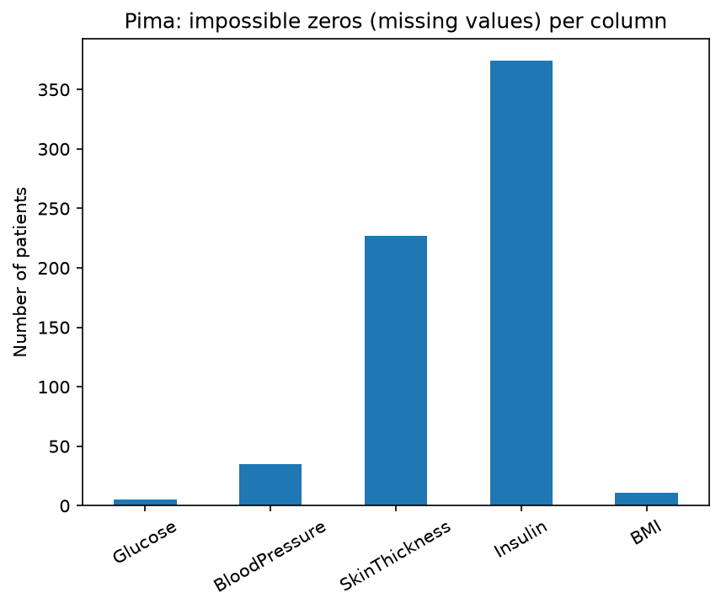
Figure 2.1: Impossible zero values per Pima column (hidden missing values)
Insulin (48.7%) and SkinThickness (29.6%) have large shares of impossible zeros. Left as zeros they would distort every mean and correlation, which is why they are treated as missing.
Table 2.3: Correlation of each feature with the target
Pima feature | r with Outcome | Kaggle feature | r with diabetes
Glucose | 0.495 | blood_glucose_level | 0.424
BMI | 0.314 | HbA1c_level | 0.406
Insulin | 0.303 | age | 0.265
SkinThickness | 0.259 | bmi | 0.215
Age | 0.238 | hypertension | 0.196
Pregnancies | 0.222 | heart_disease | 0.171

In both datasets blood sugar is by far the strongest single signal, followed by BMI and age. Diabetic Pima patients have a median glucose of 140 against 107, a median BMI of 34.3 against 30.1, and a median age of 36 against 27. For disease progression, BMI (r = 0.586) and s5, the log triglyceride level (r = 0.566), are the strongest predictors.
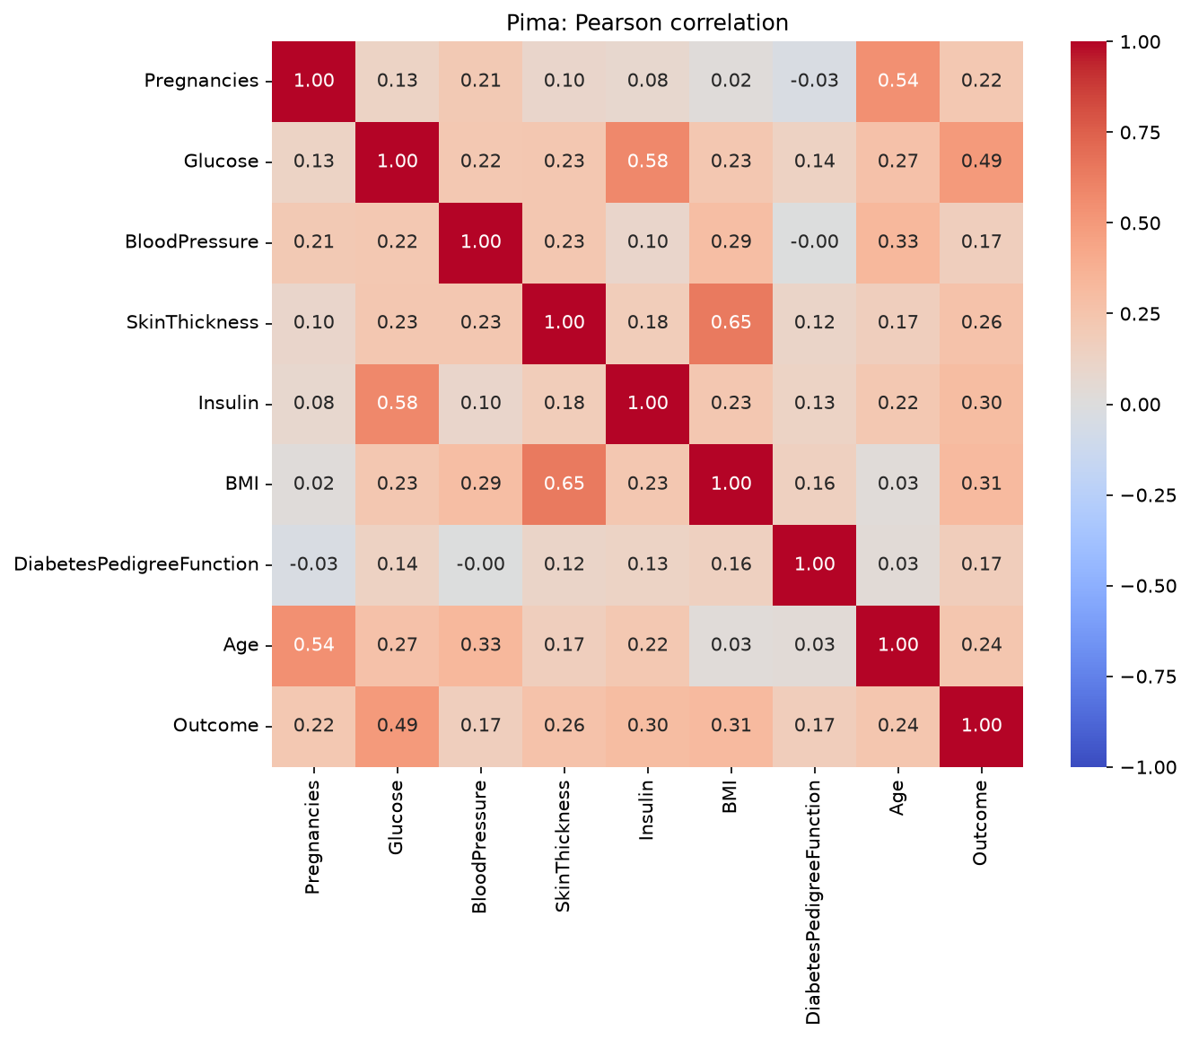
Figure 2.2: Correlation matrix of the Pima features
No pair of Pima features is so strongly correlated that one is redundant, so all features are kept for the supervised models in Unit 2.

2.5 Proposed System Architecture / Workflow
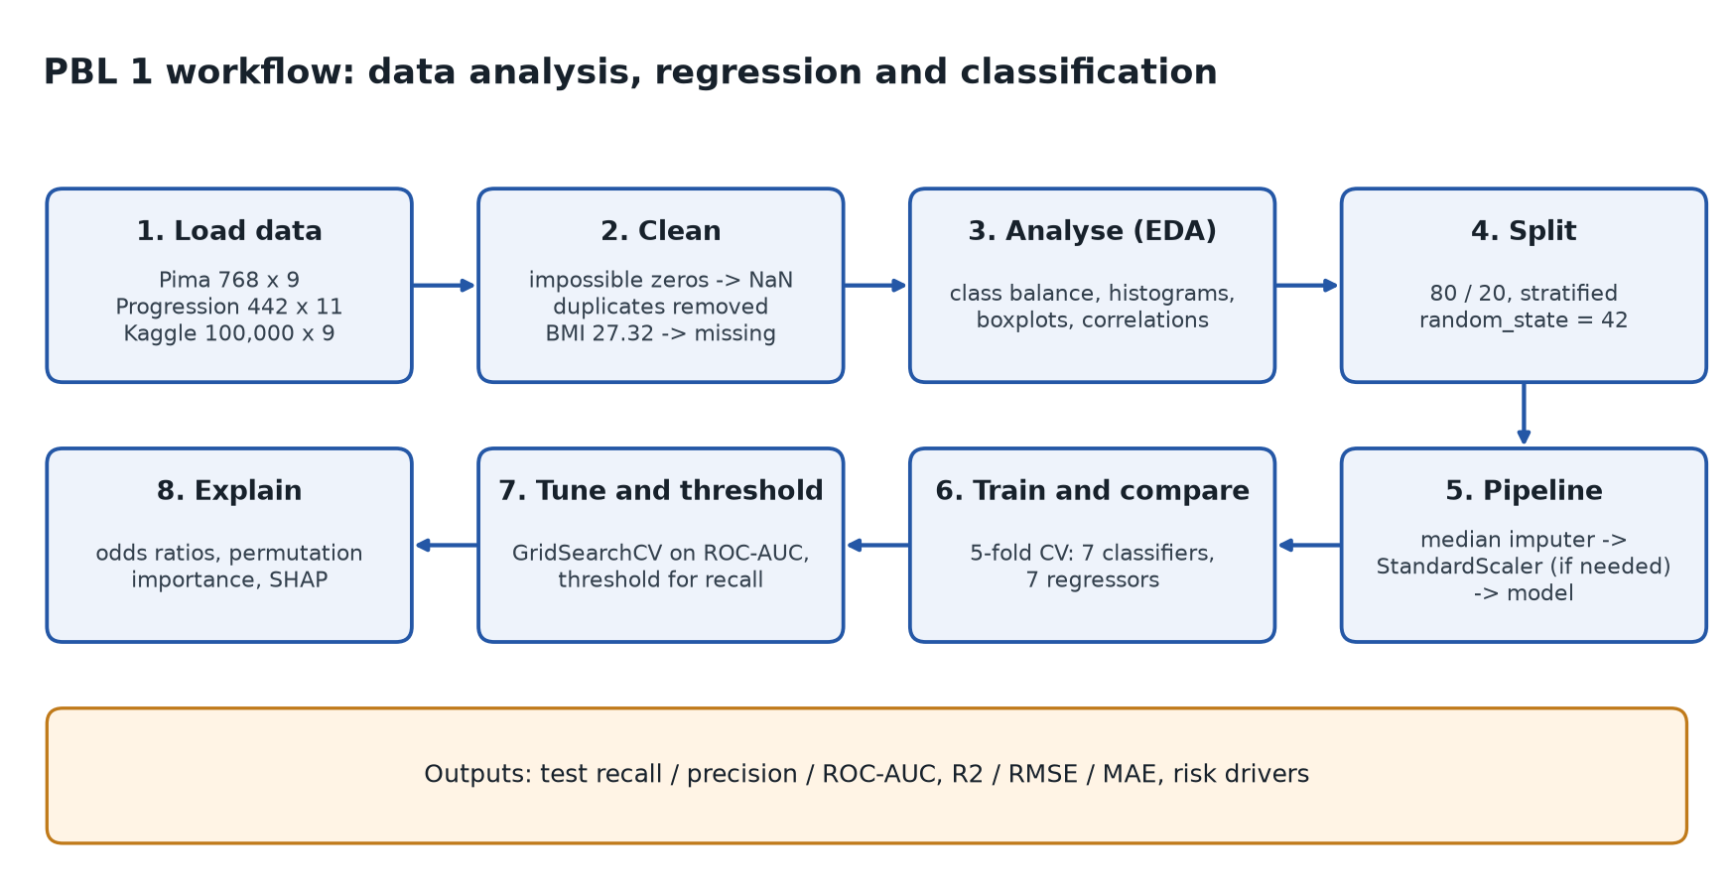
Figure 2.3: Workflow for Units 1 and 2
Data is loaded and cleaned, analysed, then split before any value is learned from it. All preprocessing sits inside pipelines, models are compared with 5-fold cross-validation, the best are tuned on ROC-AUC, the decision threshold is then lowered to reach the recall target, and the final model is explained with odds ratios, permutation importance and SHAP.

2.6 Algorithm Theory and Mathematical Formulation
Linear regression minimises the squared error; Ridge and Lasso add a penalty with strength λ (alpha):
Ridge: min_β Σᵢ (yᵢ − xᵢᵀβ)² + λ Σⱼ βⱼ² (2.1)
Lasso: min_β Σᵢ (yᵢ − xᵢᵀβ)² + λ Σⱼ |βⱼ| (2.2)
Logistic regression models the log-odds of diabetes as a linear function, so each coefficient becomes an odds ratio eᵝ per unit (or per standard deviation after scaling):
P(y = 1 | x) = σ(β₀ + xᵀβ) = 1 / (1 + e^−(β₀ + xᵀβ)) (2.3)
The SVM with an RBF kernel finds the boundary with the largest margin in a transformed feature space, K(x, x′) = exp(−γ‖x − x′‖²). Decision trees split on single-feature thresholds chosen to reduce Gini impurity; random forests average many deep trees on bootstrap samples; gradient boosting adds small trees one at a time to reduce the remaining error.
Metrics: recall = TP / (TP + FN), the share of diabetic patients found (the primary metric, because a missed diabetic costs more than a false alarm); precision = TP / (TP + FP); ROC-AUC, the probability that a random diabetic is ranked above a random non-diabetic; and for regression R², RMSE and MAE.
R² = 1 − Σ(yᵢ − ŷᵢ)² / Σ(yᵢ − ȳ)² (2.4)

2.7 Results and Performance Evaluation
Table 2.4: Pima classifiers: 5-fold CV and test ROC-AUC (before tuning)
Model | CV recall | CV ROC-AUC | Train ROC-AUC | Test ROC-AUC
SVM (RBF) | 0.762 | 0.837 | 0.909 | 0.814
Logistic regression | 0.701 | 0.844 | 0.852 | 0.813
Random forest | 0.701 | 0.820 | 1.000 | 0.821
Gradient boosting | 0.598 | 0.819 | 0.989 | 0.831
Gaussian naive Bayes | 0.598 | 0.828 | 0.833 | 0.765
KNN | 0.565 | 0.784 | 0.906 | 0.790
Decision tree | 0.533 | 0.640 | 1.000 | 0.661

The SVM had the best cross-validated recall, so it was tuned (C = 1, γ = 0.01, CV ROC-AUC 0.849) and its threshold lowered to 0.30. The single decision tree scores 1.000 on its training data but 0.640 in cross-validation: a clear case of overfitting.
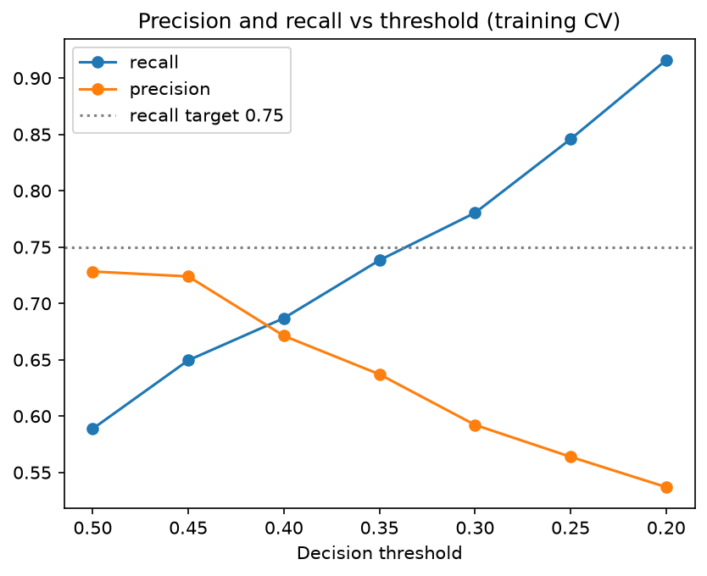
Figure 2.4: Recall and precision of the tuned SVM as the decision threshold is lowered
Lowering the threshold from 0.50 to 0.30 raises cross-validated recall from 0.589 to 0.780 at precision 0.592, which meets the recall target while flagging under half of all patients.
Table 2.5: Final PBL 1 results on the held-out test sets
Task | Final model | Test result | Target met?
Pima classification | SVM (RBF), threshold 0.30 | recall 0.796, precision 0.566, ROC-AUC 0.810 | yes (recall ≥ 0.75, ROC-AUC ≥ 0.80)
Progression regression | Lasso (alpha = 0.1) | R² 0.456, RMSE 53.71, MAE 42.81 (mean baseline R² −0.012) | yes (R² ≥ 0.40)
Kaggle classification, all features | Random forest (tuned), threshold 0.7 | recall 0.784, precision 0.729, ROC-AUC 0.974 | yes
Kaggle classification, no blood tests | Logistic regression, threshold 0.5 | recall 0.787, precision 0.211, ROC-AUC 0.825 | yes
Kaggle regression (BMI) | Ridge (alpha = 100) | R² 0.171, RMSE 7.04 (baseline 7.73) | beats baseline

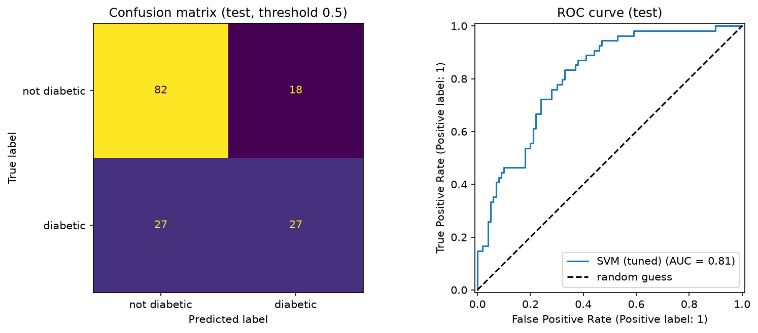
Figure 2.5: Confusion matrix and ROC curve of the final Pima classifier on the test set

2.8 Discussion and Findings
- Why the SVM and not the others: it had the highest cross-validated recall (0.762) and, after tuning, the highest ROC-AUC (0.849). Logistic regression was close and remains the explainable reference.
- Why the decision tree and KNN were dropped: the tree overfits (train 1.000 vs CV 0.640) and KNN had the lowest recall among the stable models (0.565).
- Why Lasso for regression: Ridge, Lasso and linear regression were tied in CV (R² about 0.48); Lasso was kept because it also selects features, and tree models overfitted (random forest train R² 0.920 vs CV 0.398).
- Why HbA1c was dropped as the Kaggle regression target: it cannot be predicted from the other features (CV R² 0.042), so BMI was predicted instead.
- Why the no-blood-test model matters: in the Kaggle data the label is largely determined by HbA1c and glucose, so the all-features ROC-AUC (0.974) is partly circular; without them the realistic result is 0.825.
- Risk drivers: glucose has the largest effect (odds ratio 2.78 per standard deviation), followed by BMI, pregnancies, family history and age. Odds ratios, permutation importance and SHAP agree on this order.
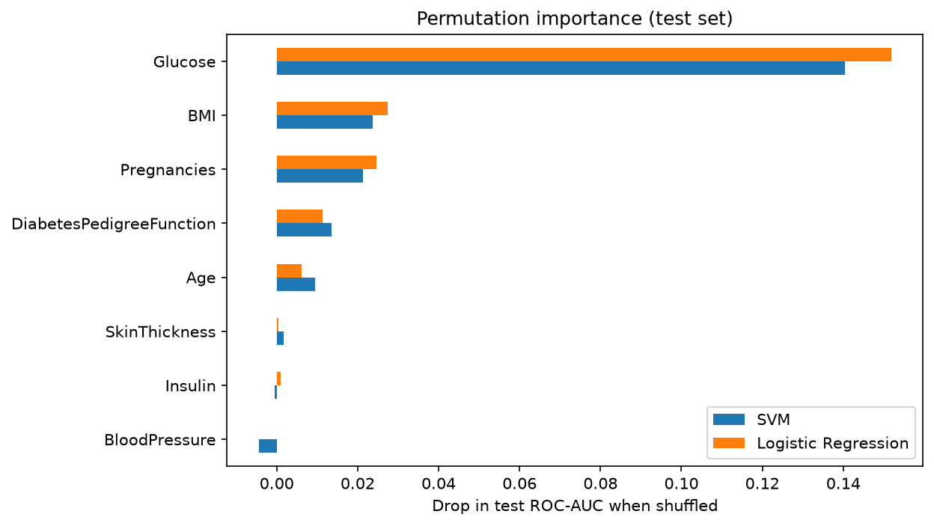
Figure 2.6: Permutation importance of the Pima features for the final model

2.9 Chapter Conclusion
PBL 1 met all its targets: the SVM finds about four in five diabetic Pima patients (recall 0.796, ROC-AUC 0.810), and Lasso explains 46% of the variation in disease progression. On the larger Kaggle data the realistic screening baseline without blood tests is ROC-AUC 0.825. These numbers, and the risk factors glucose, BMI, age and family history, are the baseline for the later units.
CHAPTER 3

3. UNSUPERVISED LEARNING AND SEQUENTIAL DATA MODELLING (UNITS 3 AND 4)

3.1 Overview of Allotted Unit 3 and Unit 4 Topics
Unit 3, Alternate EM: the alternative view of the Expectation-Maximisation algorithm, applied to a Gaussian mixture model on the existing Pima dataset, with K-means as the hard-assignment version of EM. Unit 4, Hidden Markov Model: a Gaussian HMM on a new sequential dataset of blood glucose readings, trained with Baum-Welch and decoded with forward-backward and Viterbi.

3.2 Unit 3 - Dataset Description and Preprocessing
The Pima dataset is described in Section 2.2. Unit 3 adds clustering-specific preprocessing, because a Gaussian mixture is sensitive to missing values, repeated values and scale:
Table 3.1: Unit 3 feature selection and transformation
Feature | Decision | Reason
Insulin | dropped | 48.7% missing; filling half a column with one median creates a spike a Gaussian would fit
SkinThickness | dropped | 29.6% missing (rule: drop above 25% missing)
Pregnancies | dropped | discrete count; on a first try one Gaussian collapsed onto the patients with 0 pregnancies and BIC chose K = 8
Outcome | held out | unsupervised: used only to check the clusters afterwards
DiabetesPedigreeFunction | log(1 + x) | skew 1.92 reduced to 1.12
Age | log(1 + x) | skew 1.13 reduced to 0.61
Glucose, BloodPressure, BMI | kept, median-imputed | at most 4.6% missing

Result: 768 patients by 5 features, standardised so the Euclidean distance weighs them equally. The largest correlation between the five features is 0.34, so none is redundant.

3.3 Unit 3 - Theory, EDA, Implementation and Results
EDA from Chapter 2 is not repeated. The additional check for clustering is the correlation of the five selected features, shown below, and the BIC search in Section 3.6.
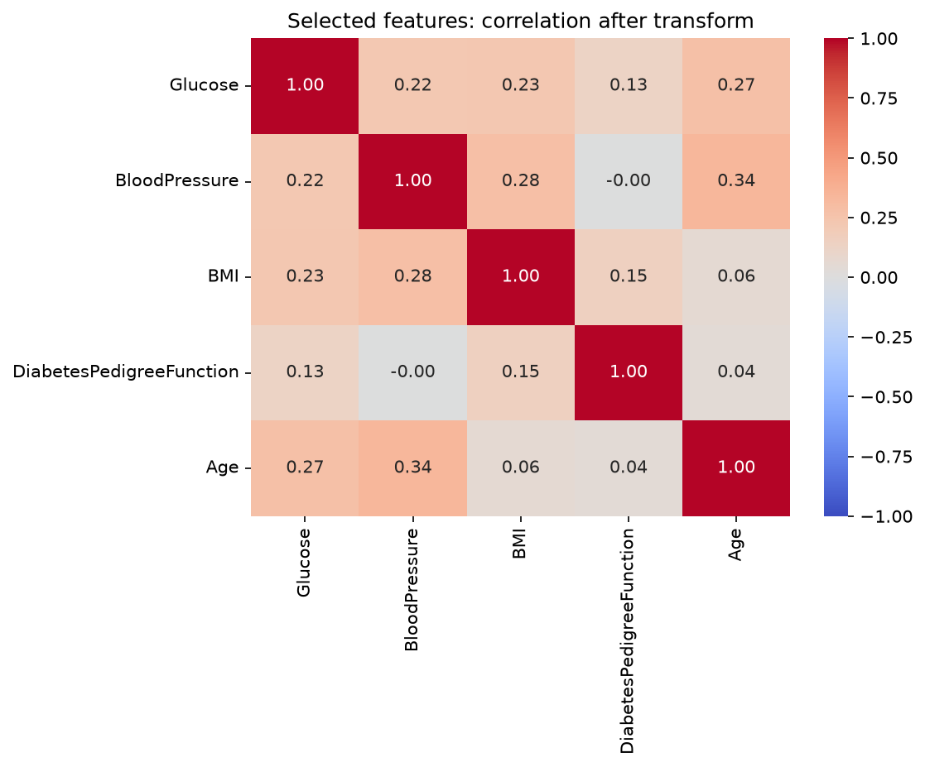
Figure 3.1: Correlation of the five features used for clustering

3.4 Unit 3 - Algorithm Theory and Mathematical Formulation
A Gaussian mixture with K components models each patient as coming from one of K groups, with mixing weights πₖ, means μₖ and covariances Σₖ:
p(x) = Σₖ πₖ N(x | μₖ, Σₖ) (3.1)
The group label z of each patient is hidden. With complete data (X, Z) fitting would be easy; with only X, the log-likelihood is a log of a sum with no closed-form maximum. EM instead maximises the expected complete-data log-likelihood Q(θ, θᵒˡᵈ), alternating two steps:
E-step: γₙₖ = πₖ N(xₙ | μₖ, Σₖ) / Σⱼ πⱼ N(xₙ | μⱼ, Σⱼ) (3.2)
M-step: Nₖ = Σₙ γₙₖ, πₖ = Nₖ / N, μₖ = Σₙ γₙₖ xₙ / Nₖ (3.3)
Each iteration never decreases the likelihood, and EM stops at a local maximum, so it is restarted from 10 random starts. Forcing γ to 0 or 1 gives K-means, the hard version of EM. The number of components is chosen with the Bayesian Information Criterion:
BIC = −2 ln L + p ln N (3.4)

3.5 Unit 3 Proposed System Architecture / Workflow
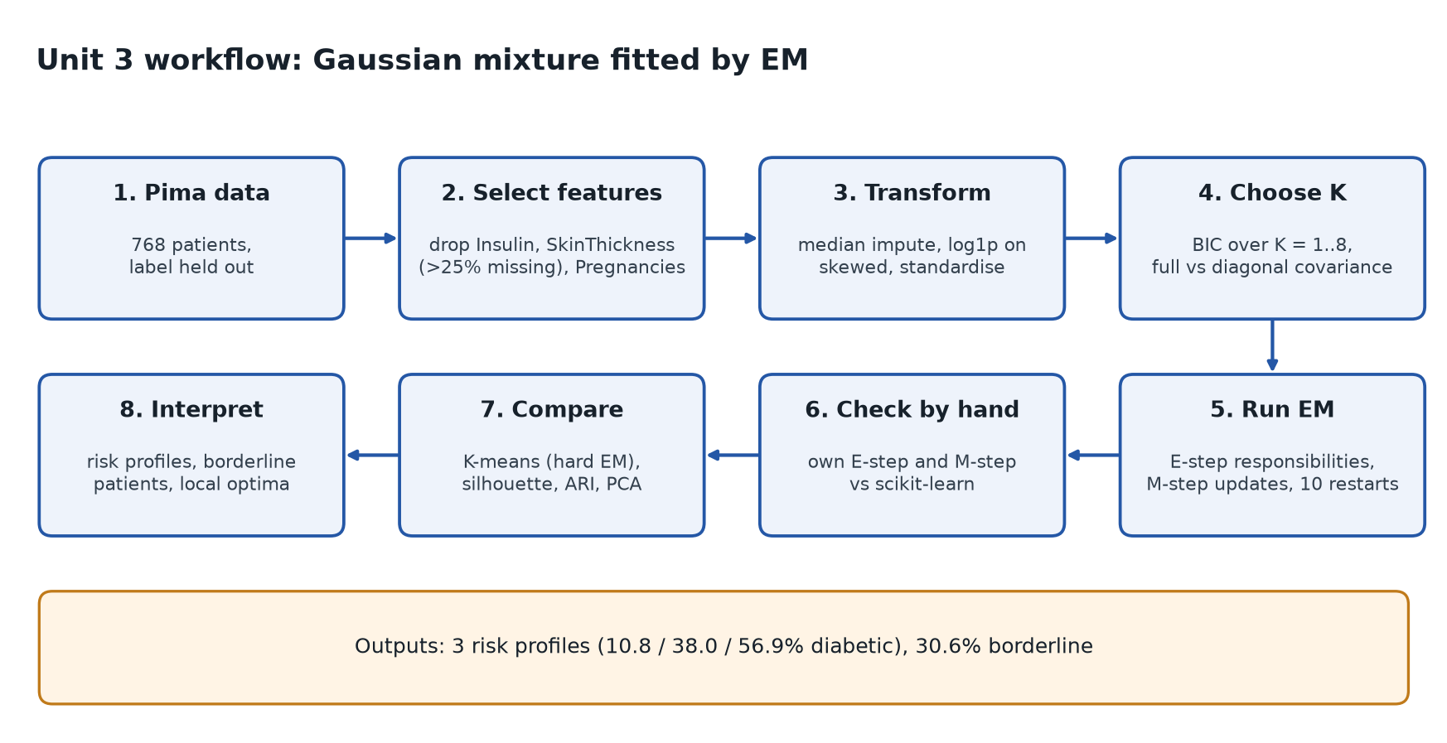
Figure 3.2: Workflow for Unit 3

3.6 Unit 3 - Results and Performance Evaluation
BIC is lowest for diagonal covariance with K = 3 (10422.4); K = 4 is practically tied (10423.5), so BIC keeps the simpler model. Full covariance wins only at K = 2.
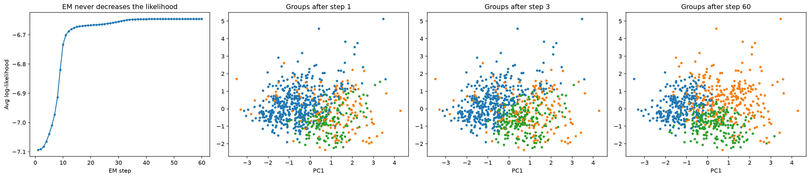
Figure 3.3: EM run one step at a time: log-likelihood and the clusters after steps 1, 3 and 60
The average log-likelihood climbs from −7.094 to −6.646 over 60 steps with zero decreases, which confirms the monotonic property. Our hand-written E-step matches scikit-learn's predict_proba to 1.3 × 10⁻¹⁵, and the final model converged after 25 steps.
Table 3.2: Three risk profiles found without the diagnosis
Cluster | Patients | Diabetic | Profile (medians)
Low risk | 269 | 10.8% | age 23, glucose 102, BMI 29.7, BP 65
Older | 237 | 38.0% | age 38, glucose 125, lowest family history (−0.68 SD)
High risk | 262 | 56.9% | glucose 130, BMI 34.6, highest family history (+0.73 SD)

Table 3.3: Soft (GMM) versus hard (K-means) clustering
Metric | GMM (soft EM) | K-means (hard EM)
Silhouette (internal) | 0.143 | 0.216
Adjusted Rand Index vs diagnosis (external) | 0.101 | 0.185
Gives probabilities | yes | no
Borderline patients (no group above 0.8) | 30.6% (235) | not available

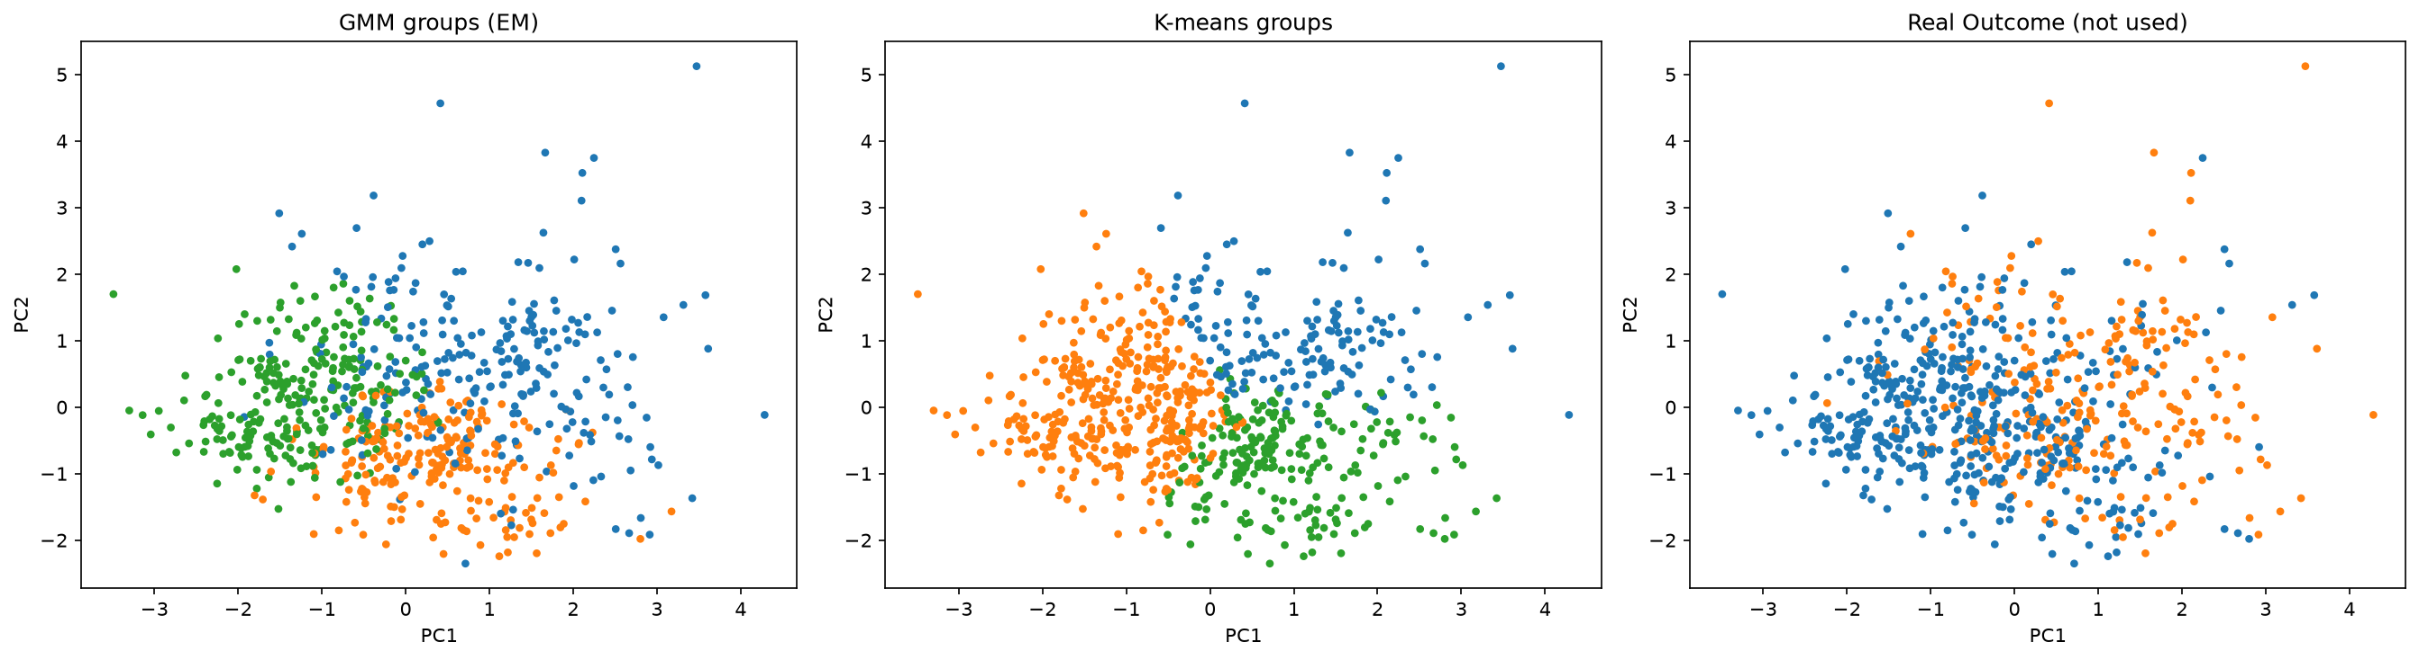
Figure 3.4: GMM clusters, K-means clusters and the real diagnosis on two PCA components (56.1% of variance)
K-means scores higher on silhouette because silhouette favours round, equal-sized clusters, which is exactly what K-means produces. Only the GMM can show that 30.6% of patients sit between groups. In 9 of 10 single random starts EM stopped at a worse local maximum (−6.670 vs −6.647), which is why 10 restarts are used.

3.7 Unit 4 - Sequential Dataset Description
Table 3.4: UCI Diabetes (AIM-94) sequential dataset
Property | Value
Source | UCI Machine Learning Repository; Michael Kahn, Washington University, St. Louis (AIM-94)
Patients and period | 70 insulin-dependent (Type 1) patients, March 1988 to September 1991
Size | 70 files, 29,330 rows by 4 fields: date, time, code, value
Sequence identifier | patient file (data-01 to data-70)
Event codes | insulin doses (33 to 35): 14,401; glucose readings (48, 57 to 64): 13,531; hypoglycaemic symptoms: 331; meals: 514; exercise: 305; special events: 94; undocumented codes: 154
Sampling | irregular; median gap 6 hours, mostly before meals; paper records use fixed times (08:00, 12:00, 18:00, 22:00)
Observation variable | blood glucose (mg/dL)
Limitations | irregular gaps, approximate paper-record times, old data from one clinic

3.8 Unit 4 - Sequential Preprocessing and EDA
- Kept only glucose codes; removed 13 rows with unreadable values or dates (for example 06-31-1991) and 3 readings below 20 mg/dL, leaving 13,515 readings from 70 patients.
- Sorted each patient's readings by time; temporal order is never shuffled.
- Kept the 68 patients with at least 50 readings and split by patient: 54 for training, 14 for testing, so no patient appears in both.
- All readings are stacked with a lengths array, so the model never learns a false transition between two different patients.
- Median of 120 readings per patient (31 to 616); median reading 149 mg/dL, a quarter above 210.
- Order matters: lag-1 autocorrelation within patients is 0.186 and drops to 0.0 when the order is shuffled.
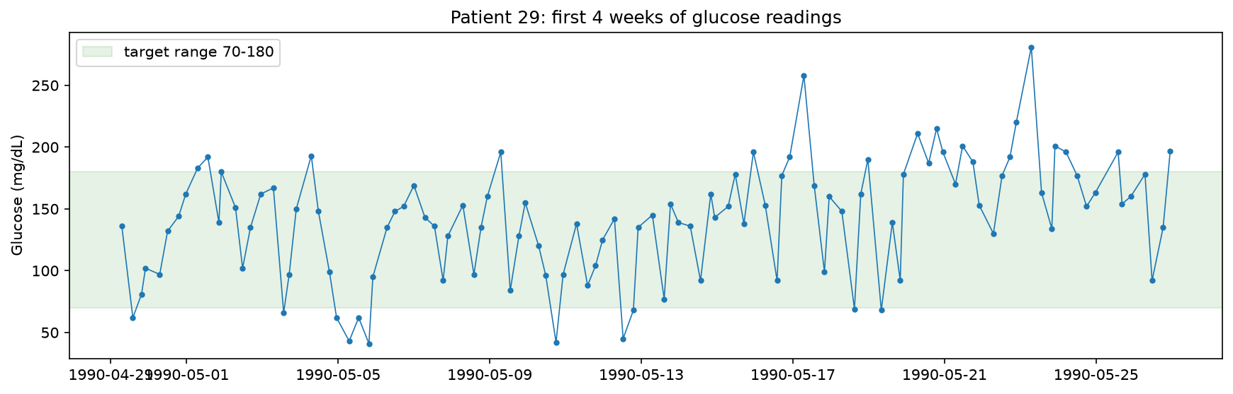
Figure 3.5: One patient's glucose readings over four weeks, against the 70 to 180 mg/dL target band

3.9 Unit 4 - Mathematical Formulation
A Hidden Markov Model λ = (π, A, B) has hidden states zₜ (here: low, target and high glucose regimes) that follow a first-order Markov chain, and observations xₜ (glucose readings) that depend only on the current state:
aᵢⱼ = P(zₜ = j | zₜ₋₁ = i), xₜ | zₜ = j ~ N(μⱼ, σⱼ²) (3.5)
The forward algorithm computes the likelihood of a sequence; Viterbi finds the most likely state path by replacing the sum with a maximum and keeping back-pointers; forward-backward gives the smoothed state probabilities γₜ(i); Baum-Welch is EM for HMMs, using forward-backward in the E-step. All recursions run in log space with log-sum-exp to avoid underflow.
αₜ(j) = [Σᵢ αₜ₋₁(i) aᵢⱼ] bⱼ(xₜ), P(x₁:T) = Σⱼ α_T(j) (3.6)
δₜ(j) = maxᵢ [δₜ₋₁(i) aᵢⱼ] bⱼ(xₜ) (3.7)
The stationary distribution π* = π*A gives the long-run share of time in each state, and the expected time spent in state i is 1 / (1 − aᵢᵢ).

3.10 Unit 4 Proposed System Architecture / Workflow
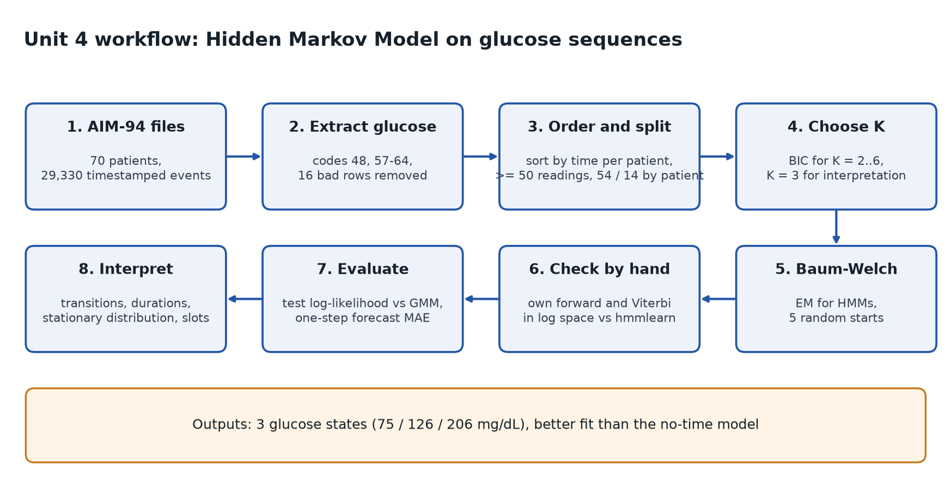
Figure 3.6: Workflow for Unit 4

3.11 Results and Performance Evaluation
BIC keeps falling until K = 5, but from K = 4 the extra states overlap (means 180, 191 and 211 mg/dL) and differ only in spread. K = 3 gives clearly separated states that match the clinical bands, so K = 3 was chosen for interpretability, and this trade-off is stated openly. Baum-Welch converged after 136 rounds with the best of 5 random starts.
Table 3.5: Learned states
State | Mean (SD) mg/dL | Stay probability aᵢᵢ | Expected duration (readings)
Low | 74.8 (24.1) | 0.43 | 1.75
Target | 126.1 (37.8) | 0.97 | 33.7
High | 205.5 (76.6) | 0.79 | 4.7

Table 3.6: Learned transition matrix A (rows sum to 1)
From \ To | Low | Target | High
Low | 0.43 | 0.01 | 0.56
Target | 0.00 | 0.97 | 0.03
High | 0.20 | 0.01 | 0.79

A low reading is usually followed by a high one (0.56), the known rebound after hypoglycaemia. Target is a stable regime that Low and High rarely jump into. The stationary distribution is 0.188 low, 0.280 target and 0.532 high, close to the share of training readings Viterbi assigns to each state (0.208, 0.304, 0.487).
Verification: our hand-written forward algorithm gives exactly the library's log-likelihood (−600.2392) for a test patient, and our Viterbi gives the identical 104-step path.
Table 3.7: Unit 4 evaluation on 14 held-out patients
Measure | Hidden Markov Model | Gaussian mixture (no time) | Single Gaussian / baselines
Test log-likelihood per reading (higher is better) | −5.6847 | −5.7313 | −5.7861
Next-reading forecast MAE, mg/dL (lower is better) | 60.1 |  | training mean 62.6; last reading 74.0

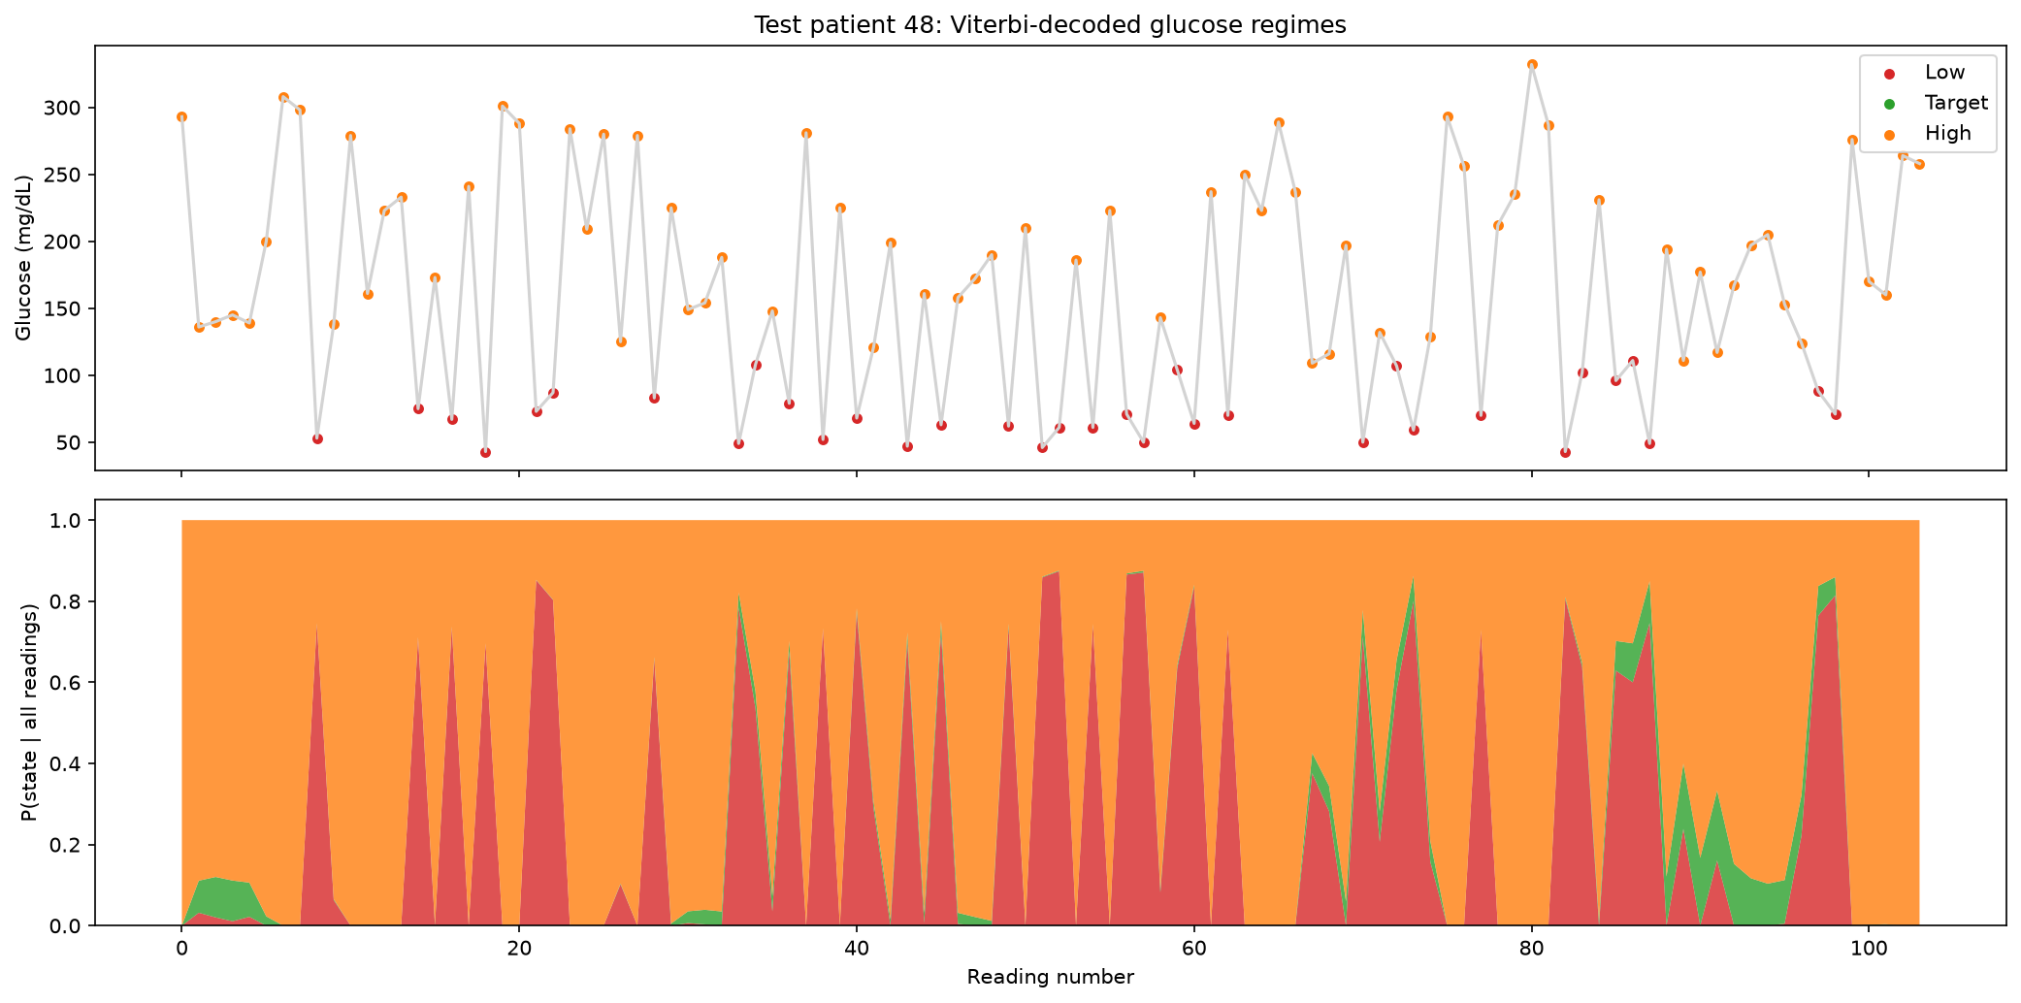
Figure 3.7: Viterbi path and smoothed state probabilities for test patient 48
Test patient 48 is never decoded as Target: mostly High with repeated drops to Low, a pattern a single average would hide. Across test patients, 63.0% of pre-breakfast readings are High against 49.4% before lunch (consistent with the dawn phenomenon), 29.9% of pre-snack readings are Low, and 8 of 14 patients never reach Target.

3.12 Discussion, Findings and Limitations
- Unit 3: EM rediscovers clinically sensible risk groups without the label, and its soft assignments expose borderline patients that hard clustering hides. Limitations: Gaussian cluster shapes, local optima, one population of women.
- Unit 4: the states are interpretable and the time order measurably helps on new patients, because the HMM and the GMM share the same Gaussian emissions and differ only by the transition matrix. Limitations: one step equals one reading regardless of the gap, glucose only (no insulin or meals as inputs), approximate paper-record times and old data.
- Validation: Unit 3 is checked against the held-out diagnosis only after fitting; Unit 4 is validated on patients never seen in training, never on shuffled readings.

3.13 Chapter Conclusion
Unit 3 showed that the existing Pima data contains three risk groups, from 10.8% to 56.9% diabetic, found without labels. Unit 4 showed, on a separate sequential dataset, that blood glucose moves between three hidden regimes with medically known patterns, and that modelling time improves the fit on new patients. The two units use different datasets and different tasks, so their performance values are not compared directly.
CHAPTER 4

4. ADVANCED PREDICTIVE MODELLING AND ENSEMBLE LEARNING (UNIT 5)

4.1 Overview of Allotted Unit 5 Topics
Unit 5 combines models. Boosting trains weak models one after another, each focusing on the patients the previous ones got wrong, and combines them in a weighted vote; we implement AdaBoost with decision stumps (one-split CART trees). Bayesian model averaging (BMA) keeps many candidate models and weights each by its posterior probability. A single CART tree and a random forest (bagging) are the baselines, and gradient boosting is included as boosting with the cross-entropy error.
Table 4.1: Three ways of combining models
 | Bagging (random forest) | Boosting (AdaBoost) | Bayesian model averaging
Training | in parallel, bootstrap samples | in sequence, on reweighted data | each candidate on all data
Combined by | equal vote | weighted vote, αₘ from error | posterior weight p(M | D)
Mainly reduces | variance | bias | model uncertainty
With more data | keeps all members | keeps all members | weight moves to one model

4.2 Dataset Description and Preprocessing
The Kaggle dataset is described in Section 2.2 and reused with the same cleaning and the same stratified 80 / 20 split (76,916 training and 19,230 test patients, 8.82% diabetic in both), so results compare directly with PBL 1. Additional Unit 5 preprocessing: BMI placeholders are filled with the training median (26.50); gender and smoking_history are one-hot encoded, giving 15 columns; trees need no scaling, while the logistic regressions used in BMA are standardised. The rounded HbA1c and glucose values that ruled this dataset out for the Gaussian models of Units 3 and 4 are no problem for trees, which only need a threshold between two values.

4.3 EDA and Feature Analysis
The additional analysis relevant to boosting is how the label depends on the two blood tests, because a stump splits on exactly one such threshold.
Table 4.2: The label is nearly a rule on HbA1c and glucose
 | HbA1c | Glucose
Values where every patient is diabetic | 6.8, 7.0, 7.5, 8.2, 8.8, 9.0 | 220, 240, 260, 280, 300
Highest value in a non-diabetic patient | 6.6 | 200
Rule: HbA1c ≥ 6.8 or glucose ≥ 220 | 5,671 patients, 100% diabetic | catches 66.9% of all diabetic patients

The data appears to have been generated with hard cut-offs close to the clinical diagnosis lines (HbA1c 6.5%, glucose 200 mg/dL). Any model that sees these two features gets two thirds of the diabetic patients almost for free, and the label is partly defined by them. Section 4.8 therefore repeats the comparison without blood tests.
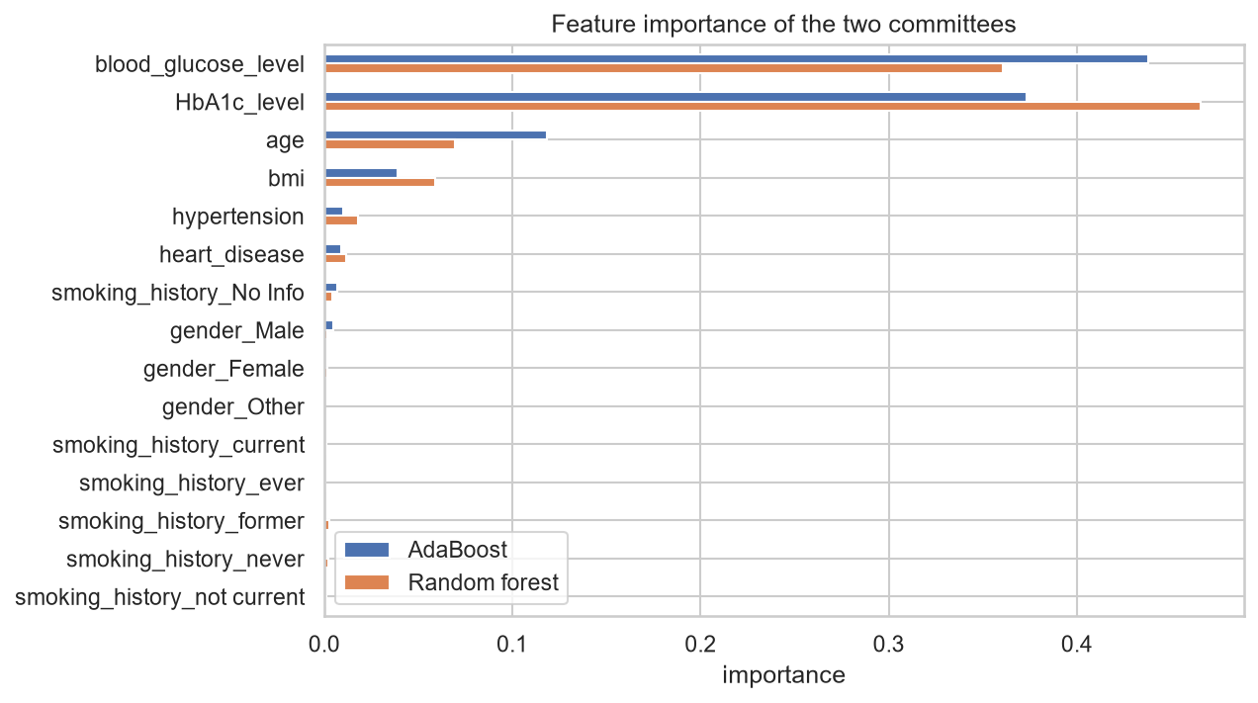
Figure 4.1: Feature importance of AdaBoost and the random forest

4.4 Proposed Workflow / Architecture
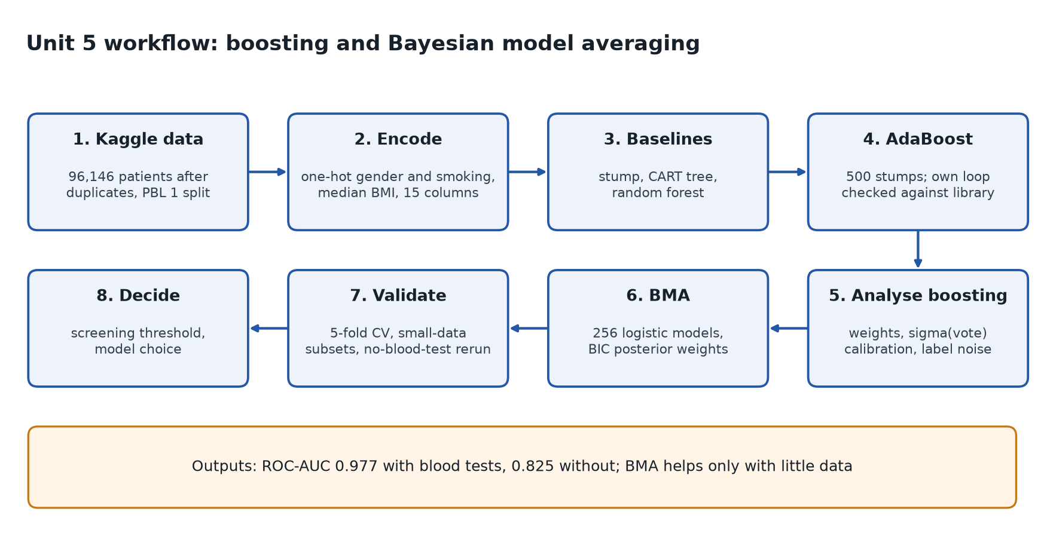
Figure 4.2: Workflow for Unit 5

4.5 Algorithm Theory and Mathematical Formulation
AdaBoost. Labels tₙ ∈ {−1, +1}; all weights start at wₙ = 1/N. In each round m a stump yₘ is fitted with weights w, and:
εₘ = Σₙ wₙ I(yₘ(xₙ) ≠ tₙ) / Σₙ wₙ (4.1)
αₘ = ln((1 − εₘ) / εₘ) (4.2)
wₙ ← wₙ exp(αₘ I(yₘ(xₙ) ≠ tₙ)), Y(x) = sign(Σₘ αₘ yₘ(x)) (4.3)
This is the form in Bishop and in scikit-learn. AdaBoost greedily minimises the exponential error, which also bounds the training error, and whose minimiser is half the log-odds, so the vote converts to a probability:
E = Σₙ exp(−tₙ fₘ(xₙ)), fₘ = ½ Σₗ αₗ yₗ, E/N = Πₘ 2√(εₘ(1 − εₘ)) (4.4)
p(t = 1 | x) = σ(Σₘ αₘ yₘ(x)) (4.5)
Bayesian model averaging. For candidate models M₁ … M_K, with the evidence approximated by BIC and an equal prior:
p(t | x, D) = Σₖ p(t | x, Mₖ) p(Mₖ | D), p(Mₖ | D) ∝ exp(−½ BICₖ) (4.6)
The posterior inclusion probability of a feature is the total posterior weight of the models that contain it.
Table 4.3: Parameter settings and model-selection decisions
Model | Settings | Reason
Decision stump | DecisionTreeClassifier(max_depth=1) | the textbook weak learner; each round readable
CART tree | max_depth = 6 | single-tree baseline
Random forest | 300 trees, min_samples_leaf = 5 (and 50 in the noise test) | bagging baseline
AdaBoost | 500 stumps, learning rate 1.0 | test ROC-AUC still rising slowly at 500; no overfitting
Gradient boosting | HistGradientBoostingClassifier, defaults | boosting with the cross-entropy error
BMA candidates | 256 logistic regressions (every subset of 8 feature groups), C = 1e6 | BIC needs a likelihood and a clear parameter count; C = 1e6 gives maximum-likelihood fits
Validation | same test split as PBL 1; stratified 5-fold CV on all 96,146 patients | check the ranking is not luck of one split

4.6 Results and Performance Evaluation
Table 4.4: First AdaBoost rounds (all features)
Round m | Stump splits on | εₘ | αₘ
1 | HbA1c ≤ 6.70 | 0.048 | 2.98
2 | HbA1c ≤ 5.35 | 0.280 | 0.94
3 | glucose ≤ 210 | 0.222 | 1.26
4 | age ≤ 41.5 | 0.257 | 1.06
5 | glucose ≤ 113 | 0.364 | 0.56
8 | glucose ≤ 113 | 0.423 | 0.31

The first stumps sit exactly in the gaps of the rule in Table 4.2, and the weighted error rises towards 0.5 as each new stump is given the patients the earlier ones got wrong.
Verification: our hand-written AdaBoost (only the stump fitting is borrowed) reproduces scikit-learn on all 500 of 500 stumps, αₘ and εₘ agree to 4.4 × 10⁻¹⁵, and the test predictions are identical for all 19,230 patients. The exponential error equals Πₘ 2√(εₘ(1 − εₘ)) to 4.4 × 10⁻¹⁶, falling from 0.428 to 0.161, while the training error falls from 4.8% to 2.9% and always stays below it.
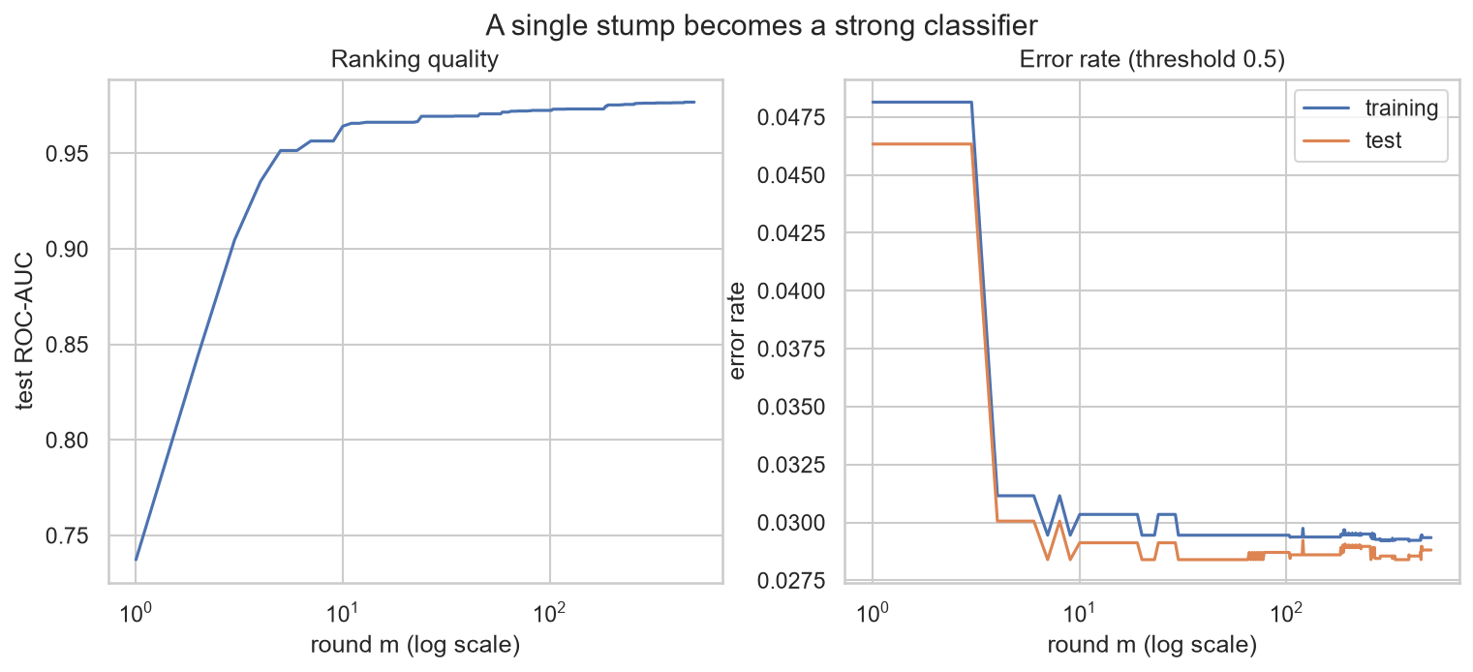
Figure 4.3: From one stump to 500: test ROC-AUC and training and test error by round
Test ROC-AUC rises from 0.737 (one stump) to 0.952 after 5 rounds and 0.977 after 500, and the test error (2.88%) stays close to the training error (2.93%), so there is no overfitting.
Table 4.5: Which patients boosting focuses on (after 500 rounds)
 | Heaviest 1% | Other diabetic | Non-diabetic
Patients | 774 | 6,012 | 70,130
Median HbA1c | 6.1 | 6.8 | 5.8
Median glucose | 155 | 200 | 140
Below both clinical cut-offs | 63.6% | 15.8% | 76.8%

The heaviest 1% of patients hold 28.4% of all the weight and every one is diabetic: boosting concentrates on diabetic patients whose lab values look almost normal, which are exactly the hard cases for screening.
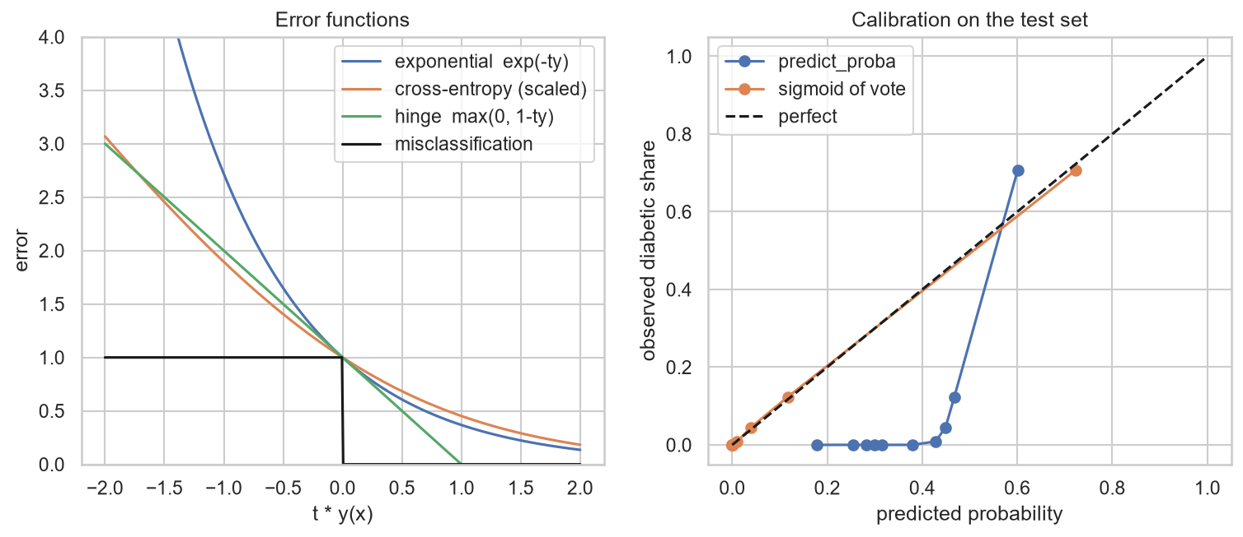
Figure 4.4: Error functions, and calibration of the library's predict_proba against σ(vote)
The library's predict_proba squeezes probabilities towards 0.5 (log loss 0.436, Brier 0.129). Converting the vote with σ(vote), as the theory says, gives log loss 0.083 and Brier 0.024, with the calibration curve on the diagonal and the same ROC-AUC.
Table 4.6: Test-set comparison, all features
Model | ROC-AUC | Avg precision | Log loss | Recall @0.5 | Precision @0.5
One stump | 0.737 | 0.521 | 0.186 | 0.475 | 1.000
CART tree, depth 6 | 0.962 | 0.825 | 0.093 | 0.678 | 1.000
Random forest | 0.970 | 0.871 | 0.093 | 0.680 | 0.997
AdaBoost, 500 stumps | 0.977 | 0.879 | 0.083 | 0.689 | 0.978
Gradient boosting | 0.977 | 0.881 | 0.083 | 0.693 | 0.978
BMA, 256 logistic models | 0.960 | 0.817 | 0.117 | 0.640 | 0.871

Table 4.7: Robustness to wrong training labels (test ROC-AUC on clean labels)
Labels flipped | AdaBoost | Random forest, leaf 5 | Random forest, leaf 50 | Gradient boosting
0% | 0.977 | 0.970 | 0.969 | 0.977
5% | 0.969 | 0.955 | 0.966 | 0.974
10% | 0.968 | 0.947 | 0.965 | 0.972

With 5% of labels flipped the flipped patients end up holding 36.2% of AdaBoost's weight, more than 7 times their share, which confirms that the exponential error chases wrong labels. The test damage is small because a stump cannot memorise one patient. The forest's loss depends on its leaf size (0.023 with leaves of 5, 0.004 with leaves of 50), so robustness here is about model capacity rather than bagging versus boosting. Three further random flips reproduce these values to within 0.002.
Table 4.8: Bayesian model averaging by training size (mean of 10 subsets)
Training patients | Top model weight | Models for 95% of weight | Log loss, BMA | Log loss, best model | Log loss, equal average
200 | 0.47 | 8.1 | 0.159 | 0.234 | 0.166
500 | 0.51 | 6.1 | 0.127 | 0.131 | 0.159
1,000 | 0.54 | 4.7 | 0.123 | 0.124 | 0.158
5,000 | 0.77 | 2.4 | 0.119 | 0.119 | 0.157
76,916 (all) | 1.000 | 1 | 0.117 | 0.117 | 0.157

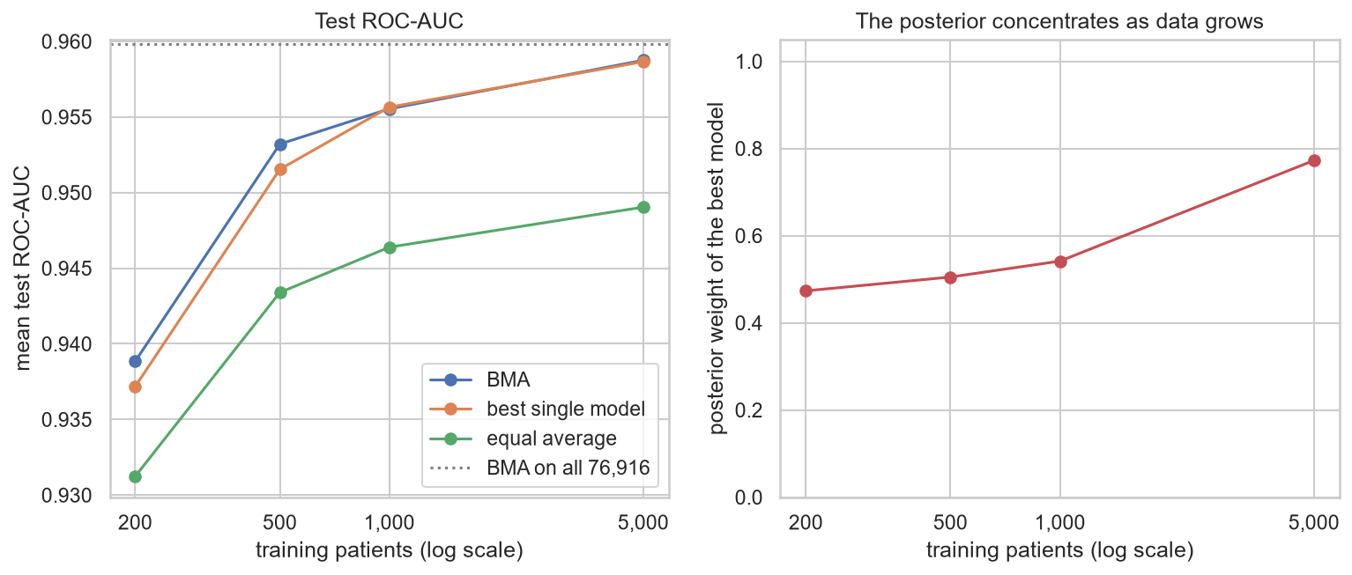
Figure 4.5: BMA, best single model and equal average by training size, and the posterior weight of the best model
On all 76,916 patients the full model gets posterior weight 1.000 (the next best, without gender, is 32 BIC units worse, weight 1.1 × 10⁻⁷), so BMA reduces to model selection. With 200 patients about 8 models share the weight and BMA gives clearly better probabilities than the single best model (0.159 vs 0.234). Equal averaging is worst at every size. With 200 patients the inclusion probabilities are glucose 1.00, HbA1c 0.99, age 0.52, BMI 0.40, heart disease 0.29, hypertension 0.18, gender 0.02 and smoking 0.00.

4.7 Comparison with Previous Models
Unit 5 uses the same task, the same test split and the same metric (ROC-AUC) as the PBL 1 Kaggle models, so the comparison is direct. 5-fold cross-validation on all 96,146 patients checks that the ranking is not luck of one split.
Table 4.9: Comparison with PBL 1 on the same Kaggle task
Model | Test ROC-AUC, all features | 5-fold CV, all features | 5-fold CV, no blood tests
PBL 1 random forest (tuned) | 0.974
PBL 1 logistic regression, no blood tests |  |  | 0.825 (test)
Logistic regression | 0.960 | 0.961 ± 0.005 | 0.830 ± 0.006
CART tree, depth 6 | 0.962 | 0.963 ± 0.004 | 0.820 ± 0.005
Random forest | 0.970 | 0.972 ± 0.003 | 0.810 ± 0.005
AdaBoost, 500 stumps | 0.977 | 0.978 ± 0.002 | 0.827 ± 0.005
Gradient boosting | 0.977 | 0.978 ± 0.003 | 0.832 ± 0.005

With all features, boosting improves on the tuned PBL 1 forest (0.977 vs 0.974) and beats the forest in all 5 cross-validation folds (by 0.006 on average); AdaBoost and gradient boosting are tied. Without blood tests the gain almost disappears: gradient boosting leads logistic regression in every fold, but only by 0.002, which is smaller than the fold-to-fold spread.

4.8 Discussion, Findings and Limitations
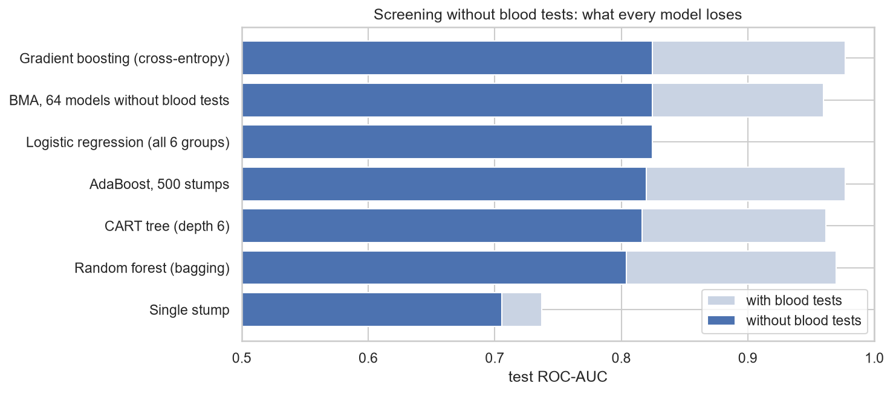
Figure 4.6: Test ROC-AUC of every model with and without the blood tests
Without HbA1c and glucose every model loses about 0.15 of ROC-AUC (AdaBoost 0.977 to 0.820, random forest 0.970 to 0.804) and average precision falls from about 0.88 to about 0.30. Ensembles win clearly when the signal has sharp thresholds; without blood tests risk rises smoothly with age (AdaBoost importance 0.758) and BMI (0.146), which a linear model already captures. For screening before a blood test, the explainable logistic regression is the sensible choice.
Table 4.10: Choosing a screening threshold (test set)
Model | Threshold | Recall | Precision | Share flagged
No blood tests: logistic regression | 0.50 | 0.054 | 0.487 | 1.0%
 | 0.10 | 0.754 | 0.220 | 30.3%
 | 0.08 | 0.808 | 0.198 | 36.0%
All features: AdaBoost, σ(vote) | 0.50 | 0.689 | 0.978 | 6.2%
 | 0.20 | 0.795 | 0.718 | 9.8%

- Interpretability: the hand-checked AdaBoost is transparent round by round, and BMA's inclusion probabilities state how sure the evidence is about each feature; the logistic regression keeps odds ratios.
- Training cost: 500 stumps fit in about 13 seconds, the random forest and gradient boosting in a few seconds, and the full 5-fold comparison in under 3 minutes on a laptop.
- Limitations: one dataset whose label is nearly a rule on two inputs; ensembles at default settings; 22.6% of training BMI values are a filled-in placeholder, which weakens BMI's measured importance; BIC is a large-sample approximation with an equal prior over models.

4.9 Chapter Conclusion
Unit 5 contributed the strongest classifier of the project (ROC-AUC 0.977 with all features), a verified implementation of AdaBoost, calibrated risk probabilities from the theory of the exponential error, and the lesson that model averaging helps only when data is scarce. It also showed, honestly, that before a blood test the simple logistic regression is as good as any ensemble (0.830 vs 0.832 in cross-validation).
CHAPTER 5

5. INTEGRATED DISCUSSION AND FINDINGS
This chapter compares the datasets and the models across all five units. Performance values are compared only where the task, data and metric are the same; otherwise the comparison is about purpose, strengths and weaknesses.

5.1 Dataset Comparison
Table 5.1: Every dataset: why it was used, and why it was not used elsewhere
Dataset | Size used | Used for | Why chosen | Why not used elsewhere
Pima Indians Diabetes | 768 x 9 (Unit 3: 768 x 5) | Units 1 and 2 classification; Unit 3 clustering | continuous clinical values; a label that can be hidden and checked afterwards | one row per patient, so no time order for Unit 4
Diabetes Progression | 442 x 11 | Unit 2 regression | continuous target (progression after one year) | no diabetes label; small
Kaggle Diabetes Prediction | 96,146 x 8 (15 after one-hot) | Units 1 and 2 classification and BMI regression; Unit 5 ensembles | large and labelled; trees handle rounded values | HbA1c and glucose rounded to 18 values each break Gaussian models (Units 3 and 4)
UCI Diabetes (AIM-94) | 13,515 readings, 68 patients | Unit 4 HMM | readings in time order, about 120 per patient | no diagnosis label; one variable

5.2 Model Comparison
Table 5.2: Every model used: purpose, result, strengths and weaknesses
Model | Unit | Learning type | Key result | Strength | Weakness
Linear / Ridge / Lasso regression | 2 | supervised regression | Lasso R² 0.456 (progression); Ridge R² 0.171 (BMI) | coefficients, feature selection (Lasso) | linear only
Logistic regression | 2, 5 | supervised classification | Pima test 0.813; Kaggle no blood tests 0.825 to 0.830 | odds ratios, calibrated | misses sharp thresholds
SVM (RBF) | 2 | supervised classification | Pima final recall 0.796, ROC-AUC 0.810 | best Pima recall | no coefficients to explain
KNN, naive Bayes | 2 | supervised classification | Pima test 0.790 and 0.765 | simple | lowest recall; not chosen
CART decision tree | 2, 5 | supervised classification | Pima 0.661; Kaggle 0.962 | readable rules | unstable, overfits small data
Random forest | 2, 5 | ensemble (bagging) | Kaggle 0.974 tuned; CV 0.972 | strong with little tuning | small leaves memorise wrong labels
Gradient boosting | 2, 5 | ensemble (boosting) | Kaggle CV 0.978; no blood tests 0.832 | top CV score, most noise-robust | least transparent
AdaBoost (stumps) | 5 | ensemble (boosting) | Kaggle 0.977; CV 0.978 | verified by hand; calibrated via σ(vote) | chases wrong labels
K-means | 3 | unsupervised, hard EM | silhouette 0.216, ARI 0.185 | compact groups | no probabilities
Gaussian mixture (EM) | 3 | unsupervised, soft EM | 10.8 / 38.0 / 56.9% diabetic; 30.6% borderline | probabilities, BIC picks K | Gaussian shape, local optima
Hidden Markov Model | 4 | sequential, EM (Baum-Welch) | test log-likelihood −5.685 vs −5.731 without time | uses time order, readable states | equal time steps, glucose only
Bayesian model averaging | 5 | model combination | 0.960; at 200 patients log loss 0.159 vs 0.234 | honest uncertainty | one model wins with large data

5.3 What Was Dropped, and Why
Table 5.3: Design decisions across the project
Dropped or changed | Where | Why
Insulin, SkinThickness | Unit 3 | 48.7% and 29.6% missing; imputing half a column creates an artificial spike
Pregnancies | Unit 3 | discrete count; a Gaussian collapsed onto zero pregnancies and BIC chose K = 8
Full covariance | Unit 3 | more parameters; BIC preferred diagonal at K = 3
HbA1c as regression target | Unit 2 (Kaggle) | unpredictable from the other features (CV R² 0.042); BMI predicted instead
Decision tree, KNN, naive Bayes as final models | Unit 2 | overfitting (tree) or lowest recall
Threshold 0.5 | Units 2 and 5 | too high with few positives; 0.30 (Pima) and 0.08 (Kaggle screening) reach the recall targets
K = 5 HMM states | Unit 4 | overlapping states; K = 3 matches the clinical bands
Insulin, meals, exercise codes | Unit 4 | a plain HMM has no inputs; listed as future work
Duplicates and BMI 27.32 | Units 2 and 5 | duplicate rows and a placeholder value, not measurements
HbA1c and glucose | Unit 5 (screening) | they nearly define the label; removed to measure realistic screening

5.4 Critical Findings
- The same risk factors appear in every method: blood sugar (glucose, HbA1c), then BMI and age, with family history in Pima. Odds ratios, permutation importance, SHAP, the GMM profiles, AdaBoost importance and BMA inclusion probabilities agree.
- Complexity pays only with sharp signals: with HbA1c and glucose, boosting beats single models and bagging; without them, logistic regression is within 0.002 of the best ensemble.
- Probabilities matter as much as rankings: σ(vote) for AdaBoost and BMA at small sample sizes both improve probability quality without changing the ranking.
- EM is the common thread: K-means, the Gaussian mixture and Baum-Welch for the HMM are all forms of the EM algorithm, and each was verified against hand-written code.
- Study limitations: public, partly old or synthetic-looking data; one population in Pima; a label that nearly follows two inputs in Kaggle; associations, not causes.
CHAPTER 6

6. OVERALL CONCLUSION AND FUTURE SCOPE
The project met each objective with evidence. PBL 1 reached test recall 0.796 and ROC-AUC 0.810 on Pima and R² 0.456 for disease progression. Unit 3 found three risk groups without labels (10.8% to 56.9% diabetic) and exposed 30.6% borderline patients. Unit 4 learned three glucose regimes from 13,515 readings and showed that time order improves the fit on new patients. Unit 5 built a verified AdaBoost that reaches ROC-AUC 0.977, showed when Bayesian model averaging helps, and established that for screening before a blood test a simple logistic regression (0.830 in cross-validation) is the right choice.

6.1 Future Scope
- Better data: a recent, multi-centre dataset with real measurement values instead of rounded or placeholder ones.
- Tuning: tune the random forest and gradient boosting and use early stopping for AdaBoost under label noise.
- Sequential model: an input-output HMM that uses insulin, meals and exercise, and a continuous-time model for irregular gaps.
- Deployment: a simple screening form that returns a risk, the threshold decision and the main contributing factors.
- Interpretability: generalised additive models (Unit 5) to give one risk curve per feature.

REFERENCES
[1] C. M. Bishop, Pattern Recognition and Machine Learning. New York, NY, USA: Springer, 2006.
[2] A. P. Dempster, N. M. Laird, and D. B. Rubin, "Maximum likelihood from incomplete data via the EM algorithm," J. Roy. Statist. Soc. B, vol. 39, no. 1, pp. 1-38, 1977.
[3] L. R. Rabiner, "A tutorial on hidden Markov models and selected applications in speech recognition," Proc. IEEE, vol. 77, no. 2, pp. 257-286, 1989.
[4] Y. Freund and R. E. Schapire, "A decision-theoretic generalization of on-line learning and an application to boosting," J. Comput. Syst. Sci., vol. 55, no. 1, pp. 119-139, 1997.
[5] J. A. Hoeting, D. Madigan, A. E. Raftery, and C. T. Volinsky, "Bayesian model averaging: a tutorial," Statistical Science, vol. 14, no. 4, pp. 382-417, 1999.
[6] G. Schwarz, "Estimating the dimension of a model," The Annals of Statistics, vol. 6, no. 2, pp. 461-464, 1978.
[7] J. W. Smith, J. E. Everhart, W. C. Dickson, W. C. Knowler, and R. S. Johannes, "Using the ADAP learning algorithm to forecast the onset of diabetes mellitus," in Proc. Annu. Symp. Comput. Appl. Med. Care, 1988, pp. 261-265.
[8] B. Efron, T. Hastie, I. Johnstone, and R. Tibshirani, "Least angle regression," The Annals of Statistics, vol. 32, no. 2, pp. 407-499, 2004.
[9] M. Kahn, "Diabetes data set (AIM-94)," UCI Machine Learning Repository, 1994.
[10] "Diabetes prediction dataset," Kaggle. [Online]. Available: https://www.kaggle.com/datasets/iammustafatz/diabetes-prediction-dataset
[11] F. Pedregosa et al., "Scikit-learn: Machine learning in Python," J. Mach. Learn. Res., vol. 12, pp. 2825-2830, 2011.
[12] American Diabetes Association, "Diagnosis and classification of diabetes: Standards of care in diabetes," Diabetes Care, 2024.
[13] R. Miotto, L. Wang, S. Wang, X. Jiang, and J. T. Dudley, "Deep learning for healthcare: review, opportunities and challenges," Briefings in Bioinformatics, vol. 19, no. 6, pp. 1236-1246, 2018.

APPENDIX A: CODING
The complete Python implementation is in five Jupyter notebooks in the project repository (https://github.com/aggamsingh/diabetes-risk). Each opens directly in Google Colab; run the first cell after cloning the repository so the data files in data/ are available. Key excerpts follow.
- Chapter 2, PBL 1 (Pima and Progression): https://colab.research.google.com/github/aggamsingh/diabetes-risk/blob/main/diabetes_risk.ipynb
- Chapter 2, PBL 1 (Kaggle): https://colab.research.google.com/github/aggamsingh/diabetes-risk/blob/main/diabetes_risk_kaggle.ipynb
- Chapter 3, Unit 3 (Alternate EM): https://colab.research.google.com/github/aggamsingh/diabetes-risk/blob/main/pbl2_alternate_em.ipynb
- Chapter 3, Unit 4 (Hidden Markov Model): https://colab.research.google.com/github/aggamsingh/diabetes-risk/blob/main/pbl3_hmm.ipynb
- Chapter 4, Unit 5 (Boosting and BMA): https://colab.research.google.com/github/aggamsingh/diabetes-risk/blob/main/pbl4_boosting_bma.ipynb

Chapter 2: Implementation Methodology and Algorithm Configuration
def make_scaled_pipeline(model):
return Pipeline([("imputer", SimpleImputer(strategy="median")),
("scaler", StandardScaler()), ("model", model)])

cv = StratifiedKFold(n_splits=5, shuffle=True, random_state=42)
grid = GridSearchCV(make_scaled_pipeline(SVC(probability=True)),
{"model__C": [0.1, 1, 10], "model__gamma": [0.001, 0.01, 0.1]},
scoring="roc_auc", cv=cv).fit(X_train, y_train)
proba = grid.predict_proba(X_test)[:, 1]
y_pred = (proba >= 0.30).astype(int) # threshold lowered for recall

Chapter 3: Unit 3 Proposed Workflow and Implementation Methodology
gmm = GaussianMixture(n_components=3, covariance_type="diag", n_init=10,
max_iter=500, random_state=42).fit(X)
# hand-written E-step, compared with the library
dens = np.column_stack([gmm.weights_[k] * multivariate_normal.pdf(
X, gmm.means_[k], np.diag(gmm.covariances_[k])) for k in range(3)])
resp = dens / dens.sum(axis=1, keepdims=True)
print(np.abs(resp - gmm.predict_proba(X)).max()) # 1.3e-15

Chapter 3: Unit 4 Proposed Workflow and Implementation Methodology
hmm = GaussianHMM(n_components=3, covariance_type="diag", n_iter=200,
tol=1e-4, random_state=seed).fit(X_train, lengths_train)
def forward(x, model): # log-space forward algorithm
log_b = norm.logpdf(x, means, stds)
log_a = np.log(model.startprob_) + log_b[0]
for t in range(1, len(x)):
log_a = logsumexp(log_a[:, None] + np.log(model.transmat_), axis=0) + log_b[t]
return logsumexp(log_a) # equals hmm.score(x): -600.2392

Chapter 4: Implementation Methodology and Hyperparameter Configuration
def adaboost_by_hand(X, y01, n_rounds, random_state):
t = np.where(y01 == 1, 1, -1); w = np.full(len(t), 1 / len(t))
rng = np.random.RandomState(random_state)
for m in range(n_rounds):
h = DecisionTreeClassifier(max_depth=1, random_state=rng.randint(2**31 - 1))
h.fit(X, y01, sample_weight=w)
miss = np.where(h.predict(X) == 1, 1, -1) != t
eps = w[miss].sum() / w.sum()
alpha = np.log((1 - eps) / eps)
w = w * np.exp(alpha * miss); w = w / w.sum()

# Bayesian model averaging over 256 logistic regressions
bic = -2 * loglik + (n_coef + 1) * np.log(N)
w = np.exp(-(bic - bic.min()) / 2); w = w / w.sum()
p_bma = w @ probs

