North Star
Second Brain
Assignment 2 submission | Evidence captured 22 August 2026
A deterministic personal information pipeline that collects real job, learning, RSS, and GitHub sources, then ranks them against one personally chosen career goal.
Applicant goal: move from Data Engineer to Generative AI Engineer by April 2027, using evidence from real work, learning, and opportunities.

1. North Star statement
By April 2027, starting from my current role as Data Engineer, I will be working as a Generative AI Engineer at a company, verified by an employment start date and an official offer letter, so I can make production AI engineering my next career focus.

Four parts a stranger can check
Part | What it says
Current state | I am currently a Data Engineer.
Time-bound goal | The deadline is April 2027.
Provable activity | Employment as a Generative AI Engineer, checked using an employment start date and official offer letter.
Reason | I want production AI engineering to become my next career focus.

2. Source list
Sources connected to this project. The two strongest signals are marked [MOST SIGNAL].
Source | What enters the brain | Signal judgment
LinkedIn Job Alerts via IMAP [MOST SIGNAL] | Real job-alert emails, including multiple jobs per digest. | Primary opportunity signal.
Zapier structured job email [MOST SIGNAL] | Structured title, company, location, URL, date, tags, and responsibilities. | Primary clean job signal.
GitHub repository search | GenAI repositories sorted by stars or recent updates. | Practical skill and trend signal.
RSS feed | Public GenAI engineering articles and posts. | Knowledge signal; not employment proof.
LMS folder | Course notes and exported learning material. | Personal learning signal.
Consciously cut | Personalized LinkedIn home feed: no stable official RSS route and mixed signal. Google security and Pipedream notices: operational mail, not career inputs. | Deliberately excluded; job alerts and public GenAI feeds remain.

3. Second brain folder and real items
The project stores raw Markdown separately from normalized and synthesized outputs. Current evidence counts:
Folder | Items | Purpose
second_brain/raw/jobs/ | 33 | Raw email and RSS job material.
second_brain/raw/github/ | 81 | Raw GitHub repository search results.
second_brain/raw/learning/ | 4 | Raw LMS Markdown notes.
second_brain/normalized/jobs/ | 53 | Structured job records.
second_brain/normalized/github/ | 81 | Structured repository records.
second_brain/normalized/learning/ | 3 | Structured learning records.
second_brain/normalized/jobs_scores/ | 65 | LLM ranking output.

Folder tree:
second_brain/
raw/
jobs/
github/
learning/
normalized/
jobs/
github/
learning/
jobs_scores/
Evidence capture: generated from the current repository folders.
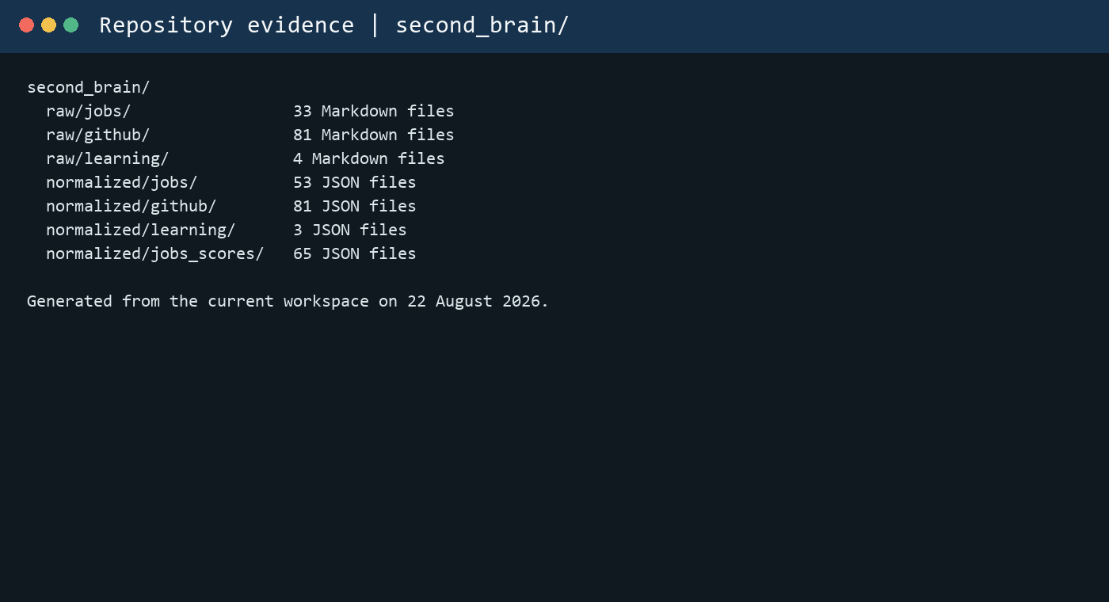
Examples: LinkedIn Generative AI Engineer alerts, Senior Data Engineer from Zapier, Scaling LLM-based Ranking Systems with SGLang, Microsoft Generative AI for Beginners, LangChain, RAGFlow, vLLM, and three LMS learning notes.

4. Personalization engine
The engine uses one scoring prompt in deterministic_ingestion/SCORE_PROMPT.md. It asks GROQ to score every normalized item against the North Star using five weighted dimensions.
Dimension | Weight | Meaning
Alignment | 40 | Direct connection to becoming a Generative AI Engineer.
Impact on goal | 20 | Employment or strong portfolio value.
Feasibility / proximity | 15 | Achievability from the current Data Engineer role.
Skill match | 15 | LLM, RAG, inference, MLOps, and related skills.
Urgency / timing | 10 | Timeliness and opportunity window.

The LLM returns JSON with score, breakdown, confidence, and notes. Jobs are judged for role fit, GitHub repositories for practical implementation, LMS items for hands-on learning, and RSS for learning and trend signals.

Before and after example
Before: raw incoming Zapier email
--- source: email date: 2026-08-21T13:01:44+00:00 raw_id: job-senior-data-engineer-acme-corp-remote-no-reply-sbhc9p-zapiermail-com from: no-reply.sbhc9p@zapiermail.com --- title: "Senior Data Engineer" company: "Acme Corp" location: "Remote" url: "https://www.linkedin.com/jobs/view/123456" date_posted: "2026-08-20" source: "LinkedIn" tags: ["data-engineer","spark","python"] Hiring team seeks 5+ years experience building scalable data pipelines. Responsibilities: design ETL, manage streaming, mentor junior engineers. Apply: https://www.linkedin.com/jobs/view/123456 --------------------------------------------------------------------------- Visit this link to stop these emails: https://zapier.com/manage/zaps/377189499/stop/?check=IjM3NzE4OTQ5OSI:1wxOsS:oI70k9chfpsBkuhUt40N7RJcBgvOZpEbLSqOtUncKGQ
After: normalized record
{
"source": "email",
"email_type": "zapier_single_job",
"title": "Senior Data Engineer",
"company": "Acme Corp",
"location": "Remote",
"url": "https://www.linkedin.com/jobs/view/123456",
"date_posted": "2026-08-20",
"tags": [
"data-engineer",
"spark",
"python"
],
"skills": [
"etl",
"python",
"spark"
],
"responsibilities": [
"design etl",
"manage streaming",
"mentor",
"design ETL, manage streaming, mentor junior engineers. Apply: https://www.linkedin.com/jobs/view/123456"
]
}
Filtered/scored output example
{
"score": 73,
"breakdown": {
"alignment": 65,
"impact": 70,
"feasibility": 80,
"skill_match": 90,
"urgency": 70
},
"confidence": 0.9,
"notes": "Open-source repo with strong LLM and agent focus, useful for portfolio; high feasibility and skill match."
}
Code proof: the scorer scans all three normalized source folders:
NORM_DIRS = [NORM_ROOT / name for name in ('jobs', 'github', 'learning')]
files = sorted(path for norm_dir in NORM_DIRS
for path in glob(str(norm_dir / '*.json')))
output = call_llm(build_prompt(north_star, item))
parse_and_save(output, item_id)
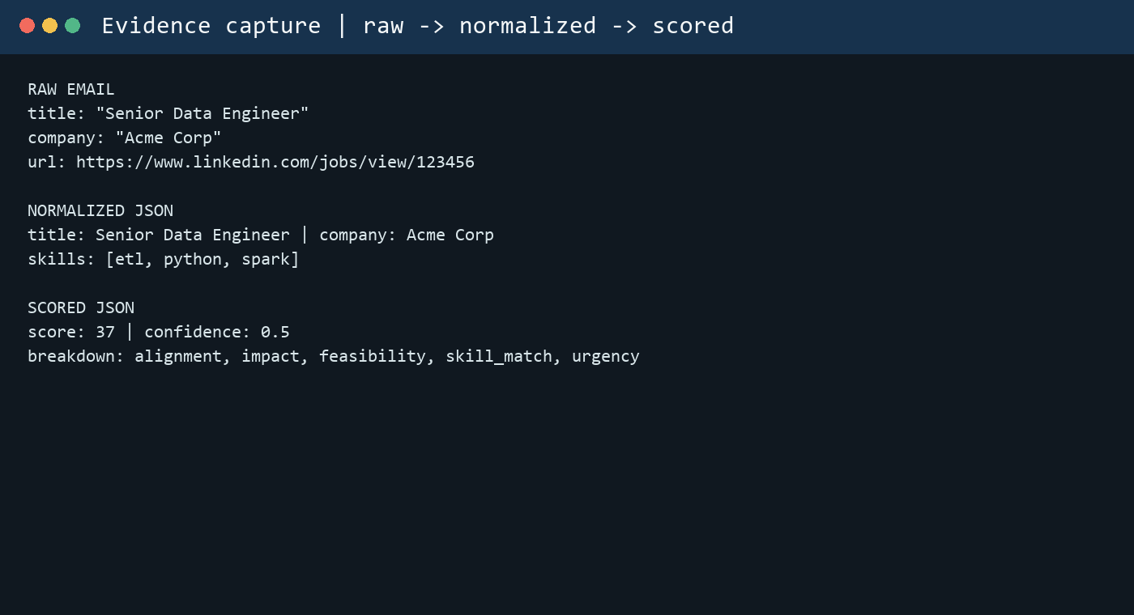

5. Ingestion mechanism
The pipeline runs manually or through GitHub Actions. The weekly workflow runs every Monday at 06:00 UTC and also supports workflow_dispatch.
Step | Implementation evidence
GitHub repositories | ingest_github.py searches GenAI repositories and writes raw Markdown.
RSS knowledge | ingest_linkedin_rss.py reads configured RSS/Atom feeds and deduplicates entries.
Email jobs | ingest_email_imap.py fetches unseen messages and filters unrelated operational mail.
LMS | ingest_lms_folder.py imports files from inbox_lms/.
Normalization | normalize_job.py handles jobs; normalize_sources.py handles GitHub and LMS.
Scoring | score_with_llm.py scans all normalized folders and calls GROQ.

Workflow evidence: .github/workflows/weekly-ingest.yml. Manual schedule evidence: deterministic_ingestion/cron_example.txt.
0 * * * * ingest_linkedin_rss.py
15 * * * * ingest_github.py
30 * * * * ingest_email.py
Code proof: workflow command sequence:
python deterministic_ingestion/ingest_email_imap.py
python deterministic_ingestion/ingest_linkedin_rss.py
python deterministic_ingestion/ingest_github.py
python deterministic_ingestion/ingest_lms_folder.py
python deterministic_ingestion/normalize_job.py
python deterministic_ingestion/normalize_sources.py
python deterministic_ingestion/score_with_llm.py
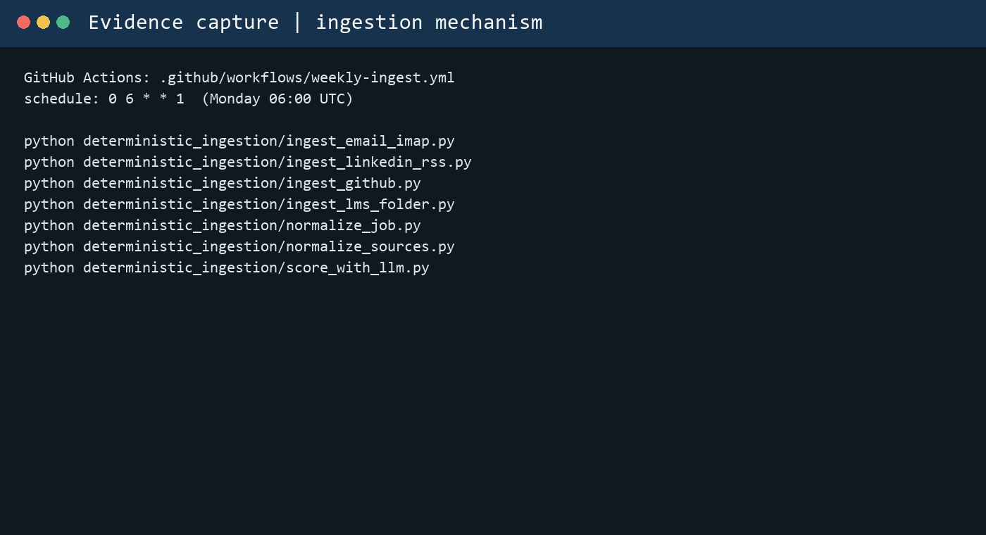
The raw records remain Markdown. The normalizers create structured JSON. Only the final scoring step calls GROQ, and its output is stored separately in jobs_scores.

