Team Members:

Somya Aggarwal (SJSU Id: 010192923)

Meera Mali

Ojas Kale

Hostname:

IP:

Option chosen:

URL(home page- add new profile) : <http://localhost:8081/profile/>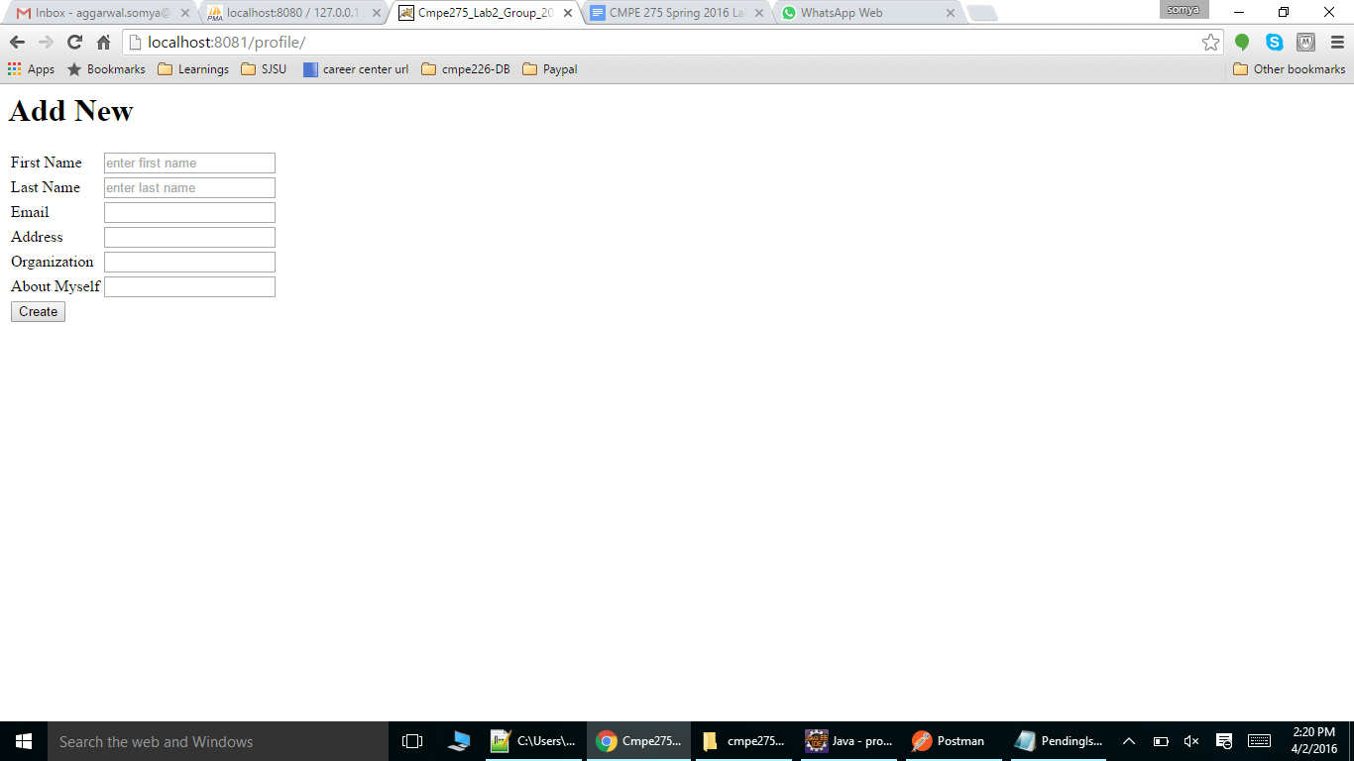

URL: <http://localhost:8081/profile/14>

Get the profile of a valid user in html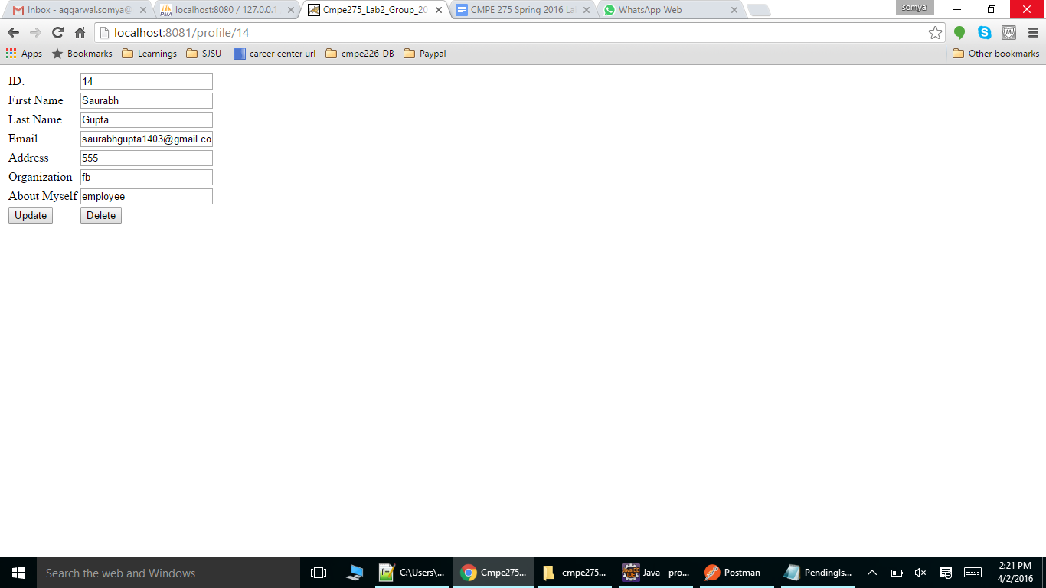

URL: <http://localhost:8081/profile/14?brief=true>

Get the user profile as plain text

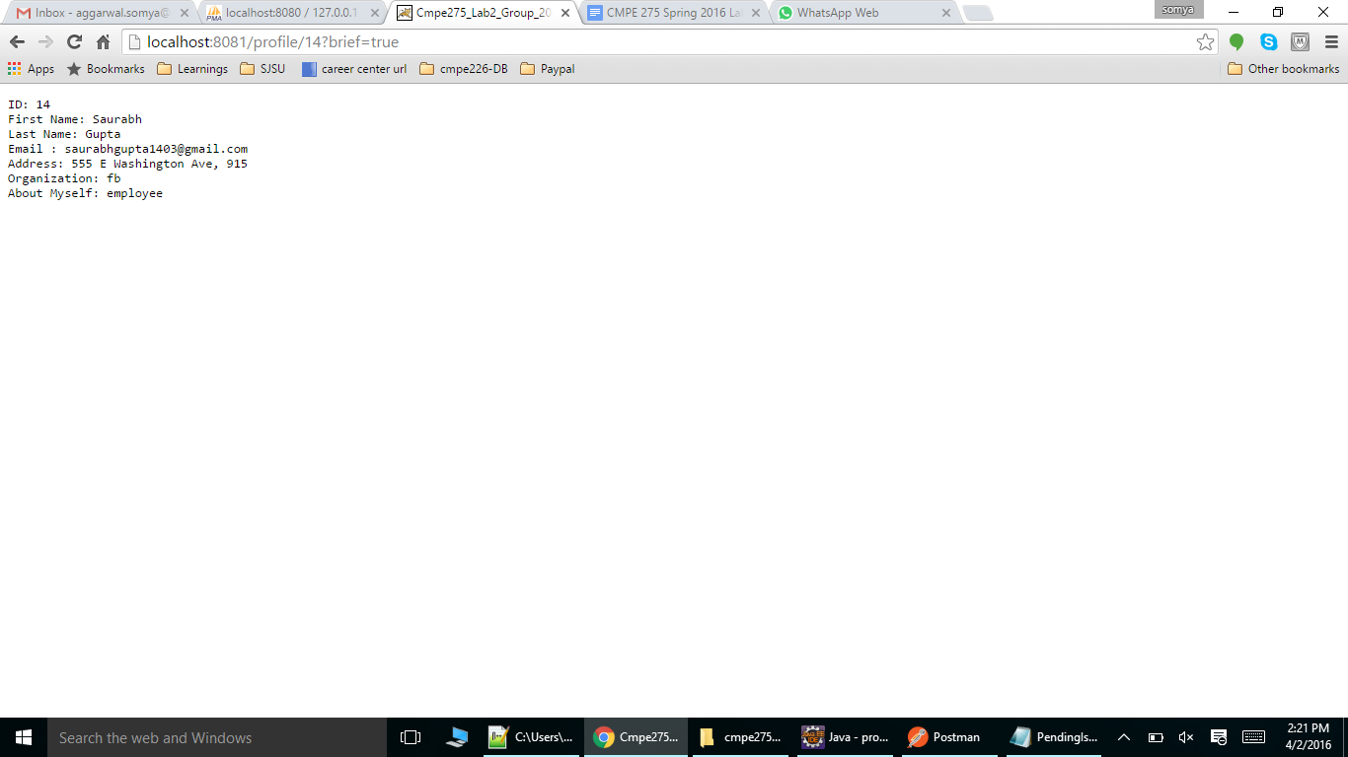

URL: <http://localhost:8081/profile/1> - Trying to get the profile of an invalid user.

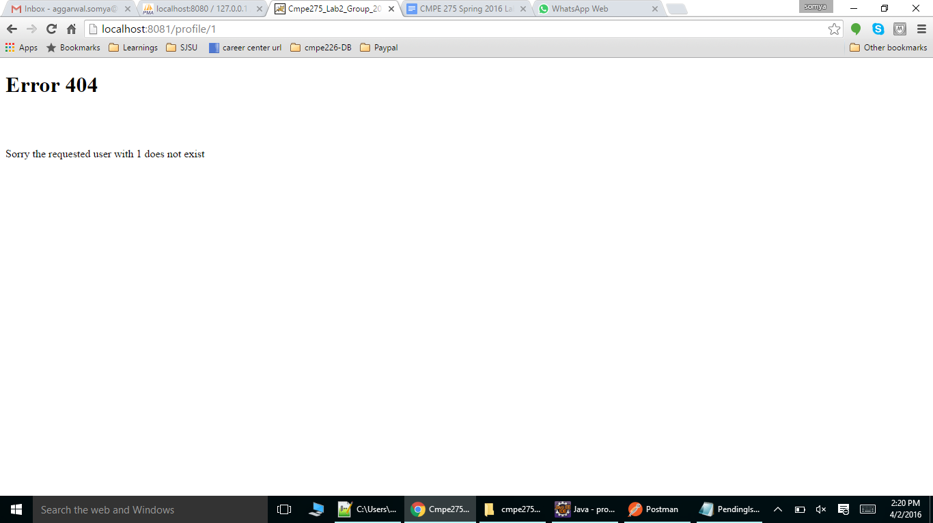

URL: <http://localhost:8081/profile/14?firstname=somya9&lastname=somyalast&email=sjsu&address=sj&organization=sjsucollege&about_myself=hello> Creating a new profile (Create or Update)

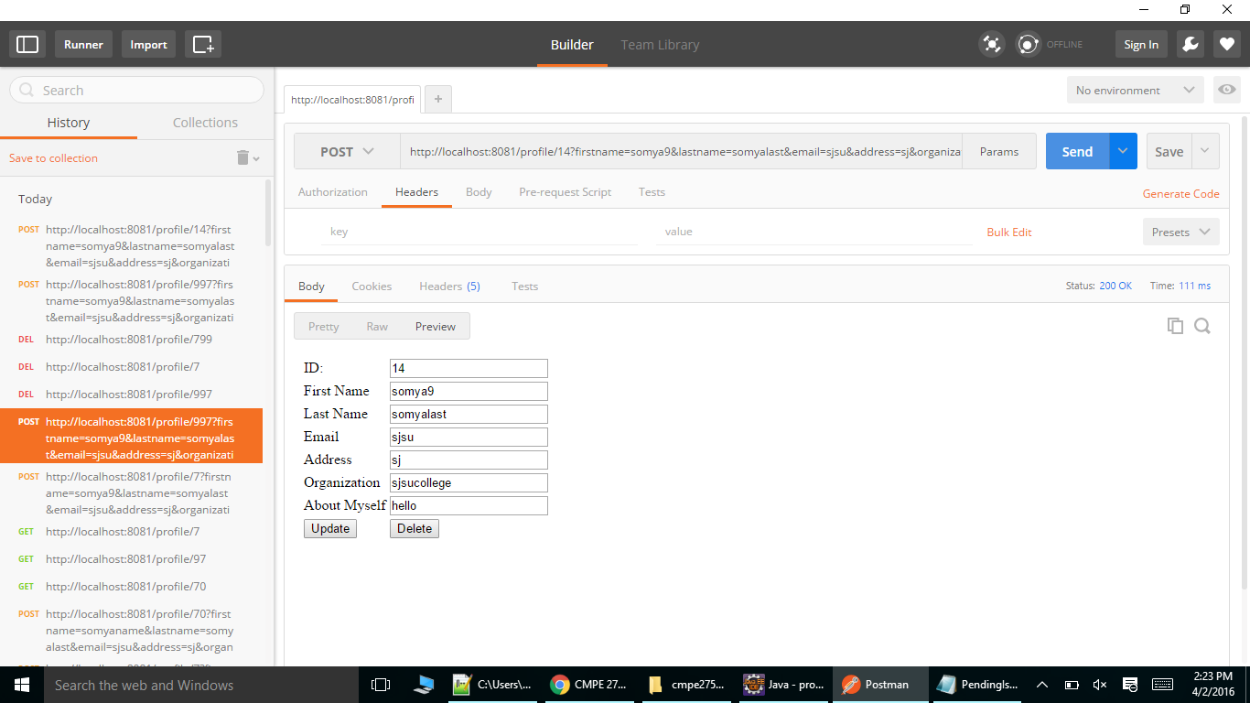

URL : (Delete a user profile with id 14) <http://localhost:8081/profile/14>. Tested using postman, so snapshot attached from there.

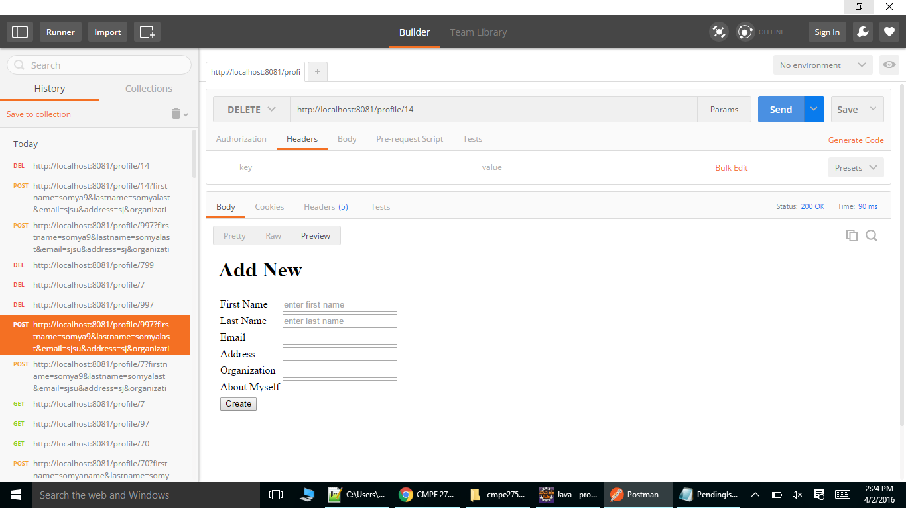

URL: <http://localhost:8081/profile/141>

Trying to delete an invalid user.

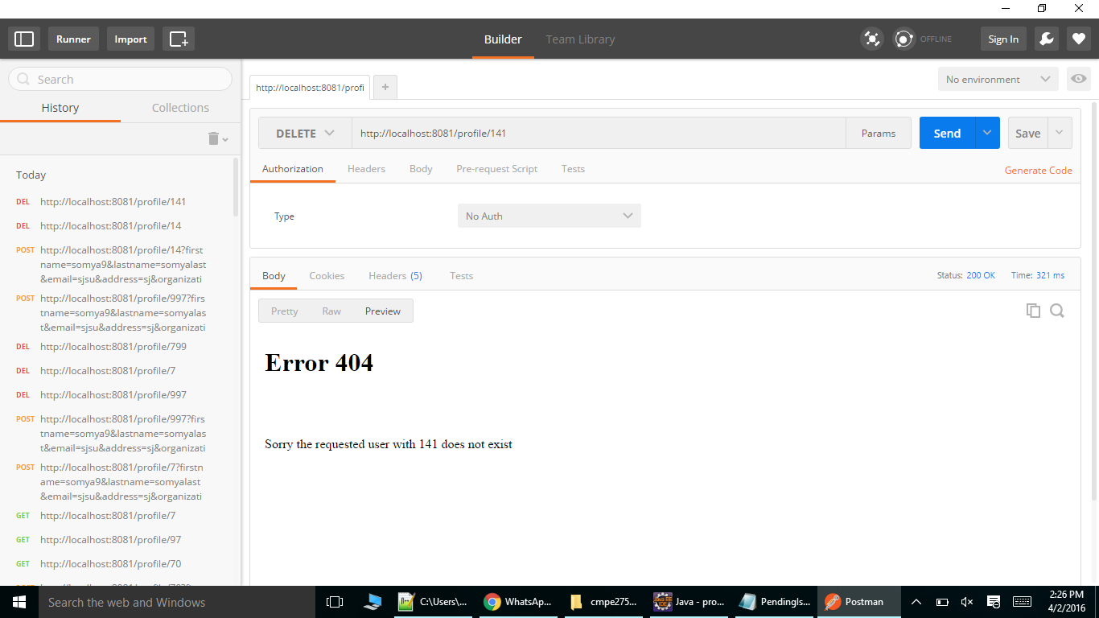

URL: <http://localhost:8081/profile/997?firstname=somya9&lastname=somyalast&email=sjsu&address=sj&organization=sjsucollege&about_myself=hello> Update the profile of the user with id 997.

