**How to compile**

PlantUML Instructions:

Add the “plantuml.jar” file in the “lib” folder in the project hierarchy. Add the external dependency to this jar file from the eclipse IDE.

* Go to Eclipse Project Tab
* Choose Properties -> Java Build Path
* Click external Jars
* Choose the path of the jar file from the LIB folder and Select OK.

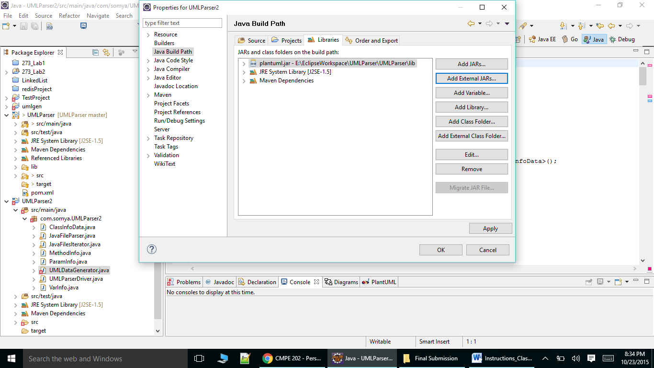

**Graphviz Installation Instructions**

Download and install “graphviz-2.38.msi” present in the shared folder.

Set the environment variable by clicking on:

* My Computer/Properties/Advanced/Environment Variables
* Create **GRAPHVIZ_DOT** to your executable.

For example: d:\example\dot.exe

**To compile and set up the project using Eclipse in Java**

You need to create a MAVEN project in eclipse with the following instructions.

* File -> New -> Project..

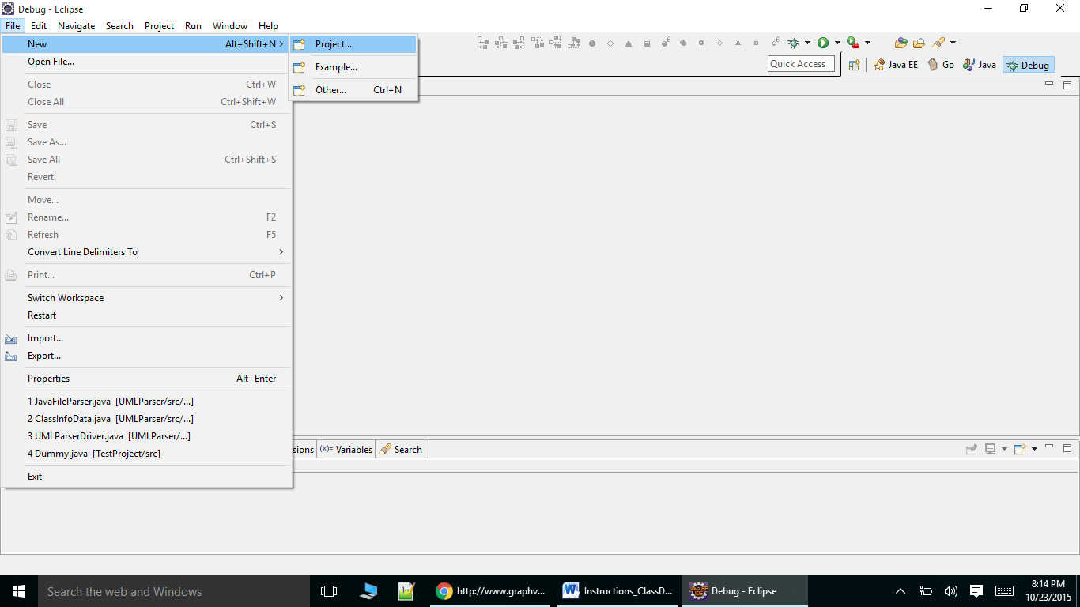

* Choose Maven From the list of projects coming.
* Choose Maven Project

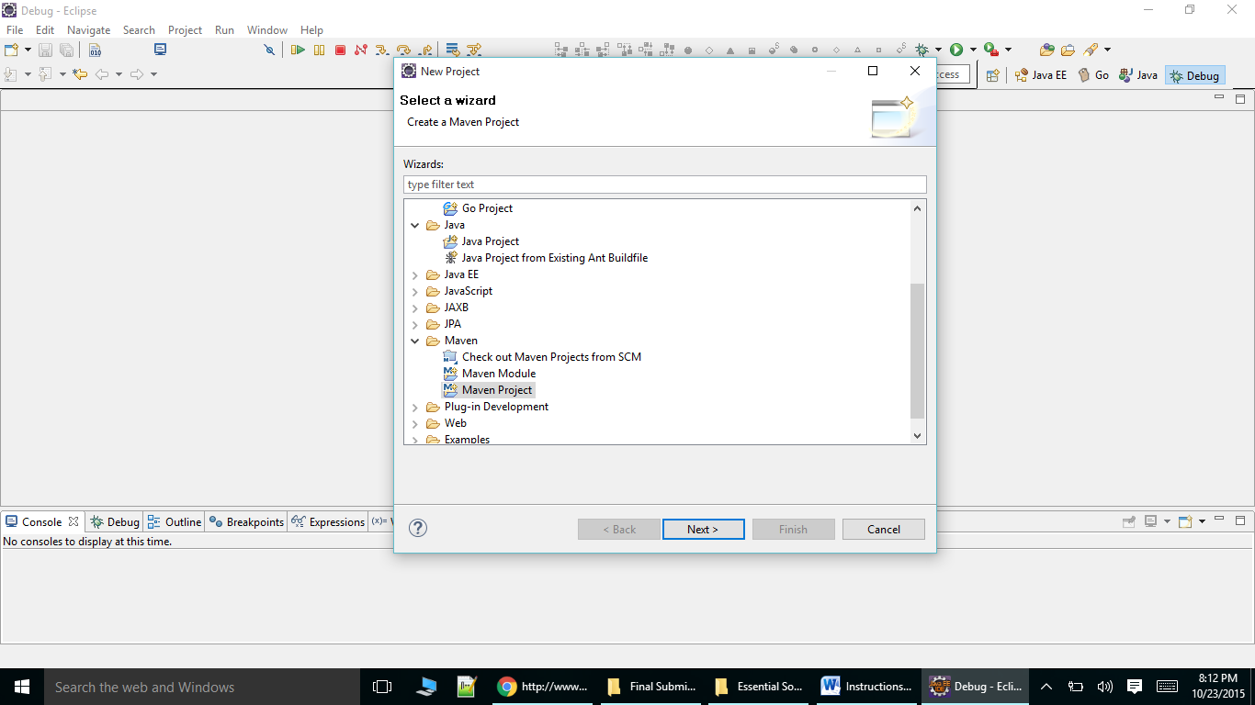

* Choose your default workspace location.
* Choose the default option here

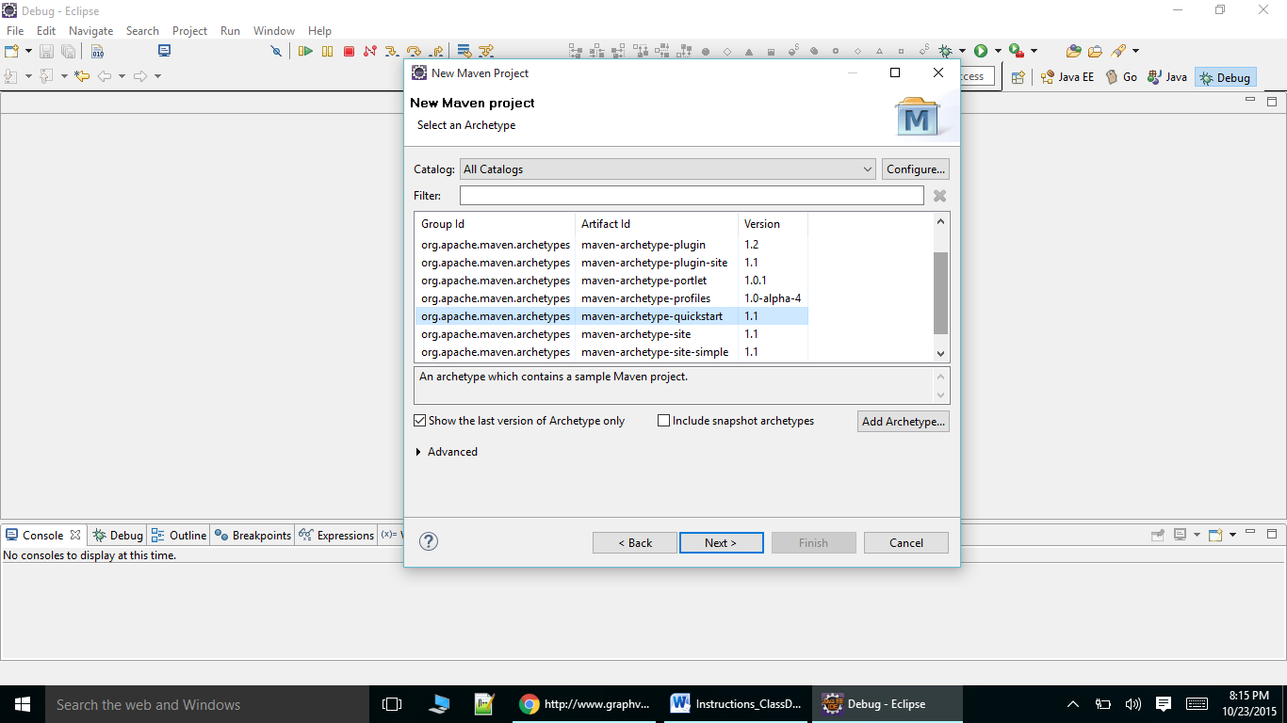

* Enter the **group Id: com.somya** and **artifact Id: UMLParser2** as:

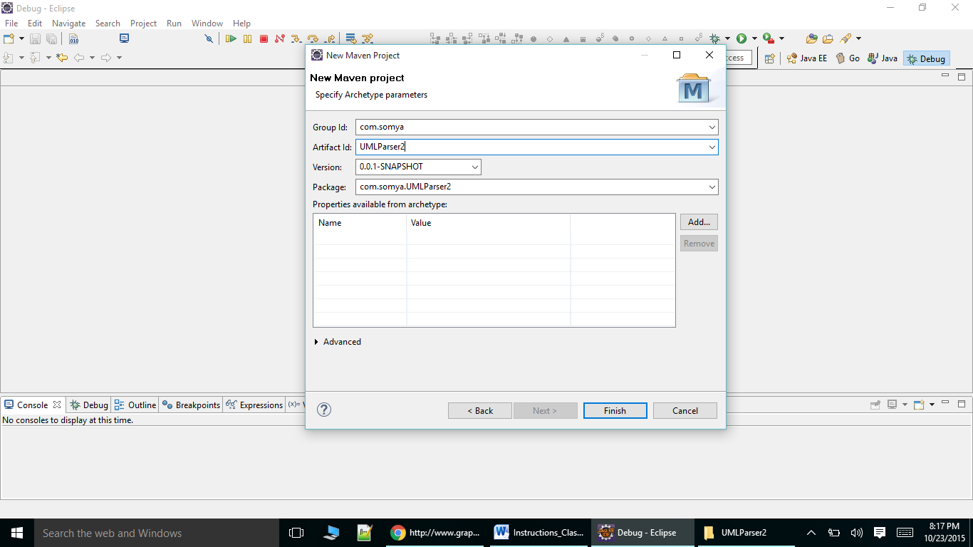

* Add the following dependency in the POM.XML (POM.XML is also attached)

<dependency>

<groupId>com.github.javaparser</groupId>

<artifactId>javaparser-core</artifactId>

<version>2.2.2</version>

</dependency>

* Remove the default App.java from the folder path

UMLParser2 -> src/main/java/ -> com.somya.UMLParser2 ->App.java

* Add the provided “.java” files from the ZIP folder
* Now the code should run and compile locally on eclipse. But you need to give the input folder where java files are kept and the output PNG file path from the command line only.