KOSPI2 Option Volatility Study
Date: 6 March 2026 | KOSPI2 Index: 821 | VKOSPI: 67.8

Vol Snapshot
Metric | Current | Pre-Crisis Avg | Multiple
VKOSPI | 67.8 | 18-20 | 3.5x
30D ATM Vol (~Apr) | 59.7 | 29.0 | 2.1x
60D ATM Vol (~May) | 53.5 | 29.4 | 1.8x
30D Skew (90%-110% MNY) | 6.8 | 5.6 | 1.2x
60D Skew (90%-110% MNY) | 4.1 | - | -
Term Spread (30D-60D) | +6.1 | ~flat | -

Key Observations
- Vol is 2x pre-crisis levels across the term structure
- Steep backwardation (front >> back) - classic post-shock pattern
- Skew only marginally wider than normal - the vol spike is mostly parallel, not skew-driven
- KOSPI2 rallied from ~430 to 933, then crashed - currently at ~820

Vol Dashboard
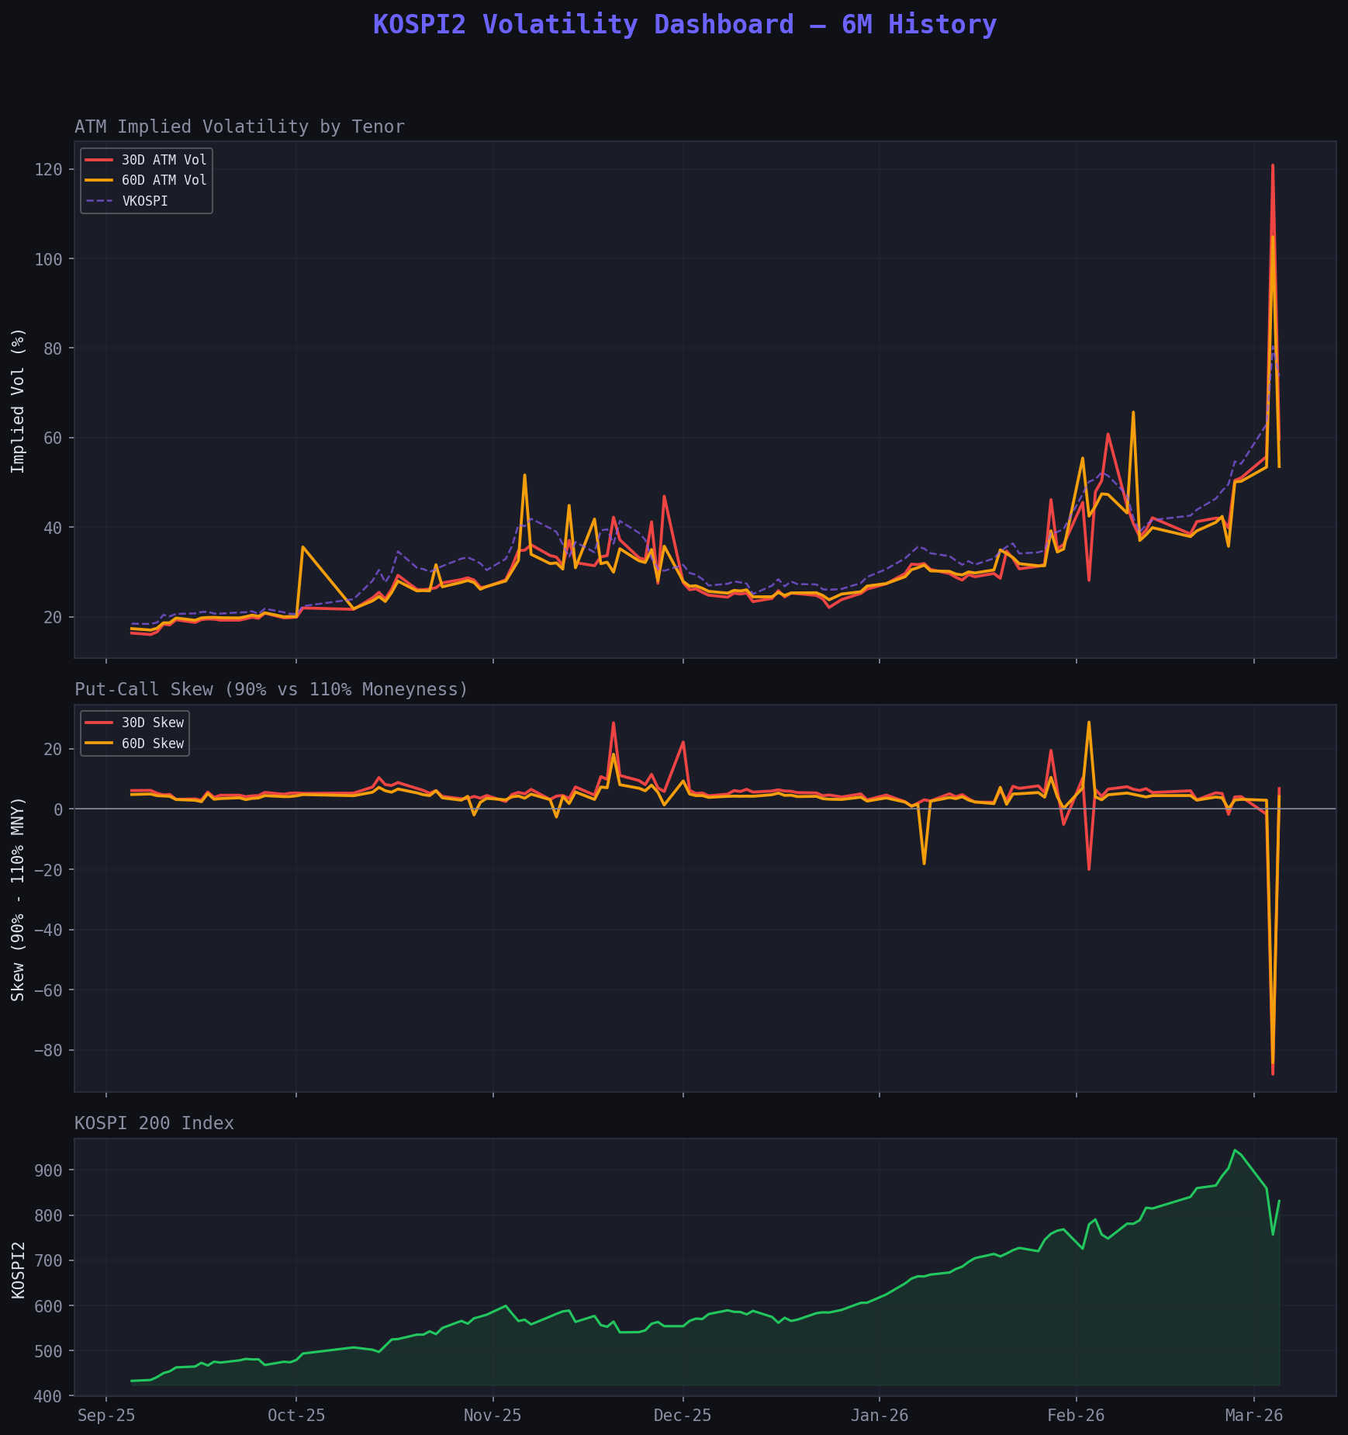

ATM Implied Volatility (30D & 60D)
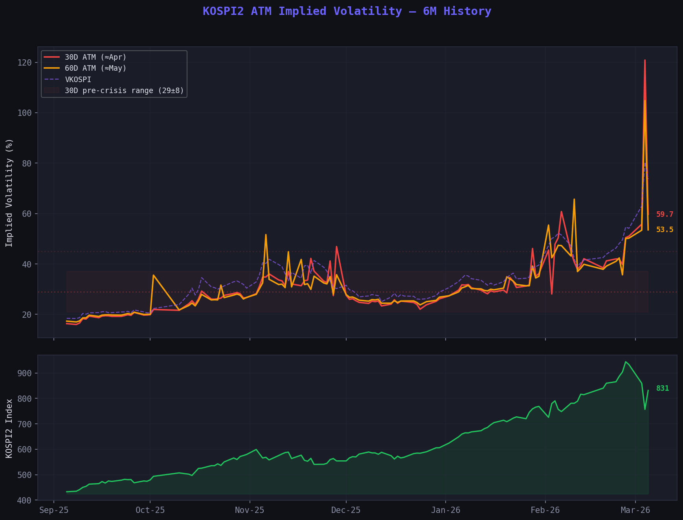

Vol Term Structure Spread (30D - 60D)
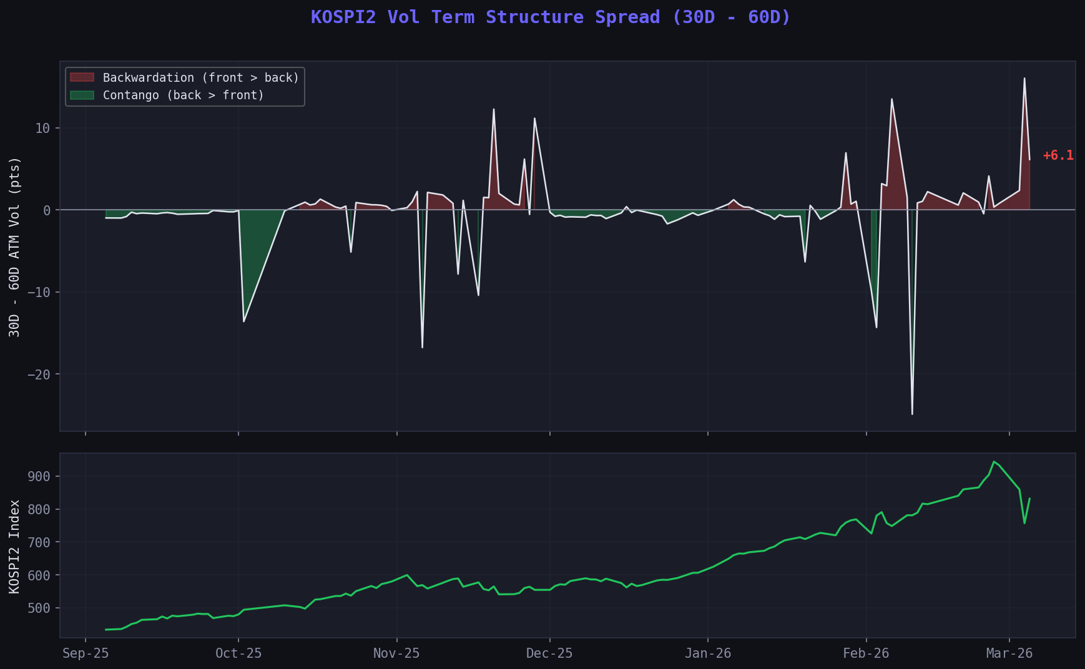

Put-Call Skew (90% - 110% Moneyness)
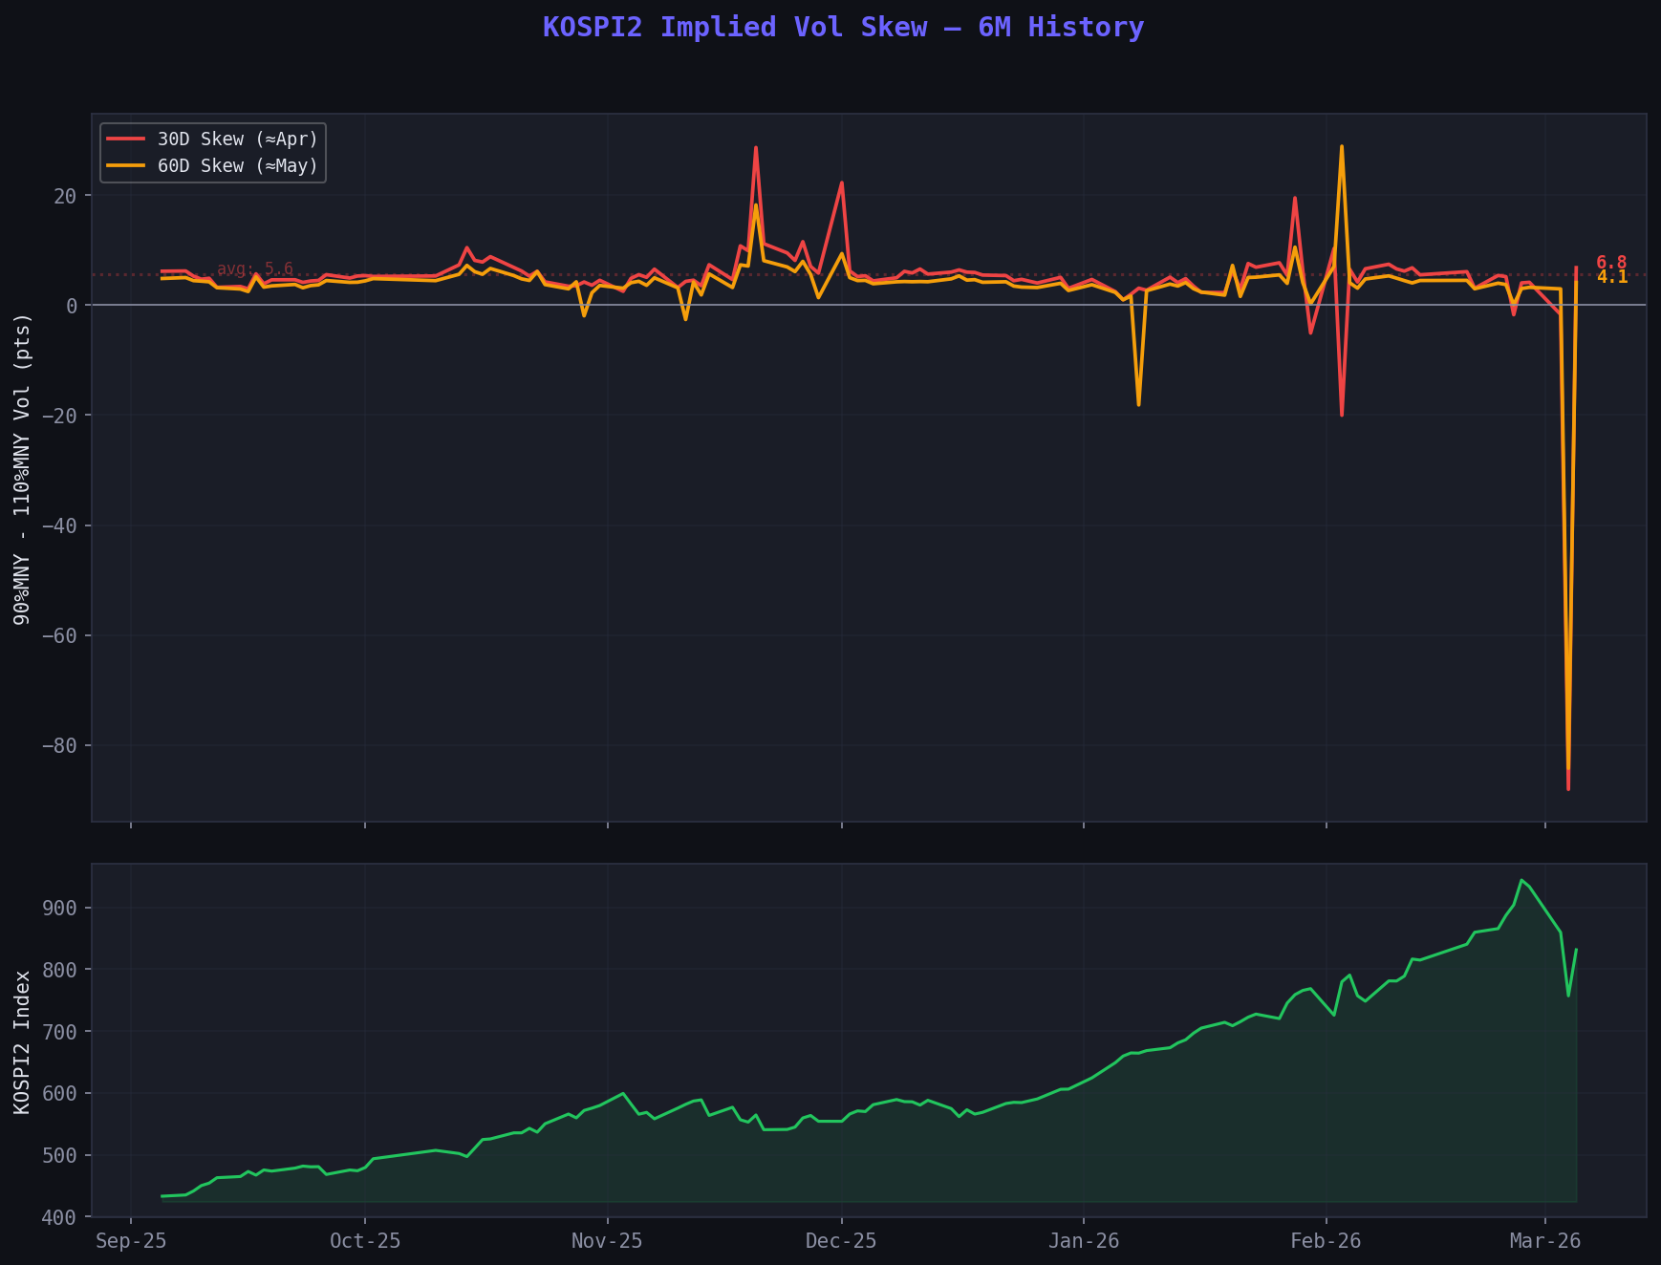

ATM Vol by Expiry
Expiry | Date | DTE | ATM IVol (Call) | ATM IVol (Put) | Avg
April | 09-Apr-26 | ~34d | 64.3% | 56.7% | ~60.5%
May | 14-May-26 | ~69d | 58.1% | 53.0% | ~55.6%
June | 11-Jun-26 | ~97d | 55.6% | 51.0% | ~53.3%

KOSPI2 Futures (KMM6): 826.55

Option Chains - Calls

April Expiry (09-Apr-26)
Strike | Bid | Ask | IVol Mid | Delta
840C | 47.50 | 59.75 | 62.8% | 0.48
860C | 38.75 | 49.30 | 61.4% | 0.42
880C | 32.05 | 40.15 | 58.9% | 0.36
900C | 26.50 | 32.75 | 58.2% | 0.34
920C | 21.30 | 26.60 | 57.5% | 0.30

May Expiry (14-May-26)
Strike | Bid | Ask | IVol Mid | Delta
940C | 29.80 | 39.30 | 53.2% | 0.32
960C | 25.80 | 33.90 | 53.2% | 0.29
980C | 22.35 | 28.40 | 52.6% | 0.26
1000C | 19.00 | 24.35 | 52.4% | 0.24

June Expiry (11-Jun-26)
Strike | Bid | Ask | IVol Mid | Delta
840C | 74.70 | 92.55 | 55.7% | 0.51
860C | 66.30 | 83.10 | 55.0% | 0.50
880C | 58.80 | 74.30 | 54.4% | 0.46
900C | 48.00 | 66.25 | 52.5% | 0.45
920C | 42.45 | 58.80 | 52.1% | 0.40

Trade Suggestions: Short Vol, Small Long Delta

Trade 1 (Recommended): May 860/920/980 Call Butterfly
Leg | Action | Strike | Delta | IVol | Est. Mid
Long 1x | Buy | 860C | 0.50 | 55.0 | ~74.7
Short 2x | Sell | 920C | 0.40 | 52.1 | ~50.6
Long 1x | Buy | 980C | 0.26 | 52.6 | ~25.4

- Net debit: ~6-8 pts
- Max profit: ~50+ at 920 at expiry
- Net delta: small long (~+0.10)
- Short vega: selling body at higher premium, net short vol
- Thesis: Vol mean-reverts + KOSPI grinds higher toward 920 (~12% above spot)
- Risk: Max loss = debit paid. Limited, defined risk.
Why May? Front month (Apr) is richest but only 34 DTE - too short for a recovery play. May at 69 DTE gives enough time for vol normalization + spot recovery, while still capturing significant vol premium.

Trade 2: May 860/900/940/980 Call Condor
Leg | Action | Strike | Delta
Long 1x | Buy | 860C | 0.50
Short 1x | Sell | 900C | 0.45
Short 1x | Sell | 940C | 0.32
Long 1x | Buy | 980C | 0.26

- Net debit: ~5-6 pts
- Max profit: ~34 (anywhere 900-940 at expiry)
- Wider profit zone than the fly - more forgiving
- Net delta: small long (~+0.08)
- Short vol: selling 2 rich options inside, buying 2 outside

Trade 3: June 880/940/1000 Call Butterfly (More Time)
Leg | Action | Strike | Delta | Est. Mid
Long 1x | Buy | 880C | 0.46 | ~66.6
Short 2x | Sell | 940C | 0.35 | ~43.9
Long 1x | Buy | 1000C | 0.24 | ~29.9

- Net debit: ~8-9 pts
- Max profit: ~51 at 940 (expiry 11-Jun)
- 97 DTE - more time for vol to normalize + spot to recover
- June vol at 52-55% still extremely rich vs 29% norm

Trade 4: May Call Ratio Spread - Buy 1x 880C / Sell 2x 960C
- Net credit of ~6 pts
- Heavily short vol at the 960 strike
- Risk: Unlimited above ~1040 (27% rally) - less suitable for defined-risk mandate
- Consider only with a stop or wing protection

Ranking
Rank | Trade | Risk Profile | Vol Exposure | Delta | Time
1 | May 860/920/980 Call Fly | Defined | Short vega | Small long | 69d
2 | May Call Condor | Defined | Short vega | Small long | 69d
3 | June 880/940/1000 Call Fly | Defined | Short vega | Small long | 97d
4 | May Call Ratio Spread | Undefined | Very short vega | Varies | 69d

Primary recommendation: May 860/920/980 Call Butterfly - cleanest expression of short vol + long delta with defined risk, and positioned for a 10-15% recovery in KOSPI2 over the next 2 months.

