**Kumon Franchise**

**Team:** Hua Rivers (Ting-ting), Ashwin Gayash and Chaitanya Jagdale

Our group elected to examine the opportunity of owning a Kumon franchise. All members in our team are parents with young children, so the Kumon company is familiar to us as a seemingly long-standing, reputable brand that serve school-aged children. In addition, Franchising Magazine rated Kumon one of the top franchise opportunities in 2017, so our group was curious to learn more about the economics of being a franchisee.

**Background on Kumon:**

Kumon is an educational franchise network that dates back to 1962. It is based on the Japanese Kumon method of teaching and handwritten practice. It was born out of the analysis of a Japanese high school teacher that textbooks don’t offer enough handwritten practice to achieve mastery over a subject. The method became very successful in Japan for mathematics as it enabled sixth graders to do calculus. Very soon the network spread to about 50 countries and the franchise added native language reading in its curriculum. Millions of students of all ages enroll every year and the institution has been awarded the “best of the best” franchise by entrepreneur magazine multiple times. The success of the institution relies largely on its established and widely respected curriculum, that allows students to progress at their own pace. Their methods emphasizes developing problem solving skills while simultaneously improving writing and memory skills.

In the United States, the Kumon Institute of Education Company, Japan, established Kumon Math and Reading Centers as subsidiaries in 1994. They serve as after-school learning centers where students attend classes and then have homework five days a week to perform daily assessments on worksheets based on the Kumon Method. This is a mastery based system where excellence is determined through speed and accuracy. There are several levels of competency in math and reading. Each level comprises a certain number of worksheets finely tuned and once the student completes them, is assigned an assessment test. On passing the test, the student progresses to the next level. If not, the student continues to do more worksheets until he/she is ready for a re-assessment. The curriculum has proven to help improve test-scores in standardized testing at schools and on exams like the SAT. Students also achieve greater confidence by being able to master advanced concepts earlier.

**Tutoring Industry Outlook:**

According to IBISWorld, tutoring and test preparation is a $4.5 billion industry driven by parents who want their kids to keep pace with classroom teaching, improve overall competency and enhance knowledge and skill level. In this industry, Kumon is a leader with 9% market share. It has around 2000 units spread across North America serving around 340,000 student and globally Kumon has around 25,000 locations serving 4.3 million students. With competition for college increasing and parents more willing than ever to spend money to help their children succeed, the tutoring and test preparation industry is forecasted to grow at a brisk pace in the near future.

Some strengths of owning a Kumon franchise are:

1. High brand recognition and global presence
2. Low initial investment and stable industry
3. Lot of support to franchise owners from Kumon as well as strong online community of current franchise owners
4. Lot of untapped markets

Some weakness or challenges that we see with owing the Kumon franchise:

1. Economic downturn can affect this industry as seen during the recent financial meltdown.
2. In recent years, profitability has been squeezed as number of competitors are increasing both online and offline (in-person teaching).
3. One Kumon franchise has to fight with other Kumon franchise to gain customers.
4. Currently only limited in teaching Math and reading skills.

**Feedback from Kumon Franchisee:**

We had the opportunity to interview a Kumon franchisee who operates a center in an affluent suburb of Syracuse, NY. This franchisee was somewhat unique in that she had purchased the franchise from her mom four years ago. Her mom had run the Kumon franchise for 17 years. The owner we interviewed had a law and public policy degree from Syracuse University and never thought she would be in the franchise business. But after having her second child, her mom needed some help running the center, and she was at a point in her life were working at a large law firm no longer worked for her quality of life.

This particular franchisee has 140 to 200 students per month, and her net profit per month is around $8K. She charges her students $140 per subject, per month, so if kids are doing both math and reading, that could be $280 per month that the family is paying per child enrolled. Kumon charges somewhere from $30 to $40 per child, per subject, per month, and that includes all materials and some marketing. Thus her main costs aside from the franchisee fee are for staff, rent, etc. She stated that most Kumon owners can expect to operate in the red for around 2 to 5 years as they’re building the business.

**Capital Required to Start a Kumon:**

According to the company, average initial investment required to start a Kumon is around $105K. The breakup of capital required in shown in the table below.Our franchisee stated that from her experience, Kumon wanted franchisees to have around $80K in liquid assets. 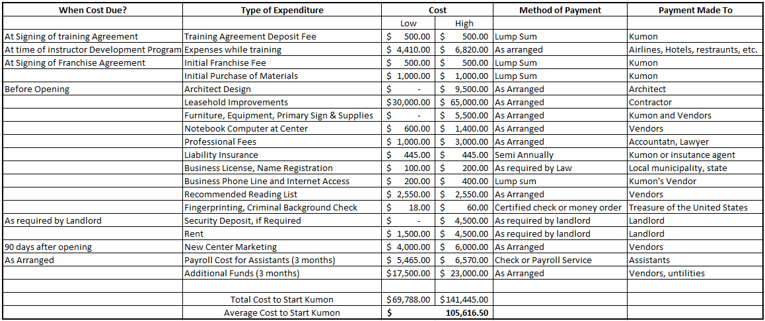

An equally significant investment that Kumon requires for interested franchisees is time. Our franchisee told us that there are six separate training sessions that Kumon requires franchisee applicants attend over the course of two years as they continue through the process of becoming a full-fledged franchisee. The initial two sessions take 3-4 days while the final 4 sessions are each week-long. During the training sessions, franchisee applicants are required to go through the entire Kumon curriculum, completing worksheets for those starting in the lowest grades. Most franchise applicants have full-time jobs while going through the franchise application process, so there are significant opportunity costs associated with going through the Kumon franchisee application process.

**Initial Financial Projections:**

A back of the envelop calculation shows that we can make approximately $5000 per month running a Kumon center with around 200 students, that is the average number of students

at current Kumon centers, paying $125 per month. Our calculations also show that due to high initial fixed cost, for the first month we can break even with around 250 students. This is just an initial calculation and lot of the profit and loss will be determined by how effectively we market and run the franchise.

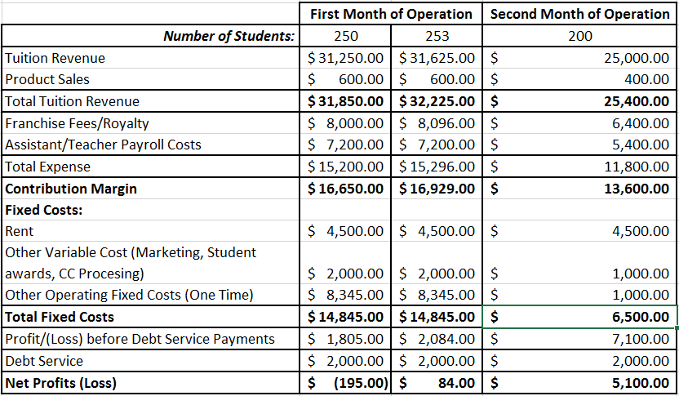

**Operating Plan :**

Our team is targeting the New Orleans and the surrounding metropolitan areas to open new set of Kumon Math and Reading centers. Based on the population of the area which is around 1.5 million, the number of Kumon centers should be about 15 as there is huge potential for growth. Each center will be capable of housing 100 students simultaneously and will be approximately 1000 square feet in size. The number of assistants in each center will be around 10. The areas that we are targeting are close to school districts so that it is convenient for our prospective students. The area of New Orleans is known to have the poorest performing public schools in Louisiana state according to research done by Vanderbilt university. The students of the schools will benefit from supplementary education provided by Kumon centers and their teaching methodology. To encourage students to enroll, Kumon should engage the state government in providing financial aid to deserving students in the districts. In addition the centers must be trained to provide coaching and instructions for parents as well as educators in the district unfamiliar with Kumon and the advantages it provides. We want to start with one center first and quickly expand to more centers. We are in the process of identifying the location of the first center and have also narrowed down on 2 other sites. These locations are close to best performing and highest rated public/private schools. We have also chosen these locations such that they are close to famous grocery and utility stores. The idea is to enable parents to drop kids to Kumon right after school and while kids train at Kumon with their classwork for 30 - 45 min, the parents could get some grocery/utility errands fulfilled. We have a roadmap to start with the first center and within the next 3 years have about 5 Kumon centers distributed across New Orleans.