ass2.R

augjo318

2019-11-24

library(readxl)  
library(ggplot2)  
data <- read_excel("/home/augjo318/Desktop/TDDE01_Lab1/machines.xlsx")  
  
LL <- function(x, theta){  
 return(length(x)*log(theta) - theta*sum(x))  
}  
  
ML <- function(x) {  
 return(length(x)/(sum(x)))  
}  
  
bayes <- function(x, lambda) {  
 prior = lambda*exp(-lambda*theta)  
 l = log(prior) + (LL(x, theta))  
   
 return (l)  
}  
  
theta <- seq(from=0.00, to=3, by=0.01)  
  
res <- LL(data$Length, theta)  
maxlik <- ML(data$Length)  
print(maxlik)

## [1] 1.126217

obs = head(data, 6)  
maxlik2 <- ML(obs$Length)  
print(maxlik2)

## [1] 1.785681

res3 <- LL(obs$Length, theta)  
  
res4 <- bayes(data$Length, 10)  
  
r1 <- data.frame(theta = theta, loglik = LL(data$Length, theta))  
  
r2 <- data.frame(theta = theta, loglik = LL(obs$Length, theta))  
  
r3 <- data.frame(theta = theta, loglik = bayes(data$Length, 10))  
  
combine2 <- rbind(r1, r3)  
combine3 <- rbind(r1, r2, r3)  
  
ggplot(r1, aes(theta, loglik))+geom_point()

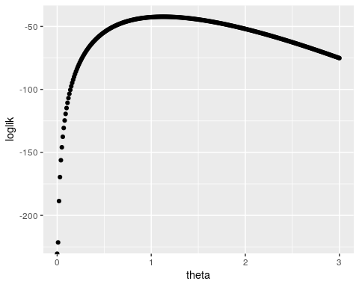

ggplot(combine2, aes(theta, loglik))+geom_point()

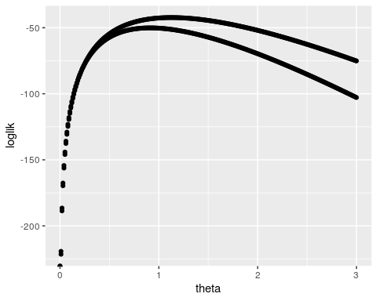

ggplot(combine3, aes(theta, loglik))+geom_point()

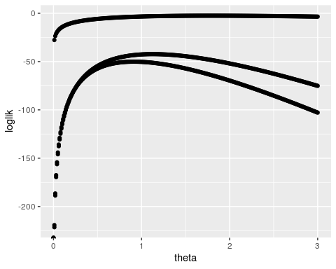

maxlik3 <- theta[which.max(res4)]  
print(maxlik3)

## [1] 0.91

observation2 = rexp(50, maxlik)  
  
hist(data$Length, col="red", xlim=c(0,5), ylim=c(0,25), main = "")

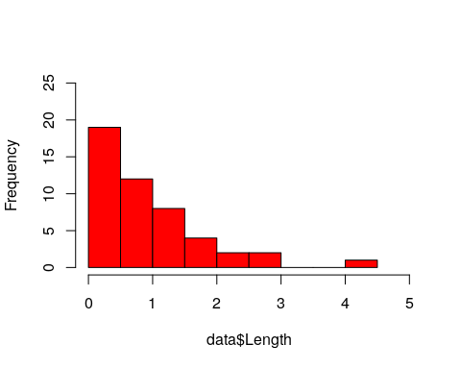

hist(observation2, col="blue", xlim=c(0,5), ylim=c(0,25), main = "")

