Ass1.R

augjo318

2019-12-08

library(readxl)  
library(ggplot2)  
library(reshape2)  
library(MASS)  
  
data <- read.csv("/home/augjo318/Desktop/TDDE01_Lab2/australian-crabs.csv")  
  
#1.1  
CL <- data$CL  
RW <- data$RW  
sex <- data$sex  
  
plot(RW, CL, col = data$sex)

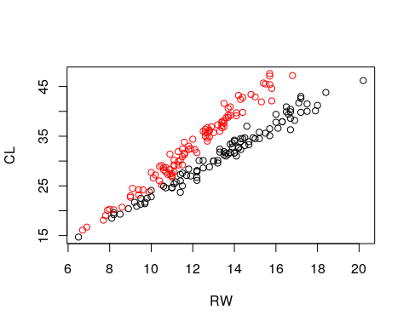

#1.2  
fit <- lda(sex~RW+CL, data= data)  
  
df = data.frame(CL, RW)  
  
pred <- predict(fit, df)  
  
plot(RW, CL, col=pred$class)

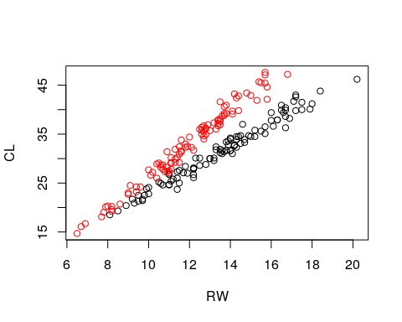

tbl <- table(pred$class, data$sex)  
  
MisClassification <- (tbl[1, "Male"] + tbl[2, "Female"])/(sum(tbl))  
  
MisClassification

## [1] 0.035

#1.3  
fit2 <- lda(sex~RW+CL, data=data, prior= c(0.9,0.1))  
pred2 <- predict(fit2, df)  
  
tbl <- table(pred2$class, data$sex)  
  
tbl

##   
## Female Male  
## Female 100 15  
## Male 0 85

MisClassification <- (tbl[1, "Male"] + tbl[2, "Female"])/(sum(tbl))  
  
MisClassification

## [1] 0.075

#1.4  
fit3 <- glm(sex~RW+CL, data = data, family = "binomial")

## Warning: glm.fit: fitted probabilities numerically 0 or 1 occurred

pred3 <- predict(fit3)  
  
pred3 <- pred3 > 0  
  
plot(data$RW, data$CL, col = pred3+1)  
abline(coef = c(0,2), col = "black")

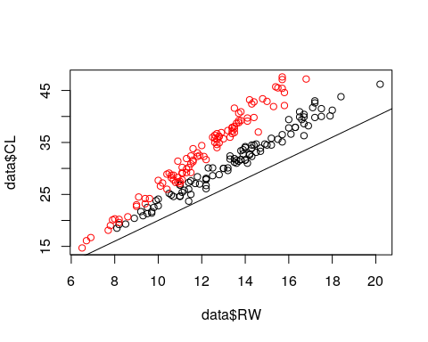

tbl <- table(pred3, data$sex)   
  
tbl

##   
## pred3 Female Male  
## FALSE 97 4  
## TRUE 3 96

MisClassification <- (tbl[1, "Male"] + tbl[2, "Female"])/(sum(tbl))  
MisClassification

## [1] 0.035