Ass4.R

augjo318

2019-12-08

library("pcaMethods")

## Loading required package: Biobase

## Loading required package: BiocGenerics

## Loading required package: parallel

##   
## Attaching package: 'BiocGenerics'

## The following objects are masked from 'package:parallel':  
##   
## clusterApply, clusterApplyLB, clusterCall, clusterEvalQ,  
## clusterExport, clusterMap, parApply, parCapply, parLapply,  
## parLapplyLB, parRapply, parSapply, parSapplyLB

## The following objects are masked from 'package:stats':  
##   
## IQR, mad, sd, var, xtabs

## The following objects are masked from 'package:base':  
##   
## anyDuplicated, append, as.data.frame, basename, cbind, colMeans,  
## colnames, colSums, dirname, do.call, duplicated, eval, evalq,  
## Filter, Find, get, grep, grepl, intersect, is.unsorted, lapply,  
## lengths, Map, mapply, match, mget, order, paste, pmax, pmax.int,  
## pmin, pmin.int, Position, rank, rbind, Reduce, rowMeans, rownames,  
## rowSums, sapply, setdiff, sort, table, tapply, union, unique,  
## unsplit, which, which.max, which.min

## Welcome to Bioconductor  
##   
## Vignettes contain introductory material; view with  
## 'browseVignettes()'. To cite Bioconductor, see  
## 'citation("Biobase")', and for packages 'citation("pkgname")'.

##   
## Attaching package: 'pcaMethods'

## The following object is masked from 'package:stats':  
##   
## loadings

library("fastICA")  
#4.1  
  
data <- read.csv(file = "/home/augjo318/Desktop/TDDE01_Lab2/NIRSpectra.csv", sep = ";", dec = ",")  
  
data$Viscosity = c()  
res = prcomp(data)  
  
lambda = res$sdev^2  
  
# xlambda  
  
sprintf("%2.3f", lambda/sum(lambda)*100)

## [1] "93.332" "6.263" "0.185" "0.101" "0.068" "0.025" "0.009" "0.003"   
## [9] "0.003" "0.002" "0.001" "0.001" "0.001" "0.001" "0.000" "0.000"   
## [17] "0.000" "0.000" "0.000" "0.000" "0.000" "0.000" "0.000" "0.000"   
## [25] "0.000" "0.000" "0.000" "0.000" "0.000" "0.000" "0.000" "0.000"   
## [33] "0.000" "0.000" "0.000" "0.000" "0.000" "0.000" "0.000" "0.000"   
## [41] "0.000" "0.000" "0.000" "0.000" "0.000" "0.000" "0.000" "0.000"   
## [49] "0.000" "0.000" "0.000" "0.000" "0.000" "0.000" "0.000" "0.000"   
## [57] "0.000" "0.000" "0.000" "0.000" "0.000" "0.000" "0.000" "0.000"   
## [65] "0.000" "0.000" "0.000" "0.000" "0.000" "0.000" "0.000" "0.000"   
## [73] "0.000" "0.000" "0.000" "0.000" "0.000" "0.000" "0.000" "0.000"   
## [81] "0.000" "0.000" "0.000" "0.000" "0.000" "0.000" "0.000" "0.000"   
## [89] "0.000" "0.000" "0.000" "0.000" "0.000" "0.000" "0.000" "0.000"   
## [97] "0.000" "0.000" "0.000" "0.000" "0.000" "0.000" "0.000" "0.000"   
## [105] "0.000" "0.000" "0.000" "0.000" "0.000" "0.000" "0.000" "0.000"   
## [113] "0.000" "0.000" "0.000" "0.000" "0.000" "0.000" "0.000" "0.000"   
## [121] "0.000" "0.000" "0.000" "0.000" "0.000" "0.000"

screeplot(res)

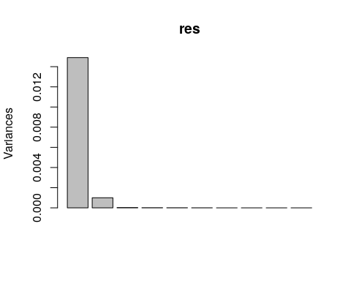

#res$x  
  
plot(res$x[,1], res$x[,2], xlab = "PC1", ylab = "PC2")

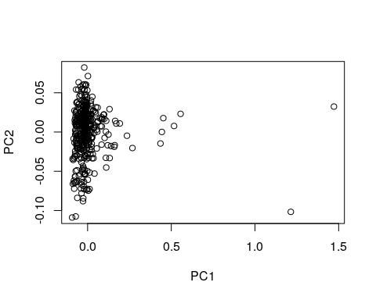

#4.2  
  
U = res$rotation  
plot(U[,1], main = "Traceplot, PC1")

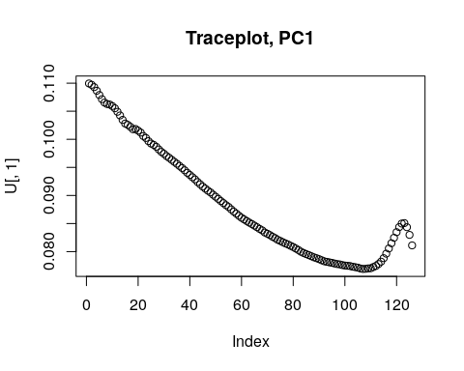

plot(U[,2], main = "Traceplot, PC2")

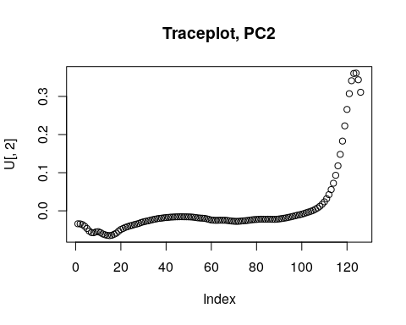

#4.3  
set.seed(12345)  
  
#S <- cbind(sin(1:1000)/20, rep((((1:200)-100)/100), 5))  
S<- U  
A <- matrix(c(0.291, 0.6557, -0.5439, 0.5572), 2, 2)  
  
a <- fastICA(data, 2)   
#a  
  
W_p <- a$K %*% a$W   
  
plot(1:length(W_p[,1]), W_p[,1])

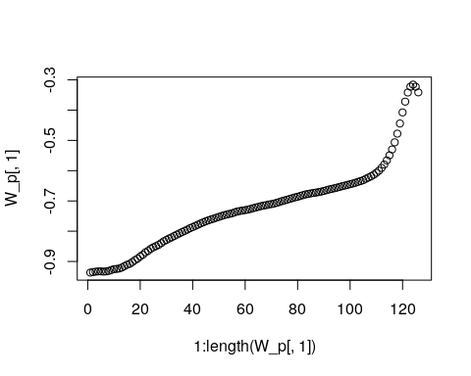

plot(1:length(W_p[,2]), W_p[,2])

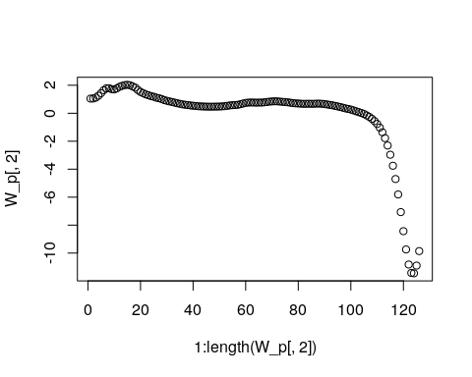

plot(a$S[,1], a$S[,2])

