# Introduction

This break out session shows how to make use of some Java 8 and Java EE 7 features. Participants will be guided to build an application to monitor a beer brewery.

# Installation

The following software needs to be installed:

## JDK 1.8

Download and install JDK 8 from <http://www.oracle.com/technetwork/java/javase/downloads/index.html>

## NetBeans 8.0.1

Select the “Java EE” or “All” download from <https://netbeans.org/downloads/> (see screenshot below)

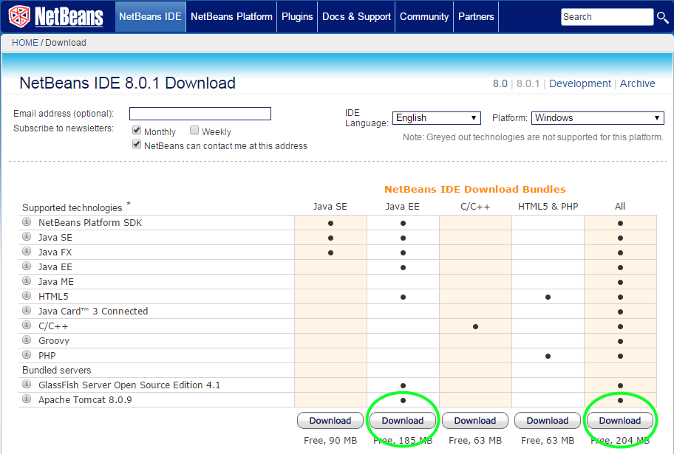

NetBeans contains Glassfish. When installing NetBeans, choose to install the pre-bundled Glassfish that comes with NetBeans.

# The application: The beer brewery monitor

We are going to build an application to monitor and manipulate kettles in a beer brewery. Brewers can manually add ingredients one by one to a kettle. This results in state changes of the kettles in the brewery.

TODO foto Gage

It is also possible to create a recipe to brew beer. This recipe is designed by the brewer and submitted to the brewery where it gets build.

TODO voorbeeld recept

The application consists of the following components:

**Back-end**  
(WebSocket, JMS, REST, Streams, Lambdas)

JSON

**Front-end**  
(AngularJS)

TODO foto live adjustment

Manual addition of an ingredient causes the front-end to send a JSON message through a WebSocket to the back-end which sends the ??? back to the client through the same WebSocket.

Recipes are constructed in the browser and sent through RESTful Web Services to the back-end which places the recipe on a JMS queue. The queue is read by a Message Driven Bean and processed ???

# Preparation