AXP2101 Single Cell NVDC PMU with E-gauge

Features
- 3.9V–5.5V Input Operating Range and Support single Cell Battery
- Battery fuel gauge: E gauge 3.0
- Support TWSI(Two Wire Serial Interface) and RSB(Reduced Serial Bus)
- 100mA-1A Linear charger, CV accuracy +/-0.5%
- Single input to support USB input
- High battery discharge efficiency with 50 mOhm
- High integration includes all MOSFETS, current sensing and loop compensation
- Power off current <20uA（BATFET off，RTCLDO output on）
- 5DCDC
DCDC1:1.5~3.4V, IMAX=2A;
DCDC2: 0.5~1.2V, 1.22~1.54V, IMAX=2A; DCDC3: 0.5~1.2V, 1.22~1.54V, 1.6~3.4V, IMAX=2A;
DCDC4: 0.5~1.2V, 1.22~1.84V, IMAX=1.5A; DCDC5: 1.2V, 1.4~3.7V, IMAX=1A.
- 11 LDOS
RTCLDO1/2: 1.8V/2.5V/3V/3.3V, 30mA;
Support RTCLDO1 supplied by backup battery (button battery)
ALDO1~4: analog LDO, 0.5~3.5V, 0.1V/step, IMAX=300mA
BLDO1/2: analog LDO,0.5~3.5V, 0.1V/step, IMAX=300mA
CPUSLDO: for CPUs, 0.5~1.4V, IMAX=30mA
DLDO1/2: analog LDO or power switch, 0.5~3.3V/ 0.5~1.4V, IMAX=300mA
- startup sequence and default voltage of DCDC/LDO setting
- Protection
Input Over-Voltage Protection
Battery Thermal Sense Hot/Cold Charge Suspend
Programmable Safety Timer for Charger Die Thermal Balance for Charger Thermistor Shutdown
DCDC Over-Voltage/Under-Voltage Protection

Applications
- SDV, CDR, IPC, smart doorbell, smart speaker

Description

AXP2101 is a highly integrated power management IC (PMIC) targeting at single cell Li-battery (Li-ion or Li-polymer) applications that require multi-channel power outputs. It provides an easy and flexible power management solution for multi-core processors to meet the complex and accurate requirements of power control.
AXP2101 supports Linear charge. Besides, it supports 16 channel power outputs which include 5 channel DC-DC and 11 channel LDO. To ensure the security and stability of the system, AXP2101 provides multiple channels 14-bit ADC for voltage/temperature monitor and integrates protection circuits such as over-voltage protection (OVP), over-current protection (OCP) and over-temperature protection (OTP). Moreover, AXP2101 features a unique E-Gauge™ (Fuel Gauge) system, making power gauge easy and exact.
AXP2101 supports TWSI and RSB for system to dynamically adjust output voltages, charge current and configure interrupt condition.

Device Information
Part Number | Package | Body Size
AXP2101 | QFN-40 | 5mm * 5mm

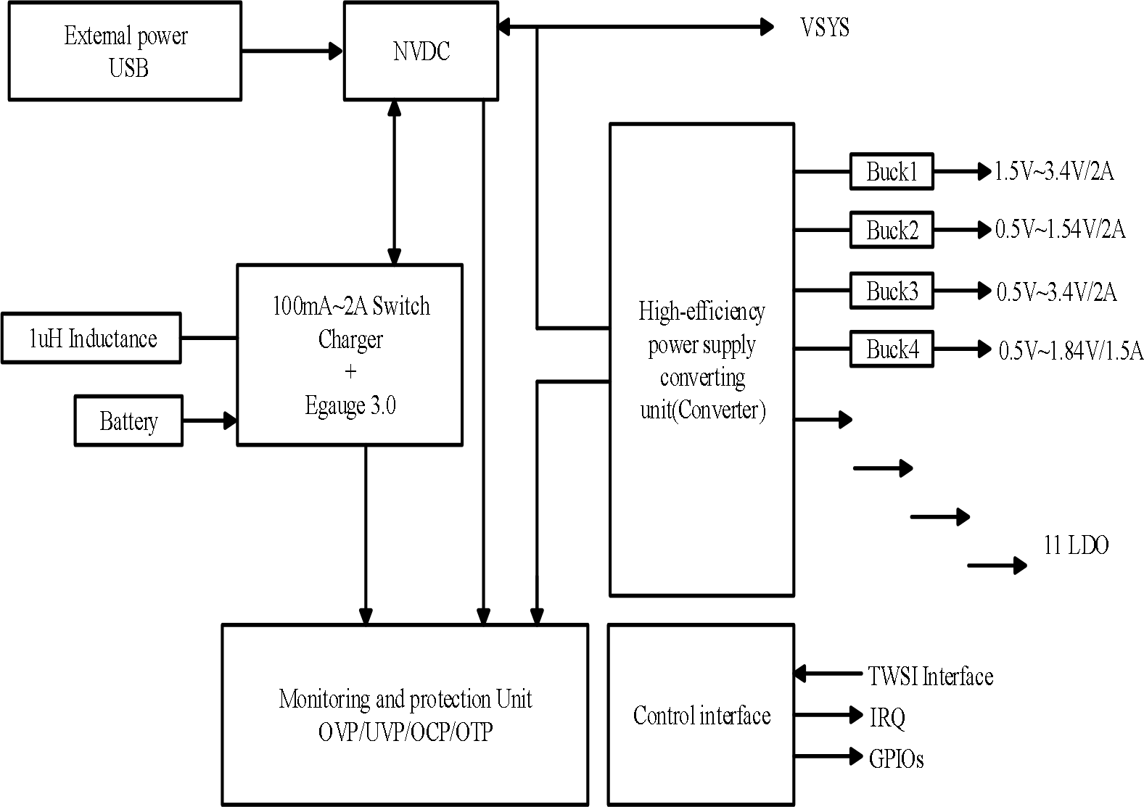
Simplified Application Diagram

Revision History

Revision | Date | Author | Description
1.0 | May 31, 2021 | AWA 1017 | Initial version

Contents

- Features 1
- Applications 1
- Description 1
Revision History 2
Contents 3
Figures 5
Tables 6
- Pin Configuration and Functions 7
- Specifications 10
  - Absolute Maximum Ratings ⁽¹⁾ 10
  - ESD Ratings 10
  - Recommended Operating Conditions 11
  - Thermal Information 11
  - Electrical Characteristics 11
- Detail Description 16
  - Overview 16
  - Function Block Diagram 17
  - Serial Interface Communication 18
  - Power Path 18
  - Power On/Off and reset 18
    - Power on reset(POR) 18
    - Power up from BAT 18
    - Power up from VBUS 18
    - System power on/off management 19
  - Multi-Power Outputs 22
  - Charger 23
    - Characteristics 23
    - Charging condition 23
    - Charging process 23
    - Charging protection 25
    - Charging indication 27
  - BATFET 27
  - RBFET 28
  - ADC 28
  - E-Gauge 28
  - IRQ /BACKUP 28
    - IRQ 28
    - BACKUP 29
  - Register 29
    - Register List 29
    - Register Description 31
- Application Information 58
  - Typical Application 58
- Package, Carrier, Storage and Baking Information 59
  - Package 59
  - Carrier 60
  - Storage 61
    - Moisture Sensitivity Level(MSL) 61
    - Bagged Storage Conditions 61
    - Out-of-bag Duration 61
  - Baking 62
- Reflow Profile 63

Figures
Figure 4-1 Pin Map 7
Figure 6-1 Function Block Diagram 17
Figure 6-2 Sleep and Wakeup 21
Figure 7-1 Typical Application 58
Figure 8-1 Package Information 59
Figure 8-2 AXP2101 marking 59
Figure 8-3 AXP2101 Tray Dimension Drawing 60
Figure 9-1 AXP2101 Typical Reflow Profile 63

Tables
Table 4-1 Pin Description 7
Table 5-1 Absolute Maximum Ratings 10
Table 5-2 ESD Ratings 10
Table 5-3 Recommended Operating Conditions 11
Table 5-4 Thermal Metric 11
Table 5-5 Electrical Characteristics 11
Table 6-1 Features of Multi-Power Outputs 22
Table 6-2 Charging Parameters 24
Table 6-3 Relationship among temperature, equivalent resistance, detected voltage and ADC data 26
Table 6-4 CHGLED Function Control 27
Table 6-5 ADC Channel and Data 28
Table 8-1 AXP2101 Marking Definitions 59
Table 8-2 AXP2101 Tray Carrier Information 60
Table 8-3 AXP2101 Packing Quantity Information 61
Table 8-4 MSL Summary 61
Table 8-5 Bagged Storage Conditions 61
Table 8-6 Out-of-bag Duration 62
Table 8-7 Baking Conditions 62
Table 9-1 AXP2101 Reflow Profile Conditions 63

Pin Configuration and Functions

Figure 4-1 Pin Map
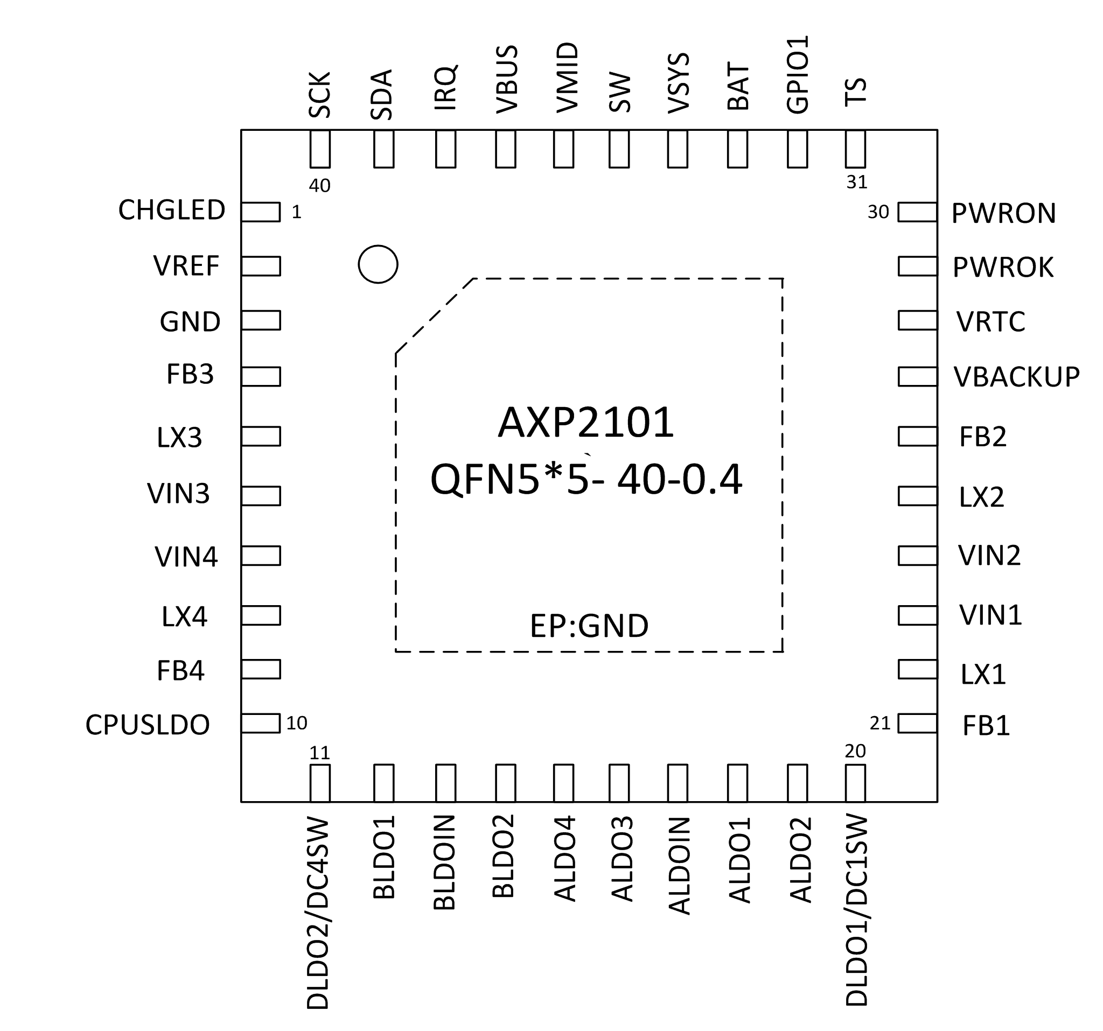

Table 4-1 Pin Description

NO. | Pin Name | Type | Description
1 | CHGLED | AO | Charge status output to indicate various charger operation.
2 | VREF | P | Internal reference voltage
3 | GND | AI | Analog ground for interrupt analog and digital circuits.
4 | FB3 | P | DCDC3 feedback pin
5 | LX3 | P | Inductor pin for DCDC3
6 | VIN3 | P | DCDC3 input source
7 | VIN4 | P | DCDC4 input source
8 | LX4 | P | Inductor pin for DCDC4
9 | FB4 | P | DCDC4 feedback pin and Switch input source
10 | CPULDOS | P | Output pin of CPULDOS
11 | DLDO2/DC4SW | DO | Output pin of DLDO2,and can be configured as the Output pin of DC4SW
12 | BLDO1 | P | Output pin of BLDO1
13 | BLDOIN | P | BLDO input source
14 | BLDO2 | P | Output pin of BLDO2

15 | ALDO4 | P | Output pin of ALDO4
16 | ALDO3 | P | Output pin of ALDO3
17 | ALDOIN | P | ALDO input source
18 | ALDO1 | P | Output pin of ALDO1
19 | ALDO2 | P | Output pin of ALDO2
20 | DLDO1/DC1SW | P | Output pin of DLDO1,and can be configured as the Output pin of DC1SW
21 | FB1 | P | DCDC1 feedback pin
22 | LX1 | P | Inductor pin for DCDC1
23 | VIN1 | P | DCDC1 input source
24 | VIN2 | P | DCDC2 input source
25 | LX2 | P | Inductor pin for DCDC2
26 | FB2 | AI | DCDC2 feedback pin
27 | VBackup | P | Input pin of backup battery
28 | VRTC | P | RTC power output
29 | PWROK | DIO | Power good indication output
30 | PWRON | DIO | Power On-Off key input，Internal 100k pull up to VINT
31 | TS | AI | Temperature qualification voltage input.  Connect a negative temperature coefficient thermistor from TS to GND.  A current source is injected to TS pin and convert TS voltage to a digital code. Charging suspends when TS pin is out of range.  Besides, TS can be connected to external input signal.
32 | GPIO1/FB5/RTC LDO2 | DIO | Output pin of GPIO1 and can be configured as the Output pin of RTCLDO2 or DCDC5 feedback pin.
33 | BAT | P | Battery connection point.  The internal BATFET is connected between BAT and SYS.  Connect a 1uF capacitor closely to the BAT pin.
34 | VSYS | P | System connection point.  The internal BATFET is connected between BAT and SYS. Connect two 22uF capacitors closely to the SYS pin.
35 | SW | P | Inductor pin for DCDC5
36 | VMID | P | VMID Power output
37 | VBUS | P | Vbus input
38 | IRQ | DIO | Open-drain interrupt Output.  Connect the IRQ to a logic rail via a 4.7kΩ resistor. The IRQ pin sends a low level signal to host to report charger device status and fault.

39 | SDA | DIO | Data pin for serial interface, needs a 2.2kΩ Pull High.
40 | SCK | DI | SCK pin for serial interface, needs a 2.2kΩ Pull High.
EP | EP | GND | Exposed Pad, needs to be connected to system ground

Specifications

Absolute Maximum Ratings ⁽¹⁾

Table 5-1 Absolute Maximum Ratings
Over operating free-air temperature range (unless otherwise noted)

SYMBOL | DESCRIPTION | MIN | MAX | UNIT
VBUS | Voltage range(with respect to GND) | -0.3 | 12 | V
Others pin (exp VBUS, PGND, GND) | Voltage range(with respect to GND) | -0.3 | 7 | V
Others pin (exp VBUS, PGND, GND) | Voltage range(with respect to GND) | -0.3 | 7 | V
PGND to GND | Voltage range(with respect to GND) | -0.3 | 0.3 | V
Ta | Operating Temperature Range | -40 | 85 | ℃
TJ | Junction Temperature Range | -40 | 125 | ℃
Ts | Storage Temperature Range | -65 | 150 | ℃
TLEAD | Maximum Soldering Temperature (at  leads，10sec) |  | 300 | ℃
(1) Stresses beyond those listed under absolute maximum ratings may cause permanent damage to the device. These are stress ratings only. Functional operation of the device at these or any other conditions beyond those indicated under recommended operating conditions is not implied. Exposure to absolute maximum rated conditions for extended periods may affect device reliability.

ESD Ratings

Table 5-2 ESD Ratings

 |  | VALUE | UNIT
VESD | Human body model(HBM)⁽¹⁾ | ±4000 | V
VESD | Charged device model(CDM)⁽²⁾ | ±750 | V
- Reference: ESDA/JEDEC JS-001-2017.

- Reference: ESDA/JEDEC JS-002-2018.

Recommended Operating Conditions

Table 5-3 Recommended Operating Conditions

SYMBOL | DESCRIPTION | MIN | MAX | UNIT
VIN | Input voltage(VBUS) | 3.9 | 5.5 | V
IIN | Input current(VBUS) |  | 2 | A
ISYS | Output current |  | 2 | A
VBAT | Battery voltage |  | 4.4 | V
IBAT | charging current |  | 1 | A

Thermal Information

Table 5-4 Thermal Metric

Thermal Metric⁽¹⁾ |  | VALUE | UNIT
θJA | Junction-to-ambient thermal resistance | 30 | ℃/W
θJB | Junction-to-board thermal resistance | 10.8 | ℃/W
θJC | Junction-to-case(top) thermal resistance | 22.8 | ℃/W
(1)Thermal metrics are calculated refer to JEDEC document JESD51.

Electrical Characteristics

Table 5-5 Electrical Characteristics

Symbol | Parameters | Test Conditions | MIN | TYP | MAX | UNIT
QUIESCENT CURRENTS
IBAT | Battery discharge current | no VBUS, BATFET Disabled, with only RTCLDO on |  | 40 |  | uA
VBUS/BAT POWER UP
VVBUS | VBUS operating range |  | 3.9 |  | 5.5 | V
VVBUS_UVLOZ | VBUS under voltage threshold |  |  | 3.75 |  | V
VVBUS_OV | VBUS over-voltage rising threshold |  |  | 7 |  | V
VSLEEPZ | Sleep mode rising threshold |  |  | 150 |  | mV

 | (VBUS-VBAT)
VBAT | VBAT operating range |  |  | 2.5 |  | 4.5 | V
VBAT_UVLOZ | VBAT under voltage threshold |  |  |  | 2.4 |  | V
VBAT_DPLZ | VBAT depletion threshold |  |  |  | 2.5 |  | V
Battery Charger
VBATREG_RANGE | Typical Charge voltage range | VBATREG= 4.0/ 4.1/ 4.2/ 4.35/ 4.4V | 4.0 |  |  | 4.4 |  | V
VBATREG | Charge voltage resolution accuracy | VBAT = 4.2V, TJ = 25℃ | -0.50% |  |  | 0.50%
ICHG_REG_RANGE | Typical Fast charge current regulation range |  | 0 |  |  | 1000 |  | mA
ICHG_REG_ACC | Fast charge current regulation accuracy | ICHG=800mA,TJ = 25℃ | -20% |  |  | 20%
VBATLOWV | Battery low voltage threshold | Fast charge to precharge |  |  | 3 |  |  | V
IPRECHG_RANGE | Precharge current range |  | 0 |  |  | 200 |  | mA
IPRECHG_ACC | Precharge current accuracy | IPRECHG = 200mA,TJ = 25℃ | -50% |  |  | 50%
ITERM_RANGE | Termination current range |  | 0 |  |  | 200 |  | mA
VTRICHG | Battery trickle charge threshold | VBAT falling |  |  | 2 |  |  | V
ITRICHG | Battery trickle charge current | VBAT < 2 V |  |  | 10 |  |  | mA
VRECHG | Recharge Threshold below VBATREG | VBAT falling |  |  | 100 |  |  | mV
Input Voltage / Current Regulation
VINDPM_RANGE | Typical Input voltage regulation range |  | 3.88 |  |  | 5.08 |  | V
VINDPM_ACC | Input voltage regulation accuracy | VINDPM=4.36V | -3% |  |  | 3%
IINLIM_RANGE | Input current regulation range |  | 100 |  |  | 2000 |  | mA
IINDPM_ACC | Input current regulation accuracy | IINLIM =500mA | 350 |  |  | 500 |  | mA
DCDC

DCDC1/2/3/4
VIN | Input Voltage |  | 2.6 |  | 5.5 | V
UVP |  |  |  | 85%
OVP |  |  |  | 130%
Accuracy | Output Accuracy | Accuracy, PWM mode, VOUT<1V | -30 |  | 30 | mV
Accuracy | Output Accuracy | Accuracy, PWM mode, VOUT>1V | -3.00% |  | 3.00%
DCDC1
VOUT | Output Voltage | Output Range | 1.5 |  | 3.4 | V
 | Output Voltage | Step Size |  | 100 |  | mV
IOUT | Output Load Current |  |  | 2 |  | A
DCDC2
VOUT | Output Voltage | Output Range | 0.5 |  | 1.54 | V
VOUT | Output Voltage | Step Size, VOUT=0.5V~1.2V |  | 10 |  | mV
VOUT | Output Voltage | Step Size, VOUT=1.22V~1.54V |  | 20 |  | mV
IOUT | Output Load Current |  |  | 2 |  | A
DCDC3
VOUT | Output Voltage | Output Range | 0.5 |  | 3.4 | V
VOUT | Output Voltage | Step Size, VOUT=0.5V~1.2V |  | 10 |  | mV
VOUT | Output Voltage | Step Size, VOUT=1.22V~1.54V |  | 20 |  | mV
VOUT | Output Voltage | Step Size, VOUT=1.6V~3.4V |  | 100 |  | mV
IOUT | Output Load Current |  |  | 2 |  | A
DCDC4
VOUT | Output Voltage | Output Range | 0.5 |  | 1.84 | V
VOUT | Output Voltage | Step Size, VOUT=0.5V~1.2V |  | 10 |  | mV
VOUT | Output Voltage | Step Size, VOUT=1.22V~1.84V |  | 20 |  | mV
IOUT | Output Load Current |  |  | 1.5 |  | A
DCDC5

VOUT | Output Voltage | Output Range | 1.2 |  | 3.7 | V
VOUT | Output Voltage | Step Size, VOUT=1.4V~3.7V |  | 100 |  | mV
IOUT | Output Load Current |  |  | 1 |  | A
LDO
RTCLDO1/2
VOUT | Output Voltage | VOUT=1.8/ 2.5/ 3/ 3.3V | 1.8 |  | 3.3 | V
VOUT | Output voltage accuracy |  | -10% |  | +10%
IOUT | Output Load Current |  |  | 30 |  | mA
CPUSLDO
VIN | Input Voltage | Input is DCDC4 | 0.8 |  | 1.84 | V
VOUT | Output Voltage | Output Range | 0.5 |  | 1.4 | V
VOUT | Output Voltage | Step size |  | 50 |  | mV
VOUT | Output Voltage | Accuracy,VIN=0.8V~1.84V, VOUT<1V, Iload=10mA | -30 |  | 30 | mV
VOUT | Output Voltage | Accuracy,VIN=0.8V~1.84V, VOUT>1V, Iload=10mA | -3% |  | 3%
IOUT | Output Load Current |  |  | 30 |  | mA
ILIM | Current Limit |  |  | 300 |  | mA
ALDO1~4/BLDO1~2
VIN | Input Voltage |  | 2.6 |  | 5.5 | V
VDrop | Dropout | VOUT=3.3V |  | 200 |  | mV
VOUT | Output Voltage | Output Range | 0.5 |  | 3.5 | V
VOUT | Output Voltage | Step size |  | 100 |  | mV
VOUT | Output Voltage | Accuracy, VOUT<1V, Iload=10mA | -30 |  | 30 | mV
VOUT | Output Voltage | Accuracy, VOUT>1V, Iload=10mA | -3% |  | 3%
IOUT | Output Load Current |  |  | 300 |  | mA
ILIM | Current Limit |  |  | 500 |  | mA
DLDO1(DC1SW)
VIN | Input Voltage | Input is DCDC1 | 1.8 |  | 3.4 | V

VOUT | Output Voltage | Output Range | 0.5 |  | 3.3 | V
VOUT | Output Voltage | Step size |  | 100 |  | mV
VOUT | Output Voltage | Accuracy, VOUT<1V, Iload=10mA | -30 |  | 30 | mV
VOUT | Output Voltage | Accuracy, VOUT>1V, Iload=10mA | -3% |  | 3%
IOUT | Output Load Current |  |  | 300 |  | mA
ILIM | Current Limit |  |  | 500 |  | mA
DLDO2(DC4SW)
VIN | Input Voltage | Input is DCDC4 | 1.5 |  | 1.8 | V
VOUT | Output Voltage | Output Range | 0.5 |  | 1.4 | V
 |  | Step size |  | 100 |  | mV
 |  | Accuracy, VOUT<1V, Iload=10mA | -30 |  | 30 | mV
 |  | Accuracy, VOUT>1V, Iload=10mA | -3% |  | 3%
IOUT | Output Load Current |  |  | 300 |  | mA
ILIM | Current Limit |  |  | 500 |  | mA
TWI&IO
TWI INTERFACE (SCL, SDA)
VIH | Input high threshold level, SCL and SDA | Pull-up rail 1.8V | 1.3 |  |  | V
VIL | Input low threshold level | Pull-up rail 1.8V |  |  | 0.8 | V
VOL | Output low threshold level | Sink Current = 5mA, sink current |  |  | 0.4 | V
Logic I/O pin Characteristics (IRQ/PWRON/PWROK)
VIH | Input high threshold level |  | 1.3 |  |  | V
VIL | Input low threshold level |  |  |  | 0.8 | V

Detail Description

Overview
AXP2101 is a highly integrated power management IC(PMIC) targeting at single cell Li-battery (Li-ion or Li-polymer) applications that require multi-channel power conversion outputs. It provides an easy and flexible power management solution for multi-core processors to meet the complex and accurate requirements of power control.
AXP2101 supports 100mA-1A Linear charge. Besides, it supports 16 channel power outputs which include 5 channel DC-DC and 11 channel LDO. To ensure the security and stability of the system, AXP2101 provides multiple channels 14-bit ADC for voltage/temperature monitor and integrates protection circuits such as over-voltage protection(OVP), over-current protection(OCP) and over-temperature protection(OTP).
Moreover, AXP2101 features a unique E-Gauge™ (Fuel Gauge) system, making power gauge easy and exact.
AXP2101 supports TWSI and RSB for system to dynamically adjust output voltages, charge current and configure interrupt condition.
AXP2101 is available in 5mm x 5mm 40-pin QFN package.

Function Block Diagram

Figure 6-1 Function Block Diagram
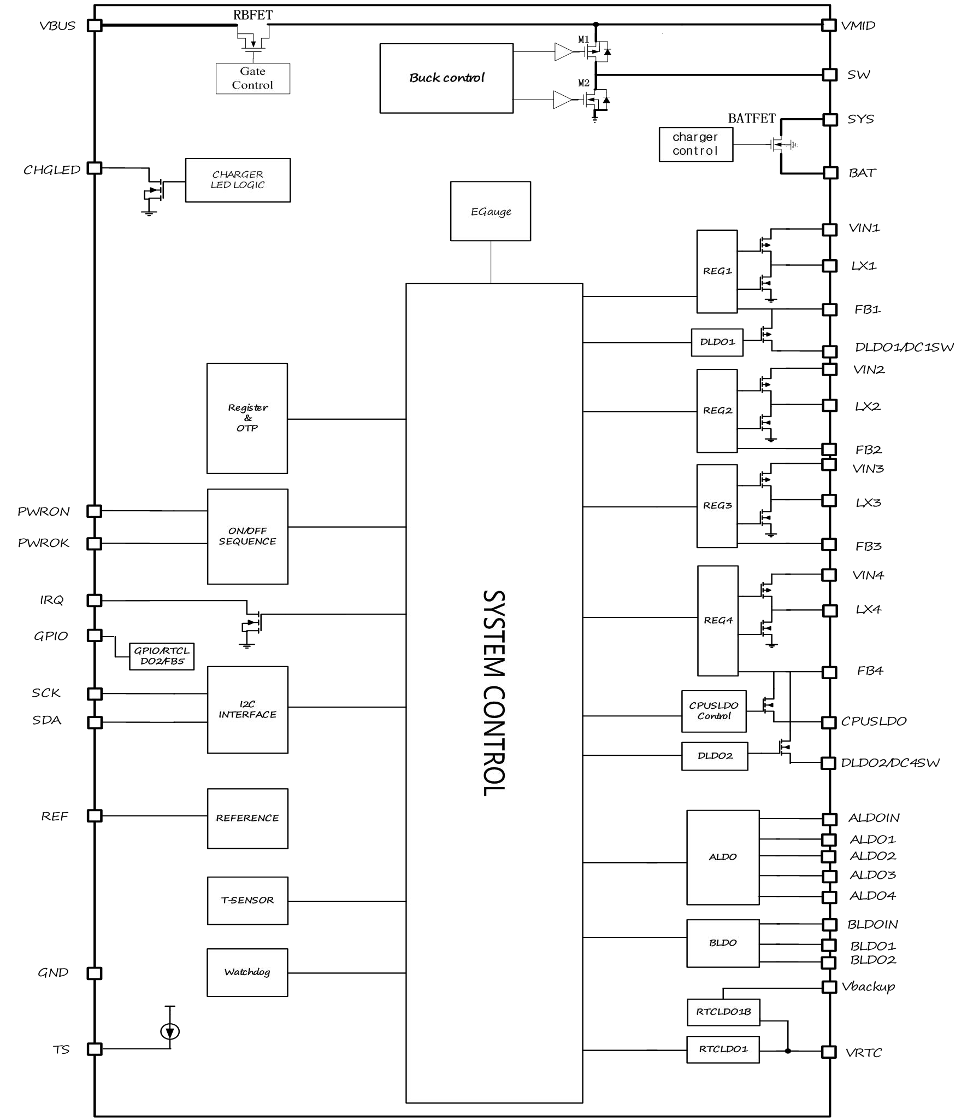

Serial Interface Communication
AXP2101 supports TWSI protocol and performs as a TWSI slave device with default address 0x68/0x69. When AXP2101 powers on, SCK/SDA pin of TWSI will be pulled up to IO Power and then Host can adjust and monitor AXP2101 with rich feedback information.
Besides, AXP2101 supports RSB for Allwinner platform with address 0x01D1 or 0x0273 by customer. Note: “Host” here refers to system processor.

Power Path
VBUS as the charger input, connecting to VSYS pin through a Linear charger, provides power to system and charges battery through BATFET. Charge current can be adjusted automatically according to the feedback current which is detected with an internal resistor. When system current (ISYS) changes, the detected current will change, and then the current change signal will feed back to charge loop to adjust the charge current to the setting value.
When battery voltage is above VSYS, BATFET is turned on and PMU enters supplement mode. When in supplement mode, if the discharge current is lower than 1A, PMU controls the voltage(VDS) between system and battery and keeps VDS at 30mV to avoid entering and exiting supplement mode repeatedly. As discharge current increases, PMU adjusts BATFET to be fully on and VDS increases linearly. If an adapter is not inserted, system current is provided only by battery. At this time, BATFET is at fully on state.

Power On/Off and reset

Power on reset(POR)
AXP2101 is powered from the higher voltage between VBUS and BAT. When VBUS voltage(VVBUS) is higher than VVBUS_UVLOZ or BAT voltage(VBAT) is higher than VBAT_UVLOZ, the sleep comparator, battery depletion comparator and BATFET driver are be activated. All registers are reset to the default value. TWSI communication is active and Host can communicate with PMU.

Power up from BAT
If only battery is present and VBAT is higher than depletion threshold (VBAT_DPLZ), BATFET, connecting battery to system, is off by default and need to be turned on by pressing the PWRON key or inserting an adapter.

Power up from VBUS
When VBUS is inserted, PMU detects the input voltage to start up the reference voltage and the bias circuit. When VVBUS is higher than VVBUS_UVLOZ, the VBUS insertion IRQ is sent and the register bit reg49H[7] is set to 1

to indicate VBUS is inserted. Then PMU detects the input source whether it is good or not. If VBUS is good, the RBFET is open and Vsys is working.

Good source condition
PMU needs to check the current capability of the input source. Only when the input source meets the following requirements can it start the buck converter.
        - VBUS voltage is lower than VACOV
        - VBUS voltage is higher than VVBUSMIN when pulling IBADBUS(typical 30mA)
Once the input source meets the requirements above,the register bit reg00H[5](VBUS_GOOD) is set to 1 to indicate the input source is good.

Set input voltage limit(VINDPM)
AXP2101 supports wide range of input voltage(3.9V~5.5V). VINDPM can be set through reg15H[3:0]. The range of VINDPM is from 3.88V to 5.08V and the step is 80mV.
When VBUS voltage reaches VINDPM, the charge current will decrease automatically until the current is zero. If ISYS is over the input power supply capability, VSYS will drop. If VBAT is above VSYS, PMU will enter the supplement mode.

Set input current limit(IINLIM)
AXP2101 supports input current limit to avoid adaptor overload. IINLIM can be set as 100mA, 500mA, 900mA, 1A, 1.5A and 2A through reg16H[2:0].

System power on/off management
PMU has power off and power on status. When at off state, all voltage outputs are turned off except RTCLDO . At this time, if only battery is present, the total power consumption is typically 40uA.

Power on-off Key (POK)
EN/PWRON pin can be configured as PWRON pin or EN pin by customization. The default is PWRON pin. The Power on-off Key (POK) can be connected between PWRON pin and GND of AXP2101. AXP2101 can automatically identify the four status (Long-press, Short-press, Negative edge, Positive edge) and then correspond respectively.

Power on
- When EN/PWRON pin is configured as PWRON pin, power on sources include:
  - POK. AXP2101 can be powered on by pressing and holding POK for a period of time that longer than “ONLEVEL”.
  - VBUS low go high. The function can be configured by customization.
  - VBAT low go high. The function can be configured by customization.

  - IRQ Low level. IRQ pin is low level for more than 16ms, AXP2101 will be powered on.The function can be configured by customization.
  - Battery is charged to normal (Vbat>3.3V and is charging). The function can be configured by customization.
- When EN/PWRON pin is customized as EN pin, AXP2101 can be powered on by EN pin from low to high(0.6V).
After power on, DCDC and LDO will be soft booted in preset timing sequence. When IRQ low level power on,
AXP2101 can be configured for fast power on by REG2B, and the DCDCs/LDOs start sequence can be configured by REG28H~REG2BH.

Power Off
- When EN/PWRON pin is configured as PWRON pin, power off sources include:
  - POK. AXP2101 can be powered off by pressing and holding POK for a period of time that longer than “OFFLEVEL”. The function can be configured by REG22H[1] and REG22H[3:2] decides whether the PMU auto turns on or not when it shuts down after OFFLEVEL POK.
  - Write “1” to REG10H[0].
  - VSYSGOOD high go low. When VSYS<VOFF or VBUS>7V, AXP2101 will be powered off. The default of VOFF is 2.6V which can be configured by REG24H[2:0].
  - The output voltage of DCDC is 15% lower than the setting value. The function can be configured by REG23H[4:0].
  - The output voltage of DCDC is much larger than their setting. The function can be configured by REG23H[5].
  - Die temperature is over the warning level2(145℃). The function can be configured by REG22H[2].
- When EN/PWRON pin is customized as EN pin, AXP2101 can be powered off by EN pin from high to low.

Sleep and wakeup
When the running system needs to enter Sleep mode, Maybe one or several power outputs should be disabled or changed to other voltage. Wakeup can be initiated by the following sources:
- Software wakeup (REG26H[1] is set to 1)
- IRQ pin wakeup (REG 26H[4] =1 and IRQ pin is low level for more than 16ms)
These sources will make the all the PMU power outputs resume to the default voltage or the setting voltage, which is configured by REG26H[2], and all shutdown powers will resume by the startup sequence.
See the control process under sleep and wakeup modes as below.

Figure 6-2 Sleep and Wakeup

All power resume to the default or setting voltage
Y
N
Write “1” to REG26H [0] to start the Wakeup, and PMU will record the configuration of REG80H, REG90H,REG91H
Write REG80H, REG90H,
REG91H, Disable corresponding power or modify the voltage
Sleep and wait to be Wakeup
Wakeup
sources

Reset
The PMU has system reset and power on reset.
- System reset
System reset means the registers will be reset when PMU is powered on. at system reset state, all voltage outputs are turned off except RTCLDO and VREF. There are three ways of system reset.
PWROK drive low.
The PWROK pin can be used as the reset signal of application system. During AXP2101 startup, PWROK outputs low level, which will be pulled up to startup the system after output voltage reaches the regulated value.
When application system works normally, If the PWROK pin is driven low by external key or other reasons, the PMU will be restarted. The function can be configured by REG10H[3].
- Write “1” to REG10H[1] to restart the PMU.
- Watchdog timeout. The function can be configured by REG18H[0] and REG19H[5:4]

  - Power on reset
Power on reset means the registers will be reset when PMU is powered up. at power on reset state, all voltage outputs are turned off including RTCLDO and VREF.

Multi-Power Outputs
The following table has listed the multi-power outputs and their functions of AXP2101.

Table 6-1 Features of Multi-Power Outputs

Output Path | Type | Default Voltage | Startup Sequence | Application Suggestion | Load Capacity(Max)
DCDC1 | BUCK | 3.3V | 3 | IO/USB | 2000mA
DCDC2 | BUCK | 0.9V | 3 | CPU | 2000mA
DCDC3 | BUCK | 0.9V | 2 | VSYS | 2000mA
DCDC4 | BUCK | 1.1V | 1 | DDR | 1500mA
DCDC5 | BUCK | 1.2V | OFF | N/A | 1000mA
ALDO1 | LDO | 1.8V | 3 | N/A | 300mA
ALDO2 | LDO | 2.8V | OFF | N/A | 300mA
ALDO3 | LDO | 3.3V | 3 | N/A | 300mA
ALDO4 | LDO | 2.9V | OFF | N/A | 300mA
BLDO1 | LDO | 1.8V | OFF | N/A | 300mA
BLDO2 | LDO | 2.8V | OFF | N/A | 300mA
DLDO1 | LDO | 3.3V | OFF | N/A | 300mA
DLDO2 | LDO | 1.2V | OFF | N/A | 300mA
VCPUS | LDO | 0.9V | 1 | CPUs/Reference of DDR | 30mA
RTC-LDO1 | LDO | 1.8V | Always on | RTC | 30mA
RTC-LDO2 | LDO | OFF | OFF | N/A | 30mA

AXP2101 includes 5 synchronous step-down DCDCs, 11 LDOs and one switch. The work frequency of DC-DC 1/4 is 3MHz and DCDC2/3/5 is 1.5MHz. External small inductors and capacitors can be connected. In addition, 4-ch DCDCs can be set in fixed PWM mode or auto mode (automatically switchable according to the load). See register REG81H.

DCDC2/3 has DVM enable option. In DVM mode, when there is a change in the output voltage, DCDC will change to the new targeted value step by step. It supports two kinds of DVM slope: 1 step/15.625us and 1step/31.250us. The slope can be chosen by REG80H[5].
AXP2101 can configure the default voltage, the startup sequence and other control of all power output.
Startup sequence：The startup sequence has eight levels from 0 to 7. When the sequence is 0, it means the output is booted at the first step. When the sequence code is 1, it means the output is booted at the second step. When the sequence is 7, it means the output is not booted.
Default voltage setting: The default voltage of each channel can be set to each step within the output range.

Charger

Characteristics
- Range of input voltage:3.9V~5.5V, PWM charger, supports single cell Li-battery
- Precharge current settable (IPRECHG, reg61H[3:0]), default:125mA, range: 0mA~200mA,step:25mA
- Fast charge current settable (ICHG, reg62H[4:0]), default:300mA, range: 0mA~200mA, step:25mA, 200~1000mA, step:100mA
- Target charge voltage settable (VREG, reg64H[2:0]), default:4.2V, range: 4.0V/4.1V/4.2V/4.35V/4.4V
- Accuracy of target voltage:±0.5%(testing ambient temperature:25℃,target voltage:4.2V)

Charging condition
- VBUS is present and available, VVBUS>VBAT+VSLEEPZ
- Input source detection finishes (reg00H[5] =1)
- Charging is enabled (reg18H[1] =1)
- Die temperature is lower than the warning level2(145℃)
- When TS pin is used to detect battery temperature, battery temperature is within the chargeable range
- VBAT is lower than VBAT_OVP
- No charger safety timer fault

Charging process
When PMU meets all charging conditions, it can complete the whole charging process without the participation of Host. The charging status can be known from the register bits reg01H[2:0]. The default values of charging parameters are shown as following. Host can modify registers to optimize the values through TWSI.

Table 6-2 Charging Parameters

Parameter | Default value
Charging voltage | 4.2V
Charging current | 300mA
Pre-charging current | 125mA
Termination current | 125mA
Temperature profile | Cold/hot
Safety timer | 12hours

Pre-charge
When VBAT is lower than VBATLOWV(3V), the charger is under pre-charge mode where charging current is limited to a value of IPRE-CHG. Safety time is set through reg67H[1:0] and its default value is 50 minutes. If pre-charge process times out, PMU will stop charging and send a corresponding IRQ to Host. The function of safety timer can be disabled through reg67H[2].

Constant current charge
Once VBAT is higher than VBATLOWV and lower than VREG, the charger is under constant current charge mode. It will charge with constant current ICHG.

Constant voltage charge
When VBAT reaches target voltage (VREG), the charger enters constant voltage charge mode. In this stage, the charger keeps the output voltage constant and step down charging current gradually, in order to fully charge battery.
When VBAT is above VRECHG and the charging current reduces under termination current (ITERM), AXP2101 reports charger done, stops charging (charger enable bit is still 1) and turns off BATFET. Meanwhile, IRQ is sent to Host.
When AXP2101 is in regulation of input current, input voltage or temperature, the function of charging termination configured through reg63H[4] is temporarily disabled and the speed of safety timer slows down. Whether to set safety timer during DPM or thermal regulation depends on reg67H[7].

Re-charge
After charge done, if VBAT falls below VRECHG, PMU will automatically enable charger without reinserting adapter.
No matter whether VBAT is above VRECHG or not, the charger is enabled when an adapter is inserted.

Battery detection
As long as an AC adapter is present and usable, battery detection will be enabled to detect whether battery is connected. Battery detection function is enabled by default and can be disabled through reg68H[0]. If the function is disabled, PMU considers that battery is always present. The detection result is saved in reg00H[3]

Charging protection

charger safety timer
Once starting pre-charge mode, PMU will enable timer1. If PMU cannot enter constant current charge mode from pre-charge within 50min (set through reg67H[1:0]), PMU will enter battery safe mode and send IRQ to indicate the battery may be damaged.
When the charger enters into constant current charge mode, PMU will enable timer2. If PMU cannot finish the whole charge cycle within 12 hours (set through reg67H[5:4]), PMU will enter battery safe mode and send IRQ to indicate the battery may be damaged.
Timing speed of timer1 or timer2 is relevant with actual charge current. The smaller the actual charge current, the slower timing speed is.

Battery safe mode
In battery safe mode, the charger always charges with 10mA current. PMU can quit battery safe mode with one of the following methods:
- VBAT>VRECHG

- Adapter removal
- Charger enable bit (reg18H[1]) is reset to 1
- Safety timer1 enable bit or safety timer2 enable bit is reset to 1

PMU die temperature protection
AXP2101 has built-in temperature protection function through ADC to monitor internal temperature.
Under charging mode, the temperature point of thermal regulation can be set through reg65H[1:0]. When die temperature rises up to the setting point, the charging current will be decreased to decrease heat. When thermal regulation works, actual charge current is lower than the setting value and thermal regulation status(reg00H[1]) is set to 1. If die temperature rises up to TSHUT (145℃), IRQ is sent, PMU is poweroff. When die temperature falls below hysteretic threshold (120℃), PMU is not poweron automatically.

Battery temperature protection
AXP2101 can monitor battery temperature, when TS pin is used to detect battery temperature and parallel with charger(reg50H[4]=0). The battery temperature sensitive resistor is connected between TS pin and GND. The suggestion resistance should be 10Kohm at 25℃ ambient temperature. Through TS pin, PMU outputs constant current which can set through reg50H[1:0] to adapt different resistance. When the resistance is 10Kohm, the current should be set to 50uA. The enable bit of TS current source is configured through

reg50H[3:2]. When current passes through the temperature sensitive resistor, PMU gets a detected voltage and calculates its value through ADC circuit. Take for example, TH11-3H103F temperature sensitive resistor of Mitsubishi Company. Using 50uA current source, the relationship among temperature, equivalent resistance, detected voltage and ADC data is as following.

Table 6-3 Relationship among temperature, equivalent resistance, detected voltage and ADC data

Temperature | equivalent resistance | detected voltage | ADC DATA
-20℃ | 63.00Kohm | 3.150V | 189Ch
-15℃ | 50.15Hohm | 2.508V | 1398h
-10℃ | 40.26Kohm | 2.013V | FBAh
-5℃ | 32.55Kohm | 1.628V | CB8h
0℃ | 26.49Kohm | 1.325V | A5Ah
5℃ | 21.68Kohm | 1.084V | 878h
10℃ | 17.78Kohm | 0.889V | 6F2h
15℃ | 14.63Kohm | 0.732V | 5B8h
20℃ | 12.07Kohm | 0.604V | 4B8h
25℃ | 10.00Kohm | 0.500V | 3E8h
30℃ | 8.320Kohm | 0.416V | 340h
35℃ | 6.954Kohm | 0.348V | 2B8h
40℃ | 5.839Kohm | 0.292V | 248h
45℃ | 4.924Kohm | 0.246V | 1ECh
50℃ | 4.171Kohm | 0.209V | 1A2h
55℃ | 3.549Kohm | 0.177V | 162h
60℃ | 3.032Kohm | 0.152V | 130h

During battery charging process, if TS pin voltage is lower than VHTF-CHG or higher than VLTF-CHG (VHTF-CHG and VLTF-CHG can be set through reg55H and reg54H. The default value of VLTF-CHG is set around 0℃ and VHTF-CHG around 45℃), which indicates battery temperature is too high or too low, then the charger is paused and IRQ is sent to notify Host. When battery temperature is back to the normal range, the charger will recovery automatically.
During battery discharging mode, if TS pin voltage is lower than VHTF-WORK or higher than VLTF-WORK (VHTF-WORK and VLTF-WORK can be set through reg57H and reg56H. The default value of VLTF-WORK is set around -10℃ and VHTF-WORK around 55℃), which indicates battery temperature is too high or too low, then the boost is paused and IRQ is sent to notify Host. When battery temperature is back to the normal range, the boost will recovery automatically.

High temperature protection threshold hysteresis for VHTF-CHG and VHTF-WORK can be set through reg53H. Low temperature protection threshold hysteresis for VLTF-CHG and VLTF-WORK can be set through reg52H. The range of temperature detection can be expanded by adding more resistors.
Some battery may have no temperature sensitive resistor. Under this situation, TS pin can be pulled down to GND with a 10Kohm resistor externally or set as external input of ADC through register.

Charging indication
CHGLED pin uses open-drain/push-pull output method. It is internally pulled up to LDO. Its output drive capability is above 10mA. Detail function control is shown as the following table.

Table 6-4 CHGLED Function Control

REG69H[2:1] = 00 (Type A CHGLED)  Open Drain | Hi-Z | No charging(conditions are not met or battery charged)
 | 25% 1Hz pull low/Hi-Z jump | Charger internal abnormal alarm(including timer  out、die temperature over temperature、battery temperature out of charging range)
 | 25% 4Hz pull low/Hi-Z jump | Input source or battery over voltage
 | Pull low | Charging
REG69H[2:1] = 01 (Type B CHGLED)  Open Drain | Hi-Z | No VBUS, and power supply by battery
REG69H[2:1] = 01 (Type B CHGLED)  Open Drain | 25% 1Hz pull low/Hi-Z jump | Charging
REG69H[2:1] = 01 (Type B CHGLED)  Open Drain | 25% 4Hz pull low/Hi-Z jump | Alarm, including input source or battery over voltage, battery temperature out of charging range, timer out ,die temperature over temperature
REG69H[2:1] = 01 (Type B CHGLED)  Open Drain | Pull low | No battery or charge finished, and power supply by VBUS
REG69H[2:1]=10  Cfg chgled | The output status is controlled by REG69H[5:4]
Note: LED is on when CHGLED is low.

BATFET
BATFET connects system and battery. The on-resistance is low to 50mohm (point to point).

RBFET
RBFET connects VMID and VBUS. The on-resistance is low to 100mOhm (point to point). It supports input and output current limit function. In charger mode, the input current limit value of RBFET is set through reg16H[2:0].

ADC
AXP2101 has a low speed 14 Bits SAR ADC for measuring BAT voltage, Vbus voltage, Vsys voltage, TS voltage and die temperature.

Table 6-5 ADC Channel and Data

No. | Channel function | 000H | 001H | 002H | … | FFFH
0 | VBAT voltage | 0mV | 1mV | 2mV | … | 8.192V
1 | VBUS voltage | 0mV | 1mV | 2mV | … | 8.192V
2 | VSYS voltage | 0mV | 1mV | 2mV | … | 8.192V
3 | TS voltage | 0mV | 0.5mV | 1mV | … | 4.096V
4 | die temperature | 0mV | 0.1mV | 2mV | … | 0.8192V
Note: ADC data is 14 bits. In order to get the complete data, TWSI must read the high 6 bits firstly and then the low 8 bits.

E-Gauge
The Fuel Gauge system is able to export information about battery capacity percentage (regA4H) and Battery Voltage (reg34H, reg35H). The Fuel Gauge can be enabled or disabled through reg18H[3]. The Battery low warning level can be set through reg1AH, and IRQ will be sent out to alert the platform when the battery capacity percentage is lower than the warning level set through reg1AH.
Once a default battery is selected for a particular design, it is highly recommended to program the battery module to achieve better Fuel Gauge accuracy. Once the battery module data are available, user can write these information to battery parameter (REGA1H) after brom is enabled on each boot. Additionally, the Fuel Gauge system is capable to learn the battery characteristic automatically.

IRQ /BACKUP

IRQ
AXP2101 has an IRQ pin which is used to indicate whether there interrupt events occur.

PMU Interrupt Controller monitors the trigger events such as over voltage, over current, PWRON pin signal, over temperature and so on. When the events occur and their IRQ enabled bits are set to 1 (Refer to registers reg40H/41H/42H), corresponding IRQ status will be set to 1 (Refer to registers reg48H/49H/4AH), and IRQ pin will be pulled down. When Host detects triggered IRQ signal, Host will scan through the IRQ Status registers and respond accordingly. Meanwhile, Host will reset the IRQ status by writing “1” to status bit.

BACKUP
AXP2101 has a backup pin which is used to connect backup battery. It is the source of RTCLDO1 when pmu has only backup battery.
When PMU is power on, the backup battery also can be charged by configuring reg18H[2] . The charger is working under linear mode with 100uA charge current and the termination voltage can be configured by reg6AH in range from 2.6V to 3.3V (default 2.9V).
The backup pin can also be configured for the RTCLDO2 by customization.

Register

Register List

Address | Description | R/W
0X00 | PMU status1 | R
0X01 | PMU status2 | R
0X04-0X07 | DATA BUFFER | RW
0X10 | PMU common configure | RW
0X12 | BATFET control | RW
0X13 | Die temperature control | RW
0X14 | Minimum system voltage control | RW
0X15 | Input voltage limit control | RW
0X16 | Input current limit control | RW
0X17 | Reset the fuel gauge | RW
0X18 | Charger, fuel gauge , watchdog on/off control | RW
0X19 | Watch dog control | RW
0X1A | Low Battery warning threshold setting | RW
0X20 | PWRON status | R
0X21 | PWROFF status | R
0X22 | PWROFF_EN | RW
0X23 | PWROFF of DCDC OVP/UVP control | RW

Address | Description | R/W
0X24 | Vsys voltage for PWROFF threshold setting | RW
0X25 | PWROK setting and PWROFF sequence control | RW
0X26 | Sleep and wakeup control | RW
0X27 | IRQLEVEL/OFFLEVEL/ONLEVEL setting | RW
0X28 | Fast pwron setting 0 | RW
0X29 | Fast pwron setting 1 | RW
0X2A | Fast pwron setting 2 | RW
0X2B | Fast pwron setting and control | RW
0X30 | ADC Channel enable control | RW
0X34-3D | ADC data | RW
0X40-0X42 | IRQ Enable | RW
0X48-0X4A | IRQ Status | RW
0X50 | TS pin CTRL | RW
0X52 | TS_HYSL2H setting | RW
0X53 | TS_HYSH2L setting | RW
0X54 | VLTF_CHG setting | RW
0X55 | VHTF_CHG setting | RW
0X56 | VLTF_WORK setting | RW
0X57 | VHTF_WORK setting | RW
0X58 | JIETA standard Enable control | RW
0x59-0X5B | JIETA standard setting | RW
0X61 | Iprechg charger setting | RW
0X62 | ICC charger setting | RW
0X63 | Iterm charger setting and control | RW
0X64 | CV charger voltage setting | RW
0X65 | Thermal regulation threshold setting | RW
0X67 | Charger timeout setting and control | RW
0X68 | Battery detection control | RW
0X69 | CHGLED setting and control | RW
0X6A | Button battery charge termination voltage setting | RW
0X80 | DCDCS ON/OFF and DVM control | RW
0X81 | DCDCS force PWM control | RW
0X82-0X86 | DCDCs voltage setting | RW

Address | Description | R/W
0X90-0X91 | LDOS ON/OFF control | RW
0X92-0X9A | LDOS voltage setting | RW
0XA1 | Battery parameter | RW
0XA2 | Fuel gauge control | RW
0XA4 | Battery percentage data | R

Register Description

REG 00：PMU status1

Bit | Description | R/W | Reset | Default
7:6 |  | RO | / | 0
5 | VBUS good indication  0：not good 1：good | RO | POR | 0
4 | BATFET state  0: close 1: open | RO | POR | 0
3 | Battery present state  0: absent 1: present | RO | POR | 0
2 | Battery in Active Mode  0: in Normal 1: in Active Mode | RO | POR | 0
1 | Thermal regulation status  0: normal 1: in thermal regulation | RO | POR | 0
0 | Current Limit state  0: not in current limit state 1: in current limit state | RO | POR | 0

REG 01：PMU status2

Bit | Description |  | R/W | Reset | Default
7 |  |  | RO | / | 0
6:5 | Battery Current Direction 00: Standby  10: discharg | 01: charge  11: reserved | RO | POR | 0
4 | System status indication 0: System is power off. | 1: System is power on. | RO | POR | 0
3 | VINDPM status 0: not in VINDPM | 1: VINDPM | RO | POR | 0
2:0 | charging status 000: tri_charge | 001: pre_charge | RO | POR | 0

010: constant charge(CC) 011: constant voltage(CV)
100: charge done 101: not charging 11X: reserved

REG 04：DATA_BUFFER 0

Bit | Description | R/W | Reset | Default
7:0 | data buffer | RW | POR | 00h

REG 05：DATA_BUFFER 1

Bit | Description | R/W | Reset | Default
7:0 | data buffer | RW | POR | 00h

REG 06：DATA_BUFFER 2

Bit | Description | R/W | Reset | Default
7:0 | data buffer | RW | POR | 00h

REG 07：DATA_BUFFER 3

Bit | Description | R/W | Reset | Default
7:0 | data buffer | RW | POR | 00h

REG 10：PMU common configuration

Bit | Description | R/W | Reset | Default
7:6 |  | RW | / | 0b
5 | Internal off-discharge enable for DCDC & LDO & SWITCH 0: disable 1: enable | RW | POR | 1b
4 |  | RW | / | 1b
3 | PWROK PIN pull low to Restart the System 0: disable 1: enable | RW | POR | 0b
2 | PWRON 16s to shut the PMIC enable 0: disable 1: enable | RW | POR | 0b
1 | Restart the SoC System, POWOFF/POWON and reset the related registers  0: normal 1: reset | RWAC | POR | 0b
0 | Soft PWROFF  0: Normal 1: PWROFF | RWAC | POR | 0b

REG 12：BATFET control

Bit | Description | R/W | Reset | Default
7:3 |  | RO | / | 0
2:1 | DIE Over Temperature Protection Level1 Configuration 00: 115deg 01: 125deg  10: 135deg 11: reserved | RW | POR | 01b
0 | DIE Temperature Detect Enable 0: disable 1: enable | RW | POR | 1b

REG 13：Die temperature control

Bit | Description | R/W | Reset | Default
7:3 |  | RO | / | 0
2:1 | DIE Over Temperature Protection Level1 Configuration 00: 115deg 01: 125deg  10: 135deg 11: reserved | RW | POR | 01b
0 | DIE Temperature Detect Enable 0: disable 1: enable | RW | POR | 1b

REG 14：Minimum system voltage control

Bit | Description | R/W | Reset | Default
7 |  | RO | / | 0
6:4 | Linear Charger Vsys voltage dpm  4.1+N*0.1 V  000: 4.1V 001: 4.2V 010: 4.3V  011: 4.4V 100: 4.5V 101: 4.6V  110: 4.7V 111: 4.8V | RW | POR | 110b
3:0 |  | RO | / | 0

REG 15：Input voltage limit control

Bit | Description |  | R/W | Reset | Default
7:4 |  |  | RO | /
 | VINDPM configuration:
 | 3.88+N*0.08 V
3:0 | 0000: 3.88V 0001: 3.96V  0011: 4.12V 0100: 4.20V | 0010: 4.04V  0101: 4.28V | RW | POR | 0110b
 | 0110: 4.36V 0111: 4.44V
 | 1000: 4.52V 1001: 4.60V | 1010: 4.68V

1011: 4.76V 1100: 4.84V 1101: 4.92V
1110: 5.00V 1111: 5.08V

REG 16：Input current limit control

Bit | Description | R/W | Reset | Default
7:3 |  | RO | /
2:0 | Input current limit  000: 100mA 001: 500mA 010: 900mA  011: 1000mA 100: 1500mA 101: 2000mA  110-111: reserved | RW | POR | 100b

REG 17：Reset the fuel gauge

Bit | Description | R/W | Reset | Default
7:4 |  | RO | / | 0
3 | reset the gauge  0: normal 1: reset | RWAC | POR | 0b
2 | reset the gauge besides registers 0: normal 1: reset | RW | POR | 0b
1:0 |  | RO | / | 0

REG 18：Charger, fuel gauge, watchdog on/off control

Bit | Description | R/W | Reset | Default
7:4 |  | RO | / | 0
3 | Gauge Module enable  0: disable 1: enable | RW | POR | 1b
2 | Button Battery charge enable 0: disable 1: enable | RW | System Reset | 0b
1 | Cell Battery charge enable 0: disable 1: enable | RW | System Reset | 1b
0 | Watchdog Module enable 0: disable 1: enable | RW | System Reset | 0b

REG 19：Watchdog control

Bit | Description | R/W | Reset | Default
7:6 |  | RO | / | 0
5:4 | Watchdog Reset Configuration  00: IRQ only 01: IRQ and System Reset | RW | POR | 0b

10: IRQ, System Reset and Pull down PWROK 1s
11: IRQ, System Reset, DCDC/LDO PWROFF & PWRON
3 | watchdog clear signal  0: normal 1: clear | RWAC | POR | 0b
2:0 | TWSI watchdog timer configuration  000: 1s 001: 2s 010: 4s  011: 8s 100: 16s 101: 32s  110: 64s 111: 128s | RW | POR | 110b

REG 1A：Low Battery warning threshold setting

Bit | Description | R/W | Reset | Default
7:4 | low battery warning threshold 5-20%, 1% per step  0000: 5% 0001: 6%  …… 1111: 20% | RW | POR | 1010b
3:0 | low battery shutdown threshold 0-15%, 1% per step  0000: 0% 0001: 1%  …… 1111: 15% | RW | POR | 0001b

REG 20：PWRON status

Bit | Description | R/W | Reset | Default
7:6 |  | RO | / | 0
5 | POWERON always high when EN Mode as POWERON Source 0: no 1: yes | RO | System Reset | 0b
4 | Battery Insert and Good as POWERON Source 0: no 1: yes | RO | System Reset | 0b
3 | Battery Voltage > 3.3V when Charged as Source 0: no 1: yes | RO | System Reset | 0b
2 | Vbus Insert and Good as POWERON Source 0: no 1: yes | RO | System Reset | 0b
1 | IRQ PIN Pull-down as POWERON Source 0: no 1: yes | RO | System Reset | 0b
0 | POWERON low for on level when POWERON Mode as POWERON Source  0: no 1: yes | RO | System Reset | 0b

REG 21：PWROFF status

Bit | Description | R/W | Reset | Default

7 | Die Over Temperature as POWEROFF Source 0: no 1: yes | RO | POR | 0b
6 | DCDC Over Voltage as POWEROFF Source 0: no 1: yes | RO | POR | 0b
5 | DCDC Under Voltage as POWEROFF Source 0: no 1: yes | RO | POR | 0b
4 | VBUS Over Voltage as POWEROFF Source 0: no 1: yes | RO | POR | 0b
3 | Vsys Under Voltage as POWEROFF Source 0: no 1: yes | RO | POR | 0b
2 | POWERON always low when EN Mode as POWEROFF Source 0: no 1: yes | RO | POR | 0b
1 | Software configuration as POWEROFF Source 0: no 1: yes | RO | POR | 0b
0 | POWERON Pull down for off level when POWERON Mode as POWEROFF Source  0: no 1: yes | RO | POR | 0b

REG 22：PWROFF_EN

Bit | Description | R/W | Reset | Default
7:3 |  | RO | / | 0
2 | DIE Over-Temperature(LEVEL2) as POWEROFF Source enable 0: disable 1: enable | RW | POR | 1b
1 | PWRON > OFFLEVEL as POWEROFF Source enable 0: disable 1: enable | RW | POR | EFUSE
0 | Function Select when btn_pwroff_en=1 and button power-off occur  0: Power-off 1: Restart | RW | POR | EFUSE

REG 23：PWROFF of DCDC OVP/UVP control

Bit | Description | R/W | Reset | Default
7:6 |  | RO | / | 0
5 | DCDC 120%(130%) high voltage turn off PMIC function  0：disable 1：enable | RW | POR | 1b
4 | DCDC5 85% low voltage turn off PMIC function  0：disable 1：enable | RW | POR | 1b

3 | DCDC4 85% low voltage turn off PMIC function  0：disable 1：enable | RW | POR | 1b
2 | DCDC3 85% low voltage turn off PMIC function  0：disable 1：enable | RW | POR | 1b
1 | DCDC2 85% low voltage turn off PMIC function  0：disable 1：enable | RW | POR | 1b
0 | DCDC1 85% low voltage turn off PMIC function  0：disable 1：enable | RW | POR | 1b

REG 24：Vsys voltage for PWROFF threshold setting

Bit | Description | R/W | Reset | Default
7:3 |  | RO | / | 0
2:0 | Battery Voltage for POWEROFF 2.6~3.3V,0.1V/step,8steps 000: 2.6V 001: 2.7V  …… 111: 3.3V | RW | POR | EFUSE

REG 25：PWROK setting and PWROFF sequence control

Bit | Description | R/W | Reset | Default
7:5 |  | R0 | / | 0
4 | Check the PWROK Pin enable after all dcdc/ldo output valid 128ms  0: disable 1: enable | RW | POR | 1b
3 | POWEROFF Delay 4ms after PWROK disable 0: disable 1: enable | RW | POR | 1b
2 | POWEROFF Sequence Control  0: At the same time 1: the reverse of the Startup | RW | POR | 0b
1:0 | Delay of PWROK after all power output good 00: 8ms 01: 16ms  10: 32ms 11: 64ms | RW | POR | EFUSE

REG 26：Sleep and wakeup control

Bit | Description | R/W | Reset | Default
7:5 |  | R0 | / | 0

4 | IRQ Pin low to Wakeup  0: disable 1: enable | RW | POR | 0b
3 | PWROK be low-level enable when Wakeup 0: disable 1: enable | RW | POR | 1b
2 | DCDC/LDO Voltage Select when Wakeup  0: The Default 1: The voltage before wakeup | RW | POR | 0b
1 | Wake Up enable  0: disable 1: enable | RWLC | System Reset | 0b
0 | SLEEP enable  0: disable 1: enable | RWLC | System Reset | 0b

REG 27：IRQLEVEL/OFFLEVEL/ONLEVEL setting

Bit | Description | R/W | Reset | Default
7:6 |  | R0 | / | 0
5:4 | IRQLEVEL configuration 00: 1s 01: 1.5s  10: 2s 11: 2.5s | RW | POR | 01b
3:2 | OFFLEVEL configuration 00: 4s 01: 6s  10: 8s 11: 10s | RW | POR | 01b
1:0 | ONLEVEL configuration  00: 128ms 01: 512ms  10: 1s 11: 2s | RW | POR | EFUSE

REG 28：Fast pwron setting 0

Bit | Description | R/W | Reset | Default
7:6 | DCDC4 Fast Power On Start Sequence  00~10: Start Sequence Code 11: disable | RW | POR | 0b
5:4 | DCDC3 Fast Power On Start Sequence  00~10: Start Sequence Code 11: disable | RW | POR | 0b
3:2 | DCDC2 Fast Power On Start Sequence  00~10: Start Sequence Code 11: disable | RW | POR | 0b
1:0 | DCDC1 Fast Power On Start Sequence  00~10: Start Sequence Code 11: disable | RW | POR | 0b

REG 29：Fast pwron setting 1

Bit | Description | R/W | Reset | Default
7:6 | ALDO3 Fast Power On Start Sequence | RW | POR | 0b

 | 00~10: Start Sequence Code 11: disable
5:4 | ALDO2 Fast Power On Start Sequence  00~10: Start Sequence Code 11: disable | RW | POR | 0b
3:2 | ALDO1 Fast Power On Start Sequence  00~10: Start Sequence Code 11: disable | RW | POR | 0b
1:0 | DCDC5 Fast Power On Start Sequence  00~10: Start Sequence Code 11: disable | RW | POR | 0b

REG 2A：Fast pwron setting 2

Bit | Description | R/W | Reset | Default
7:6 | CPUSLDO Fast Power On Start Sequence  00~10: Start Sequence Code 11: disable | RW | POR | 0b
5:4 | BLDO2 Fast Power On Start Sequence  00~10: Start Sequence Code 11: disable | RW | POR | 0b
3:2 | BLDO1 Fast Power On Start Sequence  00~10: Start Sequence Code 11: disable | RW | POR | 0b
1:0 | ALDO4 Fast Power On Start Sequence  00~10: Start Sequence Code 11: disable | RW | POR | 0b

REG 2B：Fast pwron setting 3

Bit | Description | R/W | Reset | Default
7 | Fast Power On Enable  0: disable 1: enable | RW | POR | 0b
6 | Fast Wake up Enable  0: disable 1: enable | RW | POR | 0b
5:4 |  | RO | / | 0b
3:2 | DLDO2 Fast Power On Start Sequence  00~10: Start Sequence Code 11: disable | RW | POR | 0b
1:0 | DLDO1 Fast Power On Start Sequence  00~10: Start Sequence Code 11: disable | RW | POR | 0b

REG 30：ADC Channel enable control 0

Bit | Description | R/W | Reset | Default
7:6 |  | R0 | / | 0
5 | general purpose ADC channel enable 0: disable 1: enable | RW | POR | 0b
4 | die temperature measure ADC channel enable | RW | POR | 0b

 | 0: disable 1: enable
3 | system voltage voltage measure ADC channel enable 0: disable 1: enable | RW | POR | 0b
2 | vbus voltage measure ADC channel enable 0: disable 1: enable | RW | POR | 0b
1 | TS pin measure ADC channel enable 0: disable 1: enable | RW | POR | 1b
0 | battery voltage measure ADC channel enable 0: disable 1: enable | RW | POR | 1b

REG 34：vbat_h

Bit | Description | R/W | Reset | Default
7:6 | ch_dbg_en_l is ch_dbg_en[1:0] ch_dbg_en:  000: disable 001: vbat use all channels 010: ts use all channels 011: vbus use all channels 100: vsys use all channels 101: tdie use all channels  110: gpadc use all channels 111: reserved | RW | POR | 0b
5:0 | vbat[13:8] | RO | POR | 0b

REG 35：vbat_l

Bit | Description | R/W | Reset | Default
7:0 | vbat[7:0] | RO | POR | 0b

REG 36：ts_h

Bit | Description | R/W | Reset | Default
7 | ADC in low frequency sample mode when PWROFF and Battery only enable(64s)  0: disable 1: enable | RW | POR | 1b
6 | ch_dbg_en_h is ch_dbg_en[2] | RW | POR | 0b
5:0 | ts[13:8] | RO | POR | 0b

REG 37：ts_l

Bit | Description | R/W | Reset | Default
7:0 | ts[7:0] | RO | POR | 0b

REG 38：vbus_h

Bit | Description | R/W | Reset | Default
7:6 |  | RO | / | 0
5:0 | vbus[13:8] | RO | POR | 0b

REG 39：vbus_l

Bit | Description | R/W | Reset | Default
7:0 | vbus[7:0] | RO | POR | 0b

REG 3A：vsys_h

Bit | Description | R/W | Reset | Default
7:6 |  | RO | / | 0
5:0 | vsys[13:8] | RO | POR | 0b

REG 3B：vsys_l

Bit | Description | R/W | Reset | Default
7:0 | vsys[7:0] | RO | POR | 0b

REG 3C：tdie_h

Bit | Description | R/W | Reset | Default
7:6 |  | RO | / | 0
5:0 | tdie[13:8] | RO | POR | 0b

REG 3D：tdie_l

Bit | Description | R/W | Reset | Default
7:0 | tdie[7:0] | RO | POR | 0b

REG 40：IRQ Enable 0

Bit | Description | R/W | Reset | Default
7 | SOC drop to Warning Level2 IRQ(socwl2_irq) enable 0: disable 1: enable | RW | System Reset | 1b
6 | SOC drop to Warning Level1 IRQ(socwl1_irq) enable 0: disable 1: enable | RW | System Reset | 1b

5 | Gauge Watchdog Timeout IRQ(gwdt_irq) enable 0: disable 1: enable | RW | System Reset | 1b
4 | Gauge New SOC IRQ(lowsoc_irq) enable 0: disable 1: enable | RW | System Reset | 1b
3 | Battery Over Temperature in Charge mode IRQ(bcot_irq) enable 0: disable 1: enable | RW | System Reset | 1b
2 | Battery Under Temperature in Charge mode IRQ(bcut_irq) enable  0: disable 1: enable | RW | System Reset | 1b
1 | Battery Over Temperature in Work mode IRQ(bwot_irq) enable 0: disable 1: enable | RW | System Reset | 1b
0 | Battery Under Temperature in Work mode IRQ(bwut_irq) enable  0: disable 1: enable | RW | System Reset | 1b

REG 41：IRQ Enable 1

Bit | Description | R/W | Reset | Default
7 | VBUS Insert IRQ(vinsert_irq) enable 0: disable 1: enable | RW | System Reset | 1b
6 | VBUS Remove IRQ(vremove_irq) enable 0: disable 1: enable | RW | System Reset | 1b
5 | Battery Insert IRQ(binsert_irq) enable 0: disable 1: enable | RW | System Reset | 1b
4 | Battery Remove IRQ(bremove_irq) enable 0: disable 1: enable | RW | System Reset | 1b
3 | POWERON Short PRESS IRQ(ponsp_irq_en) enable 0: disable 1: enable | RW | System Reset | 1b
2 | POWERON Long PRESS IRQ(ponlp_irq) enable 0: disable 1: enable | RW | System Reset | 1b
1 | POWERON Negative Edge IRQ(ponne_irq_en) enable 0: disable 1: enable | RW | System Reset | 0b
0 | POWERON Positive Edge IRQ(ponpe_irq_en) enable 0: disable 1: enable | RW | System Reset | 0b

REG 42：IRQ Enable 2

Bit | Description | R/W | Reset | Default
7 | Watchdog Expire IRQ(wdexp_irq) enable 0: disable 1: enable | RW | System Reset | 0b

6 | LDO Over Current IRQ(ldooc_irq) enable 0: disable 1: enable | RW | System Reset | 1b
5 | BATFET Over Current Protection IRQ(bocp_irq) enable 0: disable 1: enable | RW | System Reset | 0b
4 | Battery charge done IRQ(chgdn_irq) enable 0: disable 1: enable | RW | System Reset | 1b
3 | Charger start IRQ(chgst_irq) enable 0: disable 1: enable | RW | System Reset | 1b
2 | DIE Over Temperature level1 IRQ(dotl1_irq) enable 0: disable 1: enable | RW | System Reset | 1b
1 | Charger Safety Timer1/2 expire IRQ(chgte_irq) enable 0: disable 1: enable | RW | System Reset | 1b
0 | Battery Over Voltage Protection IRQ(bovp_irq) enable 0: disable 1: enable | RW | System Reset | 1b

REG 48：IRQ Status 0

Bit | Description | R/W | Reset | Default
7 | SOC drop to Warning Level IRQ 0: no irq 1: irq  when SOC >= Warning Level or SOC < shutdown Level to clear it | RW1C | POR | 0b
6 | SOC drop to Shutdown Level IRQ 0: no irq 1: irq  when SOC >= Shutdown Level to clear it | RW1C | POR | 0b
5 | Gauge Watchdog Timeout IRQ 0: no irq 1: irq | RW1C | POR | 0b
4 | Gauge New SOC IRQ  0: no irq 1: irq | RW1C | POR | 0b
3 | Battery Over Temperature in Charge mode IRQ 0: no irq 1: irq  Battery Temperature to normal to clear it | RW1C | POR | 0b
2 | Battery Under Temperature in Charge mode IRQ 0: no irq 1: irq  Battery Temperature to normal to clear it | RW1C | POR | 0b
1 | Battery Over Temperature in Work mode IRQ 0: no irq 1: irq  Battery Temperature to normal to clear it | RW1C | System Reset | 0b
0 | Battery Under Temperature in Work mode IRQ 0: no irq 1: irq  Battery Temperature to normal to clear it | RW1C | System Reset | 0b

REG 49：IRQ Status 1

Bit | Description | R/W | Reset | Default
7 | VBUS Insert IRQ  0: no irq 1: irq VBUS Remove to clear it | RW1C | POR | 0b
6 | VBUS Remove IRQ  0: no irq 1: irq VBUS Insert to clear it | RW1C | POR | 0b
5 | Battery Insert IRQ  0: no irq 1: irq Battery Remove to clear it | RW1C | POR | 0b
4 | Battery Remove IRQ  0: no irq 1: irq Battery Insert to clear it | RW1C | POR | 0b
3 | POWERON Short PRESS IRQ  0: no irq 1: irq | RW1C | System Reset | 0b
2 | POWERON Long PRESS IRQ  0: no irq 1: irq | RW1C | System Reset | 0b
1 | POWERON Negative Edge IRQ 0: no irq 1: irq | RW1C | System Reset | 0b
0 | POWERON Positive Edge IRQ 0: no irq 1: irq | RW1C | System Reset | 0b

REG 4A：IRQ Status 2

Bit | Description | R/W | Reset | Default
7 | Watchdog Expire IRQ  0: no irq 1: irq | RW1C | POR | 0b
6 | LDO Over Current IRQ  0: no irq 1: irq  LDO Current to normal to clear it | RW1C | System Reset | 0b
5 | BATFET Over Current Protection IRQ 0: no irq 1: irq | RW1C | POR | 0b
4 | Battery charge done IRQ 0: no irq 1: irq  Battery charge start to clear it | RW1C | POR | 0b
3 | Battery charge start IRQ 0: no irq 1: irq  Battery charge done to clear it | RW1C | POR | 0b

2 | DIE Over Temperature level1 IRQ 0: no irq 1: irq  DIE Temperature to normal to clear it | RW1C | POR | 0b
1 | Charger Safety Timer1/2 expire IRQ 0: no irq 1: irq | RW1C | POR | 0b
0 | Battery Over Voltage Protection IRQ 0: no irq 1: irq  Battery Voltage to normal to clear it | RW1C | POR | 0b

REG 50：TS pin CTRL

Bit | Description | R/W | Reset | Default
7:5 |  | RO | / | 0
4 | TS PIN function select:  0: TS pin is the battery temperature sensor input and will affect the charger  1: TS pin is the external fixed input and doesn't affect the  charger | RW | POR | EFUSE
3:2 | TS current source on/off enable 00: off  01: on when TS channel of ADC is enabled  10: on only when TS channel is working and off when others channel is working  11: always on | RW | POR | EFUSE
1:0 | current source to TS pin configuration 00: 20uA 01: 40uA  10: 50uA 11: 60uA | RW | POR | 10b

REG 52：TS_HYSL2H setting

Bit | Description | R/W | Reset | Default
7:0 | hysteresis for TS from low go to normal Thys = N*16mV (default 32mV) | RW | POR | 2h

REG 53：TS_HYSH2L setting

Bit | Description | R/W | Reset | Default
7:0 | hysteresis for TS from high go to normal Thys = N*4mV (default 4mV) | RW | POR | 1h

REG 54：VLTFCHG setting

Bit | Description | R/W | Reset | Default
7:0 | VLTF in voltage of charge configuration VLTF = N*32 mV (default is about 0deg) This is also T1 of JEITA | RW | POR | 29h

REG 55：VHTFCHG setting

Bit | Description | R/W | Reset | Default
7:0 | VHTF in voltage of charge configuration VHTF = N*2 mV (default is about 55deg) This is also T4 of JEITA | RW | POR | 58h

REG 56：VLTFWORK setting

Bit | Description | R/W | Reset | Default
7:0 | VLTF in voltage of work configuration VLTF = N*32 mV (default is about -10deg) | RW | POR | 3Eh

REG 57：VHTFWORK setting

Bit | Description | R/W | Reset | Default
7:0 | VHTF in voltage of work configuration VHTF = N*2 mV (default is about 60deg) | RW | POR | 4Ch

REG 58：JIETA standard Enable control

Bit | Description | R/W | Reset | Default
7:1 |  | RO | / | 0
0 | JEITA Standard Enable  0: disable 1: enable | RW | POR | EFUSE

REG 59：JEITA CV configuration

Bit | Description | R/W | Reset | Default
7 |  | RO | / | 0
6 | Current fall of Warm in JEITA Standard 0: 100% 1: 50% | RW | POR | 0b
5 |  | RO | / | 0

4 | Current fall of Cool in JEITA Standard 0: 100% 1: 50% | RW | POR | 1b
3:2 | Voltage fall of Warm in JEITA Standard  00: 0mV 01: 4.1/4.2/4.35/4.4V 的 1 档位  10: 4.1/4.2/4.35/4.4V 的 2 档位 11: reserved | RW | POR | 01b
1:0 | Voltage fall of Cool in JEITA Standard  00: 0mV 01: 4.1/4.2/4.35/4.4V 的 1 档位  10: 4.1/4.2/4.35/4.4V 的 2 档位 11: reserved | RW | POR | 00b

REG 5A：JIETA Cool configuration

Bit | Description | R/W | Reset | Default
7:0 | Cool Temperature(T2) in voltage of charge configuration VHTF = N*16 mV (default is about 10deg) | RW | POR | 37h

REG 5B：JIETA Warm configuration

Bit | Description | R/W | Reset | Default
7:0 | Warm Temperature(T3) in voltage of charge configuration VHTF = N*8 mV (default is about 45deg) | RW | POR | 1Eh

REG 5C：ts_cfg_data_h

Bit | Description | R/W | Reset | Default
7:6 |  | RO | / | 0
5:0 | ts_cfg_data[13:8] | RW | POR | 2h

REG 5D：ts_cfg_data_l

Bit | Description | R/W | Reset | Default
7:0 | ts_cfg_data[7:0], ts_cfg_data is TS Voltage configured by MCU when ts_ch_en = 0b | RO | POR | 58h

REG 61：Iprechg charger setting

Bit | Description | R/W | Reset | Default
7:4 |  | RO | / | 0
3:0 | Precharge current limit: | RW | POR | 0101b

25*N mA
0000: 0mA 0001: 25mA 0010: 50mA
0011: 75mA 0100: 100mA 0101: 125mA
0110: 150mA 0111: 175mA 1000: 200mA
1001~1111: reserved

REG 62：ICC charger setting

Bit | Description |  | R/W | Reset | Default
7:5 |  |  | RO | / | 0
 | constant current charge current limit:
 | 25*N mA if N<=8
4:0 | 200+100*(N-8) mA if N>8  00000: 0mA 00100: 100mA  00110: 150mA 00111: 175mA  01001: 300mA 01010: 400mA | 00101: 125mA  01000: 200mA  01011: 500mA | RW | POR | {EFUSE,  0b, EFUSE}
 | 01100: 600mA 01101: 700mA | 01110: 800mA
 | 01111: 900mA 10000: 1000mA | others: reserved

REG 63：Iterm charger setting and control

Bit | Description | R/W | Reset | Default
7:5 |  | RO | / | 0b
4 | Charging termination of current enable 0: disable 1: enable | RW | System Reset | 1b
3:0 | Termination current limit:  25*N mA  0000: 0mA 0001: 25mA 0010: 50mA  0011: 75mA 0100: 100mA 0101: 125mA  0110: 150mA 0111: 175mA 1000: 200mA  1001~1111: reserved | RW | POR | 0101b

REG 64：CV charger voltage setting

Bit | Description | R/W | Reset | Default
7:3 |  | RO | / | 0
2:0 | Charge voltage limit  000: reserved 001: 4.0V 010: 4.1V  011: 4.2V 100: 4.35V 101: 4.4V  11X: reserved | RW | POR | 011b

REG 65：Thermal regulation threshold setting

Bit | Description | R/W | Reset | Default
7:2 |  | RO | / | 0
1:0 | Thermal regulation threshold  00: 60deg 01: 80deg  10: 100deg 11: 120deg | RW | System Reset | 10b

REG 67：Charger timeout setting and control

Bit | Description | R/W | Reset | Default
7 | safety timer1/2 setting during DPM or thermal regulation 0: safety timer not slowed during input DPM or thermal regulation  1: safety timer slowed during input DPM or thermal regulation | RW | POR | 1b
6 | charge done safe timer enable 0: disable 1: enable | RW | POR | 1b
5:4 | charge done safety timer configuration 00: 5hours 01: 8hours  10: 12hours 11: 20hours | RW | POR | 10b
3 |  | RO | / | 0
2 | pre-charge safe timer enable 0: disable 1: enable | RW | POR | 1b
1:0 | pre-charge safe timer configuration 00: 40mins 01: 50mins  10: 60mins 11: 70mins | RW | POR | 10b

REG 68：Battery detection control

Bit | Description | R/W | Reset | Default
7:1 |  | RO | / | 0
0 | battery detection enable  0: disable 1: enable | RW | POR | 1b

REG 69：CHGLED setting and control

Bit | Description | R/W | Reset | Default
7:6 |  | RO | / | 0
5:4 | CHGLED pin output when the register of chgled_func is set to 10b  00: Hiz; 01: Low/Hiz 25%/75% duty 1Hz; | RW | System Reset | 00b

 | 10: Low/Hiz 25%/75% duty 4Hz; 11: drive low;
3 |  | RO | / | 0
2:1 | CHGLED pin display function configuration 00: display with type A function  01: display with type B function  10: output controlled by the register of chgled_out_ctrl 11: reserved | RW | POR | EFUSE
0 | CHGLED pin enable  0: disable CHGLED pin function  1: enable CHGLED pin function | RW | POR | 1b

REG 6A：Button battery charge termination voltage setting

Bit | Description | R/W | Reset | Default
7:3 |  | RO | / | 0
2:0 | Button Battery charge termination voltage 2.6~3.3V，100mV/step，8steps  000: 2.6V 001: 2.7V 010: 2.8V  011: 2.9V 100: 3.0V 101: 3.1V  110: 3.2V 111: 3.3V | RW | POR | 011b

REG 80：DCDCS ON/OFF and DVM control

Bit | Description |  | R/W | Reset | Default
7 |  |  | RO | / | 0b
6 | force DCDC work in CCM mode 0: disable 1: enable |  | RW | System Reset | 0b
5 | DVM voltage ramp control  0: 15.625 us/step 1: 31.250 us/step |  | RW | System Reset | 0b
4 | DCDC5 enable 0: disable | 1: enable | RW | System Reset | EFUSE
3 | DCDC4 enable 0: disable | 1: enable | RW | System Reset | EFUSE
2 | DCDC3 enable 0: disable | 1: enable | RW | System Reset | EFUSE
1 | DCDC2 enable 0: disable | 1: enable | RW | System Reset | EFUSE
0 | DCDC1 enable  0: disable | 1: enable | RW | System Reset | EFUSE

REG 81：DCDCS force PWM control

Bit | Description | R/W | Reset | Default
7 | DCDC frequency spread enable 0: disable 1: enable | RW | System Reset | 0b
6 | DCDC frequency spread range control 0: 50KHz 1: 100kHz | RW | System Reset | 0b
5 | DCDC4 PWM/PFM Control  0: Auto Switch 1: Always PWM | RW | System Reset | 0b
4 | DCDC3 PWM/PFM Control  0: Auto Switch 1: Always PWM | RW | System Reset | 0b
3 | DCDC2 PWM/PFM Control  0: Auto Switch 1: Always PWM | RW | System Reset | 0b
2 | DCDC1 PWM/PFM Control  0: Auto Switch 1: Always PWM | RW | System Reset | 0b
1:0 | DCDC UVP debounce time configuration 00: 60us 01: 120us  10: 180us 11: 240us | RW | POR | 00b

REG 82：DCDC1 voltage setting

Bit | Description | R/W | Reset | Default
7:5 |  | RO | / | 0
4:0 | DCDC1 output voltage configuration 1.5~3.4V,100mV/step,20steps 00000: 1.5V 00001: 1.6V  …… 10011: 3.4V  10100~11111: reserved | RW | System Reset | EFUSE

REG 83：DCDC2 voltage setting

Bit | Description | R/W | Reset | Default
7 | DCDC2 DVM enable control  0: disable 1: enable | RW | System Reset | 0b
6:0 | DCDC2 output voltage configuration 0.5~1.2V,10mV/step,71steps 1.22~1.54V,20mV/step,17steps 0000000: 0.50V  0000001: 0.51V  ……  1000110: 1.20V | RW | System Reset | EFUSE

1000111: 1.22V
1001000: 1.24V
……
1010111: 1.54V 1011000~1111111: reserved

REG 84：DCDC3 voltage setting

Bit | Description | R/W | Reset | Default
7 | DCDC3 DVM enable control  0: disable 1: enable | RW | System Reset | 0b
6:0 | DCDC3 output voltage configuration 0.5~1.2V,10mV/step,71steps 1.22~1.54V,20mV/step,17steps 1.6~3.4V,100mV/step,19steps 0000000: 0.50V  0000001: 0.51V  ……  1000110: 1.20V  1000111: 1.22V  1001000: 1.24V  ……  1010111: 1.54V  1011000: 1.60V  1011001: 1.70V  ……  1101011: 3.40V 1101100~1111111: reserved | RW | System Reset | EFUSE

REG 85：DCDC4 voltage setting

Bit | Description | R/W | Reset | Default
7 |  | RO | / | 0
6:0 | DCDC4 output voltage configuration 0.5~1.2V,10mV/step,71steps 1.22~1.84V,20mV/step,32steps 0000000: 0.50V  0000001: 0.51V  ……  1000110: 1.20V  1000111: 1.22V  1001000: 1.24V  ……  1100110: 1.84V 1100111~1101000: reserved | RW | System Reset | EFUSE

REG 86：DCDC5 voltage setting

Bit | Description | R/W | Reset | Default
7:6 |  | RO | / | 0
5 | slow down dcdc5 frequency compensation enable 0: disable 1: enable | RW | System Reset | 0b
4:0 | DCDC5 output voltage configuration 1.4~3.7V,100mV/step,24steps 11001: 1.2V  00000: 1.4V  00001: 1.5V  ……  10111: 3.7V 11000~11111: reserved | RW | System Reset | EFUSE

REG 90：LDOS ON/OFF control 0

Bit | Description | R/W | Reset | Default
7 | dldo1 enable  0: disable 1: enable | RW | System Reset | EFUSE
6 | cpusldo enable  0: disable 1: enable | RW | System Reset | EFUSE
5 | bldo2 enable  0: disable 1: enable | RW | System Reset | EFUSE
4 | aldo1 enable  0: disable 1: enable | RW | System Reset | EFUSE
3 | aldo4 enable  0: disable 1: enable | RW | System Reset | EFUSE
2 | aldo3 enable  0: disable 1: enable | RW | System Reset | EFUSE
1 | aldo2 enable  0: disable 1: enable | RW | System Reset | EFUSE
0 | aldo1 enable  0: disable 1: enable | RW | System Reset | EFUSE

REG 91：LDOS ON/OFF control 1

Bit | Description | R/W | Reset | Default
7:1 |  | RO | / | 0
0 | dldo2 enable  0: disable 1: enable | RW | System Reset | EFUSE

REG 92：ALDO1 voltage setting

Bit | Description | R/W | Reset | Default
7:5 |  | RO | / | 0
4:0 | aldo1 output voltage configuration  0.5~3.5V，100mV/step，31steps 00000: 0.5V  00001: 0.6V  ……  11110: 3.5V 11111: reserved | RW | System Reset | EFUSE

REG 93：ALDO2 voltage setting

Bit | Description | R/W | Reset | Default
7:5 |  | RO | / | 0
4:0 | aldo2 output voltage configuration  0.5~3.5V，100mV/step，31steps 00000: 0.5V  00001: 0.6V  ……  11110: 3.5V 11111: reserved | RW | System Reset | EFUSE

REG 94：ALDO3 voltage setting

Bit | Description | R/W | Reset | Default
7:5 |  | RO | / | 0
4:0 | aldo3 output voltage configuration  0.5~3.5V，100mV/step，31steps 00000: 0.5V  00001: 0.6V  ……  11110: 3.5V 11111: reserved | RW | System Reset | EFUSE

REG 95：ALDO4 voltage setting

Bit | Description | R/W | Reset | Default
7:5 |  | RO | / | 0
4:0 | aldo4 output voltage configuration | RW | System Reset | EFUSE

0.5~3.5V，100mV/step，31steps 00000: 0.5V
00001: 0.6V
……
11110: 3.5V 11111: reserved

REG 96：BLDO1 voltage setting

Bit | Description | R/W | Reset | Default
7:5 |  | RO | / | 0
4:0 | bldo1 output voltage configuration  0.5~3.5V，100mV/step，31steps 00000: 0.5V  00001: 0.6V  ……  11110: 3.5V 11111: reserved | RW | System Reset | EFUSE

REG 97：BLDO2 voltage setting

Bit | Description | R/W | Reset | Default
7:5 |  | RO | / | 0
4:0 | bldo2 output voltage configuration  0.5~3.5V，100mV/step，31steps 00000: 0.5V  00001: 0.6V  ……  11110: 3.5V 11111: reserved | RW | System Reset | EFUSE

REG 98：CPUSLDO voltage setting

Bit | Description | R/W | Reset | Default
7:5 |  | RO | / | 0
4:0 | cpusldo output voltage configuration  0.5~1.4V，50mV/step，20steps 00000: 0.50V  00001: 0.55V  ……  10011: 1.40V 10100~11111: reserved | RW | System Reset | EFUSE

REG 99：DLDO1 voltage setting

Bit | Description | R/W | Reset | Default
7:5 |  | RO | / | 0
4:0 | dldo1 output voltage configuration  0.5~3.4V，100mV/step，29steps 00000: 0.5V  00001: 0.6V  ……  11100: 3.3V 11101~11111: reserved | RW | System Reset | EFUSE

REG 9A：DLDO2 voltage setting

Bit | Description | R/W | Reset | Default
7:5 |  | RO | / | 0
4:0 | dldo2 output voltage configuration  0.5~1.4V，50mV/step，20steps 00000: 0.50V  00001: 0.55V  ……  10011: 1.40V 10100~11111: reserved | RW | System Reset | EFUSE

REG A1：Battery parameter

Bit | Description | R/W | Reset | Default
7:0 | Battery parameter ROM | RO | POR | xx

REG A2：Fuel gauge control

Bit | Description | R/W | Reset | Default
7:6 | reserved | RO | / | 0b
5 | reserved | RW | POR | 0b
4 | ROM or SRAM select  1：select sram; 0：select rom; | RW | POR | 0b
3:1 | reserved | RO | / | 0b
0 | brom writer control  1:enable 0:disable | RW | POR | 0b

REG A4：Battery percentage data

Bit | Description | R/W | Reset | Default
7:0 | battery percentage | RO | POR | 00h

Application Information

Typical Application

Figure 7-1 Typical Application
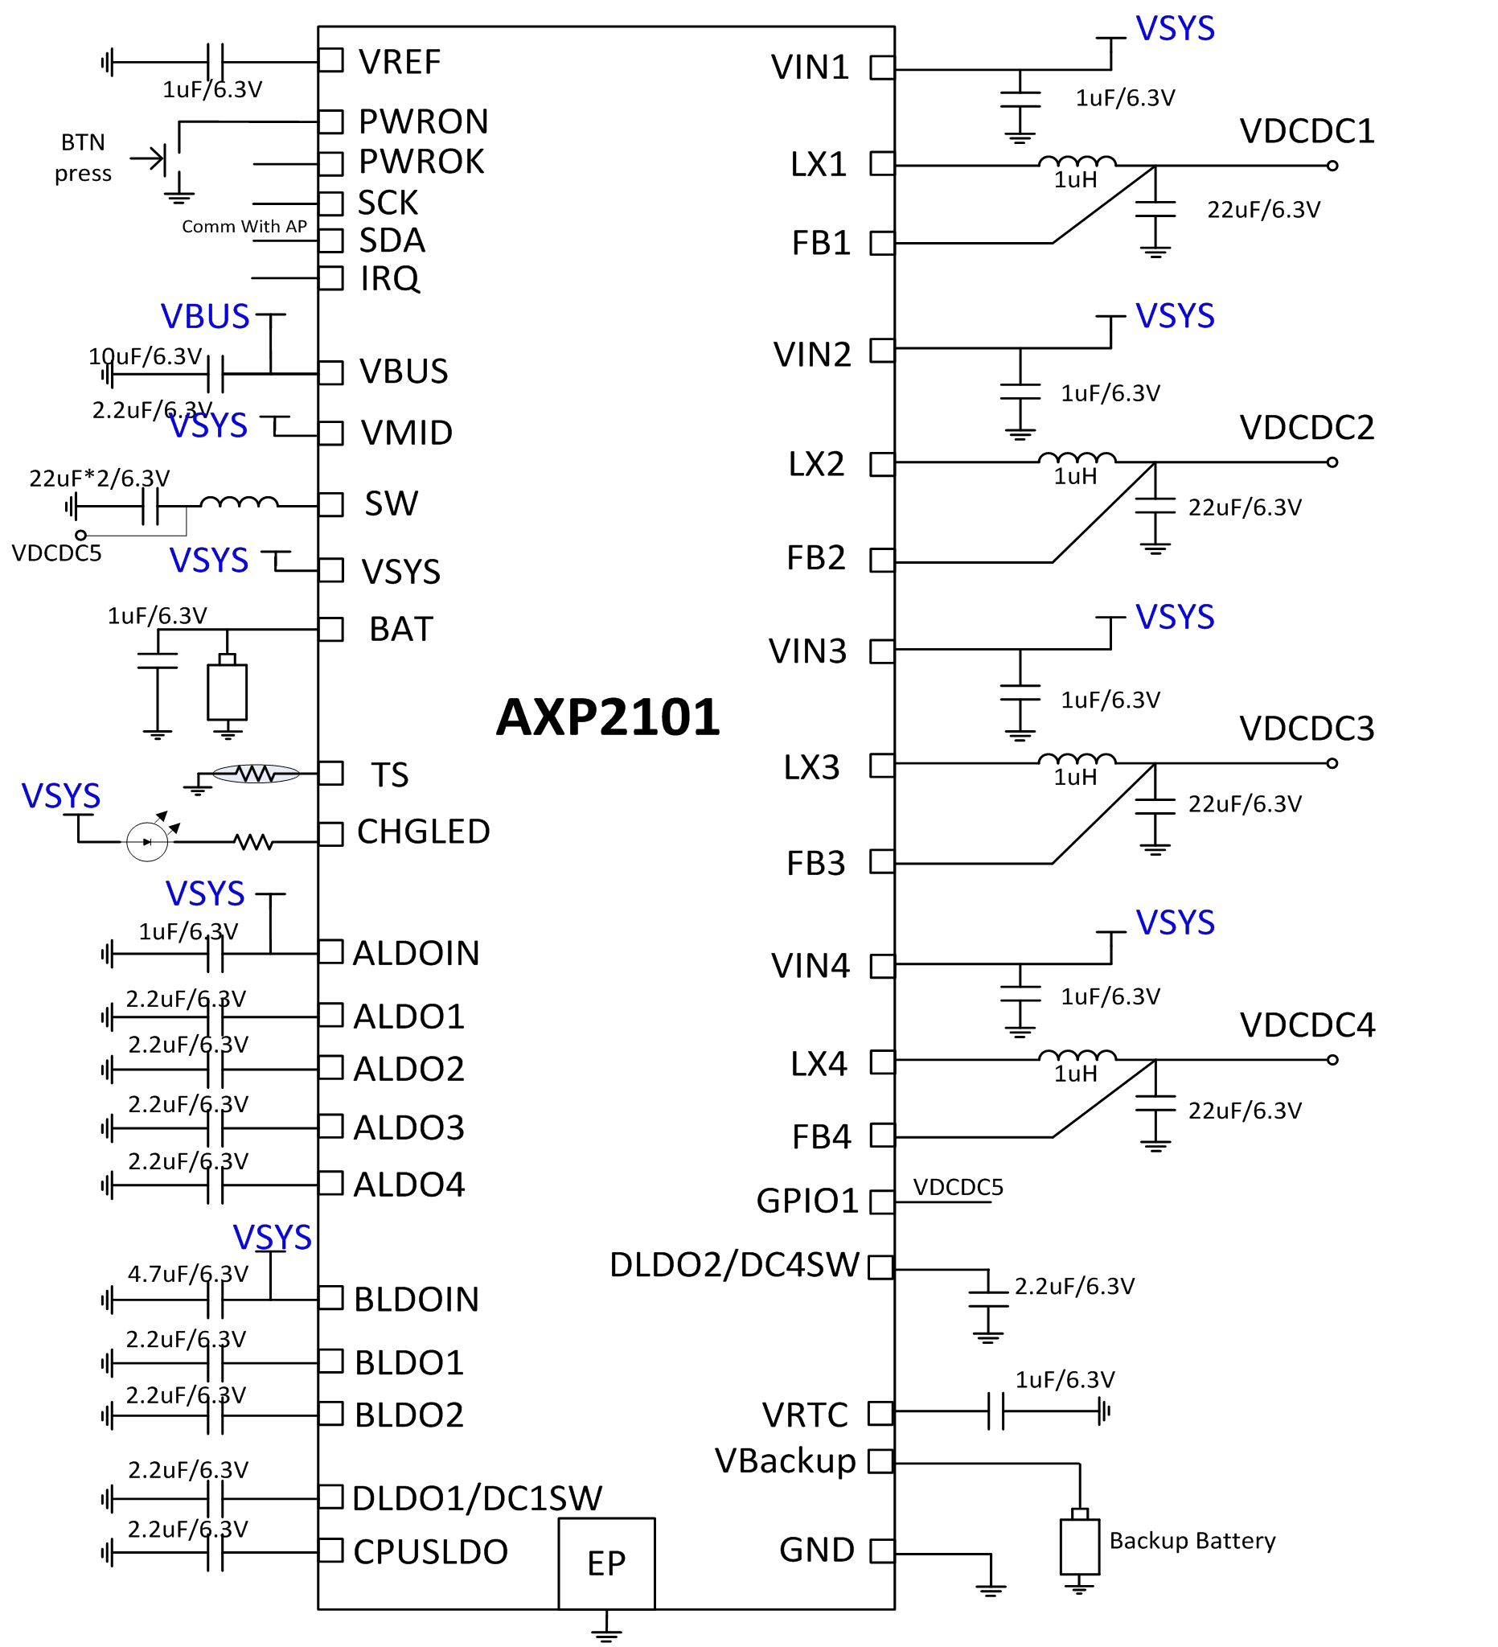

Package, Carrier, Storage and Baking Information

Package
AXP2101 package is QFN5*5, 40-pin. Figure 8-1 shows AXP2101 package.

Figure 8-1 Package Information
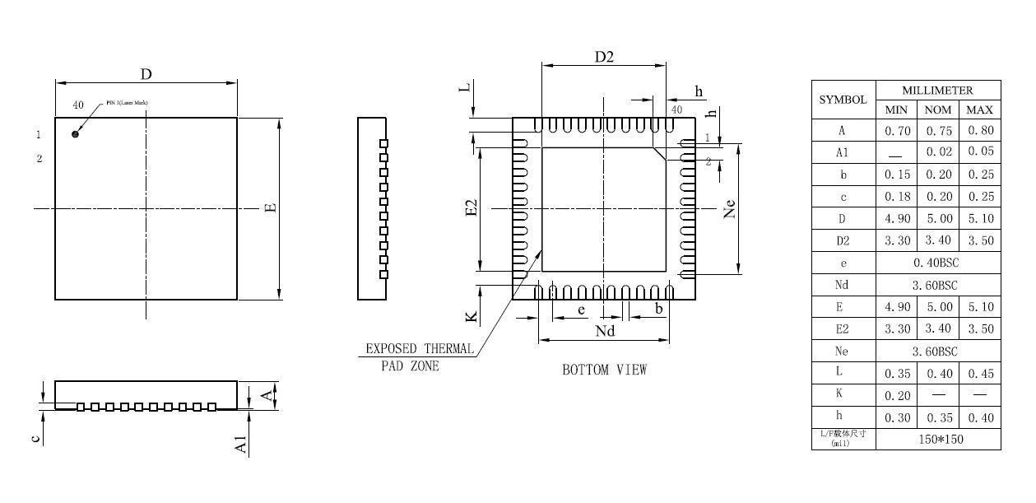

Figure 8-2 AXP2101 marking
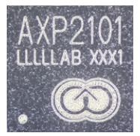
Table 8-1 describes AXP2101 marking information.

Table 8-1 AXP2101 Marking Definitions

No. | Marking | Description | Fixed/Dynamic
1 | AXP2101 | Product name | Fixed
2 | LLLLLXX | Lot number | Dynamic
3 | XXX1 | Date code | Dynamic

4 |  | X-POWERS logo | Fixed
5 | White dot | Package pin 1 | Fixed

Carrier

Table 8-2 AXP2101 Tray Carrier Information

Item | Color | Size
Aluminum foil bags | Silvery white | 540mm x 300mm x 0.14mm
Pearl cotton cushion(Vacuum bag) | White | 12mm x 680mm x 185mm
Pearl cotton cushion (The Gap between vacuum bag and inside box) | White | Left-Right:12mm x 180mm x 85mm Front-Back:12mm x 350mm x 70mm
Inside Box | White | 396mm x 196mm x 96mm
Outside Box | White | 420mm x 410mm x 320mm

Figure 8-3 AXP2101 Tray Dimension Drawing

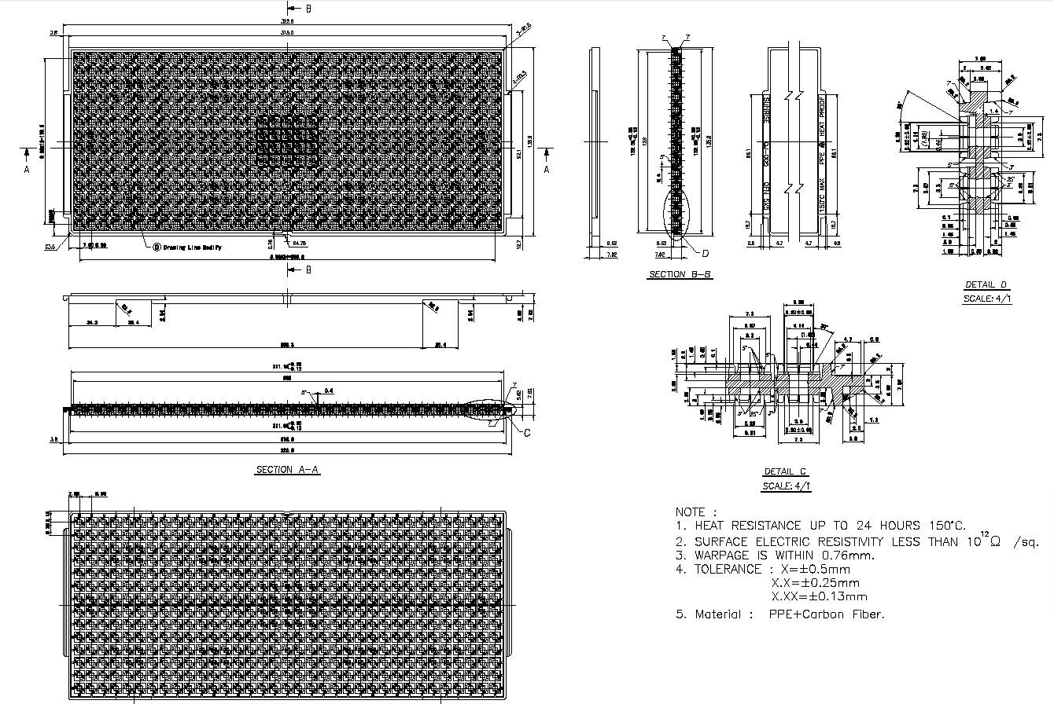

Table 8-3 AXP2101 Packing Quantity Information

Type | Quantity | Part Number
Tray | 490pcs/Tray  10Trays/package | AXP2101

Storage

Moisture Sensitivity Level(MSL)
A package’s MSL indicates its ability to withstand exposure after it is removed from its shipment bag, a low MSL device sample can be exposed on the factor floor longer than a high MSL device sample. ALL MSL are defined in Table 8-4.

Table 8-4 MSL Summary

MSL | Out-of-bag floor life | Comments
1 | Unlimited | ≤30℃/85%RH
2 | 1 year | ≤30℃/60%RH
2a | 4 weeks | ≤30℃/60%RH
3 | 168 hours | ≤30℃/60%RH
4 | 72 hours | ≤30℃/60%RH
5 | 48 hours | ≤30℃/60%RH
5a | 24 hours | ≤30℃/60%RH
6 | Time on Label(TOL) | ≤30℃/60%RH
AXP2101 device samples are classified as MSL3.

Bagged Storage Conditions
The shelf life of AXP2101 are defined in Table 8-5.

Table 8-5 Bagged Storage Conditions

Packing mode | Vacuum packing
Storage temperature | 20℃~26℃
Storage humidity | 40%~60%RH
Shelf life | 6 months

Out-of-bag Duration
It is defined by the device MSL rating. The out-of-bag duration of AXP2101 is as follows.

Table 8-6 Out-of-bag Duration

Storage temperature | 20℃~26℃
Storage humidity | 40%~60%RH
Moisture Sensitivity Level(MSL) | 3
Floor life | 168 hours
For no mention of storage rules in this document, please refer to the latest IPC/JEDEC J-STD-020C.

Baking
It is not necessary to bake AXP2101 if the conditions specified in Section 8.4.2 and Section 8.4.3 have not been exceeded. It is necessary to bake AXP2101 if any condition specified in Section 8.4.2 and Section 8.4.3 have been exceeded.

Table 8-7 Baking Conditions

Surrounding | Condition | Note
Nitrogen | 125℃/8 hours | Recommended condition. It is recommended to bake once, no more than three times.
CAUTION： If baking is required, the devices must be transferred into trays that can be baked to at least 125°C. Devices should not be baked in tape and reel carriers at any temperature

Reflow Profile
The reflow profile recommended in this document is a lead-free reflow profile that is suitable for pure lead-free technology of lead-free solder paste.
Figure 9-1 shows the typical reflow profile of AXP2101 device sample.

Figure 9-1 AXP2101 Typical Reflow Profile
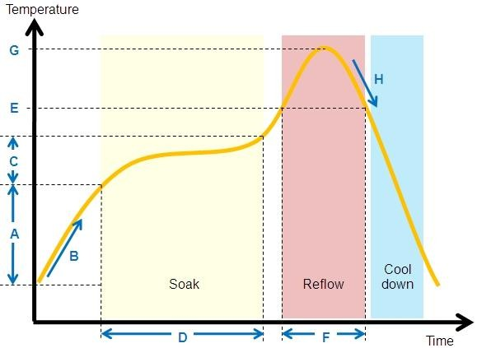
Reflow profile conditions of AXP2101 device sample is given in Table 9-1.

Table 9-1 AXP2101 Reflow Profile Conditions

 | QTI typical SMT reflow profile conditions (for reference only)
 | Step | Reflow condition
Environment | N2 purge reflow usage (yes/no) | Yes, N2 purge used
Environment | If yes, O2 ppm level | O2 < 1500 ppm
A | Preheat ramp up temperature range | 25℃ -> 150℃
B | Preheat ramp up rate | 1.5-2.5 ℃/sec
C | Soak temperature range | 150℃ -> 190℃
D | Soak time | 80-110 sec
E | Liquidus temperature | 217℃
F | Time above liquidus | 60-90 sec
G | Peak temperature | 240-250℃
H | Cool down temperature rate | ≤4℃/sec

Copyright©2021 Shenzhen X-Powers Technology Co., Ltd. All Rights Reserved.
This documentation is the original work and copyrighted property of Shenzhen X-Powers Technology Co., Ltd. (“X-Powers” ). No part of this document may be reproduced, modify, publish or transmitted in any form or by any means without prior written consent of X-Powers .

Trademarks and Permissions
X-Powers and the X-Powers logo (incomplete enumeration) are trademarks of Shenzhen X-Powers Technology Co., Ltd. All other trademarks, trade names, product or service names mentioned in this document are the property of their respective owners.

Important Notice and Disclaimer
The purchased products, services and features are stipulated by the contract made between X-Powers Technology Co.,Ltd (“X-Powers”) and the customer. All or part of the products, services and features described in this document may not be within the purchase scope or the usage scope. Please read the terms and conditions of the contract and relevant instructions carefully before using, and follow the instructions in this documentation strictly. X-Powers assumes no responsibility for the consequences of improper use (including but not limited to overvoltage, overclock, or excessive temperature).
The information in this document is provided just as a reference or typical applications, and is subject to change without notice. Every effort has been made in the preparation of this document to ensure accuracy of the contents. X-Powers is not responsible for any damage (including but not limited to indirect, incidental or special loss) or any infringement of third party rights arising from the use of this document. All statements, information, and recommendations in this document do not constitute a warranty or commitment of any kind, express or implied.
No license is granted by X-Powers herein express or implied or otherwise to any patent or intellectual property of X-Powers. Third party licences may be required to implement the solution/product. Customers shall be solely responsible to obtain all appropriately required third party licences. X-Powers shall not be liable for any licence fee or royalty due in respect of any required third party licence. X-Powers shall have no warranty, indemnity or other obligations with respect to third party licences.

