6 x 6 Loop Antenna
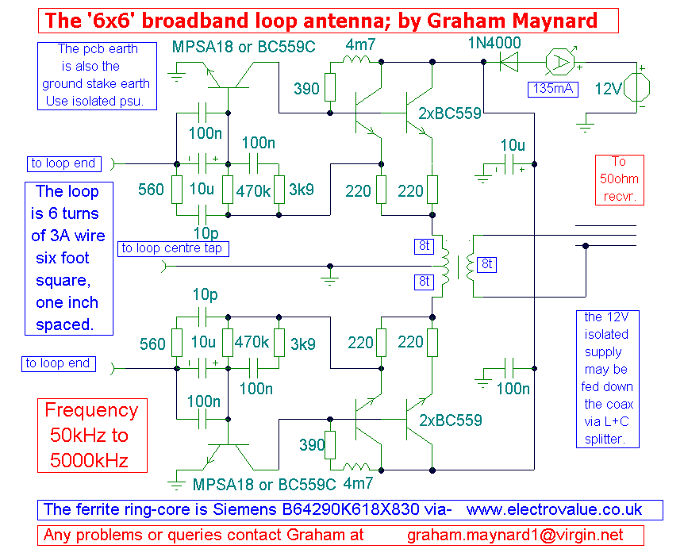
6 x 6 Loop Antenna circuit
Notes:
This new loop antenna by Graham Maynard is his best design yet and I am proud to be the first to present his work. It uses one, six foot square, six turn loop, and is aperiodic in nature, covering the frequency range 50KHz - 5000KHz.
The loop is of a size that can be mounted inconspicuously against a garden fence away from household interferences. This new '6x6' design uses the centre tapped loop winding as an input phase splitter. This ensures low distortion push-pull operation. The amplifier also has a low impedance shunt input which maximises gain. These aspects give it a better signal to noise ratio than with a single ended or high impedance amplifier. The amplifier provides a useful gain of 42 - 54dB over its frequency range, see the Bode Plot below. Please note, that the Bode plot is derived for the amplifier circuit ONLY, it is not possible to simulate the characteristics of a six foot square loop.
The first MPSA18 transistor on each loop operates in common emitter, the collector being directly coupled to a double emitter follower pair. The circuit has self DC biasing, the emitter of the first BC559 being coupled to the base of the MPSA18 transistor. The network of resistors and capacitors around the base of each MPSA18 transistor tailors the amplifier response to the specified limits. The double emitter follower pair evenly distributes the Class A heat dissipation, and direct feedback in the bias chain, counters temperature drift effects. The output from each amplifier half is fed via a 2:1 tri-filar wound push-pull output transformer, with the output winding sandwiched between each primary half. There is equal but opposite current flow and therefore maximum linearity. The output is isolated, which minimizes earth loop noise injection, either via receiver earth leakage or loop amplifier psu earth leakage.
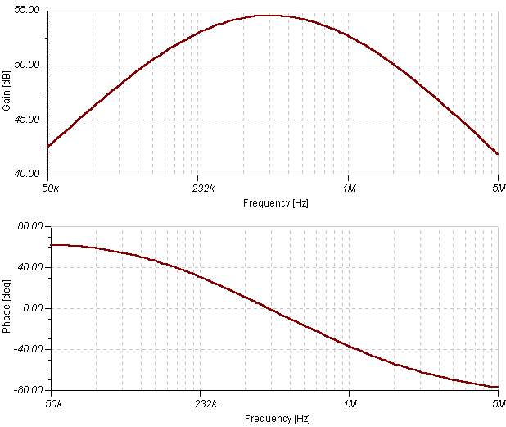
To power the amplifier a separate twin flex may be used (speaker wire) , though it is possible to use a mains PSU via the coax itself. Graham's recommended mains psu is the UNI550R from Electrovalue (£8+p/p)
In Use:
The overall phase response is reasonably flat throughout any band, thus any cardioid or other developed reception patterns can remain directionally stable over a decent frequency range, which might be useful for trans-oceanic MW reception. It is intended that the centre-tap be made at the mid point along the bottom six foot antenna span, and this may be grounded with an earth stake. Sometimes reception on some bands can be made quieter by grounding this centre tap. You should to try the '6x6' with and without the ground on your favourite band.
Construction:
To ensure stability, the component layout should follow the above circuit layout, with all signal ground connections being kept as short and thick as possible in the centre of the pcb. This is of course a sensitive DXing antenna, thus it might be overloaded if used too close to a local broadcast transmitter. You can null powerful signals by setting the loop up at right angles to their source, i.e. when the loop's winding axis is in line with the interference.
Please let Graham know if you construct this antenna, he is interested in hearing of everyone's results.
Circuit: Graham Maynard
Text: Graham Maynard and Andy Collinson

