To execute this improvement it is recommended to have the required tools and the experience in SMD circuits, as we are dealing with electronic components extremely small and the minimum error can cause serious harm in the equipment.
Required Component
-1 Capacitor 2.2 uF 16V non-polarized preferentially size 1206
Remove from the circuit the C624 Capacitor as shown in the picture 1 and 2. Solder the new 2.2uF capacitor, as shown in the picture 1,2 and 3.
Figure 1
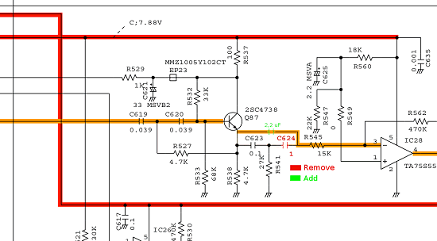
Figure 2
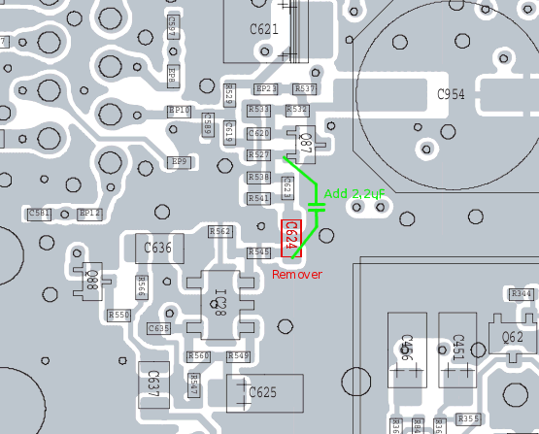
Figure 3
