CIS400 Homework 4

Question 1:

Use regex to match IP address

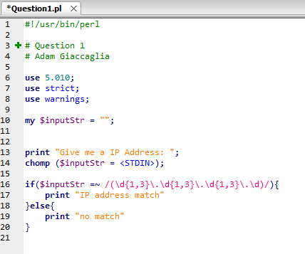

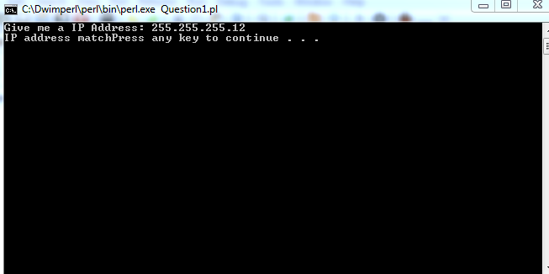

Question 2:

TODO

Question 3:

TODO

Question 4:

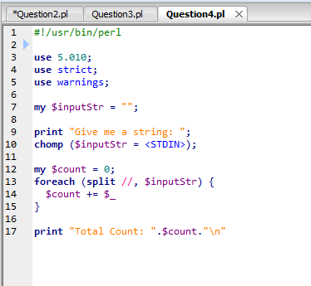

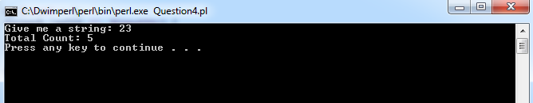

Question 5:

Use hash with keys as the unique digits and their values the count of the digits

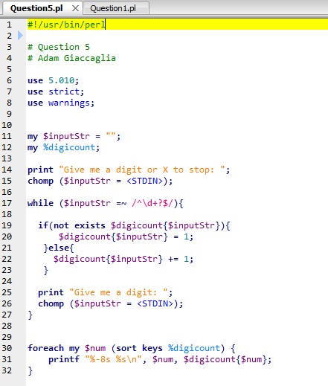

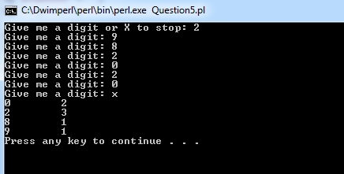

Question 6:

-No input checking must be exact,

-Used list of possible characters called alphaList to use as a basis for the resulting encoding or decoding list. Main algorithm includes taking each character from the input string, finding its index in alphaList and then applying the shift based on encode (add) or decode (subtract). The algorithm also handles wrapping by adding or subtracting the length of alphaList to handle roll over.

*"""  
 Question 6  
 Python  
 Adam Giaccaglia  
"""  
  
  
def* encode_or_decode(type, str, shift):  
 alphaList = ['A', 'B', 'C', 'D', 'E', 'F', 'G', 'H', 'I', 'J', 'K', 'L', 'M', 'N', 'O', 'P', 'Q', 'R', 'S', 'T', 'U', 'V', 'W', 'X', 'Y', 'Z',  
 'a', 'b', 'c', 'd', 'e', 'f', 'g', 'h', 'i', 'j', 'k', 'l', 'm', 'n', 'o', 'p', 'q', 'r', 's', 't', 'u', 'v', 'w', 'x', 'y', 'z']  
  
 outputLis = []  
 *for* char *in* str:  
 *if* char *is* ' ':  
 outputLis.append(' ')  
 *else*:  
 *if* type *in* "Encode e E".split(" "):  
 pos = alphaList.index(char) + shift  
 *# check and handle wrap  
 if* pos > len(alphaList):  
 pos -= len(alphaList)  
 outputLis.append(alphaList[pos])  
 *if* type *in* "Decode d D".split(" "):  
 pos = alphaList.index(char) - shift  
 *# check and handle wrap  
 if* pos < 0:  
 pos += len(alphaList)  
 outputLis.append(alphaList[pos])  
 *return* outputLis  
  
  
*if* __name__ == "__main__":  
 e_or_d_input = input("Encode or Decode? Any other character to exit: ")  
 *while* e_or_d_input *in* "Encode e E Decode d D".split(" "):  
 inputStr = input("Input String: ")  
 shift = int(input("Shift: "))  
 result = encode_or_decode(e_or_d_input, inputStr, shift)  
 print(''.join(result))  
 e_or_d_input = input("Encode or Decode? Any other character to exit: ")

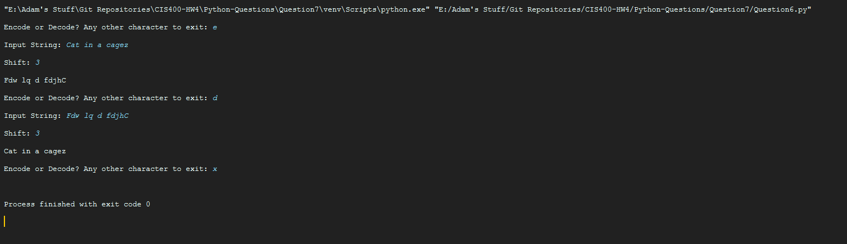

Question 7

-Algorithm: Use requests module to get html. Use re module and regex expression to grab all the tags and put them in a list. Then, sort the list alphabetically

*"""  
 Question 7  
 Python  
 Adam Giaccaglia  
"""  
  
import* requests  
*import* re  
  
*if* __name__ == "__main__":  
 inputUrl = input("Insert url: ")  
 res = requests.get(inputUrl)  
 res.raise_for_status()  
  
 tagRegex = '<[^>]*>'  
 findAll = re.findall(tagRegex, res.text)  
 sortedList = sorted(findAll)  
  
 print(sortedList)

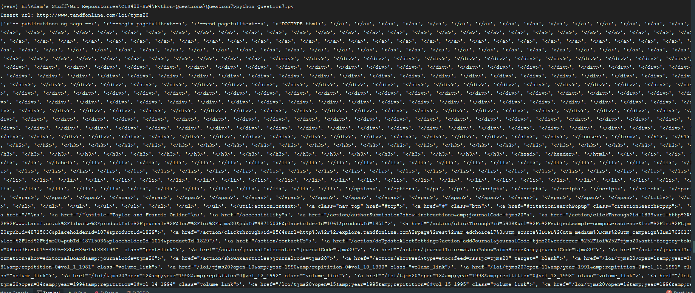

Continues but should be enough to show alphabetical sorting

Question 8

Convert input_q8.dat into a string and use python’s string counter method to count each letter in the alphabet.

*"""  
 Question 8  
 Python  
 Adam Giaccaglia  
"""  
  
if* __name__ == "__main__":  
 f = open('input_q8.dat', 'r')  
 combinedStr = ''  
 *for* line *in* f:  
 combinedStr += line  
 combinedStr = combinedStr.lower()  
  
 alpha = ['a', 'b', 'c', 'd', 'e', 'f', 'g', 'h', 'i', 'j', 'k', 'l', 'm', 'n', 'o', 'p', 'q', 'r', 's', 't', 'u', 'v', 'w', 'x', 'y', 'z']  
 countAlpha = []  
 *for* char *in* alpha:  
 countAlpha.append(char + ': ' + str(combinedStr.count(char, 0, len(combinedStr))))  
  
 f = open('count.dat', 'w')  
 *for* mode *in* countAlpha:  
 f.write(mode + '\n')

