Ashley Music

5/27/20

Lab 2

BDAT 635

Uploaded stormofswords data to Neo4j

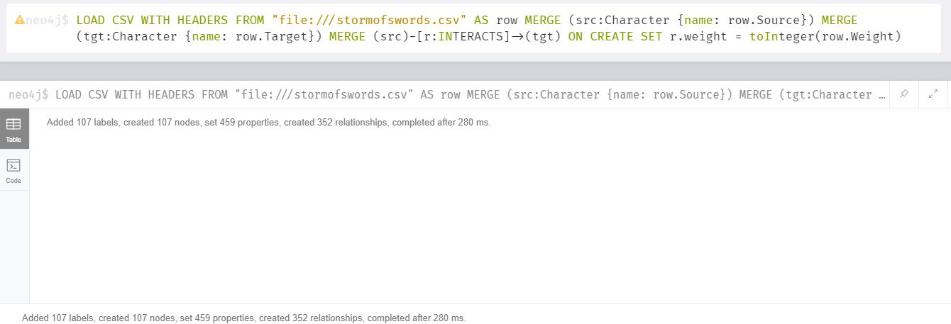

Created a node with one relationship

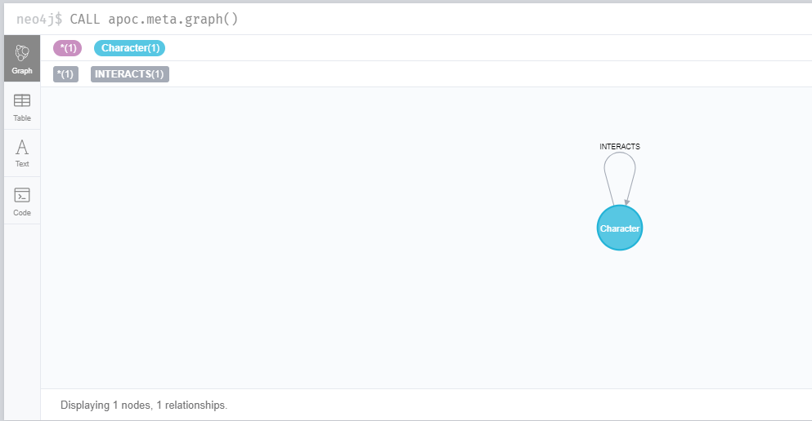

Showing the full graph:

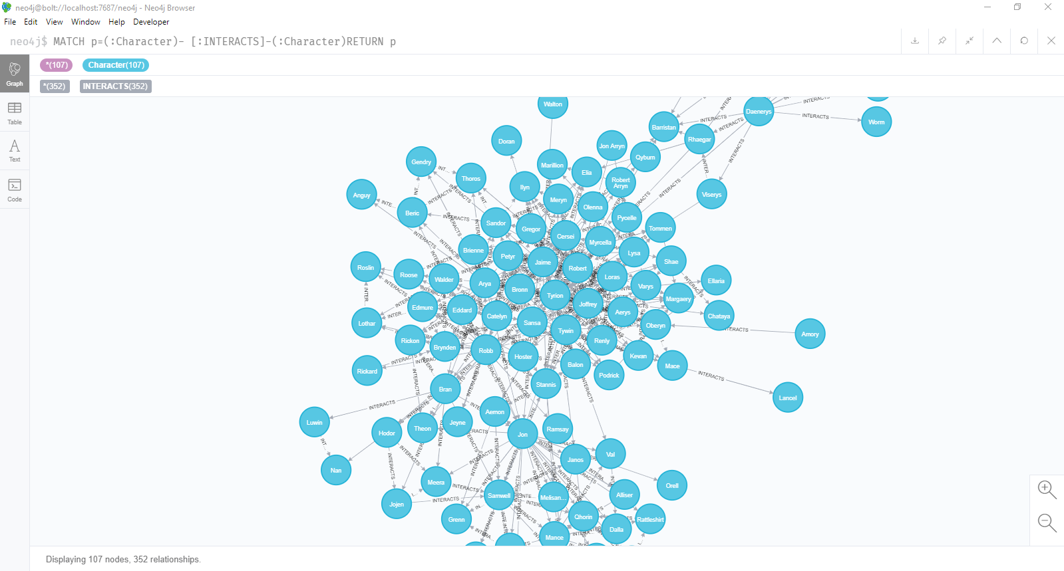

Character count:

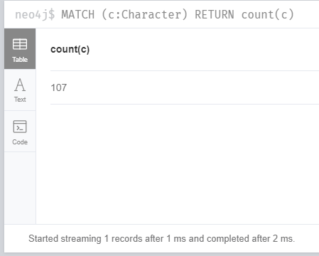

Summary Statistics:

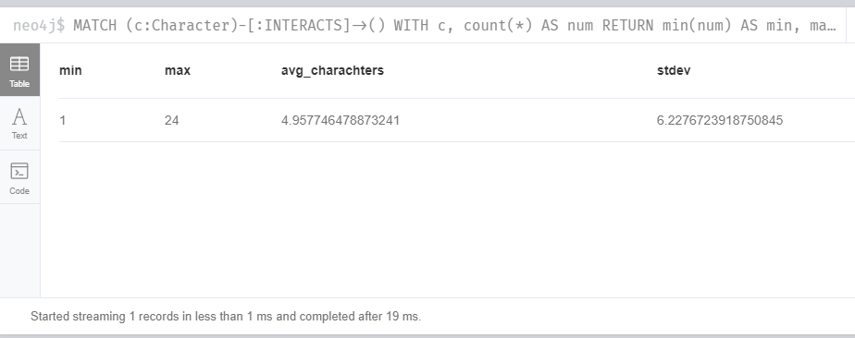

Diameter of the network:

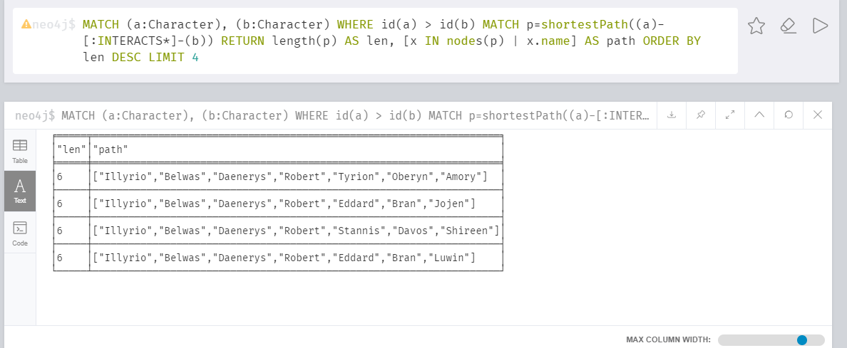

Shortest path from Catelyn to Drogo

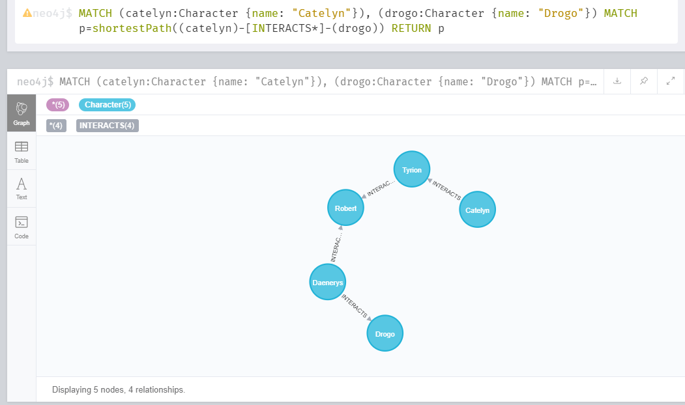

All Shortest Paths:

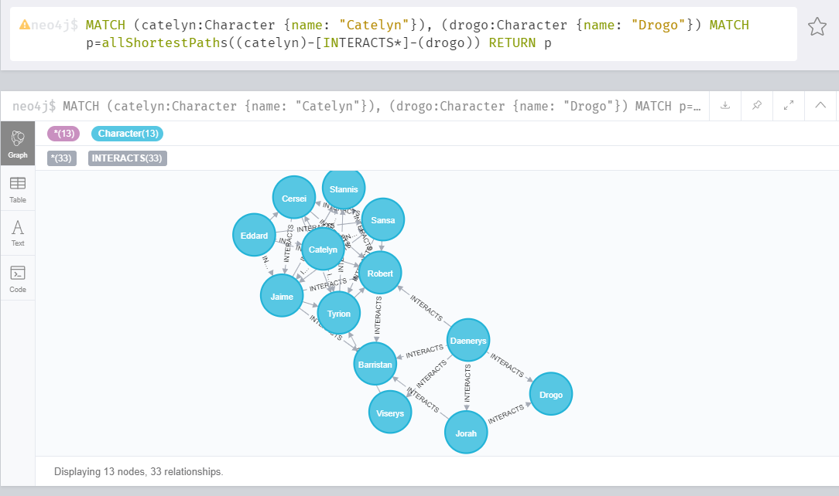

All Pivotal Nodes:

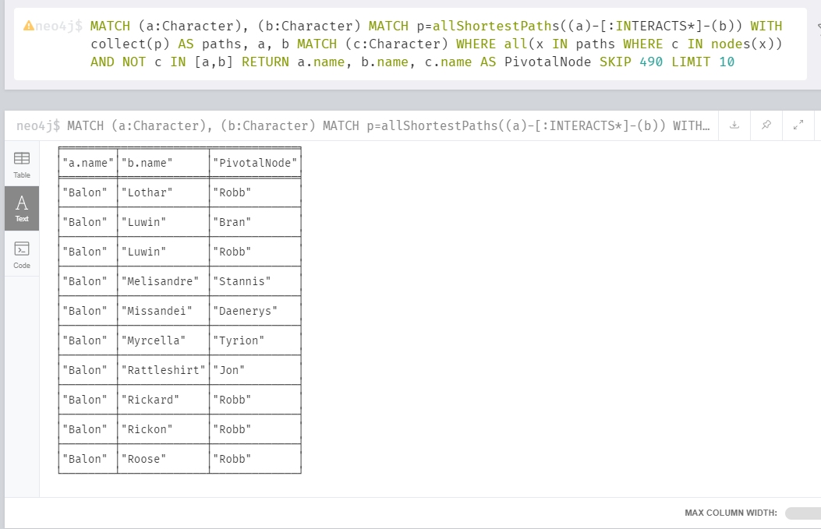

Shortest path between Drogo and Ramsay:

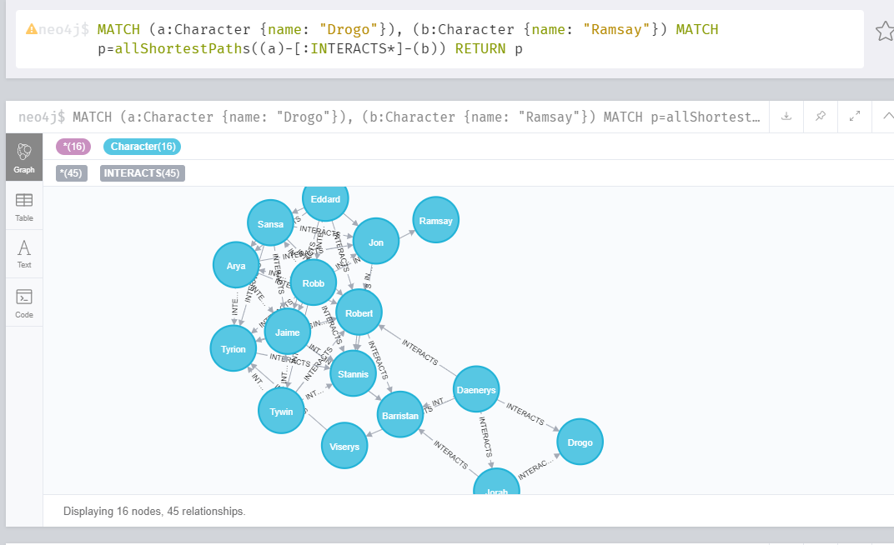

Degree Centrality:

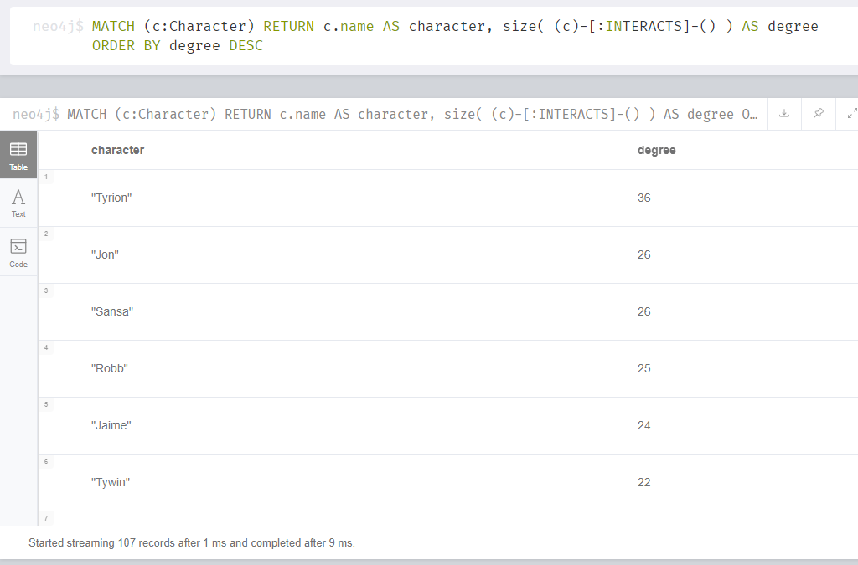

Weighted Degree Centrality:

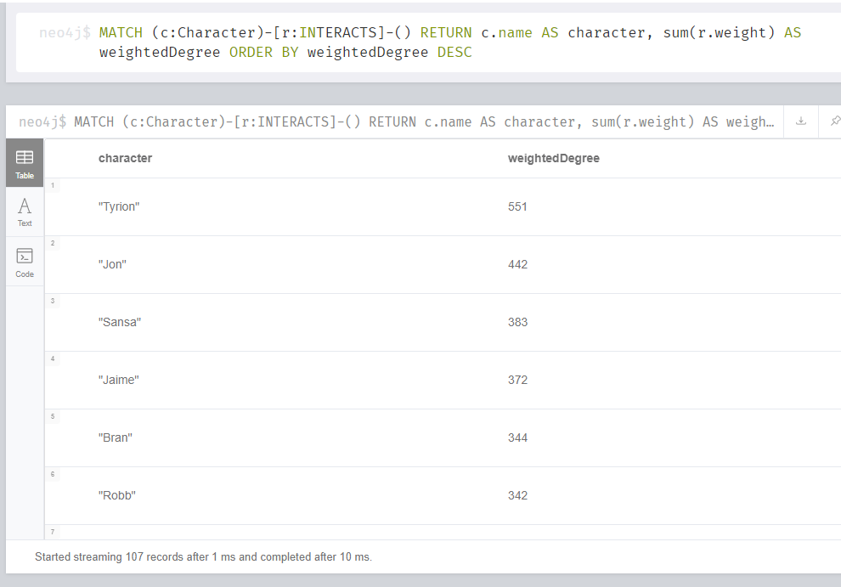

Betweenness Centrality

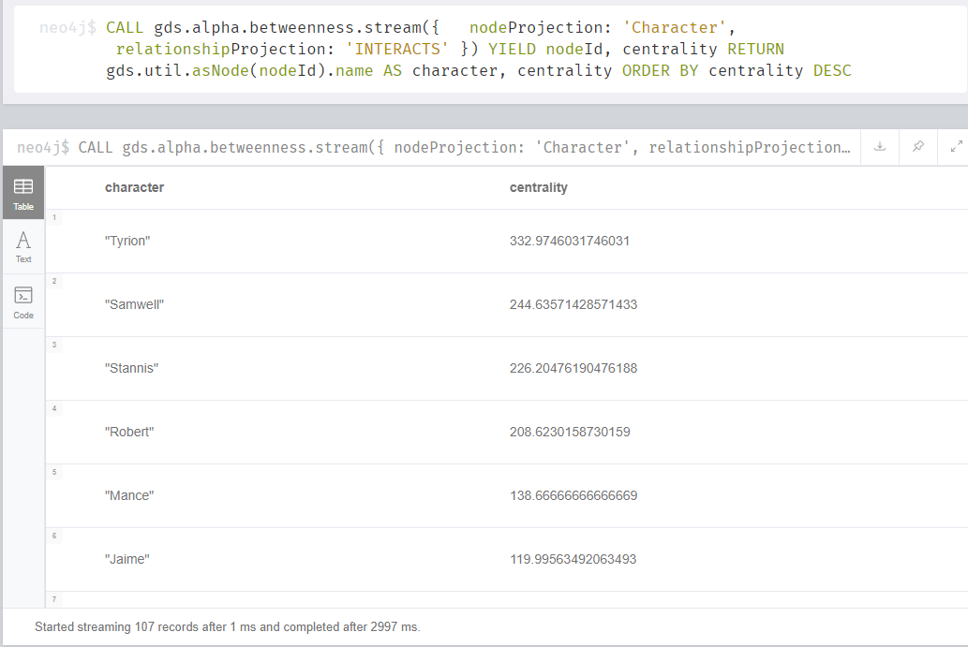

Closeness centrality

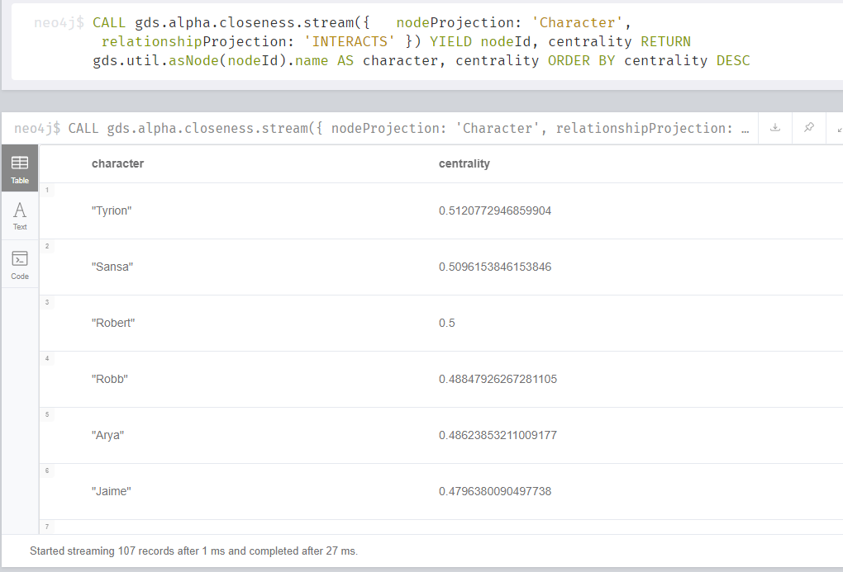

Page Rank

Creating the graph

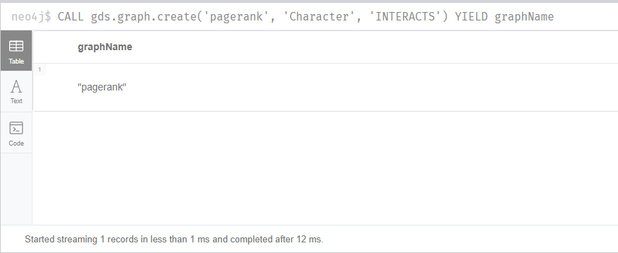

Running the algorithm

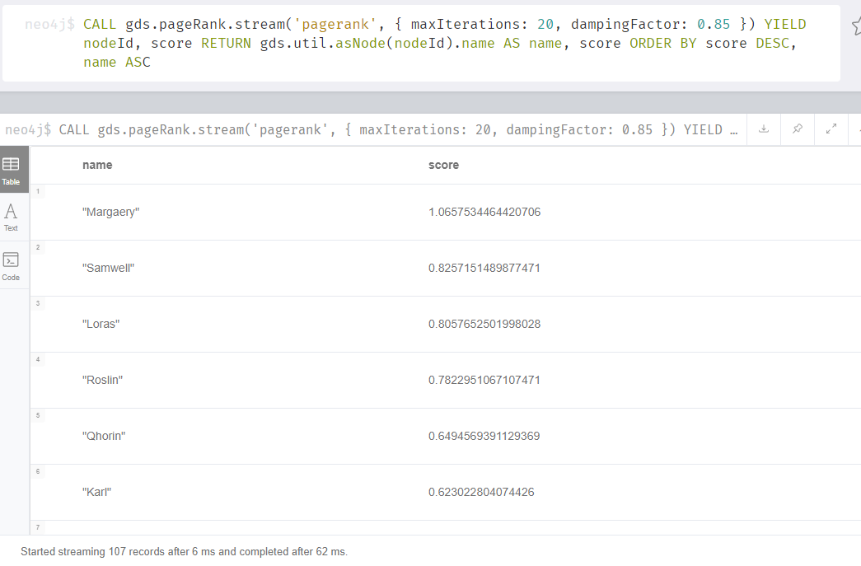

Community Detection

Creating the graph

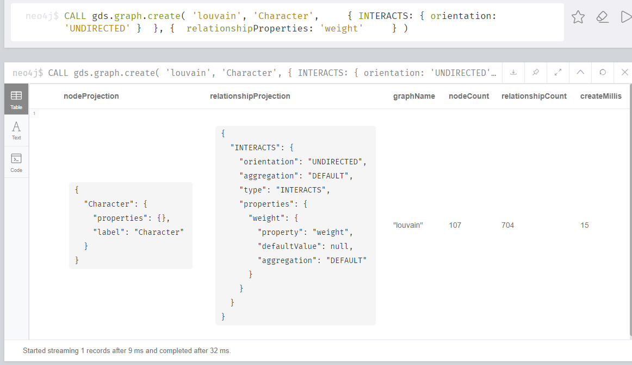

Calling the algorithm

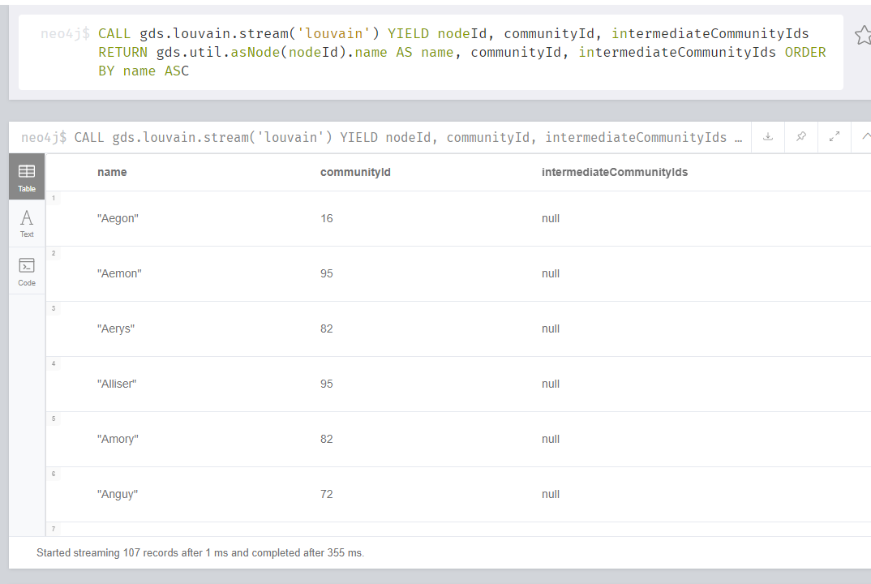

Creating a sample dataset to run Degree Centrality algorithm. This is an example of a social network where we have a list of people and who they follow.

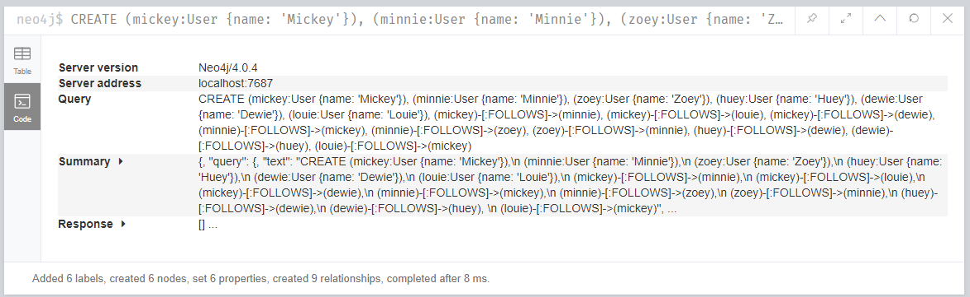

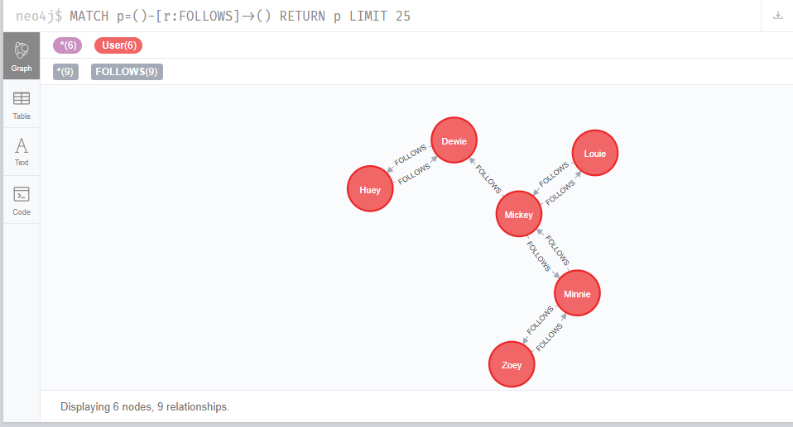

Running the algorithm to see who has the most followers… Mickey does! Duh.

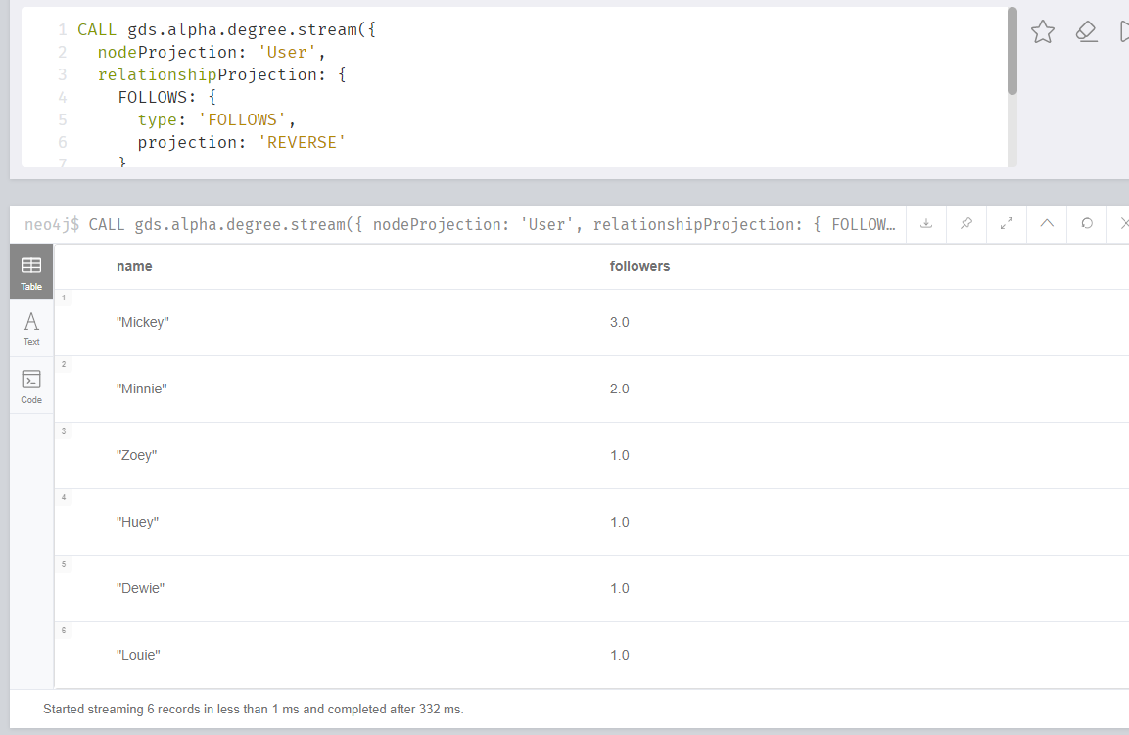

Let’s add some weight to it!

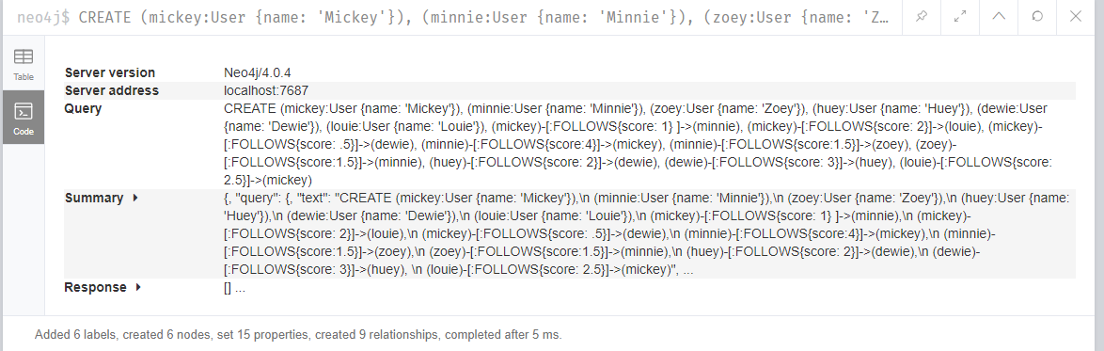

Now, let’s call the algorithm with a weighted score. Mickey wins again!!

