1. I revised the test sentences to the following as my own input:

* I hate you
* I’m cool with that
* I’ve got the sun to worry about
* Let’s get started truth or dare
* If you’ll ever feel like leaving her
* Searching for a shooting star
* This’s the shit

Running the code and have results as below:

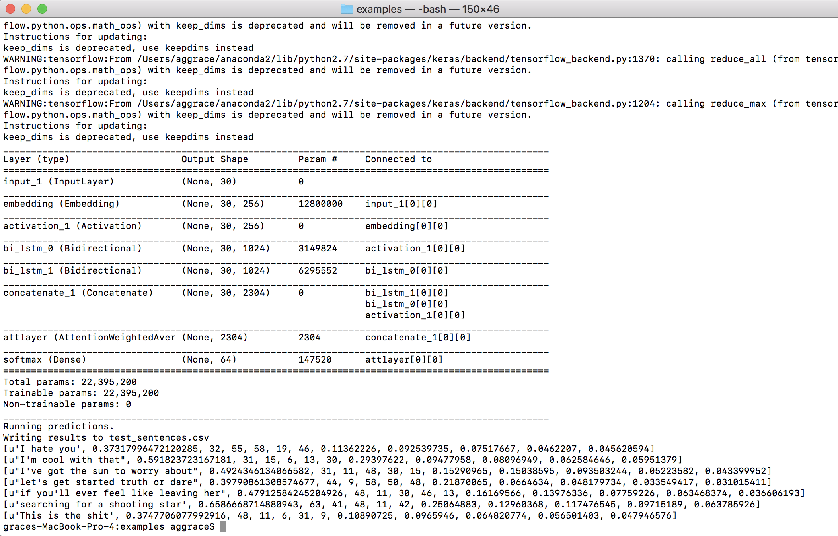

From the result, it can see that for example, the first sentence I hate you and got emojis number 32, 55,58,19,46 with accuracy of 0.11, 0.09, 0.07,0.046 and 0.045 respectively, and sum accuracy of these top 5% emojis is about 0.37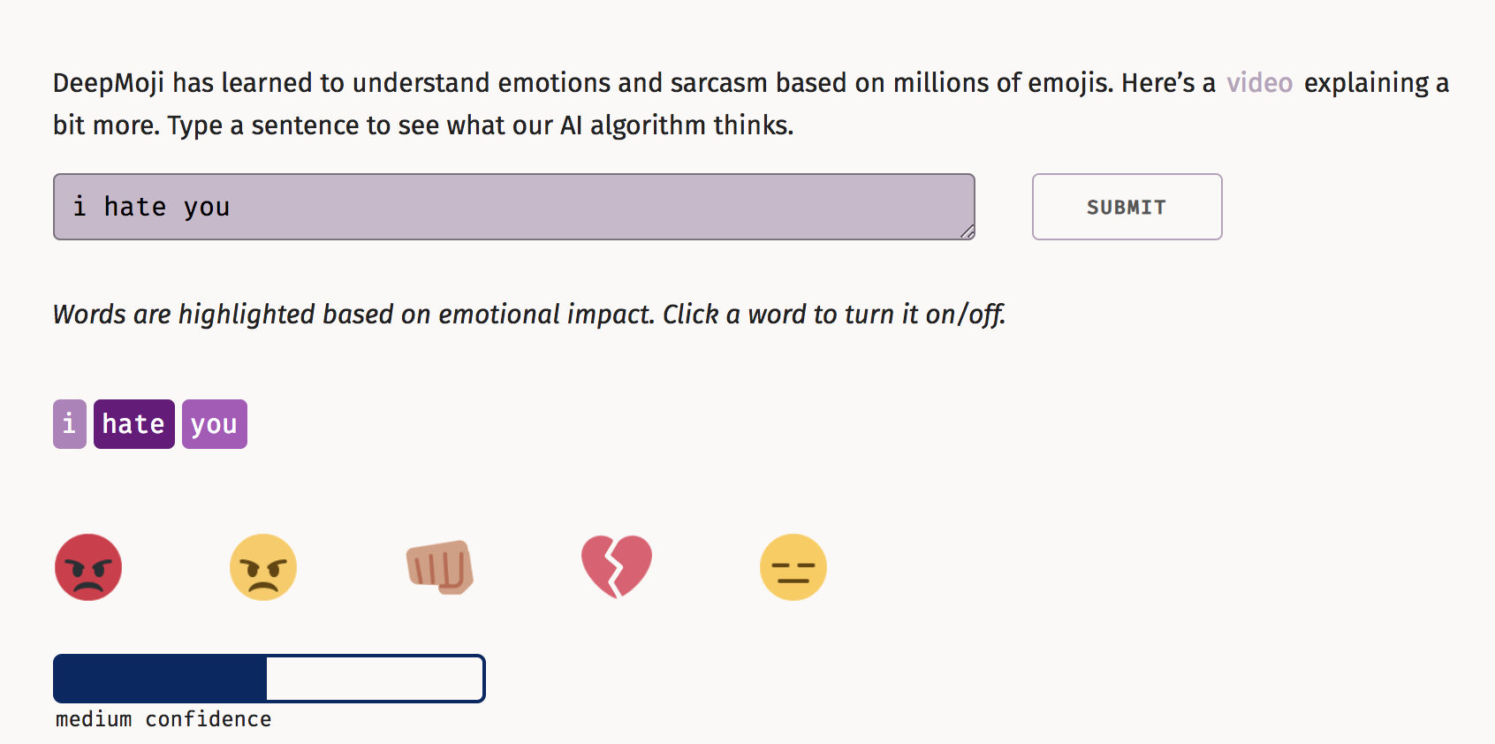

1. The chosen finetuning script is finetune_semeval_class-avg_f1.py, and have results as below:

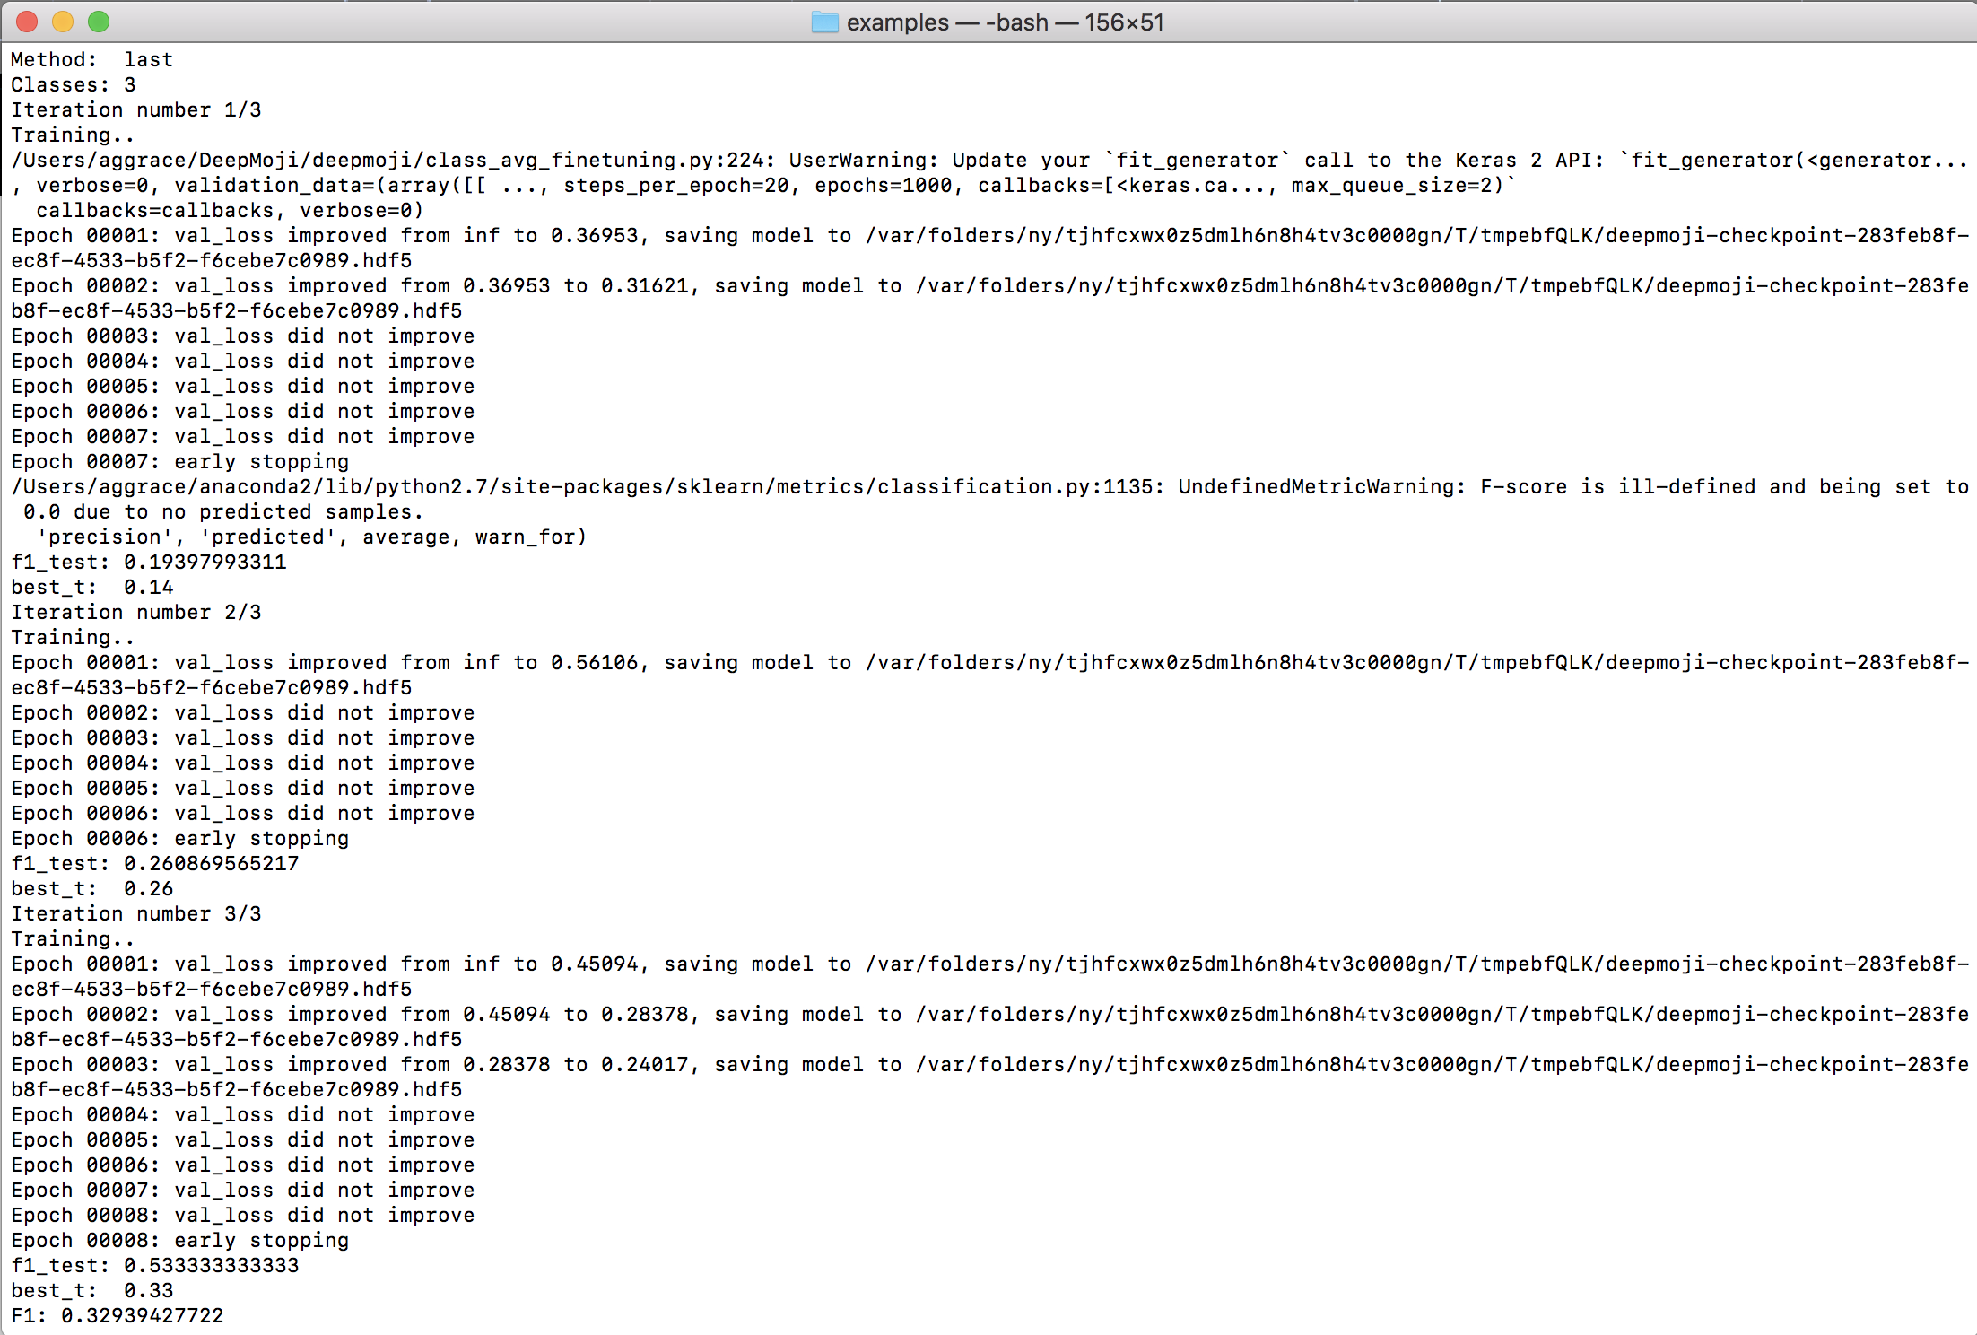

It’s clear to see that the it takes three iterations. First time it takes loss from infinite to 0.36. f1_score is 0.19; second time it takes loss from infinite to 0.56 and f1_score is 0.26; and the third time it takes loss from infinite to 0.45 and f1_score is 0.53. We see that the accuracy of model increased