**Online Test System (OTS) Bugs/ Enhancements**

1. **Tracking Session Issues and Duplicate Course Assignment**

Query

**Select** c.CourseTypeId as courseId, c.Number, c.Name, u.FirstName, u.LastName from academiccourse c

**inner join** courseassignment ca on c.CourseTypeId=ca.CourseId

**inner join** user u on u.UserId=ca.TeacherId

Query Results

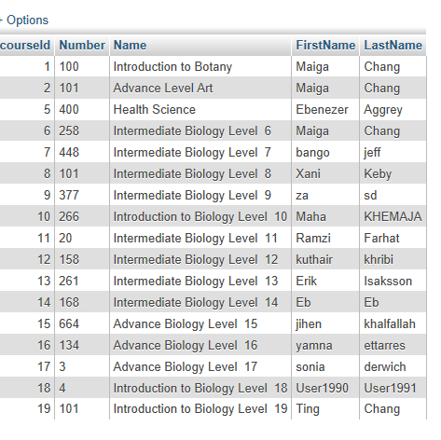

1. **Teacher – Rename Course**

Done

1. Automatic generation of test questions answers
2. Additional table to store test item and relationships
3. Automatic generation all questions from knowledge map