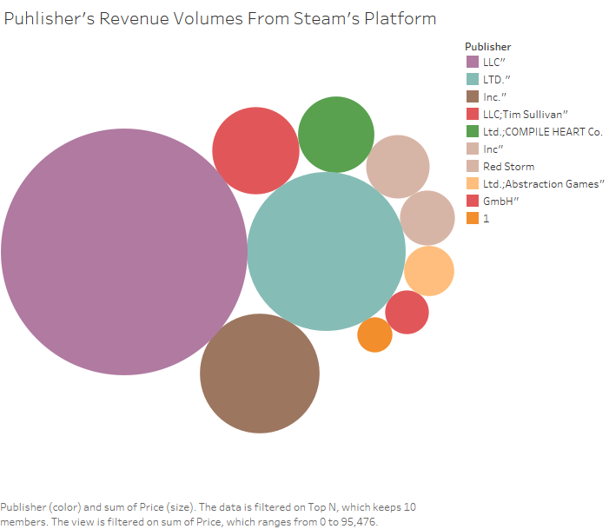

Above image shows the distribution of Top Publishers who generate revenue in volume from their games.

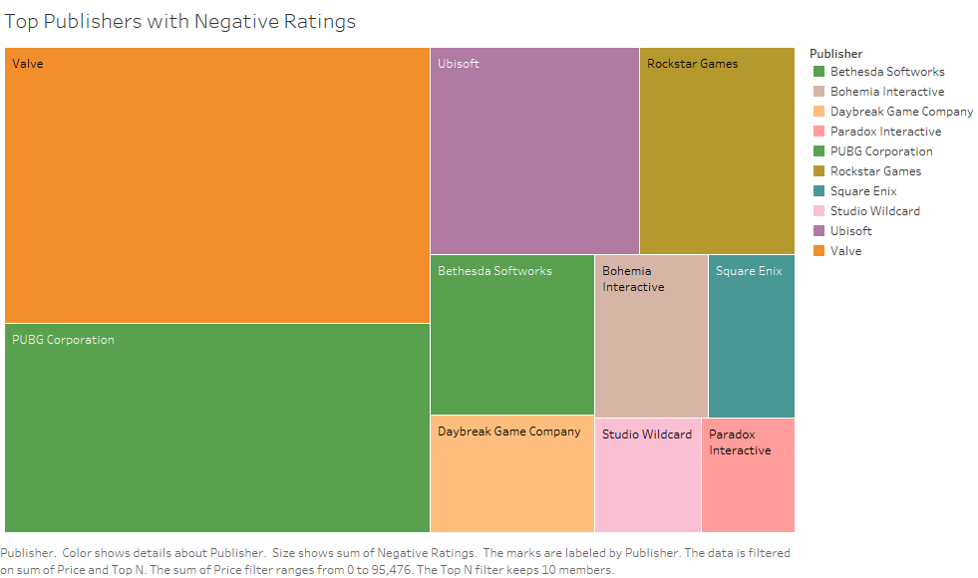

Above image shows the distribution of Top Publishers whose games where given negative ratings by the users.

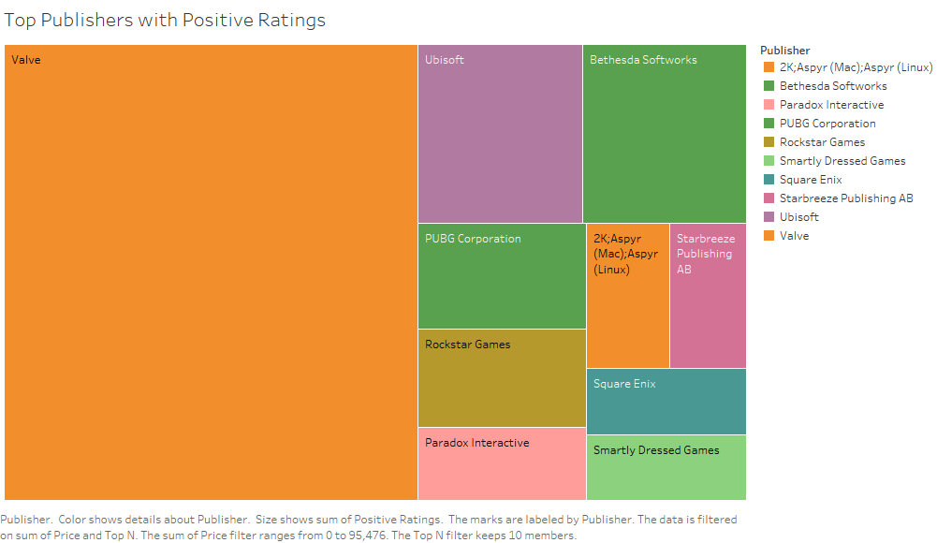

Above image shows the distribution of Top Publishers whose games where given positive ratings by the users.

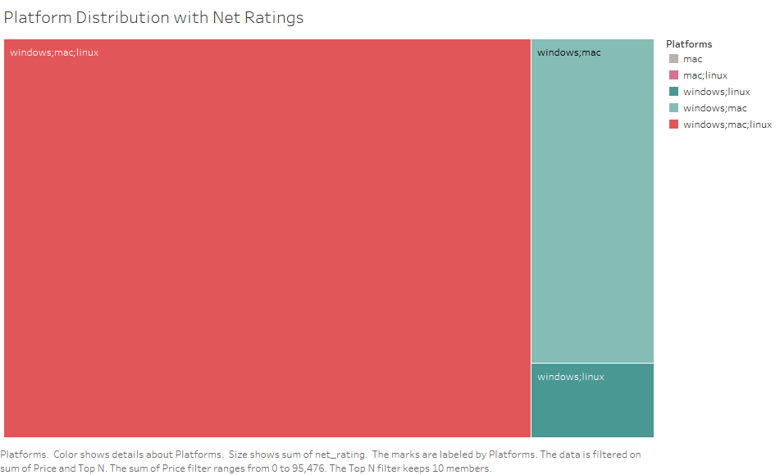

Above image shows the distribution of Top Platforms where steam is played with the net rankings (positive rankings – negative rankings) given by the users. Games on where are for Windows, Mac and Linux platform tops the chart.

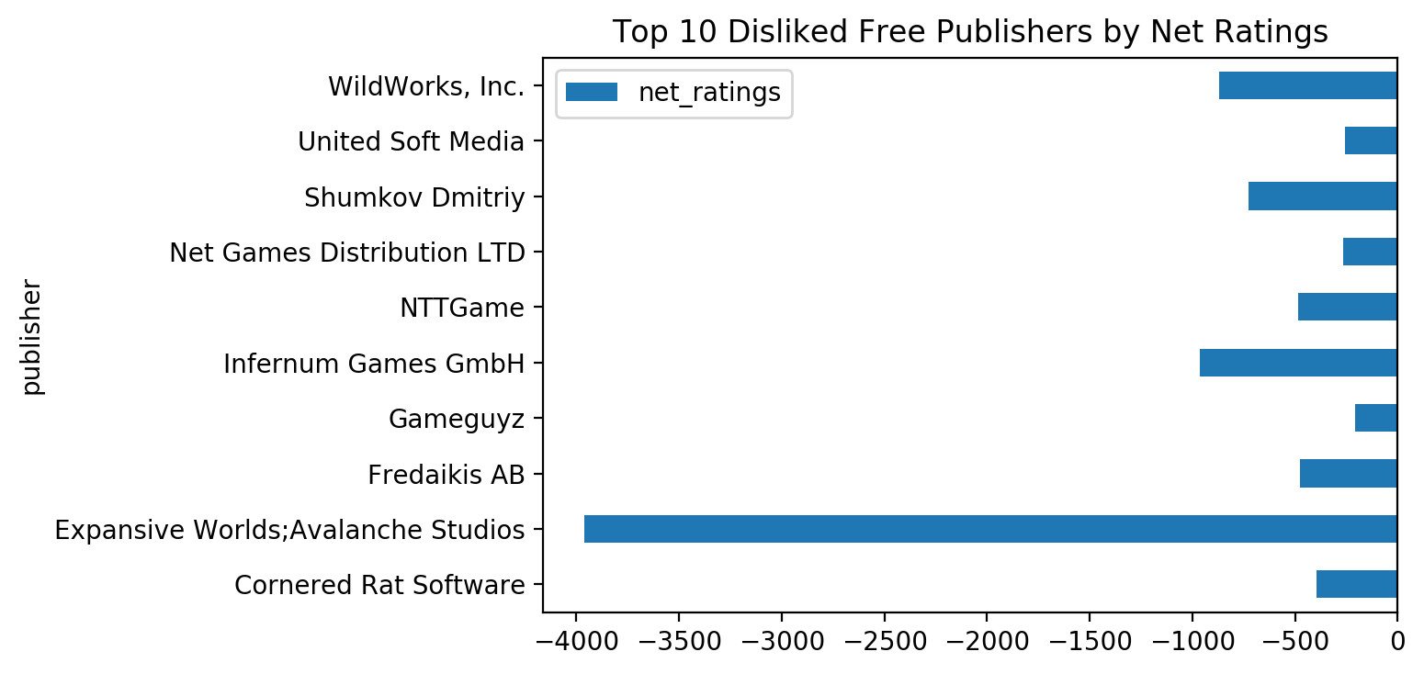

Above image shows the “Top Most Disked Free Games from These Publishers” with the negative rankings given by the users. Content form Expansive Worlds; Avalanche Studios is the most disliked. Recommendation is that Steam Platform, should talk to Expansive Worlds; Avalanche Studios Publishers and convey their concern because they are and not delivering to the user expectation.

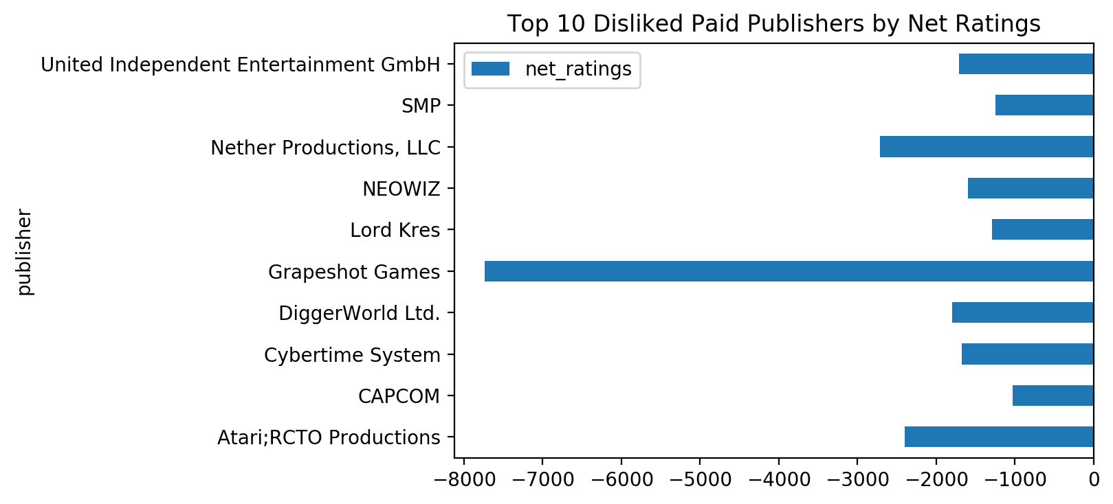

Above image shows the “Top Most Disked Paid Games from These Publishers” with the negative rankings given by the users. Content form Grapeshot Games is the most disliked. Recommendation is that Steam Platform, should talk to Grapeshot Games Publishers and convey their concern because they are charging thier amount form users for their content and not delivering to the user expectation.

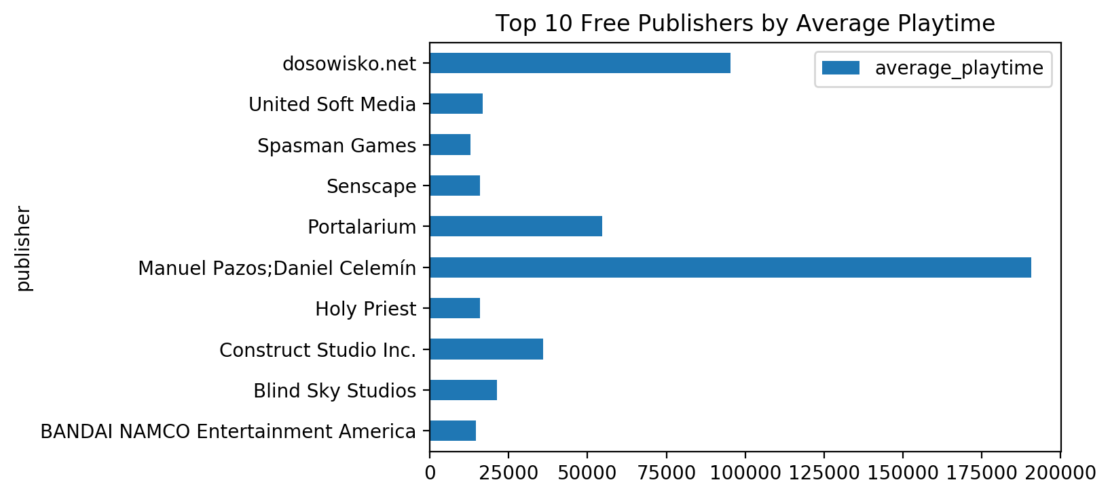

Above image shows the “Top Most Played Free Games from These Publishers” with the Average Playtime by the users. Content from Manuel Pazos; Daniel Celemin out performed them all. Recommendation is Steam should consider Manuel Pazos; Daniel Celemin in any major change related to the platform.

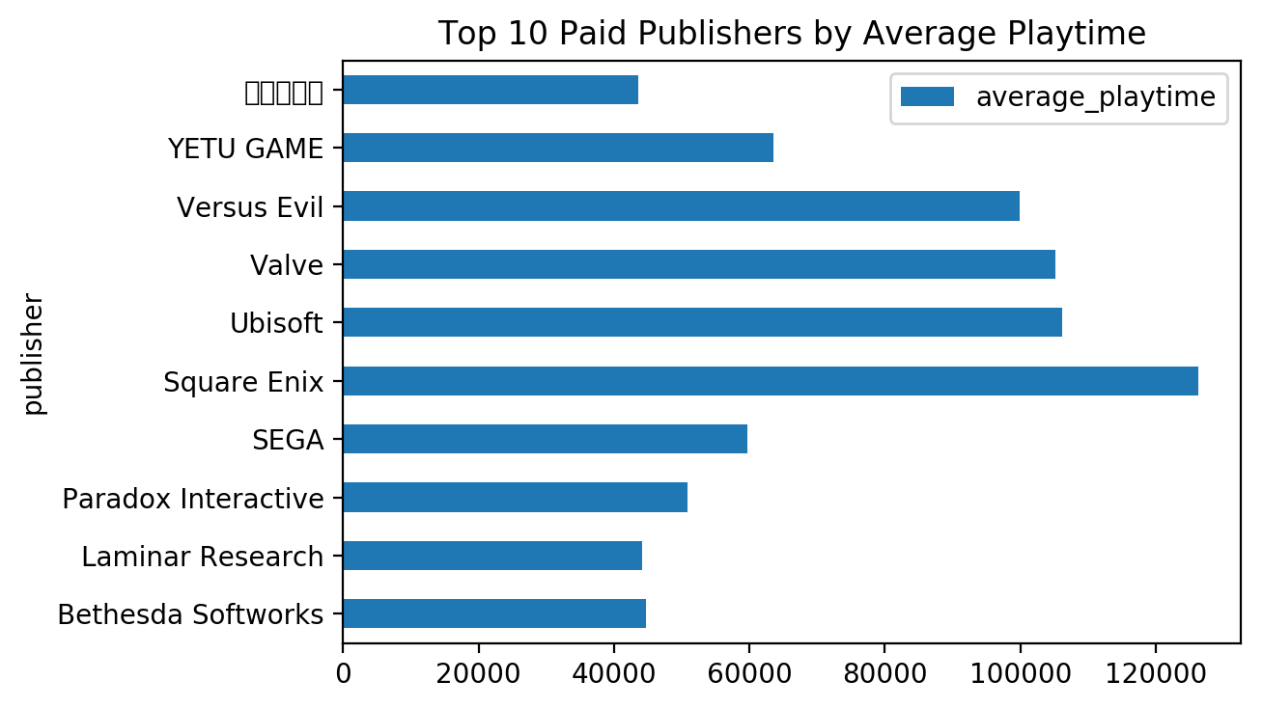

Above image shows the “Top Most Played Paid Games from These Publishers” with the Average Playtime by the users. Content from Square Enix is at the top, and there is almost a tie between Valve and Ubisoft. But there is not much difference between 3rd and 4th position. Recommendation is Steam should consider all top 4 in any major change related to the platform.

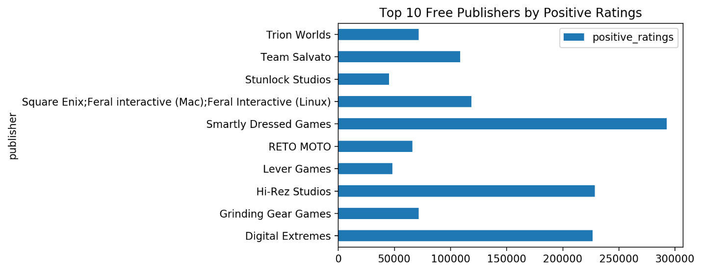

Above image shows the “Top Most Played Free Games from These Publishers” with the Positive Ratings by the users. Content from Smartly Dressed Games out performed them all. Recommendation is Steam should consider Smartly Dressed Games in any major change related to the platform.

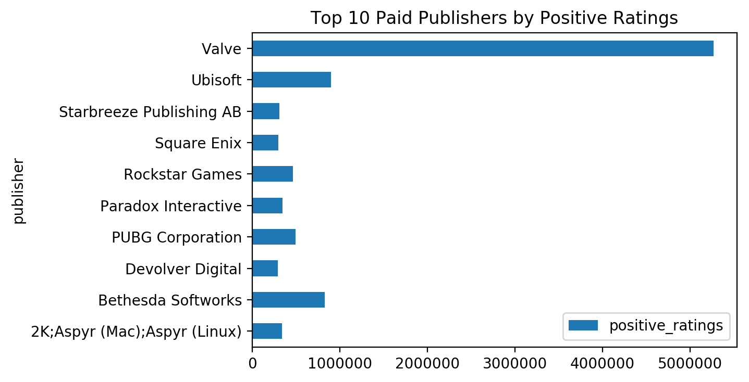

Above image shows the “Top Most Played Paid Games from These Publishers” with the Positive Ratings by the users. Content from Valve out performed them all. Recommendation is Steam should consider Valve in any major change related to the platform.

**Conclusion:**

Positive response to Publishers

* Valve
* Ubisoft
* Square Enix
* Manuel Pazos; Daniel Celemin
* Versus Evil
* Smartly Dressed Games

Negative response to Publishers

* Grapeshot Games
* Expansive Worlds; Avalanche Studios