
MSc Data Science Project
7PAM2002
Department of Physics, Astronomy and Mathematics
Data Science FINAL PROJECT REPORT
Project Title:
Predicting Employee Burnout Risk:
A Multivariate Machine-Learning Analysis of Mental Health in the Workplace (2020–2024)
Student Name and SRN:
Agha Saud Khan (23083162)
Supervisor: Prof. Krishna Kedia
GitHub: https://github.com/aghasaud1996/mental-health-workplace-analysis.git
Date Resubmitted: 20/10/2026
Word Count: ~5,750 (main text, excluding tables, captions, references and appendices)

Declaration Statement
This report is submitted in partial fulfilment of the requirement for the degree of Master of Science in Data Science at the University of Hertfordshire.
I have read the guidance on academic integrity, misconduct and plagiarism. I understand the process for handling suspected cases and the possible penalties, which include failing the project or the course.
I confirm that the work submitted is my own. Any ideas, methods, or words from other authors have been acknowledged through citation.
I did not use human participants in this MSc project. I give permission for the report to be made available on module websites, provided the source is acknowledged.

Student Name: Agha Saud Khan
Signature: Agha Saud Khan
SRN: 23083162
Date: 20/10/2026

Contents
Abstract 4
Chapter 1: Introduction 5
Chapter 2: Background 7
Chapter 3: Dataset 9
3.4 Data Cleaning and Preprocessing 13
Chapter 4: Ethical Considerations 15
Chapter 5: Methodology 16
5.2 Correlation-Based Feature Selection 16
5.4 Models and Why They Were Chosen 18
5.5 Evaluation Metrics 19
Chapter 6: Results 21
6.3 Effect of Hyperparameter Tuning 24
6.4 Residual Analysis of the Tuned Models 25
6.5 Learning Curves and Learning-Rate Curves 25
6.6 Which Features Drive the Predictions? 27
6.7 Sensitivity Check: Keeping mental_health_condition 27
6.8 Research Questions Answered 28
Chapter 7: Discussion 29
Chapter 8: Conclusion and Future Work 31
References 32
Appendix A: Full List of Dataset Features 33
Appendix B: Code and Version History 35

Abstract
This project studies which workplace, personal and organisational factors are linked to employee burnout, and how well burnout risk can be predicted from data an HR system already holds. It uses 10,000 employee records from 20 countries (2020–2024), with burnout_risk_score (a 1–10 scale) as the target.
Exploratory analysis showed that weekly work hours and overtime are by far the strongest correlates of burnout. Before modelling, three columns missing more than 25% of their values were dropped rather than filled in, and 1,207 rows recorded exactly at the scale limits of 1.0 or 10.0 were removed, because their true burnout level is unknown and they caused a straight-line pattern in the model errors. A correlation screen on the training data then kept only the 9 features with |r| of at least 0.10; the other 20, including country, industry, age, gender and all support and policy measures, were removed.
Three models were compared: Linear Regression, Random Forest and XGBoost, each tuned with a cross-validated grid search. Tuned XGBoost performed best on unseen test data (MAE 0.73, RMSE 0.98, R² 0.77), ahead of Random Forest (R² 0.76) and Linear Regression (R² 0.75). Learning curves showed that the linear model is limited by its straight-line form, while XGBoost generalised best. Weekly hours, overtime, diagnosis status, work-life balance and absenteeism were the leading features in both tree models. The results support a workload-first view of burnout and suggest that reducing excess hours is the most direct lever an employer has.

Chapter 1: Introduction

1.1 Background of the Study
Burnout is a state of exhaustion, detachment and reduced effectiveness caused by long-term work stress (Maslach, Schaufeli and Leiter, 2001). It harms employees’ health and costs organisations through absence, lower productivity and staff turnover. The Job Demands–Resources (JD-R) model explains burnout as the result of high job demands, such as heavy workload, combined with too few job resources, such as support and control over one’s work (Bakker and Demerouti, 2017). Since the move to remote and hybrid working during the COVID-19 pandemic, many employers now track wellbeing alongside productivity, but this is usually done through occasional surveys rather than routine data analysis.

1.2 Current Industry Practice
HR teams already hold data on hours worked, absence, pay, engagement scores and use of Employee Assistance Programmes (EAPs). Even so, burnout is rarely predicted as a graded score from these records. Where prediction models exist, they often focus on one country or one sector (most often healthcare) or simply label people as “burnt out” or “not burnt out”, which gives less room for early, targeted support.

1.3 Problem Statement
An HR team faces a practical question: of the many fields in its systems, which ones genuinely relate to burnout risk, and how accurately can risk be predicted from them? Burnout theory is well developed, but there are fewer studies that test, on one wide and mixed dataset, which fields matter once poor-quality and irrelevant fields have been removed, and how simple and more flexible models compare.

1.4 Aim of the Study
The aim is to identify which workforce and organisational features are most strongly linked to a continuous burnout risk score, and to build, tune and compare regression models that predict that score using only well-recorded, relevant features.

1.5 Research Questions
- RQ1. Which workforce, personal and organisational features are most strongly associated with burnout_risk_score, and which carry almost no information?
- RQ2. How accurately can burnout risk be predicted from the selected features, and which of Linear Regression, Random Forest and XGBoost performs best?
- RQ3. Which features remain the strongest predictors after tuning, and do the models agree?

1.6 Objectives
- Inspect the 10,000-row dataset and assess missing values and unusual target values.
- Drop features with high levels of missing data and remove target values that are capped at the scale limits.
- Measure each feature’s association with burnout on the training data and keep only features with an association of at least 0.10.
- Train Linear Regression, Random Forest and XGBoost on an 80/20 split and compare them using clearly defined metrics.
- Tune each model with a cross-validated grid search and check for over- or under-fitting using learning curves.
- Compare feature importance across the tree models and relate the findings to burnout research.

Chapter 2: Background

2.1 Introduction to the Literature
Two areas of work inform this project: occupational-health research on what causes burnout, mostly built on the JD-R model, and applied machine-learning research that predicts burnout from workforce data. Five studies were chosen because they relate either to the drivers found in this dataset or to the modelling approach used here. For each, the key finding, its limits and its link to this project are discussed.

2.2 Study 1: Maslach, Schaufeli and Leiter (2001)
Maslach, Schaufeli and Leiter (2001) reviewed two decades of research and defined burnout through three parts: emotional exhaustion, cynicism and reduced sense of achievement. They concluded that heavy workload and a lack of job resources are the most consistent workplace causes, especially of exhaustion. The review is foundational, but it is based mostly on survey studies that show associations rather than causes. Its conclusion gives this project a clear expectation to test: workload fields should be the strongest predictors.

2.3 Study 2: Alarcon (2011)
Alarcon (2011) combined results from many studies in a meta-analysis and found that job demands, workload in particular, were more strongly linked to exhaustion than earlier reviews suggested, while resources such as autonomy and support had weaker, protective links. A strength is the large pooled evidence base; a weakness is that the original studies used different burnout measures, which adds noise. The finding that demands outweigh resources is directly tested here by comparing workload fields with support fields such as manager support and employer support.

2.4 Study 3: Hung, Chang and Hsiao (2025)
Hung, Chang and Hsiao (2025) surveyed 200 preschool teachers in Taiwan and found that workload and emotional demands both raised intention to leave through burnout, and that the effect of workload on leaving grew stronger at higher burnout levels. The study draws on JD-R and Conservation of Resources theory, which argues that heavy workload drains personal resources in a self-reinforcing way. Its limits are a small, single-profession sample and self-reported measures. For this project it suggests that intention_to_leave should relate to burnout; as shown in Chapter 5, that link was almost absent in this dataset (r = −0.02), which is itself a finding worth noting.

2.5 Study 4: Ibsen Bruun et al. (2024)
Ibsen Bruun et al. (2024) linked burnout survey scores from 312 Danish single-handed GPs to official register data. Working more than five days a week more than doubled the risk of a high burnout score, and spending more than 7.5 hours a day on patient tasks also raised risk, while the number of services delivered did not. The key strength is the use of objective workload data rather than self-report alone. This supports the choice here to treat recorded hours as high-value predictors, and the finding that time matters more than volume of tasks matches the strong role of overtime found in this project.

2.6 Study 5: Machine-Learning Studies (Xames, 2025; Teodosio et al., 2025)
On the modelling side, Xames (2025) used bagging ensembles (many models trained on resampled data and averaged) to predict employee burnout in service operations and reported a very high R² of about 0.96, with workload and fatigue fields as leading predictors. Teodosio et al. (2025) compared k-nearest neighbours, Random Forest and support vector machines on the HackerEarth Employee Burnout dataset and found the support vector model performed best. Both studies support the use of flexible, non-linear models for burnout prediction. However, neither reports how missing values or capped scores were handled, which makes very high accuracy figures hard to judge. This project addresses that gap by reporting its data-quality decisions and showing how they affect accuracy.

2.7 Gap Identified
Most burnout research uses survey-based statistics on a single profession or country, and the machine-learning studies rarely explain how data quality was handled or how features were selected. There is limited work that uses one multi-country dataset, removes poorly recorded and irrelevant features using a stated rule, and compares a linear baseline with two tree-based models while checking learning behaviour. This project addresses that gap.

Chapter 3: Dataset

3.1 Dataset Source and Data Collection
The dataset, mental_health_workplace.csv, contains 10,000 employee records collected between 2020 and 2024 across 20 countries and 14 industries. Each row describes one employee and holds 34 columns covering personal details, job details, workload and pay, mental-health history, wellbeing scores, workplace support and lifestyle. The target, burnout_risk_score, is a continuous score from 1 (low risk) to 10 (high risk). Table 3.1 groups the columns by theme; Appendix A lists all 34 and states what happened to each.
Table 3.1: Dataset columns grouped by theme
Theme | Columns
Identifier and time | record_id, year
Personal and job details | country, industry, job_role, employment_type, work_model, company_size, age_group, gender, years_of_experience
Workload and pay | weekly_work_hours, weekly_overtime_hours, annual_salary_usd
Mental-health history | mental_health_condition, has_diagnosis, treatment_type
Wellbeing scores | stress_level, burnout_risk_score (target), work_life_balance_score, productivity_score, job_satisfaction_score, absenteeism_days_per_year
Workplace support | employer_support_level, mental_health_policy_exists, eap_available, used_eap, workplace_stigma_felt, manager_support_score, team_collaboration_score
Attitudes and lifestyle | intention_to_leave, remote_work_preference, exercise_days_per_week, sleep_hours_per_night

3.2 Justification of Dataset Selection
The dataset suits the project for three reasons. First, it has a continuous burnout score, which allows graded prediction rather than a simple yes/no label. Second, it holds objective workload measures (hours) alongside subjective wellbeing and support measures, so the JD-R idea that demands matter more than resources can be tested directly. Third, 10,000 rows across 20 countries is large enough for a reliable train/test split and cross-validation.

3.3 Exploratory Data Analysis

Missing values
Four columns contain blank values (Table 3.2). The blanks are not random. used_eap is blank exactly for employees whose employer offers no EAP, and mental_health_condition is blank exactly for employees with has_diagnosis = No, so these blanks mean “not applicable” rather than “unknown”. workplace_stigma_felt is blank for 28.32% of rows with no link to burnout.
Table 3.2: Missing values and the decision taken for each column before modelling
Column | Missing count | Missing % | Decision
used_eap | 4,812 | 48.12% | Dropped (more than 25% missing)
mental_health_condition | 3,350 | 33.50% | Dropped (more than 25% missing)
workplace_stigma_felt | 2,832 | 28.32% | Dropped (more than 25% missing)
employer_support_level | 1,018 | 10.18% | Kept as candidate; later removed by correlation screen

What this means for the project: filling a quarter or more of a column with estimated values would mostly add invented information. A clear rule was therefore applied before modelling: any column missing more than 25% of its values is dropped. This removed used_eap, mental_health_condition and workplace_stigma_felt. employer_support_level (10.18% missing) remained a candidate but was removed by the correlation screen (r = 0.01). As a result, the data used to train the models contains no imputed values. For the exploratory heatmap only (Section 3.3), blanks in these four columns were temporarily filled with the column median so that every column could be displayed; this does not affect the models.

Outliers and capped target values
An outlier check using the interquartile range (IQR) rule, which flags values more than 1.5 times the middle-50% spread beyond the quartiles, gave limits of -2.75 to 10.45. Since the score can only lie between 1 and 10, no values were flagged (Figure 3.1, right). The same histogram, however, shows a tall spike at the far left: 1,048 rows (10.48%) sit exactly on 1.0, and 159 rows (1.59%) sit exactly on 10.0. These spikes show that the score was capped at the ends of the scale. For these employees we only know that their risk is at or below 1, or at or above 10, not its true value.
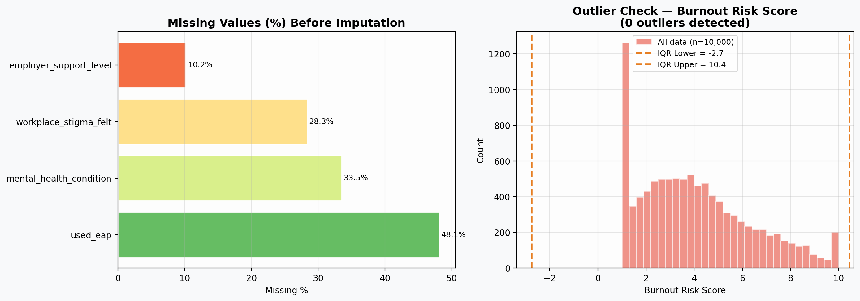
Figure 3.1: Missing values per column before cleaning (left) and IQR outlier check on burnout_risk_score (right). The tall bar at 1.0 shows the capped values.
Why this matters: if capped rows are kept, a model predicts a value based on the person’s features (for example 2.3), while the recorded answer stays fixed at 1.0. The error for all such rows is then exactly 1.0 minus the prediction, which forms the straight diagonal line visible in the residual plots of the first submission. These points describe the measuring scale, not employees, so the 1,207 capped rows were removed before modelling. Section 6.2 shows the effect of this choice.

Descriptive statistics
Table 3.3 summarises the main numeric columns before cleaning. The burnout score averages 4.03 with a spread (standard deviation) of 2.30, and is skewed towards lower values: half the employees score 3.70 or less. Weekly hours average 45.16, and overtime has a median of 5.00 hours but a long tail up to 39 hours. This spread in workload is important, because a feature cannot predict well if almost everyone has the same value.
Table 3.3: Descriptive statistics for key numeric columns (full dataset, before cleaning)
Column | Mean | Std | Min | 25% | 50% | 75% | Max
burnout_risk_score | 4.03 | 2.30 | 1.00 | 2.20 | 3.70 | 5.50 | 10.00
weekly_work_hours | 45.16 | 8.63 | 20.00 | 39.00 | 45.00 | 51.00 | 79.00
weekly_overtime_hours | 6.56 | 6.81 | 0.00 | 0.00 | 5.00 | 11.00 | 39.00
work_life_balance_score | 6.44 | 1.62 | 1.20 | 5.20 | 6.50 | 7.70 | 9.90
annual_salary_usd (USD 000s) | 86.78 | 24.02 | 36.14 | 68.22 | 84.82 | 102.63 | 177.60
years_of_experience | 14.49 | 10.05 | 0.00 | 6.00 | 13.00 | 21.00 | 44.00
absenteeism_days_per_year | 10.26 | 6.92 | 0.00 | 4.00 | 10.00 | 15.00 | 36.00
sleep_hours_per_night | 6.79 | 1.10 | 3.00 | 6.00 | 6.80 | 7.50 | 10.00

Correlation with the target
Pearson correlation (r) measures how strongly two numeric columns move together, from −1 (perfectly opposite) through 0 (no straight-line link) to +1 (perfectly together). To compute it for every column, text columns were converted to numbers: ordered categories were mapped to their natural order (for example stress: Very Low = 1 to Very Severe = 5), Yes/No to 1/0, and unordered categories such as country were given numeric codes. Figure 3.2 shows the resulting heatmap of all 33 columns.
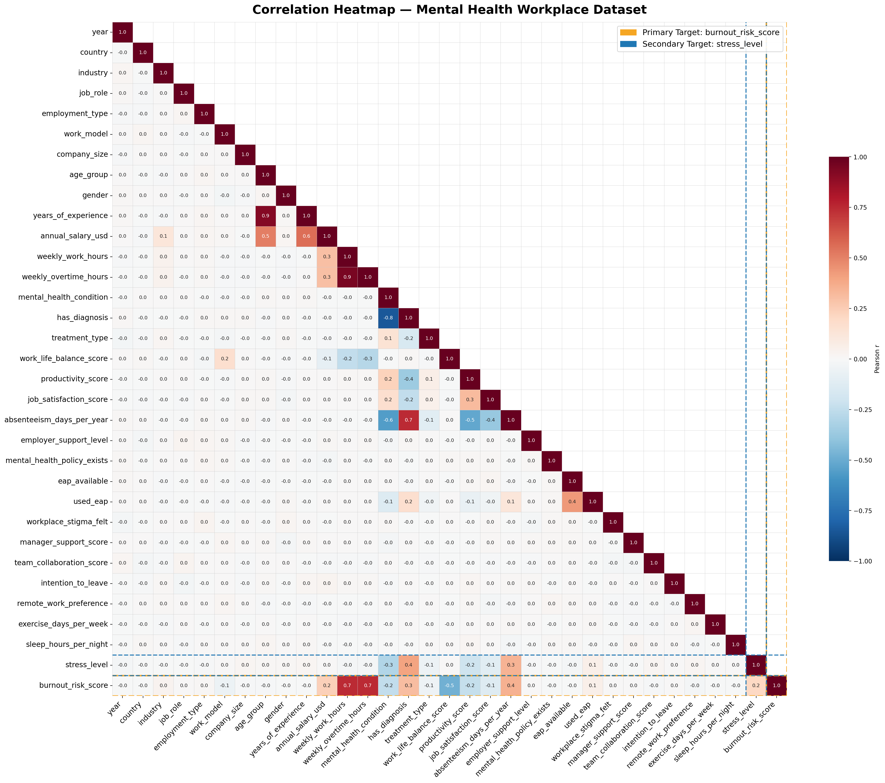
Figure 3.2: Correlation heatmap of all encoded columns (full dataset). The bottom row shows each column’s correlation with burnout_risk_score.
What the heatmap shows: the bottom row (burnout_risk_score) is almost entirely pale, meaning most columns have no meaningful link with burnout. Only a handful of cells are strongly coloured: weekly work hours and overtime (0.7), work-life balance (−0.5), absenteeism (0.4) and diagnosis status (0.3). The heatmap also reveals overlaps between predictors: work hours and overtime are almost identical (0.9), and absenteeism is strongly linked to diagnosis status (0.7) and productivity (−0.5). Table 3.4 ranks the 15 strongest correlations with burnout.
Table 3.4: Top 15 correlations with burnout_risk_score (full dataset, exploratory)
Feature | Pearson r | Feature | Pearson r
weekly_work_hours | 0.75 | stress_level | 0.21
weekly_overtime_hours | 0.75 | job_satisfaction_score | −0.13
work_life_balance_score | −0.48 | used_eap | 0.06
absenteeism_days_per_year | 0.35 | work_model | −0.06
has_diagnosis | 0.31 | treatment_type | −0.05
mental_health_condition | −0.24 | industry | 0.03
annual_salary_usd | 0.24 | remote_work_preference | −0.02
productivity_score | −0.24

What the table tells us: two workload columns stand far ahead of everything else, with r = 0.75 each, meaning burnout rises closely with hours worked. Work-life balance is the strongest protective factor (r = −0.48). Absenteeism and diagnosis status come next. After the tenth feature (job satisfaction, r = −0.13), correlations drop sharply to 0.06 or less. In other words, organisational and demographic fields such as work model, industry and remote-work preference carry almost no straight-line information about burnout. This sharp drop is the basis for the feature selection in Section 5.2, which repeats the calculation on the cleaned training data only.

Key relationships with burnout
Figure 3.3 plots the three relationships most relevant to the research questions. In panel (a), burnout rises steadily with weekly hours (r = 0.75), and the spread of points narrows as hours increase. Panel (b) shows burnout falling as work-life balance improves (r = −0.48), with a wide scatter around the trend. In panel (c), the median burnout score rises gradually from Very Low to Very Severe stress, but the boxes overlap heavily, so stress level alone is a weak guide to burnout.
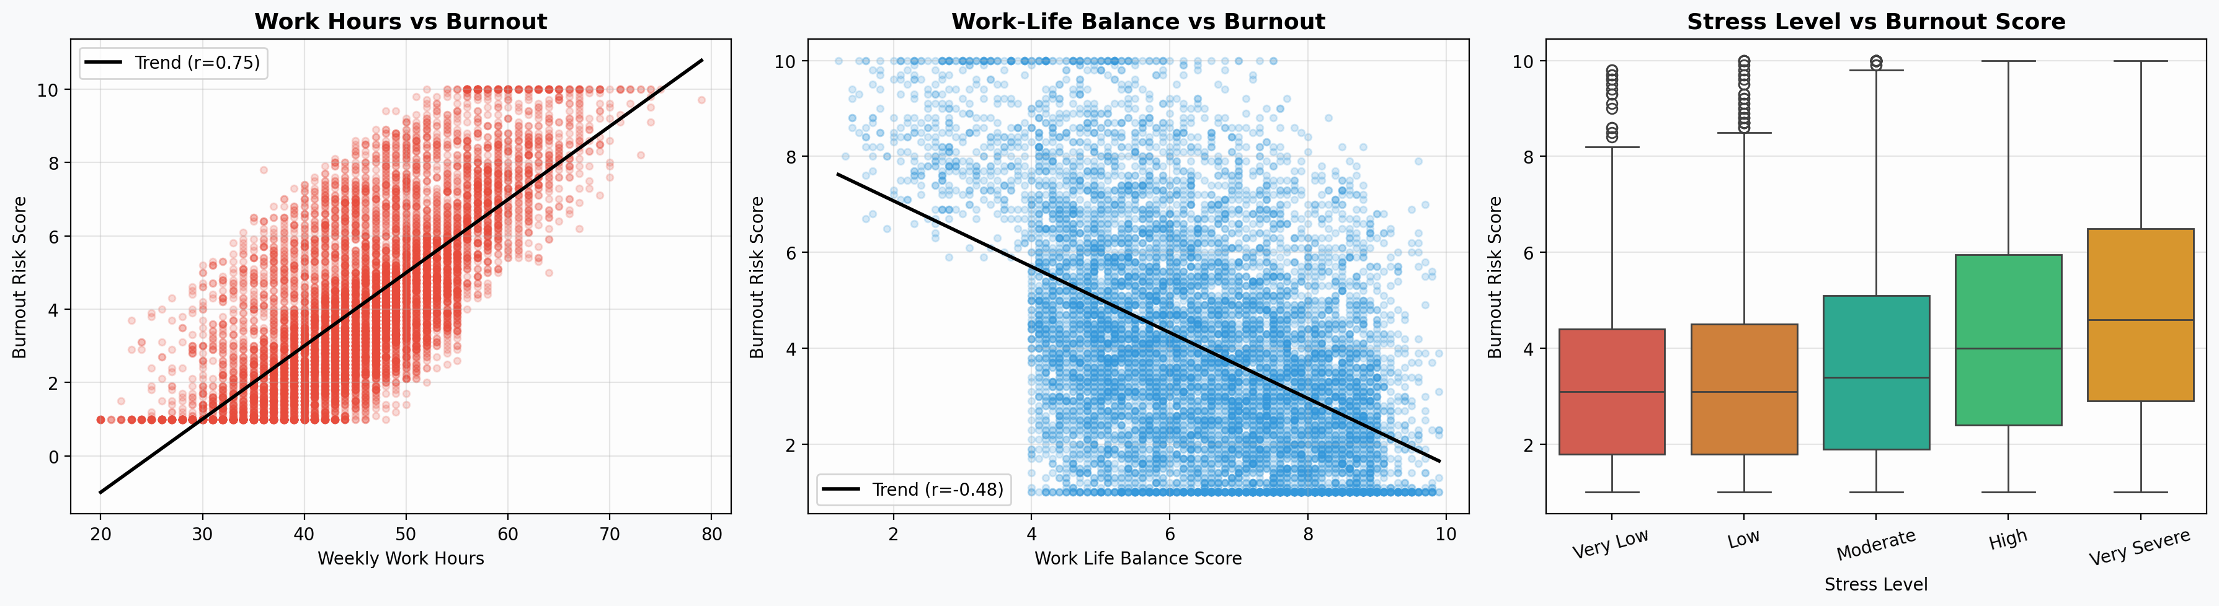
Figure 3.3: Burnout risk against weekly work hours (left), work-life balance (centre) and stress level (right).

3.4 Data Cleaning and Preprocessing
Table 3.5 lists every cleaning step applied before modelling, in order. Each step is in the notebook on GitHub, and every number in this report comes from that notebook.
Table 3.5: Cleaning and preprocessing steps for modelling
Step | What was done | Reason
1 | Dropped record_id | An identifier with no meaning for burnout
2 | Dropped used_eap, mental_health_condition, workplace_stigma_felt | More than 25% missing (Table 3.2)
3 | Removed 1,207 rows with score exactly 1.0 or 10.0, leaving 8,793 | True value unknown; caused straight-line residuals
4 | Encoded ordered, Yes/No and unordered categories as in the exploratory analysis | Pearson correlation needs numbers
5 | Split into training (7,034 rows) and test (1,759 rows) sets, 80/20, random_state = 42 | Test rows take no part in any later decision
6 | Correlation screen on training rows only; 9 of 29 candidate features kept (Section 5.2) | Removes features with no signal
7 | Standardised the 9 selected features with a StandardScaler fitted on the training rows only | Puts features on a common scale without using test data

Step 4 also fixed an error in the first submission: the old company_size mapping used category names that do not exist in the data (for example “Small (<50)” instead of “Startup (1-50)”), so three of the five sizes silently became blank. The revised code now stops with an error if any label is not mapped.

Chapter 4: Ethical Considerations

4.1 Dataset Source and Ethical Use
The dataset contains no names, contact details or other direct identifiers; record_id is an artificial key (for example MHW0000001). Personal details are recorded only as broad bands, such as age group rather than date of birth and country rather than city, which keeps the risk of re-identification low. No human participants were recruited for this project. Several features of the data suggest it is synthetic (generated) rather than collected from real employees: for example, weekly_overtime_hours equals weekly hours minus 40 for every single row, and blanks line up perfectly with other columns. This reduces privacy risk but limits how far the results can be applied to real workforces.

4.2 Privacy and Fair Use
The data combines two sensitive types of information: mental-health status and signs of work behaviour such as absence. A burnout model built on such data could be misused, for example to screen people out of jobs or promotions. That is not the purpose of this project. The model is presented as a way to understand which conditions are linked to burnout risk, so that employers can change those conditions, not as a tool for judging individuals.
Three further risks were considered. First, the sampling method is not documented, so results describe this dataset and not any particular population. Second, burnout drivers that are not recorded here, such as bullying, discrimination or job insecurity, cannot be detected. Third, because the model is driven mainly by hours, it could encourage managers to focus only on hours and overlook support and autonomy, which the JD-R model also treats as important.

4.3 Licensing and Reproducibility
All analysis is in a single Jupyter notebook stored on GitHub together with the dataset. Running the notebook from top to bottom reproduces every table, figure and number in this report; random seeds are fixed at 42 throughout.

Chapter 5: Methodology

5.1 Overview
The workflow has six stages: (1) data-quality checks and cleaning (Chapter 3); (2) an 80/20 train/test split; (3) correlation-based feature selection on the training data; (4) training three baseline models; (5) tuning each model with a cross-validated grid search; and (6) evaluating the models with residual analysis, learning curves and feature importance. Python 3 was used with pandas, NumPy, Matplotlib, seaborn, scikit-learn (Pedregosa et al., 2011) and XGBoost (Chen and Guestrin, 2016).

5.2 Correlation-Based Feature Selection
Pearson correlation between each candidate feature and burnout was recalculated on the cleaned training rows only, so that the test set played no part in choosing features. The selection rule was: keep a feature if |r| is at least 0.10. A feature below 0.10 explains less than 1% of the variation in burnout on its own (r² < 0.01). Figure 5.1 shows the result.
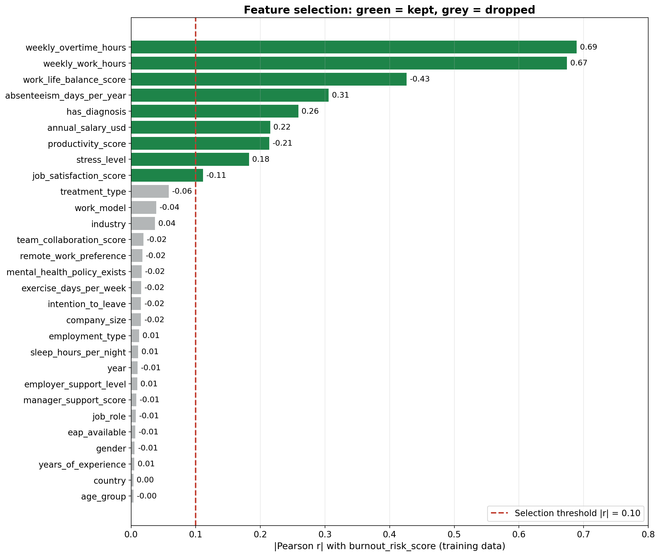
Figure 5.1: |Pearson r| of every candidate feature with burnout risk (cleaned training data). Green features were kept; grey features fell below the 0.10 threshold and were dropped.
The chart shows a clear natural break. Nine features have |r| between 0.11 and 0.69, and the next strongest (treatment_type) is only 0.06. The 20 dropped features all lie between 0.00 and 0.06: treatment_type, work_model, industry, team_collaboration_score, remote_work_preference, mental_health_policy_exists, exercise_days_per_week, intention_to_leave, company_size, employment_type, sleep_hours_per_night, year, employer_support_level, manager_support_score, job_role, eap_available, gender, years_of_experience, country, age_group. The most striking result is that every support and policy feature carries almost no signal in this data: manager support, team collaboration, employer support, mental-health policy and EAP availability all have |r| of 0.02 or less. Table 5.1 lists the kept features. Compared with the exploratory values in Table 3.4, the correlations are slightly weaker after cleaning (for example hours 0.67 instead of 0.75), because removing the capped rows narrows the range of burnout scores; the ranking is unchanged.
Table 5.1: Features kept after correlation screening (cleaned training data)
Feature | Pearson r | Direction
weekly_overtime_hours | 0.69 | Higher value, higher burnout
weekly_work_hours | 0.67 | Higher value, higher burnout
work_life_balance_score | -0.43 | Higher value, lower burnout
absenteeism_days_per_year | 0.31 | Higher value, higher burnout
has_diagnosis | 0.26 | Higher value, higher burnout
annual_salary_usd | 0.22 | Higher value, higher burnout
productivity_score | -0.21 | Higher value, lower burnout
stress_level | 0.18 | Higher value, higher burnout
job_satisfaction_score | -0.11 | Higher value, lower burnout

The heatmap in Figure 5.2 checks how the kept features relate to each other. weekly_work_hours and weekly_overtime_hours are almost identical (r = 0.97); in fact overtime equals hours above 40 for every row. Both were kept because together they let even a straight-line model capture a change in slope at 40 hours. absenteeism and has_diagnosis also overlap strongly (r = 0.74): diagnosed employees take more days off. Productivity falls as absence rises (r = −0.52). Overlaps like these do not harm prediction, but they mean that importance can be shared between related features, which is considered when interpreting results in Section 6.6.
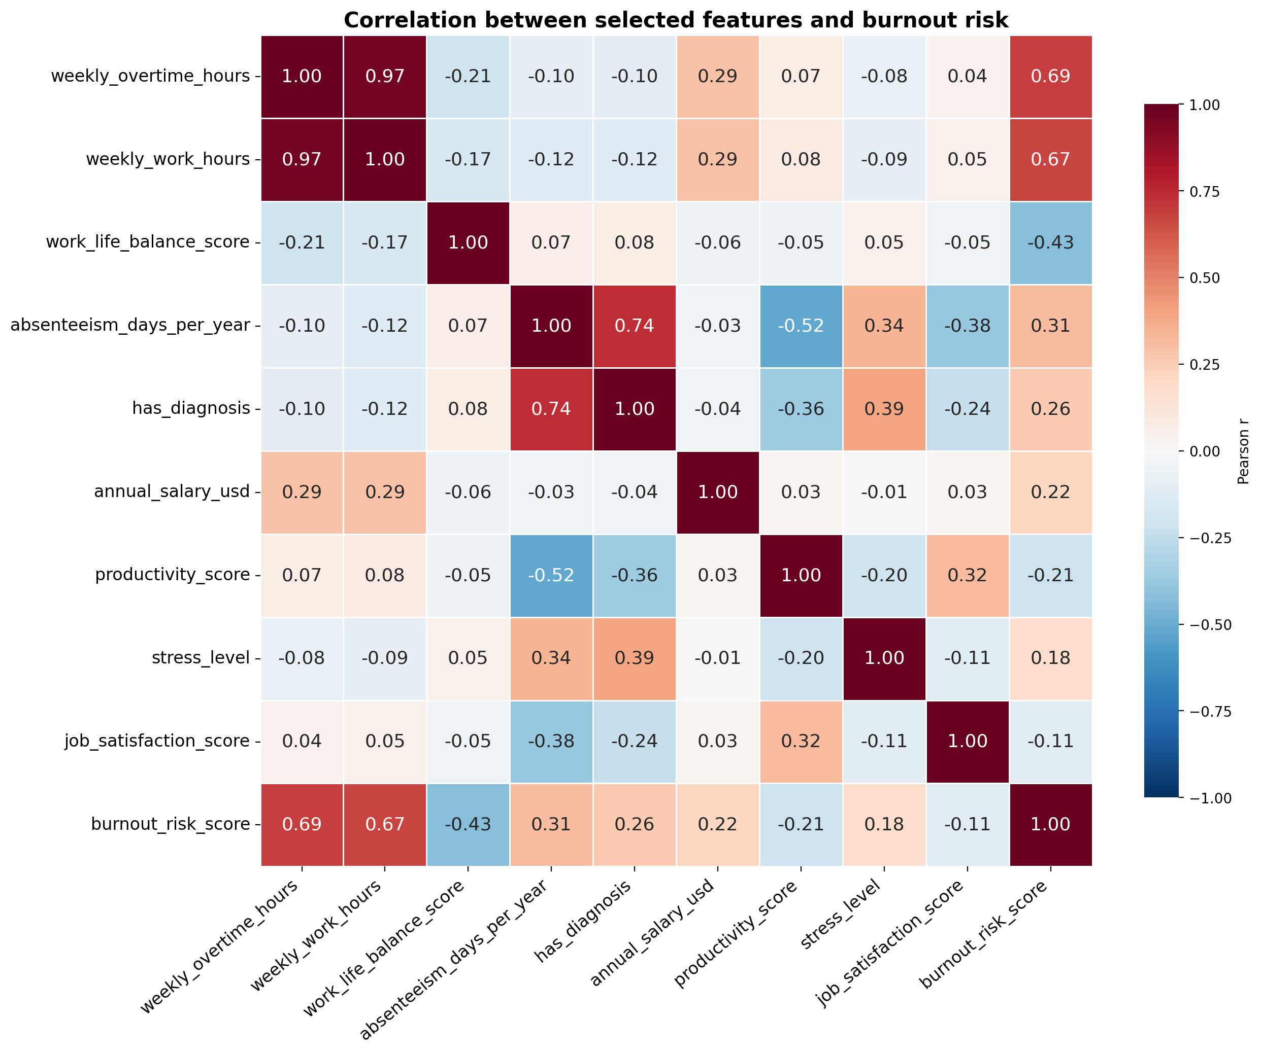
Figure 5.2: Correlation heatmap of the nine selected features and the target (cleaned training data).

5.3 Train/Test Split and Scaling
The cleaned data (8,793 rows) was split into 7,034 training and 1,759 test rows with random_state = 42. The nine selected features were standardised (rescaled to mean 0 and standard deviation 1) with a StandardScaler fitted on the training rows and then applied unchanged to the test rows, so no information from the test set entered the scaling. None of the selected features has any missing values, so no imputation was needed.

5.4 Models and Why They Were Chosen
Three models were chosen to cover increasing levels of flexibility, which lets the report test whether the relationship between features and burnout is simple and straight-line or more complex.
- Linear Regression fits a weighted sum of the inputs: predicted burnout = intercept + w₁×feature₁ + w₂×feature₂ + … The weights are chosen to minimise the squared errors on the training data. It is fast and easy to explain, and serves as the baseline: if flexible models cannot beat it, the extra complexity is not justified.
- Random Forest (Breiman, 2001) builds many decision trees. Each tree splits the data with a series of yes/no questions (for example “overtime > 8 hours?”) and predicts the average burnout of the employees in each final group. Every tree is trained on a random resample of the rows and considers a random subset of features at each split; the forest’s prediction is the average of all trees. Averaging many varied trees reduces the instability of a single tree. It was chosen because it captures bends and interactions automatically and was the basis of the strong results reported by Xames (2025).
- XGBoost (Chen and Guestrin, 2016) also uses decision trees, but builds them one after another. Each new, small tree is trained to correct the errors left by the trees before it, and its contribution is scaled down by a learning rate so that the model improves gradually. It also includes built-in penalties against overly complex trees. Gradient-boosted trees are widely regarded as among the strongest methods for medium-sized tabular data like this (Grinsztajn, Oyallon and Varoquaux, 2022).
Table 5.2 lists the settings used for the baseline (untuned) versions.
Table 5.2: Baseline model settings
Model | Settings | Meaning of the main settings
Linear Regression | scikit-learn defaults | Ordinary least squares with an intercept
Random Forest | n_estimators = 200, max_depth = 15, random_state = 42 | 200 trees, each at most 15 questions deep
XGBoost | n_estimators = 300, max_depth = 6, learning_rate = 0.10, subsample = 0.80, colsample_bytree = 0.80, random_state = 42 | 300 trees of depth 6; each tree uses 80% of rows and 80% of features

5.5 Evaluation Metrics
Three metrics were used, all calculated on the unseen test set. MAE and RMSE are in burnout-score points (on the 1–10 scale), so they can be read directly.
- Mean Absolute Error (MAE): the average size of the prediction error, ignoring whether it is too high or too low. MAE = 0.73 means predictions are off by 0.73 points on average.
- Root Mean Squared Error (RMSE): the square root of the average squared error. Squaring gives large errors more weight, so RMSE is always at least as large as MAE, and a big gap between the two signals some large misses.
- Coefficient of determination (R²): the share of the variation in burnout scores that the model explains. 1.00 is perfect; 0.00 is no better than always predicting the average score.

5.6 Hyperparameter Tuning and Cross-Validation
Each model was tuned with GridSearchCV, which tries every combination of the settings in Table 5.3. Each combination was scored with 3-fold cross-validation on the training set: the training rows are split into three equal parts, the model is trained on two and scored (R²) on the third, and this repeats so that each part is used once for scoring. The combination with the best average score was then re-trained on all training rows and scored once on the test set, so tuning never saw the test rows.
Table 5.3: Hyperparameter search space
Model | Setting | Values tried | What it controls
Random Forest | n_estimators | 100, 200, 300 | Number of trees
 | max_depth | 10, 15, 20 | How deep each tree can grow
 | min_samples_split | 2, 5 | Smallest group that may be split further
XGBoost | n_estimators | 200, 300 | Number of trees
 | max_depth | 4, 6, 8 | Depth of each tree
 | learning_rate | 0.05, 0.10 | How much each new tree corrects the previous ones
Linear Regression | fit_intercept | True, False | Whether a constant term is fitted
 | positive | True, False | Whether weights are forced to be positive

Linear Regression has no settings that control its flexibility, so its grid acts as a check rather than a real search.

5.7 Learning Curves and Model Interpretation
Learning curves plot training and cross-validated (5-fold) RMSE as the number of training rows increases. A large, lasting gap between the two lines shows overfitting (the model memorises the training data), while two lines that meet at a high error show underfitting (the model is too simple). Learning-rate curves track XGBoost’s validation error after each tree for five learning rates, using a further 80/20 split of the training data so that the test set stays untouched.
Feature importance was taken from each tree model’s built-in measure (feature_importances_). For Random Forest this is the average reduction in prediction error achieved by splits on each feature; for XGBoost it is the average improvement each time the feature is used in a split. Both are scaled to sum to 1.

Chapter 6: Results

6.1 Baseline Model Comparison
Table 6.1 shows the test-set results of the three untuned models trained on the nine selected features, and Figure 6.1 compares them visually.
Table 6.1: Baseline model performance (test set)
Model | MAE | RMSE | R²
Linear Regression | 0.80 | 1.03 | 0.75
Random Forest | 0.74 | 1.01 | 0.76
XGBoost | 0.74 | 1.00 | 0.76

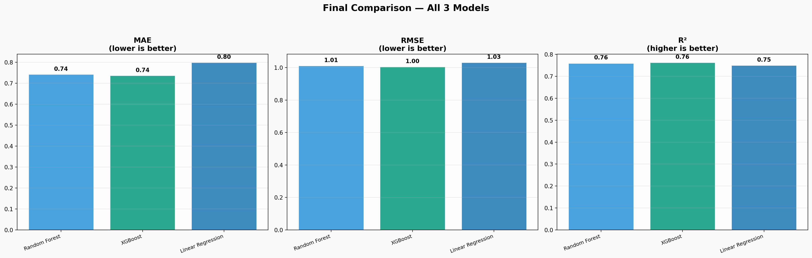
Figure 6.1: Test-set MAE, RMSE and R² of the three baseline models.
All three models explain about three-quarters of the variation in burnout. The tree models are slightly better (R² 0.76 and 0.76 against 0.75) and have a lower MAE (0.74 against 0.80). The gap is small because the strongest pattern, the rise in burnout with hours, is close to a straight line and is captured well by the linear model; the tree models add only the remaining bends and interactions.
Figures 6.2 to 6.4 show the diagnostic plots for each model. In each actual-vs-predicted plot the points follow the diagonal, but the cloud is wide, matching an MAE of around 0.75 points. The residual plots (actual minus predicted) show no straight-line patterns: removing the capped rows has fixed the problem seen in the first submission. The residual histograms are centred close to zero (means between −0.03 and 0.00) and roughly bell-shaped, with a slightly longer right tail, meaning large under-predictions are a little more common than large over-predictions.
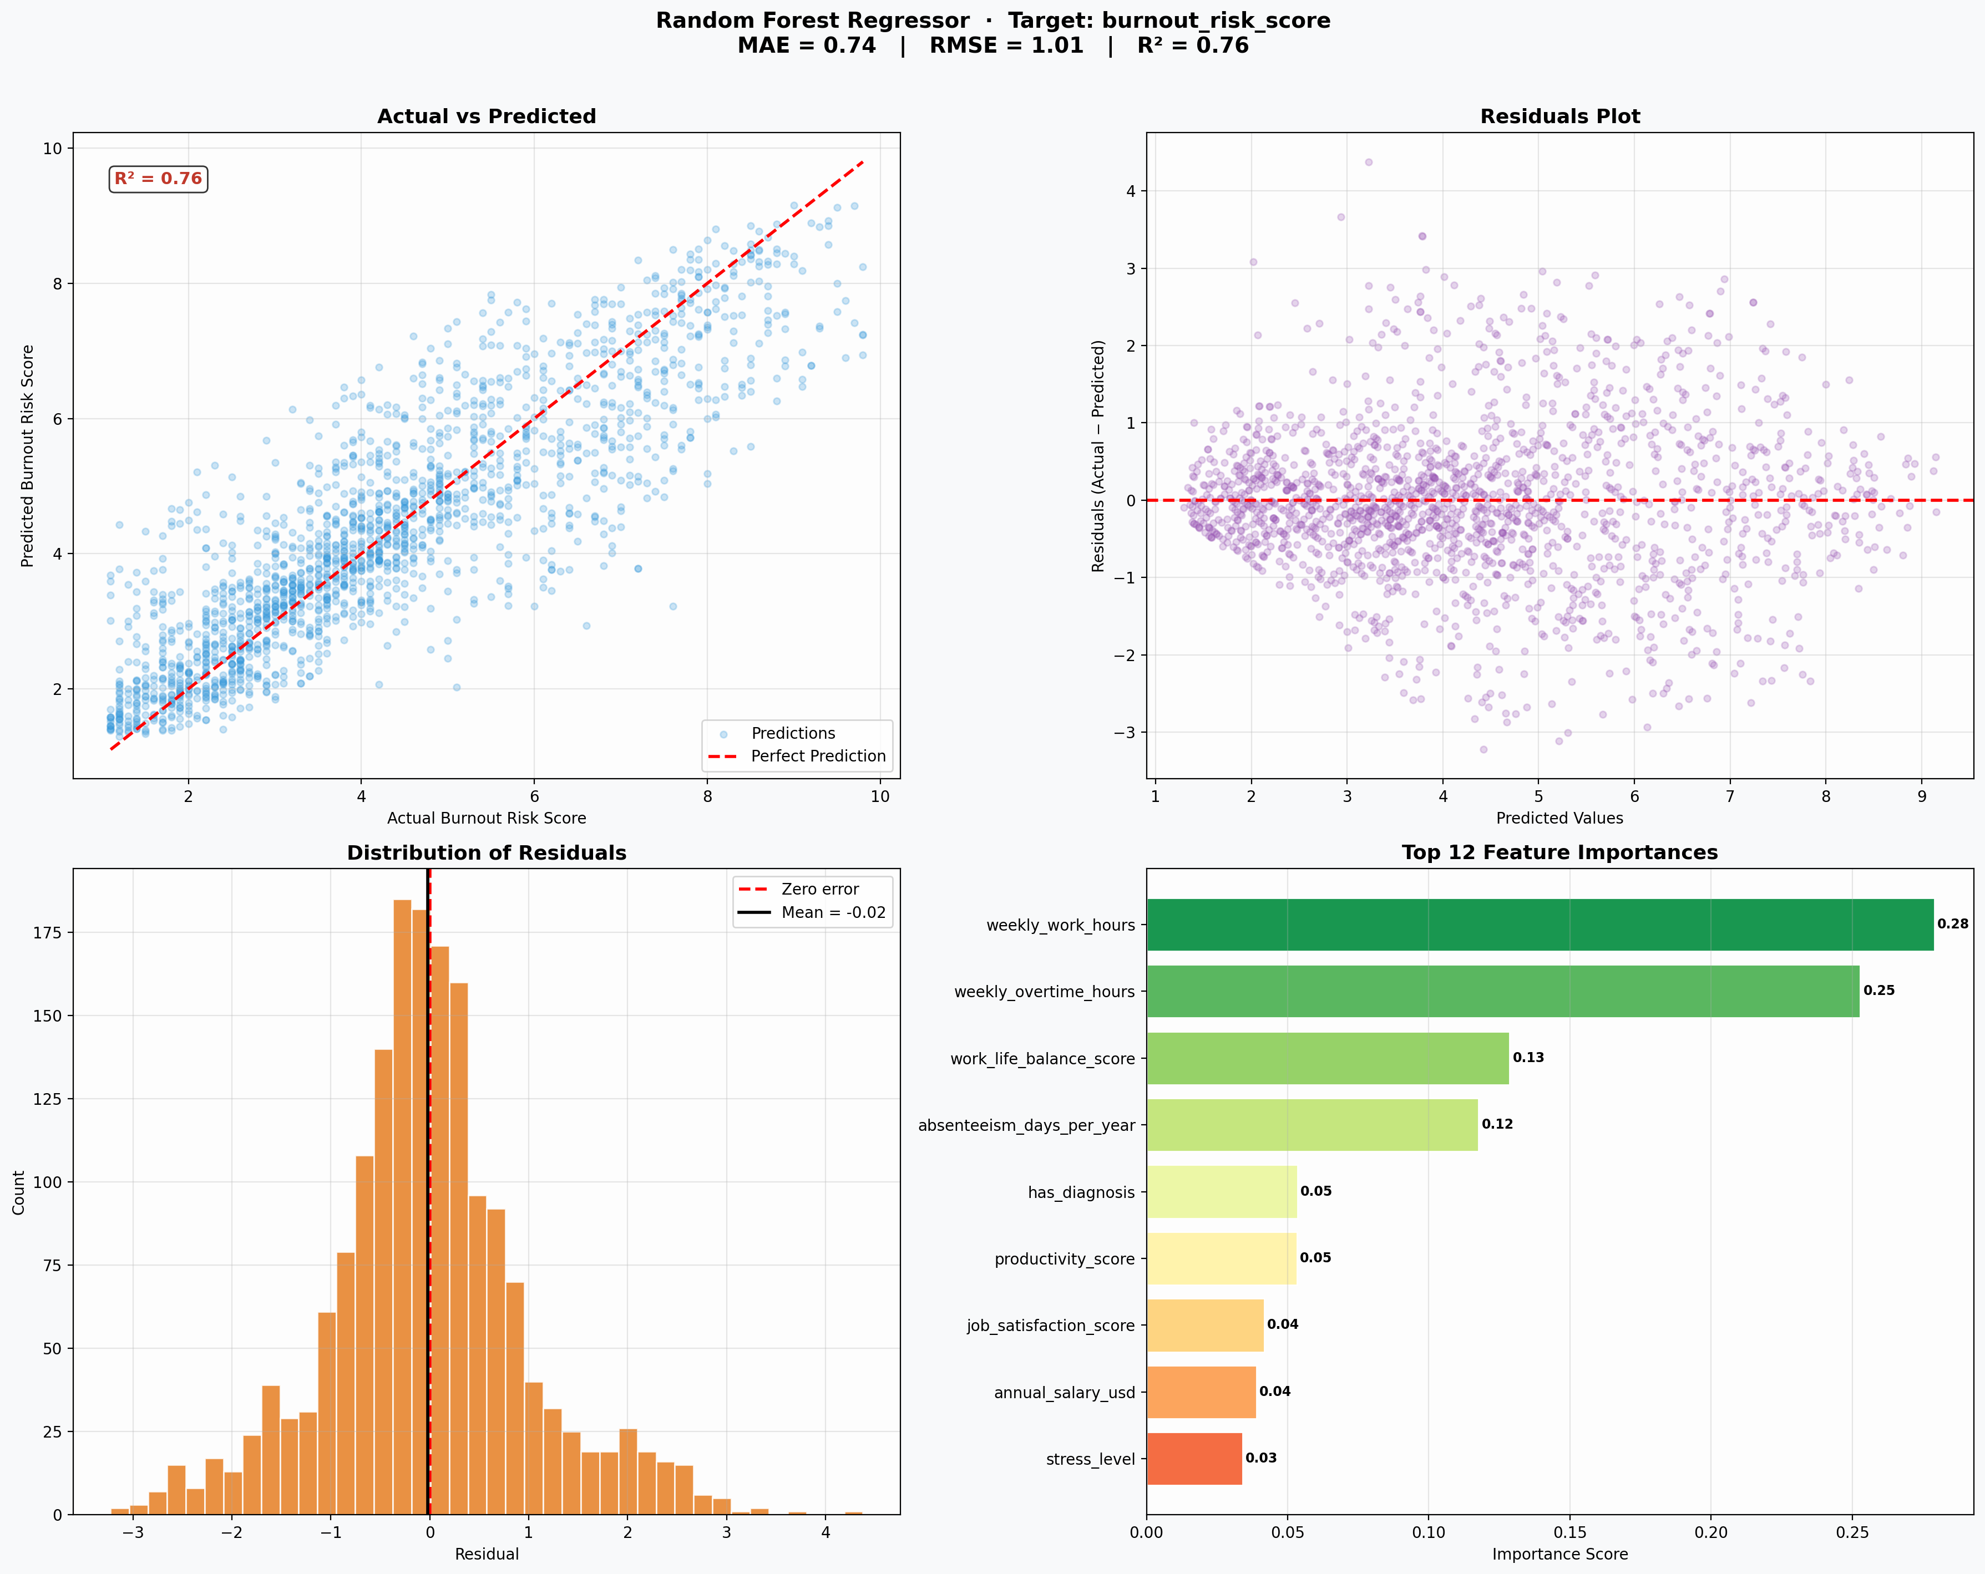
Figure 6.2: Random Forest (baseline): actual vs predicted, residuals, residual distribution and feature importances (test set).
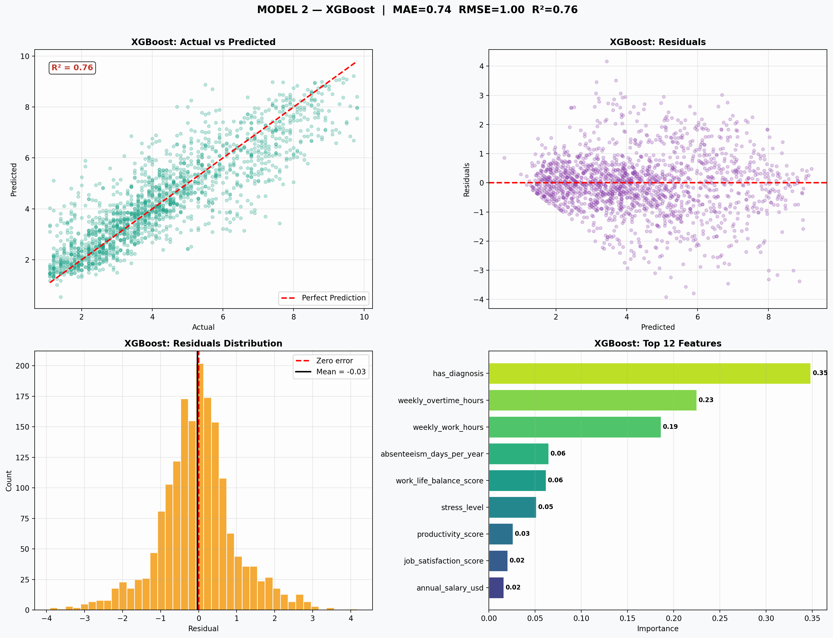
Figure 6.3: XGBoost (baseline): actual vs predicted, residuals, residual distribution and feature importances (test set).
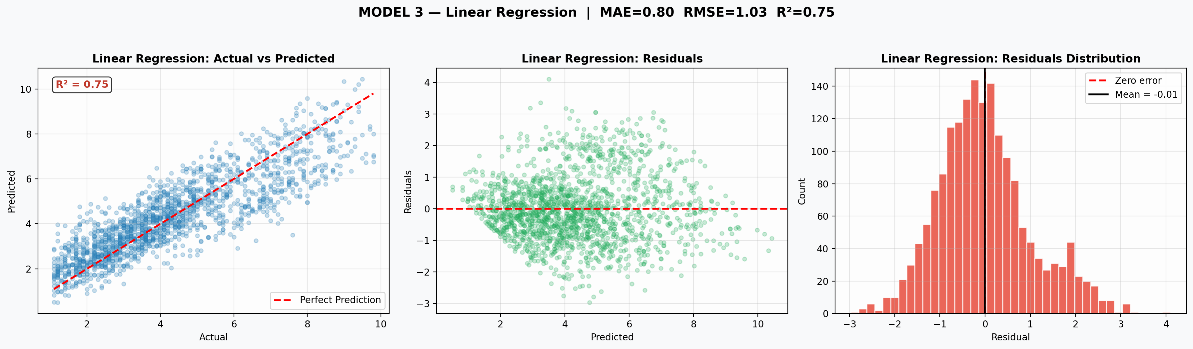
Figure 6.4: Linear Regression (baseline): actual vs predicted, residuals and residual distribution (test set).
The linear model’s actual-vs-predicted plot shows the widest scatter at the high end: employees with actual scores of 8 to 10 are often predicted at only 6 to 8. A straight-line model cannot bend to follow these extreme cases, which is why its RMSE is the highest of the three.

6.2 Effect of Removing Capped Target Values
To show why the capped rows were removed, the baseline XGBoost model was also trained on data that still included them (Figure 6.5). In panel (a), the capped rows, 12.75% of that test set, form a clear diagonal line in the lower left: their recorded score is fixed at 1.0 whatever the model predicts. This line is an artefact of the measuring scale. In panel (b), after removal, the residuals form an even cloud around zero.
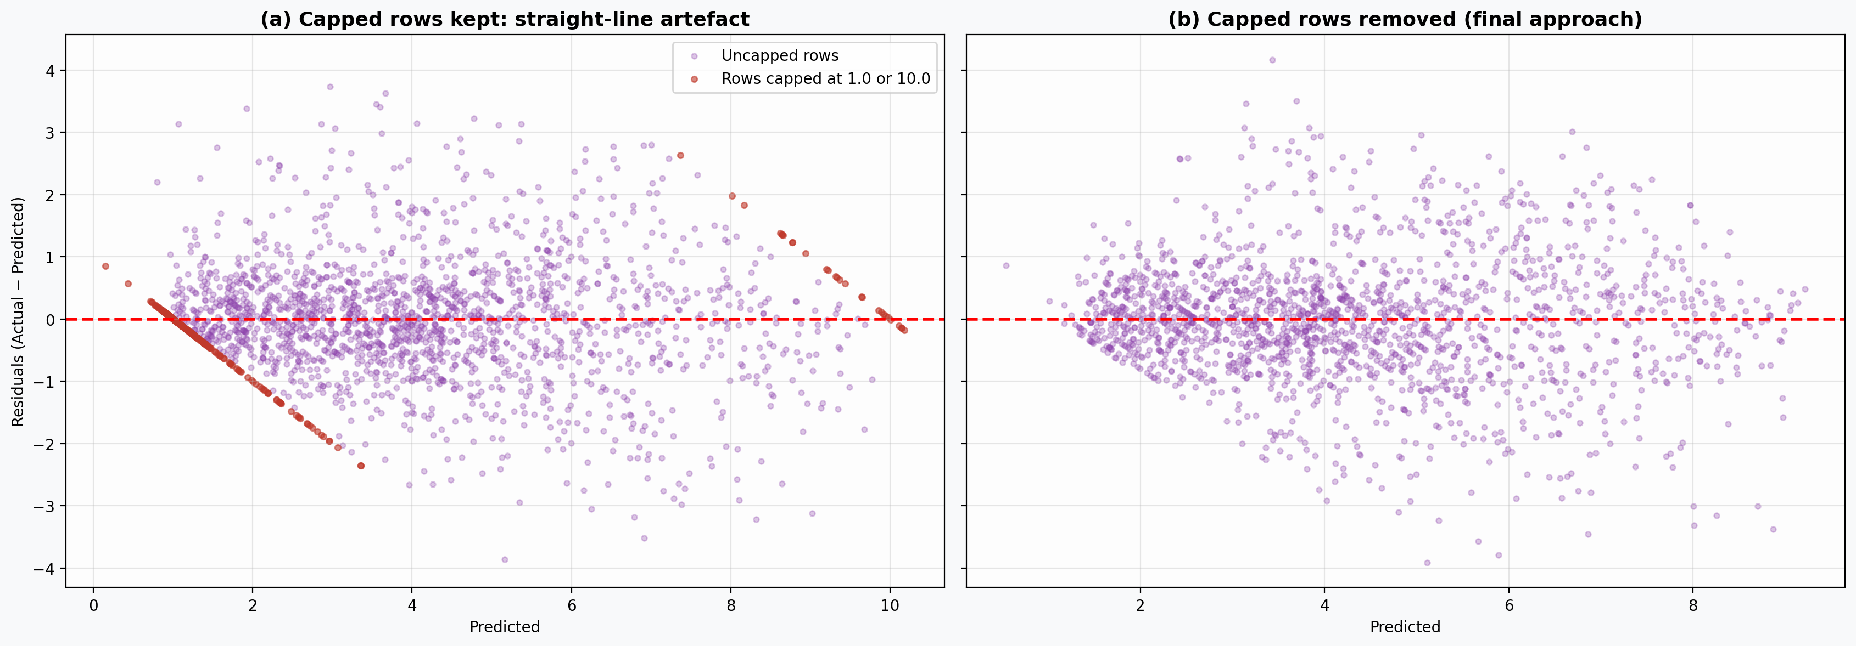
Figure 6.5: XGBoost residuals with capped rows kept (a) and removed (b). The red points in (a) are rows recorded at exactly 1.0 or 10.0.
Keeping the capped rows actually gives a higher R² (0.83 against 0.76). This does not mean that model is better: the capped rows are bunched at the ends of the scale, which makes the total variation larger and the share “explained” look bigger. The cleaned result is the more honest measure of how well the model predicts real differences between employees.

6.3 Effect of Hyperparameter Tuning
Table 6.2 gives the tuned results and the winning settings, and Figure 6.6 compares R² before and after tuning.
Table 6.2: Tuned model performance (test set) and best settings from the 3-fold grid search
Model | Best settings | CV R² | MAE | RMSE | R²
Random Forest | max_depth = 10, min_samples_split = 5, n_estimators = 300 | 0.77 | 0.74 | 1.00 | 0.76
XGBoost | learning_rate = 0.05, max_depth = 4, n_estimators = 300 | 0.78 | 0.73 | 0.98 | 0.77
Linear Regression | fit_intercept = True, positive = False | 0.75 | 0.80 | 1.03 | 0.75

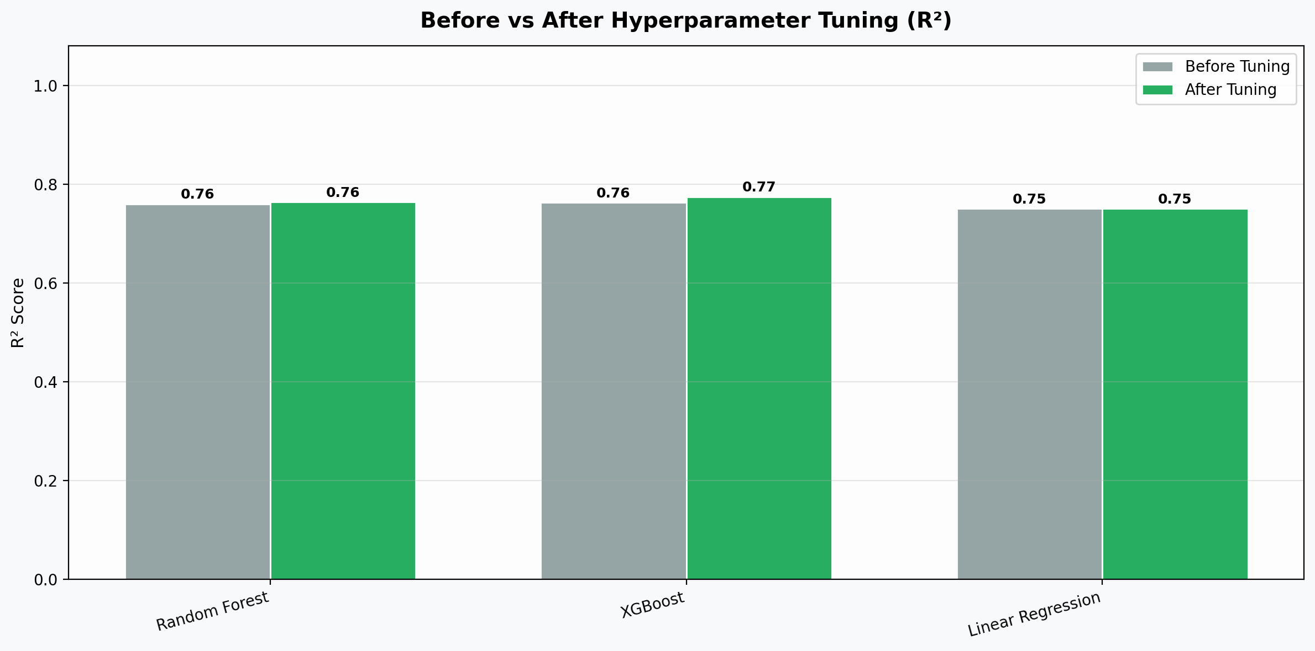
Figure 6.6: Test-set R² before and after hyperparameter tuning.
Tuning gave small gains. XGBoost improved from R² 0.76 to 0.77, with RMSE falling from 1.00 to 0.98 and MAE from 0.74 to 0.73. The search chose a lower learning rate (0.05 instead of 0.10) and shallower trees (4 instead of 6): smaller, more careful corrections generalised better than larger ones. Random Forest chose shallower trees (max_depth 10 instead of 15) and larger minimum splits (5 instead of 2), both of which reduce overfitting, but its test R² stayed at 0.76 (RMSE 1.01 to 1.00). Linear Regression did not change, because its default settings were already the best; its limit is its straight-line form, not its settings. The cross-validated scores (0.75 to 0.78) are close to the test scores, so the results are stable and not the product of a lucky split.

6.4 Residual Analysis of the Tuned Models
Across the tuned models, the mean residual is close to zero (-0.01 to -0.02), so none of them is biased overall. The share of predictions more than 1 point off is 24.79% for XGBoost, 25.81% for Random Forest and 30.42% for Linear Regression. Table 6.3 groups the test rows by their actual score to see where errors occur.
Table 6.3: Average residual (actual − predicted) by actual burnout band, tuned models (test set)
Actual score band | Rows | Linear Regression | Random Forest | XGBoost
1-3 | 567 | -0.50 | -0.44 | -0.41
3-5 | 640 | -0.18 | -0.19 | -0.16
5-7 | 315 | 0.48 | 0.41 | 0.32
7-10 | 237 | 0.99 | 0.92 | 0.86

All models over-predict low scores (negative residuals for 1–3) and under-predict high scores (positive residuals for 7–10). This “pull towards the middle” is expected whenever part of the outcome depends on things the model cannot see: with no information to separate the most and least burnt-out employees, predictions move towards the average. It matters in practice, because the most at-risk employees (7–10) are under-estimated by 0.86 points on average even with XGBoost. XGBoost shows the smallest bias in every band, which is one reason it is preferred.

6.5 Learning Curves and Learning-Rate Curves
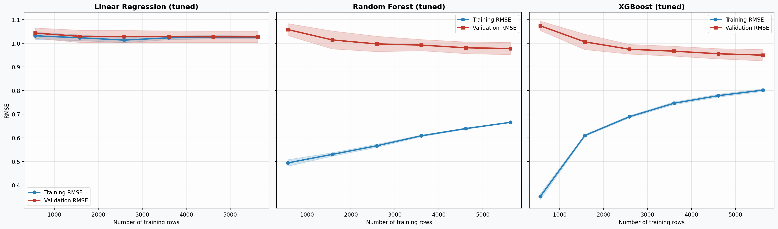
Figure 6.7: Learning curves of the tuned models: training and 5-fold validation RMSE against number of training rows (shaded bands show ± one standard deviation across folds).
Figure 6.7 shows clearly different learning behaviour. For Linear Regression, training and validation errors are almost identical (1.03 and 1.03) and flat from about 1,500 rows onwards. This is a sign of underfitting: more data will not help, because a straight-line model cannot capture the remaining patterns. Random Forest has the largest gap (training 0.67, validation 0.98), meaning it fits the training data much more closely than new data, although the gap narrows as data grows. XGBoost shows the healthiest pattern: its training error rises and validation error falls as data grows, and the gap shrinks to 0.15. Its validation curve is still sloping slightly downwards at the full training size, so more data would likely give small further gains.
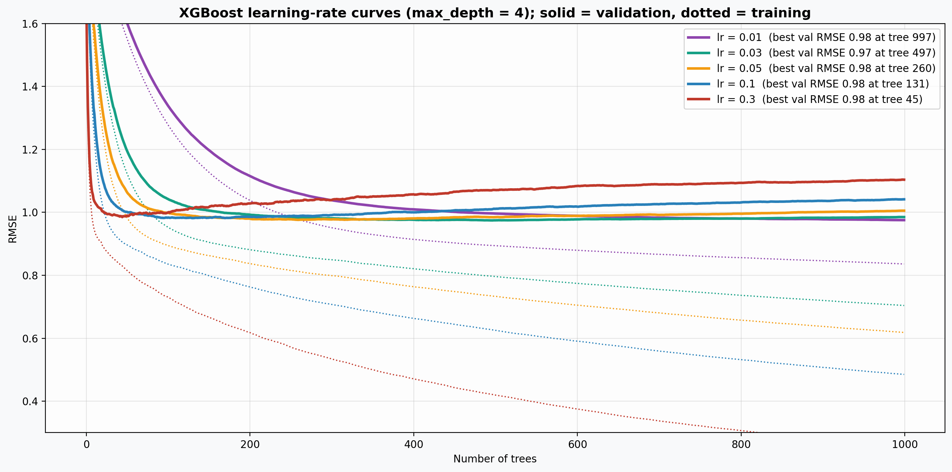
Figure 6.8: XGBoost learning-rate curves (max_depth = 4): validation RMSE (solid) and training RMSE (dotted) after each tree, for five learning rates.
Figure 6.8 shows how the learning rate affects training. All five rates reach almost the same best validation error (0.97 to 0.98), but at very different speeds and with different behaviour afterwards. With a high rate (0.30) the best point comes after only 45 trees, after which validation error rises steadily while training error keeps falling: the model starts memorising noise. With 0.10 the same happens after about 130 trees. The rate of 0.05 chosen by tuning reaches its best at about 260 trees, close to the 300 used, and rises only slowly afterwards. Lower rates (0.01 and 0.03) are the most stable but need 500 to 1,000 trees. Table 6.4 summarises this.
Table 6.4: XGBoost learning-rate comparison (validation split of the training data)
Learning rate | Best validation RMSE | Trees at best | Validation RMSE at 1,000 trees | Training RMSE at 1,000 trees
0.01 | 0.98 | 997 | 0.98 | 0.84
0.03 | 0.97 | 497 | 0.99 | 0.70
0.05 | 0.98 | 260 | 1.01 | 0.62
0.10 | 0.98 | 131 | 1.04 | 0.49
0.30 | 0.98 | 45 | 1.10 | 0.26

6.6 Which Features Drive the Predictions?
The bottom-right panels of Figures 6.2 and 6.3 show the feature importances of the two tree models; Table 6.5 lists them side by side.
Table 6.5: Built-in feature importance of the baseline tree models
Feature | Random Forest | XGBoost
weekly_work_hours | 0.28 | 0.19
weekly_overtime_hours | 0.25 | 0.23
work_life_balance_score | 0.13 | 0.06
absenteeism_days_per_year | 0.12 | 0.06
has_diagnosis | 0.05 | 0.35
productivity_score | 0.05 | 0.03
job_satisfaction_score | 0.04 | 0.02
annual_salary_usd | 0.04 | 0.02
stress_level | 0.03 | 0.05

Both models rely mainly on workload. In Random Forest, weekly hours (0.28) and overtime (0.25) are the top two features and together account for over half of the total importance. In XGBoost they are second and third (0.23 and 0.19), and together (0.42) still form the largest share. The two models split the credit differently because the two features are almost identical (r = 0.97): whichever one a tree uses first, the other adds little.
The main difference is has_diagnosis, which XGBoost ranks first (0.35) but Random Forest ranks fifth (0.05). This reflects how the two importance measures work rather than a real disagreement. XGBoost’s measure is the average improvement each time a feature is used. A yes/no feature such as diagnosis is used in few splits, but each one separates two clearly different groups (diagnosed employees score about one point higher on average), so its average is high. Random Forest’s measure is the total improvement, which favours features used in many splits, such as hours. Work-life balance and absenteeism follow in both models (0.06 to 0.13). Stress, productivity, job satisfaction and salary each contribute 0.05 or less.

6.7 Sensitivity Check: Keeping mental_health_condition
mental_health_condition was dropped by the 25% missing-value rule. Because its blanks simply mean “no diagnosis”, a check was run with the column added back and blanks recoded as “No diagnosis”, using the tuned XGBoost settings. R² rose sharply, from 0.77 to 0.94 (MAE 0.40). Table 6.6 shows where the gain comes from.
Table 6.6: Average burnout score by mental_health_condition (cleaned training data)
Condition | Mean burnout
No diagnosis | 3.48
OCD | 3.96
PTSD | 4.02
Bipolar Disorder | 4.06
Depression | 4.08
Panic Disorder | 4.08
Anxiety | 4.09
ADHD | 4.37
Burnout | 6.31
Multiple Conditions | 6.40

Almost all conditions average between 3.96 and 4.37, but “Burnout” (6.31) and “Multiple Conditions” (6.40) stand far above the rest. A diagnosed condition called “Burnout” is close to being the outcome itself, so using it to predict burnout risk is circular: it is a form of target leakage, where information about the answer leaks into the inputs. A model that relies on it would mostly identify people already diagnosed with burnout, which is not useful for early warning. This supports dropping the column on two separate grounds, and it also explains why the first submission’s R² of 0.95 was much higher than the cleaned result of 0.77.

6.8 Research Questions Answered
- RQ1. Weekly work hours and weekly overtime are by far the strongest correlates of burnout (r = 0.67 to 0.75), followed by work-life balance (r = −0.43 to −0.48), absenteeism (0.31 to 0.35) and having a diagnosis (0.26 to 0.31). Twenty features, including country, industry, age, gender, company size, sleep, exercise and all support and policy measures, show almost no straight-line association (|r| of 0.06 or less).
- RQ2. Burnout risk can be predicted to within about 0.73 points on average. Tuned XGBoost performs best (MAE 0.73, RMSE 0.98, R² 0.77), slightly ahead of Random Forest (R² 0.76) and Linear Regression (R² 0.75). XGBoost also has the smallest bias for the most at-risk employees and the smallest training–validation gap.
- RQ3. In both tree models the two hours features together carry the largest share of importance, followed by diagnosis status, work-life balance and absenteeism. The model-based ranking therefore agrees closely with the correlation ranking used for RQ1.

Chapter 7: Discussion

7.1 Why the Models Performed as They Did
The tree models outperformed Linear Regression, but only by a small margin. The learning curves explain this: the linear model is limited by its shape, not by lack of data, and the main relationship (more hours, more burnout) is close to a straight line, so the linear model already captures most of it. The tree models gain by finding the remaining bends and combinations automatically, for example the extra effect of long hours combined with poor work-life balance. XGBoost did best because it builds its trees step by step to fix earlier mistakes, and the lower learning rate and shallower trees chosen by tuning kept this process from overfitting. Random Forest’s averaged trees fitted the training data more closely than new data, which explains its larger training–validation gap. These results agree with Grinsztajn, Oyallon and Varoquaux (2022), who found boosted trees particularly strong on tabular data.
Around a quarter of the variation in burnout remains unexplained by every model, and no model reaches the very high R² values reported by Xames (2025). The sensitivity check in Section 6.7 suggests one reason: very high accuracy can come from features that are close to the outcome itself. Results from studies that do not report how they handled such features, or capped scores, should be compared with care.

7.2 Relation to the Literature
The findings strongly support the demand side of the JD-R model (Bakker and Demerouti, 2017) and the conclusions of Maslach, Schaufeli and Leiter (2001) and Alarcon (2011) that workload is the most consistent driver of burnout. They also match Ibsen Bruun et al. (2024), who found that time spent working, rather than the number of tasks, raised burnout risk. In contrast, the resource side of the JD-R model received almost no support here: manager support, employer support, policies and EAP availability were unrelated to burnout. Hung, Chang and Hsiao (2025) found a link between burnout and intention to leave, which was absent in this dataset (r = −0.02). Given the signs that the data is synthetic (Section 4.1), these missing links are more likely to reflect how the data was generated than to disprove the theory.

7.3 Possible Applications
For an HR team, the main message is practical: the strongest warning signs for burnout are already in standard HR records, namely regular overtime, poor work-life balance scores and rising absence. A simple dashboard that flags teams with sustained overtime would capture most of the predictive signal. Any use should be at team or organisation level and focused on changing working conditions, not on judging individuals, in line with the ethical concerns in Chapter 4.

7.4 Limitations
First, the dataset appears to be synthetic, so the size of effects may not match real workforces. Second, removing capped rows means the model is not designed for employees at the very ends of the scale, and the most at-risk employees are under-predicted on average. Third, the data is cross-sectional (one record per employee), so the results show associations, not proof that cutting hours would reduce burnout. Fourth, unordered categories such as industry and country were given arbitrary numeric codes for the correlation screen; Pearson correlation can understate the link between such categories and burnout, so a group-based measure would be a useful extension. Finally, built-in importance measures share credit between overlapping features, so the separate importance of hours and overtime should not be over-read.

Chapter 8: Conclusion and Future Work
This project asked which features are linked to burnout risk and how well that risk can be predicted from routine HR data. After dropping three poorly recorded columns, removing capped scores and keeping only the 9 features with |r| of at least 0.10, tuned XGBoost predicted burnout to within 0.73 points on average (R² 0.77), slightly ahead of Random Forest and Linear Regression. The correlation analysis and all three models pointed to the same conclusion: hours worked, especially overtime, are the main driver of burnout risk, followed by diagnosis status, work-life balance and absence. Location, demographics and support policies showed almost no relationship with burnout.
The revised analysis also shows why careful data preparation matters. Removing a feature that was effectively a burnout diagnosis, and rows whose true score was unknown, lowered R² from the 0.95 reported in the first submission to 0.77, but the remaining figure is a more honest measure of what routine data can predict.
Future work could take several directions. A longitudinal dataset that follows the same employees over time would allow a stronger test of whether reducing overtime lowers burnout. Methods designed for capped outcomes, such as Tobit regression, could make use of the 1,207 removed rows. One-hot encoding or group-based association measures could test unordered categories such as industry more fairly. Explanation methods such as SHAP values could show which factors drive each individual prediction. Finally, testing the pipeline on a real, documented dataset would show whether the weak role of support and resources found here also holds in practice.

References
Alarcon, G.M. (2011) ‘A meta-analysis of burnout with job demands, resources, and attitudes’, Journal of Vocational Behavior, 79(2), pp. 549–562. Available at: https://doi.org/10.1016/j.jvb.2011.03.007.
Bakker, A.B. and Demerouti, E. (2017) ‘Job demands–resources theory: taking stock and looking forward’, Journal of Occupational Health Psychology, 22(3), pp. 273–285. Available at: https://doi.org/10.1037/ocp0000056.
Breiman, L. (2001) ‘Random forests’, Machine Learning, 45(1), pp. 5–32. Available at: https://doi.org/10.1023/A:1010933404324.
Chen, T. and Guestrin, C. (2016) ‘XGBoost: a scalable tree boosting system’, in Proceedings of the 22nd ACM SIGKDD International Conference on Knowledge Discovery and Data Mining. New York: ACM, pp. 785–794. Available at: https://doi.org/10.1145/2939672.2939785.
Grinsztajn, L., Oyallon, E. and Varoquaux, G. (2022) ‘Why do tree-based models still outperform deep learning on typical tabular data?’, in Advances in Neural Information Processing Systems 35 (NeurIPS 2022), pp. 507–520.
Hung, W.-Y., Chang, I.-H. and Hsiao, Y.-C. (2025) ‘The impact of workload and emotional demands on turnover intentions: the mediating and moderating effects of job burnout’, Frontiers in Psychology, 16, 1699421. Available at: https://doi.org/10.3389/fpsyg.2025.1699421.
Ibsen Bruun, A., Vedsted, P., Pedersen, H.S. and Pedersen, A.F. (2024) ‘Workload and GP burnout: a survey and register-based study in Danish general practice’, BJGP Open, 8(1), BJGPO.2023.0077. Available at: https://doi.org/10.3399/BJGPO.2023.0077.
Maslach, C., Schaufeli, W.B. and Leiter, M.P. (2001) ‘Job burnout’, Annual Review of Psychology, 52, pp. 397–422. Available at: https://doi.org/10.1146/annurev.psych.52.1.397.
Pedregosa, F. et al. (2011) ‘Scikit-learn: machine learning in Python’, Journal of Machine Learning Research, 12, pp. 2825–2830.
Teodosio, B.W.G. et al. (2025) ‘Support vector machine-based burnout risk prediction with an interactive interface for organizational use’, arXiv preprint, arXiv:2510.25509. Available at: https://arxiv.org/abs/2510.25509.
Xames, M.D. (2025) ‘Toward a socially sustainable workforce in service operations: predicting employee burnout with ensemble machine learning’, Sustainable Manufacturing and Service Economics, 4, 100033.

Appendix A: Full List of Dataset Features
Table A.1 lists all 34 columns in their original order and what happened to each.
Table A.1: All dataset columns and their final status
# | Column | Status in final model
1 | record_id | Dropped: identifier
2 | year | Dropped: weak correlation (r = -0.01)
3 | country | Dropped: weak correlation (r = 0.00)
4 | industry | Dropped: weak correlation (r = 0.04)
5 | job_role | Dropped: weak correlation (r = -0.01)
6 | employment_type | Dropped: weak correlation (r = 0.01)
7 | work_model | Dropped: weak correlation (r = -0.04)
8 | company_size | Dropped: weak correlation (r = -0.02)
9 | age_group | Dropped: weak correlation (r = 0.00)
10 | gender | Dropped: weak correlation (r = -0.01)
11 | years_of_experience | Dropped: weak correlation (r = 0.01)
12 | annual_salary_usd | Kept (r = 0.22)
13 | weekly_work_hours | Kept (r = 0.67)
14 | weekly_overtime_hours | Kept (r = 0.69)
15 | mental_health_condition | Dropped: 33.50% missing (see Section 6.7)
16 | has_diagnosis | Kept (r = 0.26)
17 | treatment_type | Dropped: weak correlation (r = -0.06)
18 | stress_level | Kept (r = 0.18)
19 | burnout_risk_score | Target
20 | work_life_balance_score | Kept (r = -0.43)
21 | productivity_score | Kept (r = -0.21)
22 | job_satisfaction_score | Kept (r = -0.11)
23 | absenteeism_days_per_year | Kept (r = 0.31)
24 | employer_support_level | Dropped: weak correlation (r = 0.01)
25 | mental_health_policy_exists | Dropped: weak correlation (r = -0.02)
26 | eap_available | Dropped: weak correlation (r = -0.01)
27 | used_eap | Dropped: 48.12% missing
28 | workplace_stigma_felt | Dropped: 28.32% missing
29 | manager_support_score | Dropped: weak correlation (r = -0.01)
30 | team_collaboration_score | Dropped: weak correlation (r = -0.02)
31 | intention_to_leave | Dropped: weak correlation (r = -0.02)
32 | remote_work_preference | Dropped: weak correlation (r = -0.02)
33 | exercise_days_per_week | Dropped: weak correlation (r = -0.02)
34 | sleep_hours_per_night | Dropped: weak correlation (r = 0.01)

Appendix B: Code and Version History
The GitHub repository (https://github.com/aghasaud1996/mental-health-workplace-analysis) holds the dataset and the final notebook (mental_health_workplace_analysis.ipynb), which reproduces every table, figure and number in this report. The commit history shows the development of the code from the first submission to this revised version. The exploratory analysis and model code from the first submission are kept; the changes made in response to marker feedback are:
- Fixed the company_size encoding error and the detection of text columns; the code now checks that every category label is mapped.
- Columns with more than 25% missing values are dropped before modelling; the training data contains no imputed values.
- Rows with capped target values (exactly 1.0 or 10.0) are removed, which removes the straight-line residual patterns.
- A correlation screen (|r| of at least 0.10, training data only) selects the 9 features used for training.
- Added learning curves, XGBoost learning-rate curves, a residual-by-band check, a capped-rows comparison and a sensitivity check.
- Enlarged heatmap fonts; all values are reported to two decimal places.

