**Dataset Links:**

**Earthquake Dataset:**

<https://www.kaggle.com/usgs/earthquake-database/kernels>

**Climate Change Dataset:**

**Description:**

**Earthquake Dataset:**

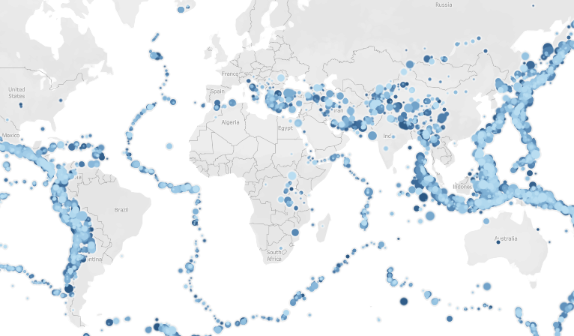

An earthquake is the shaking of the surface of the Earth resulting from a sudden release of energy, which makes plate move. We can see in graph that the earthquake is more frequent in the adjacent of the plate especially west of South America and the eastern part of South Asia.

Earthquakes can range in magnitude from being so weak that they cannot be felt to those violent enough to toss people around and destroy whole cities. Since there are hundreds of earthquakes happening each day and most of them are hard to detect by human, the data set we use has earthquake records of magnitude above 5.5.

This dataset involves different attributes like:

* Date
* Time
* Latitude
* Longitude
* Type
* Depth
* Depth Error
* Depth Seismic Stations
* Magnitude
* Magnitude Type
* Magnitude Error
* Magnitude Seismic Stations
* Azimuthal Gap
* Horizontal Distance
* Horizontal Error
* Root Mean Square
* ID
* Source
* Location Source
* Magnitude Source
* Status

**Insights:**

**Insight 1:**

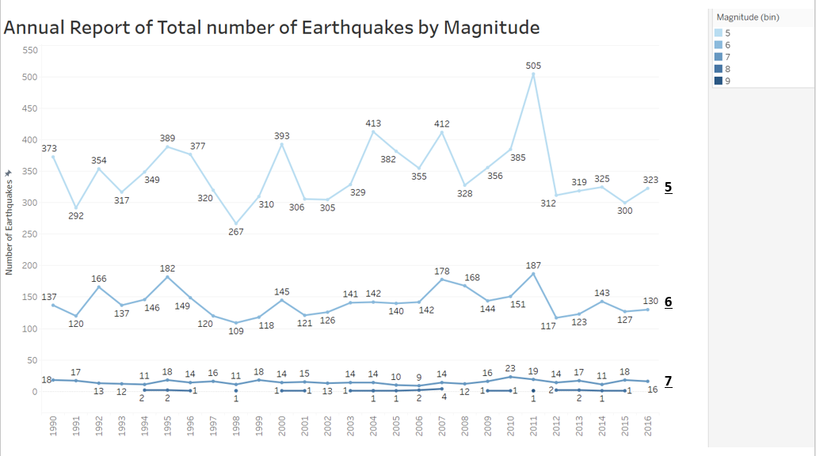

On average, there are 550 earthquake records of magnitude greater than 5.5 all over the world. Amongst them, 68% are under 6, 28% are from 6 to 7, and 4% are above 7.

The mean trend for the records of earthquake is a horizontal line, however, we can see that the variance of number of earthquakes decreases as the magnitude increase. When it is under 6 the number ranges from 260 to 500, and as the magnitude goes, we cannot observe much difference.

**Insight 2:**

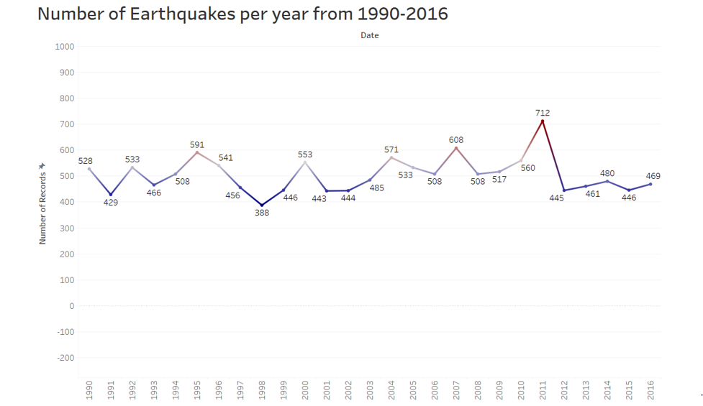

Here we have used color as visual attribute to represent number of earthquakes. Record with red color represents highest number of earthquakes while records with blue color represents lowest number of earthquakes. From this line graph we can say year 1998 which is represented in blue color has value 388 which is lowest number of earthquakes. while year 2011 which is represented in red color has value 713 which is highest number of earthquakes.

**Insight 3:**

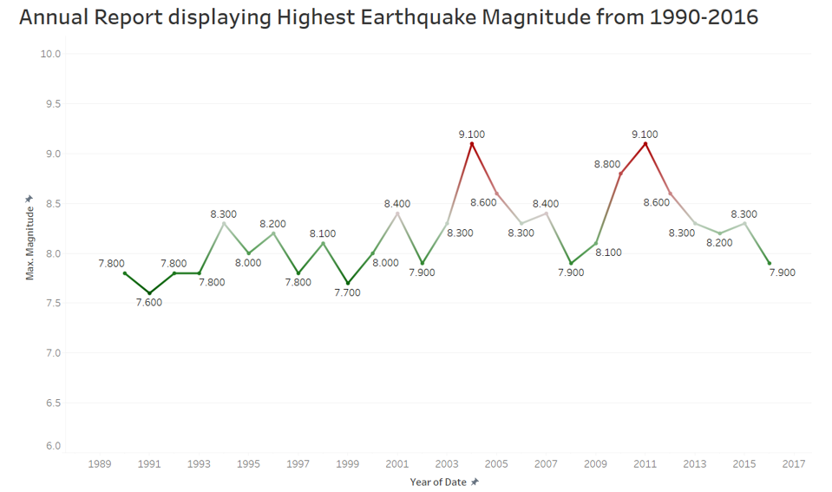

This is a line graph which represents maximum earthquake magnitude by year. Like our animation records, here color represent the approximate amount of earthquake magnitude. Records with higher magnitude are represented by dark red while re cords with comparatively low value of maximum magnitude are represented by green color. From this graph we can say highest magnitude lies between range 7.5-9.1. and from 1990-2003 we have lowest values of magnitude as we can see most of the records are represented in green color. Also, we can see that highest earthquake magnitude for both 2004 and 2011 is 9.1 which is quite high and more severe as compared to other years. While highest earthquake magnitude for 1991 is 7.6 which is lowest.

**Insight 4:**

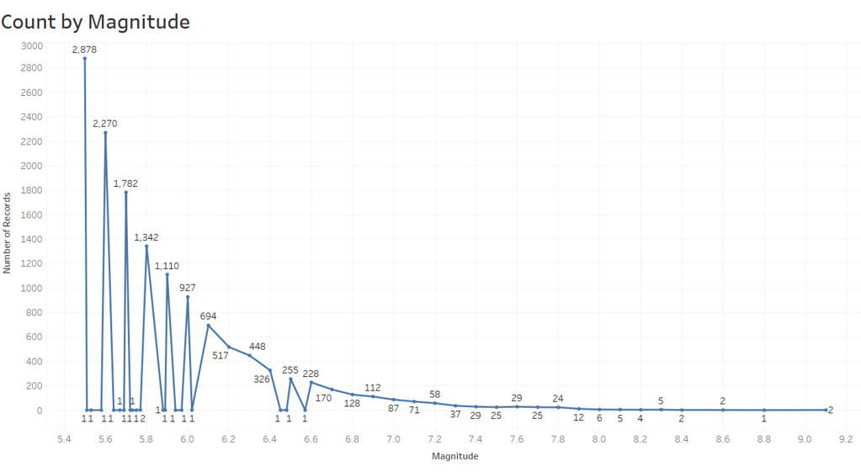

The following graph represents the total number of earthquakes of different magnitudes. We can clearly notice that the highest number of earthquakes are between 5.4 to 5.6 in magnitude and the least number of earthquakes are between 9.0 to 9.2 in magnitude. The earthquakes which are higher in magnitude are more devastating. The graph shows that there is a substantial decrease in number of earthquakes greater than 6.0 in magnitude.

**Insight 5:**

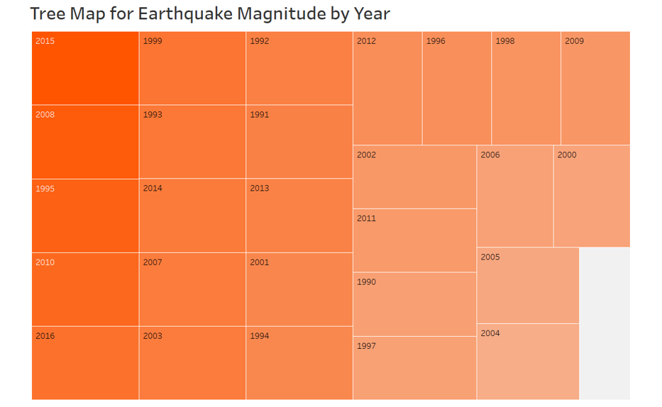

This is a tree map which represents the magnitude of earthquake every year. The rectangles with highest magnitude of earthquake are darker in shade and the ones which are lower in magnitude are lighter. We can notice that the year 2015 is darkest in shade and 2004 is lightest. This implies that in the year 2015 the earthquake with the highest magnitude occurred.

**Methods used to obtain Visualization:**

First, we have downloaded a raw dataset from Kaggle, then performed data processing to obtain clean dataset. Then we have used different visual attributes and methods from Tableau to create above visualizations and finally we have obtained above insights based on these visualizations.