UniLED Demo Task 3

“Campaign Feed”

Table of Contents
Version Control 1
Requirements 1
Database Schema 2
Implementation Schema 3
Implementation description 3
Deployment and testing workflow 5

Version Control
Version number: 1
Date: 25.08.2019 17:39

Requirements
Requirements taken from the following document provided:
UniLED Technical Test - UniLIVE Development – Confluence.pdf

Database Schema
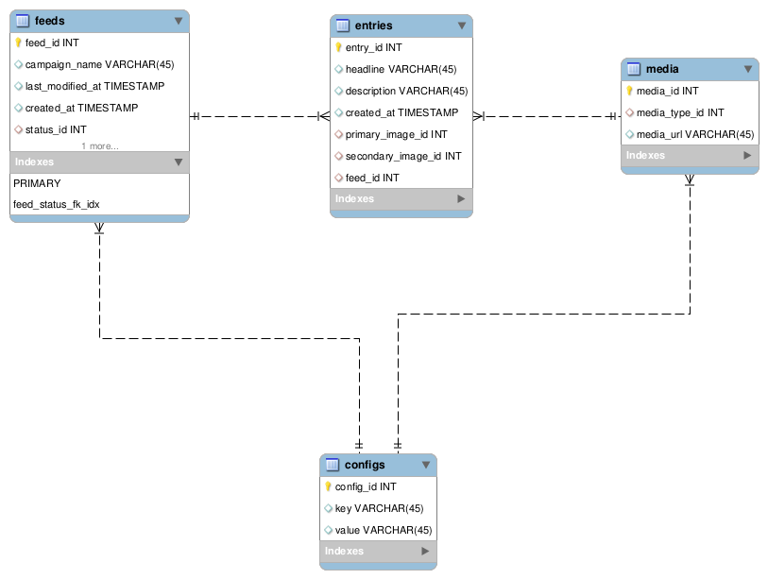

Implementation Schema
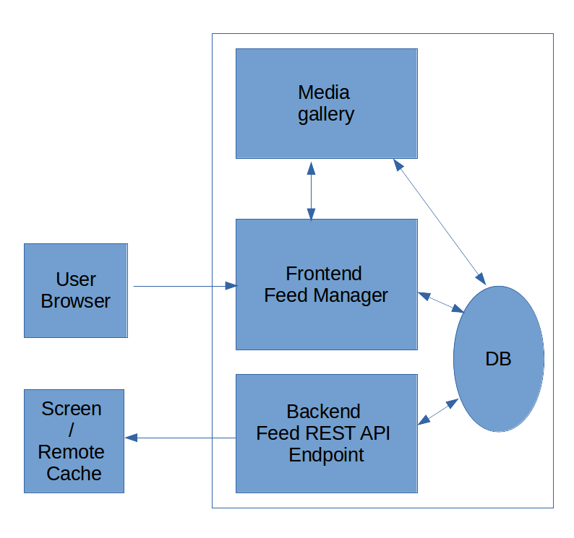

Implementation description

The “Campaign feed” platform consists of 2 layers: Application layer, Database layer. Apps in Application layer use Database layer as data source.
Application layer consits of the following apps:
- Web based frontend module called “Feed Configuration Manager”:
* has web interface implemented via Laravel MVC Framework or any other similar.
* allows a user create a new feed, enter feed details such as campaign_name, campaign description, populate feed news items either new item of duplicated from any of previously published campaigns.
* Uses FEED db table for storing feed records, ENTRIES db table for news items records. Each feed has one-to-many relationship with news items. For a new feed a single record with “new” status added, on save status changes to “publish”.
- Any previously “publish”ed feed news items can be edited and re-ordered. Implementation of such functionality with the platform can be done via adding so called “Versioning”, it needs additional db table called VERSIONS which will have One-to-one relations with FEED table and Many-to-one relations with ENTRIES table. On edit of any of existing feed it will create new record in VERSIONS table with version_id 1,2,3 and more and duplicate news items in ENTRIES table linked to VERSIONS.version_id. Another idea could be to have FEED_DURATIONS using date_from/date_to db fields.
- Web based frontend module called “Media gallery”:
* has web interface for image upload implemented via Laravel MVC Framework or any other similar.
* provides images to “Feed Configuration Manager” on news item create, allows choose either already uploaded image or let upload a new image
* keeps image urls in MEDIA db table, same image can be used more in more than one news item (Many-to-many relationship) with ENTRIES db table.
* Apart from images can support other than image media such has videos, etc.. MEDIA db table has media_type parameter for that purpose.
- HTTP protocol based backend REST API Endpoint:
* GET /feed?campaign_name=finchleyroad1 outputs JSON feed data
* Could implement Oauth authentication protocol to authenticate remote client such as remote cache or a remote screen.
* Reads only feeds with “publish” status
* FEED.last_modified_at field is set to “last modified” response in HTTP Response header as a parameter.

Deployment and testing workflow
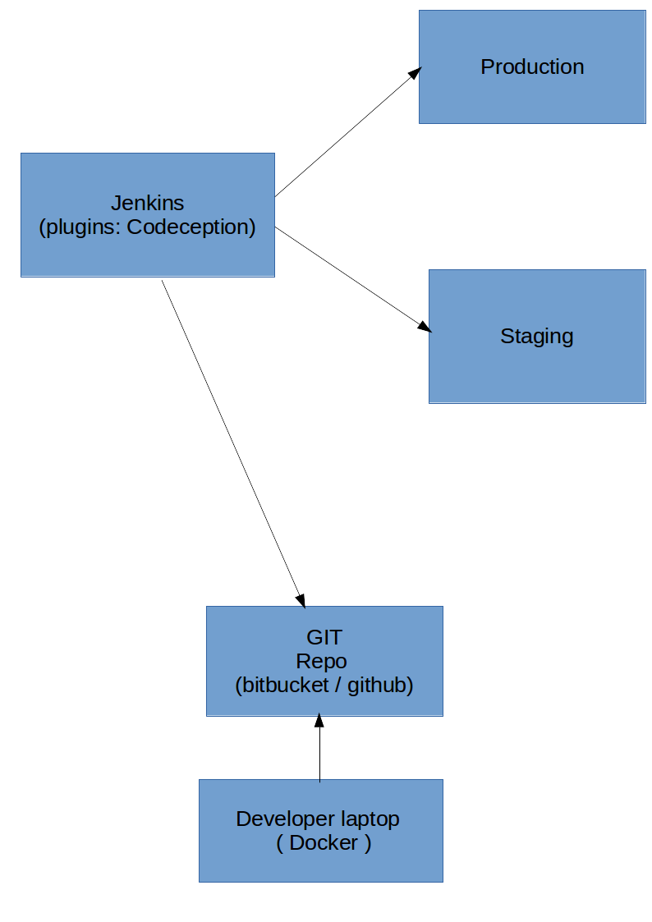
- A docker image, dockerfile (https://www.docker.com/) must be built from a production environment snapshot and a development must be done inside docker machine for compatibility with production environment.
- JIRA with Agile / Scrum dev. methodology can be used to track the development process. Stories produced in JIRA (on project Planning) can be split into sub-tasks for each particular unit of work. For each sub-task a separate branch can be forked from “develop” branch.
- A developer shall cover core-functionality described in sub-ticket by test(s). A test can be written using Codeception (https://codeception.com/) or Phpunit (https://phpunit.de/) and can be as minimum as unit test, ideally functional test. Also, a Selenium (https://www.seleniumhq.org/) can be used for autmation of functional test.
- Once a development done in sub-ticket branch it is pushed for “Code Review”. If it passes code review, it is merged into “develop” branch.
- Jenkins (https://jenkins.io/) used for continuous integration, it needs to be preconfigured for automation tests, deployment criterias. In general, it pulls a code from GIT repo, runs automation tests, in case tests fail it produces a report. Otherwise, it deploys “develop” branch to Staging / Test server for a review and manual End-user tests.
- At this stage QA Engineer runs own (could be Selenium) tests on Staging. In case tests are passed it is ready to be deployed to Production
- A release branch generated from latest “develop” branch, tagged and deployed to “master” branch. Jenkins deploys “master” branch to Production.
- Any post-deployment procedures such as cache clear, etc. shall be done at this stage

