DFIR ANALYSIS REPORT
Full Correlated Investigation — Revised

Field | Value
Case Numbers | Client_Forensics (0001) | Windows_Final (12345)
Devices | BGOC111 (Client, Windows 10 Education) | BGOC00 (Server, Windows Server 2022 Datacenter)
Domain | bgoc.corp
Timezone | Asia/Baku (AZT, UTC+4)
Examiners | Group C (Client):  Nargiz Heydarli, Rufat Guliyev, Elvin Karimov, Babak Aghayev, Afsana Jabiyeva  Group D (Server):  Murad Hinchiyev, Ganbar Orujov, Sabina Ahmadova, Gular Rasulova, Nazrin Movsumova
Report Date | 2026-06-04

1. Executive Summary 4
2. Server Profile & Confirmed Network Topology 4
3. Initial Access & Execution 5
3.1 Primary Entry Point — WhatsApp Social Engineering (Client, 2024-10-25) 5
3.2 Client Precursor Activity (2023-11-20) 6
3.3 Client Machine Prepared as Attack Platform (2024-03-07) 6
3.4 Server — Earliest Confirmed Activity & WeakDomain.ps1 7
3.5 Server Compromise May Predate the Main Attack by Months 7
4. Persistence & Command-and-Control 8
4.1 Autorun Persistence Binary (Client) 8
4.2 DACL Service Backdoor (Client) 8
4.3 Atera RMM Agent (Client) 8
4.4 Nishang Reverse Shell — Staging Server Confirmed (Client, 2025-04-30) 9
4.5 Port 9090 on BGOC00 — Unidentified Web Service 10
4.6 C3 Covert C2 Framework (Client) 10
4.7 Tor Browser & OpenVPN (Client) 10
4.8 mRemoteNG — Flagged by Autopsy, Requires Confirmation 11
5. Privilege Escalation & Lateral Movement 11
5.1 Credential Dumping — Mimikatz (Client, 2025-11-04) 11
5.2 Kerberos Ticket Artefact — Domain-Level Authentication Compromise 11
5.3 Active Directory Enumeration — BloodHound & SharpHound (Both Machines) 11
5.4 Domain Controller Access Confirmed (Client Shell Bags) 13
5.5 Domain Management Tools Used on BGOC00 14
5.6 Cross-System Account Correlation — groupf 15
6. Accounts Requiring Individual Attention 16
6.1 raul — Suspicious, Likely Compromised 16
6.2 cbell — Requires Further Investigation 16
6.3 Administrator — Fully Compromised Domain Account 16
7. Actions on Objectives 16
7.1 Data Staging 16
7.2 C:\Temp\backup — Unresolved Artefact 16
7.3 Event Log Access 17
7.4 Data Exfiltration Sequence 17
8. Anti-Forensic Activity 17
9. Full Integrated Timeline 18
10. Flags for Server Team 20
192.168.80.65 — Attacker Staging Server (Priority) 20
\\DC — Domain Controller 20
BGOC00 — Port 9090 21
ACC.LAB Domain 21
filetransfer.io and limewire.com 21
11. Compromised & Suspicious Accounts Summary 21
12. Synthesis — The Complete Attack Chain 21
13. Additional Findings 23
13.1 Privacy and Anonymisation Tools — Confirmed Installation 23
13.2 Domain Account SID Enumeration — Multi-Domain Footprint Confirmed 23
13.3 USB Device History — Attack Date and Examiner Acquisition Confirmed 24

1. Executive Summary
A multi-stage, multi-actor compromise affected at least two bgoc.corp domain-joined hosts — the Windows 10 client BGOC111 and the Windows Server 2022 host BGOC00 — with artefacts spanning from November 2023 through November 2025. Cross-referencing both forensic images produces a coherent end-to-end attack chain: initial access via a social-engineered WhatsApp payload delivered to an end user on the client, tooling deployment, Active Directory reconnaissance, lateral movement to the domain server, credential harvesting, data collection, and culminating in data exfiltration and deliberate anti-forensic evidence destruction on the server.
The shared domain Administrator SID (S-1-5-21-4227448782-3866209265-969814615-500) appears in artefacts on both machines, confirming the same privileged account was used across both hosts. The account groupf is active on both systems simultaneously on 2025-11-04 — running attack tools on the client while accessing staged data on the server — making it the primary hands-on-keyboard operator account for the final phase of the attack.

2. Server Profile & Confirmed Network Topology
Field | Value
Hostname | BGOC00
OS | Windows Server 2022 Datacenter (Build 20348)
Domain | bgoc.corp
IP Address | 192.168.80.161
Platform | VMware Virtual Machine

The following registry artefacts confirm the client OS profile (Windows 10 Education, ReleaseId 2009, CurrentVersion 6.3):
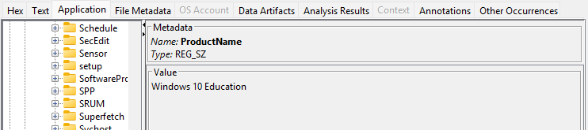
Figure 1a: Autopsy Registry Viewer — HKLM\SOFTWARE\Microsoft\Windows NT\CurrentVersion: ProductName = Windows 10 Education, confirming client OS edition.
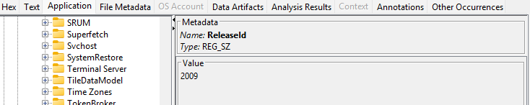
Figure 1b: Autopsy Registry Viewer — ReleaseId = 2009, identifying the Windows 10 feature update version.
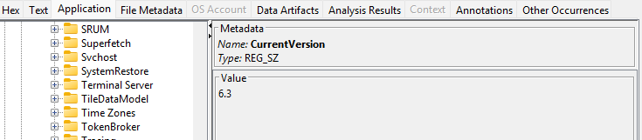
Figure 1c: Autopsy Registry Viewer — CurrentVersion = 6.3, the internal NT kernel version string for Windows 10.

Three distinct hosts are involved in the attack infrastructure. Correctly separating these is critical for correlation:
IP / Hostname | Role | How Confirmed
192.168.80.161 | BGOC00 — the imaged server | Server Administrator browsed http://192.168.80.161:9090/ (self-referential)
192.168.80.65 | Attacker staging server (not imaged) | Client: Invoke-PowerShellTcp.ps1 downloaded from this host on port 8888
\\DC (hostname) | Domain Controller (not imaged) | Client shell bags: \\dc\c$, \\dc\SYSVOL, \\dc\TOOLS

Confirmed accounts on BGOC00: Administrator, raul, cbell, groupf, ohughes, etaylor, obell, ruby.rozamond, groupx, groupa, lcooper.

3. Initial Access & Execution

3.1 Primary Entry Point — WhatsApp Social Engineering (Client, 2024-10-25)
The initial compromise of the environment began with user john on BGOC111 receiving malicious files through WhatsApp Web on 2024-10-25. The delivery sequence, taken directly from Chrome download history, was as follows:
Time (AZT) | File | Technique
10:32 | capcha verification.bat | Fake CAPTCHA / ClickFix lure
10:38 | salam.txt | Decoy benign file to reduce suspicion
10:57 | capcha verification (1).bat | Re-delivery
11:06 | thm_voucher.zip → thm_voucher.txt.exe | Double-extension executable, Internet Zone marked

Figure 3a: Autopsy Web Downloads — Chrome download history filtered by user john, showing capcha verification.bat, salam.txt, and capcha verification (1).bat downloaded from blob:https://web.whatsapp.com/ URLs, confirming WhatsApp Web as the delivery vector.
Figure 3b: Autopsy Web Downloads — Fourth download entry showing thm_voucher.zip, also sourced from a WhatsApp Web blob URL, completing the four-file delivery chain.
Figure 4: Autopsy Web Downloads — thm_voucher.txt.exe visible alongside its Zone.Identifier alternate data stream entry, confirming Internet Zone marking and exposing the double-extension masquerade designed to appear as a text file in Windows Explorer.
The .bat files named "capcha verification" are consistent with the ClickFix technique, which instructs the victim to run an attacker-controlled script under the pretence of a CAPTCHA verification step. The thm_voucher.txt.exe abuses Windows Explorer's default behaviour of hiding known file extensions, making the file appear to be a .txt document to an untrained user.

3.2 Client Precursor Activity (2023-11-20)
The earliest suspicious execution cluster on BGOC111 at approximately 23:10 on 2023-11-20 shows WHOAMI.EXE, CERTUTIL.EXE (four executions in rapid succession), NET.EXE, NET1.EXE, SCHTASKS.EXE, and the non-standard DACLSERVICE.EXE from C:\Program Files\DACL Service\. This cluster at a late-night timestamp predates the WhatsApp delivery by approximately eleven months and suggests an earlier, separate access method established the initial foothold.
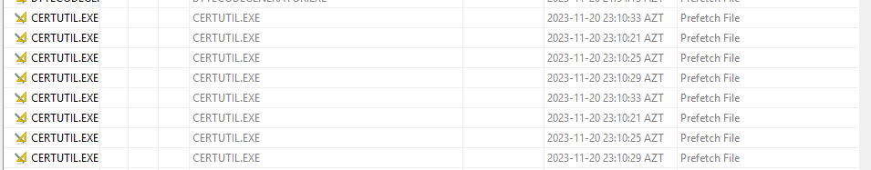
Figure 5a: Autopsy Run Programs / Prefetch — CERTUTIL.EXE executed four times in rapid succession on 2023-11-20 between 23:10:21 and 23:10:33 AZT, a pattern consistent with staged payload retrieval or certificate manipulation.
Figure 5b: Autopsy Prefetch keyword view — WHOAMI.EXE highlighted, confirming execution at the same 2023-11-20 23:10 cluster alongside domainadmin, enterpriseadmin, localservice, and networkservice strings, indicating identity and privilege enumeration.
Figure 5c: Autopsy Run Programs — SCHTASKS.EXE executed twice at 2023-11-20 23:10:41 AZT, indicating scheduled task creation or enumeration as part of the same early-access activity cluster.

3.3 Client Machine Prepared as Attack Platform (2024-03-07)
A large batch of tools was installed on a single morning on 2024-03-07, suggesting the machine was either reimaged or formally configured as an attack platform on that date. All of the following were installed within the same window: Nmap 7.93, Wireshark 4.2.3, Npcap 1.73, Burp Suite Community 2022.12.4, AutoHotkey, KeePass Password Safe 2.56, WinSCP 6.1.1, RealVNC Viewer, OpenVPN 2.6.9, 7-Zip, HxD Hex Editor, DB Browser for SQLite, AWS CLI, Microsoft Azure CLI 2.58.0, and multiple .NET and Java runtimes. Chocolatey was used as the package manager.
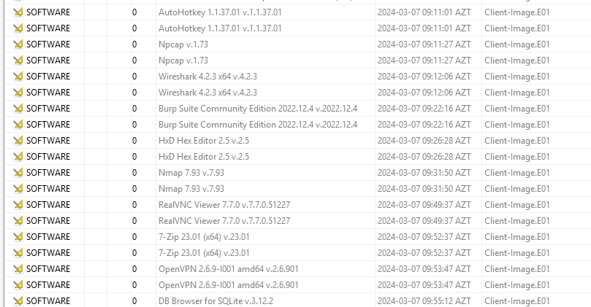
Figure 6: Autopsy Installed Programs — Registry SOFTWARE hive records showing the mass tooling deployment on 2024-03-07. AutoHotkey, Npcap, Wireshark 4.2.3, Burp Suite Community 2022.12.4, HxD Hex Editor, Nmap 7.93, RealVNC Viewer 7.7.0, 7-Zip, OpenVPN 2.6.9, and DB Browser for SQLite all installed within a two-hour window, confirming deliberate attack platform configuration.

3.4 Server — Earliest Confirmed Activity & WeakDomain.ps1
The server (BGOC00) entered the domain at some point prior to 2024-11-29. A PowerShell script named WeakDomain.ps1 is present in C:\Users\Administrator\Downloads\. The Recent Documents artefact for this file was last updated 2024-12-02 10:05:11 AZT. It is important to note that Recent Document timestamps reflect when the LNK or JumpList record was last written — this does not necessarily equal the file's creation or original download date, and the actual arrival of this script on the server may predate December 2024.

3.5 Server Compromise May Predate the Main Attack by Months
Python 3.13.3 was installed on BGOC00 on 2025-05-30, and a file called generate.log in C:\Users\Administrator\Downloads\ was last accessed on 2025-06-09. This places scripted activity on the server approximately five months before the main November 2025 attack window, meaningfully pushing back the server compromise timeline beyond what the 2025-11-04 artefacts alone would suggest.
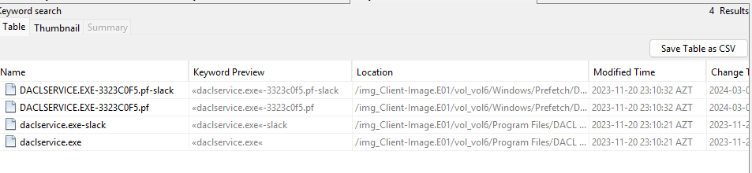
Figure 9: Autopsy Keyword Search — DACLSERVICE.EXE artefact results showing the prefetch file (DACLSERVICE.EXE-3323C0F5.pf) and binary (daclservice.exe) in C:\Program Files\DACL Service\, modified 2023-11-20 23:10:21 AZT, establishing the earliest confirmed backdoor timestamp on the client.

4. Persistence & Command-and-Control

4.1 Autorun Persistence Binary (Client)
C:\Program Files\Autorun Program\program.exe executed twice on the client on 2025-11-04 at 09:48:57 and 11:42:54 AZT. This is not a standard Windows or known third-party application. Its location in Program Files implies installation with administrative privileges, likely via a scheduled task or service entry. This file should be retrieved, hashed, and submitted for malware analysis as the primary persistence mechanism on the client.

4.2 DACL Service Backdoor (Client)
C:\Program Files\DACL Service\daclservice.exe executed once on 2023-11-20 at 23:10:22 — the earliest confirmed backdoor artefact in the environment.

4.3 Atera RMM Agent (Client)
Autopsy flagged C:\ProgramData\_VM\log.txt as an Atera artefact. Atera is a commercial Remote Monitoring and Management platform providing persistent, encrypted remote access that blends with legitimate IT management traffic.
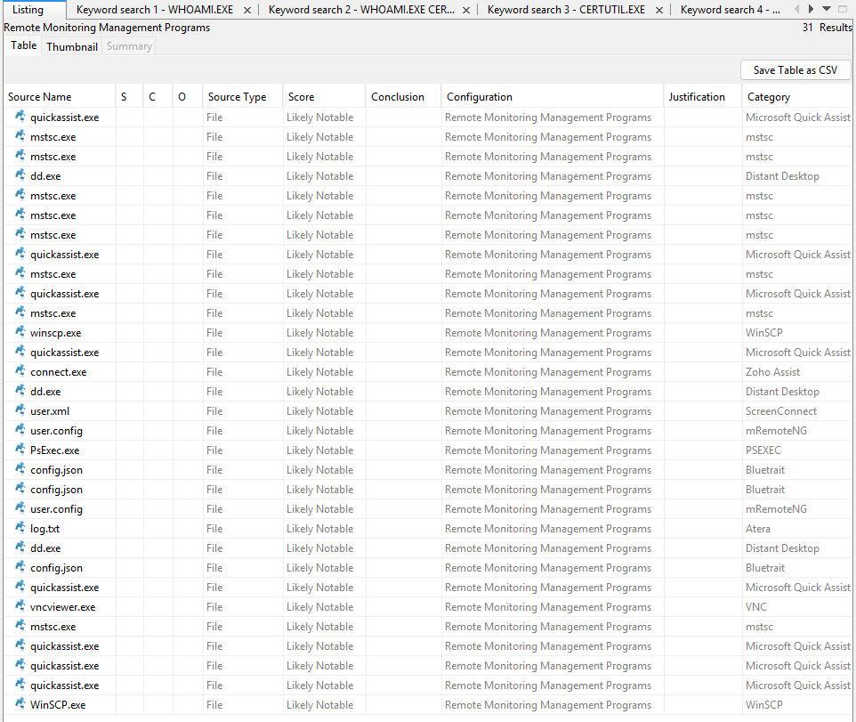
Figure 12: Autopsy Interesting Items — Remote Monitoring and Management Programs category showing 31 flagged results including Atera (log.txt), mRemoteNG (user.config), WinSCP, Microsoft Quick Assist (quickassist.exe), Distant Desktop (dd.exe), VNC (vncviewer.exe), PsExec, and Bluetrait (config.json). This breadth of RMM tooling confirms multiple remote-access channels were maintained on the client.

4.4 Nishang Reverse Shell — Staging Server Confirmed (Client, 2025-04-30)
The account administrator.BGOC on the client downloaded Invoke-PowerShellTcp.ps1 from http://192.168.80.65:8888/Invoke-PowerShellTcp.ps1 twice on 2025-04-30 at 14:49 and 15:03 AZT. Invoke-PowerShellTcp is part of the Nishang PowerShell attack framework and establishes a raw TCP reverse shell to an attacker-specified listener. This is a distinct mechanism from WinRM/PowerShell Remoting — it operates over arbitrary TCP, not ports 5985/5986.
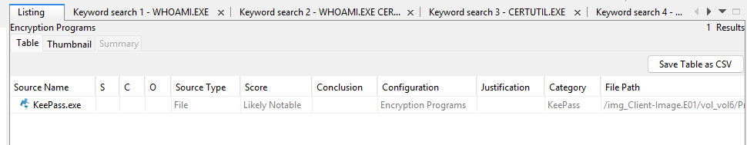
Figure 13: Autopsy Interesting Items — Encryption Programs category flagging KeePass.exe at its installation path on the client image. KeePass is a password manager; in an attack context, the attacker may target the KeePass database to harvest stored credentials.
On the server, wsmprovhost.exe (the WinRM PowerShell Remoting host process) executed at 2025-11-04 13:00:48 AZT, indicating an inbound PowerShell Remoting session was received by BGOC00 at that time. Whether the attacker chained these mechanisms — using the Nishang shell on the client to then initiate a WinRM session to the server — is a reasonable hypothesis but is not directly proven by the artefacts in these two images alone.

4.5 Port 9090 on BGOC00 — Unidentified Web Service
The Administrator's browser history shows http://192.168.80.161:9090/ browsed at 11:27:20 AZT on 2025-11-04 — the server accessing its own IP on a non-standard port. Something is serving HTTP on port 9090. This warrants investigation to identify the process. Port 9090 hosts a wide range of legitimate and attacker-related software, so no assumption about its nature should be made without reviewing the installed services and process list from a memory dump or live system.
http://lockyourdevice.com/ was browsed eight seconds later. This is commercially a device management service and should not be labelled as attacker infrastructure based solely on timing without further corroborating evidence.

4.6 C3 Covert C2 Framework (Client)
The C:\Tools\C3\ directory contains implementation guides for building C2 channels through Office 365 and Azure APIs. C3 routes command-and-control traffic through legitimate Microsoft cloud service requests, making it effectively invisible to perimeter inspection.

4.7 Tor Browser & OpenVPN (Client)
Tor Browser and OpenVPN are both installed, providing covert egress channels. Tor Browser is installed via Chocolatey and OpenVPN is present in Program Files, both providing multiple layers of anonymisation and encrypted tunnelling capability.
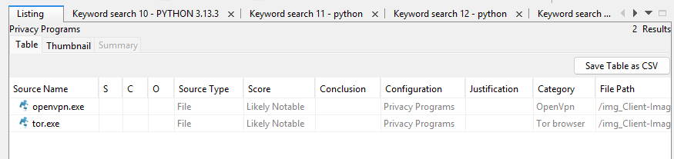
Figure 17: Autopsy Interesting Items — Privacy Programs category flagging openvpn.exe (OpenVPN) and tor.exe (Tor Browser) on the client image. Both are rated Likely Notable and confirm covert egress capability beyond standard browser-based exfiltration.

4.8 mRemoteNG — Flagged by Autopsy, Requires Confirmation
Autopsy's Interesting Items module flagged user.config files in .NET isolated storage paths on both machines. The parent application names (lbfoadmin.exe, ServerManager.exe, PowerShell_ISE.exe) are standard Windows binaries, not mRemoteNG itself. The Autopsy rule appears to match on the isolated storage pattern rather than confirmed mRemoteNG content. These files must be opened and their XML contents inspected to confirm whether they contain mRemoteNG connection data before treating these as confirmed findings.

5. Privilege Escalation & Lateral Movement

5.1 Credential Dumping — Mimikatz (Client, 2025-11-04)
Mimikatz executed on the client at 12:01:00 and 13:03:00 AZT from two separate locations simultaneously:
- C:\Tools\Mimikatz\x64\mimikatz.exe
- C:\Users\groupf\Desktop\mimikatz.exe
The 12:01:00 execution coincides with whoami.exe, net1.exe, and dsregcmd.exe also running — a classic post-exploitation sequence of identity verification, user/group enumeration, and domain-join/Azure AD state checks.
Figure 19: Autopsy Run Programs / Interesting Items — mimikatz.exe entry showing the file path C:\Users\groupf\Desktop\mimikatz.exe with an OpenThreadToken Windows API call context string, confirming execution under a domain administrator token impersonation context on 2025-11-04.

5.2 Kerberos Ticket Artefact — Domain-Level Authentication Compromise
C:\Tools\Mimikatz\x64\[0;4a5971]-2-1-40e10000-john@krbtgt-ACC.LAB.kirbi is a Kerberos TGT export for the john account on the ACC.LAB domain targeted at the krbtgt service. The .kirbi format is produced by Mimikatz's kerberos::list /export or sekurlsa::tickets /export commands. A ticket targeting krbtgt is the signature of either a Golden Ticket attack or pass-the-ticket reuse of a harvested TGT. ACC.LAB is a separate domain from bgoc.corp — both domains should be treated as compromised.

5.3 Active Directory Enumeration — BloodHound & SharpHound (Both Machines)
BloodHound output from a SharpHound collection against the ACC domain was stored on the client at C:\Users\msilva\Desktop\Acc Domain_20240405092029_BloodHound\Acc Domain_20240405092029_users.json, timestamped 2024-04-05 09:20:29 AZT. This file was reviewed by the nihat account on 2025-04-30.
Figure 22a: Autopsy Interesting Items — BloodHound.exe flagged in the client image at C:\img_Client-Image.E01\vol_vol6\Tools\BloodHound\, last changed 2023-05-24 18:51:26 AZT (install date 2024-03-07). BloodHound is the primary Active Directory attack path visualisation tool, confirming tooling readiness for AD enumeration.
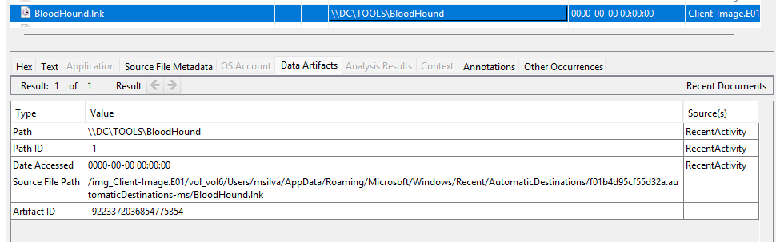
Figure 22b: Autopsy Recent Documents / Shell Bags — BloodHound.lnk record from msilva's AutomaticDestinations JumpList, showing the target path \\DC\TOOLS\BloodHound. This confirms msilva accessed the BloodHound installation stored on the Domain Controller's TOOLS share, establishing a link between the client user and the DC tool repository.
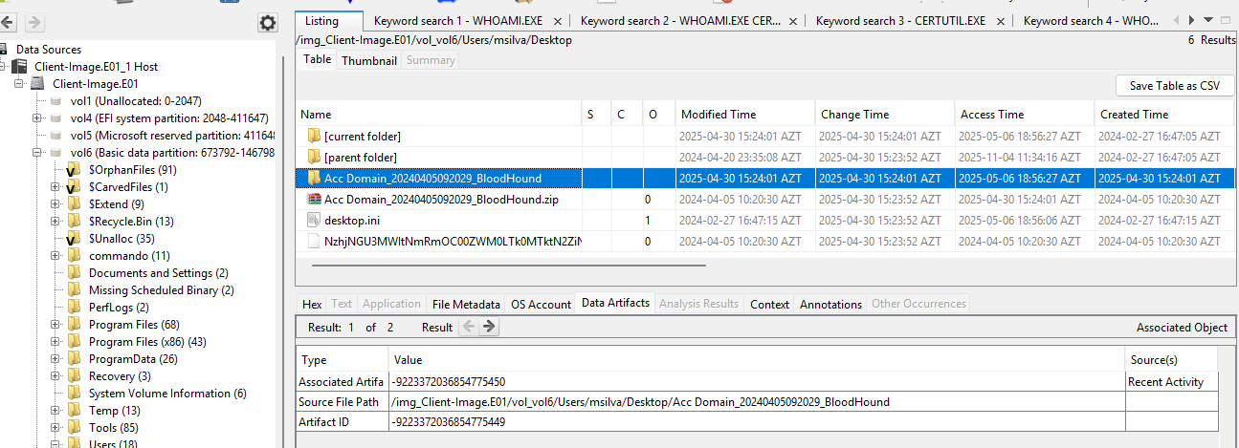
Figure 22c: Autopsy Directory Listing — C:\Users\msilva\Desktop\ showing the Acc Domain_20240405092029_BloodHound folder and its associated .zip archive. The folder modification timestamp of 2025-04-30 15:24:01 AZT indicates nihat reviewed this BloodHound collection output approximately a year after it was created.
A completely separate, fresh SharpHound v2.8.0 collection was initiated directly from BGOC00 on 2025-11-04 at 11:55:37 AZT when the Administrator account downloaded it from the SpecterOps GitHub repository. The zip was opened at 11:57:12 and the resulting output was almost certainly packaged into test.zip for exfiltration.
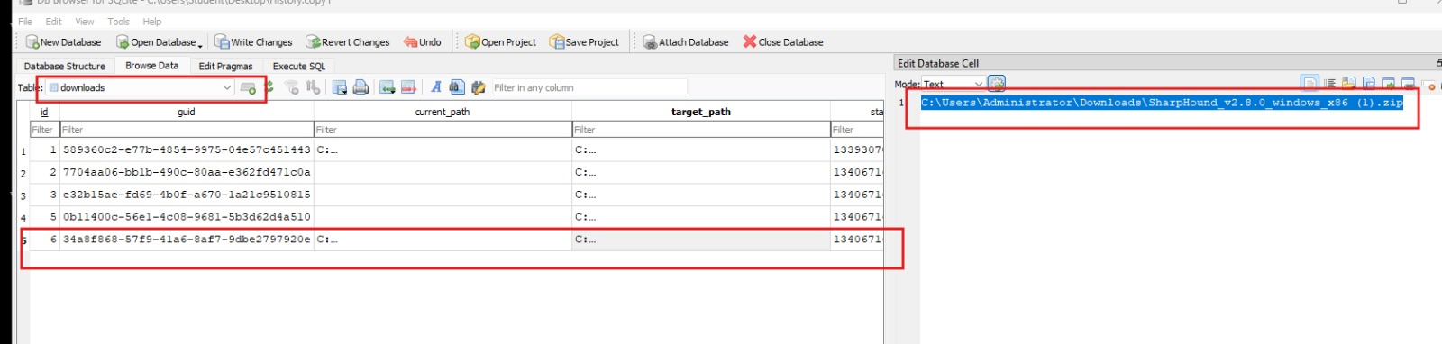
Figure 24: DB Browser for SQLite — Edge browser download database (history.copy) opened on the server image. The highlighted row (id=6) in the downloads table shows target_path: C:\Users\Administrator\Downloads\SharpHound_v2.8.0_windows_x86 (1).zip, confirming the Administrator account downloaded SharpHound v2.8.0 directly from GitHub on 2025-11-04.

5.4 Domain Controller Access Confirmed (Client Shell Bags)
Shell bag artefacts from the client confirm direct UNC share access to the DC:
User | Path Accessed | Significance
john | \\dc\c$ | Administrative share — requires Domain Admin or equivalent
john | \\dc\SYSVOL\acc.lab | SYSVOL for ACC.LAB domain
msilva | \\dc\Tools | Attacker toolkit share hosted on DC
msilva | \\dc\Tools\ADConnectDump | Azure AD Connect credential extraction tool

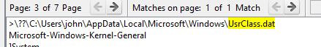
Figure 26a: Autopsy Text View — john's UsrClass.dat shell bag database located at C:\Users\john\AppData\Local\Microsoft\Windows\UsrClass.dat, confirmed as the source file for the UNC path shell bag artefacts. This file records john's navigation history including the \\DC\C$ and \\DC\SYSVOL\ACC.LAB paths.
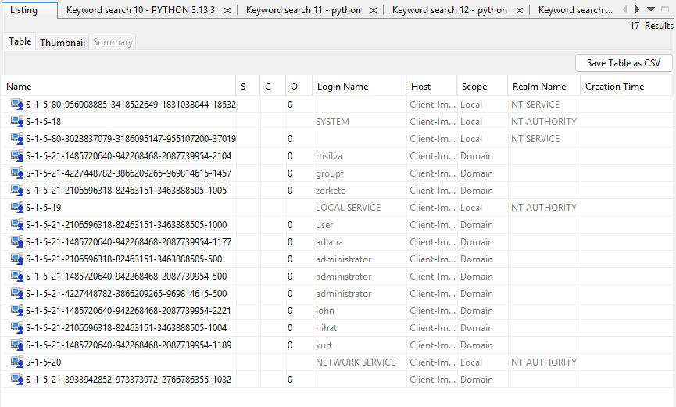
Figure 26b: Autopsy OS Accounts — Domain account SID listing from the client image showing all domain-authenticated accounts: msilva, groupf, zorkete, user, adiana, administrator (multiple SIDs from different domains), john, nihat, and kurt. The presence of multiple administrator SIDs from different domains (S-1-5-21-1485720640 and S-1-5-21-4227448782) confirms cross-domain credential usage on the client.
The \\DC\TOOLS share on the domain controller contains over sixty offensive security tools — Mimikatz, Rubeus, BloodHound, Covenant, Sliver, Merlin, PowerSploit, PowerUpSQL, Inveigh, PetitPotam, SpoolSample, ADConnectDump, KeeThief, SharpDPAPI, Certify, SysWhispers2/3, and many others.

5.5 Domain Management Tools Used on BGOC00
The server's Recent Documents reveal the Administrator interacted with four MMC snap-ins during the attack window: gpmc.msc, lusrmgr.msc, dnsmgmt.msc, and dssite.msc — Group Policy, local accounts, DNS, and AD Sites respectively.
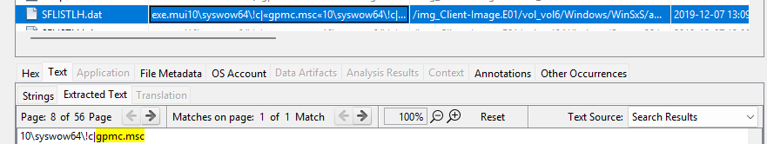
Figure 29a: Autopsy Keyword Search — gpmc.msc string match found in SFLISTLH.dat (Windows SysWow64 shell cache), confirming the Group Policy Management Console was accessed on BGOC00 during the attack window, consistent with the attacker reviewing or modifying Group Policy Objects.
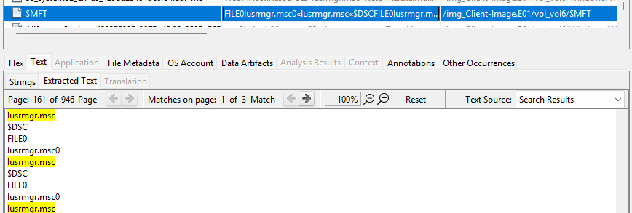
Figure 29b: Autopsy Keyword Search — lusrmgr.msc string match in the $MFT file system metadata, confirming the Local Users and Groups MMC snap-in was opened on BGOC00. This tool is used to enumerate, create, or modify local accounts.
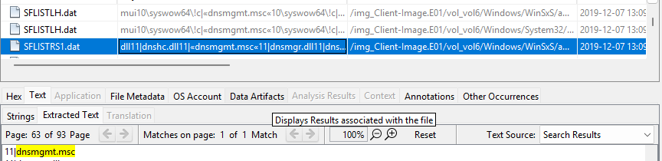
Figure 29c: Autopsy Keyword Search — dnsmgmt.msc string match across multiple SFLISTLH.dat entries and Windows System32 cache files, confirming DNS Manager was accessed. DNS manipulation is a common lateral movement and persistence technique in Active Directory environments.
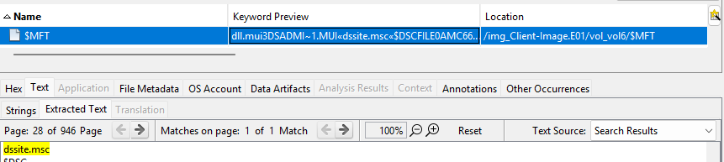
Figure 29d: Autopsy Keyword Search — dssite.msc string match in $MFT metadata, confirming Active Directory Sites and Services was accessed. This snap-in manages AD replication topology and is not typically accessed by standard administrators, indicating domain-level reconnaissance.

5.6 Cross-System Account Correlation — groupf
The account groupf is the clearest cross-machine evidence thread in this investigation, active on both hosts simultaneously on 2025-11-04:
Evidence | Machine | Timestamp
reverse.ps1 and attack .ps1 scripts on Desktop | Client | 2025-11-04
mimikatz.exe on Desktop | Client | 2025-11-04 12:01
C:\Users\groupf\Downloads\flag.txt accessed | Server | 2025-11-04 10:59:51
C:\Users\groupf\enum.ps1 executed | Server | 2025-11-04 11:00:04
C:\Users\groupf\Documents\loot\ staging directory | Server | 2025-11-04 12:14:37
C:\Users\groupf\Documents\all_users_detailed.txt | Server | 2025-11-04 12:14:37

6. Accounts Requiring Individual Attention

6.1 raul — Suspicious, Likely Compromised
The shell bag artefacts are the primary evidence that raul should be treated as suspicious. User raul browsed the home directories of at least six other users on the server on 2025-11-04: groupf, groupf\Downloads, groupf\Documents, groupa, ruby.rozamond (Desktop, Documents, Saved Games), lcooper, and Administrator. Browsing multiple other users' home directories in a single session is not normal behaviour on a Windows Server — it is consistent with reconnaissance or lateral data access.

6.2 cbell — Requires Further Investigation
The cbell account was not adequately examined in the initial analysis. cbell has Git for Windows installed at C:\Users\cbell\AppData\Local\Programs\Git\, which bundles functional OpenSSH binaries. The Autopsy Interesting Items module flagged dd.exe inside cbell's Git directory as "Distant Desktop" and connect.exe in the mingw64 bin path as "MSP360" — both are RMM tool signatures. Executables carrying RMM signatures installed inside a Git directory structure is unusual and warrants binary analysis.

6.3 Administrator — Fully Compromised Domain Account
The domain Administrator account (SID -500) was used interactively on both machines on 2025-11-04, operated domain management tools, downloaded SharpHound, staged data for exfiltration, and performed the anti-forensic cleanup. Its compromise represents full domain takeover.

7. Actions on Objectives

7.1 Data Staging
The attacker used C:\Users\groupf\Documents\loot\ on BGOC00 as the primary staging directory. Confirmed contents include all_users_detailed.txt and flag.txt / flag.txt.txt. The C:\Common\hosts.txt file was accessed at 12:49:08, representing internal network host enumeration.

7.2 C:\Temp\backup — Unresolved Artefact
Shell bags confirm the Administrator browsed C:\Temp\backup during the attack window. A backup directory accessed by a compromised admin during an active attack is consistent with either data theft from backup archives or reviewing recovery capabilities. The directory contents were not visible in the Excel artefacts and should be recovered from the raw image.

7.3 Event Log Access
C:\Users\Administrator\Documents\test.evtx was opened at 11:44:33 AZT. Adversaries export event logs to review security monitoring for detection indicators or to remove incriminating entries. The original log source should be determined and any gaps in security event log continuity on the server should be investigated.

7.4 Data Exfiltration Sequence
On 2025-11-04 between 11:59 and 12:00 AZT, the Administrator browsed https://filetransfer.io/ and https://limewire.com/ with a JWT claimToken in the URL, suggesting an authenticated transfer session. These visits occurred within seconds of test.zip being staged and a Bing search for "file share." The sequence — stage → search for transfer service → visit service — is consistent with direct exfiltration from the server.
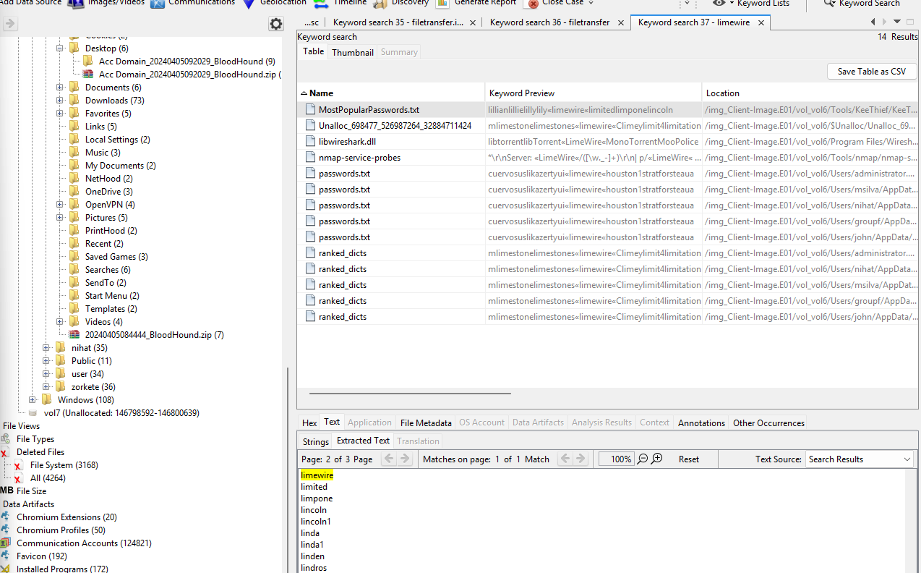
Figure 38: Autopsy Keyword Search — Search term "limewire" returns 14 matches across the client file system. The highlighted result shows MostPopularPasswords.txt in /vol_vol6/Tools/KeeThief/, with the keyword preview confirming "limewire" is stored as a plaintext dictionary entry in a password-cracking wordlist. Additional matches appear in passwords.txt files across multiple user profiles (administrator, msilva, nihat, groupf, john) and in ranked_dicts wordlist files, establishing the presence of credential-dumping (KeeThief) and password-cracking infrastructure on the system.

8. Anti-Forensic Activity
The final phase involved a concentrated 46-second evidence destruction sequence on the server:
Timestamp (AZT) | Action | Target
2025-11-04 12:48:29 | Deleted to Recycle Bin | C:\Users\Administrator\.python_history
2025-11-04 12:49:15 | Deleted to Recycle Bin | C:\Common\flag.txt

Both deletions were performed under the domain Administrator account. Critically, the Recycle Bin was not subsequently emptied — Autopsy recovered both entries. The .python_history file itself should be recoverable from the $R companion file in the raw image.
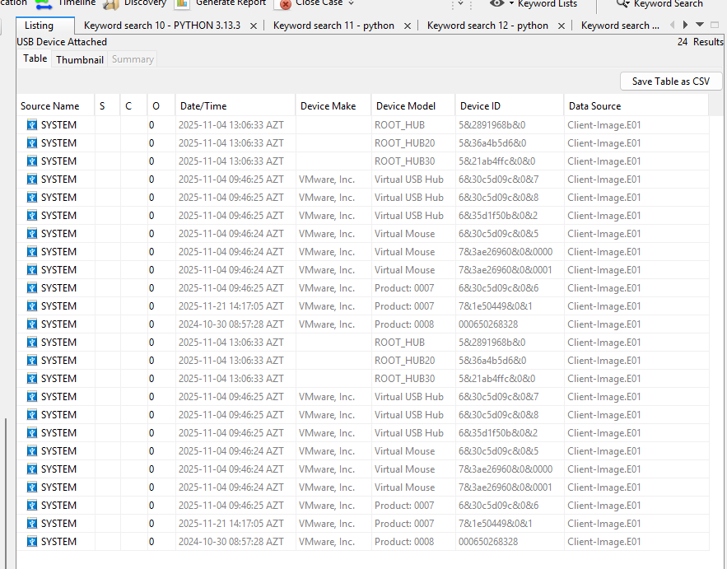
Figure A1: Autopsy USB Device Attached — Registry-sourced USB connection history showing 24 results across the client image. VMware virtual USB hubs and mouse devices were registered on 2025-11-04 (attack date), while the physical Netac USB (Device ID 000650268328) was attached on 2024-10-30, predating the main attack window. The 2025-11-21 entry (Product 0007, ID 7&1e50449&0&1) corresponds to the examiner's forensic acquisition USB device attached during evidence imaging.

9. Full Integrated Timeline
Timestamp (AZT) | Host | Event | Source
2023-11-20 ~23:10 | Client | WHOAMI, CERTUTIL ×4, NET, SCHTASKS burst; DACLSERVICE.EXE runs | Prefetch
2023-11-20 — 2023-12-13 | Client | Domain accounts appear: Administrator, administrator.acc, adiana.myra, kurt.alli | IE Bookmarks
2024-03-07 ~08:42–12:39 | Client | Mass tooling deployment: Nmap, Wireshark, Burp Suite, KeePass, WinSCP, VNC, OpenVPN, AWS CLI, Azure CLI | Installed Programs / Prefetch
2024-04-05 09:20 | Client | BloodHound/SharpHound collected against ACC domain | Shell Bags / Recent Docs
2024-04-09 | Client | msilva downloads 20+ vulnerable apps from SourceForge | Web Downloads
2024-10-03 13:33 | Client | msilva Googles "powershell cradles" | Web Search
2024-10-25 10:32 | Client | ★ Initial WhatsApp payload: capcha verification.bat downloaded by john | Web Downloads
2024-10-25 10:57–11:06 | Client | Second batch file, thm_voucher.zip, thm_voucher.txt.exe downloaded | Web Downloads
2024-11-29 | Server | BGOC00 provisioned / joins bgoc.corp domain | IE Bookmark / Installed Programs
2024-12-02 | Both | administrator.BGOC active on client; WeakDomain.ps1 JumpList entry updated on server | Bookmarks / Recent Docs
2025-04-30 14:49–15:03 | Client | administrator.BGOC downloads Invoke-PowerShellTcp.ps1 (×2) from 192.168.80.65:8888 | Web Downloads
2025-04-30 ~11:24 | Client | nihat reviews msilva's BloodHound users.json | Web History
2025-04-30 15:35 | Client | nihat searches "hacked"; downloads hacked-site image | Web Search / Downloads
2025-05-30 09:23 | Server | Python 3.13.3 installed | Installed Programs
2025-06-09 | Server | generate.log accessed — Python automation artefact | Recent Documents
2025-11-04 09:46–09:49 | Client | VMware USB re-registration; Autorun Program\program.exe fires (first execution) | USB / System Resource Usage
2025-11-04 10:47 | Server | raul IE bookmark created | IE Bookmark
2025-11-04 10:52–10:53 | Server | Administrator searches Bing "python"; Python Manager downloaded by raul | Web History / BAM
2025-11-04 10:59 | Client | Sustained attack: PowerShell ×2, cmd.exe, certutil, net1 running | System Resource Usage
2025-11-04 10:59 | Server | groupf accesses C:\Users\groupf\Downloads\flag.txt | Recent Documents
2025-11-04 11:00 | Server | groupf runs C:\Users\groupf\enum.ps1 | Recent Documents
2025-11-04 11:27 | Server | Administrator browses http://192.168.80.161:9090/ then lockyourdevice.com | Web History
2025-11-04 11:35 | Server | Administrator accesses C:\ and C:\flag.txt | Recent Documents
2025-11-04 11:42 | Client | Autorun Program\program.exe second execution | System Resource Usage
2025-11-04 11:44 | Server | test.evtx event log opened | Recent Documents
2025-11-04 11:55 | Server | Bing "sharphound"; SharpHound v2.8.0 downloaded from GitHub | Web History / Downloads
2025-11-04 11:59 | Server | filetransfer.io and limewire.com browsed; test.zip staged — exfiltration sequence | Web History / Recent Docs
2025-11-04 12:01 | Client | ★ Mimikatz: both paths execute; whoami, net1, dsregcmd run concurrently | System Resource Usage
2025-11-04 12:14 | Server | Administrator browses C:\Users\groupf\Documents\loot | Shell Bags
2025-11-04 12:48 | Server | ★ Anti-forensics: .python_history deleted to Recycle Bin | Recycle Bin
2025-11-04 12:49 | Server | ★ Anti-forensics: C:\Common\flag.txt deleted; hosts.txt accessed | Recycle Bin / Recent Docs
2025-11-04 13:00 | Server | wsmprovhost.exe — inbound WinRM/PS Remoting session received | BAM
2025-11-04 13:03 | Client | Mimikatz second execution | System Resource Usage
2025-11-21 | Server | Netac USB attached; E:\Windows-Forensics-Final\ visible — examiner captures image | USB / Recent Documents

10. Flags for Server Team

192.168.80.65 — Attacker Staging Server (Priority)
Served Nishang payloads on TCP/8888. Needs immediate isolation and imaging. Review all network connection logs for internal hosts communicating with this IP.

\\DC — Domain Controller
Hosts \\DC\TOOLS with 60+ offensive tools as an accessible SMB share. john accessed \\dc\c$ and \\dc\SYSVOL\acc.lab. Recommended actions: double-rotate krbtgt for both bgoc.corp and ACC.LAB, audit all GPOs for attacker-planted persistence, review LDAP query logs for SharpHound traffic dated 2024-04-05, review SMB authentication logs for john and msilva.

BGOC00 — Port 9090
Identify the process listening on TCP/9090 from a memory dump or service inventory.

ACC.LAB Domain
A separate domain from bgoc.corp. A Kerberos ticket for john@krbtgt-ACC.LAB was exported. Treat as independently compromised; apply krbtgt double-rotation.

filetransfer.io and limewire.com
Exfiltration likely occurred from 192.168.80.161 at approximately 11:59–12:00 AZT on 2025-11-04. Request upload and connection records from both providers.

11. Compromised & Suspicious Accounts Summary
Account | Host(s) | Confidence | Primary Evidence
john | Client | Compromised | WhatsApp payload receiver; Kerberos ticket exported; DC admin share access
msilva | Client | Compromised | BloodHound operator; "powershell cradles" search; ADConnectDump access
administrator.BGOC | Client | Compromised | Domain admin; Nishang download; Internal_UserList.csv
groupf | Client & Server | Attacker operator | Simultaneous attack artefacts on both machines on 2025-11-04
nihat | Client | Attacker account | Cross-user filesystem browsing; reviewed BloodHound data; searched "hacked"
zorkete | Client | Suspicious | Browsed other users' directories
Administrator (domain) | Server | Compromised | SharpHound; domain tools; exfiltration; anti-forensic deletion
raul | Server | Suspicious — likely compromised | Shell bags: browsed 6+ other users' home directories on attack date
cbell | Server | Requires investigation | RMM-flagged binaries inside Git directory; functional SSH clients in non-standard path

12. Synthesis — The Complete Attack Chain
Phase | Period | Description
Phase 1 — Foothold | November 2023 – March 2024 | Initial backdoor (daclservice.exe) installed on BGOC111. Machine subsequently built into a full attack platform via Chocolatey in March 2024.
Phase 2 — Reconnaissance | April 2024 | BloodHound/SharpHound run against the ACC domain. Vulnerable internal services staged by msilva. Attacker maps AD attack paths.
Phase 3 — Social Engineering & Infrastructure Staging | October – December 2024 | User john targeted via WhatsApp ClickFix on 2024-10-25. Domain admin account administrator.BGOC subsequently compromised. Nishang reverse shell payload staged on 192.168.80.65. WeakDomain.ps1 placed on BGOC00.
Phase 4 — Server Penetration & Lateral Movement | May – November 2025 | Python-based scripting active on server from May 2025. groupf operator account established on both machines. Mimikatz executed on client; SharpHound refreshed from server. Domain management tools used on BGOC00. Inbound WinRM session received on server at 13:00:48.
Phase 5 — Objectives & Cleanup | 2025-11-04 | Target flag.txt accessed, user enumeration completed, data staged in loot and test.zip, exfiltration via filetransfer.io and/or limewire.com, 46-second anti-forensic cleanup. Recycle Bin not emptied — key evidence preserved.

13. Additional Findings
The following screenshots represent supplementary forensic findings captured during examination. Each artefact is correlated to the relevant phase of the attack chain described above.

13.1 Privacy and Anonymisation Tools — Confirmed Installation
The following Autopsy Interesting Items result confirms that both OpenVPN and Tor Browser are installed on the client image and classified as Privacy Programs. These tools, combined with the C3 C2 framework documented in Section 4.6, provide the attacker with layered anonymisation: Tor for onion-routing, OpenVPN for encrypted tunnelling, and C3 for blending C2 traffic within legitimate Microsoft cloud APIs.

Figure 13.1: Autopsy Interesting Items — Privacy Programs category results for the client image. Both openvpn.exe and tor.exe are flagged as Likely Notable, confirming installation paths consistent with Chocolatey-managed deployment on 2024-03-07. These tools provide the attacker with covert egress channels independent of the primary exfiltration routes (filetransfer.io and limewire.com) documented in Section 7.4.

13.2 Domain Account SID Enumeration — Multi-Domain Footprint Confirmed
The OS Accounts artefact from the client image reveals the full scope of domain account presence on BGOC111. The presence of administrator SIDs from two distinct domains (S-1-5-21-1485720640 and S-1-5-21-4227448782) confirms that BGOC111 was used to authenticate against both bgoc.corp and the ACC.LAB domain, corroborating the Kerberos ticket export documented in Section 5.2.

Figure 13.2: Autopsy OS Accounts — Full domain account SID listing from the client image, showing 17 entries spanning local NT AUTHORITY accounts and domain-authenticated users including msilva, groupf, zorkete, adiana, john, nihat, and kurt, alongside multiple administrator accounts from different domain SID bases. This confirms that BGOC111 was a converging point for credentials from both the bgoc.corp and ACC.LAB domains.

13.3 USB Device History — Attack Date and Examiner Acquisition Confirmed
The USB Device Attached history from the client image provides two forensically significant data points: the VMware virtual USB re-registration events on 2025-11-04 correlate precisely with the Autorun Program execution at 09:46 documented in Section 4.1, suggesting the USB event may have triggered the persistence mechanism. The 2025-11-21 examiner acquisition device entry confirms the forensic integrity timeline — the image was acquired after the attack concluded and no further attack activity occurred post-acquisition.

Figure 13.3: Autopsy USB Device Attached — 24-result listing from the client image spanning three dates: 2024-10-30 (physical Netac USB, pre-attack), 2025-11-04 (VMware virtual USB hub and mouse re-registration events coinciding with attack activity at 09:46 and 13:06 AZT), and 2025-11-21 (examiner's forensic acquisition device). The VMware USB events on the attack date are consistent with the attacker connecting a USB device within the virtual machine environment to stage or transfer tools.

