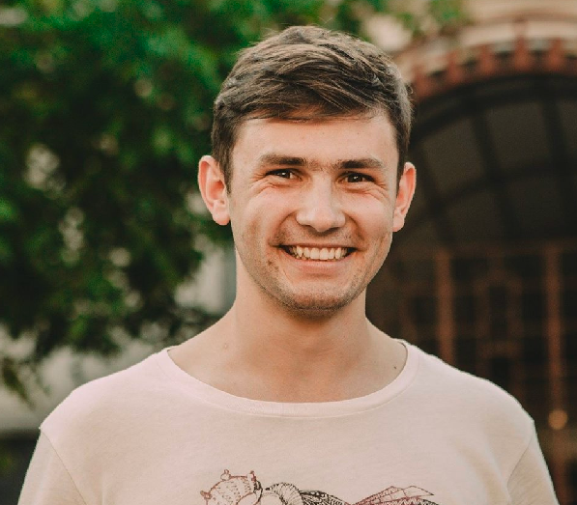
Gherman Adrian, 16.09.1997
Student, volunteer, cashier
Liviu Damian 52, MD 2059 Chisinau, Republic of Moldova
+37378553708
adrian.gherman1@gmail.com
https://www.facebook.com/adrian.gherman1997

Work experience:
Trainee | Pentalog CHI, Chisinau (Moldova)
• Organization of teamwork, with agile methodology, establishing tasks for each sprint, and making daily scrum (Stand-up meeting).
• Using GIT for better coding experience.
• Make user interface using Vue-js, Vue-Bootstrap, CSS, Javascript, HTML, AXIOS.
• Make web pages responsive with Vue-Bootstrap.
• Connect UI with Back-end using Axios
Cashier | SRL AVIX ART GROUP (Planeta Clounella), Chisinau (Moldova)
• Receive payment by cash, cheque, credit cards, vouchers.
• Issue receipts, refunds, credits or change to customers.
• Count money in cash drawers at the beginning of shifts to ensure that amounts are correct.
Volunteer coordinator | National League of Youth from Moldova Republic of
• Observe the work of volunteers to evaluate their performance and to recommend changes that could strengthen coordinating skills.
• Research, evaluate and prepare projects for community, instructional methods and material for projects.
• Team coordination, organization of team trainings.
Turists attendant | Panda Tur SRL
• Evaluate services received on the tour and report the problems to the administration.
• Lead individuals or groups to tour locations and describe points of interest.
• Solve worker problems or collaborate with employees to assist in the problem resolution.
• Maintain or verify records of time, materials.
Education and trainings:
Information technology | The Technical University of Moldova, Chisinau (Moldova) | 1 Sep 2017–Present
• Participated to Petit Festival des Sciences en Français 1-st and 2-nd editions.
• Participated to internship in Pentalog CHI company.

Tourism and hotel services | National College of Commerce, Academy of Economic Studies, Chisinau (Moldova) | 1 Sep 2013–30 Jun 2017
• Trainee at PandaTur, volunteer at LNTM.
• Graduated in top 30% of class.
• I participated at international youth forum in Penza Russian Federation
• I learned management, marketing and entrepreneurship
Extracurricular activities :
•International school of entrepreneurship organized by AUF (Agence universitaire de la Francophonie)
•Volunteering at “Innovatic Fest” organized by Orange Moldova
•Participation to webinars and afterworks organized by IT companies
•JavaScript certificate from SoloLearn

Skills:
Communication skills:
• Good communication skills gained through my experience as volunteer coordinator and through participation to conferences at university, and at internship.
• Excellent contact skills gained at internship as a trainee, and at my job as a cashier to children's spectacles
Organisational / managerial skills:
• Leadership (i was responsible for a team of 30 volunteers)
• Good organisational skills gained as trainee at IT company, working with Agile methodology.
• good team leading gained as participating as organiser to Tourism Festival 1-st edition and as volunteer at Ia-Mania festival.
Technical skills:
• Agile methodology, in the process of internship, we daily participate in the stand-ups, and we were making planings weekly.
• Beginner front-end developer, i can use GIT for better coding experience, make user interface using Vue-js, Vue-Bootstrap, CSS, Javascript, HTML, AXIOS.
• Use terminal in ubuntu 18.04
Languages
Romanian
Russian
French
English

