ORACLE

Sunday, June 30, 2024

7:09 PM

1 - Find the min of ALL_levels_active in DEPRESSION_BY_LEVEL_OF_EDUCATION Table :

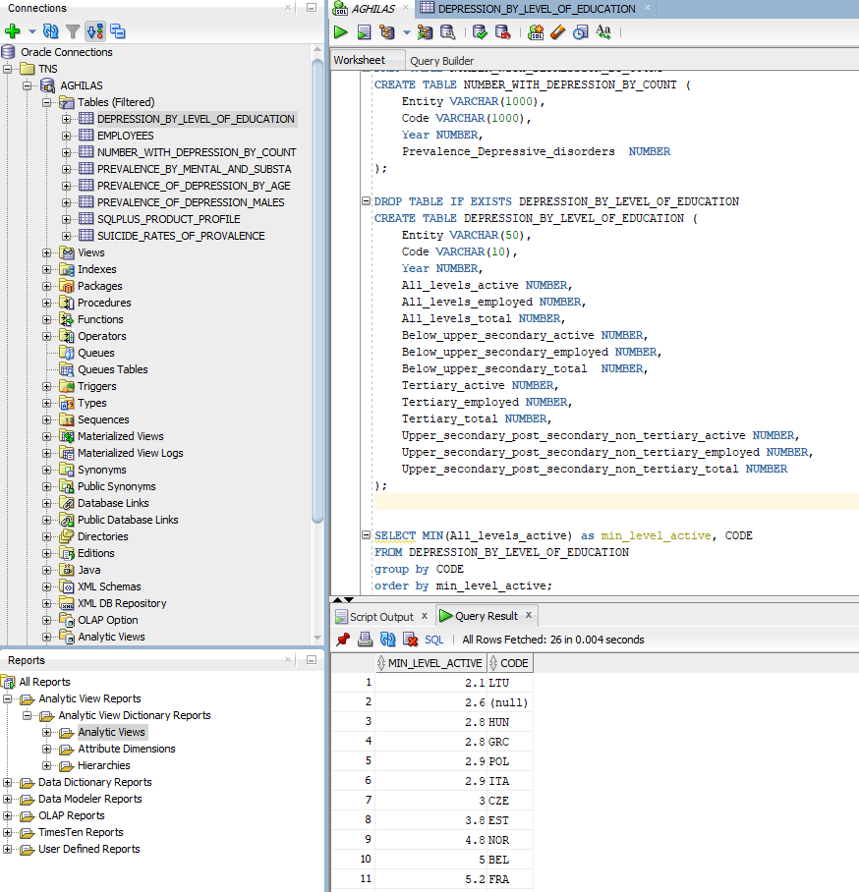

2 - Find the entites with the highest suicide rate in the year 2000 :

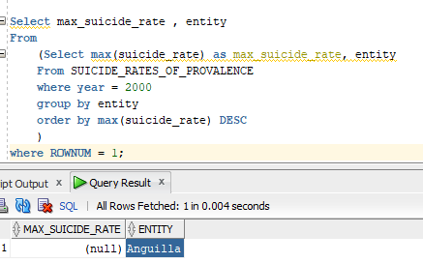

3 - Which entities have a higher prevalence of depression in female than males in the year 2010?" SQL Query Sentence:

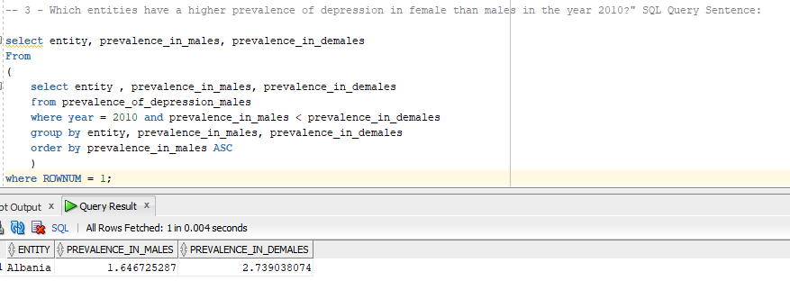

-- 4 - What is the average prevalence of depression by age for all entities in the year 2015?"

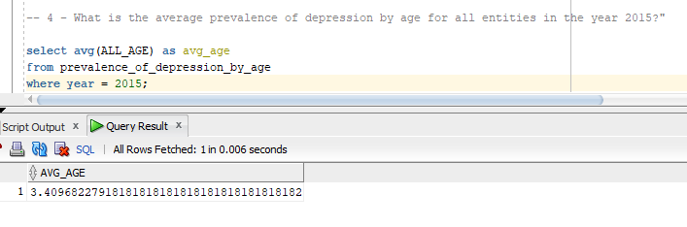

5 - Find the entities with the highest prevalence of schizophrenia and bipolar disorder in the year 2005."

