AI-Based Semiconductor Device Temperature Prediction
Capstone Project Report

1. Abstract
This project develops a machine-learning regression workflow to estimate semiconductor device temperature from electrical operating conditions and thermal-context features. A reproducible synthetic dataset is generated, three regression algorithms are compared, and the selected model is evaluated using MAE, RMSE, and R². The project includes reusable source code, a saved model, prediction outputs, and a dashboard.

2. Problem Statement and Objectives
Semiconductor junction temperature depends on ambient temperature, electrical loading, power dissipation, package and heat-sink thermal characteristics. The objective is to estimate device temperature from operating variables and compare predictions against reference temperatures.
- Generate or import operating data: current, voltage, ambient temperature, and load.
- Engineer power and interaction features that represent heating mechanisms.
- Train Random Forest, Gradient Boosting, and Linear Regression models.
- Compare MAE, RMSE, and R² on a held-out test set.
- Visualize prediction agreement and provide a reusable prediction interface.

3. Dataset and Feature Definitions
The included dataset contains 2400 synthetic samples. Each row represents one operating point. The target is device_temperature_C.
Feature | Unit | Description
current_A | A | Device current
voltage_V | V | Device operating voltage
ambient_temperature_C | °C | Ambient temperature
load_fraction | 0–1 | Normalized load
estimated_power_loss_W | W | Illustrative conduction + switching loss
thermal_resistance_C_per_W | °C/W | Illustrative thermal resistance
heat_sink_factor | unitless | Illustrative cooling/package multiplier
device_temperature_C | °C | Target/reference temperature
Engineered features: current squared, voltage-current product, and power loss normalized by load. The generated target uses a simplified thermal-rise relationship plus random noise.

4. Methodology
Data are split into 80% training and 20% test sets using a fixed random seed. Models are RandomForestRegressor, GradientBoostingRegressor, and a scaled LinearRegression pipeline. The model with the lowest test RMSE is saved for subsequent inference.

5. Results
Model | MAE (°C) | RMSE (°C) | R²
Random Forest | 1.244 | 1.848 | 0.9643
Gradient Boosting | 1.139 | 1.652 | 0.9714
Linear Regression | 1.228 | 1.699 | 0.9698
Selected model: Gradient Boosting. Its metrics are MAE 1.139 °C, RMSE 1.652 °C, and R² 0.9714.
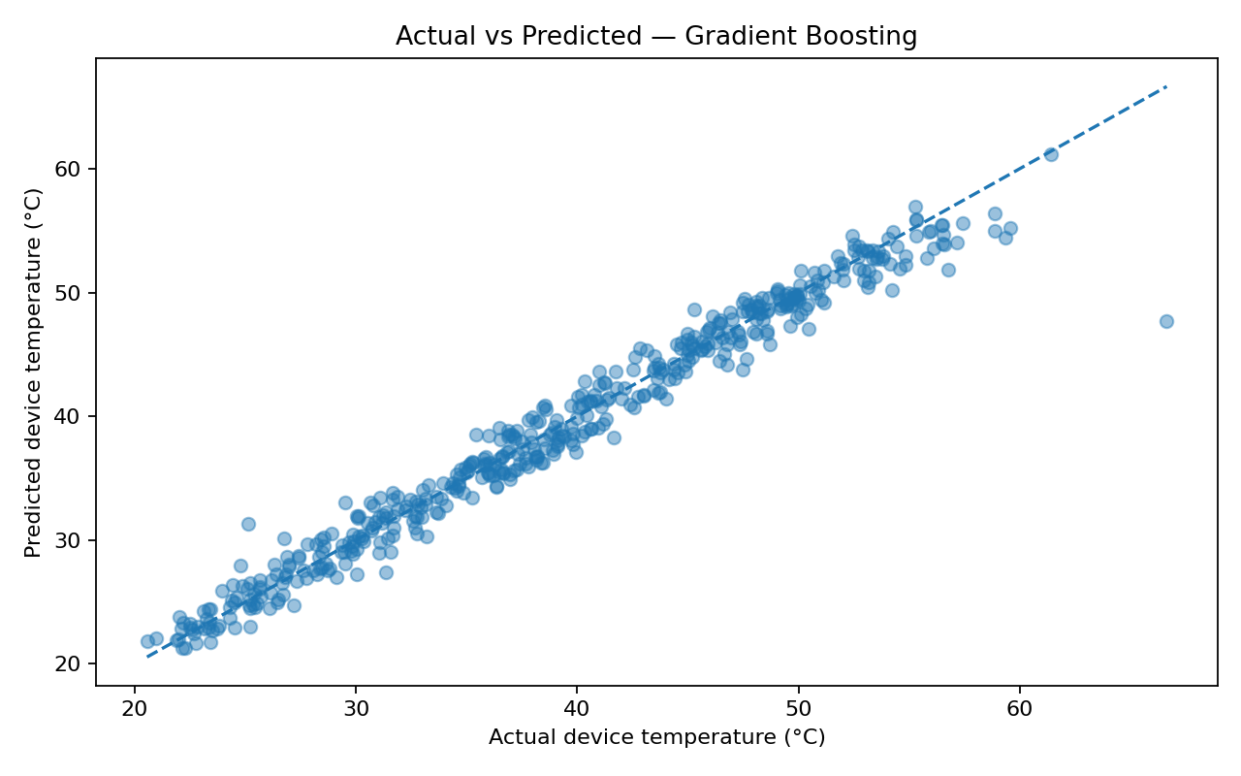
Figure 1. Actual versus predicted temperatures.
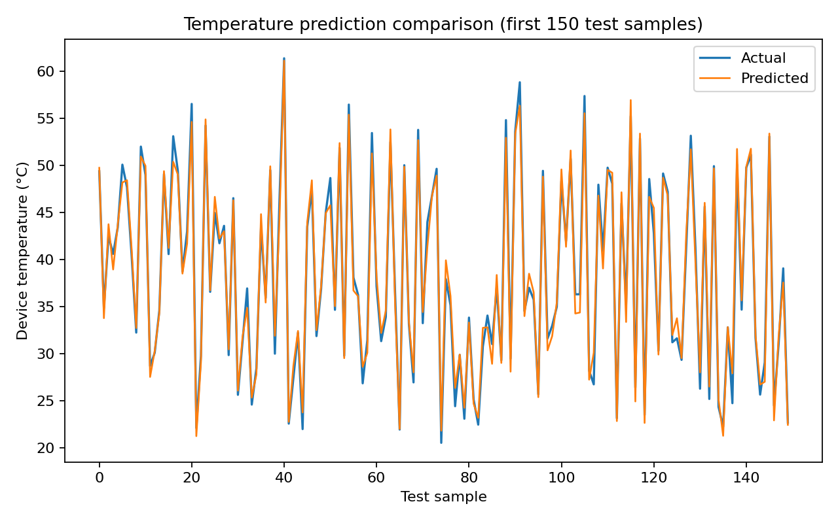
Figure 2. Actual and predicted temperature sequence.
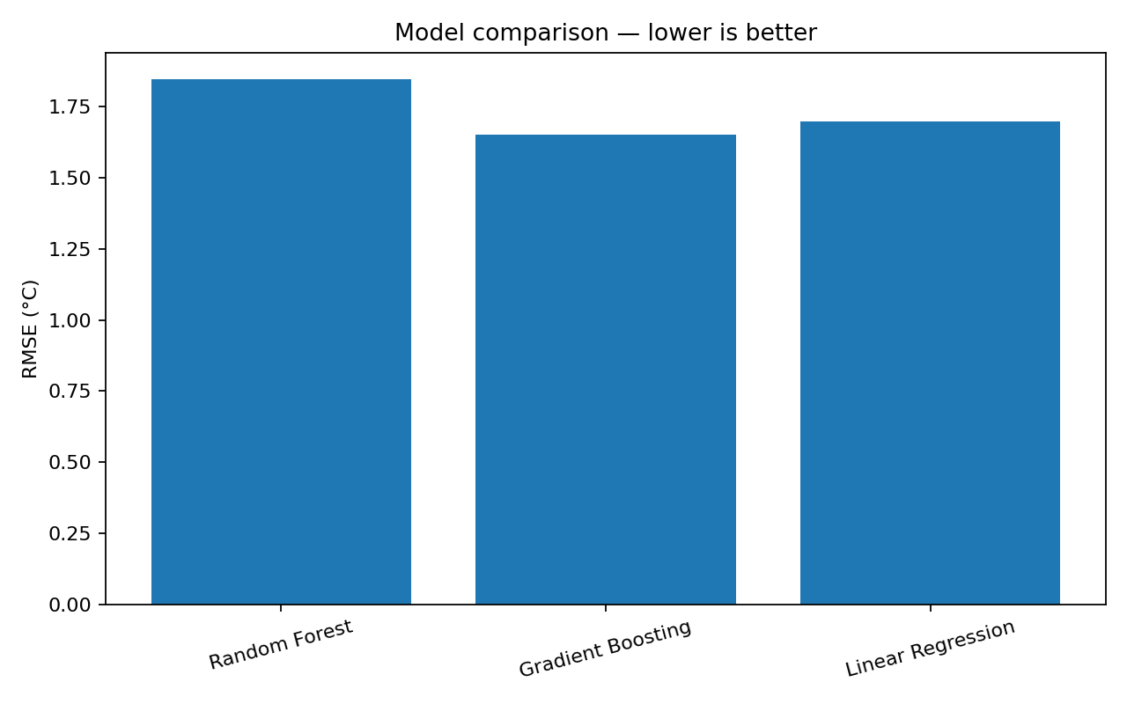
Figure 3. RMSE comparison across candidate models.

6. Discussion
The synthetic data encode a simplified relationship between power loss, thermal resistance, cooling factor, ambient temperature, and device temperature. A nonlinear ensemble can represent interactions more flexibly than a simple linear baseline. Performance scores are specific to this generated dataset and should not be interpreted as real-device accuracy.

7. Limitations and Future Work
- Replace synthetic records with measurements or LTspice/device electrothermal simulation outputs.
- Use the exact semiconductor datasheet: package thermal resistance, maximum junction temperature, SOA, and loss equations.
- Record sensor placement, calibration, sampling interval, transient duration, and cooling conditions.
- Use time-based or device-based validation when samples are sequential or come from multiple devices.
- Add uncertainty estimates and test across unseen devices, loads, and ambient conditions.

8. Conclusion
The capstone demonstrates a complete regression pipeline for semiconductor temperature prediction, including synthetic data generation, feature engineering, model comparison, evaluation, saved inference model, and visual reporting.

Safety and engineering note
This package is a software demonstration. It is not a substitute for datasheet limits, electrothermal simulation, laboratory validation, or hardware protection. Do not use its synthetic predictions to set safety limits or operate power hardware.

