Team 5 Course Registration System
Database Build Assignment - PostgreSQL Implementation
Repository: https://github.com/aghomofeunml-fr/info465_team5_registration_system.git
Prepared by: Eileena Doek, Michael Aghomo, Sinneh Bangura
Document Purpose: This database build document implements the database design from the Team 5 Architecture Design Document using AWS RDS PostgreSQL. It includes the final ER diagram, schema explanation, PostgreSQL SQL scripts, realistic test data, functional test queries, expected query results, RDS endpoint placeholder, and team contribution summary.

1. Assignment Alignment and Deliverables
This submission follows the team architecture decision to use Amazon RDS for PostgreSQL as the relational database layer. The database schema is aligned with the architecture document entities: Roles, Users, Students, Instructors, Departments, Courses, CoursePrerequisites, Terms, Sessions, and Enrollments.
Requirement | Where Addressed
Correct/refine schema to meet 3NF | Sections 2 and 3, ER diagram, schema summary, constraints
Create database in AWS RDS | Section 4 and setup README; RDS PostgreSQL endpoint placeholder included
Create tables and relationships | team5_registration_postgresql_schema_and_data.sql
Load realistic test data | SQL script includes 4 departments, 10 students, 5 instructors, 6 courses, 6 sessions, and 11 enrollments
Four functional test queries | Section 6 and team5_registration_postgresql_test_queries.sql
Query results and screenshots | Section 7 includes expected outputs and placeholders for actual AWS screenshots
Database endpoint | Section 8
Team contribution summary | Section 9

2. Database Management System
The database management system is PostgreSQL hosted on Amazon RDS. This matches the team architecture document, which selected Amazon RDS for PostgreSQL as the data layer for users, courses, sessions, enrollments, and schedules. PostgreSQL supports relational integrity, foreign keys, check constraints, transactions, indexes, and SQL queries required for course search and enrollment validation.

3. Final Database Design

3.1 Entity-Relationship Diagram
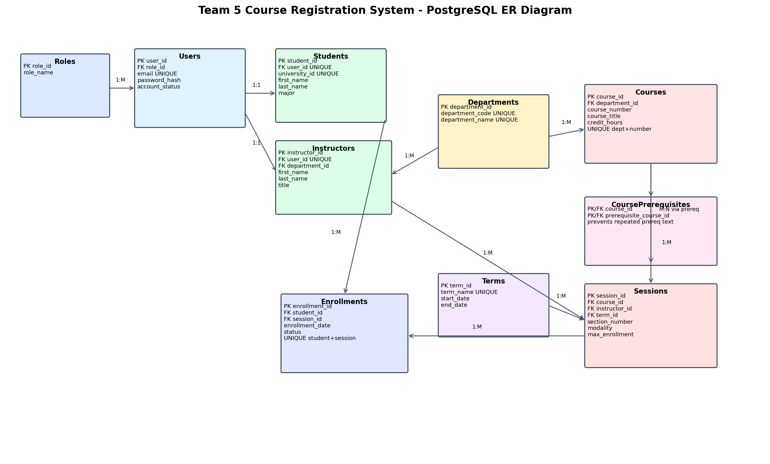
Figure 1. PostgreSQL ER diagram aligned to the Team 5 Architecture Design Document.

3.2 Third-Normal Form Explanation
The database design supports third-normal form by separating account data, role data, student data, instructor data, department data, course catalog data, term data, scheduled session data, prerequisite relationships, and enrollment records into separate tables. Non-key attributes depend on their table keys, and many-to-many relationships are handled using associative tables such as Enrollments and CoursePrerequisites. This reduces duplication and helps prevent update, insert, and delete anomalies.

3.3 Schema Summary
Table | Primary Purpose | Key Relationships / Constraints
Roles | Stores Student, Instructor, and Administrator role names. | One role can be assigned to many users; role_name is unique.
Users | Stores login account information. | Each user references one role; email is unique.
Students | Stores student profile data. | One-to-one with Users through user_id; university_id is unique.
Instructors | Stores instructor profile data. | One-to-one with Users; many-to-one with Departments.
Departments | Stores department codes and names. | One department has many courses and instructors.
Courses | Stores catalog-level course details. | Many courses belong to one department; unique department/course number.
CoursePrerequisites | Stores prerequisite course relationships. | Associative table; prevents repeated prerequisite text in Courses.
Terms | Stores academic term dates. | One term has many sessions.
Sessions | Stores scheduled course offerings. | Each session references one course, instructor, and term; modality and max enrollment vary by session.
Enrollments | Stores student registrations in sessions. | Associative table; unique student/session prevents duplicate registrations.

4. AWS RDS PostgreSQL Build Plan
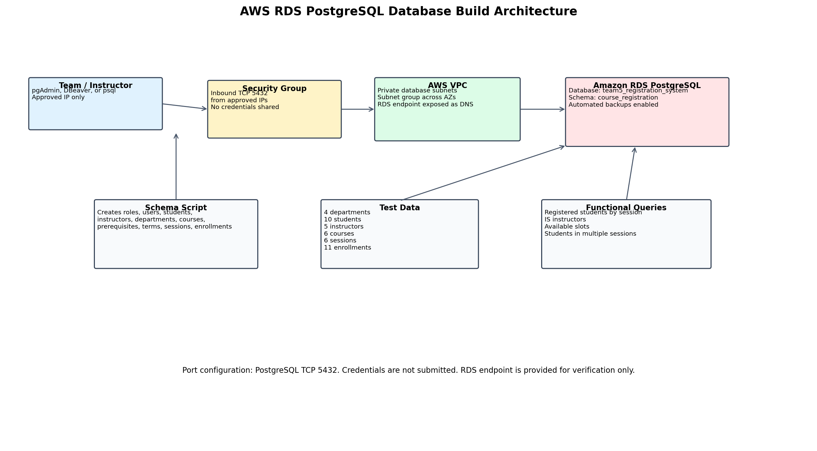
Figure 2. AWS RDS PostgreSQL build architecture and verification flow.
Configuration Item | Selected Value
Cloud service | Amazon RDS for PostgreSQL
Database identifier | team5-registration-postgres-db
Database name | team5_registration_system
Schema name | course_registration
Port | 5432
Instance class | db.t3.micro, db.t4g.micro, or db.t3.small for development/class use
Storage | 20 GB gp3 or general purpose storage
Security group | Allow TCP 5432 only from approved IP addresses or application server security group
Credentials | Do not submit credentials; endpoint only is provided for instructor verification

5. SQL Script and Test Data
The file team5_registration_postgresql_schema_and_data.sql creates the course_registration schema, creates all tables, defines primary keys, foreign keys, unique constraints, check constraints, and indexes, then loads realistic test data that satisfies the assignment requirements.
Required Test Data | Provided in Script
Departments: at least 2 | 4 departments: Information Systems, Marketing, Computer Science, Accounting
Courses: at least 5 | 6 courses: INFO 465, INFO 350, INFO 361, MKTG 302, MKTG 310, CMSC 255
Students: at least 10 | 10 students
Instructors: at least 5 | 5 instructors
Sessions: at least 5 with varying modalities/capacities | 6 sessions with In Person, Online, and Hybrid modalities
Enrollments | Alice Nguyen is enrolled in two sessions; at least five additional students are enrolled in one session

6. Functional Test Queries
The file team5_registration_postgresql_test_queries.sql includes four validation queries. These are designed to prove that relationships work across students, enrollments, sessions, courses, departments, instructors, and terms.
Query | Purpose
Query 1 | List all students registered for a specific course session: INFO 465, section 001, Fall 2026.
Query 2 | Find all instructors teaching in the Information Systems department.
Query 3 | Retrieve the number of available slots in INFO 465, section 001, Fall 2026.
Query 4 | Identify students registered for more than one active session.

7. Expected Query Results and Screenshot Placeholders
After running the test query script against the AWS RDS PostgreSQL database, paste screenshots of each query output in this section. The expected outputs below are based on the supplied test data and can be used to confirm the screenshots are correct.

7.1 Query 1 Expected Result - Students in INFO 465 Section 001
Course | Student ID | First Name | Last Name | Status
INFO 465 | V000001 | Alice | Nguyen | active
INFO 465 | V000002 | Ben | Carter | active
INFO 465 | V000008 | Hannah | Lee | active

7.2 Query 2 Expected Result - Information Systems Instructors
Instructor | Title | Course | Term | Section
Maria Garcia | Professor | INFO 465 | Fall 2026 | 001
James Lee | Associate Professor | INFO 350 | Fall 2026 | 001
James Lee | Associate Professor | INFO 361 | Fall 2026 | 001

7.3 Query 3 Expected Result - Available Slots for INFO 465
Course | Max Enrollment | Active Enrollments | Available Slots
INFO 465 | 30 | 3 | 27

7.4 Query 4 Expected Result - Students Registered in More Than One Session
Student ID | First Name | Last Name | Active Session Count | Registered Courses
V000001 | Alice | Nguyen | 2 | INFO 465, MKTG 302

8. AWS RDS Endpoint
RDS PostgreSQL endpoint for instructor verification: < info465database.cs7ca6exnjxi.us-east-1.rds.amazonaws.com>
Port: 5432
Credentials should not be included in the submission. The database must remain operational and accessible until grading is complete.

9. Team Contribution Summary
Role | Team Member | Contribution
Database Administrator | Eileena Doek | Created or coordinated AWS RDS PostgreSQL setup, endpoint documentation, and repository submission organization.
Data Engineer | Eileena Doek | Refined the PostgreSQL schema, relationships, constraints, and realistic test data based on the architecture design.
QA Analyst | Sinneh Bangura | Designed and executed the four functional validation queries and documented expected query outputs.
Project Manager | Michael Aghomo | Coordinated deliverables, GitHub upload, RDS verification checklist, and final Canvas submission package.

