**Basic  OSPF configuration.**

1. Build the network topology.

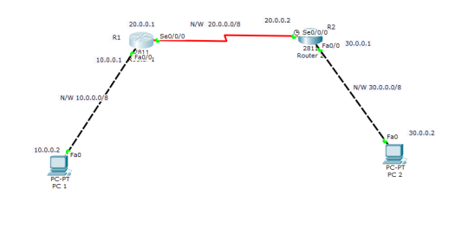

2.Configure IP addresses on PCs and router interfaces.

**Router 1**

R1(config)#int fa 0/0

R1(config-if)#ip add 10.0.0.1 255.0.0.0

R1(config-if)#no shut

R1(config-if)#

R1(config-if)#int serial 0/0/0

R1(config-if)#ip add 20.0.0.1 255.0.0.0

R1(config-if)#no shut

**Router 2**

R2(config-if)#int fa0/0

R2(config-if)#ip add 30.0.0.1 255.0.0.0

R2(config-if)#no shut

R2(config-if)#

R2(config-if)#int serial0/0/0

R2(config-if)#ip address 20.0.0.2 255.0.0.0

R2(config-if)#no shut

Now do IP configurations for the PCs.

**PC1**  IP add 10.0.0.2  Subnet mask 255.0.0.0   Default gateway  10.0.0.1

**PC2** IP add 30.0.0.2  Subnet mask 255.0.0.0    Default gateway   30.0.0.1

3**. Configure OSPF** on the routers.

The configuration is pretty simple and requires only two major steps:

1.  Enable OSPF on a router using the *router* *ospf PROCESS_ID* in the global configuration mode.

2.Define on which interfaces OSPF will run and what networks will be advertised using *network IP_ADDRESS  WILCARD_MASK  AREA*command in the OSPF configuration mode.

Note that the OSPF **process ID** *doesn’t have to be the same* on all routers in order for the routers to establish a neighbor relationship, but the **area** parameter *has to be the same* on all neighboring routers in order for the routers to become neighbors.

**Router 1**

R1(config)#

R1(config)#router ospf 1

R1(config-router)#network 10.0.0.0  0.255.255.255  area 0

R1(config-router)#network 20.0.0.0  0.255.255.255  area 0

**Router 2**

R2(config)#

R2(config)#router ospf  2

R2(config-router)#network 20.0.0.0  0.255.255.255 area 0

R2(config-router)#network 30.0.0.0  0.255.255.255 area 0

As you can see from the above picture,we just need to **enable OSPF** on the routers which then advertise the networks **directly connected** to each of them.

*Have in mind:*The **OSPF process IDs** used for the two routers  have been made **optionally** different but their **area  numbers** **must be** the same.

4. Verify OSPF configuration

First, let’s verify that the routers have established a neighbor relationship by typing the *show ip ospf neighbor*command on **R1**:

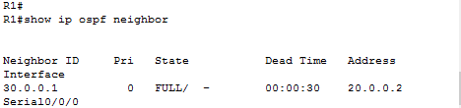

Next, to verify that R1 has learnt the route to 30.0.0.0/8 network, we’ll use  *show ip route ospf* command on **R1**:

show ip ospf on R1.PNG

Note that the letter **O**indicates OSPF routes.

Lastly, verify connectivity. Ping **PC2** from **PC1**. Ping should be successful.

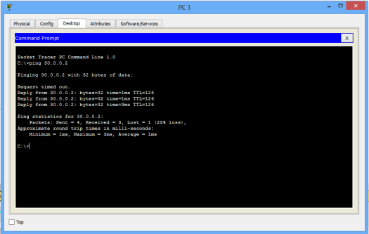

**Other OSPF verification commands**

* *show ip ospf  neighbors detail*
* *show ip ospf database*
* *show ip ospf interface*